Module 1 Assignment

# Part 1: Pseudocode for Addition and Subtraction

BEGIN

* PROMPT user to enter the first number
* STORE the first number in variable a
* PROMPT user to enter the second number
* STORE the second number in variable b
* CALCULATE the sum of a and b
* DISPLAY the sum
* CALCULATE the difference when b is subtracted from a
* DISPLAY the difference
* DISPLAY thank you message

END

# Part 2: Pseudocode for Multiplication and Division

BEGIN

* PROMPT user to enter the first number
* STORE the first number in variable a
* PROMPT user to enter the second number
* STORE the second number in variable b
* CALCULATE the product of a and b
* DISPLAY the product
* IF b is not equal to 0 THEN
* CALCULATE the division of a by b
* DISPLAY the quotient
* ELSE
* DISPLAY error message
* END IF

END

# Source Code

Below is the Python source code that implements the addition, subtraction, multiplication, and division operations as specified in Parts 1 and 2.

class Calculator():  
   
 def add(self, a, b):  
   
 print(f'The total from adding {a} to {b} is: {a + b}.')  
   
 def subtract(self, a, b):  
   
 print(f'The total for subtracting {b} from {a} is: {a - b}.')  
   
 def multiply(self, a, b):  
   
 print(f'The total for multiplying {a} by {b} is: {a * b}.')  
   
 def divide(self, a, b):  
   
 if b == 0:  
   
 print('Dividing by 0 results in undefined.')  
   
 return  
   
 print(f'The result of dividing {a} by {b} is: {a // b}.')

## Part 1

import Calculator

if __name__ == '__main__':

num_1 = int(input('Enter the first whole number: '))

num_2 = int(input('Enter the second whole number: '))

myCalculator = Calculator()

print('Part 1 - Addition and Subtraction', end='\n')

print('******************************************')

myCalculator.add(num_1, num_2)

myCalculator.subtract(num_1, num_2)

print('Thank you for using this calculator')

## Part 2

import Calculator

*if* __name__ == '__main__':

    num_1 = int(input('Enter the first whole number: '))

    num_2 = int(input('Enter the second whole number: '))

    myCalculator = Calculator()

    print('Part 2 - Multiplication and Divison')

    print('******************************************')

    myCalculator.multiply(num_1, num_2)

    myCalculator.divide(num_1, num_2)

    print('Thank you for using this calculator')

# Screenshots of Execution

## Part 1

## Part 2

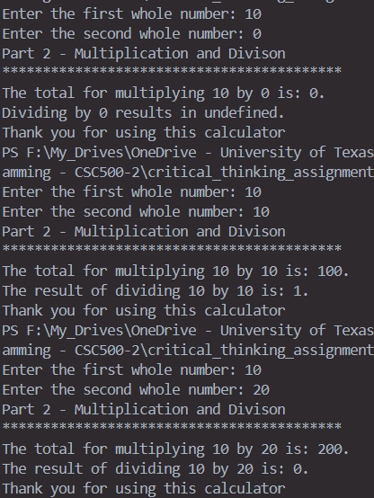

# Results

The result of running the program was as expected with the assumption of the user entering whole numbers. Areas of improvement include:

* Error handling for non-numerical characters
* Handling division with remainders
* Allowing the program to continue until the user wants to stop

# Git Repository

Git repository - https://github.com/Mr-Abe/critical_thinking_assignments.