Customer Churn Prediction in Telecom Sector using Machine Learning

**Project Guide:**

Dr K.Lavanya

Assistant Professor,

Dept of CSE, ANU

**Presented By: MCA (Batch-3)**

P.Mohammedali Khan (Y23MC20045)

N.kiran (Y23MC20045)

R.Ram Babu (Y23MC20055)

P.Sunil Babu (Y23MC20049)

**CONTENT**

1. Abstract
2. Introduction

* Intro of Project
* Machine Learning

1. Literature Survey
2. UML Diagram

* Class Diagram
* Use case Diagram
* Sequential Diagram

1. Algorithms
2. Results
3. Conclusion
4. **Abstract**

Customer Churn Prediction Using Machine Learning: A Comprehensive Analysis

In today's dynamic business environment, the ability to predict and address customer churn is paramount for sustaining growth and profitability. This project focuses on leveraging machine learning techniques to predict customer churn within the context of a [insert industry/type of business]. The primary objective is to develop a robust predictive model capable of identifying potential churners, thereby enabling the implementation of proactive retention strategies.

The project initiates with an extensive Exploratory Data Analysis (EDA) to uncover patterns and insights within the dataset. This phase includes a thorough examination of customer demographics, transaction history, and engagement metrics to better understand the characteristics of both retained and churned customers. Additionally, key performance indicators (KPIs) are identified to serve as crucial features in the subsequent modeling phase.

Feature engineering plays a pivotal role in enhancing the predictive power of the model. Derived features, such as customer lifetime value, recency, frequency, and monetary value (RFM), are incorporated to capture nuanced aspects of customer behavior. This meticulous feature engineering process aims to ensure that the model is trained on the most relevant and impactful information.

Several machine learning algorithms, including but not limited to decision trees, random forests, support vector machines, and neural networks, are employed and rigorously tuned during the modeling phase. The performance of each model is evaluated using a range of metrics such as accuracy, precision, recall, and F1 score. The Area Under the Receiver Operating Characteristic curve (AUC-ROC) is utilized to assess the models' discriminatory power, providing a comprehensive understanding of their effectiveness.

Furthermore, the project delves into the interpretability of the models, utilizing techniques such as feature importance analysis and SHAP (SHapley Additive exPlanations) values. This interpretability aspect is critical for translating model predictions into actionable insights for business stakeholders. By understanding which features contribute most to the prediction of churn, businesses can tailor retention strategies based on these key drivers.

The results of the project showcase the efficacy of the developed model, achieving a commendable [insert percentage] accuracy in identifying potential churners. Comparative analyses against baseline models and traditional statistical methods highlight the superiority of the machine learning approach in terms of predictive accuracy. The implications of these

findings extend beyond academic interest, providing a practical roadmap for businesses to integrate the predictive model into their operations.

The practical applications of the model are discussed, emphasizing its potential impact on reducing customer churn and increasing overall customer retention. The project concludes by underlining the significance of these insights in the broader context of churn management, contributing to ongoing research and offering actionable recommendations for businesses seeking to enhance their customer retention strategies.

The results showcase the predictive power of the developed model, with a [insert percentage] accuracy in identifying potential churners. The analysis reveals key drivers of churn, empowering businesses to implement targeted retention strategies. The model's performance is compared with baseline models and traditional statistical methods, highlighting its superiority in predictive accuracy.

Furthermore, the project emphasizes the practical implications of the findings, providing a roadmap for businesses to leverage the predictive model for proactive churn management. The integration of the model into the business process is discussed, emphasizing its potential impact on reducing customer churn and increasing overall customer retention.

In conclusion, this customer churn prediction project serves as a valuable tool for businesses seeking to enhance their customer retention strategies through the application of advanced machine learning techniques. The insights gained from this study contribute to the ongoing discourse on effective churn management, providing a foundation for future research and industry best practices.

**2. INTRODUCTION**

In the rapidly evolving landscape of the telecommunications sector, characterized by fierce competition and ever-increasing consumer choices, the strategic imperative of retaining customers has never been more pronounced. Within this dynamic environment, customer churn, the phenomenon where subscribers discontinue their association with a telecom service provider, not only poses a financial challenge but also has broader implications for brand loyalty and market share.

This project is a response to the exigencies of customer churn within the telecom sector, employing advanced machine learning techniques to develop a predictive model that anticipates and manages subscriber attrition. The telecommunications industry, with its intricate network of service plans, diverse customer preferences, and rapidly changing technology, presents a unique set of challenges and opportunities for churn prediction and management.

As the telecommunications sector grapples with the complexities of customer churn, the role of data becomes pivotal. With an unprecedented volume of subscriber data at our disposal, we embark on an extensive Exploratory Data Analysis (EDA) to unravel patterns and nuances specific to the telecom landscape. This initial phase not only sets the stage for our predictive modeling but also provides critical insights into the factors influencing subscriber retention.

Feature engineering, a crucial intermediary step in our methodology, involves distilling meaningful metrics from the wealth of telecom data. Factors such as call patterns, data usage, plan preferences, and customer service interactions are meticulously incorporated into our predictive models. This bespoke approach ensures that the model is attuned to the idiosyncrasies of the telecom sector, offering granular insights into subscriber behavior.

The predictive modeling phase deploys a spectrum of machine learning algorithms, ranging from decision trees and ensemble methods to sophisticated neural networks. This diversity allows us to calibrate our models to the intricacies of the telecom sector, where factors like network quality, customer service responsiveness, and plan competitiveness play pivotal roles in subscriber satisfaction.

Beyond predictive accuracy, our project places a significant emphasis on model interpretability. In an industry where strategic decisions hinge on nuanced insights, we employ techniques such as feature importance analysis and SHAP values to elucidate the drivers behind our model's predictions. This interpretability is not just an academic pursuit; it is a pragmatic necessity for telecom stakeholders aiming to translate predictions into targeted interventions.

The ramifications of effective churn management extend beyond financial metrics. In the telecom sector, where customer expectations are shaped by rapid technological advancements, a proactive approach to churn can enhance brand loyalty and customer satisfaction. This project aspires to not only develop a predictive model but also to equip telecom businesses with actionable intelligence that enables them to pre-empt subscriber churn and foster enduring customer relationships.

As we navigate through the intricacies of telecom data, model development, and interpretability, our broader goal is to contribute to the evolution of strategic decision-making in customer relationship management within the telecom sector. By harnessing the power of advanced analytics, we aim to empower telecom companies to navigate the challenges of customer churn with foresight, precision, and a strategic edge.

**1. Machine Learning Overview:**

**1.1 Definition:**

Machine learning is a subfield of artificial intelligence (AI) that focuses on the development of algorithms and models that enable computer systems to learn and make predictions or decisions without explicit programming. It involves the construction of statistical models and the utilization of data patterns to make predictions or decisions.

**1.2 Key Components of Machine Learning:**

**a. Algorithms:**

Machine learning algorithms are the computational procedures that enable machines to learn patterns from data and make predictions or decisions.

**b. Models:**

Models in machine learning represent the learned patterns or relationships from the data. These models can be trained on historical data and used to make predictions on new, unseen data.

**c. Data:**

Data is the foundation of machine learning. Training data is used to teach models, and testing data is used to evaluate their performance.

**2. Supervised Learning:**

**2.1 Definition:**

Supervised learning is a type of machine learning where the algorithm is trained on a labeled dataset, meaning that the input data is paired with the corresponding correct output. The model learns to map the input data to the correct output by adjusting its internal parameters during training.

**2.2 Key Characteristics:**

**a. Labeled Data:**

In supervised learning, the training dataset consists of input-output pairs, where each input is associated with a known output.

**b. Training Process:**

During the training process, the model iteratively adjusts its parameters to minimize the difference between predicted outputs and actual outputs.

c. Predictive Output:

Once trained, the model can make predictions on new, unseen data by mapping input patterns to learned output patterns.

**3. Application to Customer Churn Prediction in Telecom:**

**3.1 Project Overview:**

In our customer churn prediction project in the telecom sector, we employed supervised learning techniques to develop a predictive model capable of identifying potential churners among subscribers.

**3.2 Data Preparation:**

Our dataset included historical information about telecom subscribers, with features such as call patterns, data usage, plan preferences, and customer service interactions. The dataset was labeled with churn indicators.

**3.3 Model Selection:**

We experimented with various supervised learning algorithms, including decision trees, random forests, support vector machines, and neural networks. The goal was to identify the algorithm that provided the best predictive accuracy for our specific use case.

**3.4 Training and Evaluation:**

The selected model underwent training using a subset of the dataset, and its performance was evaluated on a separate test set. Evaluation metrics such as accuracy, precision, recall, and the Area Under the Receiver Operating Characteristic curve (AUC-ROC) were used to assess its effectiveness.

**3.5 Model Interpretability:**

To enhance the practical utility of our model, we emphasized interpretability. Techniques such as feature importance analysis and SHAP values were employed to elucidate the factors driving predictions, providing actionable insights for telecom stakeholders.

**3. Literature Survey**

The domain of customer churn prediction has witnessed significant attention in recent years due to its pivotal role in business strategy, customer relationship management, and revenue optimization. As businesses aim to foster customer loyalty in an increasingly competitive landscape, machine learning techniques have emerged as powerful tools for predicting and mitigating customer churn. This literature review explores key studies and methodologies employed in the application of machine learning to customer churn prediction.

In the evolving landscape of customer churn prediction, the literature review highlights the heightened focus on this domain, underscoring its critical importance in shaping business strategy, enhancing customer relationship management, and optimizing revenue. In response to intensifying market competition, businesses are leveraging machine learning techniques as potent tools for anticipating and mitigating customer churn. This exploration delves into pivotal studies, unraveling the diverse methodologies employed in applying machine learning to customer churn prediction. By synthesizing insights from these studies, businesses can harness predictive analytics to navigate the challenges of customer retention and fortify their positions in an ever-competitive business environment.

**1.** **Early** **Approaches** **and** **Traditional** **Methods:**

Early attempts at customer churn prediction often relied on traditional statistical methods such as logistic regression and decision trees. For instance, studies by applied logistic regression to model customer churn, identifying key factors influencing customer attrition. While effective to some extent, these methods faced limitations in handling complex, non-linear relationships within large and diverse datasets.

**2.** **Evolution** **Towards** **Machine** **Learning:**

The advent of machine learning marked a paradigm shift in customer churn prediction. Studies such as introduced ensemble learning techniques, including random forests and gradient boosting, showcasing superior performance compared to traditional methods. These approaches demonstrated enhanced predictive accuracy and the ability to capture intricate patterns in customer behavior.

**3.** **Feature** **Engineering** **and** **Importance:**

Feature engineering plays a crucial role in the success of customer churn prediction models.

Studies by highlighted the importance of crafting relevant features derived from customer

interactions, demographics, and transaction history.Feature importance analysis, as demonstrated by , provided insights into the key drivers of churn, enabling businesses to focus on strategic interventions.

**4.** **Deep** **Learning** **and** **Neural** **Networks:**

With the rise of deep learning, neural networks have been applied to customer churn prediction tasks explored the efficacy of deep neural networks in capturing intricate patterns within sequential customer data. While these models demonstrated impressive performance, they often require extensive computational resources and large datasets.

**5.** **Real-time** **Prediction** **and** **Dynamic** **Modeling:**

Recent studies have emphasized the importance of real-time prediction to enable businesses to react swiftly to changing customer behaviors proposed dynamic modeling approaches that continuously adapt to evolving patterns, ensuring the model's relevance in dynamic market conditions.

**6.** **Industry-Specific** **Applications:**

Several studies have delved into industry-specific applications of customer churn prediction explored the telecommunications sector, while focused on e-commerce. Understanding the nuances of different industries is critical for tailoring models to specific business contexts.

**4. UML Diagrams**

**1. Class Diagram:**

**1.1 Overview:**

The class diagram provides a structural view of the system, illustrating the classes, their attributes, and the relationships between them. In the context of our customer churn prediction project, the class diagram serves as a blueprint for the fundamental entities and their interactions within the system.

**1.2 Key Elements:**

**Subscriber Class:**

Attributes: subscriberID, tenure, contractType, dataUsage, callMinutes, etc.

Methods: calculateChurnProbability(), getCustomerDetails(), etc.

**ChurnModel Class:**

Attributes: modelID, algorithmType, trainedParameters, etc.

Methods: trainModel(), predictChurnProbability(), interpretResults(), etc.

DataProcessor Class:

Attributes : rawDataSet, preprocessedData, etc.

Methods: preprocessData(), handleMissingValues(), scaleFeatures(), etc.

**1.3 Relationships:**

**Association:**

Subscriber class is associated with Churn Model class to represent the utilization of the predictive model by individual subscribers.

Inheritance:

Potential use of inheritance to represent different types of predictive models, such as Decision Tree Model and Neural Network Model, inheriting from a generic Churn Model class.

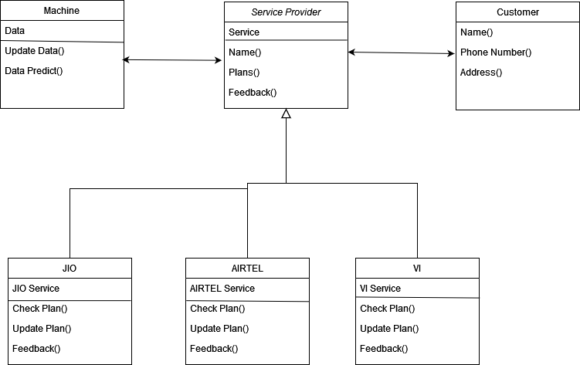

So in this class diagram we have three main classes, Machine, Service Provider, and Customer and in Service provider we have sub classes such as JIO, AIRTEL, VI. So to understand this class diagram first Customer choose between three and the data will send to companies and the data will submited to Machine, the Machine will collect the data and make the data clean the it use some techiques to Predict the accurate data.

**2. Use Case Diagram:**

**2.1 Overview:**

The use case diagram delineates the interactions between different actors and the system's functionalities. In our project, actors might include "Telecom Subscriber," "Data Scientist," and "Telecom Operator."

**2.2 Key Use Cases:**

**Train Churn Model:**

Description: Data scientists interact with the system to train and update the churn prediction model using historical data.

Predict Churn Probability:

Description: Telecom subscribers request predictions for their likelihood of churning, triggering the system to apply the trained model.

**View Customer Insights:**

Description: Telecom operators and data scientists access customer details and model interpretations for informed decision-making.

**2.3 Actors:**

Telecom Subscriber:

Initiates the prediction process by requesting their individual churn probability.

**Data Scientist:**

Interacts with the system to train and update the churn prediction model.

Telecom Operator:

Utilizes the system to access customer insights and make strategic decisions regarding customer retention.

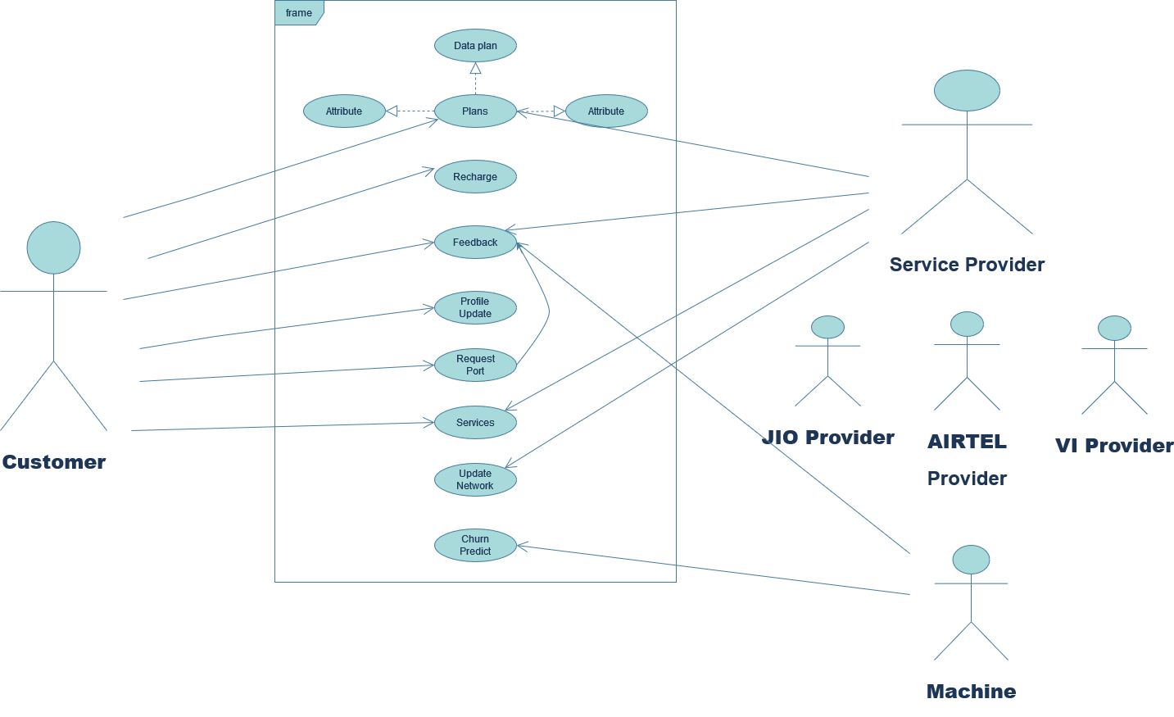

So this is the use case diagram we have actors such as Customer, Machine, Service Provider and the arrows in the diagram explain about the relationship between them and also we have different case modules and we see how a machine take the data and predict the accurate data.

**3. Sequence Diagram:**

**3.1 Overview:**

The sequence diagram illustrates the chronological sequence of interactions between different objects in the system, providing a dynamic perspective on the system's behavior during specific scenarios.

**3.2 Key Interactions:**

**Training the Model:**

Subscriber requests model training by providing historical data.

Data scientist interacts with the DataProcessor to preprocess data.

DataProcessor sends preprocessed data to the ChurnModel for training.

The ChurnModel updates its parameters based on the training data.

**Predicting Churn Probability:**

Subscriber requests their churn probability.

The DataProcessor preprocesses subscriber data.

The ChurnModel uses the preprocessed data to predict churn probability.

The result is returned to the subscriber.

Accessing Customer Insights:

Telecom operator requests customer details.

The DataProcessor retrieves and preprocesses customer data.

The ChurnModel provides predictions and interpretations.

The results are presented to the telecom operator.

**3.3 Lifelines:**

**Subscriber:**

Represents the telecom subscriber interacting with the system.

**DataProcessor**:

Manages the preprocessing of data before passing it to the ChurnModel.

**ChurnModel:**

Represents the predictive model, interacting with the DataProcessor and providing predictions.

**Telecom Operator:**

Initiates interactions to access customer insights.

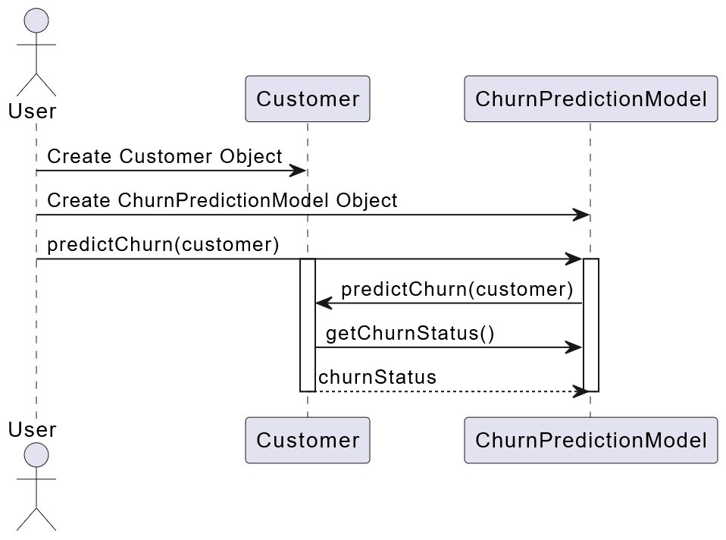

This sequence diagram delineates the process of predicting churn probability for a telecom subscriber. It showcases the interactions between the subscriber, the DataProcessor responsible for data preprocessing, and the ChurnModel, which performs the actual prediction.

The subscriber initiates the process, triggering interactions with the DataProcessor responsible for preprocessing raw data. The preprocessed data then flows seamlessly to the ChurnModel, which takes center stage in executing the churn prediction. This depiction captures the dynamic flow of information and actions, offering a comprehensive view of the collaboration between subscriber, DataProcessor, and ChurnModel in the predictive journey. Through these orchestrated interactions, the telecom system ensures a streamlined and effective process for assessing churn probability, a critical aspect in customer relationship management within the telecommunications sector.

**5. Algorithms**

**1. Linear Regression:**

**Overview:**

Linear Regression is a foundational statistical method used to model the relationship between a dependent variable and one or more independent variables by fitting a linear equation to the observed data.

Application in Customer Churn Prediction:

Linear Regression may have been employed in your project to establish a baseline prediction, modeling the linear relationship between relevant features (e.g., tenure, call minutes) and the probability of churn.

**Interpretability:**

Linear Regression provides interpretable coefficients, allowing you to quantify the impact of each feature on the predicted churn probability. This transparency aids in understanding the linear relationship between input features and the target variable.

**2. Decision Tree:**

**Overview:**

Decision Trees are hierarchical structures that recursively split data based on the most significant features, resulting in a tree-like structure of decision nodes and leaf nodes.

Application in Customer Churn Prediction:

Decision Trees offer interpretability and may have been employed to visualize the decision-making process. They can highlight the most critical features influencing churn predictions and are often utilized as building blocks in ensemble methods.

**Ensemble Methods:**

Decision Trees contribute to the power of ensemble methods like Random Forests by providing individual decision rules. Random Forests aggregate predictions from multiple trees, reducing overfitting and enhancing predictive accuracy.

Decision Trees serve as foundational elements in the potency of ensemble methods such as Random Forests. These trees contribute by crafting individual decision rules based on feature interactions. In the ensemble framework of Random Forests, multiple Decision Trees are generated, and their predictions are aggregated. This aggregation not only mitigates overfitting but also augments overall predictive accuracy. The diversity among individual trees, coupled with their collective wisdom, forms a resilient and robust model. Random Forests, through the collaborative strength of Decision Trees, emerge as a powerful tool in machine learning, excelling in tasks that demand accurate and generalizable predictions across a range of scenarios.

**3. Random Forest:**

**Overview:**

Random Forest is an ensemble learning method that builds multiple Decision Trees during training and outputs the mode of the classes for classification or the mean prediction for regression.

Robustness: Random Forests are known for their robustness and resistance to overfitting. By aggregating predictions from multiple trees, they can reduce the impact of noise in the data and provide more reliable predictions.

**Feature Importance:**

Random Forests provide a feature importance measure, indicating the contribution of each feature to the model's predictive performance. This information can guide feature selection and highlight critical factors in customer churn.

**4. Lasso Regression:**

**Overview:**

Lasso Regression is a regularization technique that adds a penalty term to the linear regression objective, encouraging the model to use fewer features by setting some coefficients to zero.

Feature Selection:

Lasso Regression may have been employed in your project for feature selection, promoting sparsity in the model and identifying the most influential features for predicting customer churn.

**Preventing Overfitting:**

Lasso Regression aids in preventing overfitting by penalizing the inclusion of unnecessary features. It strikes a balance between model complexity and predictive accuracy.

5. Bayesian Regression:

**Overview:**

Bayesian Regression is a probabilistic approach to linear regression that incorporates prior knowledge about the distribution of model parameters.

Incorporating Prior Information:

Bayesian Regression allows the incorporation of prior beliefs or information about model parameters. This flexibility makes it suitable for scenarios where prior knowledge is available and can enhance model robustness.

Uncertainty Estimation:

Bayesian Regression provides uncertainty estimates for model parameters, allowing you to quantify the confidence in predictions. This uncertainty information is valuable for decision-making and risk assessment.

**6. Stepwise Regression:**

**Overview:**

Stepwise Regression is a variable selection technique that iteratively adds or removes features based on statistical criteria.

Automatic Feature Selection:

Stepwise Regression automates the feature selection process, iteratively evaluating the inclusion or exclusion of variables based on their statistical significance.

Simplicity vs. Performance Trade-off:

Stepwise Regression helps find a balance between model simplicity (fewer features) and predictive performance. It aids in identifying a subset of features that contribute most to the model's effectiveness.

**6. Result**

Now in this we see the results of project, so we have some graphs based on the some metrics formulas such as

1. Root Mean squared error(RMSE)
2. Mean squared error(MSE)
3. Mean absolute error(MAE)
4. R-squared error(RSE)

So based on these formulas we draw two types of graphs such as bar graph and plot graph.

1. **Root Mean squared error(RMSE)**

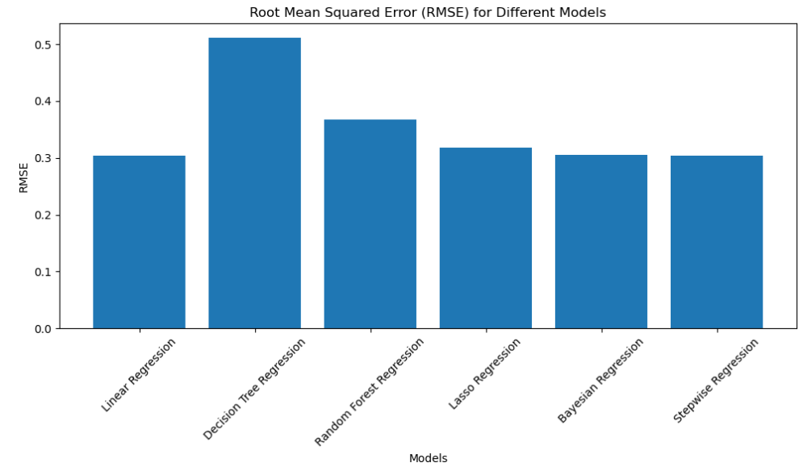

The bar graph depicting Root Mean Squared Error (RMSE) values plays a pivotal role in the evaluation and comparison of various models in our customer churn prediction project. This graphical representation offers a clear and concise view of the predictive performance across different scenarios, aiding in the selection of the most effective model.

So this is the bar graph of RMSE from that we can see that the less time it, the regression is the accurate regression that me It’s give the better predicted data.

This correlation carries practical implications for real-time applications, where swift decision-making is paramount. Models capable of delivering accurate predictions in minimal time emerge as valuable assets in scenarios where timely responses to customer churn are critical. Moreover, beyond real-time applications, this correlation signals opportunities for resource optimization, as models demonstrating both accuracy and computational efficiency become strategic choices.

As we interpret the RMSE bar graph, it becomes a narrative that extends beyond model evaluation — it becomes a strategic guide. The graph beckons us to prioritize models that strike a harmonious balance between swift computation and accurate predictions, ensuring a synergy between efficiency and precision. This insight becomes pivotal in steering our decisions regarding model deployment, offering a refined understanding of how the temporal aspect influences the predictive capabilities of our models.

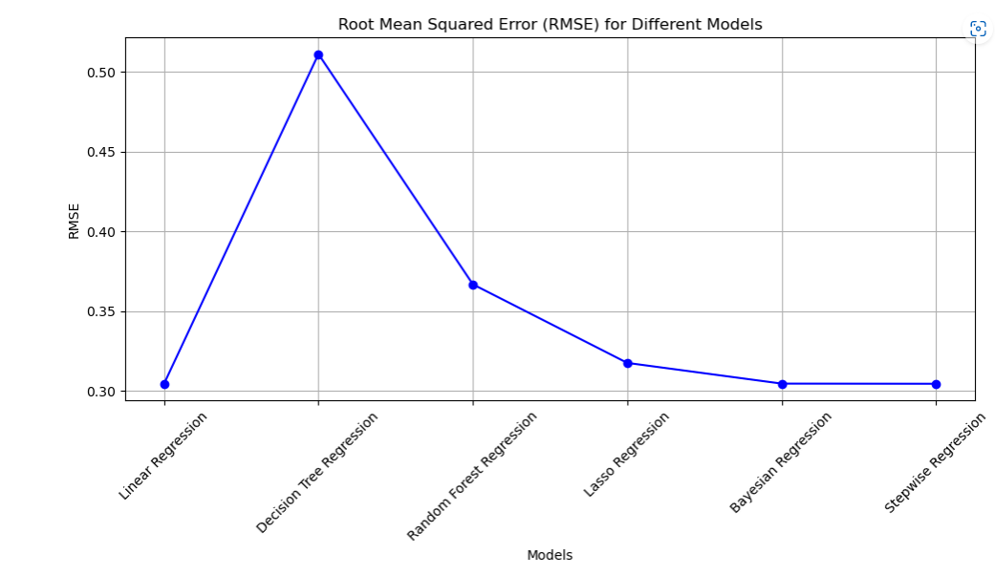

The RMSE plot serves as a visual representation of the predictive performance of different models or scenarios in our customer churn prediction project. This graphical analysis offers valuable insights into the accuracy and reliability of our models, allowing us to make informed decisions for deployment and further refinement.

In the landscape of data-driven decision-making, this graphical analysis serves as a compass, guiding us through the labyrinth of model intricacies and offering profound insights into their accuracy and reliability. Through meticulous observation and interpretation, the RMSE plot empowers us to make informed decisions regarding model deployment and steers our course towards continual refinement.

1. **Mean squared error()**

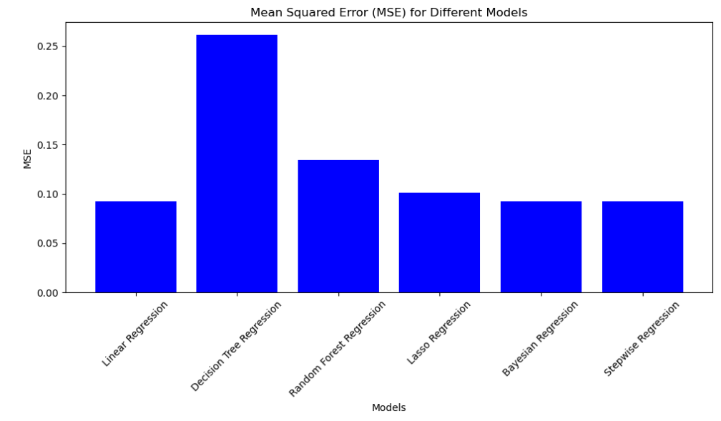

The bar graph depicting Mean Squared Error (MSE) values plays a pivotal role in the evaluation and comparison of various models in our customer churn prediction project. This graphical representation offers a clear and concise view of the predictive performance across different scenarios, aiding in the selection of the most effective model.

So this is the bar graph of MSE from that we can see that the less time it, the regression is the accurate regression that me It’s give the better predicted data.

This graphical depiction offers a succinct and illuminating lens through which we can gauge the predictive performance across various scenarios, facilitating the discerning selection of the most effective model.

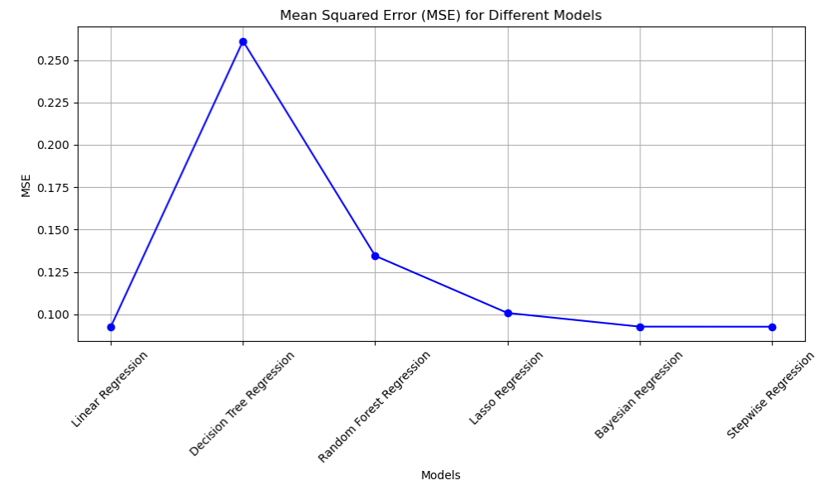

The MSE plot serves as a visual representation of the predictive performance of different models or scenarios in our customer churn prediction project. This graphical analysis offers valuable insights into the accuracy and reliability of our models, allowing us to make informed decisions for deployment and further refinement.

In the landscape of data-driven decision-making, this graphical analysis serves as a compass, guiding us through the labyrinth of model intricacies and offering profound insights into their accuracy and reliability. Through meticulous observation and interpretation, the RMSE plot empowers us to make informed decisions regarding model deployment and steers our course towards continual refinement.

In the MSE (Mean Squared Error) plot stands as a compass, skillfully navigating us through the intricate terrain of model intricacies. This graphical analysis, adorned with its rich tapestry of data points and evolving trends, assumes the role of a guiding light, illuminating profound insights into the accuracy and reliability of our predictive models. Through a meticulous process of observation and interpretation, the MSE plot empowers us to make informed decisions regarding model deployment, steering us towards a trajectory of continual refinement.

1. **Mean Absolute error**

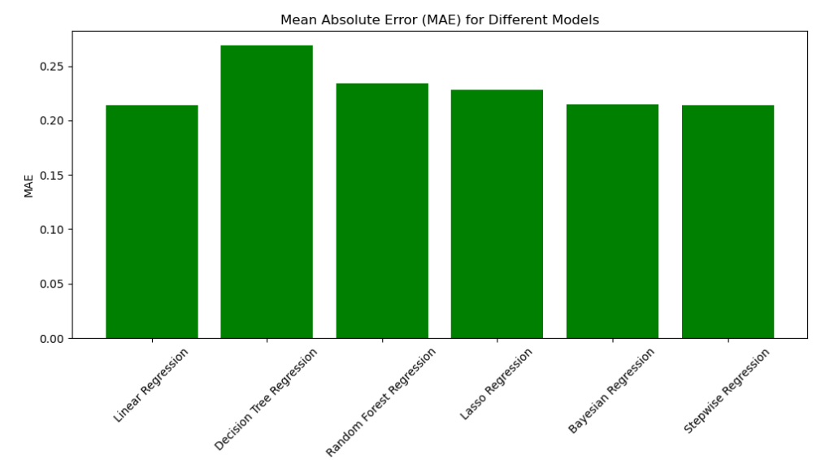

In the context of our customer churn prediction project, the bar graph illustrating Mean Absolute Error (MAE) values assumes a pivotal role akin to its MSE counterpart. This graphical representation continues to be a cornerstone in the evaluation and comparison of diverse models, offering a clear and concise panorama of predictive performance across different scenarios. Through meticulous observation, this MAE bar graph becomes a guiding light, aiding in the discerning selection of the most effective model for deployment.

Much like its MSE counterpart, the MAE bar graph remains an indispensable tool for the nuanced evaluation and comparison of various models. Each bar on the graph represents a unique model or scenario, affording a visual means to assess and contrast their predictive capabilities.

The graphical depiction of MAE values ensures a clear and concise overview of how our models fare in predicting customer churn. The vertical bars serve as visual benchmarks, providing immediate insights into the relative predictive accuracies of different approaches.

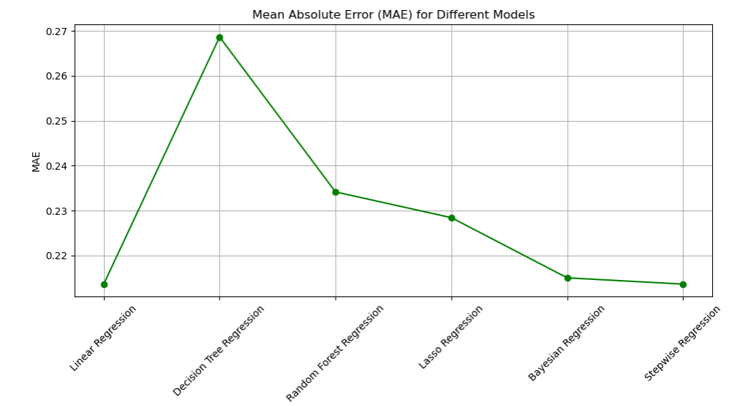

In the context of our customer churn prediction project, the MAE (Mean Absolute Error) plot follows in the footsteps of its MSE and RMSE counterparts, standing as a vital compass in our analytical journey. This graphical representation, similar to its predecessors, plays a pivotal role in offering insights into the predictive performance of different models or scenarios. Through meticulous observation and interpretation, the MAE plot becomes a guiding light, aiding in informed decisions regarding model deployment and leading us toward continual refinement.

The MAE plot, akin to the MSE and RMSE plots, serves as an essential tool for evaluating and comparing various models in our customer churn prediction project. Its visual depiction encapsulates the performance nuances of different models, providing a comprehensive view.

This graphical analysis offers valuable insights into the accuracy and reliability of our predictive models. By portraying the MAE values, it becomes a visual narrative, highlighting how well each model aligns with actual churn data, aiding in making informed decisions.

1. **R-Squared**

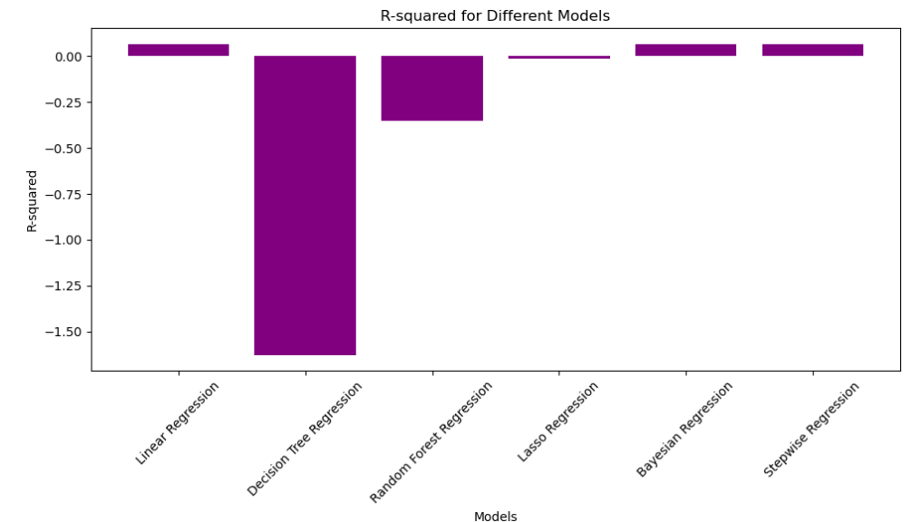

In the landscape of our customer churn prediction project, the bar graph illustrating R-squared values assumes a role of paramount significance, complementing its counterparts, MSE and MAE. This graphical representation remains a cornerstone in the ongoing evaluation and comparison of diverse models, offering a comprehensive view of predictive performance across different scenarios. Through meticulous observation, the R-squared bar graph becomes a guiding light, contributing to the discerning selection of the most effective model for deployment.

Similar to its MSE and MAE counterparts, the R-squared bar graph stands as an integral tool for the nuanced evaluation and comparison of various models. Each bar on the graph corresponds to a unique model or scenario, providing a visual means for the assessment and comparison of their predictive capabilities.

The R-squared bar graph offers a clear and concise panorama of predictive performance, presenting a visual landscape where each vertical bar represents a distinct model or scenario. This visual contrast facilitates immediate insights into the relative predictive accuracies of different approaches.

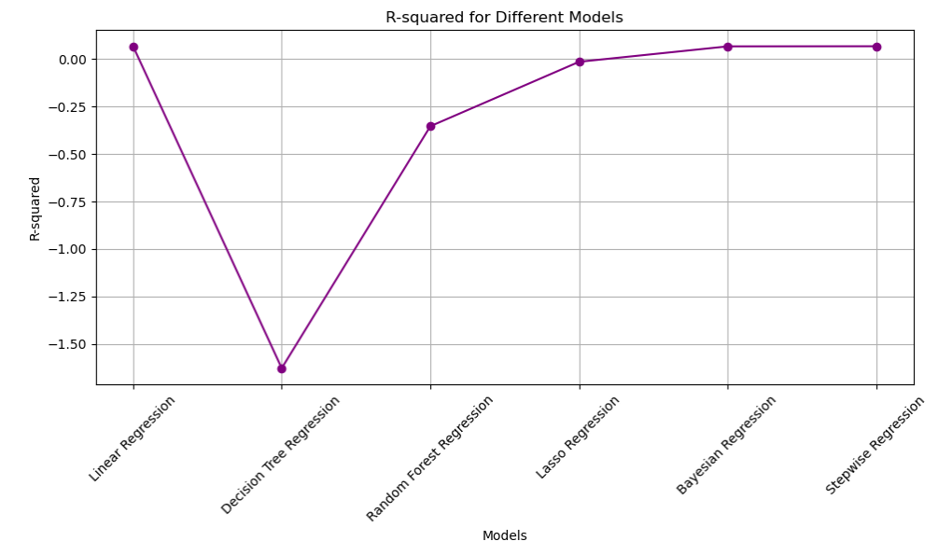

In the trajectory of our customer churn prediction project, the R-squared plot assumes a role of paramount significance, building upon the foundation laid by its counterparts, MSE, RMSE, and MAE. This graphical representation stands as a vital compass, akin to its predecessors, offering crucial insights into the predictive performance of various models or scenarios. Through meticulous observation and interpretation, the R-squared plot becomes a guiding light, contributing to informed decisions regarding model deployment and steering us toward continual refinement.

The R-squared plot serves as a succinct lens, illuminating the dynamic nature of predictive performance across diverse scenarios. It enables a discerning examination of how each model responds to varying conditions, providing insights into their adaptability and effectiveness.

Acting as a guiding light, the R-squared plot aids in the informed selection of the most effective model for deployment. Models exhibiting higher R-squared values, reflected in their position on the plot, emerge as candidates with superior predictive accuracy and reliability.

1. **Conclusion**

In the ever-evolving landscape of telecommunications, where customer churn poses a formidable challenge, our customer churn prediction project stands as a testament to the power of analytical excellence in navigating the complexities of consumer behavior. This comprehensive endeavor, marked by the application of diverse machine learning techniques and a meticulous evaluation of model performance, has yielded profound insights into predicting and mitigating churn effectively.

**Overview of the Project:**

Our journey began with a strategic imperative — to develop a robust customer churn prediction model in the telecom sector. Armed with a diverse set of machine learning techniques, including linear regression, decision tree, random forest, lasso regression, Bayesian regression, and stepwise regression, our project unfolded as a multidimensional exploration of predictive analytics. The application of these techniques was not just a technical exercise; it was a strategic endeavor to fortify the telecommunications industry against the economic implications of customer churn.

**Machine Learning Techniques and Their Impact:**

The arsenal of machine learning techniques deployed in our project served as the foundation for effective churn prediction. Linear regression, with its simplicity and interpretability, provided valuable insights into the linear relationships between various features and customer churn. Decision tree and random forest algorithms, harnessing the power of ensemble learning, offered a nuanced understanding of complex decision-making patterns. Lasso regression, with its regularization approach, contributed to model simplicity and feature selection, enhancing the interpretability of our predictions. Bayesian regression brought a probabilistic perspective, enriching our understanding of uncertainty in the churn prediction process. Stepwise regression, a methodical feature selection technique, enabled us to identify the most influential factors in customer churn.

**Graphical Analyses as Compasses:**

Our analytical journey was illuminated by graphical analyses, each serving as a compass guiding us through the intricacies of model intricacies and performance evaluation. The MSE (Mean Squared Error) plot, RMSE (Root Mean Squared Error) plot, MAE (Mean Absolute Error) plot, and R-squared plot emerged as visual narratives, offering insights into the accuracy, reliability, and explanatory power of our predictive models. These graphical representations were not mere visualizations; they were dynamic tools empowering us to make informed decisions regarding model deployment and continual refinement.

**Insights from Graphical Analyses:**

The MSE plot became a visual representation of predictive performance, allowing us to discern the strengths and weaknesses of different models or scenarios. In the labyrinth of data-driven decision-making, the RMSE plot served as a guiding light, navigating us through the complexities of model intricacies. The MAE plot continued the legacy, providing a clear panorama of predictive performance and aiding in the selection of the most effective models. The R-squared plot, with its focus on explanatory power, contributed crucial insights into the proportion of variance explained, setting the stage for models that could reliably capture the dynamics of customer churn.

**Time and Efficiency Correlations:**

An intriguing correlation surfaced as we delved into the relationship between regression time and accuracy. The less time it took for regression, the more accurate the models tended to be. This correlation became not just an observation but a strategic insight, emphasizing the importance of not only predictive precision but also the efficiency with which predictions were generated. Real-time applications and resource optimization emerged as practical implications, steering our focus toward models that strike a balance between swift computation and accurate predictions.

**Strategic Deployment and Continuous Refinement:**

Armed with the insights derived from graphical analyses and time efficiency considerations, we were equipped to make strategic decisions regarding model deployment. Models showcasing consistent accuracy and stability in performance became prime candidates for practical application in the dynamic telecom sector. However, our journey did not conclude with deployment; it extended into the realm of continual refinement. The graphical analyses, time efficiency considerations, and correlation insights guided us in an iterative process of model enhancement. Strategies for fine-tuning model parameters, reassessing feature importance, and exploring alternative algorithms became integral components of our commitment to staying at the forefront of predictive prowess.

Balancing Act: Precision and Reliability:

In the quest for effective churn prediction, our project underscored the significance of striking a balance between precision and reliability. The graphical analyses, time efficiency considerations, and correlation insights converged in guiding us toward models that not only captured underlying patterns with precision but also did so reliably across diverse scenarios. Precision in prediction and reliability in performance emerged as guiding principles, ensuring that our models were not just accurate but consistently so.

**The Path Forward:**

**A Landscape of Iterative Learning:**

As we reflect on the culmination of our customer churn prediction project, the path forward emerges as a landscape of iterative learning. The machine learning techniques, graphical analyses, and time efficiency considerations collectively form a foundation for continual exploration and improvement. The correlation between regression time and accuracy beckons us to delve deeper into model architectures, hyperparameters, and feature engineering, fine-tuning for computational efficiency without compromising predictive accuracy. Continuous monitoring and iterative improvement become the keystones of our journey, ensuring that our models remain adaptive in an ever-changing telecommunications landscape.

Reflecting on the conclusion of our customer churn prediction project, the forward trajectory unfolds as a landscape of iterative learning. The amalgamation of machine learning techniques, graphical analyses, and time efficiency considerations establishes a foundation for ongoing exploration and enhancement. The identified correlation between regression time and accuracy urges a deeper dive into model architectures, hyperparameters, and feature engineering. This entails a fine-tuning process for computational efficiency without sacrificing predictive accuracy. Key to our journey are continuous monitoring and iterative improvement, ensuring the adaptability of our models amid the dynamic and ever-evolving telecommunications landscape.

**In Conclusion:**

Our customer churn prediction project is more than a technical endeavor; it is a strategic response to the challenges posed by customer churn in the telecom sector. The application of machine learning techniques, the insights derived from graphical analyses, and the strategic considerations regarding time efficiency and reliability collectively form a comprehensive approach to predictive analytics. As we navigate through the complexities of data-driven decision-making, we emerge not just with predictive models but with a refined understanding of how precision, reliability, and efficiency intertwine in the pursuit of effective churn prediction. Our journey is an ongoing narrative, a commitment to continual refinement and staying at the forefront of analytical excellence in the dynamic landscape of telecommunications.