A+ Computer Science QUADRATIC EQUATION

Lab Goal : This lab was designed to teach you more about objects, input, output formatting, and the Math class.

Lab Description : Given the values of a quadratic equation, calculate the two possible answers.

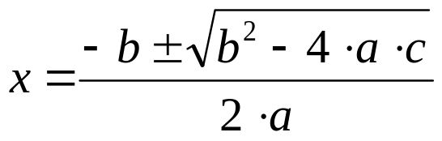
Sample Data :
Files Needed ::
Quadratic.java
QuadracticRunner.java

5 -8 3
3 2 -7
9 6 1

Sample Output :
Additional Test Data
7x^2-2x-3=0

roots :: 0.81 -0.52

1y^2-6y-1=0
roots :: 6.16 -0.16

Allow .01 variance on the answers.
Enter a :: 5
Enter b :: -8
Enter c :: 3

rootone :: 1.00
roottwo :: 0.60

Enter a :: 3
Enter b :: 2
Enter c :: -7

rootone :: 1.23
roottwo :: -1.90

Enter a :: 9
Enter b :: 6
Enter c :: 1

rootone :: -0.33
roottwo :: -0.33
FORMATTING OUTPUT

//printf is a void method
System.out.printf("%.3f\n",9.541724); //outs 9.542

//format is a String return method
System.out.println(String.format("%.3f",9.541724)); //outs 9.542

