Embedding Systems · Technical Article
Part B
Implementing the Completely Fair Scheduler (CFS) with Monitors
Design and implementation of the Completely Fair Scheduler using a monitor as the synchronization construct
Article Details
Title | Implementing the Completely Fair Scheduler (CFS) with Monitors
Topic | Design and implementation of the Completely Fair Scheduler using a monitor as the synchronization construct
Part | Part B
Language | English
Field | Embedding Systems — process scheduling and synchronization
Author(s) | Mohammadreza Azodi
Course | Real time Systems
Supervisor | Mr. Majid Shamshirgaran
University / Faculty | Eshragh university
Date | October 29, 2026
Keywords | CFS, monitor, condition variable, scheduling, virtual runtime, synchronization
Contents
1. Abstract
2. Introduction
3. What Is a Monitor?
4. CFS Recap
5. Designing the CFSMonitor
6. Algorithm Flowchart
7. Monitors versus Semaphores
8. Concurrency Problems and Solutions
9. Conclusion
10. References

Abstract
A monitor is a high-level synchronization construct that bundles shared data, mutual exclusion and condition variables into one unit. This article designs the CFS run queue as a monitor whose insert, select and update operations execute atomically by default. We show that a monitor reduces programmer error compared with raw semaphores, because locking and unlocking are automatic, and we compare the two approaches in tables.
Keywords: CFS, monitor, condition variable, scheduling, virtual runtime, synchronization
Introduction
Part A showed that semaphores can protect the red-black tree of a CFS run queue, but their wait and signal calls are scattered across the code: every thread must follow the right order. A monitor moves this responsibility into a single unit, where each public method runs atomically.
Objectives
- Introduce the monitor and its condition variables
- Design a CFSMonitor class with enqueue and pick_next methods
- Provide pseudocode, a flowchart and a comparison with semaphores
What Is a Monitor?
A monitor has three parts: private data, public methods in which only one thread may be active at a time, and condition variables for waiting inside the monitor.
Tool | Operation | Function
Monitor lock | enter / exit | Guarantees one active thread at a time
Condition variable | wait(cv) | Releases the lock and blocks the thread
Condition variable | signal(cv) | Wakes one waiting thread
Condition variable | broadcast(cv) | Wakes all waiting threads

CFS Recap
Every task has a vruntime. The scheduler always picks the task with the smallest value. Ready tasks live in a red-black tree ordered by vruntime, and the leftmost node is the next task to run.
Designing the CFSMonitor
Members and methods
Element | Kind | Description
rbtree | Private data | Red-black tree of ready tasks
min_vruntime | Private data | Smallest vruntime in the queue
not_empty | Condition variable | Wait until the queue has a task
enqueue(task) | Public method | Insert a task into the tree
pick_next() | Public method | Remove the task with the smallest vruntime
account(task, slice) | Public method | Update vruntime after a run

Monitor pseudocode
monitor CFSMonitor:
private rbtree, min_vruntime
condition not_empty

procedure enqueue(task):
task.vruntime = max(task.vruntime, min_vruntime)
rbtree_insert(task)
signal(not_empty)

function pick_next():
while rbtree_is_empty():
wait(not_empty)
task = leftmost()
rbtree_remove(task)
min_vruntime = max(min_vruntime, task.vruntime)
return task

procedure account(task, slice):
task.vruntime += slice * (BASE_WEIGHT / task.weight)
Note: the wait always sits inside a while loop so that spurious wake-ups are harmless.
Scheduler main loop
loop forever:
task = CFSMonitor.pick_next()
slice = compute_slice(task)
run(task, slice) // outside the monitor
CFSMonitor.account(task, slice)
if task.not_finished:
CFSMonitor.enqueue(task)
Algorithm Flowchart
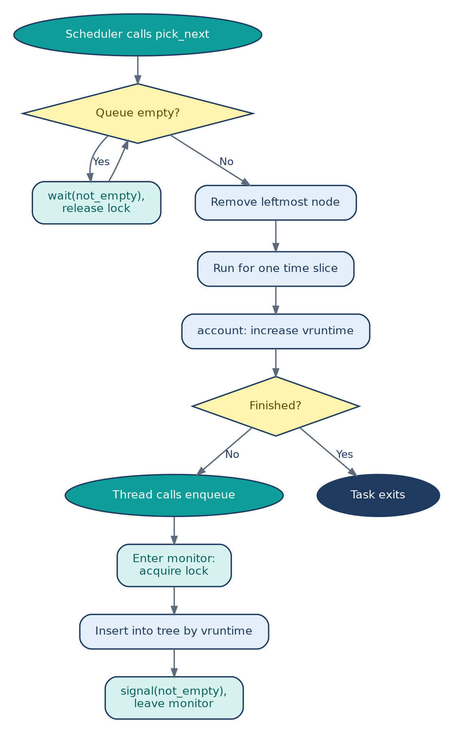
Teal: monitor operations; blue: ordinary steps. Unlike semaphores, locking and waiting are hidden inside the monitor, so no manual ordering of wait and signal is needed.
Monitors versus Semaphores
Criterion | Semaphore | Monitor
Abstraction level | Low | High
Risk of programmer error | High (forgotten signal, wrong order) | Low
Code readability | Scattered | Centralized in one unit
Waiting on a condition | Simple counter | More flexible with condition variables
Mutual exclusion | Via a binary semaphore | Automatic

Concurrency Problems and Solutions
Problem | Cause | Monitor-based solution
Race condition | Concurrent tree modification | Atomic monitor methods
Spurious wake-up | Condition not rechecked | Use while instead of if
Deadlock | Running a task inside the monitor | Run tasks outside the monitor
Starvation | Unfair wake-up | FIFO queue per condition variable

Conclusion
A monitor makes the CFS implementation safer and easier to read than semaphores, but the single monitor lock still limits scalability. The next part combines monitors and semaphores.
References
- Hoare, C.A.R. Monitors: An Operating System Structuring Concept.
- Silberschatz, Galvin, Gagne. Operating System Concepts.
- Love, R. Linux Kernel Development.

