Embedding Systems · Technical Article
Part C
Implementing the Completely Fair Scheduler (CFS) with a Combination of Semaphores and Monitors
A hybrid CFS design in which a monitor protects the run queue and semaphores handle signalling and capacity limits
Article Details
Title | Implementing the Completely Fair Scheduler (CFS) with a Combination of Semaphores and Monitors
Topic | A hybrid CFS design in which a monitor protects the run queue and semaphores handle signalling and capacity limits
Part | Part C
Language | English
Field | Embedding Systems — process scheduling and synchronization
Author(s) | Mohammadreza Azodi
Course | Real time Systems
Supervisor | Mr. Majid Shamshirgaran
University / Faculty | Eshragh university
Date | October 29, 2026
Keywords | CFS, semaphore, monitor, hybrid approach, scheduling, synchronization
Contents
1. Abstract
2. Introduction
3. Why Combine Them?
4. Proposed Architecture
5. Pseudocode
6. Algorithm Flowchart
7. Comparing the Three Approaches
8. Concurrency Problems and Solutions
9. Conclusion
10. References

Abstract
Monitors and semaphores have different strengths. A monitor suits protecting a shared data structure; a semaphore suits counting resources and coordinating threads. This article presents a hybrid design in which the red-black tree stays inside a monitor, while two counting semaphores control the number of ready tasks and the queue capacity.
Keywords: CFS, semaphore, monitor, hybrid approach, scheduling, synchronization
Introduction
Parts A and B examined the two techniques separately. Many real systems use both: the monitor gives safety and readability for the run queue, and the semaphore simplifies notifying the scheduler and bounding the queue.
Objectives
- Divide responsibilities between the monitor and the semaphores
- Design a bounded producer–consumer scheme
- Provide pseudocode, a flowchart and a comparison with the earlier approaches
Why Combine Them?
Need | Suitable tool | Reason
Protect the red-black tree | Monitor | Atomic methods
Limit the number of queued tasks | Counting semaphore | Counts free capacity
Wake the scheduler when work arrives | Event semaphore | Notification without busy waiting
Complex condition waiting | Condition variable inside the monitor | More flexibility

Proposed Architecture
The run queue lives inside a monitor called CFSMonitor. Two semaphores sit outside it:
- slots (counting, initial value N = queue capacity): free positions; producers wait on it before entering the monitor.
- ready (counting, initial value 0): number of ready tasks; the scheduler waits on it before entering the monitor.
Tool | Initial value | Role
CFSMonitor (internal lock) | — | Atomic tree operations
slots | N | Bounds queue capacity
ready | 0 | Counts ready tasks

Pseudocode
Simplified monitor
Because waiting on capacity and readiness is handled by the semaphores, the monitor performs only atomic tree work and never blocks:
monitor CFSMonitor:
private rbtree, min_vruntime

procedure insert(task):
task.vruntime = max(task.vruntime, min_vruntime)
rbtree_insert(task)

function remove_leftmost():
task = leftmost()
rbtree_remove(task)
min_vruntime = max(min_vruntime, task.vruntime)
return task

procedure account(task, slice):
task.vruntime += slice * (BASE_WEIGHT / task.weight)
Submit and pick
function submit(task):
wait(slots) // block if the queue is full
CFSMonitor.insert(task)
signal(ready)

function pick_next():
wait(ready) // block if the queue is empty
task = CFSMonitor.remove_leftmost()
signal(slots)
return task
Scheduler main loop
loop forever:
task = pick_next()
slice = compute_slice(task)
run(task, slice)
CFSMonitor.account(task, slice)
if task.not_finished:
submit(task)
Algorithm Flowchart
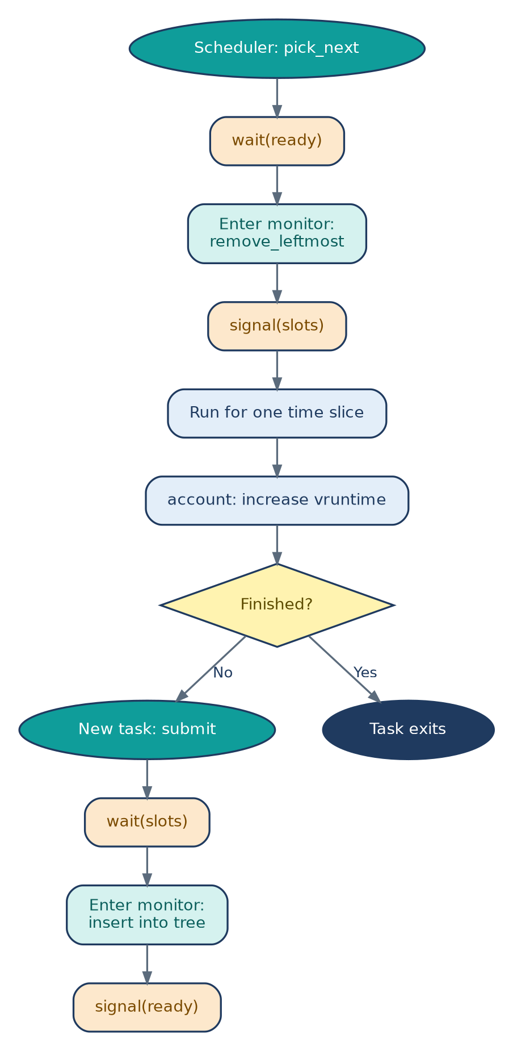
Orange: semaphore operations; teal: monitor operations; blue: ordinary steps. The semaphores wait outside the monitor, so no thread blocks while holding the monitor lock.
Comparing the Three Approaches
Criterion | Semaphore | Monitor | Hybrid
Tree safety | Depends on the programmer | Automatic | Automatic
Queue capacity control | Yes | Needs a condition variable | Yes (semaphore)
Lock hold time | Variable | Short | Shortest
Code readability | Low | High | Medium to high
Flexibility | Medium | Medium | High

Concurrency Problems and Solutions
Problem | Cause | Hybrid solution
Race condition | Concurrent tree access | Atomic monitor methods
Deadlock | Waiting on a semaphore inside the monitor | Always wait before entering, signal after leaving
Starvation | Unfair queued waiters | FIFO queues on the semaphores
Queue overflow | Too many tasks submitted | Semaphore slots limits capacity

Conclusion
The hybrid approach covers the producer–consumer pattern naturally: the monitor secures the tree, and the semaphores guarantee coordination and capacity. The price is slightly more design effort and a strict ordering rule for entry; in return the monitor lock is held very briefly and becomes less of a scalability bottleneck.
References
- Silberschatz, Galvin, Gagne. Operating System Concepts.
- Hoare, C.A.R. Monitors: An Operating System Structuring Concept.
- Love, R. Linux Kernel Development.

