Embedding Systems · Technical Article
Part A
Implementing the Completely Fair Scheduler (CFS) with Semaphores
Design and implementation of the Completely Fair Scheduler using semaphore-based synchronization
Article Details
Title | Implementing the Completely Fair Scheduler (CFS) with Semaphores
Topic | Design and implementation of the Completely Fair Scheduler using semaphore-based synchronization
Part | Part A
Language | English
Field | Embedding Systems — process scheduling and synchronization
Author(s) | Mohammadreza Azodi
Course | Real time Systems
Supervisor | Mr. Majid Shamshirgaran
University / Faculty | Eshragh university
Date | October 29, 2026
Keywords | CFS, semaphore, scheduling, virtual runtime, red-black tree, synchronization
Contents
1. Abstract
2. Introduction
3. Foundations of CFS
4. Semaphores and Synchronization
5. Implementation Design
6. Algorithm Flowchart
7. Concurrency Problems and Solutions
8. Evaluation
9. Conclusion
10. References

Abstract
The Completely Fair Scheduler (CFS) has been the default Linux scheduler for ordinary tasks since 2007. Its core idea is that every task should receive a fair share of CPU time, tracked through a per-task virtual runtime. This article shows how to implement CFS in a multithreaded setting using semaphores. It covers the run-queue data structure, critical sections, pseudocode, a flowchart and comparison tables, and closes with the strengths and limits of the approach.
Keywords: CFS, semaphore, scheduling, virtual runtime, red-black tree, synchronization
Introduction
In a multitasking system, several tasks compete for one CPU. The scheduler decides which task runs next and for how long. Classic schedulers such as Round Robin use a fixed time quantum and ignore priorities. CFS replaces the fixed quantum with the notion of virtual runtime (vruntime).
In a real implementation, many cores or threads touch the run queue. Without synchronization, two threads may remove the same task or modify the tree at the same moment. This article uses semaphores to prevent such failures.
Objectives
- Explain the principles of CFS and how vruntime is computed
- Present the data structure needed for the run queue
- Design a semaphore-based synchronization scheme
- Provide pseudocode, a flowchart and an evaluation
Foundations of CFS
Virtual runtime
Every task has a vruntime that grows as the task runs. The scheduler always picks the task with the smallest vruntime. A task with a higher weight (higher priority) accumulates vruntime more slowly, so it runs more often. In simplified form:
vruntime += run_time × (base_weight ÷ task_weight)
Run-queue data structure
Ready tasks are stored in a red-black tree keyed by vruntime. The leftmost node always has the smallest vruntime and is cached for constant-time access.
Operation | Complexity | Description
Pick next task | O(1) | Read the cached leftmost node
Insert task | O(log n) | Add a node to the tree
Remove task | O(log n) | Delete a node from the tree
Update vruntime | O(log n) | Remove, then re-insert

Main parameters
Parameter | Meaning | Role in the algorithm
vruntime | Virtual runtime | Ordering key in the tree
weight | Task weight | Derived from the nice value
sched_latency | Target latency | Period in which every task should run once
min_granularity | Minimum time slice | Prevents excessive context switching

Semaphores and Synchronization
A semaphore is a non-negative integer changed only by two atomic operations: wait (P) and signal (V). If the value is zero, a caller of wait blocks until another thread calls signal.
Semaphore type | Initial value | Use in CFS
Binary (mutex) | 1 | Protect the red-black tree during insert and remove
Counting | N | Count ready tasks in the queue
Event semaphore | 0 | Wake the scheduler when a new task arrives

Implementation Design
Required semaphores
- tree_mutex (binary, initial 1): exclusive access to the tree.
- ready_count (counting, initial 0): number of ready tasks; the scheduler blocks on it when the queue is empty.
- stat_mutex (binary, initial 1): protects shared statistics such as min_vruntime.
Pseudocode: enqueue
function enqueue(task):
wait(tree_mutex)
task.vruntime = max(task.vruntime, min_vruntime)
rbtree_insert(task)
update_leftmost()
signal(tree_mutex)
signal(ready_count)
Pseudocode: pick next task
function pick_next():
wait(ready_count) // block while the queue is empty
wait(tree_mutex)
task = leftmost()
rbtree_remove(task)
update_min_vruntime()
signal(tree_mutex)
return task
Pseudocode: scheduler main loop
loop forever:
task = pick_next()
slice = compute_slice(task)
run(task, slice)
task.vruntime += slice * (BASE_WEIGHT / task.weight)
if task.not_finished:
enqueue(task)
Algorithm Flowchart
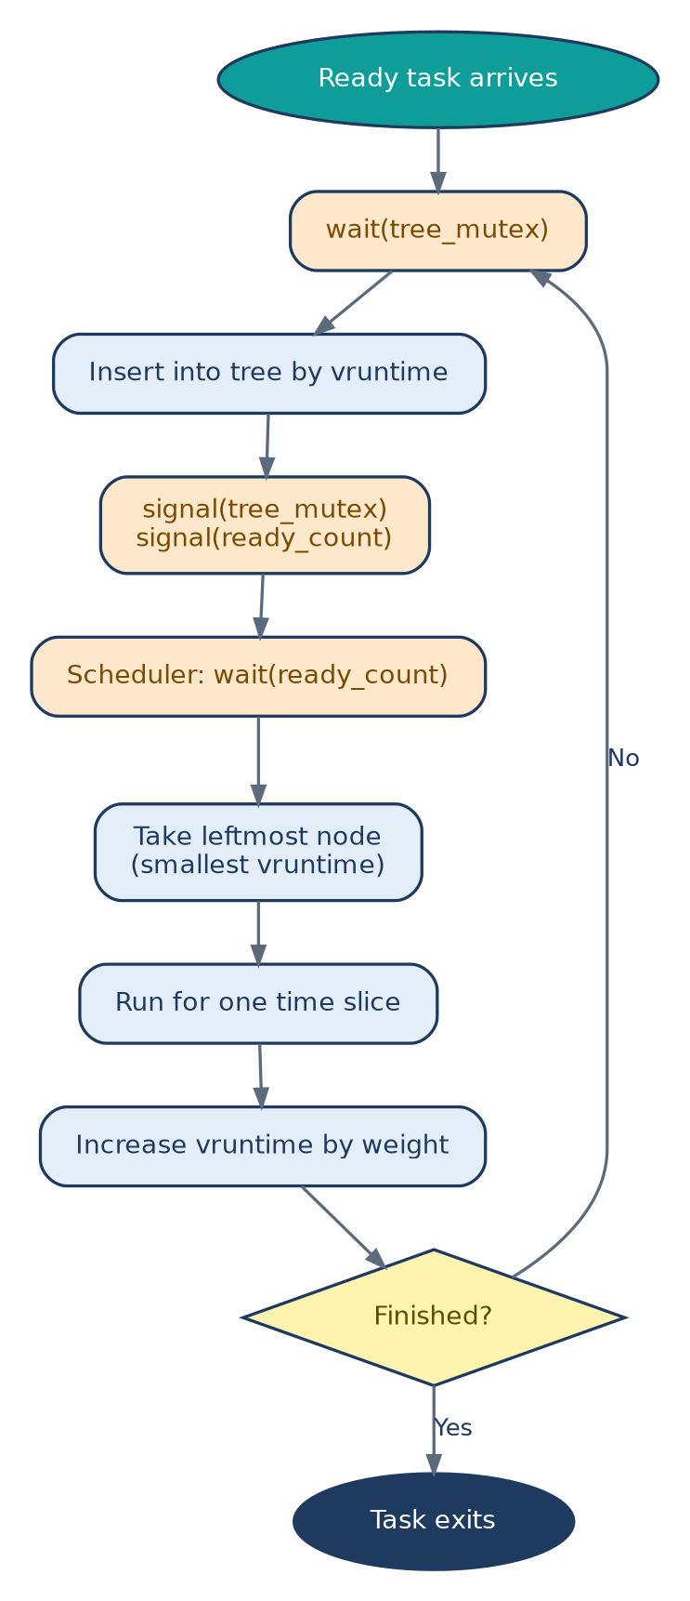
Orange: semaphore operations; blue: ordinary steps. A task re-enters the tree after every slice with its updated vruntime and leaves only when it finishes.
Concurrency Problems and Solutions
Problem | Cause | Semaphore-based solution
Race condition | Concurrent tree modification | Guard with tree_mutex
Deadlock | Acquiring locks in different orders | Fixed order: ready_count, then tree_mutex
Starvation | Tasks waiting indefinitely | FIFO wake-up order in the semaphore queue
Priority inversion | Low-priority task holds the lock | Keep the critical section short

Evaluation
Criterion | Expected result | Notes
Fairness | High | vruntime differences stay small
Synchronization overhead | Medium | Each insert and remove takes a lock
Scalability | Limited | One global lock becomes a bottleneck
Implementation simplicity | High | Classic producer–consumer pattern

Conclusion
Implementing CFS with semaphores is simple and covers the producer–consumer pattern well. Its main limitation is the global lock, which bottlenecks systems with many cores; the common remedy is a separate run queue per core. The next parts examine a monitor-based design and a combined monitor-and-semaphore design.
References
- Silberschatz, Galvin, Gagne. Operating System Concepts.
- Love, R. Linux Kernel Development.
- Tanenbaum, A. Modern Operating Systems.
- Linux kernel documentation: Documentation/scheduler/sched-design-CFS

