# Validation plan

## HTML:

Index.html

about.html

author.html

contact.html

products.html

## CSS:

carousel.css

styles_about.css

styles_contact.css

styles_index.css

styles_products.css

# HTML Validation

Validator: [Showing results for index.html - Nu Html Checker (w3.org)](https://validator.w3.org/nu/#file)

Index.html

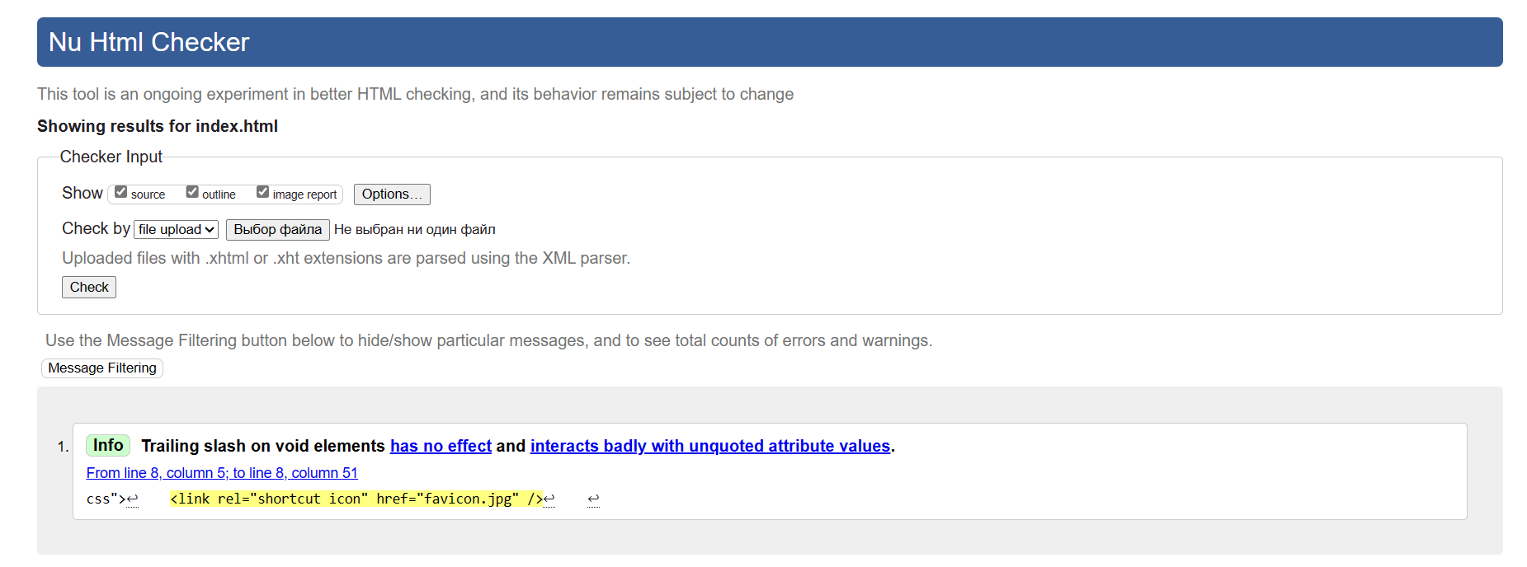

Problem solved

About.html

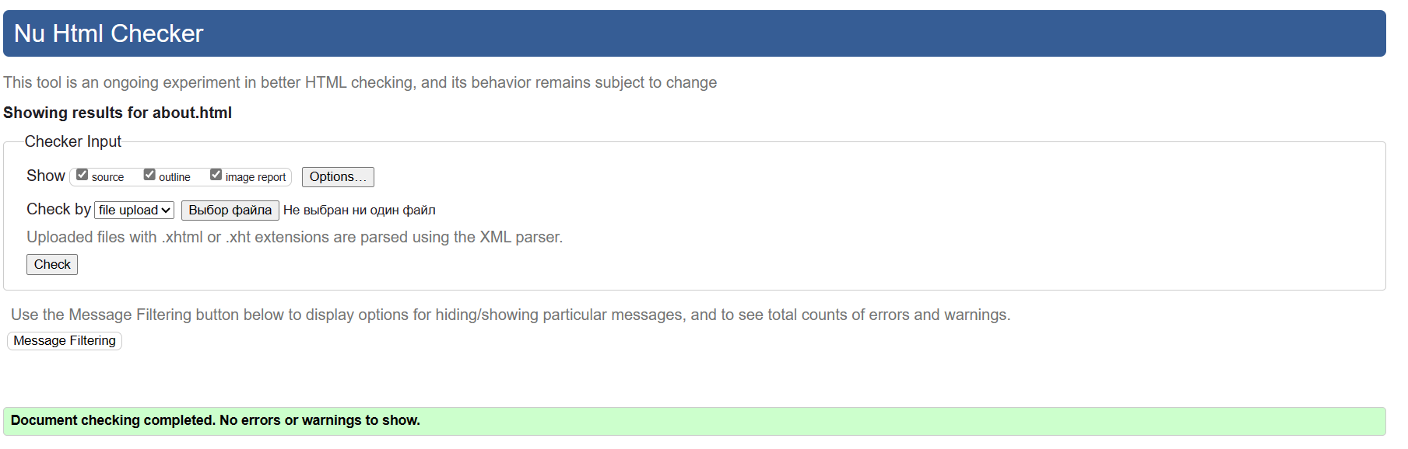

No problems found

Author.html

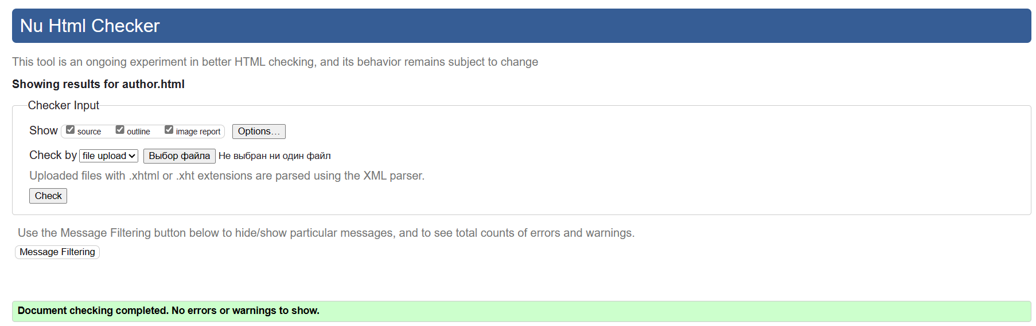

No problems found

Contact.html

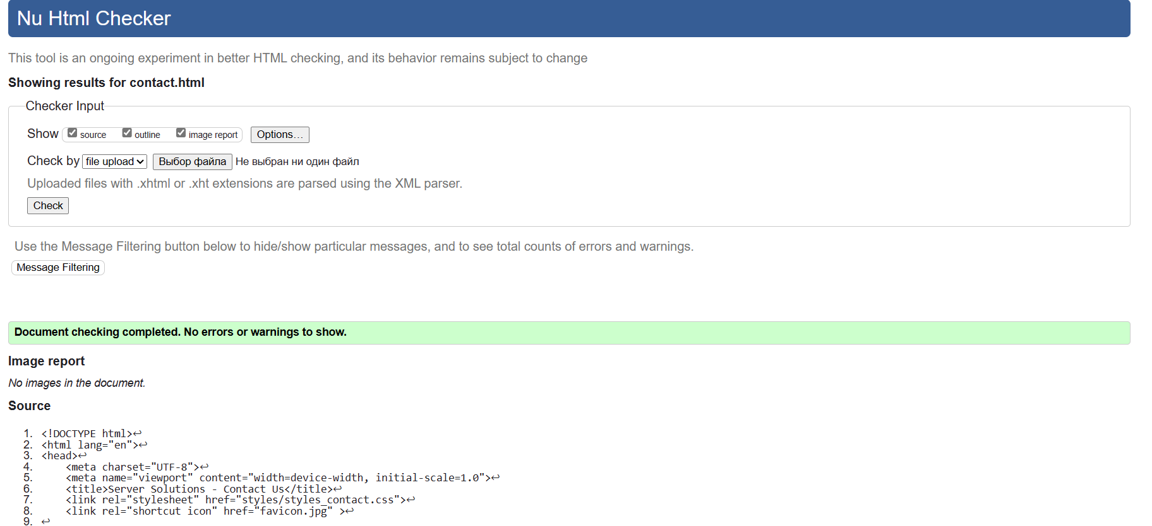

No problems found

Products.html

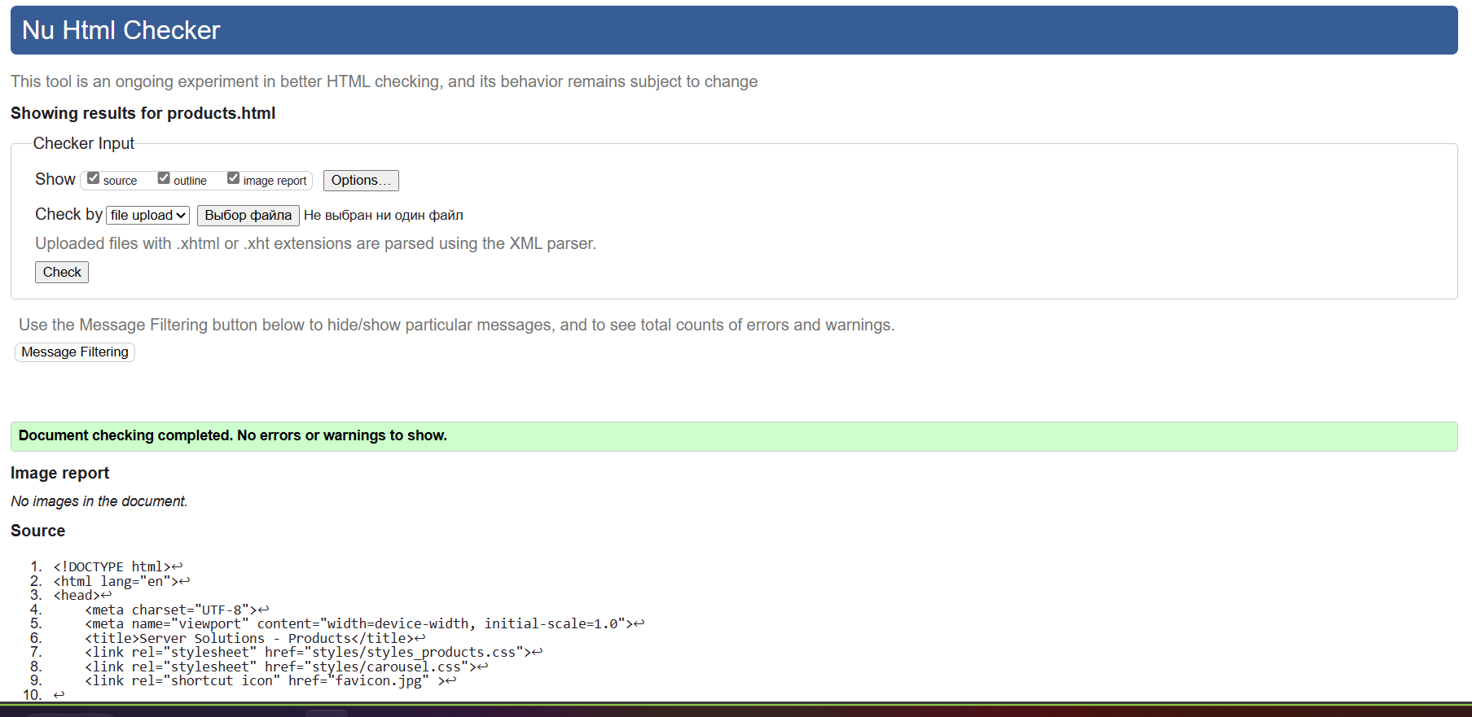

No problems found

# CSS Validation

Validator: [W3C CSS Validator results for carousel.css (CSS level 3 + SVG)](https://jigsaw.w3.org/css-validator/validator)  
  
carousel.css

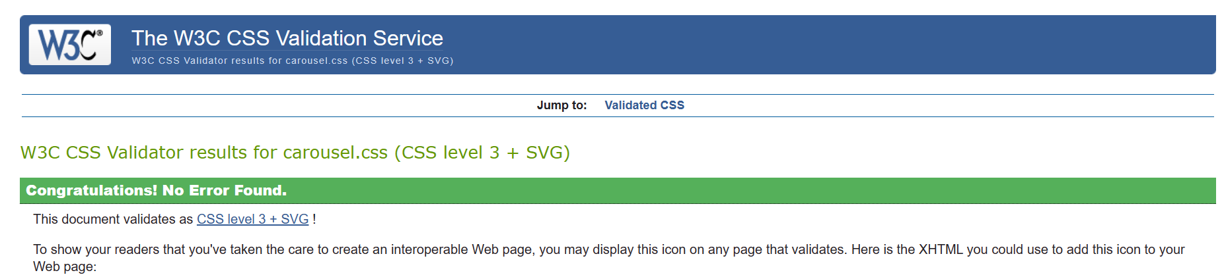

No problems found

styles_about.css  
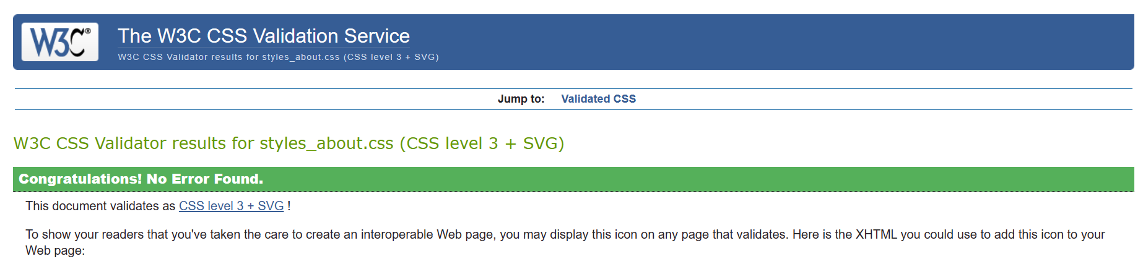

No problems found

styles_contact.css

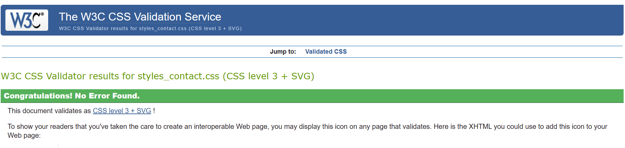

No problems found

styles_index.css

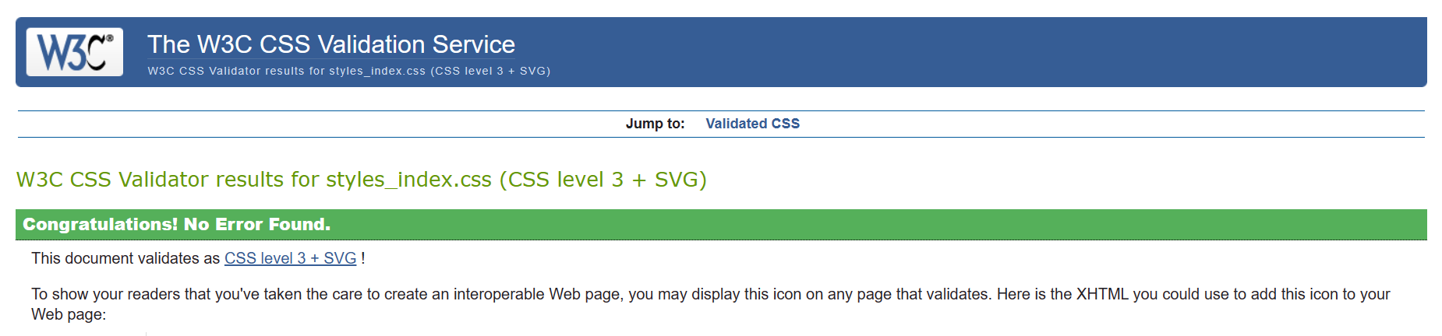

No problems found

styles_products.css

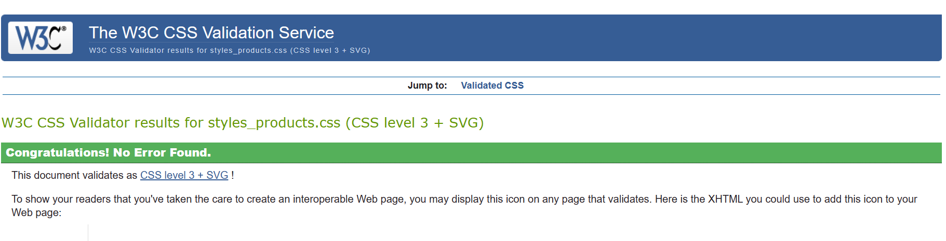

No problems found