Week 11 homework

Problem 3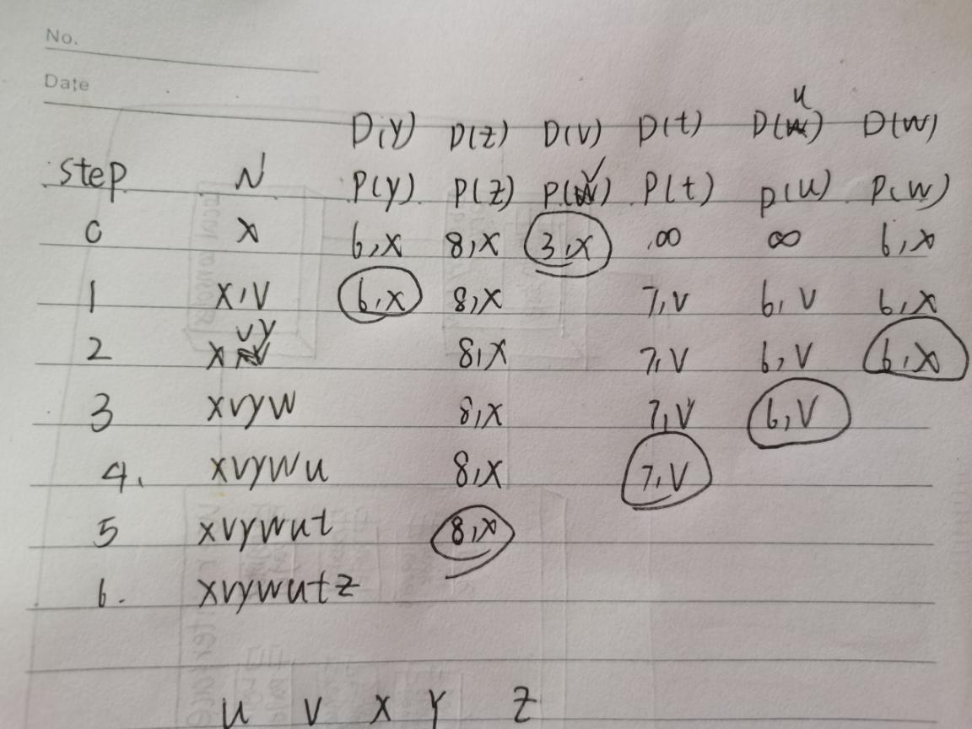

Problem 5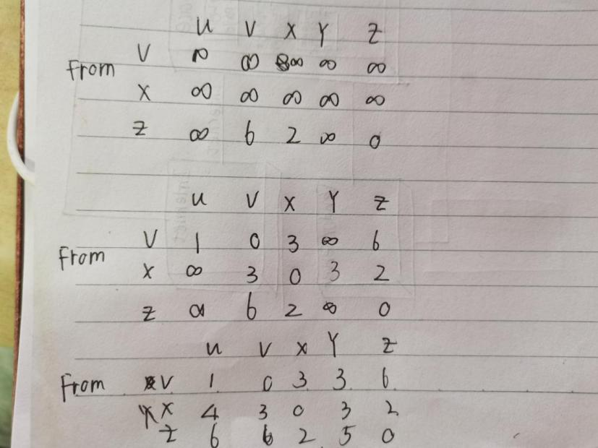

Problem9

1.it wouldn't cause count-to-infinite problem.because it don't cause the loop

2.connect two point just like to decrease the link weight from finite to the infinite state.