Computer Based
Problem Solving
Computer Based Problem Solving
This book is licensed under a Creative Commons Attribution-Noncommercial-Share Alike 3.0 Unported.
(http://creativecommons.org/licenses/by-nc-sa/3.0/)


Printed in USA by: Lulu.com
Written by: Patrick Coxall
Last Update: Sunday, October 21, 2012
Cartoons by: Geek and Poke (http://geekandpoke.typepad.com/)

ISBN: 978-0-9784251-0-4

Microsoft ®, Visual Basic ® and C# ® are either registered trademarks or trademarks of the Microsoft Corporation in the United States and/or other countries.

Names of all other products mentioned herein are used for identification purposes only and may be trademarks of their respective owners.

For more information on ordering a hardcopy of this book or to get the code examples see:
http://www.vector3studios.com

Preface

The goal of the book is to take students from the point of never having done any formal programming and lead them first through a structured method of problem solving (Input-Process-Output and Top-Down design) and then into the early basics of Object Oriented Programming (or OOP). If this book is used to teach a high school course in computer programming, there are likely many other learning outcomes that students are required to do that are not presented in this book. The focus of this book is strictly on solving problems with computer programming.
This book will use Visual Basic and C# as the example languages. Although there are hundreds of different programming languages and many good ones that can be used to teach someone that has never programmed before, these languages have many advantages. The first and probable most important is that they are completely free. This is a huge advantage, since schools and students do not have to worry about the cost. Students can have the exact same IDE at home as they do at school, which up until now has not happened often. Although they are free, both are still first class development environments with everything a student and most professional developers would ever need.

Visual Basic is an excellent language for first time programmers. They can get visual GUIs on the screen fast, which builds confidence. It is also very “forgiving”, so that students do not get bogged down in syntax problems. C#, although not as forgiving as Visual Basic, is very close to Java and is therefore a great second language for students to learn especially if they will be doing programming after high school. In addition to these reasons, there is a huge amount of online resources for these languages, which will help students and teachers alike.

It should be remembered that the focus of this book is to teach students how to program, not to just teach them a programming language. To do this the focus is on “Problem Solving”, using a computer program as a problem solving aid. Programming languages change over time and come and go but a good foundation of programming concepts and how to solve a problem will allow anyone to get over the syntax of a new programming language.

This book does not include any instructions on how to load, use, create GUIs or any other housekeeping of the VB or C # IDE. There are many other resources that can aid both students and teachers alike for this. Many of them are available from Microsoft online.

The following are links to the programming languages as well as to the above mentioned resources that might be useful:
- Visual Studio Express editions
  - http://msdn.microsoft.com/vstudio/express/downloads/
- Coding 4 Fun
  - http://blogs.msdn.com/coding4fun/
- Kids Corner
  - http://msdn.microsoft.com/vstudio/express/beginner/kids/default.aspx
- Beginner Developer Learning Center
  - http://msdn.microsoft.com/vstudio/express/beginner/windows/tier1

Within the text you will see words or groups of words that are hyperlinked (blue text and underlined). If the full URL is included, then type that into your web browser to see the page. If the link directs you to the Wikipedia webpage (http://en.wikipedia.org) for a topic, then just the word that is underlined and you can place that word in the previous URL to find it definition. The point of linking to Wikipedia is to give additional information about a topic if the reader is unsure about the concept. Please note that I do not have control over what is placed on the Wikipedia webpages and although it seemed useful and correct when I looked at the link, these pages are changing all the time. Despite this, the information is usually correct and can be very helpful.

When coding examples are included, they are colour coded so that they can be easily distinguished. VB code is in light blue and C# is in light green. There are also two tables of contents for code examples so that you can easily find what you are looking for, in the appropriate language. The coding examples are usually just snippets and do not include the complete source code you would need to recreate the program. Also as mentioned above, there is none or very little reference to the underlying GUI that exists in the program.

Key words and concepts that are being described are placed on the left-hand side of the page in the margin in blue. These are the words that you will see in the index and there so that they are easily referenced when looking up some topic.

Table of Contents

Preface i
Table of Contents iii
Table of VB Code Snippets vi
Table of C# Code Snippets viii
Chapter 1 – Introduction 2
What is Programming 2
Goal of this Book 3
Chapter 2 – Problem Solving 6
Steps in Problem Solving 6
1. What is the Problem 7
2. Make a Model 7
3. Analyze the Model 8
4. Find the Solution 8
5. Check the Solution 8
6. Document the Solution 9
Example Problems 9
Top-Down Design 13
Flow-Charts 14
Pseudo code 16
Computer Problem Solving 17
CHAPTER 3 – STRUCTURED PROBLEM SOLVING 20
TOP-DOWN DESIGN IN PROGRAMMING 20
Input-Process-Output 21
Variables 21
Assignment Statements 23
Scope of Variables 24
Constants 25
Sequence 26
Example Sequence Problem 26
Selection 33
Boolean Expressions 33
If…Then 34
If…Then…Else 36
If…Then…ElseIf…Else 38
Compound Boolean Expressions 41
Nested If Statements 43
Select Case 45
Repetition 47
Do…Loop While 48
Do While…Loop 50
Do Until…Loop 51
Do …Loop Until 51
For…Next 52
For…Each 54
Nested Loops 55
Timers 56
Moving Buttons 57
Chapter 4 – Procedures and Functions 60
Procedures 60
Calling a Procedure 61
Passing Parameters 62
Passing By Value 62
Passing By Reference 64
Control Objects are a Type! 65
Optional Parameters 66
Functions 68
Recursion 70
Chapter 5 – Holding Data 74
What is an Array 74
Passing Arrays as Parameters 76
For Each and Arrays 77
Dynamic Arrays 78
Preserving Data 79
2-Dimensional Arrays 80
Multi-Dimensional Arrays 81
Lists 82
Stacks 83
Link-Lists 83
Tree 83
CHAPTER 6 – REPRESENTING AND SORTING DATA 86
Enumeration 86
Explicit Assignment 88
Using Enumerated Types 90
Abstract Data Types 91
Using an Enum in an ADT 94
An array (or List) of ADT 95
A Function inside an ADT 96
Searching 98
Linear 98
Binary 98
Sorting 98
Bubble Sort 98
Selection Sort 98
Insertion Sort 98
Quick Sort 98
Chapter 7 – Reading and Writing Files 100
File Stream 100
Stream Reader 101
Stream Writer 101
Chapter 8 – Using OOP 104
What is an Object? 104
What is a Class? 106
Fields 108
Property Members 109
ReadOnly Property 111
Methods 112
UML 114
Class Diagrams 115
Chapter 9 – Creating Objects 117
Encapsulation 117
Constructors 117
Overloading Methods 119
Inheritance 122
Class Diagrams Again! 124
Polymorphism 125
Abstract Methods & Classes 128
UML once More!! 129
Multiple Class Interactions 130
Arrays of Objects 130
Index 131

Table of VB Code Snippets

VB Code 1: Declaration Statements 23
VB Code 2: Assignment Statements 24
VB Code 3: Constant Declaration 26
VB Code 4: Tax Problem Solution 30
VB Code 5: VB Example Comment Section 33
VB Code 6: If...Then Statement in VB 35
VB Code 7: If...Then...Else Statement in VB 37
VB Code 8: If...Then...ElseIf...Else Statement in VB 39
VB Code 9: Compound Boolean Expression in VB 42
VB Code 10: NOT Logical Operator in VB 43
VB Code 11: Nested If Statement in VB 45
VB Code 12: Select Case in VB 46
VB Code 13: Do...Loop While example in VB 49
VB Code 14: Do While ... Loop example in VB 50
VB Code 14: Creating a procedure in VB 61
VB Code 15: Calling a procedure in VB 62
VB Code 16: Calling a procedure with parameters in VB 63
VB Code 17: Passing parameters in VB 63
VB Code 18: Passing parameters By Reference in VB 64
VB Code 19: Call a procedure with passing By Reference in VB 65
VB Code 20: Optional parameters in VB 66
VB Code 21: Function declaration in VB 69
VB Code 22: Function declaration in VB 70
VB Code 24: Declaring an array in VB 75
VB Code 25: Traversing an array in VB 75
VB Code 26: Arrays as a parameter in a function in VB 77
VB Code 26: Arrays as a parameter in a function in VB 77
VB Code 28: For … Each and arrays in VB 77
VB Code 26: Re-dimensioning an array in VB 78
VB Code 25: List in VB 82
VB Code 31: Defining an Enumerated type in VB 87
VB Code 32: Declaring a variable that is an Enum type in VB 88
VB Code 33: Defining an Enum with a value in VB 89
VB Code 34: Retrieving an Enum’s value in VB 89
VB Code 35: Placing Enum values in a Listbox in VB 90
VB Code 36: Convert String to Enum to Number in VB 91
VB Code 37: Declaration of an ADT in VB 93
VB Code 38: Declaring a variable that is a Structure type in VB 93

Table of C# Code Snippets

C# Code 1: Declaration Statements 23
C# Code 2: Assignment Statements 24
C# Code 3: Constant Declaration 26
C# Code 4: Tax Problem Solution 31
C# Code 5: Tax Problem Solution Fixed 32
C# Code 6: If...Then Statement in C# 35
C# Code 7: If...Then...Else Statement in C# 37
C# Code 8: If...Then...ElseIf...Else Statement in C# 40
C# Code 9: Compound Boolean Expression in C# 43
C# Code 10: NOT Logical Operator in C# 43
C# Code 11: Nested If Statement in C# 45
C# Code 12: Switch Structure in C# 47
C# Code 13: Do...Loop While example in C# 49
C# Code 14: Nested Looping in C# 56
C# Code 15: Creating a procedure in C# 61
C# Code 16: Calling a procedure in C# 62
C# Code 17: Calling a procedure with parameters in C# 63
C# Code 18: Passing parameters in C# 63
C# Code 19: Passing parameters By Reference in C# 64
C# Code 20: Call a procedure with passing By Reference in C# 65
C# Code 21: Optional parameters in C# 66
C# Code 22: Call a procedure with passing By Reference in C# 68
C# Code 20: Call a procedure with passing By Reference in C# 68
C# Code 24: Function declaration in C# 69
C# Code 25: Function declaration in C# 70
C# Code 26: Declaring an array in C# 75
C# Code 27: Traversing an array in C# 75
C# Code 28: Arrays as a parameter in a function in C# 77
C# Code 28: Arrays as a parameter in a function in C# 77
C# Code 30: For … Each and arrays in C# 78
C# Code 27: List in C# 82
C# Code 32: Defining an Enumerated type in C# 87
C# Code 33: Declaring a variable that is an Enum type in C# 88
C# Code 34: Defining an Enum with a value in C# 89
C# Code 35: Retrieving an Enum’s value in C# 89
C# Code 36: Placing Enum values in a Listbox in C# 90
C# Code 37: Convert String to Enum to Number in C# 91
C# Code 38: Declaration of an ADT in C# 93
C# Code 39: Declaring a variable that is a Structure type in C# 93
C# Code 40: Declaration of a List of ADTs in C# 94
C# Code 41: Declaration of a List of ADTs in C# 95
C# Code 42: Declaration of a List of ADTs in C# 97
C# Code 43: Class definition in C# 107
C# Code 44: Property Definition in C# 110
C# Code 45: Read-only Property in C# 111
C# Code 46: Protected Function inside a Class in C# 113

Chapter 1 –
Introduction
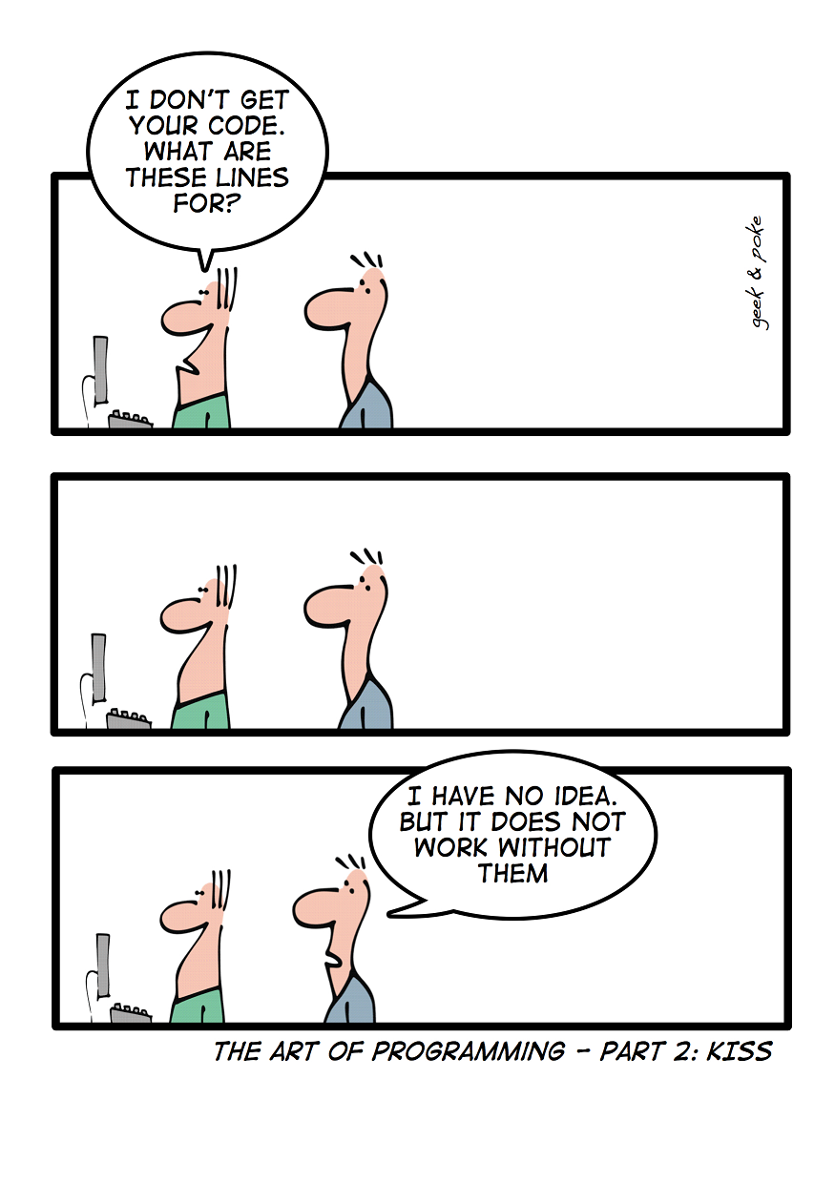

Chapter 1 – Introduction

Problems have been around for as long as people have been around. The process of solving a problem is not something new. Using a computer to aid in solving a problem is new. Modern electronic computers have only been around since the end of the Second World War (1945), which might seem like a long time to you but in the history of the human race it is a very short time. The purpose of this book is to help you learn to structure your problem solving method, so that you can consistently develop a verifiable solution that will solve a problem and in the process, use the computer to help you more easily and quickly solve that problem.

What is Programming
Before you can actually start to write programs on a computer to help you solve problems, it would be nice to know what programming really is! We all use and see computers every day and hear people say how smart they are. Actually, computers are not very smart at all! A computer, broken down into its most basic form, is nothing more than a bunch of tiny electronic switches that can be set to either a 1 or 0 (on or off, also known as binary). By getting the computer to set these tiny switches on or off in a certain pattern, you can get the computer to actually do something useful, like show a picture on the screen that you have taken. The computer does not know how to do this by itself though. A person has to instruct it to do this.
Binary
To communicate with your friends, one way for them to understand what you mean is for you to talk to them. To keep things simple, you usually talk in the same language. Since a computer is just a bunch of switches, it does not understand English, so you have to talk to it in a language that it does understand. Computers use a language called machine language, made up of just the 1’s and 0’s mentioned above. Trying to talk in machine language is quiet difficult, easy to make mistakes in and tedious. To help people talk to a computer an intermediate language is used, that is translated into machine language so that the computer can understand what to do. This intermediate language is called a programming language and you have probably already heard of some of them (Java, C++, Visual Basic…). Just like there are many different languages that people use around the world (English, French, Spanish…), there have been many different programming languages developed to help people instruct computers in what to do. The purpose of a programming language is to make it easier for a human to tell a computer what to do, by not having to talk machine language.
Programming Language
Machine Language
Figure 1: Programming Language Levels
Hardware
Machine Language
Assembly Language
High-Level Language

A person that uses a programming language to instruct a computer what to do is called a programmer. The programmer solves whatever problem they are working on, then writes the instructions that the computer is to follow in the programming language that they have chosen. Then the computer translates the instructions into machine language (the language that the computer actually understands) and the computer performs the action.
Programmer

Goal of this Book
The goal of this book is to make you a “good” programmer. Despite the fact that normal high school semester courses only run for 90 days, you will not become an expert programmer in just one semester. It has been said that it takes over 10 years to really become proficient at anything and programming is no different. By the end of the book you will be very much on your way and have a good foundation in the skills you will need. The important thing to remember is that the point is not to teach you a specific programming language, since programming languages come and go and change over time. This is just like real languages. Although it is the official language of the Catholic Church, not too many people go around on the streets and speak Latin to their friends. Many years ago, it might have been common but not today. The tools you will learn from this book are good programming techniques. These tools will be useful no matter what programming language you are using. Just like in the real world, you cannot be called a “linguist” if you only know one language. The same thing is true for a programmer; knowing more than one language is essential. The fortunate thing is that if you know one programming language, picking up a second one is much easier. The cornerstone of being a good programmer is to be able to solve problems in a logical and systematic way and hopefully have fun in the process.

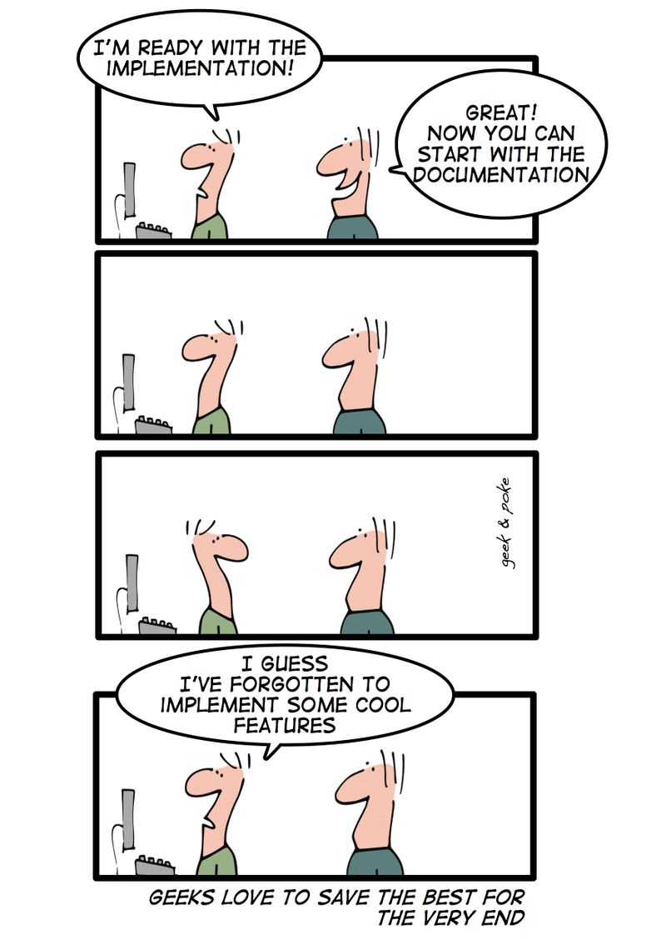
Chapter 2 –
Problem Solving

Chapter 2 – Problem Solving

As previously mentioned problems have been around forever. The use of a computer to help in solving problems is new but computers do not solve problems, people still solve problems. Computers can be used to aid in solving problems but they are just a tool. People have been creating tools to help them solve problems for 1,000’s of years. The key to remember is that a computer is just a tool, just like a hammer is a tool to help people put nails in a board.
My father is a joiner by trade but worked in construction, building houses for years. He has often told me stories of the “good old days” when they built houses completely with hand tools (using no electricity). They use to have competitions to see who could be the most accurate on estimating the length of a board, by cutting it first and then measuring it. They were usually within less than ½ inch (half the width of your thumb on a board 8 or 10 feet long!). It use to take dozens of men months to build a house this way. Then power tools were developed (electric drills, power saws, nailing guns …). Now a house can be built by a fraction of the men it use to take, in a fraction of the time. Power tools have revolutionized the housing industry.
Computers have also revolutionized many of the ways people have solved problems from the past. The first modern electronic computer (the ENIAC) was built to calculate tables for firing artillery shells. The computer was developed because it took too long and there were too many mistakes when people were doing it by hand. The same book of tables could be produced in a modern computer in a few seconds!
ENIAC

Steps in Problem Solving
There are many ways to solve a problem but having a process to follow can help make problem solving easier. If you do not think through a problem logically, then you end up just going around in circles and never solving it. The following is a six step problem solving system, which can be used to solve any type of problem, not just ones that will be solved on a computer. The good thing is that the system translates nicely to computer problems, which is very useful, since the focus of the book is to solve problems on a computer. The six steps in this system are:
- What is the problem
- Make a model
- Analyze the model
- Find the solution
- Check the solution
- Document the solution

1. What is the Problem
Before you can solve a problem correctly, you have to ensure that you understand the problem thoroughly. Many times you will have to go back to the source of the problem and confirm information or ask additional questions. You might have to have them restate the problem so that it is very clear what they are asking. Here are things to remember:
- What am I trying to find?
- What do I know / don’t know?
- State the problem in your own words.
- Get them to restate the problem.

2. Make a Model
Making a model of a problem is a great way to see what is really going on and to lead you to a solution. It can show you patterns or you might recognize the problem from before. The model might be a drawing, picture, chart, a physical 3D scale model, or something else. Most “good” problems are too complex to be solved simply, they need to be broken down into smaller pieces, solve each of the smaller pieces and then bring all the small solutions back together to solve the original problem. Here are things to remember:
- Draw or create a model.
- Break the problem down into pieces.
- Is there a pattern?
- Have you seen something similar?

3. Analyze the Model
Once you have broken the problem down into more manageable pieces and made a model of the problem or the pieces of the problem, the next step is to understand what is really going on. If you do not become an expert at the problem, you might miss an important aspect. It is always a good idea to go back, not to the person that asked the question but the person that will be using the solution, to get information from them. Each piece might have a pattern that can be followed. You might have seen a solution for one of the pieces before. Here are things to remember:
- Ensure the model does what you think it does.
- Look for patterns you have seen before.
- Go back to the user to get more information.

4. Find the Solution
The hard part is now to find a solution. Hopefully you are well on your way by doing the above three steps. Can you find a pattern? Do you know the solution to one of the pieces? Can you find the solution somewhere (internet!)? In the world of programming there are book call, “Patterns and Practices”, that are full of common problems and their solutions. Once you have all your solutions, the next step is to bring them all together to a final overall solution to the original problem. Here are things to remember:
- Find a solution to each piece of the problem.
- Find other people’s solutions to similar problems.
- Make sure all the pieces fit back together.

5. Check the Solution
You now (hopefully) have a solution to the original problem that you are pretty sure works. The next step is to ensure it actually solves exactly what the problem was. You might need to go through, step by step, to ensure it works. You might need to work through the solution and confirm the answer you get is correct. You might have to work through the solution several times and ensure you always get the same (or similar) answer. Here are things to remember:
- Is the answer reasonable?
- Work through the solution and check for errors.
- Go through the solution several times and compare results.

6. Document the Solution
So you have come up with a brilliant solution to a problem. If you do not share the solution with anyone, what was the point? You have to ensure that you answer is verifiable and reproducible, so anyone can use it. Here are things to remember:
- Document what the problem and solution is.
- Ensure anyone can follow your steps.

Example Problems
Here are some examples of problems and a possible solution using the six step method. Note that these problems are not necessarily problems that you would use a computer to help you solve. Latter on these six steps will be translated into six step used to solve problems that a computer program will be used to help solve.

Problem: Folding Paper
How small can a piece of paper be made?
- What is the problem?
The wording in the problem is a little vague and could be confusing. What is meant by “made”? Is it cutting, burning, shredding or cutting? You should go back to the source of the question to find out.
You might find out that the real question is, “How many times can a piece of paper be folded?”
- Make a model.
For this problem our model will just be our actual physical piece of paper. It is not always possible to make a model using that “real” item. What would happen if the question was to fold paper made of gold, can you afford gold leaf paper? You might have to use a suitable substitute.
- Analyze the model.
You should check to make sure that your model will be correct. What is your size of paper? Would that not make a difference in how many times you can fold it? Maybe not? Once again you might have to go back to the source of the question and get more information. Maybe the real question is, “How many times can a piece of 8 ½ “x 11” paper be folded?”
- Find the solution
In this case to find the solution we will take our piece of 8 ½ “x 11” piece of paper and keep folding it until we cannot longer do it. Should we try more than once?
- Check the solution
It is always important to check your solution to see if it can be reproduced with accuracy. Maybe you could get someone else to fold a piece of paper and see how many times they can do it. Is it different from your answer? Maybe they have some special technique?
- Document the solution
Now that you have proven that a piece of 8 ½ “x 11” can only be folded X number of times (where X is your answer), the next step is to document the solution so that other people can benefit from your analysis and can reproduce your experiment.

So what did you get as your answer? When you got someone else to do the experiment, did they get a higher number than you? Here are a few web links to also look at.
- Amazing paper folding facts
  - http://educ.queensu.ca/~fmc/june2002/PaperFact.htm
- Folding paper
  - http://mathworld.wolfram.com/Folding.html

Problem: The Salmon Swim
A salmon swims 3 km upstream and the current brings her back 2 km each day. How long does it take her to swim 100 km?
- What is the problem?
The first thing that should be asked is, does the fish swim up 3 km during the day and fall back 2 km at night or does she swim continuously all day and would go 3 km if it was not for the 2 km current so she only ever gets 1 km? Once again you will have to go back to the source of the problem to find out.
We will say she swims 3 km and then drifts back 2 km.
- Make a model.
For this problem our model will be a picture of a piece of what is happening.
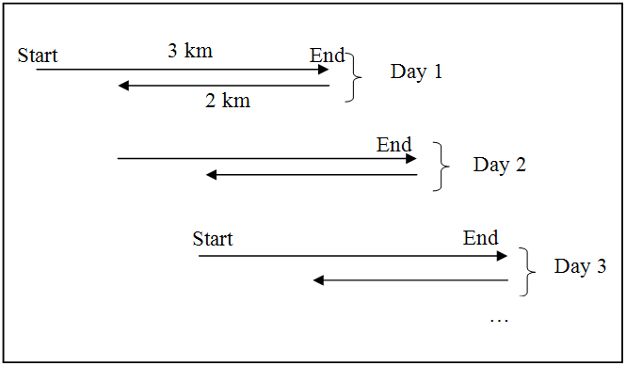
Figure 2: Salmon swimming
- Analyze the model.
You should check to make sure that your model will be correct. We will follow what is going on in a table.

Day Number | Distance @ end of Swam | Distance after being moved back
1 | 3 | 1
2 | 4 | 2
3 | 5 | 3
4 | 6 | 4
5 | 7 | 5
… | … | …
96 | 98 | 96
97 | 99 | 97
98 | 100 | 98
99 | 101 | 99
100 | 102 | 100
Table 1: Salmon Swimming
- Find the solution
In this case to find the solution we need to know how many days it took to get to 100 km. Your first reaction might be 100 days BUT if you look at the table on day 98 after the fish swam the 3 km, it is actually at 100 km, so that is the answer, 98 days not 100 days.
- Check the solution
It is always important to check your solution. In this case since our solution came from the table, check to make sure there is no error in the table. It might be a good idea to let it sit for a few days and then come back to look at it or get somebody else to look at your solution and see if it is correct.
- Document the solution
Now that you have proven that the answer is 98 days, make sure you document it, so that someone else does not have to figure it out but can just refer to your answer and check your solution.

Remember not to always go with your gut instinct and thing because it is following a patter you know the answer instantly without following through with the steps. Do all six steps and always check your answer.

Top-Down Design
Top-down design is a method of breaking a problem down into smaller, less complex pieces from the initial overall problem. Most “good” problems are too complex to solve in just one step, so we divide the problem up into manageable pieces, solve each one of them and then bring everything back together again. The process of making the steps more and more specific in top-down design is called stepwise refinement.
Top-Down Design
As mentioned before my father use to work in construction building houses. If someone gave you a piece of land and told you to, “Build me a house”, you would not immediately go over and start nailing 2 x 4’s together. Building a house is a very complex adventure, not to mention there are many rules, codes and laws that must be followed. To build a house you could break the project up into smaller jobs, plan and do each one of these jobs (in the correct order) and in the end you would have a house. You will notice in the following top-down design diagram that some jobs get broken down several times, until they are a manageable size.
We will be using top-down design (and top-down design diagrams, like the one above) to help us understand a problem and all its components.
Figure 3: Build a House Top-down Design
Build a House
Exterior
Foundation
Inside
Footings
Digging
Foundation walls
Walls
Flooring
Ceiling
Exterior walls
Roughing
Roof
Studs
Windows and Doors
Shingles
Trusses
Eves Toughing
Trim & Cabinets

Flow-Charts
Some people think that there is no need to do flow-charts before writing a program; that you can just go to the computer and start writing code. Any “interesting” computer problem is so complex though, that without planning, you would just end up spinning your wheels and have to throw out most of your code. In our six step problem solving model, the second step was to create a model and flow-charts are an excellent tool to make a model of what happens in most computer problems. Remember that a computer program is just a set of steps that the computer follows to solve a problem. A flow-chart is just a pictorial representation of a sequence of steps.
Flow-Charts
A flow-chart is a set of different shapes that each represent a certain type of action. These shapes are connected together with arrows so that you can see the flow of logic. The shapes are:

Here is an example of a flowchart for a none-computer based problem.
Figure 4: Flow-Chart Symbols
Start / Stop
- Every flow-chart must start and end with one of these
Operation
- Doing something, also known as a process
Decision
- Answering a yes or no question. There are usually 2 branches and you take 1 of them
Information In / Out
- Getting data from the user or presenting data back to a user
Connectors
- Used if the flow-chart is longer than one page
Looping
- Used when a process repeats several times
Is Assigned
- Used to represent a value (or variable) being placed into another variable
←
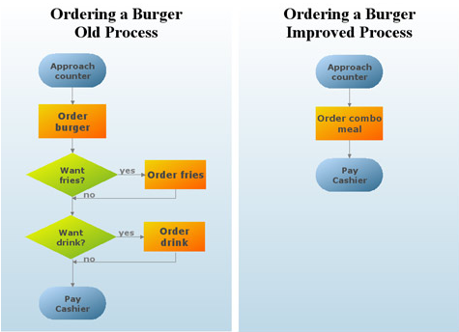
Figure 5: Flow-Chart of Ordering a Burger

Pseudo code
Pseudo code is a kind of structured English for describing algorithms. It allows the designer to focus on the logic of the algorithm without being distracted by details of language syntax. At the same time, the pseudo code needs to be complete. It describes the entire logic of the algorithm so that implementation becomes a rote mechanical task of translating line by line into source code.
We will be translating our flow-chart that we create from the previous step into pseudo code to aid us in writing our computer program. In general the vocabulary used in the pseudo code should be the vocabulary of the problem, not written in “computer speak”. A non-computer scientist should be able to read and understand what is going on. The pseudo code is a narrative for someone who knows the problem and is trying to learn how the solution is organized. Several keywords are often used to indicate common input, output, and processing operations.
Input: READ, OBTAIN, GET
Output: PRINT, DISPLAY, SHOW
Compute: COMPUTE, CALCULATE, DETERMINE
Initialize: SET, INIT
Add one: INCREMENT, BUMP
Here is the burger example from above in pseudo code:
GET burger order
IF (want fries = yes) THEN
Order fries
ENDIF
IF (want drink = yes) THEN
Order drink
ENDIF
PAY cashier
GET order

Computer Problem Solving
The initial goal of learning problem solving was to help us to solve problems that a computer program could be used for to help solve. The initial six step problem solving model that was presented can be used to help solve any type of problem. If we know that we are going to use a computer program to help solve the problem, the six steps can be translated into six steps that are more tailored for computer programming problems. They are the same basic six steps; they are just more focused on computer programming problems.
The table below shows the initial six steps that we have been using for generic problems. They are then translated into the six steps we will be following for computer programming problems.

 | Generic Six Steps | Computer Programming Six Steps
1 | What is the problem | Top-Down Chart
2 | Make a model | Flow Chart
3 | Analyze the model | Pseudo-code
4 | Find the solution | Actually type in the code
5 | Check the solution | Debug your code & test for errors
6 | Document the solution | Document the code – comments, help files, manuals…
Table 2: Six Steps to Computer Programming Problem Solving

These six steps are here to help you. Most people have the urge when they are given a programming assignment to just go to the computers and start coding. This is NOT a good idea. If you have not thought through the problem first and worked through these steps, you will make too many mistakes, get lost and waste too much time.

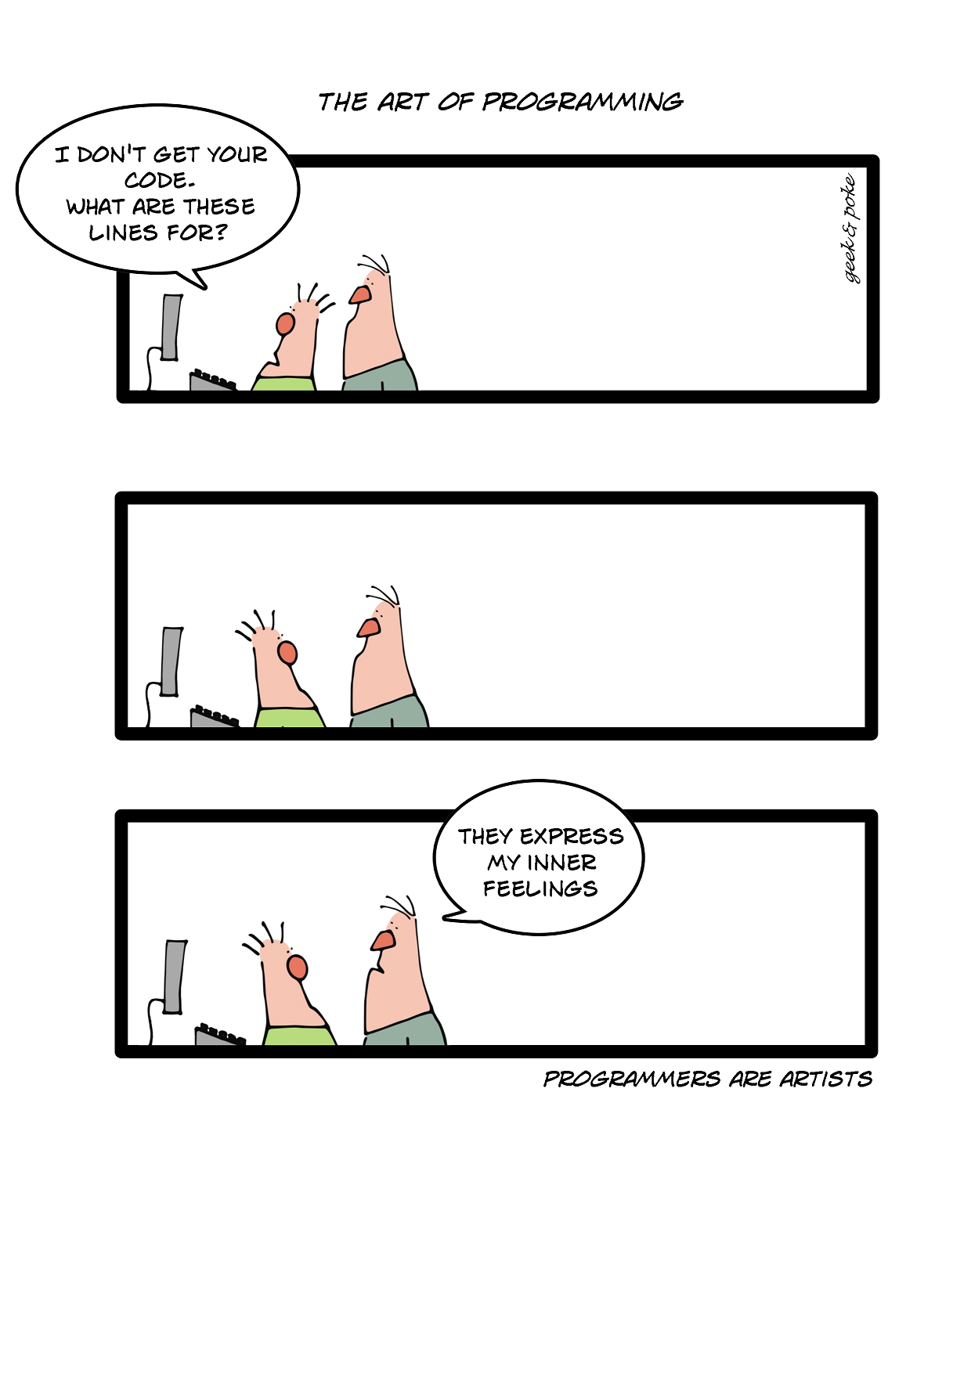
CHAPTER 3 –
STRUCTURED PROBLEM SOLVING

CHAPTER 3 – STRUCTURED PROBLEM SOLVING

Teachers often hear students complain that they "…don't know where to begin." when they are expected to solve what seem to be straightforward problems. Obviously they are not straightforward to the students for reasons that we are now beginning to understand, knowing where to begin is usually the hardest part. Structured problem solving is a set of tools to help you guide yourself though the process of solving computer related problems that seem to be impossible to solve.

TOP-DOWN DESIGN IN PROGRAMMING
As we have seen above, top-down design is a process of breaking a complicated problem down into simpler steps that actually can be solved. In programming one of the easiest models to follow for beginner programmers is the “Input-Process-Output” model. You are most likely already familiar with this model, even if you do not realize you are using it. In life there are many examples of getting information, doing something with it and then returning the result. The most common example is probable the problems you do in math class every day. You get information, do calculations and then return the answer. We are going to use this model to help us solve our computer problems. The first step in our top-down design will always be to break the problem up into input-process-output.
Problem Name Here
Process
Input
Output
Figure 6: Input-Process-Output Model

Input-Process-Output
As mention above, “Input- Process -Output” is a very useful model to help solve problems. It is kind of misleading though because one very important point is missing, storage. What actually really happens is that we get information and then place it somewhere (write it down in a math problem or use a variable like “x” to hold some important number), we then process it (do some calculations), we get the answer and then give it back. We need storage as a temporary location to keep information. In really long problems many pieces of information might be kept, we might even have information that we just need to keep for some intermediate step. The real model looks more like:
Storage
Process
Input
Output
Figure 7: Input-Process-Output Model with Storage
Technically speaking the types of variables we will be using here are “Value Types”. The other type of variables is “Reference Type”. We will get to that when we do OOP.

Variables
A variable is a name that we use to represent a value that we want the computer to store in its memory for us. When solving problems, we often need to hold some valuable pieces of information we will use in our solution. From the “Input-Process-Output” model above, this would be the information we place in storage. The pieces of information could be people’s names, important numbers or a total in a purchase. We use a name that means something to us (and hopefully the people that come after us and read our source code, commonly referred to as just code) so that we know right away when we read our code what it is holding. In math class you might be familiar with equations that involve variables like “x or y”. We would not name a variable x, if it is holding the number of students in class, we might call it numberOfStudents. This has much more meaning to us and other people that also look at our code.
Variable
A variable should always be declared (warn the computer we will be using a variable before we use it) before we use it in a program. Some programming languages do not enforce this rule, other do. Since you are new to programming, it is really good programming style to always declare a variable before using it. The process of declaring a variable is called a declaration statement.
Data Type
Identifier
Declaration Statement
In most programming languages you will have an identifier, which is the name you are giving your variable (ex. numberOfStudents) and the data type. The identifier will be the way that you refer to this piece of information latter in your program. The data type determines what kind of data can be stored in the variable, like a name, a number or a date. In the computer world you will come across data types like integer, character, string & boolean. It is always important that you ensure you select the right kind of data type for the particular data that it is going to hold. You would not use an integer to hold your name and vice versa, you would not use a string to hold your age. The following is a table of some common built in types from VB and C# that you will be using:
Boolean
Type Range | Type Range
Boolean | True or False
Byte | 0 to 255
SByte  Comments are lines in your code that the computer does not use. They are there as an explanation so other people can understand what your code does. | -128 to 127
Short | -32,768 to 32,767
Integer | -2,147,483,648 to 2,147,483,647
Decimal | -1.0*10^-28 to 7.9*10^28
Double | 5.0*10-^324 to 1.7*10^308
Char | A single character (like A or % or @)
String | Variable length number of characters
Table 3: Variable Types
Variable declaration usually should be grouped at the beginning of a section of code (sub, procedure, function, method…), after the initial comments. A blank line follows the declaration and separates the declaration from the rest of your code. This makes it easy to see where the declaration starts and ends. Ensuring that your code is easy to read and understand is as important in computer science as it is in English. It is important to remember that your code has two audiences, the computer that needs compile it so that the computer can run your program and even more important, you and everyone else that looks at your source code that are trying to figure out how your program works. Here are some examples of declaring a variable:
Comments
Dim sideLength As Integer
Dim areaOfSqaure As Integer
Compile
In VB “Dim” stands for dimension and is just one way to declare a variable. NEVER say “Dim sideLength as integer”, it is read as “declare sideLength as integer”.
VB Code 1: Declaration Statements

int numberOfStudents;
bool studentPassed;
C# Code 1: Declaration Statements

Assignment Statements
Programs can have many variables. Usually information is gathered from the user, stored in variable, processed with other variables, saved back to one/some variable(s) and then returned to the user. Variables are changed or initially assigned a value by the use of an assignment statement. Assignment statement are usually written in reverse from what we are use to in math class. A variable on the left side of the assignment statement will receive the value that is on the right hand side of the assignment statement. Note that different programming languages use different symbols to represent the assignment statement (for example in Alpha it is” ←”, in Pascal it is” :=”). No matter what the symbol is, you always read it as, “is assigned”. This is particularly important in languages like VB, where the assignment symbol is an equal sign ( = ) and people are use to reading this as “is equal to”. C# also uses and equals sign ( = ) as its assignment operator. To make it even more confusing, the same symbol ( = ) is used in another context in VB and in that one it actually is an equal sign and is read as such. In C# the equals symbol is actually two equals signs next to each other (==). Here are a few examples of assignment statements:
Assignment Statement
areaOfSqaure = sideLength * sideLength
areaOfSqaure = sideLength ^ 2
VB Code 2: Assignment Statements
moreThings = numberOfStudents * 2;
C# Code 2: Assignment Statements

Scope of Variables
Where a variable is declared is important because it determines its scope. The scope refers to where it is visible or can be used within a program. Usually you would declare a variable at the beginning of a procedure (for example a click event on a button or menu). Since it is declared at the beginning of a procedure, it can only be used within that procedure. Once the flow of your program exits this procedure, the variable is removed from memory (actually it is just de-allocate) and can no longer be used. This type of variable is referred to as a local variable. Any other procedure in your program can not use or refer to this variable.
Global Variable
Local Variable
Scope
What if for some reason you needed a variable to be accessible to several different procedures within a single program or form. In this case declaring it within a procedure is no good. Another option is to declare the variable at the top of the form class, just before any procedure. If this is done then any procedure within that form can see and use this variable. This type of variable is called a global variable. Global variables should only be used when absolutely necessary; if only one procedure needs a variable, it should be declared within the procedure. This is good programming style and also saves computer memory. The following is an example where you can see variables with the same name, being used as global and local variables. Type it in and follow the variables by stepping through the program.
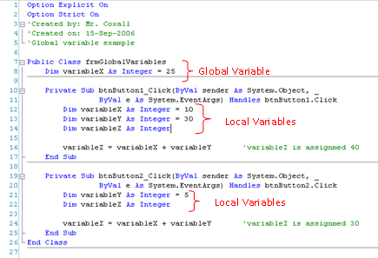
Figure 8: Global & Local Variables

Constants
There are times in a computer program where you have a value that you need the computer to save that does not change or changes very rarely. Some examples are the value of π (3.14…) and the federal tax rate (it was 7% but was lowered to 6% in 2006). When you have values like these, you do not want them to be saved as a variable (since they do not vary or change) but you place them in a constant.
Constant
Constants just like variables hold a particular value in memory for a programmer that will be used in the program. The difference is that the computer will not let the programmer change the value of a constant during the running of the program. This prevents errors from happening if the programmer accidently tries to change the value of a constant. It should always be declared, just as a variable is declared to warn the computer and people reading your code that it exists. Constants should be declared right before variables, so that they are prominent and easy to notice. Here are some examples of declaring constants:

Const PI As Double = 3.14
Const GOODS_AND_SERVICES_TAX As Decimal = 0.06
VB Code 3: Constant Declaration

const double PI = 3.14;
const decimal GOODS_AND_SERVICES_TAX = 0.06;
C# Code 3: Constant Declaration

Sequence
The computer is not a very smart machine and just follows a set of steps and does them one right after another. The power of the computer is its speed. These steps that it follows can easily be represented in a flowchart as a sequence of processes. All of the computer programs we have made so far follow these sequential steps and are the first type of programs people write when learning to program. This type of structure is called a “Sequence”.

Example Sequence Problem
The following is an example problem that has been solved using the six step computer based problem solving method mentioned above. The goal is to show you how a sequential program works and also to show how the six steps are used to develop a program from a given problem.

Problem: Sequence Programming Example
Write a program that will allow the user to enter a subtotal and the program will calculate the final total including tax.
- Top-Down Chart
The first thing we need to find out is how to calculate tax in your particular province. If the program is to be used anywhere in Canada, it could get really confusing since each province has a different tax rate and some even calculate taxes differently than other provinces. To help simplify the problem, we are just going to do it for Ontario. The Good and Services tax in Canada (GST) is 8% and the provincial tax (PST) in Ontario is currently 6%. The following is a top-down design breaking the problem up into smaller manageable pieces:
Figure 9: Sales Tax Top-down Design
Sales Tax
Process
Input
Output
Get Subtotal
Put final total
Calculate PST

Calculate GST

Add 3 values together

- Flow Chart
The next step is to convert the top-down design into a flowchart. To help create the flow chart, use the bottom boxes of each of the arms, in order from left to right from the top-down design. This would mean Get subtotal, Calculate GST, Calculate PST, Add 3 values together and Put final total. Remember that every flowchart has the “Start” oval at the top and the “Stop” oval at the bottom. This is so people know where to begin and end. The arrows are used so people can follow the flow. The words in the flow charts are not full sentences but simplified pieces of code. Ensure that you include any formulas and use the variable names that you will plan on using in your code.
Figure 10: Sales Tax Flow Chart
GST ← subTotal * GST_RATE
Get subTotal
Start
PST ← subTotal * PST_RATE
finalTotal ← subTotal + GST + PST

Put finalTotal
Stop

- Pseudo-code
Pseudo-code converts your flowchart into something that more resembles the final code you will write. Once again though it is not code (hence the name pseudo-code), so it is generically written so that it can be translated into any language. It should be understood by anyone that can write a computer program, not just people that use the same programming language that you do. The first word on each line should be a verb (an action word), since you want the computer to do something for you. By convention the first verb is also in all caps (capital letters). Here is the pseudo-code for the problem:
GET subtotal from user
CALCULATE GST ← subTotal * GST_RATE
CALCULATE PST ← subTotal * PST_RATE
CALCULATE finalTotal ← subTotal + GST + PST
PUT finalTotal back to user
- Code
Once you have the pseudo-code done, the hardest part of solving the problem should be finished. Now you just convert your pseudo-code into the specific programming language you have chosen to use. Here is a VB and C# version of the same program solution:
VB Code 4: Tax Problem Solution
Option Explicit On
Option Strict On
' Created by: Mr. Coxall
' Created on: Aug-2007
' Created for: ICS2O - Fall 2007
' This program accepts a subtotal and then calculates the
' Ontario provincial tax and federal tax. It then shows the
' user the final total

Public Class frmOntarioTax

Private Sub btnCalculateTotal_Click(ByVal sender As System.Object, _
ByVal e As System.EventArgs) Handles btnCalculateTotal.Click
' this procedure accepts the subtotal and calculates the tax

Const GOODS_AND_SERVICES_TAX_RATE As Decimal = 0.06D
Const PROVINCIAL_SALES_TAX_RATE As Decimal = 0.08D

Dim subTotal As Decimal
Dim goodsAndServiceTax As Decimal
Dim provincialSalesTax As Decimal
Dim finalTotal As Decimal

subTotal = CDec(Me.txtSubTotal.Text)

goodsAndServiceTax = subTotal * GOODS_AND_SERVICES_TAX_RATE
provincialSalesTax = subTotal * PROVINCIAL_SALES_TAX_RATE
finalTotal = subTotal + goodsAndServiceTax + provincialSalesTax

Me.lblFinalTotal.Text = Format(finalTotal, "C")

End Sub
End Class

C# Code 4: Tax Problem Solution
// Created by: Mr. Coxall
// Created on: Aug-2007
// Created for: ICS2O - Fall 2007
/* This program accepts a subtotal and then calculates the
Ontario provincial tax and federal tax. It then shows the
user the final total */

using System;
using System.Collections.Generic;
using System.Text;

namespace CalculateTaxCSharp
{
class Program
{
static void Main(string[] args)
{
const decimal GOODS_AND_SERVICES_TAX_RATE = 0.06M;
const decimal PROVINCIAL_SALES_TAX_RATE = 0.08M;

decimal subTotal;
string subTotalString;
decimal goodsAndServiceTax;
decimal provincialSalesTax;
decimal finalTotal;

Console.Write("Enter the sub total: ");
subTotalString = Console.ReadLine();
subTotal = System.Convert.ToDecimal(subTotalString);

goodsAndServiceTax = subTotal * GOODS_AND_SERVICES_TAX_RATE;
provincialSalesTax = subTotal * PROVINCIAL_SALES_TAX_RATEﻰﻰ
finalTotal = subTotal + goodsAndServiceTax + provincialSalesTax;

Console.WriteLine("The final total is " +
finalTotal.ToString("C"));
Console.ReadLine();

}
}
}
- Debug
It is hard to show the debugging step, since I ensured that the program above worked correctly before I pasted it into the page. When programmers write code it is extremely unlikely that it will work right away the first time. This is why the development environment has tools to help the programmer fix simple mistakes. The two main kinds of mistakes are syntax errors and logical errors.
In modern languages like VB and C#, syntax errors are usually easy to see and fix. A syntax error is a piece of code that the computer does not understand. It would be like speaking to you and one of the sentences did not make any sense to you. The in VB and C# the IDE will nicely place a squiggly line under the code it does not understand, so that you can fix the problem. A logical error is a lot harder to find. This is a problem with the way you solved the problem. The code will still compile and run but the program will give you the wrong answer (or maybe just the wrong answer some times!). There is not easy way to solve these problems than to step though your code one line at a time. In the above C# code, you might have noticed a read squiggly at the end of line 32. This is because I did not place a semi-colon at the end of the line. In C# each line must end with a semi-colon, so the compiler knows where the next line of code starts. Since I did not include it, the computer could not understand what I had written. The code below shows that mistake corrected.
Logical Errors
Syntax Errors
C# Code 5: Tax Problem Solution Fixed

goodsAndServiceTax = subTotal * GOODS_AND_SERVICES_TAX_RATE;
provincialSalesTax = subTotal * PROVINCIAL_SALES_TAX_RATE;
finalTotal = subTotal + goodsAndServiceTax + provincialSalesTax;

- Document the code
This is hopefully not done just at the end of your programming but as you write your code. All the same it is good practice to go over you code at the end to ensure that someone else looking at it will understand what is going on. In the above example you can see that there is a comment at the start of the program and in the Sub as well. Also I have used a naming convention that is hopefully easy to understand what the variables are holding. In addition, the values of the taxes are places as constants, since they only change very infrequently. Below is the top part of the VB solution showing the comment section at the beginning of the program, so everyone will know who made it, when, and why.
VB Code 5: VB Example Comment Section
Option Explicit On
Option Strict On
' Created by: Mr. Coxall
' Created on: Aug-2007
' Created for: ICS2O - Fall 2007
' This program accepts a subtotal and then calculates the
' Ontario provincial tax and federal tax. It then shows the
' user the final total

The above six steps are an example of how you should go about solving a compute based problem. Ensure when you are given a problem, you do not make the mistake that most people do and go directly to the computer and start coding. If you have not first been able to break the problem down into smaller pieces and solve the problem on paper, going to the computer and starting to code will not help you. You will just end up going in circles, wasting time, creating bad code and getting nowhere. Programming is just problem solving on a computer but you have to have solved the problem before you actually get to the computer to help you get the answer.

Selection
If computer programs could only do just a linear sequence of steps and nothing else, they would not be very useful. One additional thing that computer are very good at doing is conditional control or making a decision, as long as you provide all the parts it needs to figure out the decision. This gives a computer program the ability to make a decision, based on a boolean expression.

Boolean Expressions
A boolean expression is an expression (or equation) that has two possible values or outcomes, either a “True” or a “False” (or you can look at it as a 1 or a 0). An example of a boolean expression is “A Volkswagen beetle is a car.” Clearly this statement is true, so that is how it is evaluated. You could also have “a frog is a mammal”. This statement is not correct, so it evaluates to false. You could also have mathematical expression, “3+2 = 6”. This equation (and yes it is an equations so you read the “=” as “is equal”) is not correct, so it is also evaluated to false. There are many other types of expressions that can be checked, besides equality. You could have “3+2 <= 6”. This time the equation is evaluated as true, since 5 is <= to 6. Some of the most common operators are:
Conditional Control
Boolean Expression
Operator | Meaning
= or eq | Equal to
< | Less than
> | Greater than
<= | Less than or equal to
>= | Greater than or equal to
<> or != | Not equal to
Table 4: Common Boolean Operators

If…Then
The If…Then structure is a conditional statement, or sometimes referred to as a decision structure. It is used to perform a section of code if and only if the condition is true. The condition is checked by using a Boolean statement. If the condition is not true, then the section of code is not performed it is just passed over. The If…Then statement (in most computer programming languages) takes the generic form of:
If…Then
If (boolean expression) Then
Statements to be performed
EndIf
The indentation used in the If…Then statement is a coding convention used in almost every language. It is there to make the statement easier to read. It has no effect on how the code works and could be ignored; however it is really bad programming style not to have it. An example of what this looks like in a specific programming language is:
If (numberOfStudents > 30) Then
Me.lblClassOverFilled.Text = "Too many Students!"
End If

VB Code 6: If...Then Statement in VB

C# Code 6: If...Then Statement in C#
if (numberOfStudents > 30)
{
this.lblClassOverFilled.Text = "Too many Students!";
}

In the above examples, if the variable numberOfStudents happens to be a number that is greater than 30 (say 32), the next line of code is performed (Me.lblClassOverFilled.Text = “Too many Students!”). If the variable is not greater than 30 (say it is exactly 30), then the next line of code is skipped over and NOT performed. Remember from the section on flowcharts, the diamond shape represented decision. The If…Then statement is the translation of a decision in a flow-chat to code. The above examples would look like the following in a flow-chart:
Figure 11: If...Then Statement represented as a Flow-Chart
If
(numberOfStudents > 30)
Put “Too many Students!”
Yes
No

If…Then…Else
In the previous section we looked at the If…Then statement that is used for making a decision. When used a section of code is either performed or not performed, depending if the boolean statement is true or not. In some situations, if the statement is false and the section of code is not performed you would like an alternative piece of code to be performed instead. In this case an optional Else statement can be used. The If … Then … Else statement (in most computer programming languages) takes the generic form of:
If…Then…Else
If (boolean expression) Then
Statements to be performed
Else
Alternate Statements to be performed
EndIf
An example of what this would look like in a specific programming language is:
VB Code 7: If...Then...Else Statement in VB
If (numberOfStudents = 30) Then
Me.lblClassOverFilled.Text = "Exactly 30!"
Else
Me.lblClassOverFilled.Text = "Not 30 students!"
End If

C# Code 7: If...Then...Else Statement in C#
if (numberOfStudents == 30)
{
this.lblClassOverFilled.Text = "Exactly 30!";
}
else
{
this.lblClassOverFilled.Text = "Not 30 students!";
}

In the above examples, if the variable numberOfStudents happens to be exactly 30, the next line of code is performed (Me.lblClassOverFilled.Text = “Exactly Students!”). If the variable is not 30 (say it is 32 or 17), then the next line of code is skipped over and NOT performed but the text box is filled with “Not 30 students!” Once again the diamond shape represented decision, even if it has a statement if it is true and a different one if it is false. The above examples would look like the following in a flow-chart:
Figure 12: If...Then...Else Statement represented as a Flow-Chart
If
(numberOfStudents eq 30)
Put “Exactly 30 Students!”
Yes
No
Put “Not 30 Students!”

If…Then…ElseIf…Else
In some problems there are not just two different outcomes but more than two. If this is the case, then a simple If…Then…Else structure will not work. In these situations an If…Then…ElseIf…Else might be used. In this type of structure there can be more than just one Boolean condition and each is checked in sequence. Once a Boolean expression is met (the value is true), then the specified section of code for that Boolean expression is executed. Once executed, all other conditions are skipped over and the flow of logic goes right down to the bottom of the structure. It is important to remember that one and only one section of code can be executed. Even if several of the Boolean conditions happen to be met, the first and only the first one will be evaluated and run.
If…Then…ElseIf…Else
The structure can contain many ElseIfs, as many as the programmer needs. Another optional piece of the structure is the “Else”. If none of the above boolean conditions are met, the programmer might want a section of code to be executed. If this is the case, then the code is placed in the else section. Any code in the else section is run if and only if, none of the Boolean expressions were met. It should also be noted that there is no Boolean condition associated with the else. That is because it is run only if all the above boolean conditions are not met. The If…Then…ElseIf…Else statement (in most computer programming languages) takes the generic form of:
If (boolean expression #1) Then
First potential statement to be performed
ElseIf (boolean expression #2) Then
Second potential statement to be performed
…
ElseIf (boolean expression #n) Then
Nth potential statement to be performed
Else
Alternate statement to be performed
EndIf
An example of what this would look like in a specific programming language is:
VB Code 8: If...Then...ElseIf...Else Statement in VB
If (colourOfLight = “red”) Then
Me.txtWhatCarAreToDo.Text = "Stop!"
ElseIf (colourOfLight = “yellow”) Then
Me.txtWhatCarAreToDo.Text = "Slow Down."
ElseIf (colourOfLight = “green”) Then
Me.txtWhatCarAreToDo.Text = "Go, if all clear"
Else
Me.txtWhatCarAreToDo.Text = "No idea!"
End If

C# Code 8: If...Then...ElseIf...Else Statement in C#
if (colourOfLight == “red”)
{
this.txtWhatCarAreToDo.Text = "Stop!";
}
else if (colourOfLight == “yellow”)
{
this.txtWhatCarAreToDo.Text = "Slow Down.";
}
else if (colourOfLight == “green”)
{
this.txtWhatCarAreToDo.Text = "Go, if all clear";
}
else
{
this.txtWhatCarAreToDo.Text = "No idea!";
}

In the above examples, if the variable colourOfLight is red, yellow or green than the appropriate section of code is executed. If the variable does not equal any of these, then the last statement is executed, “No idea!” The above examples would look like the following in a flow-chart:
Figure 13: If...Then...ElseIf...Else Statement represented as a Flow-Chart
If
(colourOfLight = “red)
Put “Stop!
Yes
No
If
(colourOfLight = “yellow”)
Put “Slow Down”
Yes
No
If
(colourOfLight = “green)
Put “Go, if all clear”
Yes
No
Put “No idea!”

Compound Boolean Expressions
Just before we looked at the If … Then statement we looked at Boolean expressions. Boolean expressions have two and only two potential answers, either they are true or false. So far we have looked at just simple boolean expression, with just one comparison. A boolean expression can actually have more than one comparison and be quiet complex. A compound boolean expression is generated by combining more than one simple boolean expression together with a logical operator And or Or. And is used to form an expression that evaluates to True only when both operands are true. Or is used to form an expression that evaluates to true when either operand is true. Here is a truth table for each operator:
Compound Boolean Expressions
A  Logical Operator | B | A AND B
True | True | True
True | False | False
False | True | False
False | False | False
Table 5: AND Truth Table
A | B | A OR B
True | True | True
True | False | True
False | True | True
False | False | False
Table 6: OR Truth Table
In VB the operators are simpley the words “AND and OR”. In C# they are “&&” for AND and “||” for OR. The following are some examples of compound boolean expressions:
VB Code 9: Compound Boolean Expression in VB
If (guess > 30 Or maneyLeft = 0) Then
Me.lblMessage.Text = "Game Over!"
Else
Me.lblMessage.Text = "Would you like to play again?"
End If

if (guess < 1 && guess > 30)
{
this.lblMessage.Text = "Invalid #";
}
else
{
this.lblMessage.Text = "That # of guesses is OK";
}

C# Code 9: Compound Boolean Expression in C#

Besides these two logical operators, there is one more, the Not. Not is used most often at the beginning of a Boolean expression to invert its evaluation. For example:
VB Code 10: NOT Logical Operator in VB
If Not(guess = 30) Then
Me.lblMessage.Text = "Would you like to play again?"
End If

if (!(guess == 30) )
{
this.lblMessage.Text = "Would you like to play again?";
}

C# Code 10: NOT Logical Operator in C#

Nested If Statements
Sometimes a single if statement, even a long If…Then…ElseIf…ElseIf…Else is not a suitable structure to model your problem. Sometimes after one decision is made, there is another second decision that must follow. In these cases, if statements can be nested within if statements (or other structures as we will see later). Here is a problem:
Nested If Statements
A school is going to sell chocolate bars to raise money. If a student sells over 20 boxes, they get a prize. If they sell 20 to 10, they get a “small” prize. If they sell less than 10, they get honorable mention. Create a program that will let the user input the number of boxes sold and then state what the reward would be and use nested if statements.
The flowchart for this type of problem will look something like this:

Do something …

If
(boxesOfChoc > 20)
lblReward ← “Prize”
Yes
No

If
(boxesOfChoc < 10)
Yes
lblReward ← “Small Prize”
lblReward ← “Hon. Mention”
No
Yes
No
Yes
No
If (boxesSold > 20) Then
Me.lblReward.Text = "The reward is a proze"
Else
If (boxesSold < 10) Then
Me.lblReward.Text = "The reward is honorable mention"
Else
Me.lblReward.Text = "The reward is a small prize"
End If
End If

VB Code 11: Nested If Statement in VB

if(boxesSold > 20)
{
this.lblReward.Text = "The reward is a proze";
}
else
{
if(boxesSold < 10)
{
this.lblReward.Text = "The reward is honorable mention";
}
else
{
this.lblReward.Text = "The reward is a small prize";
}
}

C# Code 11: Nested If Statement in C#

Note: notice how the second if statement is indented within the first one. This is because each if statement is a “structure” and gets indented, within the structure it is already in.

Select Case
As you have seen from the If…Elseif…Elseif… statement, when there are many choices, the structure can be hard to follow. Some programming languages have an alternative structure when this happens. The Select Case statement is also a decision structure that is sometimes preferred over the If…Elseif structure because code might be easier to read and understand, by people. There is no benefit to the computer or speed in using it.
Select Case
The Select Case structure takes a variable and then compares it to a list of expressions. The first expressions that is evaluated as “True” is executed and the remaining of the select case structure is skipped over, just like an If…ElseIf… statement. There are several different ways in VB to create you expression. You can just use a value (a single digit for example), several digits (separated by commas), a range (by using a “To” between two digits) or by using the reserved word “Is” and having a regular expression (Is < 10). Just like the If structure, there is an optional “Else” that can be placed at the end as a catch all. If none of the expressions is evaluated to “True”, then the flow will go to the else. The general form looks like:
Select Case variable
Case value
Statement
Case value
Statement
Case Else
Statement
End Select

An example of what it could look like in VB using all the above techniques might be:
VB Code 12: Select Case in VB
Select Case studentScore
Case 0
Me.lblMessage.Text = "Really, Really low!"
Case 1, 2
Me.lblMessage.Text = "Really low!"
Case 3 To 5
Me.lblMessage.Text = "Somewhat low"
Case Is < 10
Me.lblMessage.Text = "Not Bad"
Case Else
Me.lblMessage.Text = "Great Score"
End Select

C# does not have a “Select Case” structure; it has a “Switch” instead. In the “Switch” you can only refer to a single number at a time.
switch (studentScore)
{
case 0:
this.lblMessage.Text = "Really, Really low!";
break;
case 1:
this.lblMessage.Text = "Really low!";
break;
…
case 8:
this.lblMessage.Text = "Not Bad";
break;
case 9:
this.lblMessage.Text = "Not Bad";
break;
default:
this.lblMessage.Text = "Great Score";
break;
}

C# Code 12: Switch Structure in C#

Repetition
A loop is a sequence of instructions that are repeated until a certain boolean condition is true (or false). When looping, the program must have an instruction to allow the loop to stop. If the instruction is missing (or present but never triggered), the repetitions will go on forever. This is known as an infinite loop. If you accidentally create an infinite loop, you will have logical error in you program. The program will compile but when you run it, it will most likely give you an overflow error. The condition that must be triggered can either be at the beginning or the end of the repletion structure. There are several repletion structures, just like there were several different conditional structures, each for a different purpose.

Do…Loop While
The do…loop while is a repetition structure where the statements in the structure are repeated as long as the boolean expression is true. It can be represented in a flow-chart like the one below:
Looping statements
No
Boolean Condition

No
Yes
Notice that the looping action continues while the condition is true. It is for this reason that the repetition structure is called the do…while structure. The boolean condition is also not checked before the looping statements are executes the first times. This mean if the condition is not true the first time, the statements will still happen once. It has the following general looking structure in most programming languages:
Do
Statements
Loop While (boolean condition)
It is a common occurrence to have an accumulator or counter within a looping structure. The counter is incremented (1 is added) or decremented (1 is subtracted) each time the condition is meet and the statements inside the loop are performed. When the counter reaches a certain number that is expressed inside the boolean statement, then the loop is exited. Ensure you use proper style and do not do what is very common in programming, just declare the variable as i, j or x. Always name a variable for what it is actually doing and holding.
The following code snippet, show a factorial program (please follow the link so you understand what factorial is). The program takes all the positive integer values, staring at 1 and multiples them together until you reach the number you have chosen to end at. For example, the factorial of 5 (written 5!) is equal to 1*2*3*4*5 = 120
Dim factorialNumber As Double
Dim factorialAnswer As Double
Dim factorialCounter As Integer

Me.lstFactorialNumbers.Items.Clear()
factorialAnswer = 1
factorialNumber = CInt(Me.txtStartNumber.Text)
factorialCounter = 0
Do
factorialCounter = factorialCounter + 1
Me.lstFactorialNumbers.Items.Add(factorialCounter)
factorialAnswer = factorialAnswer * factorialCounter
Loop While (factorialNumber <> factorialCounter)

Me.txtAnswer.Text = CStr(factorialAnswer)
VB Code 13: Do...Loop While example in VB

Double factorialNumber;
Double factorialAnswer;
int factorialCounter;

this.lstFactorialNumbers.Items.Clear();
factorialAnswer = 1;
factorialNumber = Convert.ToDouble(this.txtStartNumber.Text);
factorialCounter = 0;
do
{
factorialCounter = factorialCounter + 1;
this.lstFactorialNumbers.Items.Add(factorialCounter);
factorialAnswer = factorialAnswer * factorialCounter;
} while (factorialNumber != factorialCounter);

this.txtAnswer.Text = Convert.ToString(factorialAnswer);

C# Code 13: Do...Loop While example in C#

Do While…Loop
The boolean condition can also be placed at the top instead of the bottom, like in the flow-chart above. In this case the general structure will look like:
Do While (Boolean condition)
Statements
Loop
Since the boolean condition is at the top in this case, the statements inside the loop might not be executed at all if the boolean expression is false the first time it is encountered. As a flow-chart it would look like:
'input
numberOfIterations = CInt(Me.nudIterations.Value)

' process
Do While (counter < numberOfIterations)
counter = counter + 1
nSquaredAnswer = CLng(nSquaredAnswer + (counter ^ 2))
Loop

'output
Me.lblAnswer.Text = "Answer: " & nSquaredAnswer
Looping statements
No
Boolean Condition

No
Yes

VB Code 14: Do While ... Loop example in VB

Do Until…Loop
The Do Until…Loop is similar to the above examples. The condition is placed at the top, so it is evaluated before the statements are executed the first time. Unlike the “While” structures, this time the looping continues until the boolean expression is true. Once true, then the loop is exited.
Looping statements
No
Boolean Condition

No
Yes

Do …Loop Until
The Do Loop…Until once again loops until the Boolean expression is met or becomes “True”. Once met the loop is exited. This time the Boolean condition is placed at the bottom of the structure, so it is not evaluated the first time though.
Looping statements
No
Boolean Condition

No
Yes

For…Next
The For…Next loop is another repetition structure, used to repeatedly execute a section of code an exact number of times. Since the number of repetitions is know in advance, the For…Next loop executes the instructions for this fixed number of times, unlike the do…while loop where it keeps looping until some condition is met.
To use the For…Next loop, there will also be a loop counter that keeps track of how many times through the loop the program has executed. Each time the code inside the loop is executed, the loop counter is automatically incremented by 1. Then a expression checks to see that the predetermined number of times has been reached. This process like the following in a flow-chart:
Boolean Condition
Looping statements
No
Yes
Initialize loop counter
Increment loop counter

In pseudo-code it looks like:

… other stuff
For loop counter = start to end
Statements
Next
… next code stuff

Loop counter is a variable that will hold the current number of times the program has looped through the statements. Start is the starting point of how many times though the loop (usually 1, but you can start at some other positive integer if need be). End is the ending integer value, of when the loop will stop executing the code statements inside the loop and move on to the next line of code. An example of what a for…next loop will look like in VB 2005 is:

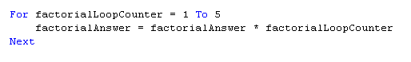
Hopefully the above looks familiar. It will calculate 5 factorial (5!). Note that the for…next structure actually increments the loop counter automatically for you and you do not have to increment it by a line of code (like in the do…while loop by doing counter = counter +1). If you need to increment by more that 1, this can also be done.
The start and end values do not necessarily have to be actual integer values placed in the code, like every other number in a program, it could be a variable. The above code would then look like:
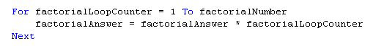
Not all programming languages have the above syntax for a for…next loop. Languages like C, C++, C#, Java,… use the following syntax:
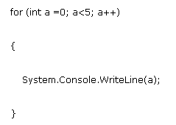
The logic is the same, a is the loop counter, it starts at 1 and goes until 5 and is incremented by 1 each time.

For…Each
The for…each looping structure is used when you have some kind of collection of items (variable, controls…) You might or might not know how many items are in the collection, so coming up with a boolean condition to decide when to terminate the loop is difficult to do. The for…each loop gathers together all the items that you are interested in and then presents each item one at a time, just like the counter in a do…loop is used to keep track of where you are.
Just like I the last few lessons, we used a new type that was not like the regular integer or string. In today’s example we will use a new type called “control”. The control type holds not a number but the reference any kind of control, like buttons or text boxes. As you iterate through the list of control, you can do interesting things like changing the colour of the buttons (just like the example below).

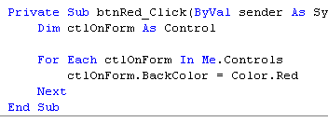

Nested Loops
We have seen the advantages of using various methods of iteration, or looping. Now let's take a look at what happens when we combine looping procedures.
The placing of one loop inside the body of another loop is called nesting. When you "nest" two loops, the outer loop takes control of the number of complete repetitions of the inner loop. While all types of loops may be nested, the most commonly nested loops are for loops. How this works is that the first pass of the outer loop triggers the inner loop, which executes to completion. Then the second pass of the outer loop triggers the inner loop again. This repeats until the outer loop finishes. In a flow chart it looks like:
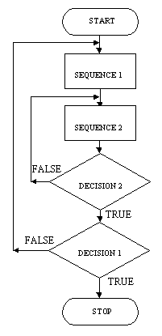
In VB 2005, it would look like:
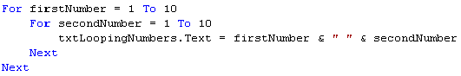
// clear listbox
this.lstNumbers.Items.Clear();

for (firstNumber = 0; firstNumber <= 10; firstNumber++)
{
for (secondNumber = 0; secondNumber <= 10; secondNumber++)
{
this.lstNumbers.Items.Add(firstNumber + " -> " + secondNumber);
}
}

C# Code 14: Nested Looping in C#

Timers
Applications often need to perform certain actions at a given interval. Like a clock counting down. In VB 2005 there is a control object that can be used to trigger a set of code to be executed at a given time interval. This control object, the timer, does not show up on the form but below during design time is at the bottom of the IDE below the form (like the menu control object). When the program is run, the timer can be turned on and the code is executed repeatedly, until the timer is turned off again.

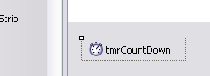
Do not forget to turn the timer on (and off) in your code. Many errors occur when people forget to do this. The timer has a property called “Interval” that is used to set how many milliseconds (millionth of a second) between each time the code is executed. If you set it to 1,000, the code will be executed every second.
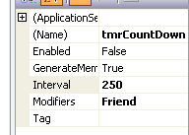

Moving Buttons
In the last example we made a picture look like a man was walking. The problem was that he was not moving anywhere! To make this happen, we first have to understand a new type that exists in VD 2005, the Point. A point is a special type of variable (like an integer or string) except it holds not only 1 piece of information but 2.
If you think back to math class, the Cartesian Plane was a way to represent 2-dimensional space. In VB 2005 the same concept exists for locating objects within a form, except the origin is in the upper left hand corner and the numbers increase in the positive direction as you move down and to the right.
X
Y
You declare and use this type of variable like this:
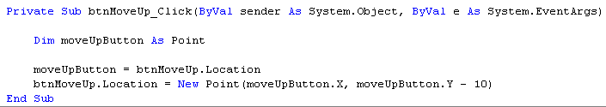

Notice that just like in math class, the X and Y co-ordinates are separated by a comma. The X and Y values are also of type Integer and must be used with all of the rules that we have become use to.
Once we have a variable that is of type “Point”, I then assigned it the current position of the button. I then took the variable that is holding the co-ordinates of the button position and decreased the Y value by 10, which will move it closer to the origin. Thus moving the button up in our form.

Chapter 4 – Functions and Procedures
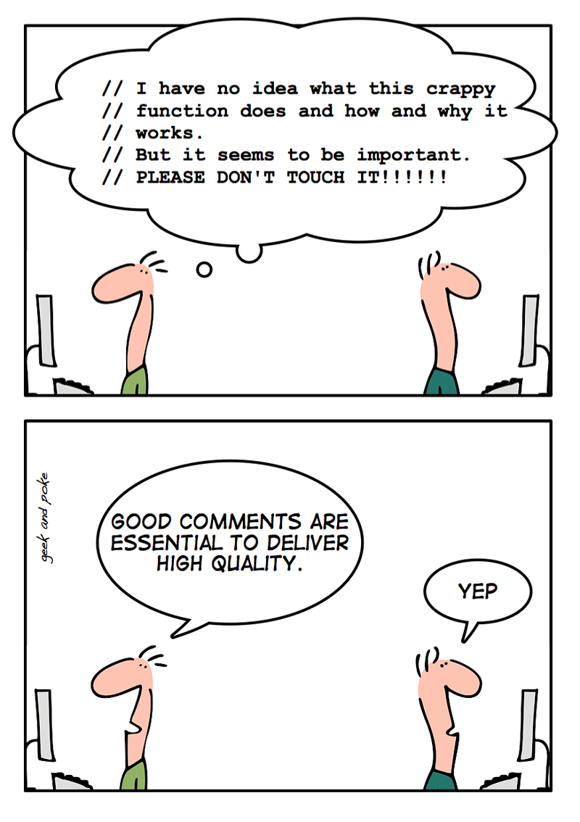

Chapter 4 – Procedures and Functions

The goal of the previous section was to introduce you to the concept of structured programming design. The reasons programs are designed using this method are to:
- easier to develop accurately
- develop in less time
- easier to read and understand
- easier to modify and maintain
- easier to test and correct errors
There are two groups of methods to use in structured programming to ensure the above occur. The first is the three basic control structures we have learned in the previous chapter, sequence, selection and repetition. The second method is modularity. A complicated problem is broken down into smaller problems. Each of these smaller problems is coded. The small sections of code are then organized to make the solution. Modularity in programming is usually done with subroutines.

Procedures
A procedure is a block of code written to perform a specific task. We have actually come across and have been using a special kind of procedure ever since we started writing code in VB or C#. An event procedure, also called an event handler, is a type of procedure that performs tasks in response to user interaction with a control object. Event handlers are a central concept in event-driven programming. Every time you double click on a button, in design mode, and write a piece of code in the btnButton_Click event, you are writing code in a procedure. Although up to this point event handlers have been useful, in many cases we would like a piece of code to be executed when the user is not clicking on some button. For example, we have previously created a program that converts temperature from Celsius to Fahrenheit and Kelvin. This type of conversion is very common and we might want to use it in another program (re-usability is very important in programming. Why re-invent the wheel, just use someone else code).
To create a procedure in VB, a regular procedure not and event handler, you start the code with the reserved word “Sub”, which will automatically create an “End Sub” statement. Ensure you create it outside of any event handlers, at the top of your code right under any global variables you may have declared. The name for a procedure should begin with a capital letter and the beginning of each other word should also begin with a capital letter. There are no underscores. The following procedure will show a message box every time it is called.
Sub PromptUser()
' this procedure displays a messagebox to warn users
MessageBox.Show("Please complete all text boxes.")
End Sub

VB Code 15: Creating a procedure in VB

In C#, the basic structure is the same but the syntax is a little different. The reserved words is “public” and then “void” and then you place the procedure’s name. You must also place a set of brackets after it, just like in VB.
public void PromptUser()
{
//this procedure displays a messagebox to warn users
MessageBox.Show("Please complete all text boxes.");
}

C# Code 15: Creating a procedure in C#

Calling a Procedure
Once you have a procedure, the next thing you need is a way to make the code execute. This process is called “calling” or “invoking” the procedure. In VB, oddly enough, the command you use is “Call” and then the name of the procedure. The following pieces of code, will actually call the PromptUser procedure from above.
Private Sub btnClick_Click(ByVal sender As System.Object, ByVal e As System.EventArgs) Handles btnClick.Click
Call PromptUser()
End Sub

VB Code 16: Calling a procedure in VB

private void btnClick_Click(object sender, EventArgs e)
{
PromptUser();
}

C# Code 16: Calling a procedure in C#

Passing Parameters
A procedure often needs pieces of information to be able to complete its work. One method of doing this is to declare the variable as a global variable and then any code within that form can access it. This is a very bruit force method and is very bad programming style. By doing it this way, the variable is created and held in memory for the entire time the form exists, even thought the information may only be needed for a small fraction of the time the form exists. A better, more elegant and more memory friendly way is to pass the information into the procedure. This way the new variable will only exist in memory for the time the procedure is running. There are two main ways to pass information to a procedure, by value and by reference.

Passing By Value
The first method of transferring information to a procedure is to pass it “By Value”. This means that a copy of the data is made and it is passed over to the procedure to do with it what it pleases. Since it is a copy of the data, any changes to the data are not reflected in the original variable.
A variable or value passed along with a procedure call is called an argument. Argument(s) are placed inside a bracket when you invoke the procedure. For example:
VB Code 17: Calling a procedure with parameters in VB
RandomNumbers(lowerBound, upperBound);
C# Code 17: Calling a procedure with parameters in C#
Call RandomNumbers(lowerBound, upperBound)

In the above examples, two values will be passed to the RandomNumber procedure.
When you are creating your procedure, you must also tell the program that the procedure is expecting two values. To do this after the procedure name you place in brackets two declaration statements declaring that the procedure must be passed two variable and what type of variables they are (just like when a regular variable is being declared). The following is the procedure declaration line for the RandomNumber procedure:
VB Code 18: Passing parameters in VB
C# Code 18: Passing parameters in C#
Sub RandomNumbers(ByVal lowerBound as Integer, ByVal upperBound as Integer)

public void RandomNumbers(int lowerBound, int upperBound)

Note that in the VB version the reserved word ByVal (this is why you never say, “I have dimmed a variable”. You always say “I have declared a variable”. In this case you are declaring a variable By Value) is used first, to tell the procedure to make a copy of the value to be used inside this procedure. In C# all variables are passed ByVal by default (except for objects but we are not there yet). Then the variable is declared in the exact same manner that we have previously been using.
In the above examples the same variable name for the value being passed to the procedure and the name for the value that the procedure makes a copy of is being used. This does not always have to be true. You can use different names, and sometimes it might be advantageous to do so. Remember that once the value is passed to the procedure, if you are using ByVal, a copy of the data is made. Just because the variable names are the same, does not mean it is the same variable. This is analogous to when you have two variables with the same name, one global and one local.

Passing By Reference
The second method of transferring information to a procedure is to pass it “By Reference”. This means that a pointer or reference to where the data is stored in memory is passed to the procedure and not a copy of the data. Since a pointer to where the data exists has been passed, if you actually change the value of the data in the procedure, the actual values of the data in the program where the procedure was called from will also be changed. This can be very powerful but also very dangerous. Be careful using passing parameters By Reference, you might mistakenly change a value when that is not what you expect. The rule of thumb is that unless there is a really good reason to pass something By Reference, you never do and you always pass parameters By Value (even though it takes up more space in memory). To declare a procedure with a parameter that will be passed by reference, you us the reserved word ByRef, for example:
Sub RoundOffNumber(ByRef numberToRoundOff As Decimal,_
ByVal numberOfDecimalPlaces As Integer)
VB Code 19: Passing parameters By Reference in VB

public public void RoundOffNumber(ref decimal numberToRoundOff,
int numberOfDecimalPlaces)
C# Code 19: Passing parameters By Reference in C#

In this procedure, the parameter numberToRoundOff is passed in by reference but the second parameter is passed in by value and a local copy of it will be made in the procedure. Note that the two different kinds can exist in the same procedure. In the calls to procedures in C#, if a parameters is being passed in By Reference, not only in the procedure declaration but also in the procedure invocation the “ref” key word must be used. This is to ensure that it is always made clear when a parameter is being passed in by reference. This convention is not used in VB though. Here is what the call looks like:
Call RoundOffNumber(roundThisNumberOff, thisManyDecimalPoints)
VB Code 20: Call a procedure with passing By Reference in VB

RoundOffNumber(ref roundThisNumberOff, thisManyDecimalPoints);
C# Code 20: Call a procedure with passing By Reference in C#

Control Objects are a Type!
So far we have been passing either ByVal or ByRef, variables of type integers, string or something common like that. As we have previously seen in the control structure ForEach, control objects are a type just like integers are. Since control objects are a type like any other variable, we can pass them to procedures and get procedures to do things to them, just like we can any other variable. You would normally not pass a control object ByVal, since it will make a copy of the object and leave the original one intact, especially since once the procedure is finished, the object will be deallocated and you will no longer be able to use it. For this reason, we normally pass control object ByRef.
When you are passing in a control object like a label, it is always good programming style and practice to use the full name including the “Me.” in VB and the “this.” in C#, so that people reading the code know exactly what control object you are talking about.

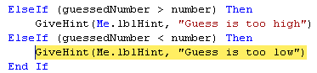

In contrast, when you are referring to the passed in reference to the control object within the procedure you DO NOT use the “Me.” or “this.” reference, because the object with the name you used in the procedure might not exist in the form, it is just a place holder holding to pointer to where the object really exists. You should therefore just refer to the object by the name you called it in the procedure declaration statement.
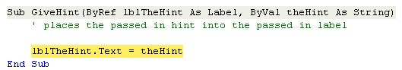

Optional Parameters
All of the procedures that we have looked at to this point, you had to ensure that you were sending the exact same number of parameters to the procedure as it was expecting. To help us do this IntelliSense™ gives us a little pop out window to show us what should be passed over to the procedure and what types they should be.
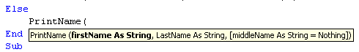
VB Code 21: Optional parameters in VB
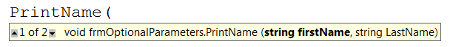

C# Code 21: Optional parameters in C#

In the above examples IntelliSense tells us that the first parameter should be a string. You will also notice that the last parameter in the VB version is in square brackets. In the C# version there is a 1 of 2 with little up and down arrows. If you click one of the arrows, you will see the other “option” for entering in parameters. This new style tells us that the middle name is an “Optional” parameter (it is not required to be sent) and if it is not sent, the procedure will by default use the value Nothing (or the string “”).
If you decide to use 1 or more optional parameters in VB, they must be declared at the end of the procedure declaration statement, after all the required parameters are declared. You are also required to place some kind of default value in, even if it is some value like nothing or 0. The syntax to declare an optional parameter is to place the reserved word “Optional” in front of the ByVal or ByRef. For example:
When you call a procedure in VB that has an optional parameter, there are three different ways to call it. Since in the above example, the last parameter is optional, you can just ignore it and choose to place just 2 parameters in the procedure call.
You might want to tell other people that look at you code, that there is actually three parameters and you have just chosen not ignore the last optional one. To do this you place a comma (,) after the second declaration, showing that there is actually a place holder for the value we are not sending.
The third option is to actually send the optional parameter, just like we have been doing.
If you decide to use 1 or more optional parameters in C#, you actually have to re-write the entire procedure with the EXACT SAME NAME, for each combination of parameters that you want your users to have. The only good news is that the second procedure can actually call the first one, so that you do not have to (and it would be bad programming style to) re-write all the code for the procedure over again. The following is an example of a C# procedure having an “optional” parameter and the first procedure being called by a second:
public void foo(int reqdParam)
{
foo(reqdParam, 0);
}

void foo(int reqdParam, int optParam)
{
// do something ...
}
foo(5); // calls the first overload

foo(5, 10); // calls the actual function

C# Code 22: Call a procedure with passing By Reference in C#
RoundOffNumber(ref roundThisNumberOff, thisManyDecimalPoints);
C# Code 23: Call a procedure with passing By Reference in C#

Functions
A functional procedure or just more commonly known as a function (just like in math class), performs a specific task and then returns a value (or precisely a value type or an object). We have already seen, used and become familiar with several functions that are built into the VB and C# programming language. Things like
- CInt( …
- Convert.ToString
- CStr( …
are all functions that do something and then give us something back. Since a function returns something, they should never change any of the parameters that they are passed. Thus, you should only use ByVal parameters inside a function, so the original values remain unchanged, no matter what you do to them inside the function.
To create a function in VB, just like a procedure, you start with a reserved word to indicate that this is a function. This time you use the reserved word “Function”, to warn the computer that it will have to return something. Once again, just like in procedures, ensure you create it outside of an event handler, where you would place a global variable. The name for a function should begin with a capital letter and the beginning of each other word should also begin with a capital letter. There are no underscores. It should also be an action word (a verb) since it is doing something. Since the function will return some object, the declaration statement must include what type will be sent back. This is done at the end of the function declaration, just outside the closed bracket. The following VB function will return a random number, between the two parameters that were passed in.
Function GenerateRandomNumber (ByVal lowerBound As Integer, _ ByVal upperBound As Integer) As Integer

VB Code 22: Function declaration in VB
Notice the “As Integer” at the end of the function declaration, just after the end bracket.
In C#, there is no reserved word “Procedure” or “Function” like in VB. You will remember that for a procedure we place the reserved word void before the procedures name. This was to tell the computer that the procedure will not return anything (i.e. it is a procedure). For a function we replace that void with the type that will be passed back by the function. This is the key that turns a procedure into a function in C#.
Public GenerateRandomNumber int (int lowerBound, int upperBound);
C# Code 24: Function declaration in C#

To return the value back to the piece of code that called the function, we need to include a method to pass back our final answer. We do this by using the reserved word “Return”. Whatever value (or variable) is after this reserved word, will be passed back as the answer. Here is the example for the random number function:
Just like we have been doing with all the functions that are built into VB or C#, since it is a function and it will return some object or value, we must assign the answer to something (hopefully a variable of some kind, since assigning it right into a control object like a text box is bad style). To do this we must place the function name after an assignment statement, with the values that we are passing into the function. Here is the example for the random number function.

randonlyGeneratedNumber = GenerateRandomNumber (-10, 45)
VB Code 23: Function declaration in VB
randonlyGeneratedNumber = GenerateRandomNumber (-10, 45);
C# Code 25: Function declaration in C#

In these examples, we will be using the function we created. We passed it a lower bound of -10 and an upper bound of 45. The function will then return the integer and place it into the variable randomlyGeneratedNumber.

Recursion
Up to this point we have been focusing on a structured approach to programming. We have ensured that we can easily follow the flow of a program, even if we create functions and procedures to modulate out components that we use often. There is one more interesting method to solve programs, that uses modularity but in a strange method. We have become accustomed to calling a procedure of function, doing the action and then returning to the flow of the program. But what would happen if in a procedure or function we called the exact same procedure or function? If we do this it is called recursion.
The first question we need to ask ourselves is can we legally do this. This is a really good question, since in some programming languages, recursion is actually illegal and you will not be able to compile you program. Most modern languages actually let you do this. The second question you might be asking is, would I end up in an infinite loop? The answer is you might, just like you could in any looping structure if you do not write the code correctly. But if you write the code “properly” you will not end up in an infinite loop.
By using recursion, what you do is simplify out the problem to something very trivial to program. Remember that in our problem solving model, trying to simplify out the problem was really important. Here is an example program that reverses the characters in a string, an easy enough task with a loop but by using recursion, it become even easier.
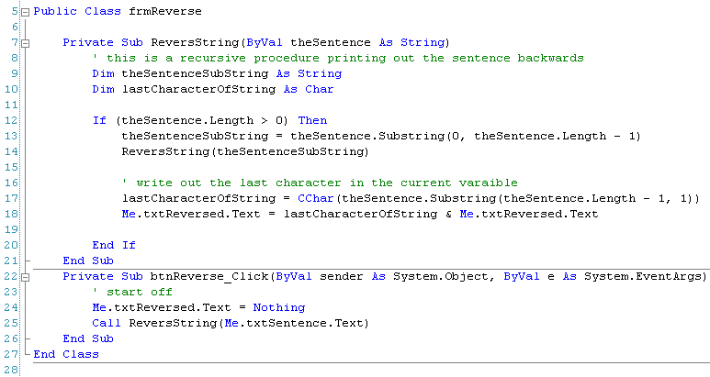

Chapter 5 – Holding Data

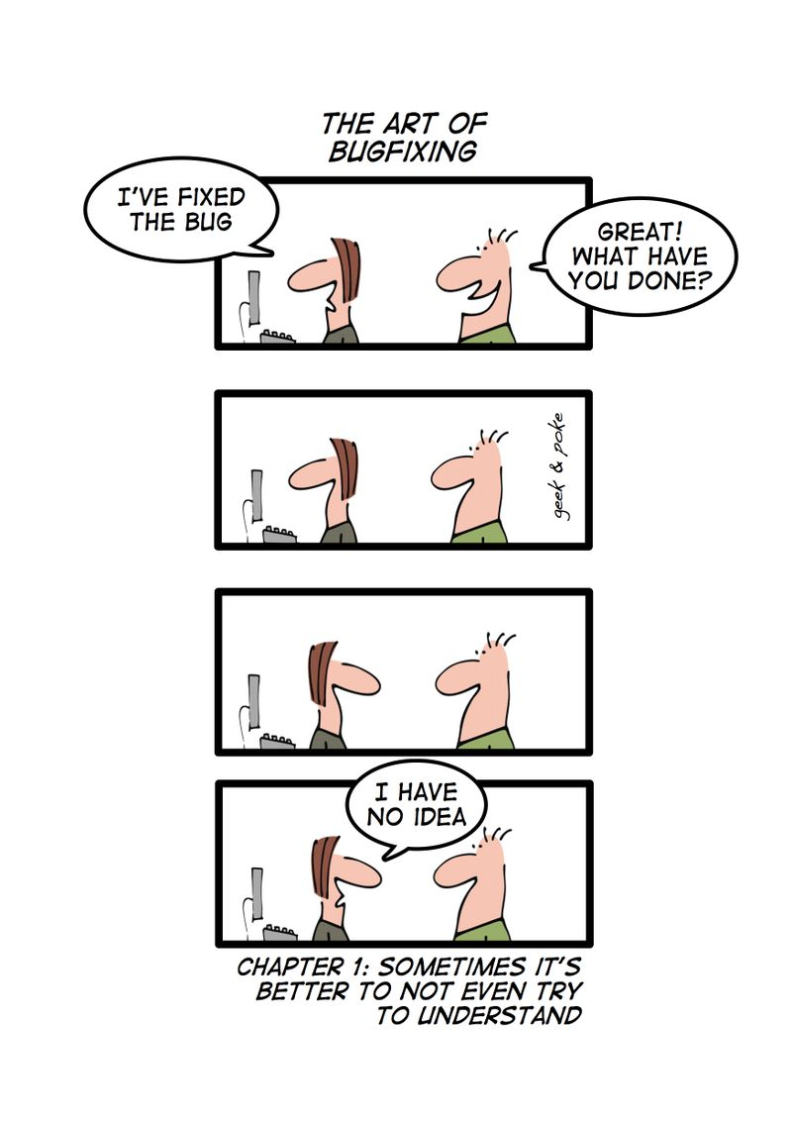

Chapter 5 – Holding Data

Up to this point, every time we saved a piece of information (a number, string, an object …) into a variable, it has always been a single piece of information and we have saved it into one single variable. This makes good sense for many things but sometimes it is very inconvenient. If I asked you to save the final mark for every student in this class, we would have to create a variable for every student in this class to hold their mark. Recreating these variables over and over again, should be the clue that there is a better way of doing this. Another problem is the program would only be useful for a class that had that exact same number of students, not very likely to occur often. To save information like this we should be using an array.

What is an Array
An array stores many pieces of data but in the same variable. For example I could save the marks for 5 students in an array like:
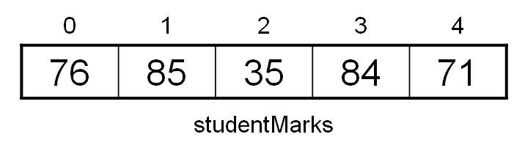 This array has 5 elements (note that you always start counting at 0 with arrays!) but they all have just one variable name (studentMarks). To refer to a specific mark you place the index of the mark after the variable name in brackets. For example, you would refer to the mark of 84 as studentMarks(3). Arrays are an important programming concept because they allow a collection of related objects to be stored within a single variable.

To declare an array, you must specify how many elements will be in the array during the declaration. This is done in VB and C# like:
Dim studentMarks(5) As Integer
VB Code 24: Declaring an array in VB
int[] studentMarks = new int[5];
C# Code 26: Declaring an array in C#

This will create our student mark array and ensure 5 student marks can be held. You can fill an entire array by placing a reference to each index as above and entering in the value. Once the array is all filled with information, you can then use a loop (like a for…next loop since you know the beginning and end index) to traverse through the loop. Here is an example:
Dim studentMarks(10) As Integer
Dim studentIndex As Integer

For studentIndex = 0 To 4
Me.lstStudentMarks.Items.Add(studentMarks(studentIndex))
Next

VB Code 25: Traversing an array in VB
int[] studentMarks = new int[10];
int studentIndex;

for (studentIndex = 0; studentIndex < 10; studentIndex++)
{
this.lstStudentMarks.Items.Add(studentMarks[studentIndex]);
}

C# Code 27: Traversing an array in C#

Passing Arrays as Parameters
We know from the previous section that functions and procedures are a great way to ensure that your program is modular in its design. Any time a piece of code needs to be repeated more than once or twice, a function or procedure might want to be used. When we used functions and procedures, we passed variables by value (making a copy) or by reference (passing the pointer); so that the function or procedure can do some process on our data. We normally pass variables like integers, strings, and doubles but we have seen that you can pass any object, like a picture box. Since an array is just a variable that happens to hold several values and not just one, it also can be passed to a function or procedure, either by value or by reference.
There is some disagreement in the computer world whether it is wise to pass arrays, especially large ones with many values in them, by value. This is because you are making a complete copy of the array and it could take up a large quantity of memory. Other programmers do not like the idea of passing by reference if you do not want the original array to change, because there is always the risk that you or someone that comes after you, will change the array by accident. They argue that modern computers have so much memory these days (as compared to the “old days”) that the risk of changing the original array is not worth the potential memory usage. We will continue to pass variables into parameters by value, unless there is a really good reason that you want to pass the object in by reference.
To pass an array into a function or procedure, you declare the array inside the name of your sub-program, just like you have been doing for regular variable, but you do not place any number inside the arrays brackets. This is because the procedure or function does not know exactly how many elements the array will have. If you had to set it to a fixed amount, your procedure or function would not be very flexible. When the array is passed into the procedure or function, it will determine how many elements it has and an appropriate variable with that many elements will be created. To declare an array in a sub-program, it would look like this in

Function SumArray(ByVal arrayNumbers() As Double) As Double
C# Code 28: Arrays as a parameter in a function in C#
VB Code 26: Arrays as a parameter in a function in VB
private double SumArray(double [] arrayNumbers)

To pass an array into this function, it would look like:
sumOfNumbers = SumArray(enteredNumebrs)
VB Code 27: Arrays as a parameter in a function in VB
sumOfNumbers = SumArray(enteredNumebrs);
C# Code 29: Arrays as a parameter in a function in C#

For Each and Arrays
If you think way back to when we did different types of looping structures, one of the methods to loop was using the For … Each loop. This type was used when you had a collection of things and you wanted to TTTiterate through each one of them. At the time we used a collection of control objects (buttons and labels). Now that you are familiar with arrays and know that an array is just a collection of values of the same type collected into one variable; you can now use the For Each loop to iterate through all the values in an array. From the above example of summing up all the values in an array, a For Each loop would look like the following function:
Function SumArray(ByVal arrayNumbers() As Double) As Double
' this function summs the values in an array
Dim arrayValue As Double
Dim arraySum As Double

For Each arrayValue In arrayNumbers
arraySum = arraySum + arrayValue
Next

Return arraySum
End Function

VB Code 28: For … Each and arrays in VB

private double SumArray (double [] arrayNumbers)
{
// this function summs the values in an array
double arraySum = 0;

foreach (double arrayValue in arrayNumbers)
{
arraySum = arraySum + arrayValue;
}

return arraySum;
}

C# Code 30: For … Each and arrays in C#

Dynamic Arrays
All the arrays that we have declared thus far have been declared with previous knowledge during design time how large the array will need to be. For times when we know in advance the size, this is good programming practice. There are many situations where we do not know in advance how many elements will be needed in an array. For example, if we were to create a student mark program, we do not know in advance how many students will be in a class. Also, different classes will have different numbers of students. One solution is to make an array the maximum size possible. The problem with this is that we are wasting memory if we only have a few students in the class and wasting memory (for no good reason) is never a good idea.
Another method is to declare the array as a dynamic array. A dynamic array varies in size during run time and is used in situations where the size of the array is unknown during design time or when it will have to grow or shrink while the program is running. When we want to change the size of the array, we will have to re-declare the array to include the number of elements we would like. In VB this is done like:
ReDim numbers(howManyNumbers – 1)
VB Code 29: Re-dimensioning an array in VB

Note that howManyNumbers is just an integer variable holding a number and 1 is being subtracted from it, decreasing the size of the array. In the initial declaration of the array, since we do not know how many elements will be in the array, the number of elements can just be left blank between the brackets.
Dim numbers() As Integer
This is poor programming style though. It is better form to place a “-1” in the brackets to warn the programmer that it is a dynamic array and the array will be re-declared latter on in the code with the number of elements. In VB this is done like:
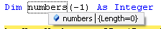
The debug window that shows that the length of this array is 0.
You will note that all the above discussion was only for VB and not for C#; that is because C# does not have dynamic arrays like VB does with just regular array objects.

Preserving Data
When the size of an array is unknown at design time or will change during run time, these are situations when you would need to use a dynamic array. The problem (or more importantly one thing to remember) is that when VB re-declares an array variable for you, all the data in the array is lost. If you had any values saved in the array, their values will be zeroed (or set to nothing depending on what the type is).
To prevent this from happening when you need to keep the data in your array but just add elements to the end (or delete some from the end), you can use the reserved word ”Preserve” after the ReDim statement. For example:
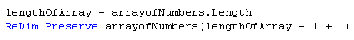
Notice that before I can add another element to an array, I need to know how big the current array is. The method .Length returns an integer stating how many elements are in the array. Since it returns the number of elements and we always start counting at 0 not 1, we need to subtract 1 from this number but we are trying to add 1 more element to the array, so we add 1 back on. This is why I have the strange code to subtract 1 and then add it right back on. It is good programming style to do this, to remind people what is really going on.

2-Dimensional Arrays
All the arrays that we have used thus far have been to represent a list of information. This is a very powerful tool and can save the programmer a lot of time and confusion when dealing with items that are somehow related to each other in a list. Not all things can be represented with a list though. Several times we use a grid or spreadsheet (like Excel) to keep information in rows and columns. This matrix of information can not be represented in a list. In these situations we present our data with a 2-dimensional (or multi-dimensional array).
A 2-D array can just be thought of a list of lists or an array of arrays.
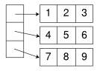
We represent a given element with 2 indices now, instead of 1 when we had a single dimension. Unlike in math class where you used the Cartesian plane, and moved in the X direction and then the Y direction,
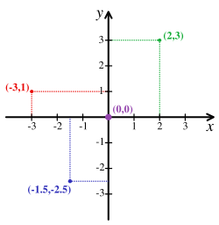
in computer science you move up and down in the rows first and then across to the column position. Thus if we want to refer to the element in the above array that has a value of 8, we would say, studentMarks(2, 1).

There are many applications of 2-D arrays, like a game board (tic-tac-toe), adventure games and business applications like spreadsheets.

Multi-Dimensional Arrays
Moving from one dimensional array (a list) to two dimensional arrays (a grid) helps the programmer solve problems where data is saved in a grid. There are applications where data is actually saved in a structure in 3 dimensions (like a Rubik's Cube). To declare an array like this, we just add a third dimension to our declaration:

Dim rubiksCube(2, 2, 2) As Integer

In theory you could have arrays of 4, 5, 6… dimension. These are very rare in programming but could exist. They are more often used in the business world to describe variables that affect sales for example (size of sign, length of TV commercial, number of magazine advertisements…).

Lists
Since C# does not have a way to dynamically change the size of an array during run time, we are at a huge disadvantage. One great example of wanting to have dynamic arrays is the classic video game, Space Invaders. If you imagine that all the aliens at the top of the screen are held in an array (the type would be some object called Aliens), then as you shoot at the aliens and they die, you would want to remove them from memory to save space. If you cannot change the size of the array, what can we do? Fortunately in the .Net framework there is a class called “Lists”.
The best comparison that can be made to understand how a list works is to compare it to a “List Box”. We have already worked with list boxes. If you need to add items to the list box, you use the method “Add”. The same is true for a list. As you need to add items, you just use the “.Add” method. The list class has many useful methods for adding, sorting, clearing, finding the length …
Dim studentName As New List(Of String)
Dim locationOfStudent As Integer

studentName.Add("Bart")
studentName.Add("Maggie")
studentName.Add("Lisa")

locationOfStudent = studentName.IndexOf("Maggie")

VB Code 30: List in VB

List<string> studentName = new List<string>();
int locationOfStudent;

studentName.Add("Bart");
studentName.Add("Maggie");
studentName.Add("Lisa");

locationOfStudent = studentName.IndexOf("Maggie");

C# Code 31: List in C#

Stacks

Link-Lists

Tree

Chapter 6 –Representing and Sorting Data
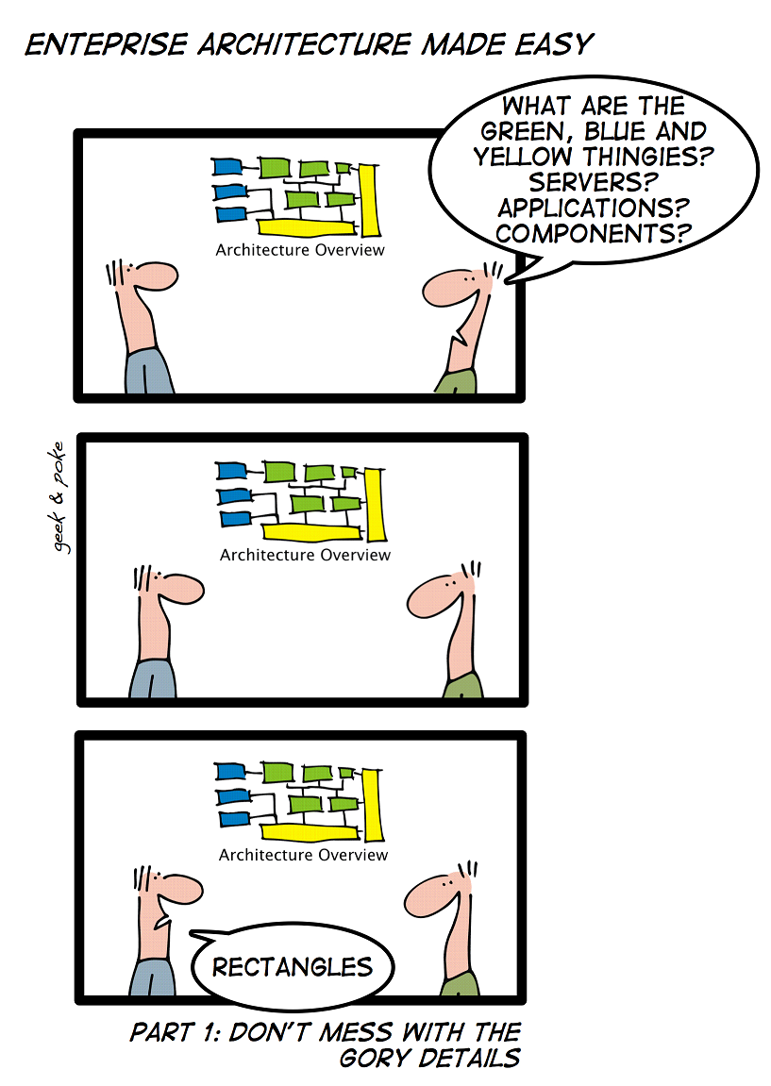

CHAPTER 6 – REPRESENTING AND SORTING DATA

As programming and programming languages matured, there developed a need to better deal with all kinds of data and data processing in programming languages. In some of our previous programs that we have made, we have used a “Magic number” to represent something. For example in the game of 21 (Blackjack) we might have used a 5 to represent the 6 of clubs. In our calculator program when we were saving the mathematical operator, we might have placed it in a string type. Although this is useful and can get us around the problem of saving some piece of information, saving 4 distinct values in a string is bad style and can be dangerous. What would happen is we mistakenly placed “\” and not “/” in our if statement? Syntactically it is correct, so the complier would not have warned us. Our code might not have also found the error (or it might if we wrote really good code) and the program would have looked like it was running correctly, even though it was not.

Enumeration
We know from past sections that whenever you know that a value does not change (or changes very infrequently); you should not declare this type of information as a variable but as a constant. When you need to represent a constant but it can have one of a fixed set of values that somehow relate to each other, how do you save that in one constant? Examples of such a situation would be natural bodies such as the planets in our solar system and data sets where you know all possible values at compile time—for example, the choices on a menu or grade levels.
As an example if you are writing a program that lets the user enter the planet that they would like to go visit on their next holiday (if that was possible), you could just save it in a variable of type string. But there is a predefined set of possible values that is constant (or in this case changes very infrequent since Pluto was removed as a planet in 2006!). So why have the possibility of somebody making a fat finger mistake in your program and having it crash. If you can lock out users and the programmer from using any invalid values, this will help prevent mistakes and make code maintenance easier.
In computer programming, an enumerated type is a data type whose set of values is a finite list of identifiers chosen by the programmer. Enumerated types make program code more self-documenting than the use of explicit magic numbers. Because they are constants, the name of the enumerated type should be declared in all upper case. They are declared as follows:
Enum PLANETS
Mercury
Venus
Earth
Mars
Jupiter
Saturn
Uranus
Neptune
End Enum

VB Code 31: Defining an Enumerated type in VB
enum PLANETS
{
Mercury,
Venus,
Earth,
Mars,
Jupiter,
Saturn,
Uranus,
Neptune
}

C# Code 32: Defining an Enumerated type in C#

Once you have defined your enumerated type, you can now use it in code. It works just like any other type we have used so far, like strings and integers, except it can only contain a pre-defined set of values. To declare a new type of the one you have just defined, you would use the regular declaration statement, like this:
Dim selectedPlanet As PLANETS
VB Code 32: Declaring a variable that is an Enum type in VB
PLANETS selectedPlanet;

C# Code 33: Declaring a variable that is an Enum type in C#

When you would like to assign a value to your new type, after you enter the name of the type (selectedValue) and place an assignment operator (=), IntelliSense will display the list (in alphabetical order) of all the possible valid values.
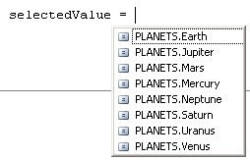

Explicit Assignment
When creating an enumerated type sometimes we want to hold not only the name of the item but some related numerical data. In our example from above with the planets, we might want to also hold the place in the solar system that the planet is sitting. The earth is the third planet. This can be done when we define our type. To do this after the definition of each element in the type, an equal sign is placed and then the value that it will be given. For example:

Enum PLANETS
Mercury = 1
Venus = 2
Earth = 3
Mars = 4
Jupiter = 5
Saturn = 6
Uranus = 7
Neptune = 8
End Enum

VB Code 33: Defining an Enum with a value in VB

enum PLANETS
{
Mercury = 1,
Venus = 2,
Earth = 3,
Mars = 4,
Jupiter = 5,
Saturn = 6,
Uranus = 7,
Neptune = 8
}

C# Code 34: Defining an Enum with a value in C#

When you want to retrieve the numeric value of the type you can use code like:
Dim selectedValue As PLANETS
Dim planetNumber As Integer

selectedValue = PLANETS.Earth
planetNumber = selectedValue

VB Code 34: Retrieving an Enum’s value in VB
PLANETS selectedValue;
int planetNumber;

selectedValue = PLANETS.Earth;
planetNumber = (int)(selectedValue);

C# Code 35: Retrieving an Enum’s value in C#
By default, if you do not give your definitions in your type an explicit value (like in the previous section), it will give them values for you. Just like in array, it will start at 0 and go up by 1 from each additional value.

Using Enumerated Types
Once you have created an enumerated type it is useful for other things inside a program GUI. Since enumerated types are actually a collection of constants, they are a sub-group of something in the .Net framework called an iCollection (which is a fancy term for a collection of things that the computer can use). One of the most useful things you can do is place the values into a list box and select values from a list box.
Remember that when we had a collection of items and we wanted to select each one of them one at a time, but we did not know in advance how many there were, we used the for…each loop structure. This is how we will place values in a list box from an enumerated type. As we have seen with dynamic arrays, this was very useful. The same technique can be used for enumerated types. The following code will place the values from our Planet type into a list box:
Dim singlePlanet As String
Dim allPlanets As Type = GetType(PLANETS)

For Each singlePlanet In [Enum].GetNames(allPlanets)
lsbPlanets.Items.Add(singlePlanet)
Next

VB Code 35: Placing Enum values in a Listbox in VB
foreach (PLANETS singlePlanet in Enum.GetValues(typeof(PLANETS)))
{
this.lstPlanets.Items.Add(Convert.ToString(singlePlanet));
}

C# Code 36: Placing Enum values in a Listbox in C#

Remember that a list box hold text, so anything going into our list box must be converted to text first.
Once we have our enumerated type loaded into our list box (remembering that it is now just text), the next thing we would like to do is click on a value and get back our enumerated type (a variable of type Planet, NOT type string). The following code does this:
Dim selectValue As String
Dim planetNumber As Integer
Dim thePlanetSelected As PLANETS

selectValue = Convert.ToString(Me.lstPlanets.SelectedItem)
thePlanetSelected = CType([Enum].Parse(GetType(PLANETS), selectValue), PLANETS)
planetNumber = Convert.ToInt32(thePlanetSelected)

MessageBox.Show("You would like to go to " & selectValue & ", planet #" & planetNumber, "Enum Planet")

VB Code 36: Convert String to Enum to Number in VB

// say what item you selected
string selectValue;
int planetNumber;
PLANETS thePlanetSelected;

selectValue = Convert.ToString(this.lstPlanets.SelectedItem);
thePlanetSelected = (PLANETS)Enum.Parse(typeof(PLANETS), selectValue, true);
planetNumber = (int)(thePlanetSelected);

MessageBox.Show("You would like to go to " + selectValue + ", planet #" + planetNumber, "Enum Planet");

C# Code 37: Convert String to Enum to Number in C#

Abstract Data Types
All of the different ways to use data so far have been based on the one assumption that we cannot mix different data types. When we create an array, all the elements in the array must be of the same type. When we created a new type by using enumeration, all of the elements inside our new type were all the same type. This has been very helpful up to this point to ensure that our code is type safe.

Type safe is a feature in VB and C# (and other programming languages) and we enforced it even more in VB by using Option Strict On at the top of our programs. Type safe means that we employ a type system to prevent certain forms of erroneous or undesirable program behavior (called type errors). In simple terms this means that our programs don’t make mistakes like sticking a string inside a variable that is of type integer. If we really want this to happen, then we must first convert the string to an integer using the CInt or Convert.ToInt32 functions. If we did not do this conversion, the program might crash or even worse give us a wrong answer.
Although this was been useful, in certain cases we need a way to store related information which is not of the same type. To do this we use what is called a data structure (or sometimes referred to as an abstract data type). A data structure is a composite data type that groups together related information. Unlike arrays, each member of the structure can be of a different data type. For example, suppose we want to keep some information about a student for a marks program. We would most likely want information like:
- First name
- Last name
- Middle initial
- Grade
- If identified
How would we save such information since first and last name will be a string, middle initial should be a character (just 1 letter), grade should be an byte (0 to 255) and identified or not should be a Boolean? Converting them all to string is an option but very poor programming style.
In VB and C# we declare our abstract data type (ADT) in the global declaration section, right with the enumerated types so that it can be used in our entire program. It could technically be placed in a local procedure, but usually this is not very useful. The following is an example of a student structure:

Structure Student
Dim firstName As String
Dim middleInitial As Char
Dim lastName As String
Dim grade As Byte
Dim identified As Boolean
End Structure

VB Code 37: Declaration of an ADT in VB
public struct Student
{
public string firstName;
public char middleInitial;
public string lastName;
public byte grade;
public bool identified;
}

C# Code 38: Declaration of an ADT in C#

Notice that each member inside the structure is declared just like a regular variable. Since the structure will be used to declare one or more variable of type Student, it is good style to capitalize the first character of every word, just like we do form variables.
To declare a variable of type student, you declare the variable just as we have been doing:
Dim aSingleStudent As Student

VB Code 38: Declaring a variable that is a Structure type in VB
Student aSingleStudent;

C# Code 39: Declaring a variable that is a Structure type in C#

When you would like to enter a piece of information into one of the members of the structure, you access the member by placing a dot (.) between the variable name and the member.
studentInformation.firstName = Me.txtFirstName.Text
When you would like to retrieve a piece of data from a particular member, you use the same process.
MessageBox.Show(studentInformation.firstName & " " …

Using an Enum in an ADT
Since the new type you have created by using a Struct is a composite type, made up of several different types put together; any valid type is acceptable to use. This includes enumerated type like the ones we have just learnt how to create in the previous section. If you wanted to you could include the type Planet as one of the members inside the Student ADT (maybe this could be the student’s favorite planet!).
Before you can use an enumerated type inside an ADT, it must first be declared in your code, above where you are declaring your ADT. This is needed so that the people reading your code will know about the enumerated type before it is used. In the student structure, say we would like to create a member called sex. Since it can only be one of two values (male or female) and it is not really a good idea to use a Boolean (it would have to be something like female or not, which is not really useful), an enumerated type is a good idea. Here is an example for a Gender enumerated type being used inside the Student ADT.
// global varaibles
public enum GENDER
{
male,
female
}

public struct Student
{
public string firstName;
public string lastName;
public char middleInitial;
public GENDER sex; // GENDER is an ENUM defined above
public byte grade;
public bool identified;
}

C# Code 40: Declaration of a List of ADTs in C#

An array (or List) of ADT
One again, since the new type you have created by using a Struct is a type, made up of several different types put together, it can be used wherever any valid type is expected. This means that you could create an array (1 or multi-dimensional) that has as its type an ADT. This is the true power of ADT, creating a collection of the type for related elements. As an example, if we were to once again look at our student type, if we were to create a marks program, we would need to keep track of student information. We would not create a new variable for every student, we would create a dynamic array (or list) and each element in the array would represent a student. The type we would use for this array would be the ADT Student.
Here is what the declaration for a dynamic array to hold student information saved in a structure would look like.
// global varaibles
public enum GENDER
{
male,
female
}

public struct Student
{
public string firstName;
public string lastName;
public char middleInitial;
public GENDER sex; // GENDER is an ENUM defined above
public byte grade;
public bool identified;
}
List<Student> aClassOfStudents = new List<Student>();

C# Code 41: Declaration of a List of ADTs in C#

A Function inside an ADT
Now that you have become familiar with and use to using an abstract data type, we will now use them in functions and procedures. Since an abstract data type is just a type, like any other types we have used so far (Integer, String …), they can be used in every case where we have been using regular types. This includes passing them to procedures and functions.
Say for instance we wanted to create a function that accepted our Student type and then returned a String that was the students “official” name in full. It might turn out that writing a student’s name in full (first name, initial and then last name) is a very common request and there is no point in re-writing the code over and over again. In every case when you start repeating similar code, you should step back and see if it is a good place for modularity (a function or procedure). To create this function, we can just pass in a variable of type Student (ByVal) and then pass back the String. The code might look something like this in VB:

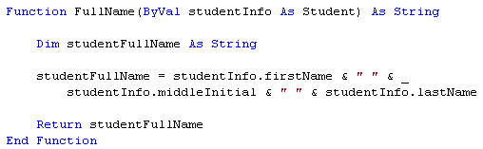

The above function will do the job of converting the two strings and one character into one complete string variable that can be passed back. There is just one thing to note. Since this function will only be valid on variables of type Student, the ADT that we have just created, the chances that somebody else can reuse this function is very slim, because the chances that somebody else has created a structure that is identical to our Student structure is not very likely. That is to say, the function that needs a type of Student and the type Student itself are interconnected. There is no point in giving one to someone without the other. Since this is the case, one programming style is to place the function inside the structure definition itself. This means that the function will be embedded inside the Student type definition and can therefore only be used with this type. This would look something like:
public struct Student
{
public string firstName;
public string lastName;
public char middleInitial;
public GENDER sex;
public byte grade;
public bool identified;

public string FullName()
{
// this function returns the full name
// first, Initial and Last of a student
string fullNameOfStudent;

fullNameOfStudent = this.firstName + " " + this.middleInitial + " " + this.lastName;

return fullNameOfStudent;
}
}

C# Code 42: Declaration of a List of ADTs in C#

Note that now our function does not have anything being passed into it. This is because by definition, since it is embedded inside our Student structure, and the only things we want to reference are declared inside the structure as well, we have access to them locally. If there was a situation where a function inside an ADT needed other information besides local variables, then parameters can be used to pass that information in. Since we are not passing any variable into the function, when we need to refer to any members of the structure (like firstName) we can do so a dot, for example how we already did in code like studentInfo.firstName). What you should use is the this. (or Me.), which in this case is referring to the structure not the form.

Searching

Linear

Binary

Sorting

Bubble Sort

Selection Sort

Insertion Sort

Quick Sort

Chapter 7 – Reading and Writing Files

Chapter 7 – Reading and Writing Files

All of the programs we have written so far have all saved their valuable information in memory. The only problem with this model is that as soon as you exit the application or turn the computer off, all the information that is in memory is lost. To save valuable pieces of information we need a way to write and read that information from and to disk.
Before we can go any further we need to be introduced to “Imports“. Imports are used to add a set of library, that are provided by Microsoft, to your application so that you can use them. In this case the set of libraries that we are including are “Imports“. System.IO is a set of libraries that let the user do Input and Output to disk. This statement comes right after you top comment section and before the “Public Class” statement.

File Stream
To be able to actually open a file in Visual Basic you must associate the file with a files stream object. This object can then perform all the usual actions you would expect a file to be able to do, read, write and so on. Since it is an object, it is a two step process; you must first reserve the space in memory and then instantiate the object. This is done like:
Dim aFileStream As FileStream

aFileStream = New FileStream(fileNameToOpen, FileMode.Open, FileAccess.Read)
You will notice that the New method from this class has 3 mandatory parameters. The first one is the location and name of the file. The easiest way to get this information is through an open file dialogue box control object. This is just another control object like a text box or a button in your toolbox. The next parameter is an enumerated type that states what kind of operation we are performing. In this case we are opening up the file (as compared to creating a new one, truncating or appending). The last parameter is also and enumerated type and states the action we are performing (reading or writing).

Stream Reader
Once we have the file open, the next task is to be able to read in the text. To do this we are going to use another class, this time called “Stream Reader”. This class gives us the ability to read either a single character or line from a file streamer. Since in the last section we learned how to open up a file, we are going to use that to read in one line of text at a time. Instantiating a stream reader object looks like:
Dim aStreamReader As StreamReader

aStreamReader = New StreamReader(aFileStream)
aLineOfText = aStreamReader.ReadLine
You will notice that the New method from this class has 1 mandatory parameters and it is a file stream object that we just learnt how to instantiate. The method ReadLine then brings in one line at a time from the file. In the above example we just place each line into a string variable.
The key to stop reading in a new line is when you reach the end of a file. This is noted by returning a -1 from the Peek method in the StreamReader class (Do While (aStreamReader.Peek > -1)). Also once you are finished with the stream reader and filestream; it is always good OO practice to close the objects down gracefully by using the close method.

Stream Writer
The logical next step after learning how to read in a file would be to write out a file. Once again VB has a class to help us with this, StreamWriter. This class has a method that allows the user to take a line of text and write it out to a text file. Instantiating a stream writer object looks like:
Dim aStreamWriter As StreamWriter

aStreamWriter = New aStreamWriter(aFileStream)
aStreamWriter.WriteLine(aLineOfText)
You will notice that the New method from this class has 1 mandatory parameters and it is a file stream just like we used in the StreamReader class. The method WriteLine as expected will take a line of text and write it to the file.
Although we are using a file stream class again, we have to ensure that we have it set up correctly for writing. You will remember that last time it was set just to read in a file. To set it to create a new file and write it out we would have to do the following:
Dim aFileStream As FileStream

aFileStream = New FileStream(fileNameToWrite, FileMode.Create, FileAccess.Write)
You will notice that the second and third parameters have been changed to reflect the fact that we will be creating a new file and writing to it. You will also notice that the first parameter has changed to “fileNameToWrite”. Since this file name (most likely) does not already exist, we will have to create it and that means using the open file dialog box control object is not good. Fortunately VB has provided us with yet another control object, the “SaveFileDialog” control object. Once again there is a “show” method and a method to return the location and name of the file we are saving.

Chapter 8 – Using OOP
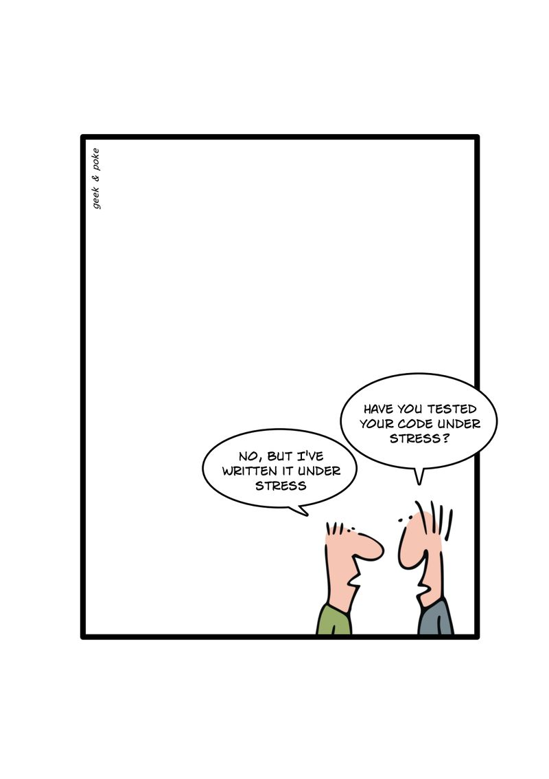

Chapter 8 – Using OOP
(The following concepts, explanations and diagrams taken from a Sun tutorial on OOP)
We have been using OOP all along and you have not been aware of it. The foundation of VB and C# (even all the way back to its 1.0 version) was built on OO concepts, to help make GUI programming easier. Every time you drag a control object like a button onto a form, you were doing OOP.
You did not have to re-write all the code that is needed for that button to appear. You did not have to write all the code to change the text that appears. And so on and so on. All the properties and methods were written by someone else and you got to just use them. In this section we are going to step back and look at the foundation of OOP and see how it is implemented.

What is an Object?
Objects are key to understanding object-oriented technology. Look around right now and you'll find many examples of real-world objects: your dog, your desk, your television set, your bicycle.
Real-world objects share two characteristics: They all have state and behavior. Dogs have state (name, colour, breed, hungry) and behavior (barking, fetching, wagging tail). Bicycles also have state (current gear, current pedal cadence, current speed) and behavior (changing gear, changing pedal cadence, applying brakes). Identifying the state and behavior for real-world objects is a great way to begin thinking in terms of object-oriented programming.

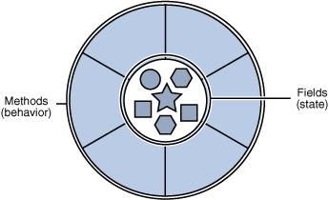
A Software Object

Software objects are conceptually similar to real-world objects: they too consist of state and related behavior. An object stores its state in fields (variables) and exposes its behavior through methods (functions). Methods operate on an object's internal state and serve as the primary mechanism for object-to-object communication. Hiding internal state and requiring all interaction to be performed through an object's methods is known as data encapsulation — a fundamental principle of object-oriented programming.

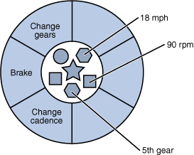
A bicycle modeled as a software object.
By attributing state (current speed, current pedal cadence, and current gear) and providing methods for changing that state, the object remains in control of how the outside world is allowed to use it. For example, if the bicycle only has 6 gears, a method to change gears could reject any value that is less than 1 or greater than 6.
Bundling code into individual software objects provides a number of benefits, including:
- Modularity: The source code for one object can be written and maintained independently of the source code for other objects. Once created, an object can be easily passed around inside the system.
- Information-hiding: By interacting only with an object's methods, the details of its internal implementation remain hidden from the outside world.
- Code re-use: If an object already exists (perhaps written by another software developer), you can use that object in your program. This allows specialists to implement/test/debug complex, task-specific objects, which you can then trust to run in your own code.
- Pluggability and debugging ease: If a particular object turns out to be problematic, you can simply remove it from your application and plug in a different object as its replacement. This is analogous to fixing mechanical problems in the real world. If a bolt breaks, you replace it, not the entire machine.

What is a Class?
In the real world, you'll often find many individual objects all of the same kind. There may be thousands of other bicycles in existence, all of the same make and model. Each bicycle was built from the same set of blueprints and therefore contains the same components. In object-oriented terms, we say that your bicycle is an instance of the class of objects known as bicycles. A class is the blueprint from which individual objects are created. Think of it as a cookie cutter. The cookie cutter is the class and the cookies themselves that you eat are instances of the cookie cutter class.
The following Bicycle class is one possible implementation (in C#) of a bicycle:

class Bicycle
{
// this is the class definition for a bicycle

//private fields

private int _cadence = 0;
private int _speed = 0;
private int _gear = 1;

// public method(s)

public void SpeedUp(int speedIncrease)
{
// increase the current speed by value passed in
this._speed = this._speed + speedIncrease;
}

public void ApplyBrakes(int speedDecrease)
{
// decrease the current speed by value passed in
this._speed = this._speed + speedDecrease;
}

public string CurrentState()
{
// returns the current state of the bicycle as a string

// this varaible is local to this property
string returnString;

returnString = "Cadence: " + this._cadence + " Speed: " +
this._speed + " Gear: " + this._gear;

return returnString;
}
}

C# Code 43: Class definition in C#

The syntax of the class might will look new to you, but the design of this class is based on the previous discussion of bicycle objects. (It should also look somewhat familiar to a structure that has a function in it!). The fields (cadence, speed, and gear) represent the object's state, and the methods (SpeedUp, ApplyBrakes and Current State) define its interaction with the outside world.
You may have noticed that the Bicycle class does not contain a starting point (a click event or main method). That's because it's not a complete application; it's just the blueprint for bicycles that might be used in an application. The responsibility of creating and using new bicycle objects belongs to some other class in your application. For now what we will do is create a Windows application, like normal, and interact with our new class. The final GUI window might look like:
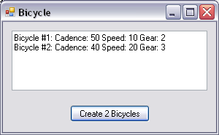

Fields
All (or almost all) classes will have properties that we will need to have saved somewhere. This piece of information must be saved somewhere in memory and as usually it will be saved in a variable.
The problem with saving it in a variable is that we DO NOT want anyone (or any piece of code) outside of the class to be able to see the variable, since if they could then they could also change the value. This would break all the rules of encapsulation and there would be no point in having properties in the first place. To overcome this there is a new way to declare a variable using the reserved word “Private” (once again this is why we do not say we are “Dimming” a variable in VB).
This privately declared variable that actually holds the current value of a property is also called a Field. Once again the field is hidden from any code outside of the class and can only be accessed through a predefined way. The standard naming convention for a field is to an underscore before it (i.e. _ ). You might also see code that has an “m_” instead of just the “_”.

Property Members
Variables of a class are called data members. They are declared as Private to make them accessible to the methods of a class only (encapsulation from above). If we want to change one of these values, we must go through a method to do so.
A property member is used to return or change information in a field. For example, in the bicycle class, if we want to find out what the value of cadence is or to change the value of cadence, we could use a property member. In VB, to declare a property we use the reserved word Property. VB is also nice enough to write the basic plumbing of the code for you. All you have to type in is the first line of the declaration (ex. Property BicycleCadence() As Integer) and then press Enter and VB will create for you.
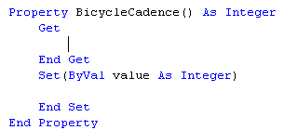
Then you just have to write the rest of the procedure.
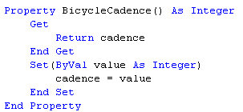
Note that to return the variable; the code is identical to what you have been doing with functions (Return cadence). To change the variable to a new value you just use the value that is passed into the procedure (ByVal value As Integer) and assign it to cadence (cadence = value). You should only be doing this to fields that you want to be allowed to change by outside code. Some of your private variables you might want to be completely hidden and never accessible. It is normal to have several variables inside a class that are just used to hold temporary values that are used in intermediate steps.
In C#, there is no reserved word Property used to create a property. The basic structure is the same though.
public int Cadence
{
get
{
return this._cadence;
}
set
{
this._cadence = value;
}
}

C# Code 44: Property Definition in C#

Once all the plumbing for properties have been completed in your class, you can now use them in your program when you want to find out what the current value of a property is or when you want to change the property to a new value. The syntax will be exactly what you are use to when you get or set the values for properties like textboxes or labels (bike1.BicycleCadence = 5). Notice from the screen shot below, that IntelliSense will give you all the valid properties; let it do its job and do not try to remember and write them yourself.

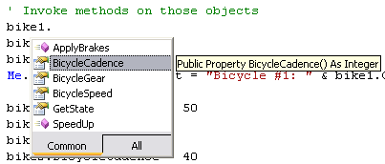

ReadOnly Property
Sometimes there are properties that you would like to give people the ability to see what the current value is but not change that value. From our bicycle class, it would be reasonable to let someone see what the current speed is, but it would not be reasonable to let them just set the current speed to a value. To be able to change the speed of a bicycle, you either need to speed up the cadence, change to a higher gear or apply the brakes to slow down.
To allow a property to be seen but not changed directly, you declare a property in VB as ReadOnly Property. When you do this VB will just create the plumbing for the Get method; it will not create (or let you add in) the Set method. In our bicycle example, the bicycle speed property would look like:
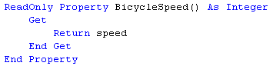
Once again in C# there is no property key word, so there will be no ReadOnly Property key word. For C#, if you just include the “get” but no “set”, then by definition, you have created a read only property.
public int Speed
{
// this is read-only because you can't suddenly just decide to go 100km/h!
get
{
return this._speed;
}
}

C# Code 45: Read-only Property in C#

Methods
In structured programming, we used functions and procedures to group together code that performed an action. The idea behind grouping them together in a package, like a procedure or function, was code reuse. The related code was used several times or we thought it could be used in another program in the future. In OOP we will still need functions and procedures to perform actions and to return values. In OOP functions and procedures are called methods.
A method is a procedure or a function in a class. Methods are used to perform actions on or return values from our fields. Just like in structured programming methods might have none, one or several parameters passed to them. Just like a function, a method might also have a return value. The purpose of having methods in our class is to provide a way for the class’s private variables to be accessed, changed and returned. Remember in OOP, the data is hidden (encapsulation) and can only be changed by the proper use of methods or properties.

Since methods are the only publicly available way for objects to access or change their private variables, the methods will usually be declared as Public. Since methods are just like procedures and functions, the proper naming convention for methods is the same as procedures and functions; each word starts with a capital letter, there are no underscores and it must be an actions word (verb) since they are performing some action. A method for our bicycle class would look something like:
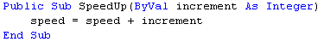
Sometimes in our class, just like in our structured programming code, we might have classes that we do not want to make visible to the object but we would like to be used for “background” work inside of our class. Since we do not want the object to see them, we declare them as Protected, so that any code inside of our class can see them, but no outside object can use them. In our bicycle example, if you change the gear that you are in, then the speed of the bicycle will change (given everything else stays the same). We will therefore include a Protected procedure called RecalculateSpeed that will change the speed for us when the gears are changed. It will look something like:

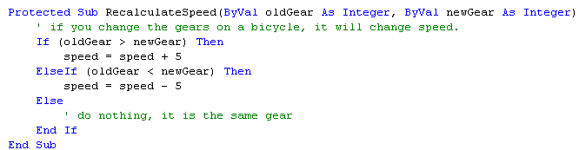
protected void CadenceSpeedRecalculate(int newCadence)
{
// if you change the Cadence on a bicycle, it will change the speed
// (this formula is not real, I just made it up!

int cadenceDifference;
cadenceDifference = newCadence - _cadence;

if (cadenceDifference > 0)
{
_speed = _speed * (1 + (cadenceDifference / 20));
}
else if (cadenceDifference < 0)
{
_speed = _speed * (1 + (cadenceDifference / 20));
}
else
{
// do nothing, it is the same gear
}
}

C# Code 46: Protected Function inside a Class in C#

Now every time the gear is changed, we can call this procedure. We should also remove our old “speed” method, since it does not really make any sense to be able to change the speed directly. The only way that we should be able to change the speed is with a change of gears or a change of cadence.

UML
Unified Modeling Language (UML) is a standard language for specifying, visualizing, constructing, and documenting the artifacts of software systems, as well as for business modeling and other non-software systems. The UML represents a collection of best engineering practices that have proven successful in the modeling of large and complex systems. The UML is a very important part of developing object oriented software and the software development process. The UML uses mostly graphical notations to express the design of software projects. Using the UML helps project teams communicate, explore potential designs, and validate the architectural design of the software. UML is designed to aid the program in their Object-Orient Design (OOD).
It is important to distinguish between the UML model and the set of diagrams we will be using. We will only be using a few of the many types of UML diagrams. Also a diagram is a partial graphical representation of the complete system's model. The model also contains a "semantic backplane" — textual documentation that brings all the model elements and diagrams together. The following diagram represents all the different types of UML diagrams in a hierarchical diagram.

Class Diagrams
In the UML, a class diagram is a type of static structure diagram that describes the structure of a system by showing the system's classes, their attributes, and the relationships between the classes.
When drawing a class diagram, a class is represented by a box with the name of the class written inside it. An optional compartment below the class name can show the class's attributes (i.e. its properties). Each attribute is shown with at least its name, and optionally with its type, initial value, and other properties. The class's operations (i.e. its methods) can appear in another compartment. Each operation is shown with at least its name, and optionally also with its parameters and return type. Just like in code when we place comments to ensure people understand what we are writing, in a class diagram other compartments may be defined, e.g., to capture responsibilities, requirements, constraints. Attributes and operations may have their visibility marked as follows:
- + for public
- # for protected
- − for private

The class diagram for our bicycle class would look something like:
Bicycle
+ cadence : integer
+ speed(increment) : integer
+ gear (newGear): integer

# RecalculateSpeed (oldGear : integer, newGear: integer)
+ SpeedUp (increment : integer)
+ ApplyBrakes (decrement : integer)

Chapter 8 – Creating Objects
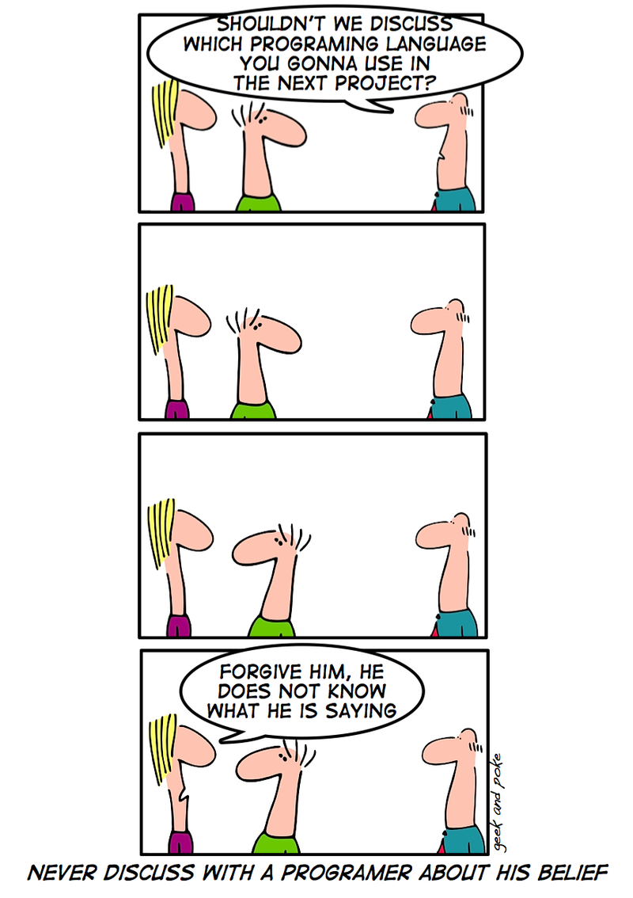

Chapter 9 – Creating Objects

Encapsulation
One important aspect of classes is that the methods of a class are the only way to change the values of the private data (fields) of that class. The reason for this is that the methods (and properties) use “logic” to ensure the operation is legal. For example, in the bicycle class, you cannot change the variable speed directly you must use methods (or properties) like (ChangeCadence, ChangeGear, SpeedUp, and ApplyBrakes). The variables are not directly accessible to the Bicycle object and they are said to be encapsulated by the class. Limiting access to data is call data hiding and is the basis for encapsulation.
Encapsulation is accomplished by using an access modifier in declarations of variables. Access modifiers are keywords that control access to members:
- Private declares a member as accessible to the method of the class only
- Protected declares a member that can be used from within the class only
- Public explicitly declares a member available to an object of the class.

Constructors
A constructor is a method that is automatically called by the New keyword when an object is instantiated. Assignment of values to fields (private variables) is normally done in the constructor. This is a better method of assigning initial values to variables than the way we have been doing, by assigning the value in the declaration statement (see example below).

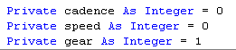

If you use a method, then the programmer instantiating the object can pass in the initial values that they would like. For example when you instantiate a new button object, you would like to set the property position to the value you would like to set. The New keyword must be used, since this is the key to the compiler to run this during the instantiation of the object.
A constructor works just like a normal method. Since its syntax is just like a method (except it cannot return a value, it is like a Sub or procedure not a Function) it can either have none, one or many parameters passed to it. If it is going to have parameters passed to it, then these parameters must be supplied when the object is instantiated. Since you can pass parameters into the constructor, it must be marked a Public and not Private. (You can actually mark it as Protected, but you must wait until you learn heritance first to understand this.)
For our bicycle class, the constructor would look like the following. Notice that the user will now have to pass in the initial cadence, speed and gear.
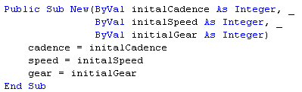
public Bicycle(int initialGear, int cadence, int speed)
{
// initial values

this._gear = initialGear;
this._cadence = cadence;
this._speed = speed;
}

C# Code 47: Constructor in C#

The code to actually instantiate our two bicycles will now look like:
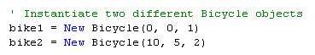

Overloading Methods
Several different objects that we have already become use to using give us the opportunity to pass them 1, 2 or more variables as parameters, depending on how we want to use them. A great example of this is the message box. In its most basic form, we must pass it what we want the message to show when the box appears on the screen. If we just place this one variable in the parameter list we will get a message box that looks something like:
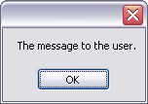
On the other hand, we might want it to also include a title, so that the user knows what the message box is all about. This is the second (and an optional parameter) that we can enter. If we do this, we get a message box that looks something like:
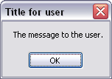
These optional parameters can also be used when we have a method in a class. IntelliSense gives the user a clue that there are options as soon as you start typing the open bracket. For the message box, there are actually 21 different way to send parameters to the method.
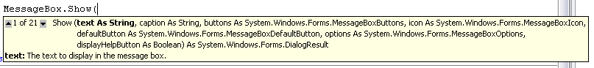

In OOP, not only can a method have optional parameters, the method can actually do a completely different process, depending on what parameters are passed to it. A method that performs a different action depending on the number or type of arguments it receives is said to be overloaded. Constructors are a great example of a method that you might want to overload (just like the above mentioned message box constructor). Not that overloading can be done with other methods besides constructors; we are just using constructors as an example. By overloading the constructor method, you give the programmer more flexibility when creating their objects.
Take for example our bicycle class. So far the class constructor requires that the programmer include 3 parameters (cadence, speed & gear). If we say for example that most bicycles that come from the factory are set to gear 1 and that that is OK with most people, then there is no reason to force the programmer to type in this parameter every time. The class can be designed to have this set as a default but if the person wants to change it they can.
To create this second way of instantiating our class into an object, we just create a whole new constructor. Oddly enough, we use the exact same steps and even call the second procedure the exact same name (it is important that the method must have the exact same name or you have not overloaded the method, you have just created a brand new method). Since we are creating a second Public Sub New method for our bicycle class, the two constructors would look something like:
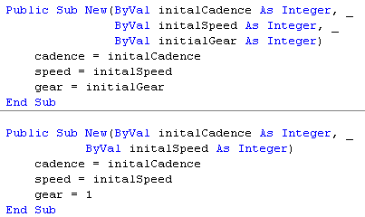
public Bicycle(int initialGear, int cadence, int speed)
{
// initial values

this._gear = initialGear;
this._cadence = cadence;
this._speed = speed;
}

public Bicycle(int cadence, int speed)
{
// initial values

this._gear = 1;
this._cadence = cadence;
this._speed = speed;
}

C# Code 48: Overloading the Constructor in C#

Note that we now have two constructors, with the exact same name (Public Sub New) but the second one only has 2 parameters being passed to it and the variable gear is set automatically to 1.
Since we now have two different ways to pass parameters to instantiate our class into an object, when you start typing the open bracket IntelliSense will show you the first constructor method (our original one) but also show you that there is another constructor method.
To see what the other constructor method is, click the little down arrow after the 1 of 2.
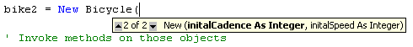
We now have two different ways to instantiate our bicycle objects and it might look like the following in code.
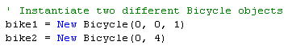

Inheritance
Programmers (just like all good high school students) are lazy by design; why recreate the wheel when somebody has already done it. As has been stated several times, code reuse is a good thing (as long as you know what you are doing and what the code is doing!). Large programs have enough new code in them; programmers do not need to re-write lines of code if it is not needed. So far we have seen and created functions and procedures to aid in code reuse. If we are doing something over and over again in a program, then we should probably create a procedure or function to do that task and then call the procedure or function when needed.

In many programs that use classes, we may need several different classes that are related but slightly different. Since we would not want to re-write all the code in the different classes that is the same, we would need a way to avoid the code repetition. In OOP you use inheritance.
Inheritance is one way to reuse and extend previously written classes. Inheritance also provides a powerful and natural mechanism for organizing and structuring your software. Mountain bikes, road bikes, and tandem bikes, for example, all share the characteristics of bicycles (current speed, current pedal cadence and current gear). Yet each also defines additional features that make them different: tandem bicycles have two seats and two sets of handlebars; road bikes have drop handlebars; some mountain bikes have an additional chain ring, giving them a lower gear ratio.
Object-oriented programming allows classes to inherit commonly used state and behavior from other classes. In our example, Bicycle now becomes the superclass (or baseclass) of MountainBike, RoadBike, and TandemBike. In OOP languages, each class is allowed to have one direct superclass (most of the time!), and each superclass has the potential for an unlimited number of subclasses (or childclasses or derived classes):

In VB, the syntax to inherit from a baseclass is oddly enough the reserved word Inherits. In C# you use the symbol (:). You place this at the top of your class declaration, right after the class name. The TandemBike class definition would now be very short and look something like:

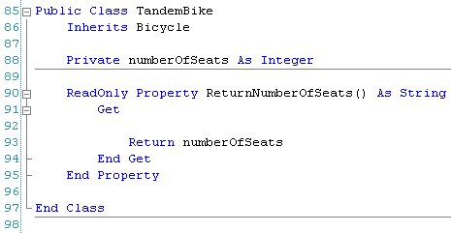
Inheritance is one of the three key things that make up OOP (encapsulation, inheritance and polymorphism). In university you can take entire course on inheritance in OOP. Inheritance can get much more complicated and involved than the above but at its core, it is just reusing the code from a superclass so that you do not have to re-write it when you create a subclass.

Class Diagrams Again!
Now that we can use the power of inheritance to derive child classes from super classes, the next question usually is how do we represent that in a class diagram. You will remember from before that in a UML class diagram, the name of the class goes first, then the properties, then the methods. Using a new example, suppose we have a generic bank account and we want to model it in a class diagram, it might look something like the following:

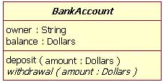

A bank account is a great example of something that can be inherited from. There are many different types of bank accounts, including checking accounts and savings accounts. The following diagram represents the hierarchical relationship between bank account (base class) and checking and savings account (derived classes).

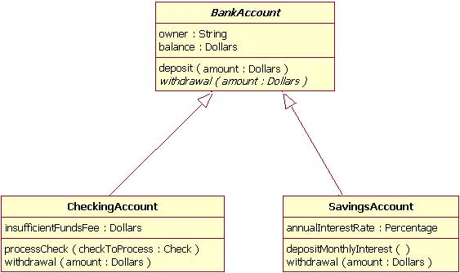
Note that for the derived classes, you add in the name of the class and only the fields and methods that are new or changed from the base class. In the above example, insufficientFundsFee is new to checking account, because in a regular bank account there is no concept of having a negative balance, since the teller (or ATM) will tell you when you have run out of money. Also the withdrawal methods are slightly different for a checking and a savings account, so they are both re-declared in the class diagram. This will be explored in more detail in the next section.

Polymorphism
Once you have created a subclass of your parent class, it could happen that you need to redefine how a certain method works, since it is not exactly the same logic as the parent class. An example of this that you have most likely already seen before is a regular text box and a password input box. In a regular text box, the user types in characters and they show up in the text box. The text box object itself has many methods and properties, like .Text that we use all the time. A password text box is actually derived from a text box but the text does not show up when you type; a “*” shows up for each character you type, so that somebody looking over your shoulder can not see your password. The method that places the characters into the text box still exists in a password text box but it clearly needs to be changed, so someone cannot steel your password. The process of redefining a base class method in a sub class is known as polymorphism.
By using polymorphism, you can make the exactly same named method appear polymorphic, that is changing its task to meet the needs of the object calling it. For example, in our above example of inheritance, a bank account has a withdrawal method. Our two derived classes redefined how these methods will work in their classes, because maybe there is a different withdrawal fee depending on the account type. A method that is declared in “general” in a supper class is declared with the key word Overridable. This allows a sub class to redefine the method with a new one in its class declaration. The sub class will use the same name for the method that the supper class used, but use the key word Overrides, to indicate that the new method should take precedence over the old one. Members (or variables) that are general purpose (to be used in both the parent and child class) should be declared as Protected so that they are accessible to the derived class as well as the parent class. You can also use the key word MyBase.XXX, to call the super class’s method and then just add the code after this statement that changes the methods functionality. This is really valuable because you would never want to copy and paste code from the base class into child classes. If you did and latter you needed to make a change, how would you find all the exact places where the changes would need to be made? MyBase.XXX is often used in the constructor (Note that the key words Overridable and Overrides are not used in the declaration of the constructors in VB).
For the bicycle class that we have been working with, suppose that when the cadence is changed on a tandem bike the speed actually increases (or decreases) more that on a regular bike, since there are two people peddling. This would be an example of a method that would need to be redefined in the child class. To do this the parent class’s method would first have to be marked as Overridable.
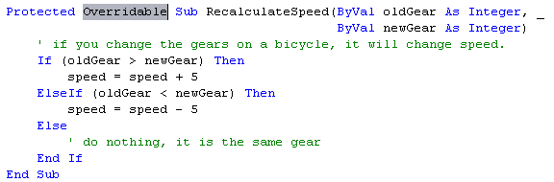
Next in the TandemBike class, which inherits from the Bicycle class, the exact same method name would have to be rewritten to work as it should for a tandem bike. It will have to use the Overrides key word though.
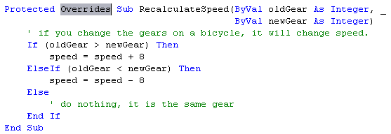
As mentioned above, the constructor does not use the same Overrides and Overridable nomenclature. To call the base class’s constructor, you use the key word MyBase. In the TandemBike class it would look something like:
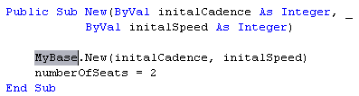

Abstract Methods & Classes
Many times when a set of classes are being designed, the full picture of what everything is going to do might not be fully flushed out before the program design work is done. In other cases it might be known that two or more different child classes will have the same method but they are so different that there is no common code that can be written in the parent class that would be useful to inherit. In situations like these, a class might have something called abstract methods.
An abstract method is just a place holder. The external plumbing of the method is created but there is actually no code in the method. This way the child classes are forced to completely implement their own version of the method. In VB, this can be taken one step further and a method can be marked with the key word MustOverride, which forces the child classes to re-implement the method. If you do not, you get the little red underline and the code will not compile.
In the same way, if you want to design a class but do not want the class to be able to be instantiated into an object, you only want the class to be inherited and the child classes to be able to be turned into objects, and then you can create an abstract class. Abstract classes cannot be instantiated, only their child classes can be. To do this you mark the class with the key word MustInherit. From our bicycle class, if it is actually a child class and the parent class is ThingThatHaveWheels, then the parent class might be an abstract class. The code for that might look something like:

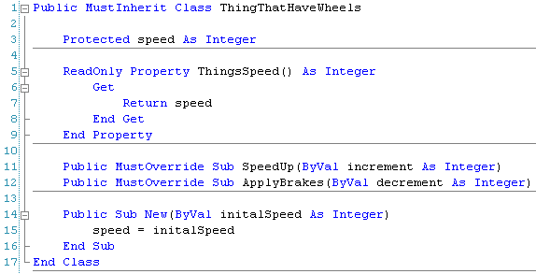
Remember that any class that is marked with the key word MustOverride means that it cannot be instantiated. You will be able to create a variable of that type but when you actually try to write the instantiation line of code, you will not be able to select the type. If you try you will get an error.

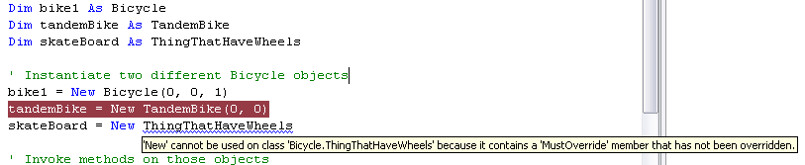

UML once More!!
How to show abstract classes, abstract methods and enumerated types in class diagrams:

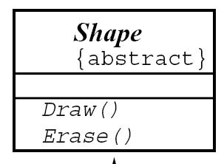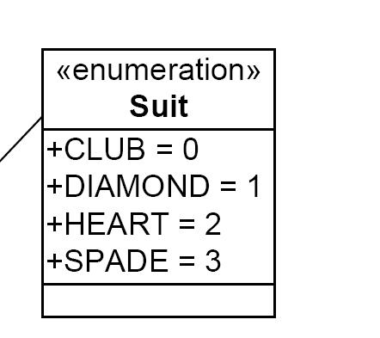

Multiple Class Interactions

Arrays of Objects

Index

A
abstract class 128
abstract methods 128
argument 62
array 74, 75, 76, 77, 78, 79, 80, 81, 82, 88, 89, 93
assignment statement 69
Assignment Statement 23
B
binary 2
Boolean 22
Boolean expression 52
Boolean Expression 33
C
Cartesian plane 81
Cartesian Plane 58
character 90, 91, 126
class 58, 68, 74, 78, 81, 106, 107, 108, 109, 110, 111, 112, 115, 117, 118, 120, 121, 123, 124, 125, 126, 127, 128, 129
Code re-use 106
Comments 23
Compile 23
Compound Boolean Expressions 42
Conditional Control 33
constant 84, 120
Constant 25
counter 48, 52, 53, 54
D
data hiding 117
data members 109
data structure 90
data type 85, 89, 90, 93, 94
Data Type 22
declaration statement 63, 66, 67, 69, 86, 117
Declaration Statement 22
dynamic array 78, 79, 88, 93
E
elements 74, 75, 76, 78, 79, 80, 89, 93, 114
ENIAC 6
enumerated type 85, 86, 88, 89, 90, 92
event handler 60, 61, 68
event-driven programming 60
Excel 81
F
factorial 49, 54
fat finger 84
Flow-Charts 14
for…each 88
for…next 52, 53, 54, 75
function 68, 69, 70, 76, 77, 90, 94, 95, 107, 112, 122
G
global variable 61, 62, 68
Global Variable 24
I
iCollection 88
Identifier 22
If … Then … Else 36
If…Then 34
If…Then…ElseIf…Else 38
index 74, 75
Information-hiding 106
inheritance 122, 124, 126
instance 94, 106
integer 49, 53, 54, 55, 70, 78, 80, 90
IntelliSense™ 66
iterate 55, 77
L
Local Variable 24
Logical Errors 32
Logical Operator 42
loop 48, 50, 52, 53, 54, 55, 75, 77, 88
loop counter 52, 53, 54
M
Machine Language 2
Magic number 84
matrix 81
methods 60, 77, 105, 106, 107, 109, 112, 115, 117, 124, 125, 126
Modularity 60, 106
multi-dimensional array 81
N
Nested If Statements 43
nested loops 55
O
Objects 65, 104
OOP 112, 120, 122, 123, 124
overloaded 120
P
Pluto 84
polymorphism 124, 126
procedure 60, 61, 62, 63, 64, 65, 66, 67, 68, 69, 76, 94, 109, 112, 113, 120, 122
programmer 79, 81, 82, 85, 118, 120
Programmer 3
programming language 48, 54, 68, 84, 90
Programming Language 2
R
run time 78, 79
S
Scope 24
Select Case 46
self-documenting 85
spreadsheet 81
string 55, 65, 66, 74, 84, 89, 90, 94
structure 45, 48, 54, 65, 82, 88, 90, 91, 92, 93, 94, 95, 107, 115
subclasses 123
subroutines 60
superclass 123, 124
Syntax Errors 32
T
Top-Down Design 13
TTTiterate 77
type 44, 55, 58, 60, 63, 65, 69, 77, 79, 84, 85, 86, 87, 88, 89, 90, 91, 92, 93, 94, 109, 115, 120, 126, 129
type safe 89
U
UML 114, 115, 124
V
variable 46, 48, 53, 54, 58, 62, 63, 65, 69, 70, 74, 76, 77, 78, 79, 84, 89, 90, 91, 93, 94, 109, 119, 121, 129
Variable 21
verb 68, 112

