Adventist University of Central Africa
Faculty of Information Technology — Department of Software Engineering
SENG 8240 — Best Programming Practices and Design Patterns

WAREHOUSE MANAGEMENT SYSTEM
Case Study: Magerwa Ltd, Rwanda

PHASE 1: System Analysis and Design

Prepared by: Prince
Instructor: RUTARINDWA Jean Pierre
Academic Year: 2025/2026 — Semester II
April 2026

Table of Contents

1. Introduction
This document presents the system analysis and design phase (Phase 1) of the Warehouse Management System (WMS) developed for Magerwa Ltd, Rwanda. The project is part of the SENG 8240 course — Best Programming Practices and Design Patterns — at the Adventist University of Central Africa (AUCA).
The purpose of this phase is to conduct a thorough analysis of the case study organization, identify the problems they face in their current warehouse operations, and design a comprehensive software solution using Object-Oriented Analysis and Design (OOAD) methodology.

1.1 Topic
The chosen topic is a Warehouse Management System (WMS) — a software application designed to digitize and automate warehouse operations including inventory tracking, order processing, cargo management, client management, and compliance reporting.

1.2 Case Study
The selected case study organization is Magerwa Ltd (Magasins Generaux du Rwanda), Rwanda's premier public bonded warehousing and logistics company. Magerwa was established in 1969 by Presidential Decree and has served as the backbone of Rwanda's import and export logistics infrastructure for over five decades.

2. General Description and Analysis of the Case Study
Magerwa Ltd (Magasins Generaux du Rwanda) is a company of Rwandan law, created in 1969 by Presidential Decree No. 153/10 of July 10, 1969. It was originally founded as a Company Limited by Shares (S.A.R.L) and was later incorporated as a Public Limited Concern on March 27, 1998. It is now a subsidiary of Portek International Pte Ltd, which itself is owned by Mitsui & Co., Ltd. of Japan.
As Rwanda's first public bonded warehouse, Magerwa has been handling most of the country's imports and exports of goods. The company is experienced in managing assorted varieties of cargo including land freight, air freight, and transit goods. Its operations span across multiple locations in Rwanda, making it a critical logistics hub for the country's economy.

2.1 Core Services
- Public bonded warehousing — secure storage of imported and exported goods under customs supervision
- Cargo handling — loading, unloading, and sorting of goods using heavy equipment (cranes, forklifts, reach stackers)
- Air cargo handling — operations at Kigali International Airport (KIA) for import and export air freight
- Cargo damage survey — independent assessment and reporting of cargo conditions
- Equipment rental — sideloaders, forklifts, reach stackers, and containers available for rent
- Office and parking space rental at Gikondo facility

2.2 Key Locations and Infrastructure
Location | Type | Description
Gikondo, Kigali | Headquarters | Main warehouse hub with 1.36 hectares of covered storage, office space, and truck parking for 250 vehicles
Kigali International Airport | Air Cargo Terminal | Handles import/export air freight with X-ray screening equipment certified by RCAA and IATA
Rusumo Border Post | OSBP Facility | Warehousing and handling at the Tanzania-Rwanda border
Rusizi Border Post | OSBP Facility | Major facility at the Rwanda-DRC border, recently expanded with 2,000 sqm new warehouse for MCD Corporation
Kiyanzi | Warehouse Facility | Regional storage location serving inland cargo operations

2.3 Scale of Operations
Metric | Value
Employees | 111+ staff across all locations
Annual Revenue | Approximately $6 million USD
Covered Storage | 1.36 hectares at Gikondo alone
Equipment Fleet | 60T mobile crane, 45T reach stackers, sideloaders, 30+ forklifts (3T to 16T capacity)
Parent Company | Portek International (Mitsui & Co., Ltd.)
Year Established | 1969 — over 55 years of operation

3. Functional Diagram
The functional diagram below illustrates the internal working of Magerwa Ltd's warehouse operations. It shows the core process flow that cargo follows from arrival to dispatch, along with the supporting functions that enable the full logistics operation.
The main process flow consists of six sequential stages: Goods Arrival (receiving trucks and air cargo), Customs Clearance (RRA verification and documentation), Inspection and Sorting (physical examination and damage survey), Warehouse Storage (zone and bay assignment), Inventory Tracking (stock monitoring and updates), and Order Dispatch (client delivery and departure).
Supporting these core stages are five cross-functional areas: Client Management handles client registration, communication, and relationship tracking. Equipment Management oversees the fleet of forklifts, cranes, reach stackers, and sideloaders. Reporting and Analytics generates compliance reports for the Rwanda Revenue Authority (RRA) and operational analytics. Space Allocation manages zone and bay assignments to optimize warehouse capacity. Damage Survey provides independent cargo condition assessments and reports.
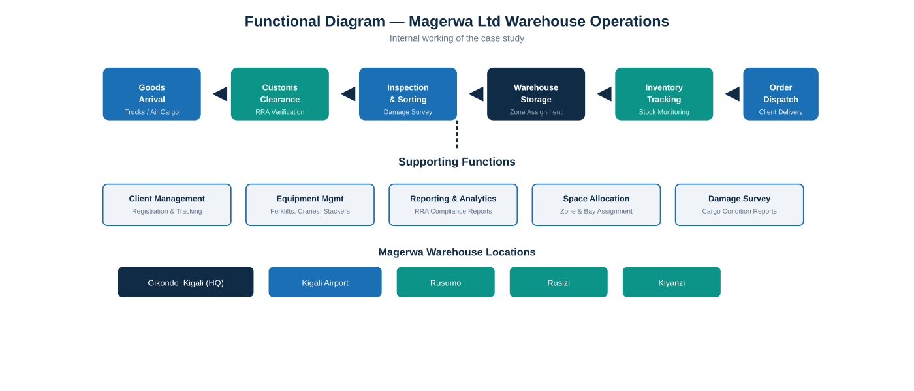
Figure 3.1: Functional Diagram showing Magerwa's warehouse process flow and supporting functions

4. Problem Statement
Despite being Rwanda's leading logistics and warehousing company with over five decades of experience, Magerwa Ltd faces several operational challenges that impact efficiency, accuracy, and client satisfaction. These challenges stem from the reliance on manual processes and the absence of an integrated digital system.

4.1 Manual Inventory Tracking
Currently, Magerwa relies heavily on paper-based records and spreadsheets to track inventory across its multiple warehouse locations. This manual approach leads to frequent errors in stock counts, misplaced cargo, delayed reporting, and difficulty reconciling physical inventory with recorded data. When goods arrive at Gikondo or any border post, staff manually record details in ledgers, which are prone to human error and difficult to cross-reference.

4.2 Lack of Real-Time Visibility
Warehouse managers at headquarters in Kigali cannot view live stock levels or cargo status at remote locations such as Rusumo, Rusizi, or Kiyanzi in real time. This lack of visibility leads to poor space utilization, as managers cannot see which zones and bays are available without physically checking or calling site staff. Decisions about storage allocation are delayed, and opportunities to optimize warehouse capacity are missed.

4.3 Inefficient Order Processing
The coordination between customs clearance, storage assignment, and dispatch currently involves manual communication between multiple departments. This results in processing bottlenecks, extended cargo dwell times (the time goods remain in the warehouse), and client dissatisfaction. Clients often cannot get timely updates on the status of their cargo without calling Magerwa staff directly.

4.4 Weak Reporting and Audit Trail
The absence of automated logging makes it difficult to trace cargo history, generate compliance reports for the Rwanda Revenue Authority (RRA), or perform accurate damage surveys. Each report must be compiled manually from scattered records, consuming significant staff time and introducing the risk of incomplete or inaccurate data.

4.5 Proposed Solution
To address these challenges, we propose developing a Java-based Warehouse Management System (WMS) that will digitize inventory tracking, automate order processing workflows, provide real-time visibility across all Magerwa locations, and generate compliance reports automatically. The system will follow the MVC architecture and implement design patterns (Singleton, Factory Method, Observer, DAO) to ensure maintainability, scalability, and adherence to software engineering best practices.

5. Object-Oriented System Analysis and Design
This chapter presents the five UML (Unified Modeling Language) diagrams created using Object-Oriented System Analysis and Design methodology. Each diagram captures a different perspective of the Warehouse Management System — from user interactions and data structures to process flows, interaction sequences, and system architecture.

5.1 Use Case Diagram
The Use Case Diagram identifies the actors (users) who interact with the system and the specific use cases (functions) they can perform. Four primary actors are identified: the Warehouse Manager who oversees operations and generates reports; Warehouse Staff who handle daily receiving, inspection, and storage tasks; Clients who track their orders and view cargo status; and the System Administrator who manages user accounts and system configuration.
The system boundary encloses nine use cases: Receive Goods, Assign Storage, Track Inventory, Process Orders, Generate Reports, Manage Clients, Customs Clearance, Manage Users, and Login/Logout. Association lines connect each actor to the use cases they interact with, showing the scope of each role within the system.
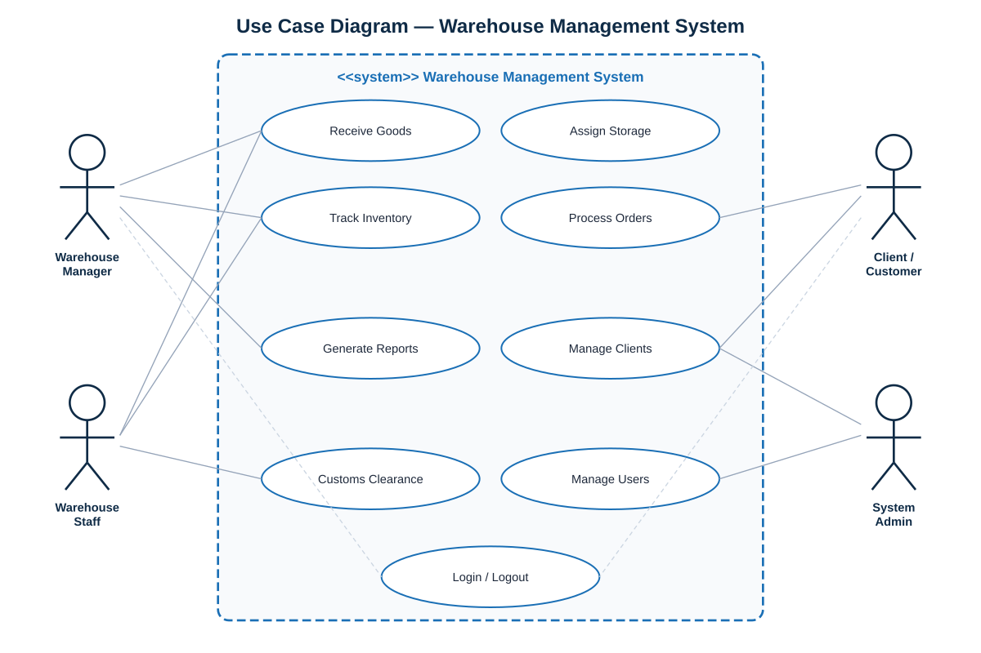
Figure 5.1: Use Case Diagram — Warehouse Management System

5.2 Class Diagram
The Class Diagram defines the object-oriented structure of the system, showing the classes, their attributes (data fields), methods (operations), and the relationships between them. Eight core classes are identified:
Product represents physical goods stored in the warehouse, with attributes for identification, categorization, and weight. Warehouse represents a physical Magerwa location with capacity tracking. StorageLocation models individual zones and bays within a warehouse, tracking occupancy status. Client stores information about companies and individuals who use Magerwa's services. InventoryItem links products to specific storage locations and tracks quantities and stock status. Order captures inbound and outbound cargo transactions with lifecycle status tracking. Employee represents Magerwa staff with role-based assignments. Report serves as the base for generating various compliance and operational reports.
Key relationships include: a Warehouse contains multiple StorageLocations (1-to-many composition), Products are tracked through InventoryItems (association), Orders are placed by Clients and contain InventoryItems, and Employees manage Orders.
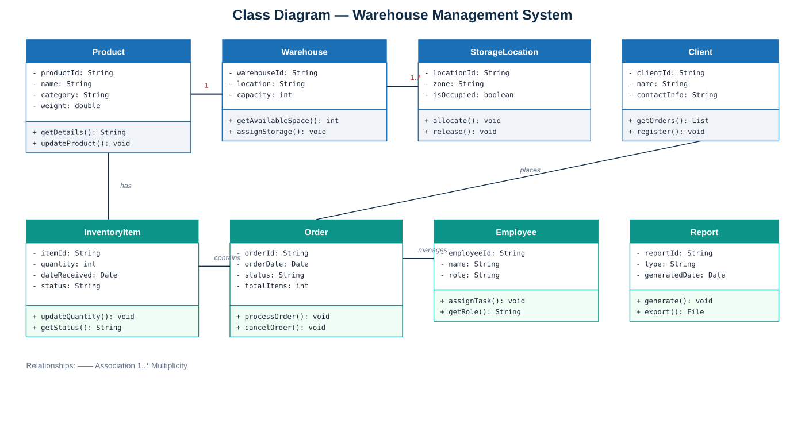
Figure 5.2: Class Diagram — System Object Structure

5.3 Activity Diagram
The Activity Diagram models the Goods Receiving Process — one of the most critical workflows in Magerwa's operations. It shows the step-by-step flow from when goods arrive at the warehouse until they are stored and recorded in the system.
The process begins when goods arrive at the warehouse (either by truck or air cargo). Two parallel activities occur: the shipping documents are verified for accuracy and completeness, while simultaneously the client is notified of the cargo arrival. A decision point checks whether the documents are valid — if not, the goods are rejected and returned to the sender with notification.
If documents pass verification, staff perform a physical inspection of the cargo, checking for damage and matching contents against the shipping manifest. The goods are then recorded in the system with all relevant details, inventory counts are updated, and a suitable storage location is assigned based on cargo type, size, and available capacity. Finally, a receipt is generated and the client is notified that their goods have been processed and stored.
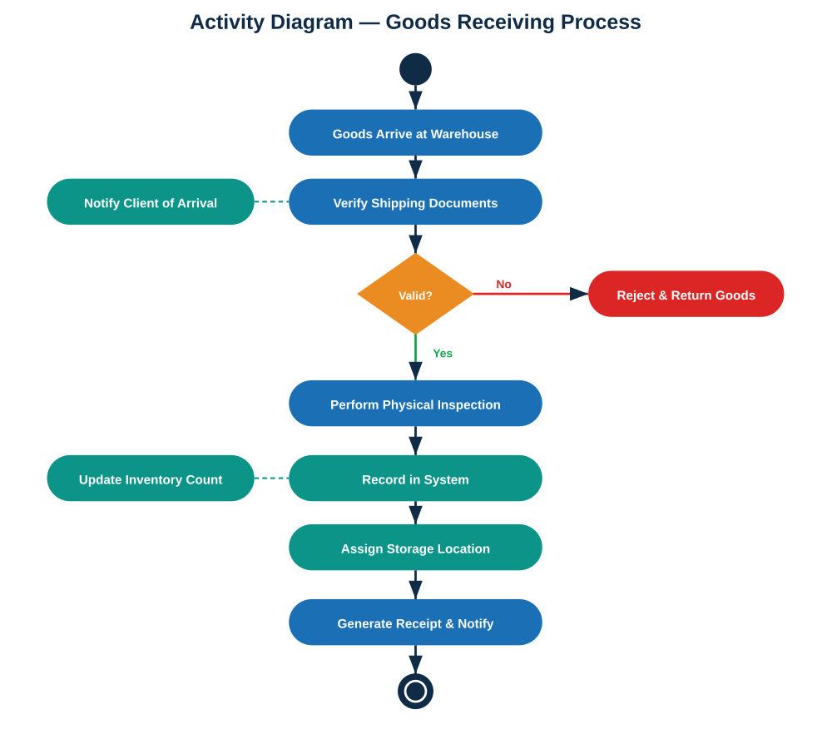
Figure 5.3: Activity Diagram — Goods Receiving Process

5.4 Sequence Diagram
The Sequence Diagram illustrates the interaction flow for the Order Processing use case, showing how messages pass between system components over time. Five participants (objects) are involved: Client, OrderService, InventoryManager, Warehouse, and Database.
The sequence begins when the Client submits an order with details (step 1). The OrderService forwards this to the InventoryManager to check item availability (step 2). The InventoryManager queries the Database for current stock levels (step 3), receives the stock level response (step 4), and confirms availability back to the OrderService (step 5). The OrderService then requests the Warehouse to prepare the dispatch (step 6). The Warehouse updates inventory through the InventoryManager (step 7), which persists the changes to the Database (step 8). Finally, the OrderService sends an order confirmation back to the Client (step 9).
Solid arrows represent synchronous calls (requests), while dashed arrows represent return responses. This diagram demonstrates the separation of concerns across service layers.
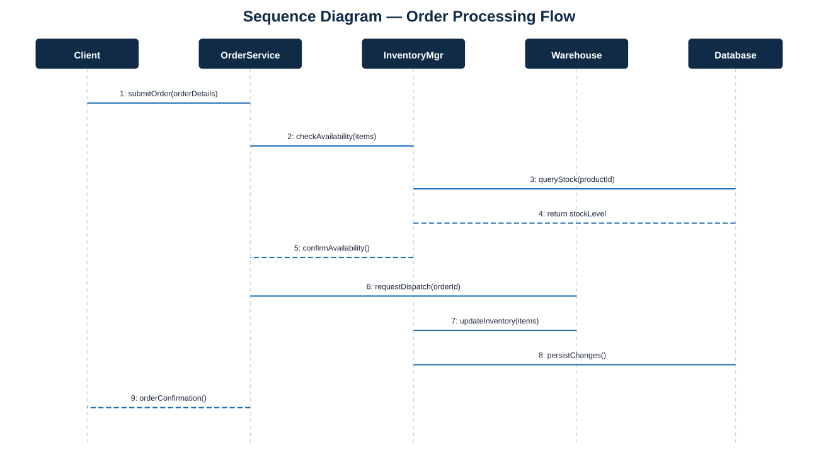
Figure 5.4: Sequence Diagram — Order Processing Flow

5.5 Component Diagram
The Component Diagram shows the high-level architecture of the Warehouse Management System, illustrating the major software components and their dependencies. The system follows a Layered (N-Tier) architecture pattern with clear separation of concerns, aligned with SOLID principles.
The Presentation Layer (built with Spring MVC and Thymeleaf) contains all user-facing views: LoginView, DashboardView, InventoryView, OrderView, ClientView, and ReportView. It provides a responsive web UI with sidebar navigation, data tables, forms, and color-coded status badges.
The Business Logic Layer contains the core application services: AuthenticationService handles user login and session management; InventoryService manages stock operations; ReportFactory implements the Factory Method Pattern for generating different report types; and the Observer pattern components (InventorySubject and StockAlertObserver) provide automatic low-stock alerts.
The Data Access Layer implements the DAO (Data Access Object) pattern with a GenericDAO interface and concrete implementations for each entity (InventoryDAO, OrderDAO, ClientDAO, UserDAO). All data access flows through the Singleton DatabaseConnection.
The Database component stores all application data, and the External Services component represents integration points with the RRA Customs API, email/SMS notifications, and backup services.
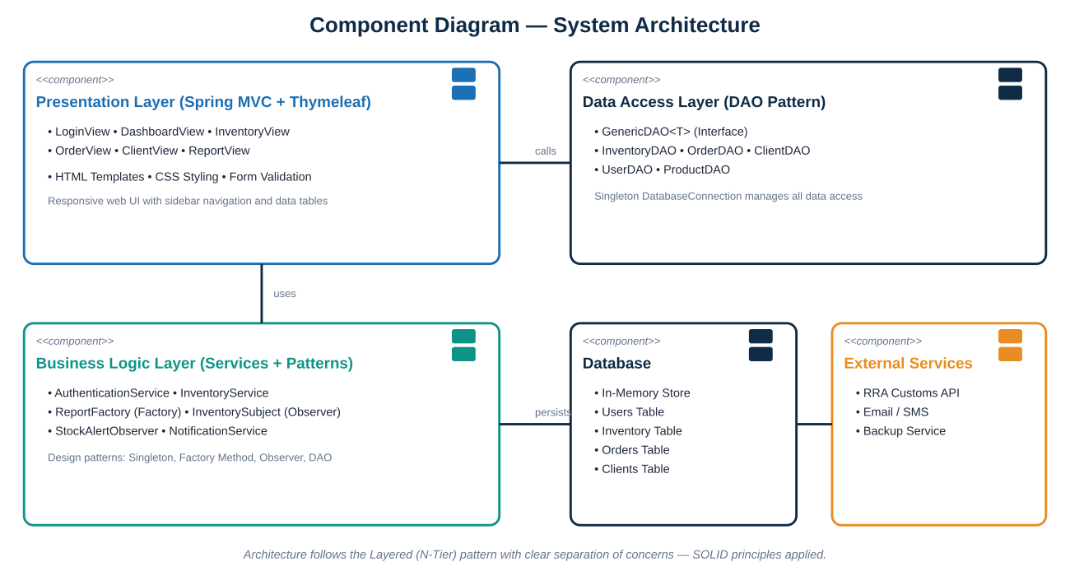
Figure 5.5: Component Diagram — System Architecture

6. Conclusion
This Phase 1 document has presented a comprehensive system analysis and design for the Warehouse Management System for Magerwa Ltd, Rwanda. Through detailed analysis of the case study organization, identification of key operational challenges, and rigorous application of Object-Oriented Analysis and Design methodology, we have established a solid foundation for the software development phase.
The five UML diagrams (Use Case, Class, Activity, Sequence, and Component) collectively provide a complete blueprint of the system from multiple perspectives — user interactions, data structure, process flows, interaction sequences, and architectural composition. The proposed system architecture follows the Layered N-Tier pattern with Spring Boot MVC, implements five design patterns (Singleton, Factory Method, Observer, DAO, and MVC), and is designed to address all four identified problems: manual inventory tracking, lack of real-time visibility, inefficient order processing, and weak reporting capabilities.
The subsequent phases will build upon this foundation to develop a working prototype (Phase 2), containerize the application using Docker (Phase 3), and validate the system through comprehensive testing (Phase 4).

