Adventist University of Central Africa
SENG 8240 — Best Programming Practices and Design Patterns

WAREHOUSE MANAGEMENT SYSTEM
Case Study: Magerwa Ltd, Rwanda

PHASE 2: Software Development Prototype
Code Documentation & Prototype Report

Prepared by: Prince | Instructor: RUTARINDWA Jean Pierre
April 2026

Table of Contents

1. Project Overview
This document provides a comprehensive technical documentation of the Warehouse Management System (WMS) prototype developed for Magerwa Ltd. It includes the complete source code with explanations, prototype screenshots, design pattern implementations, and best programming practices applied throughout the development.

1.1 Technology Stack
Component | Technology | Purpose
Language | Java 17 | Primary programming language
Framework | Spring Boot 3.2 | Web application framework with embedded Tomcat server
Template Engine | Thymeleaf | Server-side HTML rendering with dynamic data binding
Styling | CSS3 with Google Fonts | Responsive UI with animations and modern design
Build Tool | Apache Maven | Dependency management and project compilation
Architecture | MVC (Model-View-Controller) | Separation of concerns into layers
Database | In-memory (ArrayList) | Simulated database using Singleton pattern

1.2 Project Structure
The project follows a layered architecture with packages organized by responsibility:
WMS/src/main/java/com/wms/
├── WmsApplication.java // Spring Boot entry point
├── model/ // Data model classes (POJOs)
│ ├── User.java // User with role-based access
│ ├── InventoryItem.java // Inventory tracking entity
│ ├── Order.java // Order management entity
│ └── Client.java // Warehouse client entity
├── repository/ // ★ SINGLETON + DAO PATTERNS
│ ├── DatabaseConnection.java // Singleton database instance
│ ├── GenericDAO.java // DAO interface (CRUD)
│ ├── InventoryDAO.java // Inventory data access
│ ├── OrderDAO.java // Order data access
│ ├── ClientDAO.java // Client data access
│ └── UserDAO.java // User authentication
├── factory/ // ★ FACTORY METHOD PATTERN
│ └── ReportFactory.java // Creates reports by type
├── observer/ // ★ OBSERVER PATTERN
│ ├── InventoryObserver.java // Observer interface
│ ├── InventorySubject.java // Subject (notifier)
│ └── StockAlertObserver.java // Concrete observer
├── service/ // Business logic layer
│ ├── AuthenticationService.java
│ └── InventoryService.java
└── controller/ // ★ MVC CONTROLLERS
├── LoginController.java // Login/logout handling
├── DashboardController.java // Dashboard with stats
├── InventoryController.java // Inventory CRUD
├── OrderController.java // Order management
├── ClientController.java // Client management
└── ReportController.java // Report generation

2. Software Development Prototype
The following screenshots show the prototype's user interface. The application runs in a web browser at http://localhost:8080 after starting with the command: mvn spring-boot:run

2.1 Login Screen
The login screen is the entry point of the user journey. It features a split-screen design with company branding on the left and a credential form on the right. The form validates input fields (required) and displays error messages for invalid credentials. Three demo accounts are provided for testing with different role levels.
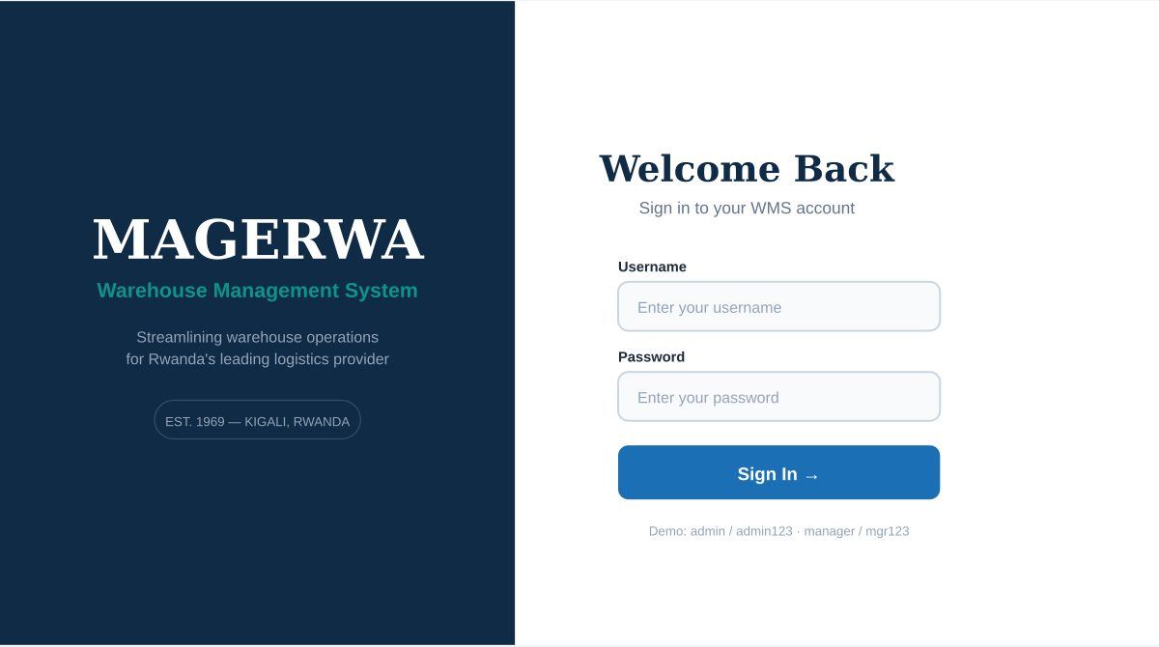
Figure 2.1: Login Screen — Split-screen with branding and authentication form

2.2 Dashboard
After successful login, users are redirected to the Dashboard. It displays four animated statistics cards (Total Products, Units in Stock, Pending Orders, Low Stock Alerts) that update dynamically based on current data. The sidebar provides navigation to all system modules with the active page highlighted. Recent orders are shown in a table with color-coded status badges, and Quick Actions provide one-click navigation to common tasks.
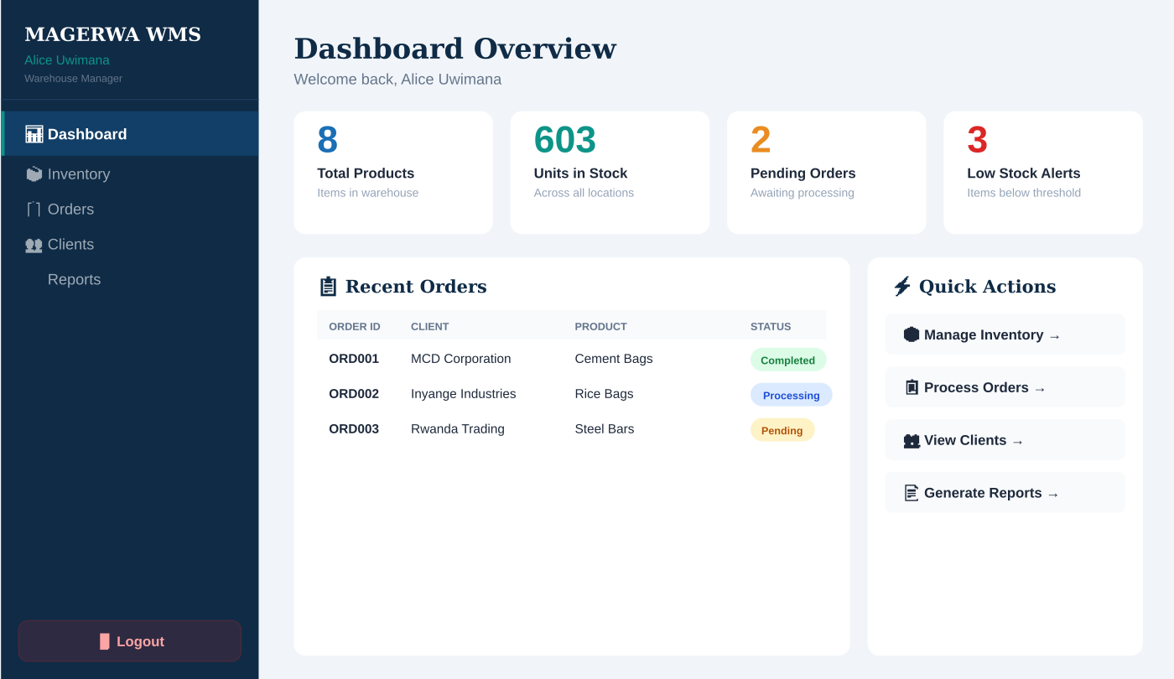
Figure 2.2: Dashboard — Statistics cards, recent orders, and quick actions

2.3 Inventory Management
The Inventory page provides full CRUD functionality. At the top, an inline form allows adding new items with fields for product name, category (dropdown), quantity, and storage location. A search bar filters the table by product name in real time. The data table displays all inventory items with color-coded status badges: green for In Stock, yellow for Low Stock, and red for Out of Stock. Each row has a Delete button for removal.
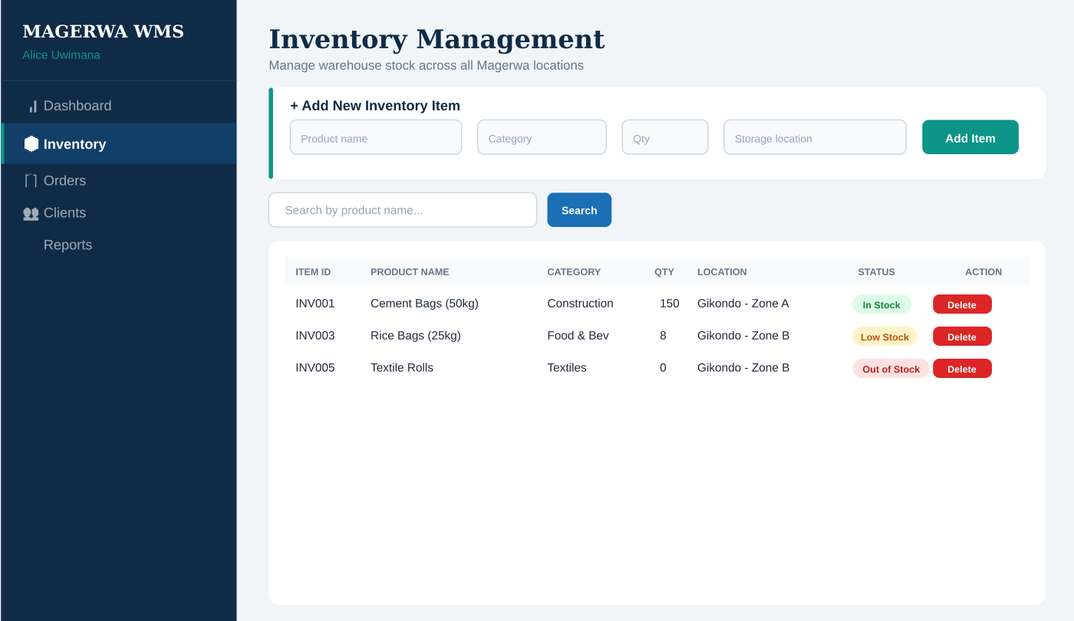
Figure 2.3: Inventory Management — Add form, search, data table with status badges

2.4 Report Generation (Factory Pattern)
The Reports page demonstrates the Factory Method Pattern in action. Three report type buttons are displayed: Inventory Report (blue), Order Report (teal), and Low Stock Report (red). When clicked, the ReportFactory.createReport() method determines which concrete report to generate. The output is displayed in a dark-themed terminal-style panel showing the formatted report content with headers, data rows, and summary totals.
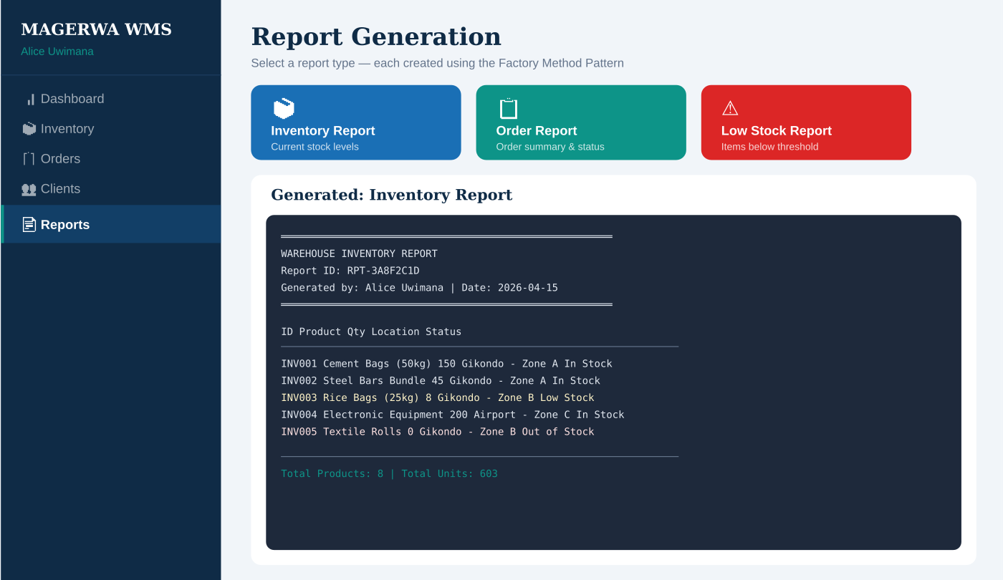
Figure 2.4: Report Generation — Factory Pattern creates different report types

2.5 User Journey Flow
The complete user journey through the application follows this path:
Login Screen (enter credentials)
│
▼
Dashboard (view stats, recent orders, alerts)
│
├──→ Inventory (view, add, search, delete items)
├──→ Orders (view, add, filter by status, update status)
├──→ Clients (view, register, delete clients)
└──→ Reports (select type → Factory generates report)
│
▼
Logout → Returns to Login Screen

3. Design Patterns Implementation

3.1 Singleton Pattern — DatabaseConnection.java
The Singleton pattern ensures that only one instance of the DatabaseConnection class exists throughout the entire application lifecycle. This is critical because all DAOs share the same in-memory data store, and creating multiple instances would result in inconsistent data.
Implementation uses double-checked locking with a volatile field for thread safety. The private constructor prevents external instantiation, and the static getInstance() method provides the single global access point.
public class DatabaseConnection {

// volatile ensures visibility across threads
private static volatile DatabaseConnection instance;

// Private constructor — prevents direct instantiation
private DatabaseConnection() {
this.usersTable = new ArrayList<>();
this.inventoryTable = new ArrayList<>();
initializeSampleData();
}

// Double-checked locking for thread-safe lazy init
public static DatabaseConnection getInstance() {
if (instance == null) {
synchronized (DatabaseConnection.class) {
if (instance == null) {
instance = new DatabaseConnection();
}
}
}
return instance;
}
}
Usage: Every DAO class calls DatabaseConnection.getInstance() to access the shared data tables. Since the constructor is private, the only way to get the instance is through this method, guaranteeing a single instance.

3.2 Factory Method Pattern — ReportFactory.java
The Factory Method pattern encapsulates report creation logic. When a user clicks a report button on the Reports page, the controller calls ReportFactory.createReport(type, user). The factory's switch statement determines which concrete report generation method to invoke. This follows the Open/Closed Principle — new report types can be added by creating a new method and adding a case, without modifying existing report logic.
public class ReportFactory {

public static final String TYPE_INVENTORY = "Inventory Report";
public static final String TYPE_ORDER = "Order Report";
public static final String TYPE_LOW_STOCK = "Low Stock Report";

// Factory method — creates correct report based on type
public static String createReport(String reportType,
String generatedBy) {
switch (reportType) {
case TYPE_INVENTORY:
return generateInventoryReport(id, generatedBy);
case TYPE_ORDER:
return generateOrderReport(id, generatedBy);
case TYPE_LOW_STOCK:
return generateLowStockReport(id, generatedBy);
default:
throw new IllegalArgumentException(
"Unknown report type: " + reportType);
}
}
}

3.3 Observer Pattern — InventoryObserver, Subject, StockAlertObserver
The Observer pattern provides automatic stock alert notifications. When inventory quantities change, the InventorySubject notifies all registered observers. The StockAlertObserver checks if stock falls below the threshold (10 units) and generates alerts that appear on the Dashboard.
Three classes work together: InventoryObserver (interface defining the update method), InventorySubject (maintains a list of observers and broadcasts changes), and StockAlertObserver (concrete observer that logs low-stock alerts).
// Observer Interface
public interface InventoryObserver {
void update(String productName, int oldQty, int newQty);
}

// Subject — notifies all registered observers
public class InventorySubject {
private final List<InventoryObserver> observers = new ArrayList<>();

public void addObserver(InventoryObserver observer) {
observers.add(observer);
}

public void notifyObservers(String name, int oldQty, int newQty) {
for (InventoryObserver obs : observers) {
obs.update(name, oldQty, newQty);
}
}
}

// Concrete Observer — generates stock alerts
public class StockAlertObserver implements InventoryObserver {
private final List<String> alertLog = new ArrayList<>();

@Override
public void update(String name, int oldQty, int newQty) {
if (newQty < 10 && newQty > 0) {
alertLog.add("LOW STOCK: " + name);
} else if (newQty == 0) {
alertLog.add("OUT OF STOCK: " + name);
}
}
}

3.4 DAO Pattern — GenericDAO Interface and Implementations
The DAO (Data Access Object) pattern separates data access logic from business logic. The GenericDAO interface defines five standard CRUD methods: findAll(), findById(), save(), update(), and delete(). Each entity (Inventory, Order, Client, User) has a concrete DAO class that implements this interface and accesses data through the Singleton DatabaseConnection.
// Generic DAO interface — one interface for all entities
public interface GenericDAO<T> {
List<T> findAll();
Optional<T> findById(String id);
void save(T entity);
void update(T entity);
void delete(String id);
}

// Concrete implementation for Inventory
@Repository
public class InventoryDAO implements GenericDAO<InventoryItem> {
private final List<InventoryItem> table;

public InventoryDAO() {
// Access shared data via Singleton
this.table = DatabaseConnection.getInstance()
.getInventoryTable();
}

@Override
public List<InventoryItem> findAll() { return table; }

@Override
public void save(InventoryItem item) { table.add(item); }
// ... other CRUD methods
}

3.5 MVC Pattern — Spring Boot Architecture
The MVC (Model-View-Controller) pattern is implemented through Spring Boot's architecture. Models are POJO classes in the model package. Views are Thymeleaf HTML templates that dynamically render data passed from controllers. Controllers are annotated Spring classes that handle HTTP requests, call services, and return view names with model data.
// Controller example — handles /inventory requests
@Controller
@RequestMapping("/inventory")
public class InventoryController {

private final InventoryService inventoryService;

@GetMapping
public String listInventory(HttpSession session, Model model) {
// Check authentication
if (session.getAttribute("currentUser") == null)
return "redirect:/";

// Pass data to the view template
model.addAttribute("items", inventoryService.getAllItems());
return "inventory"; // renders inventory.html
}

@PostMapping("/add")
public String addItem(@RequestParam String productName,
@RequestParam int quantity, ...) {
inventoryService.addItem(productName, quantity, ...);
return "redirect:/inventory"; // redirect after POST
}
}

4. Best Programming Practices Applied

4.1 Meaningful Variable, Class, and Method Names
All identifiers clearly describe their purpose. Examples:
Type | Example | Explanation
Class | AuthenticationService | Handles user authentication — name indicates its single responsibility
Class | StockAlertObserver | Observes stock changes and generates alerts — both pattern and purpose are clear
Method | findLowStockItems() | Returns inventory items below the stock threshold
Method | authenticate(username, password) | Verifies credentials and returns the matching user
Variable | currentUser | Stores the currently logged-in user in the session
Variable | inventoryTable | The in-memory list simulating the inventory database table
Constant | STATUS_LOW_STOCK | Defines the low stock status string, avoiding magic strings

4.2 Single Responsibility Principle
Each class has exactly one reason to change:
- AuthenticationService — only handles login/logout logic
- InventoryDAO — only handles inventory data access operations
- ReportFactory — only handles report creation decisions
- LoginController — only handles HTTP login/logout requests
- StockAlertObserver — only monitors stock thresholds and generates alerts

4.3 Proper Indentation and Formatting
The entire codebase follows consistent formatting rules: 4-space indentation throughout, opening braces on the same line, one blank line between methods, imports organized by package, and consistent spacing around operators and parameters. This follows the Google Java Style Guide as recommended by the course.

4.4 Comments and Documentation
Javadoc comments are used on every class to explain its purpose and the design pattern it implements. Inline comments explain key logic decisions without over-commenting obvious code. Design pattern annotations (e.g., "DESIGN PATTERN: Singleton Pattern") are placed at the top of relevant classes to make patterns easy to identify during examination.

4.5 Code Organization
The codebase is divided into seven distinct packages (model, repository, factory, observer, service, controller, and resources/templates), each handling a specific layer of the application. This modular structure makes the code navigable, testable, and maintainable. Unnecessary features and complexity were avoided — the prototype focuses on demonstrating core functionality and design patterns clearly.

5. Conclusion
This Phase 2 prototype demonstrates a fully functional Warehouse Management System built with Java Spring Boot. The application implements five design patterns (Singleton, Factory Method, Observer, DAO, and MVC) and follows software programming best practices including meaningful naming, single responsibility, proper formatting, and appropriate commenting. The web-based UI provides a complete user journey from login through all management modules to logout, with responsive design, interactive forms, data tables, and real-time statistics.

