Adventist University of Central Africa
SENG 8240 — Best Programming Practices and Design Patterns

WAREHOUSE MANAGEMENT SYSTEM
Case Study: Magerwa Ltd, Rwanda

PHASE 3: Dockerization & Version Control

Prepared by: Prince | Instructor: RUTARINDWA Jean Pierre
April 2026

Table of Contents

1. Dockerizing the Application

1.1 What is Docker?
Docker is a platform and tool used for containerization, which is a method of packaging, distributing, and running applications and their dependencies in a consistent environment. A Docker container bundles the application code, runtime, libraries, and operating system packages into a single portable unit that runs identically on any machine that has Docker installed.
Unlike virtual machines, which require a full guest operating system, Docker containers share the host OS kernel, making them lightweight, fast to start (seconds vs minutes), and efficient with system resources.

1.2 Key Docker Concepts
Concept | Description | Analogy
Image | A read-only template containing instructions for creating a container | Like a recipe or blueprint
Container | A running instance of an image — the actual executing application | Like a cooked meal from the recipe
Dockerfile | A text file with step-by-step instructions to build an image | Like the recipe instructions
Docker Hub | A public registry for storing and sharing Docker images | Like a cookbook library online
Port Mapping | Links a host port to a container port (e.g., -p 8080:8080) | Like a doorway from outside to inside
Volume | Persistent storage that survives container restarts | Like a filing cabinet that stays
Docker Compose | Tool for defining multi-container applications in a YAML file | Like an assembly plan for multiple containers

1.3 Why Dockerize the WMS Application?
- Consistency — The application runs exactly the same way on every machine, eliminating configuration differences between development and production environments
- Portability — The same Docker container can be deployed on a developer laptop, a university server, or a cloud provider (AWS, Azure, GCP) without any code changes
- Isolation — The WMS runs independently from the host system; it cannot conflict with other applications or be affected by different Java versions installed on the host
- Easy Deployment — Instead of writing complex installation guides, deployment becomes a single command: docker-compose up
- Scalability — Multiple containers can be launched to handle increased load, enabling horizontal scaling

1.4 Multi-Stage Build Process
Our WMS application uses a multi-stage Docker build, which is a best practice for Java applications. The build process has two stages: Stage 1 uses a large Maven+JDK image to compile the source code into a JAR file, and Stage 2 uses a lightweight JRE-only image to run the compiled JAR. This approach produces a final image that is approximately 150MB instead of 400MB, because build tools (Maven, JDK compiler) are excluded from the runtime image.
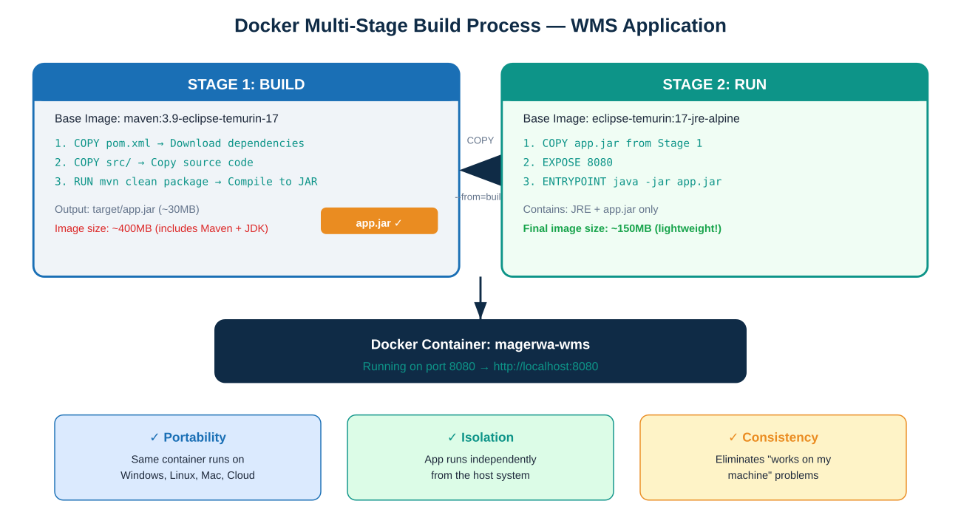
Figure 1.1: Docker Multi-Stage Build Process showing Stage 1 (Build) and Stage 2 (Run)

1.5 Our Dockerfile — Line by Line
Below is the complete Dockerfile used to containerize the WMS application, with each line explained:
# ═══ STAGE 1: BUILD ═══
# Use Maven with JDK 17 as the build environment
FROM maven:3.9-eclipse-temurin-17 AS build

# Set /app as the working directory inside the container
WORKDIR /app

# Copy pom.xml first (Maven dependency caching optimization)
# If pom.xml hasn't changed, Docker reuses cached dependencies
COPY pom.xml .

# Download all Maven dependencies (cached as a Docker layer)
RUN mvn dependency:go-offline -B

# Now copy the actual Java source code
COPY src ./src

# Compile and package into a JAR file (skip tests for speed)
RUN mvn clean package -DskipTests

# ═══ STAGE 2: RUN ═══
# Use a minimal JRE Alpine image (no build tools needed)
FROM eclipse-temurin:17-jre-alpine

WORKDIR /app

# Copy ONLY the compiled JAR from Stage 1 (not Maven/JDK)
COPY --from=build /app/target/*.jar app.jar

# Document that the container listens on port 8080
EXPOSE 8080

# Command executed when the container starts
ENTRYPOINT ["java", "-jar", "app.jar"]

1.6 Docker Compose Configuration
Docker Compose allows us to define the entire application setup in a single YAML file. Instead of remembering long docker run commands with flags, we simply run docker-compose up:
version: '3.8'

services:
wms-app:
build:
context: . # Build from current directory
dockerfile: Dockerfile # Using our Dockerfile
container_name: magerwa-wms
ports:
- "8080:8080" # Host:Container port mapping
environment:
- SPRING_APPLICATION_NAME=Magerwa-WMS
restart: unless-stopped # Auto-restart on crash

1.7 Docker Commands Reference
Command | Purpose
docker-compose up --build | Build image and start the container
docker-compose up -d --build | Build and start in background (detached)
docker-compose down | Stop and remove the container
docker-compose logs -f | View live application logs
docker ps | List all running containers
docker images | List all Docker images on the system
docker stop magerwa-wms | Stop the WMS container
docker rm magerwa-wms | Remove the stopped container
docker rmi magerwa-wms | Delete the WMS Docker image

2. Version Control with Git

2.1 What is Version Control?
A Version Control System (VCS) is a tool that tracks and manages changes to source code over time. It allows developers to maintain a complete history of every modification made to the codebase, revert to previous versions if something breaks, collaborate with team members without overwriting each other's work, and create branches for experimenting with new features without affecting the main codebase.

2.2 Why Git?
Git is the most widely used distributed version control system in the world. Unlike centralized systems like SVN, Git gives every developer a complete copy of the entire repository, including its full history. This means developers can work offline, commit changes locally, and synchronize with the team when connected. Git is used by organizations of all sizes, from individual developers to companies like Google, Microsoft, and Facebook.

2.3 Git Workflow Diagram
The following diagram shows how code flows through Git's three main areas: the Working Directory (where you edit files), the Staging Area (where you prepare changes for commit), and the Repository (where committed snapshots are permanently stored).
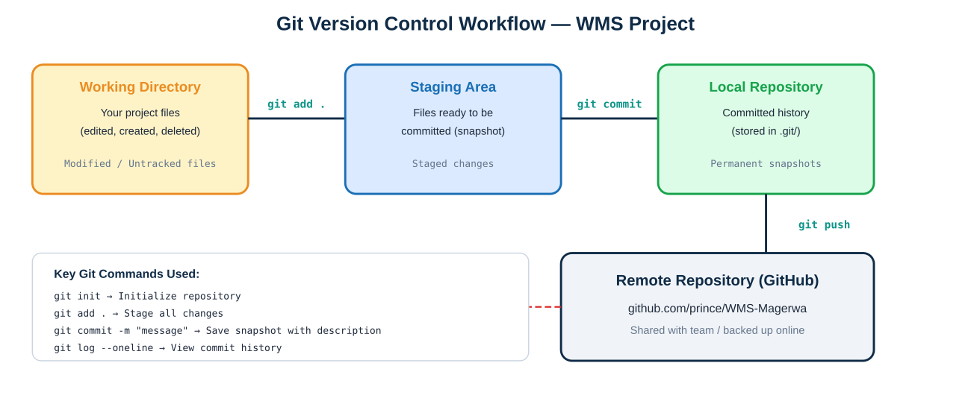
Figure 2.1: Git Workflow — Working Directory → Staging → Local Repo → Remote (GitHub)

2.4 Installing and Configuring Git
Git is installed from https://git-scm.com/downloads. After installation, the first step is configuring your identity, which is attached to every commit you make:
# Verify Git is installed
git --version

# Configure your identity (used in every commit)
git config --global user.name "Prince"
git config --global user.email "prince@student.auca.ac.rw"

# Verify configuration
git config --list

2.5 Complete Git Workflow for the WMS Project
Below is the exact sequence of Git commands used to version-control the WMS project from initialization to pushing to GitHub:
# Step 1: Navigate to the project folder
cd WMS

# Step 2: Initialize a new Git repository
git init
# Creates a hidden .git/ folder that tracks all changes

# Step 3: Add .gitignore (excludes compiled files, IDE configs)
git add .gitignore
git commit -m "Add .gitignore for Java/Maven project"

# Step 4: Add all source code files
git add .
git commit -m "Initial commit: WMS prototype with Spring Boot"

# Step 5: Add Docker configuration
git add Dockerfile docker-compose.yml .dockerignore
git commit -m "Add Docker containerization for Phase 3"

# Step 6: Add test files
git add src/test/
git commit -m "Add JUnit test cases for Phase 4"

# Step 7: View commit history
git log --oneline
# Output:
# a3f2c1d Add JUnit test cases for Phase 4
# b7e8d4a Add Docker containerization for Phase 3
# c1a9f3e Initial commit: WMS prototype with Spring Boot
# d5b2e7f Add .gitignore for Java/Maven project

# Step 8: Connect to GitHub and push
git remote add origin https://github.com/prince/WMS-Magerwa.git
git branch -M main
git push -u origin main

2.6 The .gitignore File
The .gitignore file tells Git which files and directories to exclude from version control. This prevents compiled output, IDE configurations, and environment-specific files from cluttering the repository:
# Compiled output (can be rebuilt with mvn package)
target/
*.class
*.jar

# IDE files (personal to each developer)
.idea/
*.iml
.vscode/

# OS files
.DS_Store
Thumbs.db

# Environment secrets
.env

2.7 Files Tracked by Git
The following table shows which files are tracked (included) and excluded (ignored) by our Git configuration:
Tracked (Committed) | Excluded (.gitignore)
All .java source files | target/ (compiled output)
HTML templates | .idea/, .vscode/ (IDE settings)
CSS stylesheets | *.class, *.jar (compiled files)
pom.xml (Maven config) | *.log (runtime logs)
Dockerfile, docker-compose.yml | .env (environment secrets)
README.md, documentation files | .DS_Store, Thumbs.db (OS files)
.gitignore, .dockerignore

3. Conclusion
In Phase 3, the Warehouse Management System was successfully containerized using Docker and placed under version control using Git. The Docker multi-stage build produces a lightweight, portable container image (approximately 150MB) that can be deployed on any machine with Docker installed using a single command. The Git repository maintains a complete history of all project changes across all four development phases, enabling easy rollback, collaboration, and code review.
These tools are industry-standard practices that ensure the WMS application is production-ready, maintainable, and deployable in any environment — from a developer's laptop to Magerwa's production servers.

Tool | File(s) Created | Key Command
Docker | Dockerfile, docker-compose.yml, .dockerignore | docker-compose up --build
Git | .gitignore, .git/ repository | git add . && git commit -m "message"

