Chapter 4: System Architecture and Design

This chapter deals with the system design and starts with the requirements that the system must meet, then works its way through the overall architecture, the question bank and assessment model, the design of the database, the CMAB recommendation engine, and the weakness classifier that transforms stakeholder answers to a result. It also addresses the API design and user interface design and concludes with the important design decisions and tradeoffs.

Requirements Analysis

Functional Requirements

- FR1. The system shall replace the manual, periodic ASPICE assessment procedure with a continuous and automated assessment procedure that is aligned with the ASPICE SWE.1 – SWE.6 standard.
- FR2. Stakeholders will be able to register, log in and participate in an evaluation session.
- FR3. The system shall have a structured question bank on ASPICE SWE.1 – SWE.6.
- FR4. The stakeholder(s) shall only be asked questions that are relevant to their stake in the system.
- FR5. The system shall automatically identify the gaps in the processes.
- FR6. The system shall present the assessment results to the stakeholder in a clear way.

Non-Functional Requirements

- NFR1 (Determinism). Question selection shall be deterministic – for the same input (context, model state), the system shall always return the same result, thus it can be reproduced.
- NFR2 (Traceability). Each question should be related to one of the ASPICE SWE.1–SWE.6 base practices.
- NFR3 (Security). No one will be able to access the system without authentication.
- NFR4 (Bounded session length). An assessment session shall have a set number of questions, and shall not require a stakeholder to spend more than a reasonable and predictable amount of time on it.
Table 1 shows how each functional requirement is related to the research question. This allows the subsequent design decisions to be seen as answers to the research questions posed in Chapter 1, rather than as individual design decisions unrelated to the research questions.
Table 1: Functional requirements mapped to the research questions from Chapter 1
Req. | Requirement | RQ
FR1 | Continuous, automated, ASPICE-aligned assessment (core objective) | RQ1–RQ4
FR2 | Stakeholder signup, login, and session participation (supporting infrastructure) | —
FR3 | Structured SWE.1–SWE.6 question bank | RQ1
FR4 | Role-targeted question selection | RQ2
FR5 | Automatic weakness computation | RQ3
FR6 | Clear presentation of results | RQ4

System Architecture

Overall Architecture

The highest level of the system is shown in Figure 1. The diagram is based on the concept architecture originally proposed for this line of work [6] and is still a good fit for the system developed in this thesis. The system is accessed by the development stakeholders and their manager through a GUI. Every request goes through a central Model Controller, selection of the questions is delegated to a Recommendation System, the answers are passed to an Evaluation Model which converts the answers to a result, and everything is persistently stored in a Database.

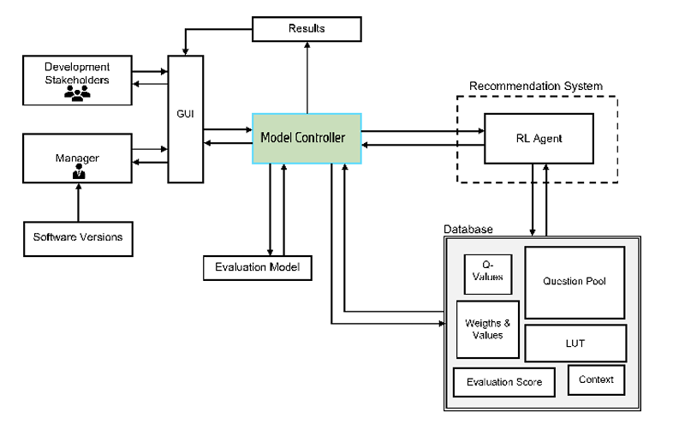
Figure 1: Overall system architecture: The stakeholders interact via the GUI, the Model Controller coordinates the Recommendation System (CMAB agent) and the Evaluation Model, and all the state is stored in the database. Based on the concept architecture[6]

If such an architecture is mapped to the architecture which was actually developed for this thesis, each box represents a concrete component. The GUI is created with the React front end. The Model Controller is the business logic of the FastAPI backend, the audit session service that deals with an audit session from its inception to its completion. LinUCB is the CMAB engine described in Section 4.5, which is called the Recommendation System. The Evaluation Model is the weakeness classifier given in Section 4.6. The four labelled sub-parts of the Database correspond directly to the four types of data stored in this thesis: the AuditQuestion table, the AuditOption table, the CMAB context vector and the learned BanditArmState parameters are all related to the Question Pool and Weights & Values, while the Evaluation Score is represented by the computed WeaknessResult.
One thing must be noted here that it's a simplified version. The original diagram considers “Development Stakeholders” and “Manager” to be two distinct actor types and “Software Versions” to be an input that is distinct. In this thesis, each stakeholder is instead managed via a single stakeholder role field on the user account, and each audit session is treated as a stand-alone assessment cycle, rather than being associated with a specific tracked software release.

System components and responsibilities

Figure 2 shows the same architecture once more but from a different perspective, the responsibilities. It does not indicate the flow of requests in the system, but rather what each component is responsible for.

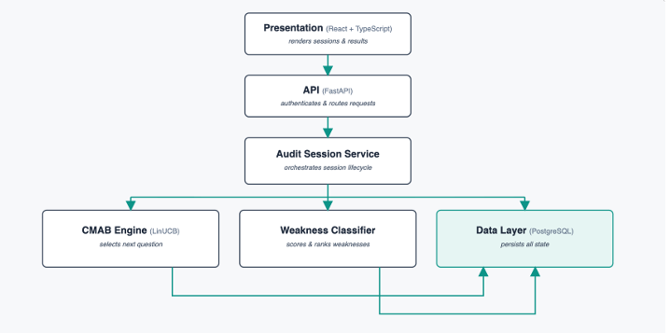
Figure 2: System components and their responsibilities.

Data and Control Flow

The following is a single example of a request for an answer, as it passes through the system, as shown in Figure 3. Solid arrows are used for control flow and dashed arrows are used for data reads/writes. Stakeholder's response flows through the API to the audit session service. The CMAB engine is then updated and, if the session has not reached the question budget, the system gets the next question from the CMAB engine otherwise it passes control to the weakness classifier. In this direction, each component accesses the data layer, and writes to it when necessary.

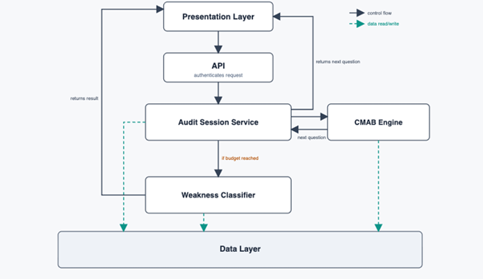
Figure 3: Control and data flow for a single answer-submission request.

The API contract and classification logic are introduced and then the same flow is repeated in Sections 4.7 and 4.6.

Question Bank and Assessment Model

The key to making the ASPICE standard a stakeholder's answer is the question bank. The transformation is explained in this section, with the example of one seeded question, SWE1 L1 01.

ASPICE Base Practice to Question Transformation

The process of building the question bank requires a bit of work to go through each of the base practices for each SWE process (as outlined in the PAM [24]) and to transform each of these items into a question that a stakeholder can answer with respect to their existing work. SWE.1 is a base practice, which reads: “Specify software requirements . . . based on defined characteristics (verifiability, unambiguity, freedom from design/implementation, no contradictions)” [24]. This is called SWE1 L1 01: “How are software requirements specified for the current release?” in the question bank. The answer key does not include the same characteristics that are provided in the original base practice. Rather, they manifest themselves in the variations among the answer alternatives.

Question Structure and Traceability

Each question has a fixed structure for storing. It has a unique code, its process and capability level, the base practice ID that will link it back to the PAM, the question text and a recommendation that will be displayed when an answer mentions a weakness. SWE1 L1 01, for instance, is a descendant of SWE.1.The recommendation for BP1 is to implement a requirement-specification template and examine the tools that are used to manage requirements. This traceability field meets the NFR2 of Section 4.1 as a question's justification to the ASPICE standard can be obtained by one look-up.

Answer Options and Weighting

There are five answer options (A, B, C, D and E) that have been pre-defined for each question. They vary from high to low, and are rated from 0 (high) to 5 (low). Table 4.2 contains all of the options for SWE1 L1 01. This weight is then translated to a reward when an option is chosen by the CMAB engine, and when calculating the process score (Sections 4.5 and 4.6), the same value is used as a weakness value.

Stakeholder Role Assignment

Also, each question is mapped to one or more of seven roles of the stakeholders such as Software Developer, Software Architect, Project Manager, QA Engineer, Test Engineer, Team Lead, and ASPICE Assessor. The Software Architect, Software Developer and QA Engineer are most likely to be aware of how requirements are specified and are assigned to them in SWE1 L1 01. On the other hand, a Project Manager will never ask you this question.
This enables the same question bank to be used for different stakeholders with no questions about work outside their scope which will satisfy FR4 of Section 1.1.

Table 2: Answer options and weights for the worked example question SWE1 L1 01
Option | Answer text | Weight
A | Each requirement is uniquely identified, atomic, verifiable, and references its source | 0
B | Requirements are uniquely identified but verifiability criteria are missing for some | 2
C | Requirements exist as free-text paragraphs without unique IDs | 3
D | Requirements are partially captured in slides or e-mails | 4
E | No formal software requirements set exists | 5

Question-to-Assessment Flow

After the question is formulated, weighted and given to the appropriate roles, it is ready for use. The question bank is reduced to those that are still suitable for the stakeholder's role, and have not been previously asked, at the start of a session and after each answer. Each eligible question is then considered an arm of the CMAB engine (described in Section 4.5) and one of the options is selected. These are the same fields as those defined during the design of the question bank, and are the ones that are used by the eligibility filter and the weakness classifier at runtime.

Database Design

All of the above, such as the question bank, roles and weights should be retained from request to request and be accessible to all stakeholders who initiate a session. The seven tables that contain that state are described here, and, more importantly, why they are split up in this way.

Entity-Relationship Model

The entire database schema is given in Figure 4. The dashed boundary is not a boundary of stakeholder input, but rather a boundary of two tables that contain learned or derived state as opposed to direct stakeholder input.
The schema is a simple chain in the centre. Many AuditSessions can be started over the course of a User's lifetime. Many AuditResponse rows are stored in each session while the stakeholder is answering the various questions and selecting the AuditOption. The two other tables are not part of this chain, but are located at the ends. A WeaknessResult is associated with a single completed session, and is the final result for that session. A BanditArmState is a single question and it contains the question's memory of its performance throughout its lifetime, regardless of session or user.
In other words, sessions and responses capture what happened and results and bandit state what was learned from it.

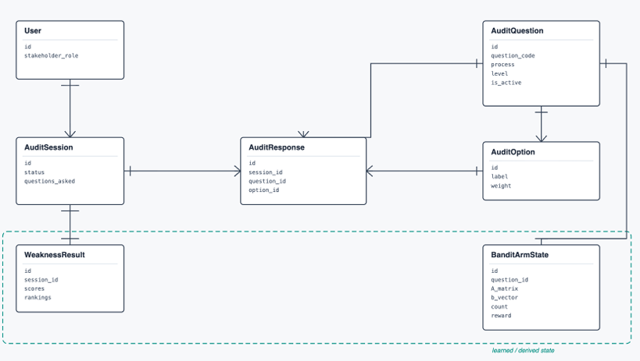
Figure 4: The entity-relationship diagram of the database schema

User and Question Models
The User table is the same as the rest of the application uses for logging into it, except for an extra column, stakeholder role. This role is only asked for once when signing up and isn't asked again. By having that one field, each subsequent step, such as determining eligibility of questions, and what results a person can see, can be performed without asking the stakeholder to identify his/her role again.
The structure described in Section 4.3.3 is essentially the representation of the schema in the database, AuditQuestion. It includes the question code, process and capability level, the base practice ID that is connected to it and the standard, the question text, the stakeholders that it is applicable to, and the recommendation that is displayed when it is answered incorrectly.
The one field that is of special significance is is_active. Questions are not permanently deleted. Rather, they're turned off. This is important because if a question has already been asked by someone, and answered, it should not just vanish from the database, and the previous answer remain without any follow up. AuditOption is directly below a question, and has one row for each answer choice. Each row has the label, option text and weight (as described in Section 4.3.3).

Assessment session and Response Models

An AuditSession is kept as simple as possible. It contains the list of users who are taking the session, its status (active, completed or abandoned), the maximum number of questions it can ask before stopping and the list of the served questions in order.
This is the field where the questions asked are placed which makes the session self-aware. When it is time to pick the next question, it doesn't have to recall the history from another location, it already knows what questions have been asked.
The answers that each stakeholder gives become individual rows in the AuditResponse table. This row will contain details of the session that it belongs to, the question asked, the answer selected, and the time of the answer. Having one row per answer, instead of having all answers stored in one row per session, will enable the weakness classifier to group the answers in other ways, like by process, level, or question, without having to foresee all the groupings in the session table.

Result and CMAB State Models

The last two tables contain the two types of intelligence of the system and they have been intentionally separated from the above tables as well as from each other.
WeaknessResult is a single object that is created once for each session completed. It keeps the scores for each (process, level) combination that were processed in the session, as well as a small list of the worst (process, level) combinations, ranked. Writes once when session is over, and never changes thereafter. It is therefore a statement of a final judgment and not a value that is continually changing.
BanditArmState works differently. It is not session specific, but rather question specific and it is continually updated. It keeps two matrices needed for learning with LinUCB, and a running total of the number of times the question has been selected and the cumulative reward for the question. Each stakeholder who responds to that question, in any session, will update the same row.
It is not just that AuditQuestion is normalized that BanditArmState is separated from AuditQuestion, but rather that it is a deliberate design choice. The content of questions will change relatively infrequently, usually when an administrator edits it. The learned parameters of the bandit, however, may vary with each answer given by each session. The two would be the same database operation if their wording were changed and what the algorithm learns about that question were updated.They are two distinct things, and should be kept separate, but if they were the same database operation, editing the wording of a question and updating what the algorithm learned about that question would be the same operation.

CMAB Recommendation Engine

In the abstract terms of Chapter 2, the contextual bandit concept involved the following: arms, rounds, context, and reward. This section relates those concepts to the real objects and decisions that are involved with the system.

Mapping Assessment to the CMAB Problem

Each active AuditQuestion a stakeholder can view is an arm and each question answered is a round. The engine is not learning a single "best question. Rather, it learns for each question, how rewarding that question is to a specific role at a specific time in an evaluation session.
This state is maintained in the BanditArmState row in Section 4.4.4. Each row represents one question, will be updated after each use of the question and will not be reset.

Context Vector

The engine must first explain the situation that it is in before it can score the available questions. It does this by the 23 dimensional "context" vector x introduced in Chapter 2 in a more general context.
The vector is re-built each time it is requested, and is not cached. Stakeholder's role is represented by 7 dimensions using one-hot encoding. The x axis is a measure of progress towards the question budget. The six dimensions show which SWE processes have been covered in the current session and the three dimensions show which capability levels have been covered. The last six dimensions have a running weakness score for each process, based on the answers provided.
The role dimensions make it possible for the same question to be effective for one stakeholder role, and not for another. The coverage flags enable the engine to determine, within a session, that a process has been covered less than desired, and select a new process for the next session.

Eligibility Arm

Prior to the start of scoring, the engine narrows down the question bank to those questions that are admissible in the arms. The stakeholder-role list of the question should include the current user's role, and the question shouldn't be in the list of questions that were asked during the current session.
These are constraints that are difficult. They are enforced directly, instead of having to learn it from LinUCB that asking an inappropriate question is not good. The UCB calculation also only has to take into account the relatively small number of questions that can be asked next, as filtering first means that only a small number of questions are considered.

LinUCB Question Selection
Selection follows the rule introduced in Chapter 2. For each eligible arm a, the engine calculates
θₐ = Aₐ⁻¹bₐ
and then scores it using
UCBₐ(x) = θₐᵀx + α √(xᵀAₐ⁻¹x)

In the current session, against the context vector created for the current session.The value of the exploration coefficient α is 1.0 at the beginning of the exploration. It's just one single hyperparameter that is easy to explain, that we'll be talking about again in Chapter 7. The arm that gets the highest score will be returned by the engine. The score is a function of Aₐ, bₐ, and x and so the next question is the same for the same session history.

Reward Function

Base reward is the weight of the chosen answer option (as described in Section 4.3.3) scaled in the range of 0.0 to 1.0. 0.2 is also added to the coverage of a question if it is the first question of that session from its process. Otherwise, no bonus will be given. The base reward and the coverage bonus will be combined, and then capped at 1.0.
The rationale behind the bonus is simple: If weight is the only indicator, it's not always a safe bet to follow. If it wasn't for this, an engine that was on high weights might just keep returning to one process that was high weighted, and use the remaining session budget without covering the other processes. The coverage bonus provides the system with an incentive to appreciate breadth as well.

Online updates and State persistence

The reward is only given to the arm that was selected, after,
Aₐ ← Aₐ + xxᵀ
and
bₐ ← bₐ + rx.
The new matrices are directly written back to the BanditArmState row for that question. That is, the learning that has been created by the request will persist after the request and will not be confined to the first session or the first user. All the stakeholders who respond to a specific question in a specific session add to the same state.
The initial question is a new one with aₐ = I and bₐ = 0.

Session Budget

The max questions field is set to 12, but can be changed for each audit, and is contained within each AuditSession. When the number of questions asked reaches this limit or when all of the eligible questions are exhausted the session ends and the control is passed to the weakness classifier.
This budget is key to the need for the recommendation engine. The fixed questionnaire can just include all the questions in the bank. The intent here is different: to get the maximum diagnostic information from a stakeholder who has time to answer only 12 questions.

Weakness Classification and and Result Generation

At the end of a session the CMAB engine will have fulfilled its role. Another, and much simpler portion of the system then comes into play: the aggregation of the answers into a final result.

Response Scoring

Each answer to a question is assigned a number, which is the weight of the selected answer, normalized between 0.0 and 1.0 as in the reward in Section 4.5.
The weights of the questions in the seeded question bank are actually 0, 2, 3, 4, and 5, and not just 0, 2, 3, 4; thus, a few individual answers can normalize to more than 1.0. This will not be a problem downstream as the classification step in Section 4.6.3 will deal with any value above the highest threshold in the same manner. However, it may be good to make it clear instead of rounding the values off.

Process × Capability-Level Scoring

Each answer is associated with only one pair (process, level) from the question to which it answers. The classifier classifies all the responses of a session into the same group for that pair and averages the normalized weights of the responses in each group. This yields a score for each of the 6 × 3 = 18 process level cells.
It is not given a score of zero if a pair was not covered during the session. If a zero is recorded it means that the process was not assessed, even though it is compliant.

Classification and Thresholds

The scores for each student are assigned to one of four bands, according to the scheme in Table 4.3. This is the four-band version of the three-band traffic-light classification that was introduced earlier in Chapter 3.

Table 3:Weakness classification thresholds
Score range | Classification | Colour
0.00 – 0.25 | Compliant | Green
0.25 – 0.50 | Minor Weakness | Yellow
0.50 – 0.75 | Significant Gap | Orange
0.75 – 1.00 | Critical Gap | Red

Weakness Ranking

There is more to it than just knowing what is compliant; the most useful part of the result is the knowledge that is gained. It is being aware of the areas where the most significant gaps are.
After all the cells have been given a score, the classifier sorts the cells and retains the top three. They are presented in the form of keys, e.g., "SWE3-L2". The cells in the matrix that are not filled do not contribute to the ranking since an unassessed process should not automatically be assumed as a weak process.

Result Generation

This section can be summarized with Section 4.5, as shown in Figure 4.5. The upper portion of the flow is repeated once for every question, up to the session budget, the lower portion is executed once, when the session actually ends. The Question-to-result processing flow (Fig. 4.5) is the process of selecting questions and storing the results. All 18 scores are written along with the three best-scored weaknesses in a WeaknessResult row for the session, and a timestamp. This is the same record as described in Section 4.4.4, except that it is not to be updated. It is a final judgement of that session and not a value that will change later in the session. It's also the last step before the stakeholder gets results. All of the results dashboard (Section 4.8) displays are taken directly from this one row.

API and interaction design

All the above mentioned (question bank, database, CMAB engine and classifier) are accessed from outside with one versioned REST API.

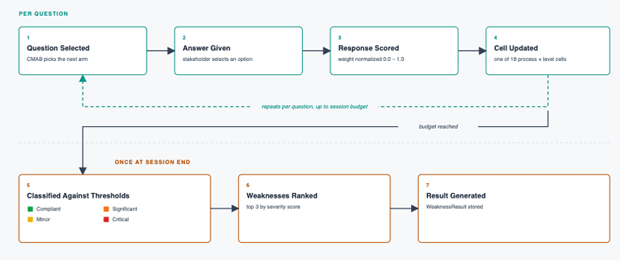
Figure 5: Question-to-result processing flow, from question selection to a stored

API Responsibilities

The API layer is intentionally very lightweight. It does not have the business logic, but rather routes that validate requests and forward them to the appropriate service that is described earlier in this chapter.
All the endpoints under /api/v1 are grouped into the following categories: audit session endpoints: These can be accessed by any authenticated stakeholder; question bank endpoints: These are used by the administrator to create, edit and deactivate questions (Section 4.3.3); analytics endpoints: These are available for the administrator to get aggregate views across all sessions and feed the administration interface (Section 4.8).

Authentication and Authorization

Access is JWT-based. The system generates a token when a user logs in and each subsequent request includes the token. The stakeholder role is collected only once during Signup (as detailed in Section 4.1). The difference between an ordinary stakeholder and an administrator is an is_superuser flag on the user account. This flag is explicitly checked in the question bank and analytics endpoints, and is required only in the audit session endpoints. This fulfils NFR3 in Section 4.1.

Assessment Session Interaction

Table 4.4 shows the endpoints that a stakeholder uses to join an assessment session before he/she submits an answer.

Table 4: Assessment session endpoints
Endpoint | Purpose
POST /audit/sessions/ | Start a new session; returns the first selected question.
GET /audit/sessions/ | List the current user’s own sessions, past and present.
GET /audit/sessions/{id} | Retrieve one session’s detail, including every question asked so far.

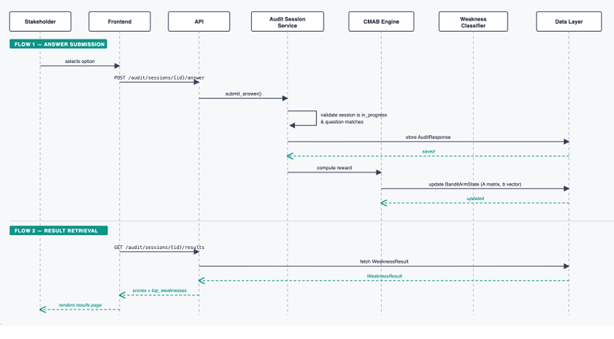
Figure 6: Answer submission and result retrieval sequence

4.7.4. Answer Submission and Result Retrieval
This interaction is displayed in the following figures, from start to finish, in Figure 4.6. The entire interaction in Sections 4.5 and 4.6 is performed at a single endpoint for submitting answers.
Firstly, it verifies that the session is still active and that the question being answered is indeed the question that the session is waiting for. It then saves the response, determines its reward, and updates the BanditArmState for the answer it has given.
There are two possible routes from there on. If the session hasn't used up its question budget, it picks and returns the next question. Once the budget has been reached, the system executes the classifier and keeps the result of the classification in the WeaknessResult object and sets the session as completed.
If there is a result stored, it can be retrieved by using the separate results endpoint. This is helpful for the frontend as the result of the session can be requested without the request that was used to create it. The outcome of this is that the client's connection is not required at the end of the session.

User Interface Design

Where the decisions made throughout this chapter are realized as something that a stakeholder can see and interact with is the interface. That's why it operates in the same way as the API separates based on roles.

User Roles and Views

There are two types of user and each are offered different views. The views of the assessment are available to an authenticated stakeholder, including starting and finishing an assessment, viewing the assessment result and browsing their own session history. An administrator (the same is_superuser flag that is tested at the API level in Section 4.7) also has access to the question bank manager and analytics dashboard.
Administrators' views of the assessment do not change. They only get additional administration views on top.

Assessment Session Flow

The stakeholder will not have to wait for an empty screen as the first question is displayed as the session begins. Questions are displayed one at a time, and the five possible answers and the progress indicator are displayed, e.g. “Question 3 of 12”, in the same way as described in Section 4.7.
Once an answer is given one of two things occurs. The next question on the CMAB engine is then presented as the current question, or if the budget for the session is full, the stakeholder is immediately presented with the results of the session.
The stakeholder's role is asked only once when signing up, in the same field as described in Section 4.1 and will not be asked again.

4.8.3. Results Visualization
A completed session's WeaknessResult from Section 4.6 is displayed in three different ways, each of which addresses a different question.
A radar chart, having one axis for each SWE process, gives an instant overview of the health of the processes. The heatmap table shows processes vs capability levels, and colours each assessed cell with the same four bands as shown in Table 4.3. This will allow the stakeholder to not only see the severity of a weakness, but where it is.
Lastly, a ranked list of the top three weaknesses, links each weakness to the recommendation text for the question that revealed the weakness. This way, there is more than a score at the end, there is something that can be done.

Administration Interface

There are two more views for administrators, both of which are related to the two administrator-only endpoint groups that are described in Section 4.7.
The question bank manager can list, filter and directly edit questions and options. It provides the administrators with the power to add, edit and disable questions in the question bank stored in FR3 (Section 4.1).
The analytics dashboard is not session specific, but rather applies to all sessions completed. It offers a weakness heatmap of the entire question bank, arm statistics of which questions are most often selected and most rewarding to the participants, and participation statistics by stakeholder role.
The difference lies in the question they answer: the stakeholder facing views answer “How did this session go?” and the administration view answers “How is the system behaving overall?”
4.9. There are a number of key design decisions and trade-offs that must be taken into account.
4.9.1. The results are compared to those obtained by the alternative algorithms.
In Chapter 2, we presented four methods to address the exploration–exploitation dilemma: Epoch-Greedy, ϵ-greedy, Thompson Sampling and UCB-style methods. This thesis ultimately makes use of the contextual member of this group, LinUCB. This subsection puts that decision on record, and it also deals with the evidence that is against it; and, as is important, it does so.
That evidence isn't concealed. Table 3.1 in Chapter 3 is reproduced from the closest previous work, and demonstrates that ϵ-greedy outperformed LinUCB in all simulated scenarios tested in terms of the raw reward. This was approximately 13 percentage points at a 0% deficiency-change rate and was reduced to about 1 point at a 50% deficiency-change rate [5]. Hence, LinUCB was not considered as it is known to give the highest score. The selection is based on the requirements of this thesis assessment which might differ from the maximization of the raw average reward.
Table 4.5 shows the comparison of the four candidates based on the properties which are relevant to this thesis.

Table 5: Bandit algorithms considered, compared on the properties relevant to this thesis
Algorithm | Selection rule | Deterministic? | Context-aware?
Epoch-Greedy [14] | Alternates fixed explore/exploit blocks | Within a block | No
ϵ-greedy [22] | Best known arm, or a random arm with probability ϵ | No | No
Thompson Sampling [1] | Samples an arm from a fitted reward distribution | No | Contextual only
LinUCB [15, 9] | θₐᵀx + α√(xᵀA⁻¹x), highest score wins | Yes | Yes, natively
Three reasons, all visible in this table, led to the final choice:
First is determinism. Randomness is utilized on every round in both ϵ-greedy and Thompson Sampling, either to choose between exploration and exploitation, or to sample directly from a posterior. It's a good design for a production system that is averaging behaviour over millions of rounds. A problem with it, however, for a thesis is that the same context and model state can give a legitimate different next question in another run. This will make it more difficult for an individual session to be repeated and explained later.
LinUCB's score is, on the contrary, a function of Aₐ, bₐ, and x that is determined. It is therefore possible to always re-compute and explain a particular session with a particular history.
Secondly, there is native context-awareness. The plain ϵ-greedy and plain UCB policies take primary account of the average reward they have received in the past from the arm. They can't automatically know that a specific question could be relevant to a QA Engineer, but less relevant to a Project Manager, or that a question might become more relevant after 3 questions have been asked in the session, without adding another layer around the algorithm.
The 23-dimensional context vector in Section 4.5 is directly used in the construction of LinUCB's scoring rule. The term θₐᵀx is not an extra added on to the algorithm, but an integral part of the algorithm. Although there are variants of Thompson Sampling, the one used for the benchmark in Table 3.1 is not one.
Thirdly, one hyperparameter is explainable. The meaning of LinUCB's exploration coefficient α is clear: It is the influence of the uncertainty bonus over the direct reward estimate. Compared to ϵ-greedy, the latter is a simpler (fixed or decaying) probability of ignoring the current estimate and exploring randomly, and Thompson Sampling incorporates exploration into the fitted distribution. For a reader who doesn't know anything about Bayesian analysis, it may be more difficult to explain that behaviour.
All of this is irrelevant to the simulated result for ϵ-greedy. It remains a true result from the best previous work and it demonstrates that LinUCB is not the best scorer under pure reward maximization on simulated data. It does not tell us, however, whether the same gap persists with real pilot sessions as opposed to simulated sessions. That's not what either of the previous papers did. It is then an empirical issue that this thesis can address, and this question is addressed directly in Chapter 7.

Adaptive versus a static questionnaire

Expert labels vs weight based reward

Rule Based vs ML Based classification

Chapter Summary

We have now completed the requirements of Section 4.1 and made them into a concrete system design in this chapter. The design is an overall architecture that includes an engine (CMAB) and a weakness classifier, both of which are based on the same database. It provides a question bank that maps all of the questions to an ASPICE base practice, a REST API and user interface to allow stakeholders and administrators to use it without having to expose the internal structure.
This chapter has found a design decision that had a legitimate alternative, and provided information about it and the reasons for the design choice that was selected. The most obvious is that we chose to use LinUCB, when there was previous evidence that a simpler algorithm scored higher in simulation.

