Chapter 1: Introduction

Introduction

In this chapter, the context and main problem of this research are outlined and the main objectives are defined. It starts with the problem statement and the motivation, emphasizing the need for a continuous assessment of the process in automotive software development, which is aligned with ASPICE. It then introduces the research questions, contribution of this work, scope of the work and concludes by providing an overview of the thesis structure.

Problem Statement

Automotive Software Process Improvement and Capability dEtermination (ASPICE) is an automotive process assessment model developed by the automotive OEMs and suppliers to assess the implementation of software process at a supplier [22]. Does not evaluate software. Instead it concentrates on the process: Proper analysis of requirements, consistency of architecture and detailed design with requirements, and software verifiability. In the Software Engineering process group – SWE.1 to SWE.6 – this involves looking at each stage of the process, from analysis of the requirements through to the final verification of the software.
This evaluation is done on a structured manner in practice, which is known as an audit. At specific points in the project, a certified assessor comes in and evaluates available evidence and assigns a score to each process on a predetermined scale of NOT achieved to FULLY achieved [22, 16]. This method is good for evaluating process capability at a given time, but does not give much information about what is happening in between audits.
Here is the heart of the issue of this thesis. After a project has been evaluated, there is no ongoing method to check if the project process is continuing to be implemented properly. A weakness can be introduced just after an audit, like a poorly thought out requirement or a design decision that is not checked at any point after it's made, and go unnoticed for months. It might only be seen at the next audit or even at a later audit when it is presented as a defect [5]. At that time, solving the problem might be quite expensive, compared to if it had been solved earlier [18, 12]. When used as it's intended, it's not really a solution for this: ASPICE doesn't give a signal for a development team to respond to between audits, it just gives a rating when the audit is performed.
This thesis begins by exploring this gap – can the SWE.1 – SWE.6 base practices be translated to something that stakeholders can refer to continuously as part of their daily development activities, not just when an assessor is present?

Motivation

This thesis is motivated by a problem faced in modern car software development. Car software is becoming more and more complex and software from one generation to the next must be compatible with in-vehicle software systems, cloud services, and vehicles [24, 6]. The more complex it becomes the more challenging it is to identify weaknesses in the process and to remediate them, if they are discovered at the end of the process. The importance of regular and effective process assessment is growing, as a result of this.
Automotive SPICE (ASPICE) has established a good framework for Software Development Process Assessment. In the past, however, the assessment is predominantly carried out by regularly scheduled and structured audits. While not all questions are equally useful in all situations, in most cases stakeholders are asked a large number of pre-determined questions. There might be a few questions that don't give you much information, and another question, at just the right moment, could give you a clue to a weakness. An important question here is whether this can be done, using fewer questions, but more relevant questions?
This idea is further supported by research on reinforcement learning recommender systems, which have been shown to be able to adapt to a specific situation by learning to choose more useful questions rather than strictly playing a pre-defined sequence [5]. This is the same principle that can be used for an ASPICE assessment. The utility of a question may vary from one ask to another and relate to what has already been addressed, the process areas that are perceived as being not strong enough, the capability being explored, and the stakeholder who is answering the question. A contextual multi-armed bandit (CMAB) is thus an appropriate solution as it can leverage on this evolving context to determine the next question to ask.
The selection of questions based on ASPICE has been studied before, in a CMAB setting [5] and comparing each of the bandit algorithms in simulated settings [4]. One thing remains though – getting from a successful concept that has been simulated to an actual system that has been tested via real assessment data. This is the primary reason behind this thesis.
The thesis thus creates a web-based program which is able to adaptively pick questions from the SWE.1–SWE.6 process group according to the information it has at an assessment session. The answers then are used to pinpoint and categorize potential process weaknesses. It is not intended to supplant the expertise of the individual or ASPICE principles. Rather, the intent is to focus the assessment process by suggesting the right question and the right time in the system.
In the end, the motivation for this research is for the possibility to reduce reliance on long and static questionnaires in process assessment, and make it more responsive to the situation being assessed. This thesis seeks to demonstrate that adaptive question selection can make ASPICE assessment not only practical to use, but also continuous over time, as it is implemented as a working Web application and tested using actual audit sessions, instead of simulated data.

Research Questions

The thesis has four research questions:
- RQ1: What are the steps needed to convert the base practices of ASPICE SWE.1-6 into a question bank of auditor-style questions, aligned with SWE processes and stakeholder roles, which is structured and weighted?
- RQ2: How can a web-based recommendation system narrow down the question bank down to a few questions that are well-targeted in the evaluation cycle?
- RQ3: How do the stakeholder answers get automatically classified to a process weakness rating for each of the SWE processes without a human assessor's judgement?
- RQ4: How can these results be communicated in such a way that process deficiencies (and their evolution from version to version of the software) can be identified early, and not just at the next scheduled ASPICE audit?

Contributions

The following are the contributions aligned to the above research questions:
- RQ1. A well-organised question bank covering the ASPICE SWE.1 – SWE.6, with each question linking to a specific base practice, and stakeholder roles and weighted answers assigned.
- RQ2. A CMAB-based recommendation engine using the LinUCB algorithm, that recommends a few well-targeted questions per session to a user, based on a session-state context that includes what the stakeholder has done, how far he has progressed and what the process and capability level of the session has accomplished to date.
- RQ3. A rule based weakness classifier that is able to score each (process, capability level) cell assessed, and automatically rank each weakness, without the need of a labelled training data set, or human assessor's judgement.
- RQ4. Early visibility of weakness classifications for each SWE process and their trends over sessions in a results dashboard - instead of having to wait for the next scheduled audit.
- A full end-to-end web application that integrates the four contributions above using FastAPI, React and PostgreSQL for real users.
- This is followed by a real evaluation of pilot sessions that are not simulated. This thesis gives this evaluation for the scope SWE.1–SWE.6, while both papers from the supervisors [5, 4] leave it for future work.

Scope and Limitations

This research deals with one component of ASPICE: the Software Engineering process group, SWE.1 to SWE.6 and the capability levels, L1 to L3 (Performed, Managed, Established). Not covered, nor is capability level L4 and L5, is System Engineering, Validation, Management, Supporting and Process Improvement. The higher levels address quantitative process control and organisation-wide improvement, and rely on information from several projects, over a period of time, and not information that a stakeholder can provide during one session.
This limited scope introduces two weaknesses that will be highlighted here.
- The capability levels L2 and L3 are partially based on the definition and deployment of a process in an organization, not just on the execution of the process in a single project [22]. This can only be addressed by one stakeholder in a session, but not by an assessor who will have a look at the process assets that the organization actually uses.
- A panel of independent experts did not validate the weights given to the answer options in this thesis. These question weights were validated by interviews with automotive experts [5] and it is left for future work to validate these weights here.

Structure of the Thesis

Chapter 2 presents a brief introduction to the ASPICE, recommender systems and multi armed bandits, which will be needed to follow the discussion that follows. In Chapter 3 this thesis is compared to the two papers of the supervisors mentioned above and compared to the use of ASPICE as it is usually done. In Chapter 4, the design of the system is explained, that is, the database schema, the engine of the CMAB, the weakness classifier, and the design of the API and frontend. Chapter 5 explains how this design has been realized. The assessment of the system is explained in Chapter 6 and the results of the assessment is presented in Chapter 7. Finally, Chapter 8 is a recap of the research questions and what is still to be done.

Chapter 2: Background and Fundamentals

In this chapter, the three major concepts that are the core of this research are introduced: what is ASPICE, how is it typically performed, what is a recommender system, and what is a multi-armed bandit. If you already know the terms of any of these topics, you can skip them; the important terms introduced in this chapter are assumed in Chapter 4.

Automotive SPICE (ASPICE)

The automotive OEMs and suppliers have adopted a process assessment model called automotive SPICE (ASPICE) to assess the capability of automotive suppliers in software and systems development [22]. Does not evaluate the product itself. Rather, it evaluates the process that is followed to create that product. That is, a supplier is not judged on the software's functionality, but on whether requirements were captured against, designed against, implemented against, and verified by the software's development process consistently.In other words, a supplier is not judged based on the software's functionality, but on whether the software's development process consistently captured requirements against, designed against, implemented against, and verified by requirements.

Process Reference and Assessment Models (PRM/PAM)

ASPICE is based on two interrelated models. The Processes Reference Model (PRM) outlines the processes to be assessed against a supplier and the intent and desired results of each process. The Process Assessment Model (PAM) then provides what is needed to actually assess those processes: a set of capability levels and indicators, known as base practices and generic practices, that an assessor looks for as evidence [22]. These models complement each other in a 2-D way: a process dimension, determining the process being assessed, and a capability dimension, determining the capability of the assessed process. The dimension of capability, which is the one that the ASPICE measurement framework uses, is taken from the internationally agreed process assessment standard ISO/IEC 33020 [10, 22]. The terms of its core concepts, such as information item and process attribute are taken from ISO/IEC 33000 [9].

The total process reference model as kept by the VDA Quality Management Center, who maintains the ASPICE standard [21, 22] is shown in Figure 2.1. The processes are segmented into three life-cycle categories and then into process groups with each process group having a two-letter code.
Acquisition (ACQ) The work of an outside contractor.
Supply (SPL) deals with the way in which a product is supplied to a customer.
System Engineering (SYS) brings stakeholder needs from system-level requirements to system architecture, integration and verification.

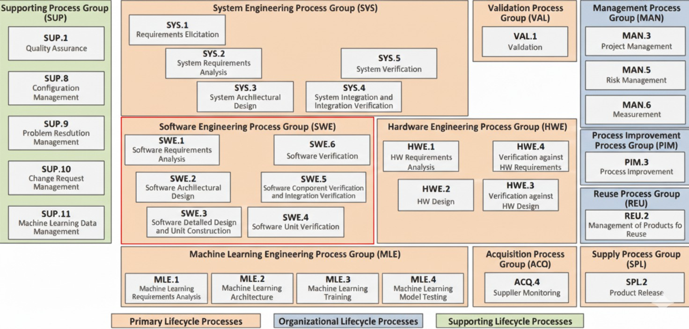
Figure 1: The process group model for the Automotive SPICE process reference model (PRM), with the Software Engineering process group (SWE) in red. Taken from the official process reference model published by the VDA Quality Management Center [21, 22]

Software Engineering (SWE) The software level development flow, from requirements to verification is the process group used in this thesis.
Hardware Engineering (HWE) The equivalent development processes for hardware components
Machine Learning Engineering (MLE) covers requirements, architecture, training and testing of machine-learning components.
Validation (VAL) determines if the completed product fulfills the expectations of the stakeholders that are experienced in the real world, not just in the written requirements.
Supporting Process (SUP) Covers quality assurance, configuration management, problem resolution management, change request management, and machine-learning data management.
Management (MAN) is about project management, risk management and measurement.
Process Improvement (PIM) deals with the improvement of processes as time passes.
Reuse (REU) is for managing products that can be used again for various projects.
This is a grouping that will enable a supplier to be evaluated only on the process groups that it actually develops. This thesis is confined to a single, main life-cycle group: Software Engineering (SWE).

The SWE Process Group: SWE.1 – SWE.6

The Software Engineering process group includes all the software engineering activities from defining software requirements through verifying the software. It is made up of 6 processes as described below.
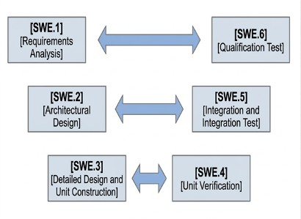
Figure 2: The V-model view of the SWE.1 – SWE.6 processes. Adapted from [23].
SWE.1 — Software Requirements Analysis Records the software requirements that are extracted from the System Requirements and System Architecture.
SWE.2 — Software Architectural Design Describes the software architecture, which is the division of software into components and the interactions between the components.
SWE.3 — Software Detailed Design and Unit Construction Specifies each software unit in detail and constructs it.
SWE — Software Unit Verification Verifies that each implemented unit meets its detailed design.
SWE.5 — Software Integration and Integration Test verified units into larger components and the complete software build, and tests if this integration is correct.
SWE.6 Software Qualification Test Tests the fully integrated software against the original software requirements.
The six processes are grouped around the V-shape as shown in Figure 2: SWE.1 (requirements) is paired with SWE.6 (software qualification test), SWE.2 (architecture) is paired with SWE.5 (integration test), and SWE.3 (detailed design) is paired with SWE.4 (unit verification) [22]. There are base practices for each process, these are the specific activities an assessor is looking for. These are the base practices that are directly used in this thesis as the source material for the question bank described in Chapter 5).

Capability Levels and Base Practices (L1–L3)

Processes cannot be just said to be present or not. ASPICE establishes six capability levels (see Figure 3) and a process can only attain a specific level if it meets all the levels on its way to the specified level.

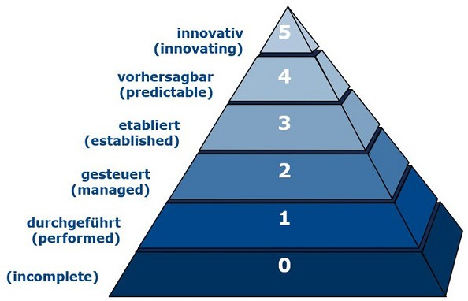
Figure 3: The ASPICE capability levels are shown ranging from level 0 (Incomplete) to level 5 (Innovating). The process model adapted from the official model of Automotive SPICE [21].

L0, Incomplete – The process is not implemented or is not effective.
L1, Performed The process is effective in achieving the purpose. Evidence for this level is found in the base practices which outline, for each of the SWE.1-SWE.6 processes, the activities that are required for the process.
L2, Managed The process is not only carried out, but planned and monitored, and the work products are appropriately controlled.
L3, Established The process is documented and is customised and applied throughout the organisation.
L4, Predictable The process will function within certain quantitative limits, and the operation of the process will be predictable.
L5, Innovating The process is continually improved throughout the organisation through quantitative feedback.
This thesis includes the first three levels (L1 – L3). The levels L4 and L5 are not included: They would need evidence gathered over multiple projects over time, which a single stakeholder is unlikely to be able to provide in a single session [22].

The Traditional (Manual) Assessment Procedure

An ASPICE assessment is conducted by a certified assessor that evaluates work products (documents, models, test records, etc.) and interviews project staff to identify if each base practice and generic practice has been met. The percentage of evidence found is then used to assign scores to each of the process attributes on an ordinal scale from Not achieved to Fully achieved [22]. The outcome is a capability profile which gives a rating for each process and level that has been measured in the assessment.
This procedure is performed once or twice in a project, at a specific time and results in a judgment [22, 16]. There is, however, no inbuilt process to ensure that the processes that have been assessed continue to be followed between assessments.

Pain Points of Manual Assessment (Time, Consistency, Continuity)

This is a procedure that has three main consequences. First, feedback is only given when an assessment occurs – feedback on a process weakness that occurred the following week from an assessment may not be known until the next assessment. Second, fixing a problem at the end of the development cycle is much more costly than fixing the same problem at the start of the development cycle, since other work may be dependent on the incorrect requirement or design at the time the problem is discovered.Second, if a problem is discovered late in the development cycle, it will be more expensive to correct the problem than when it was discovered earlier in the development cycle when other work may have depended on the incorrect requirement or design. Third, an assessor's depth of a manual assessment is limited by the amount of time that he or she has. An assessor does not have a lot of time to spend onsite so a sample of evidence must be examined instead of all evidence; thus, the extent of the sample of evidence examined during a particular audit is dependent on the questions the assessor decides to ask. Dimitrios recognizes the same gap first, which is that once a supplier is certified, there is no way to directly monitor the supplier's process to ensure that it continues to meet the requirements, and therefore organizations often use generic project management or defect-tracking systems, which were not designed to perform process assessment [5]. This is the particular issue that will be tackled in the rest of this thesis.

Recommender Systems

A recommender system is used to filter out a small, relevant subset of items from a large pool of items and for a specific user and context [15]. The same fundamental principle is used in this thesis to determine which next question to ask out of the ASPICE questions.

Content Based and Collaborative Filtering

There are two classical approaches for content-based filtering and collaborative filtering but none is directly applicable to this thesis [15]. Both require a consistent past preference – either of the stakeholder or other users. The next time this system is deployed, however, there is no history with regard to the questions and the stakeholders that answer them. The analysis of this comparison is described in Chapter 3.

Sequential and Adaptive Recommendation

Sequential, Adaptive recommendation is better fit. In this case, one item is selected, the outcome is observed, and the outcome is then used to determine the next item to select during the session and so on. This is the approach that was taken in this thesis, and is what is being used in the approach described in the next section [5]; Chapter 3 will discuss the previous work which led to this in more detail.

Multi-Armed Bandits

Multi-armed bandit is a repeated decision problem where an agent has to select one of several options on each round which gives him a reward, and maximizes his cumulative reward over the rounds [17, 19]. The name is based on a string of slot machines, that are sometimes referred to as “one-armed bandits”, and have an unknown and possibly different payout rate.

The Exploration–Exploitation Trade-off

The main difficulty in a bandit problem is that the agent has no information about in advance which arm will yield the highest reward. It thus needs to invest some rounds in trying out arms over which it has limited knowledge (exploring) and other rounds in choosing the arm that has performed best so far (exploiting). Importantly, it is only able to observe the reward for the arm it selected [5, 17]. It can be expensive if this balance is not achieved. If one pursues an arm too early, he may end up with a random looking arm, and if he waits too long to explore, he may miss out on an opportunity to get a good arm.
There are a number of algorithms that try to solve this trade-off in various ways:
Epoch-Greedy is an algorithm that alternates between regular epochs of exploration and exploitation [13].
Softmax / ϵ-greedy Selects the current best arm with a fixed or decreasing probability, but selects a random arm with the rest of the time.
The Thompson Sampling algorithm keeps an updated probability of the effectiveness for each arm, and draws from that probability to decide which arm to attempt [1].
Upper Confidence Bound (UCB) Each arm's estimated reward is incremented by a bonus that depends on the level of uncertainty associated with that reward; an arm is more likely to be chosen if it looks like it's very rewarding, or if it hasn't been played enough to determine whether it's [2].

From Stateless Bandits to Contextual Bandits

The algorithms above make the assumption that all rounds of the problem are identical in that the same set of arms is available and the reward received for each arm is independent of the situation. This is not the case in this thesis. The most informative question will vary according to the person who is answering it, including the role of the stakeholder, and what has taken place in the session so far, e.g., processes and capability levels already addressed [5].
A contextual multi-armed bandit (CMAB) does not make this assumption. At the beginning of each round, the agent sees a context, which can be encoded as a vector of features to capture the current context, and lets the expected reward of each arm be based on this context [14]. The context vector in this thesis will refer to the role of the stakeholder and the status of the assessment session taking place; this is fully defined in Chapter 4. This way, by selecting questions, the algorithm learns which questions are useful and which are not for different stakeholder roles, while using the same question pool for all the roles [7].

LinUCB — Mathematical Foundations

In this thesis, a contextual bandit algorithm called LinUCB has been assumed in which the expected reward for each arm can be modeled as a linear function of the context vector [14, 8]. Each arm a has two learned quantities, an d × d matrix Aa and a d-dimensional vector ba, with d the number of context features. These quantities are used to estimate a weight vector from,
θ_{a} = A⁻¹b_{a},
a
and scores arm a for the current context as
UCB_{a}(x) = θ⊤x + αqx⊤A−1x.
a a
The first term, θ⊤x, is the best guess the algorithm has for the reward that it would receive if it pulled arm a in this context. The second term is larger if Aa has little information about contexts like x, thus adding value to arms in which the algorithm is not sure. This uncertainty bonus is given a greater or lesser degree of influence through the exploration coefficient α, which is compared to the direct reward estimate [14]. At each round, LinUCB picks the arm with the largest UCBa(x).
Once the chosen arm has returned a reward r, the parameter of the arm is changed:
Aa ← Aa + xx⊤, ba ← ba + r x.
Every new question is started with the same, maximally uncertain estimate, Aa = I (the identity matrix) and ba = 0.
The uncertainty bonus in UCBa(x) provides a level playing field for the new question to be chosen in the first couple of times it can be played [14]. The update rule is only dependent on matrix and vector arithmetic and the arm selection is a deterministic function of the variables Aa, ba, and x, so that the same context and the same history will always yield the same arm choice. One of the reasons why LinUCB is a suitable choice for a thesis with the requirement of repeatability and reproducibility is this property.

Chapter Summary

The domain for this thesis is six software engineering processes at three capability levels, typically assessed by a person in a scheduled assessment, ASPICE. Recommender systems, especially sequential and adaptive types, give the general outline of the proposed solution: It is not necessary to ask all the questions, but rather a small subset of them that are informative. Contextual bandits (and LinUCB specifically) offer the mechanism that is used in this thesis: a mechanism for determining the next question to ask based on who is answering, what has already been covered in the session, and how the question selection can be improved as more sessions are conducted. Chapter 3 situates this thesis in the context of the most similar and relevant work in the literature and Chapter 4 describes the connection of these three ideas in the real system.

Chapter 3: State of the Art

In this chapter, this research is placed in its relation to the most similar work already been done. It starts with a short introduction to ASPICE and the assessment in practice. It then explains the two papers by Dimitrios which this thesis relies on most directly, along with the diagrams which explain their approach. Lastly, it connects the various approaches in a comparison table and describes the research gap that this thesis will fill.

ASPICE and Current Assessment Practice

Chapter 2 outlined the typical process for an ASPICE assessment. It is implemented as a periodic audit, where a certified assessor visits a project at certain points and takes samples of evidence of base practices from the SWE.1-SWE.6 elements, and issues a capability rating that is valid until the next audit [22, 16]. This is the standard to which the rest of this chapter is contrasted. The biggest drawback is pointed out by Dimitrios, which is that the certification under ASPICE does not offer an inbuilt mechanism to track the compliance of the process once it has been certified. Consequently, the organizations are forced to resort to project management software or defect tracking software, which were not originally intended to discover if a particular base practice is being adhered to [5]. Since this is the case, the next section examines how Dimitrios suggests filling this gap.
The structure of the indicators that underlie that rating are shown in Figure 1. The purpose and outcomes of a process are derived from the PRM and the PAM provides the evidence used by an assessor to rate the process. The evidence at Capability Level 1 includes process performance indicators, base practices, and work products that are specific to each process. At level 1 and above, the assessment is based on process capability indicators, generic practices and generic resources, these are applicable across processes [23].

Prior Work: CMAB-Based Recommendation for Automotive Process Assessment

Two papers from TU Chemnitz suggest to use a contextual multi-armed bandit to choose assessment questions for automotive software processes. The first paper presents the idea and its architecture [5] and the second paper extends the idea with a real example of comparing bandit algorithms with simulated data [4]. The two papers are the closest prior art to this thesis and the design described in Chapter 4 is a development of those two papers.
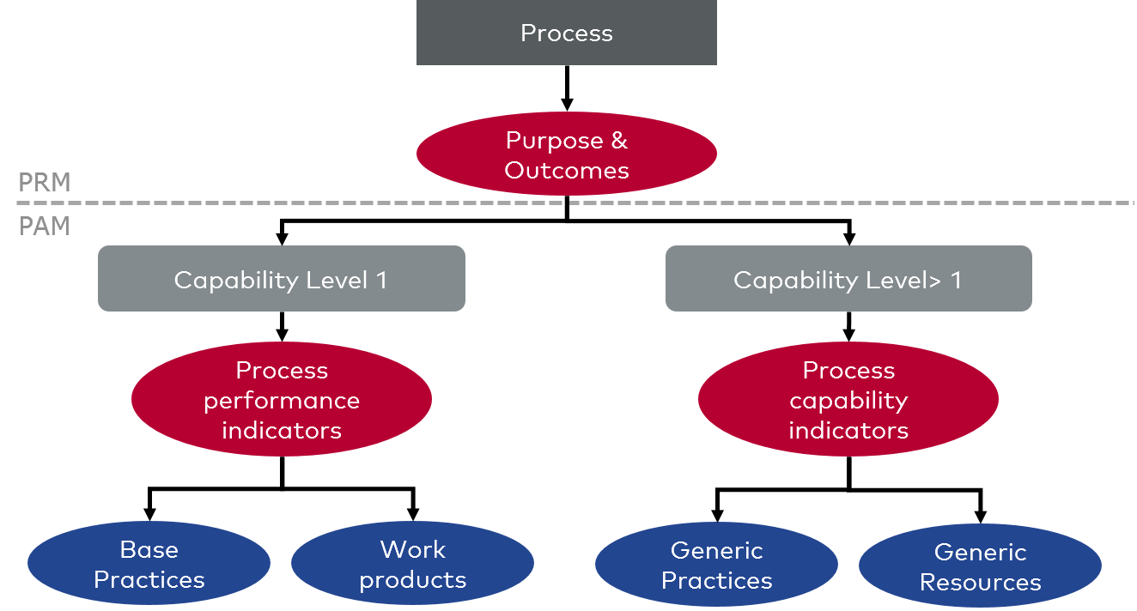
Figure 1:Relationship between PRM and PAM indicators to capability levels: base practices and work products are used to provide evidence of Capability Level 1; generic practices and generic resources are used for evidence of all levels above Capability. Adapted from Vec-tor Consulting [23].

2024 — A Dynamic Survey Model for Automotive Process Evaluation

Dimitrios recommends a system that handles a dynamic questionnaire, instead of a fixed one [5]. The questions are based on the literature search on automotive software development metrics, automotive specific studies, ASPICE (SYS.1-SYS.5, SWE.1-SWE.6, VAL.1, PIM.3), ISTQB [11] and documented OEM electrical/electronic processes. Answers are given a value and each question has a weight representing its importance. The higher the score, the worse the answer; the most revealing answer will have the highest score. At this stage, the question is packaged as shown in figure 2: It includes an identifier, roles who can ask it, roles who'll be affected by a failed answer, its weight, question and answer payloads, and the actual answer provided.

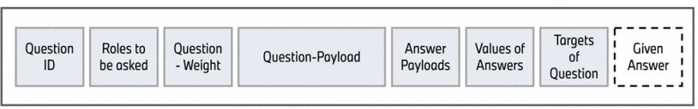
Figure 2: Structure of an evaluation packet, from the question identifier to the given answer. Reproduced from [5].

In each development cycle, a CMAB agent chooses which questions to ask, and which of the seven roles of the stakeholders will respond to those questions. This is shown in Figure 3 as a continuous serving loop instead of a single computation: The agent explores the current context, and the resulting context, action, reward is logged and added to the training data. A new model is then learned online from the data and the new model is deployed back to the agent before the next round.
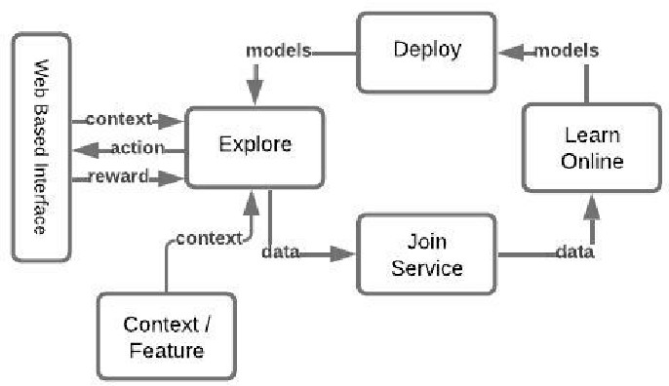
Figure 3: The CMAB serving loop: explore, log context/action/reward, learn a new model online, deploy it, and explore again. Reproduced from [5].

The paper also suggests a three banded (red, yellow, green) traffic-light categorization of the results to enable the use of two thresholds on a calculated score. But it doesn't go so far as a complete implementation. The conclusion of its own paper confirms that the concept was still under development at the time of writing and training and evaluation outcomes would be published later [5].
Relevance to this thesis: There are two design aspects from this paper that are carried over directly. First, each question carries a weight and each answer a value, so that the answers obtained in a session can be translated into a number without further interpretation. Second, the reward payoff for the CMAB agent is such that the worst response to the most important question would receive the maximum reward. This way, the agent is led to questions that are more likely to reveal a genuine weakness and not just a question that is easy to answer. Unlike this paper, the three-band classifier is extended to a four-band classifier (Chapter 4), and the resulting system is implemented and tested.

2025 — Algorithm Benchmarking on Simulated Data

In a similar fashion, Dimitrios extends the concept with a pool of 137 questions and compares three bandit algorithms directly: ϵ-greedy, LinUCB and Thompson Sampling [4]. As there was no real deployment at that point, the comparison is based on a simulated environment that mimics the behavior of real software releases. There are four different scenarios that alter the degree of variation in the underlying set of process deficiencies between rounds: 0%, 10%, 30%, and 50% of the process deficiencies change between rounds. All algorithms were separately tuned for each scenario (as summarized in Figure 4) and then compared over 1000 simulated rounds, using the following measures: cumulative reward, average reward per round, and percentage of rewards in four score bands (shown for one scenario in Figure 3). Table 1 shows the results for the least volatile and most volatile cases with the best tuning for each algorithm.

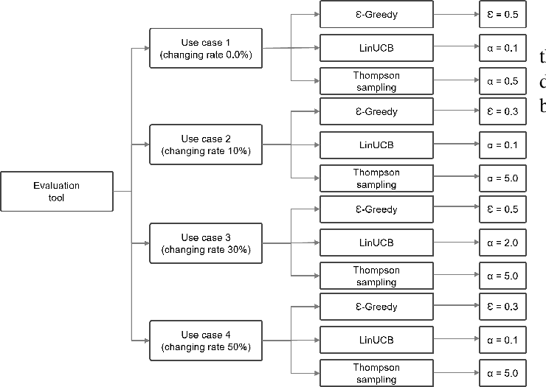
Figure 4: Best tuning parameter found for each of the three algorithms, in each of the four deficiency-change scenarios. Reproduced from [4].

The share of high-reward outcomes is the same across all four scenarios with ϵ-greedy: ϵ-greedy consistently has the largest share of high-reward outcomes. However, the benefit it has over LinUCB decreases as the deficiency-change rate rises, from approximately 13 percentage points at 0% change to approximately 1 percentage point at 50% change [4]. The tuning parameter, α, is also different for different scenarios, with the value of 0.1 in most of the scenarios and α = 2.0 in the 30%-change scenario. The two results are not actual deployment results. But the results of a real automotive development environment would be reported in another paper, according to the paper itself.
Relevance to this thesis: This is the most similar available comparison of the performance of LinUCB (the algorithm used in this thesis) compared to other methods. It is thus not a standard that can be disregarded just because LinUCB did not perform the best in the simulation. In Section 3.3, that result is taken into account, but the reasons for this choice of thesis are also considered.

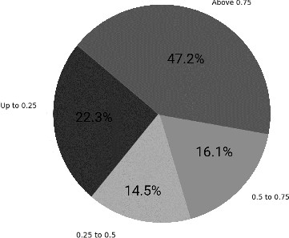
Figure 5: Distribution of ϵ-greedy’s rewards at 0% deficiency change, across four score bands. Reproduced from [4].

Table 1: Comparison of simulated algorithms at 0% and 50% deficiency-change rate adapted from [4]. The right-hand column indicates the percentage of rewards that exceeded 0.75, the band that contains the most significant questions and the least satisfactory answers
Scenario | Algorithm | Tuning | Rewards > 0.75
0% change | ϵ-greedy | ϵ = 0*.*5 | 47.2%
0% change | LinUCB | α = 0*.*1 | 34.4%
0% change | Thompson Sampling | α = 0*.*5 | 36.7%
50% change | ϵ-greedy | ϵ = 0*.*5 | 25.3%
50% change | LinUCB | α = 0*.*1 | 24.3%
50% change | Thompson Sampling | α = 5*.*0 | 23.9%

Cross-Comparison and the Recommended Method for This Thesis

Table 2 makes a comparison between manual ASPICE practice, the previous work described above and this thesis for the properties that are relevant to a continuous, automated process assessment. A ✓ means the property is true, and a ✗ means it is false; the rest of the rows are properties which are not just true or false. Manual practice and the prior work both meet some of these criteria but neither meets all of them. This thesis is the only one of the three to meet all the checkable requirements, in part because it restricts the scope but in part because it is actually implemented and tested.
In the following, this thesis has made three deliberate choices concerning the previous research. First, it reduces the number of process groups in the ASPICE to one (SWE.1 – SWE.6) and so the question bank in Chapter 5 can be created directly from the base practices for this group, instead of from a larger literature review. Second, it takes a specific approach, namely LinUCB,

Table 2: This thesis, manual ASPICE practice and prior CMAB based work, compared.
Aspect | ASPICE (current practice) | Prior work [5, 4] | This thesis
Assessment style | Manual, audit-driven | Continuous, question-driven | Continuous, ASPICE-aligned, web-based
Question-based evaluation | ✓ Yes, by auditors | ✓ Yes, derived from metrics | ✓ Yes, ASPICE base practices turned into questions
Structured question database | ✗ Not a standardized dataset | ✓ Generic questions for general software | ✓ New structured SWE.1–SWE.6 question bank
ASPICE scope / focus | ✓ Full standard, as needed | ✗ SYS.1–SYS.5, SWE.1–SWE.6, VAL.1, PIM.3 (not SWE-specific) | ✓ Explicit SWE.1–SWE.6 mapping only
Automated question selection | ✗ Human assessor selects | ✓ CMAB agent (three algorithms compared) | ✓ CMAB agent (LinUCB)
Early feedback | ✗ Mostly late, at audit time | ✓ Early evaluation, in simulation | ✓ Early SWE weakness visibility
Evaluation basis | Not applicable (the standard itself) | ✗ Simulated data only | ✓ Real pilot audit sessions

It is simpler to reproduce and reason about a single algorithm selection rule than to compare multiple ones; although Table 1 demonstrates that ϵ-greedy is superior in simulation, it does not provide the ability to compare algorithms with a selection rule that is different than the one used in the thesis. This is discussed again in Chapter 7. Third, it assesses the system based on the actual pilot sessions, whereas both of the above papers do not.
The literature does not provide much coverage of recommender systems in the automotive processes. The most recent non-supervisor related work is Bader's dissertation on proactive recommender systems for automotive scenarios [3] that does not rely on ASPICE and that is based on in-vehicle recommendations for the driver instead of the assessment of the process for a development team.

Research Gap

The previous sections demonstrate there is clearly a gap. The manual ASPICE assessment does not offer a way to monitor continuously [5]. The most similar previous work suggests an alternative approach which is continuous and based on the CMAB, but has not yet been realised as a working system and only tested by simulation [5, 4]. A continuous, automated, stakeholder-driven recommendation system coupled with an explicit implementation for the ASPICE SWE.1–SWE.6 and an evaluation in real assessment sessions has not been published so far. It is this gap which this thesis aims to fill.

Chapter Summary

Manual ASPICE assessment is if the ASPICE rating is to be provided manually, then it will be clear but the rating can be obtained only at the audit time. The previous studies discussed in this chapter indicate that a questionnaire driven by a CMAB is conceptually possible and also has been simulated, but has yet to be implemented in the real world. This thesis deals with this space in particular for SWE.1–SWE.6: It is based on the same underlying idea, it has a more limited scope of the ASPICE, it has a fixed algorithm, and it tests the system with real sessions instead of simulated ones. It is explained how that system is built in chapter 4.

