CARRY
Peer-to-Peer Campus Delivery System

Android Application — Project Report

Khulna University of Engineering & Technology (KUET)

Platform: Android (Pure Java) | Architecture: MVVM | Cloud: REST API & Firebase

Table of Contents
1. Project Overview & Core Mission
2. Feature Walkthrough (4 Screenshots Per Showcase Page)
2.1 User Authentication & Role Application System
2.2 Product Catalog, Browsing & Catalog Management
2.3 Order Lifecycle, Live Deliveries & Real-Time Chat
2.4 Profile Administration & Full Management Operations
3. 3D System Architecture
4. 3D Application Workflow (Customer & Delivery Partner)
5. Backend REST API & Database Models
6. Firebase Services Setup & Real-Time Sync
7. Security Rules & Role-Based Access Control
8. Project Summary & Conclusion

1. Project Overview & Core Mission
CARRY is an Android mobile application engineered specifically for students and staff at Khulna University of Engineering & Technology (KUET). The campus is located at a distance from Khulna's primary commercial markets (e.g., Daulatpur, Shib Bari, New Market). Students frequently require academic equipment, electronics components, stationery, medicines, and specialty foods that are unavailable locally on campus.
At the same time, many students regularly travel into Khulna city for academic or personal reasons. CARRY bridges this gap by creating a trusted, peer-to-peer delivery network. A student travelling to town can register a delivery trip, accept orders from fellow peers, purchase requested items, and deliver them back to student halls while earning a fair delivery fee.

Key Android Engineering Highlights
- Platform & Tooling: Pure Java (minSdk 24, targetSdk 34) built using Android Jetpack, ViewBinding, and Material Design 3.
- Dual-Layer Identity: Synchronous dual-login across the cloud REST backend (JWT) and Firebase Authentication.
- Multi-Role System: Granular role hierarchy: Regular Student, Delivery Partner, Community Moderator, and Platform Admin.
- Zero-Cost Image Pipeline: Client-side image downscaling (<256px) and Base64 persistence directly in Cloud Firestore.
- Real-Time Infrastructure: Firebase Realtime Database for live order nudge events and Google Maps driver GPS sharing.
- In-App Order Chat: Direct order-scoped two-party messaging powered by Cloud Firestore real-time snapshot listeners.

2. Feature Walkthrough

2.1 User Authentication & Role Application System
Every student registers using their official KUET student email address. The application authenticates credentials through the secure REST API to obtain an access token, while seamlessly establishing an authenticated session in Firebase for real-time synchronization. Students can apply in-app for advanced roles such as Delivery Partner or Community Moderator with customized questionnaire dialogs.
- Login & Register: KUET student email validation and credential authentication.
- Dual-Auth Sync: Self-healing user synchronization between backend and Firebase Auth.
- Delivery Partner Form: Includes alternative phone number, bKash payout account, schedule, and safety agreement.
- Moderator Form: Formal application workflow for students assisting with community dispute management.
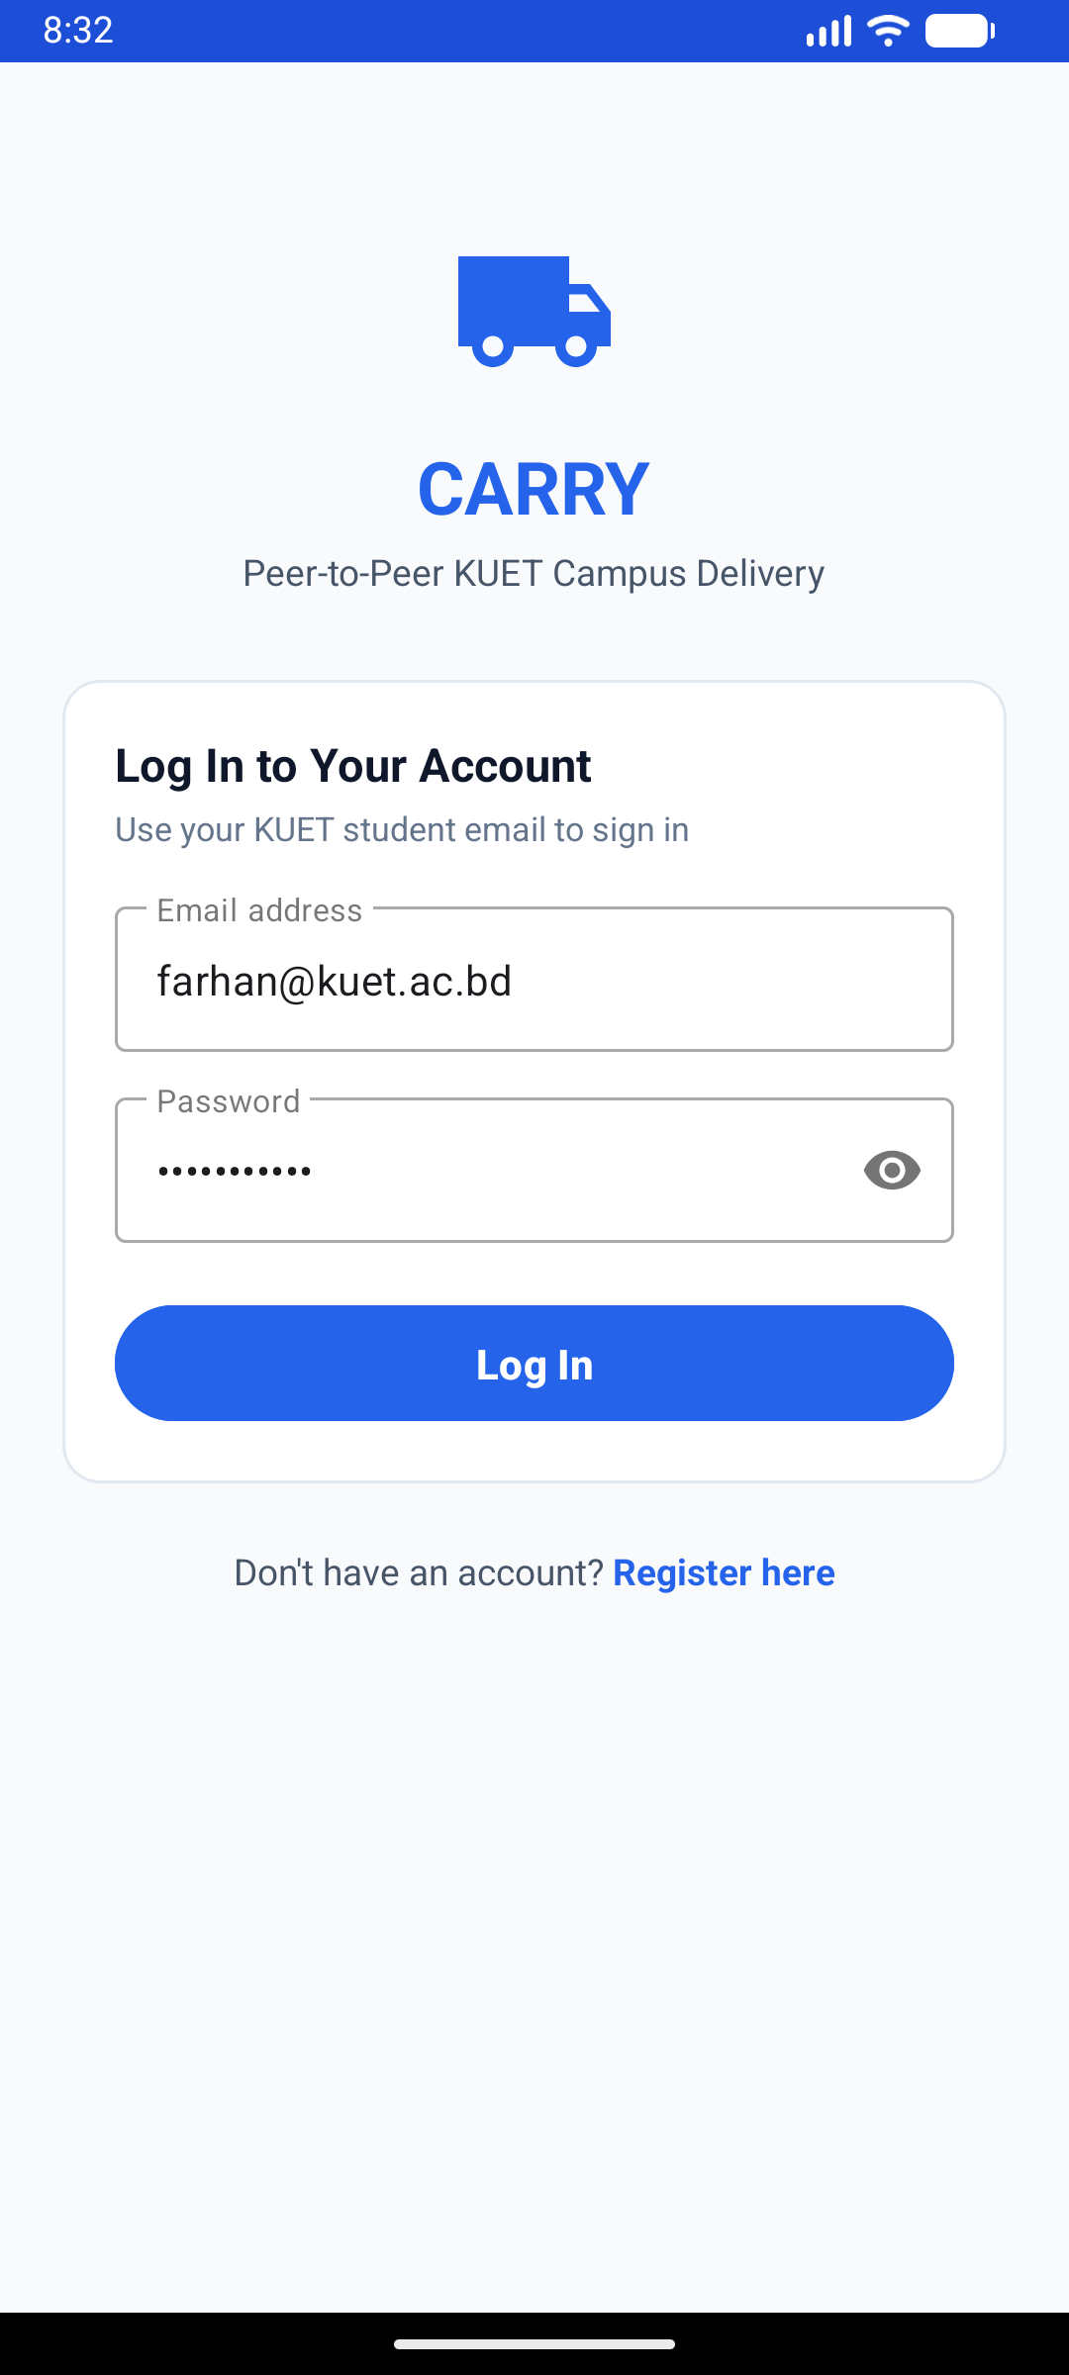 | 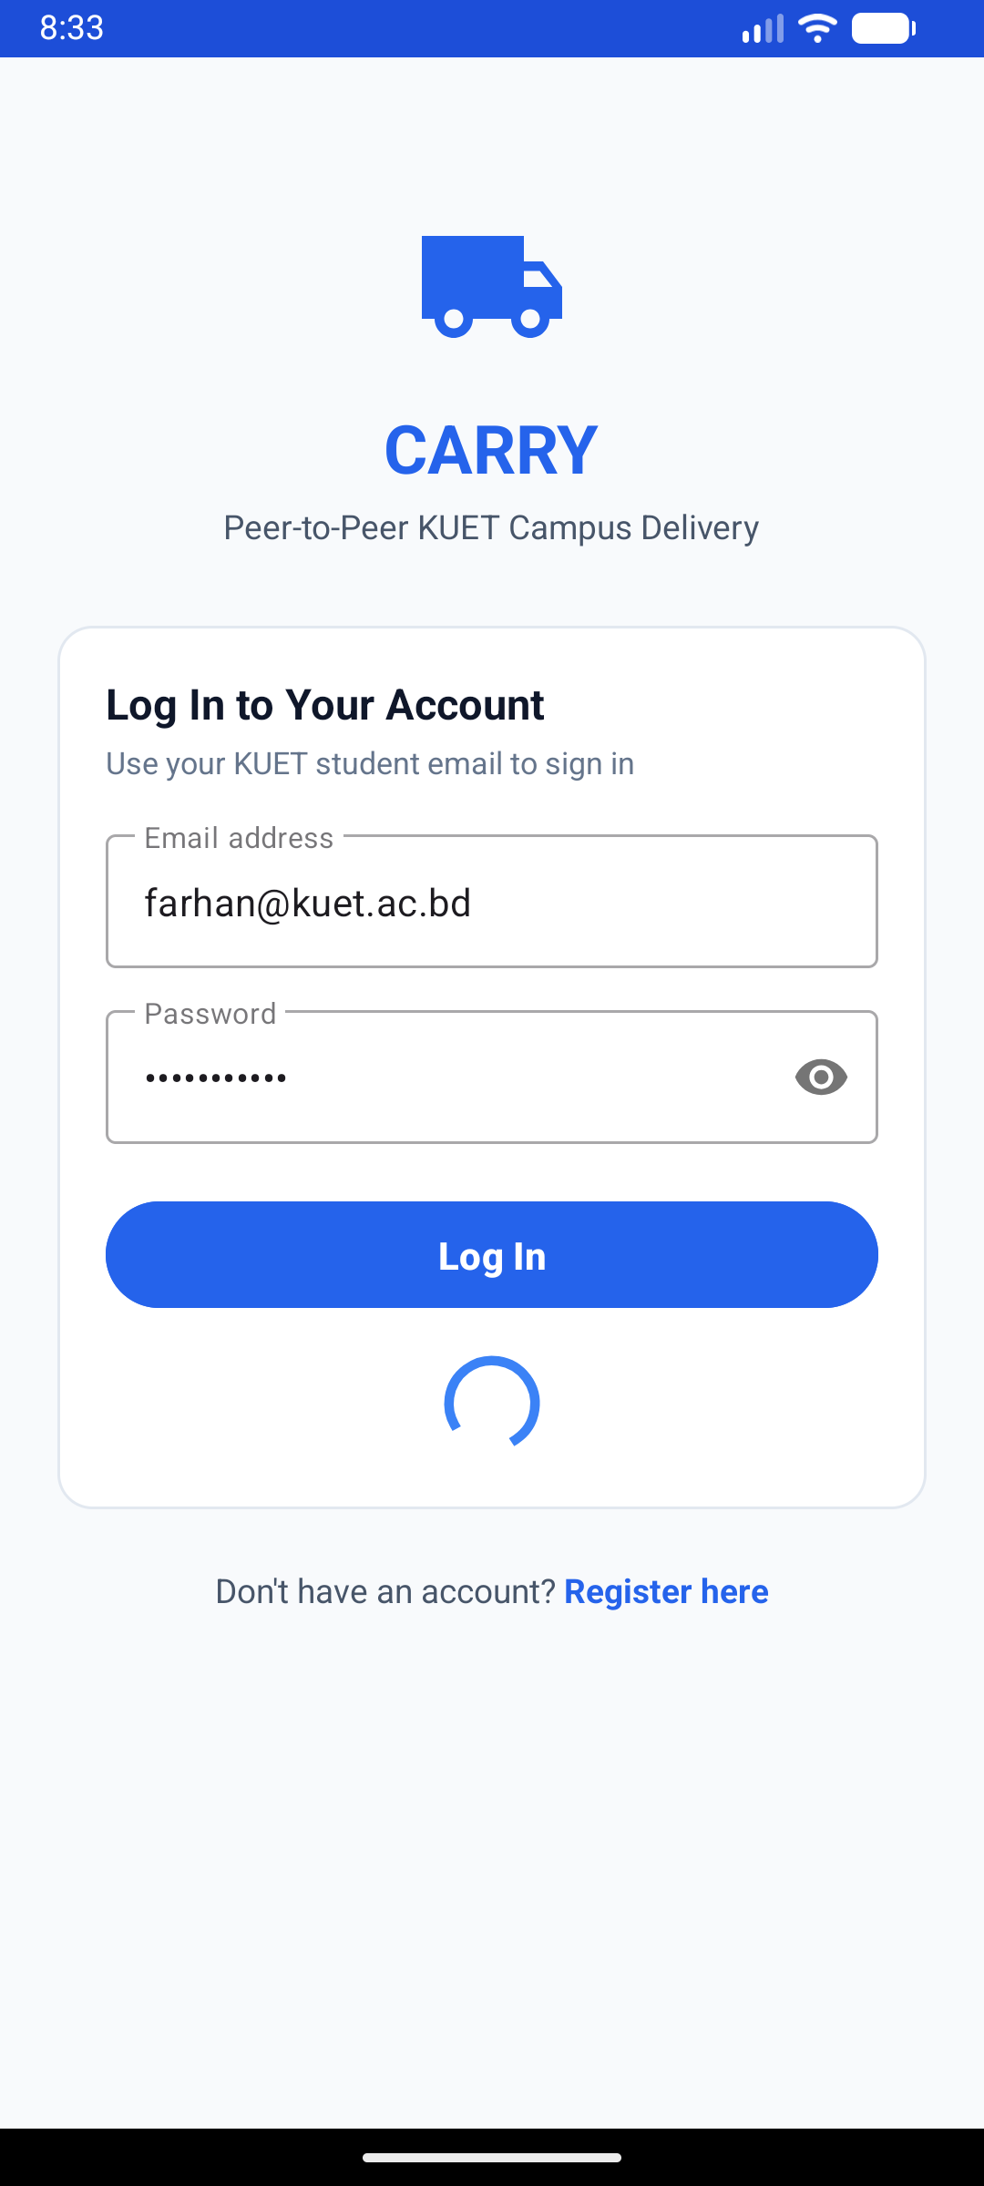 | 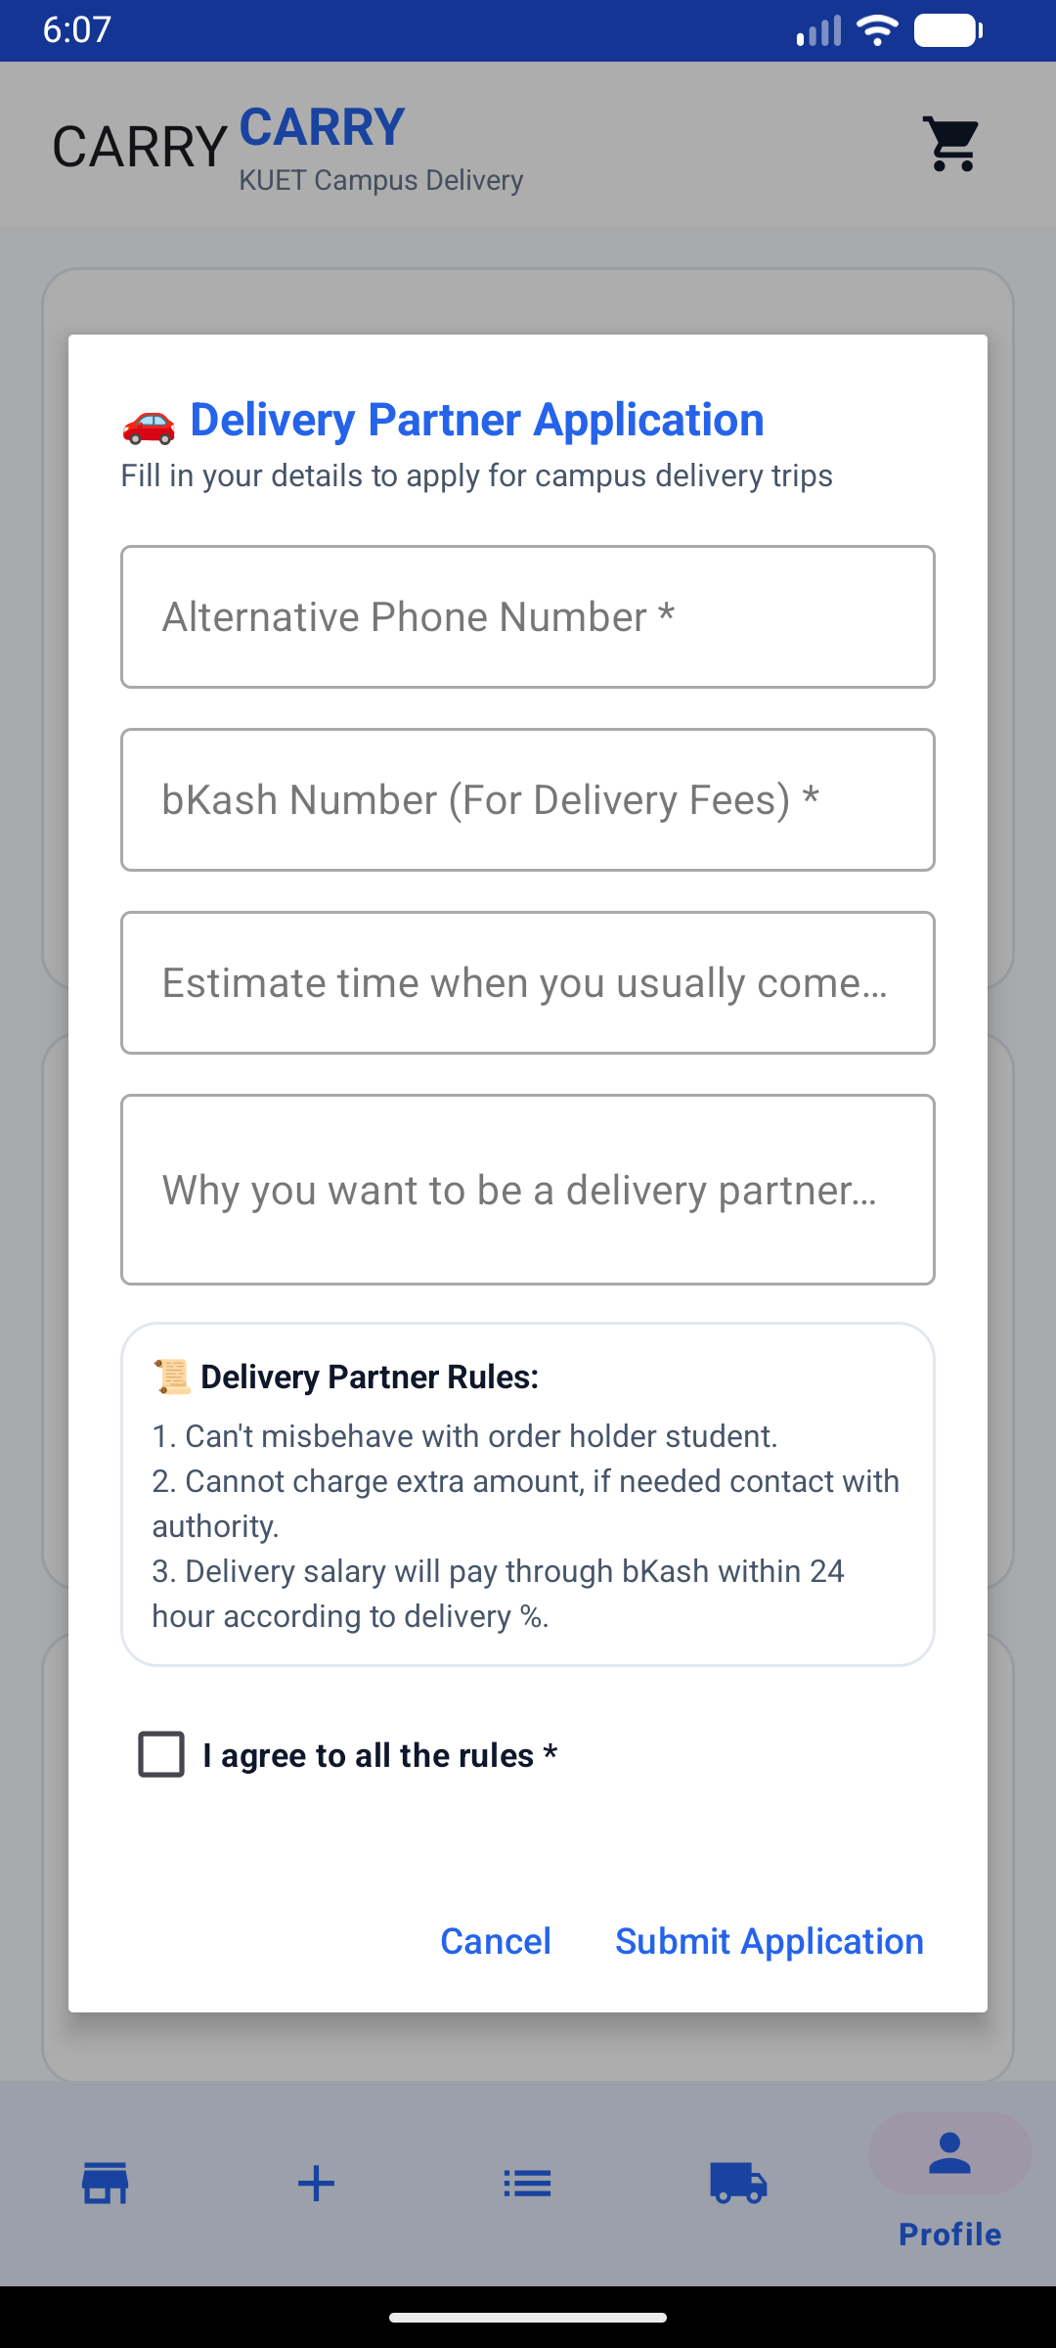 | 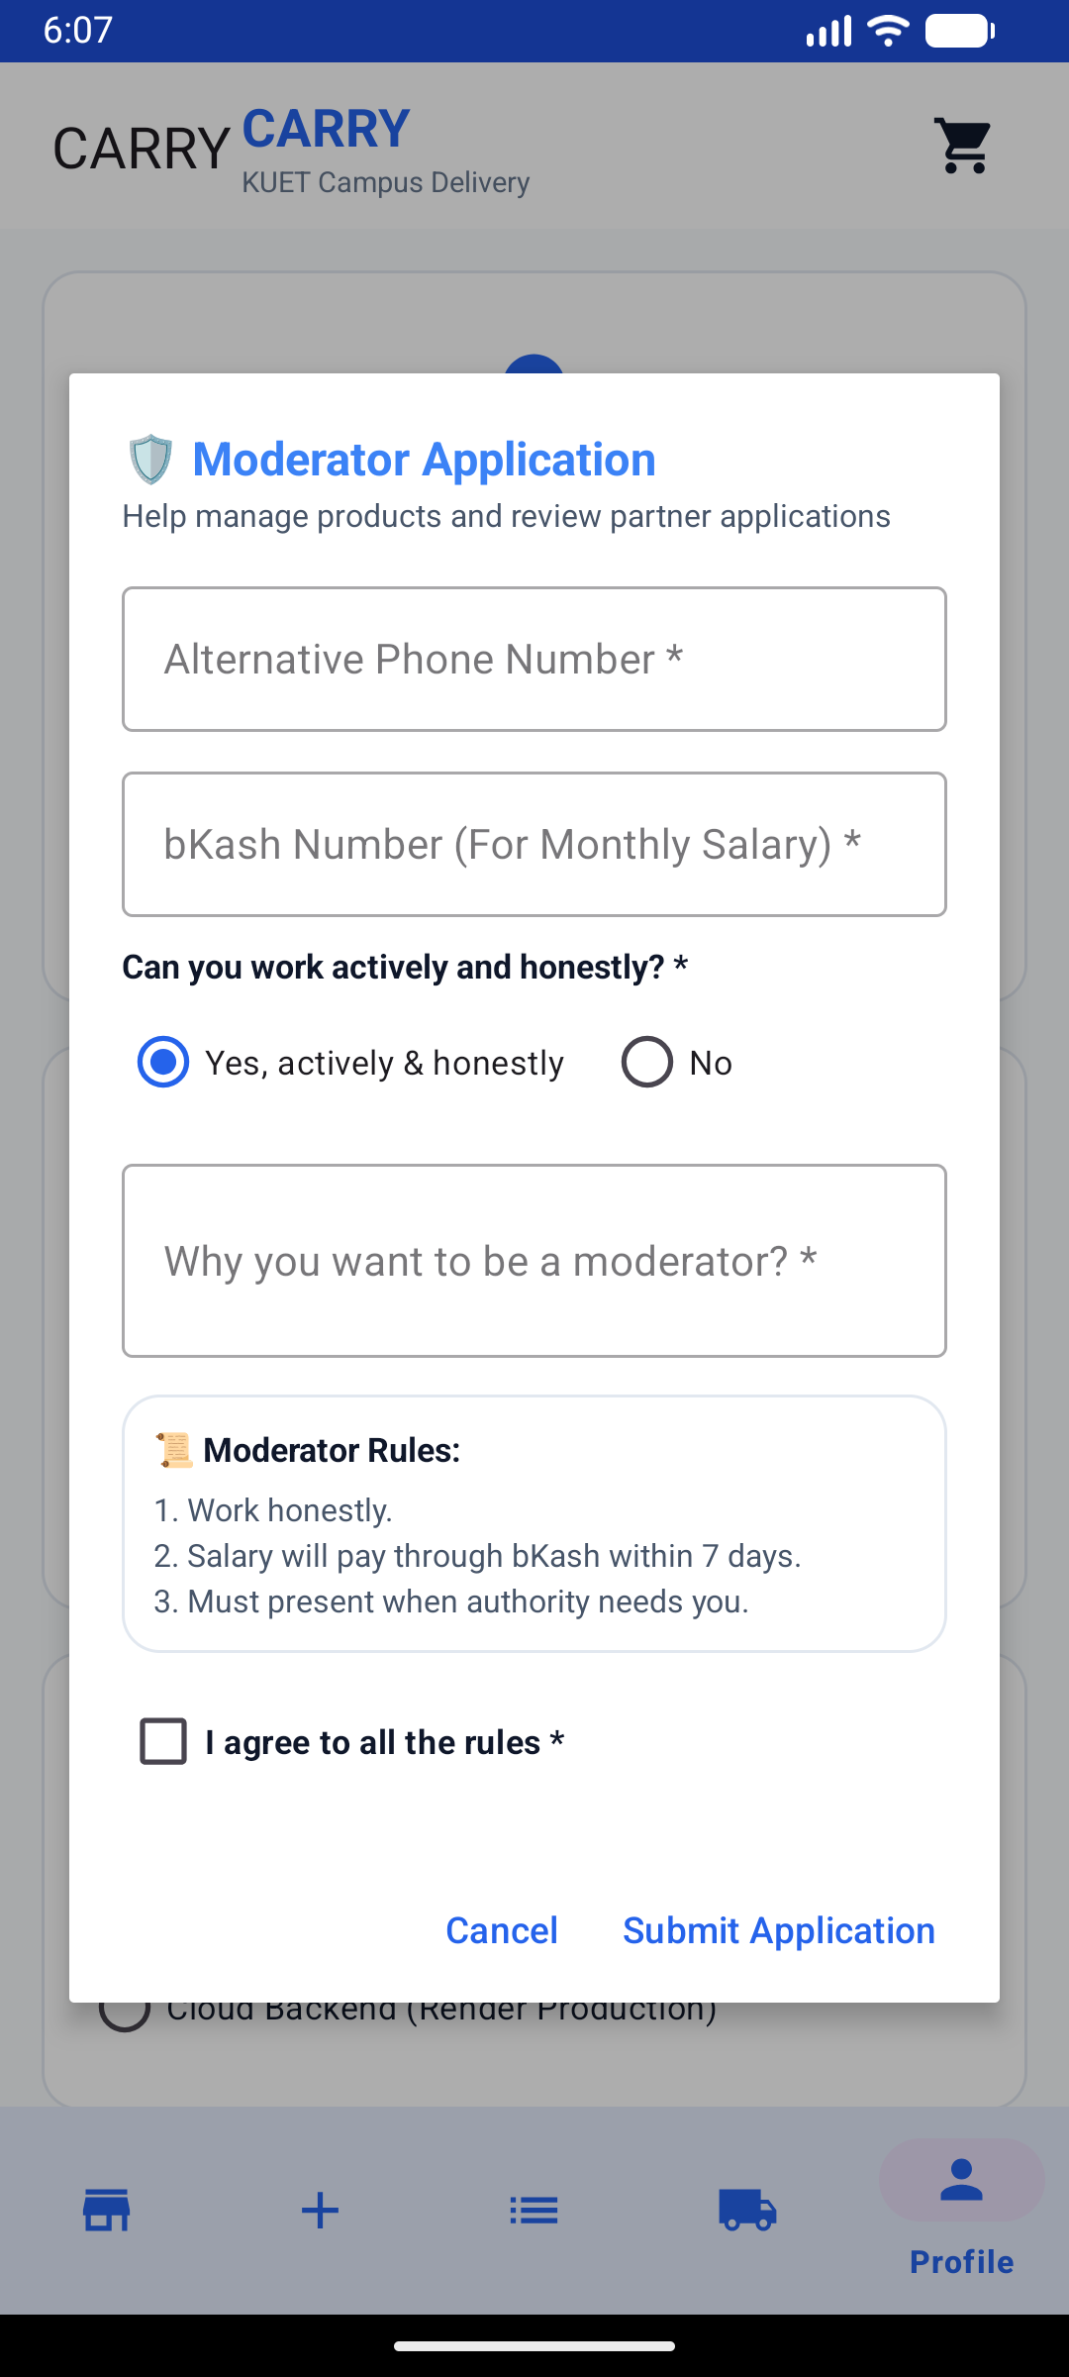
Figure 2.1a: Login Screen  KUET student email & pass | Figure 2.1b: Async Login  Dual-backend authentication | Figure 2.1c: Partner Application  Rules & bKash payout setup | Figure 2.1d: Moderator Form  Community audit application

2.2 Product Catalog, Browsing & Catalog Management
The Shop is the central marketplace hub. Students can browse curated campus products across categories like Food & Snacks, Electronics, and Stationery. Each item displays dynamic delivery fees, inventory pricing in BDT, and item quantities. Administrators can add, edit, or adjust catalog offerings directly from the Android app interface without accessing external web consoles.
- Category Filtering: Filter products by Food, Electronics, Stationery, or search by keyword.
- Instant Order Placement: Adjust quantity counter with +/- buttons and trigger immediate order checkout.
- Add New Product Dialog: Input product name, category selection, BDT pricing, and image URL.
- Catalog Controls: Full administrative options to modify live prices or remove outdated items.
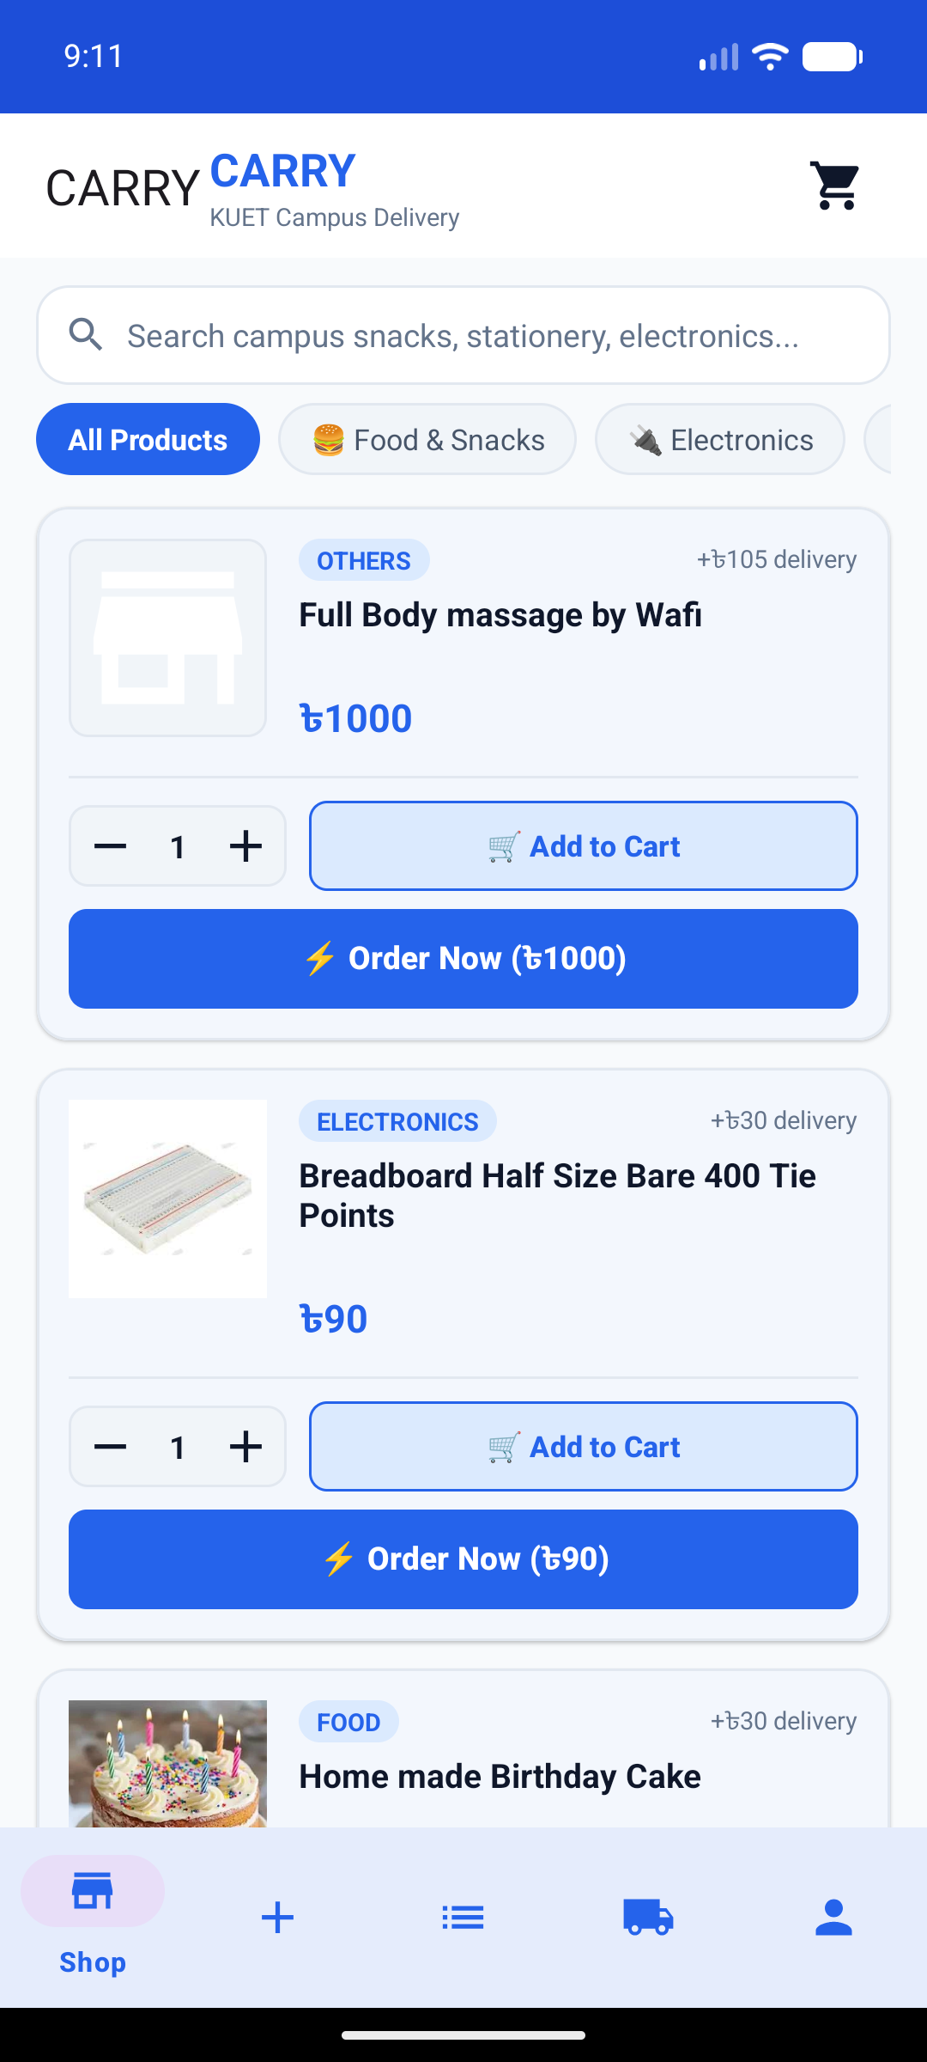 | 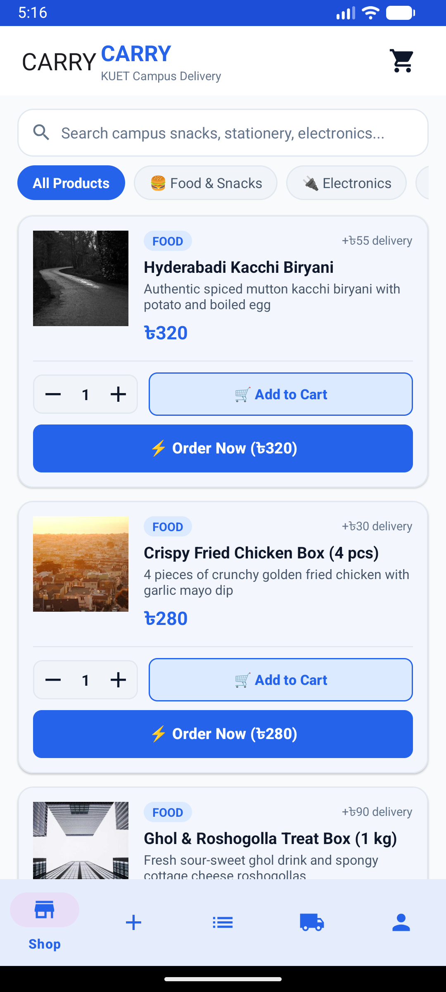 | 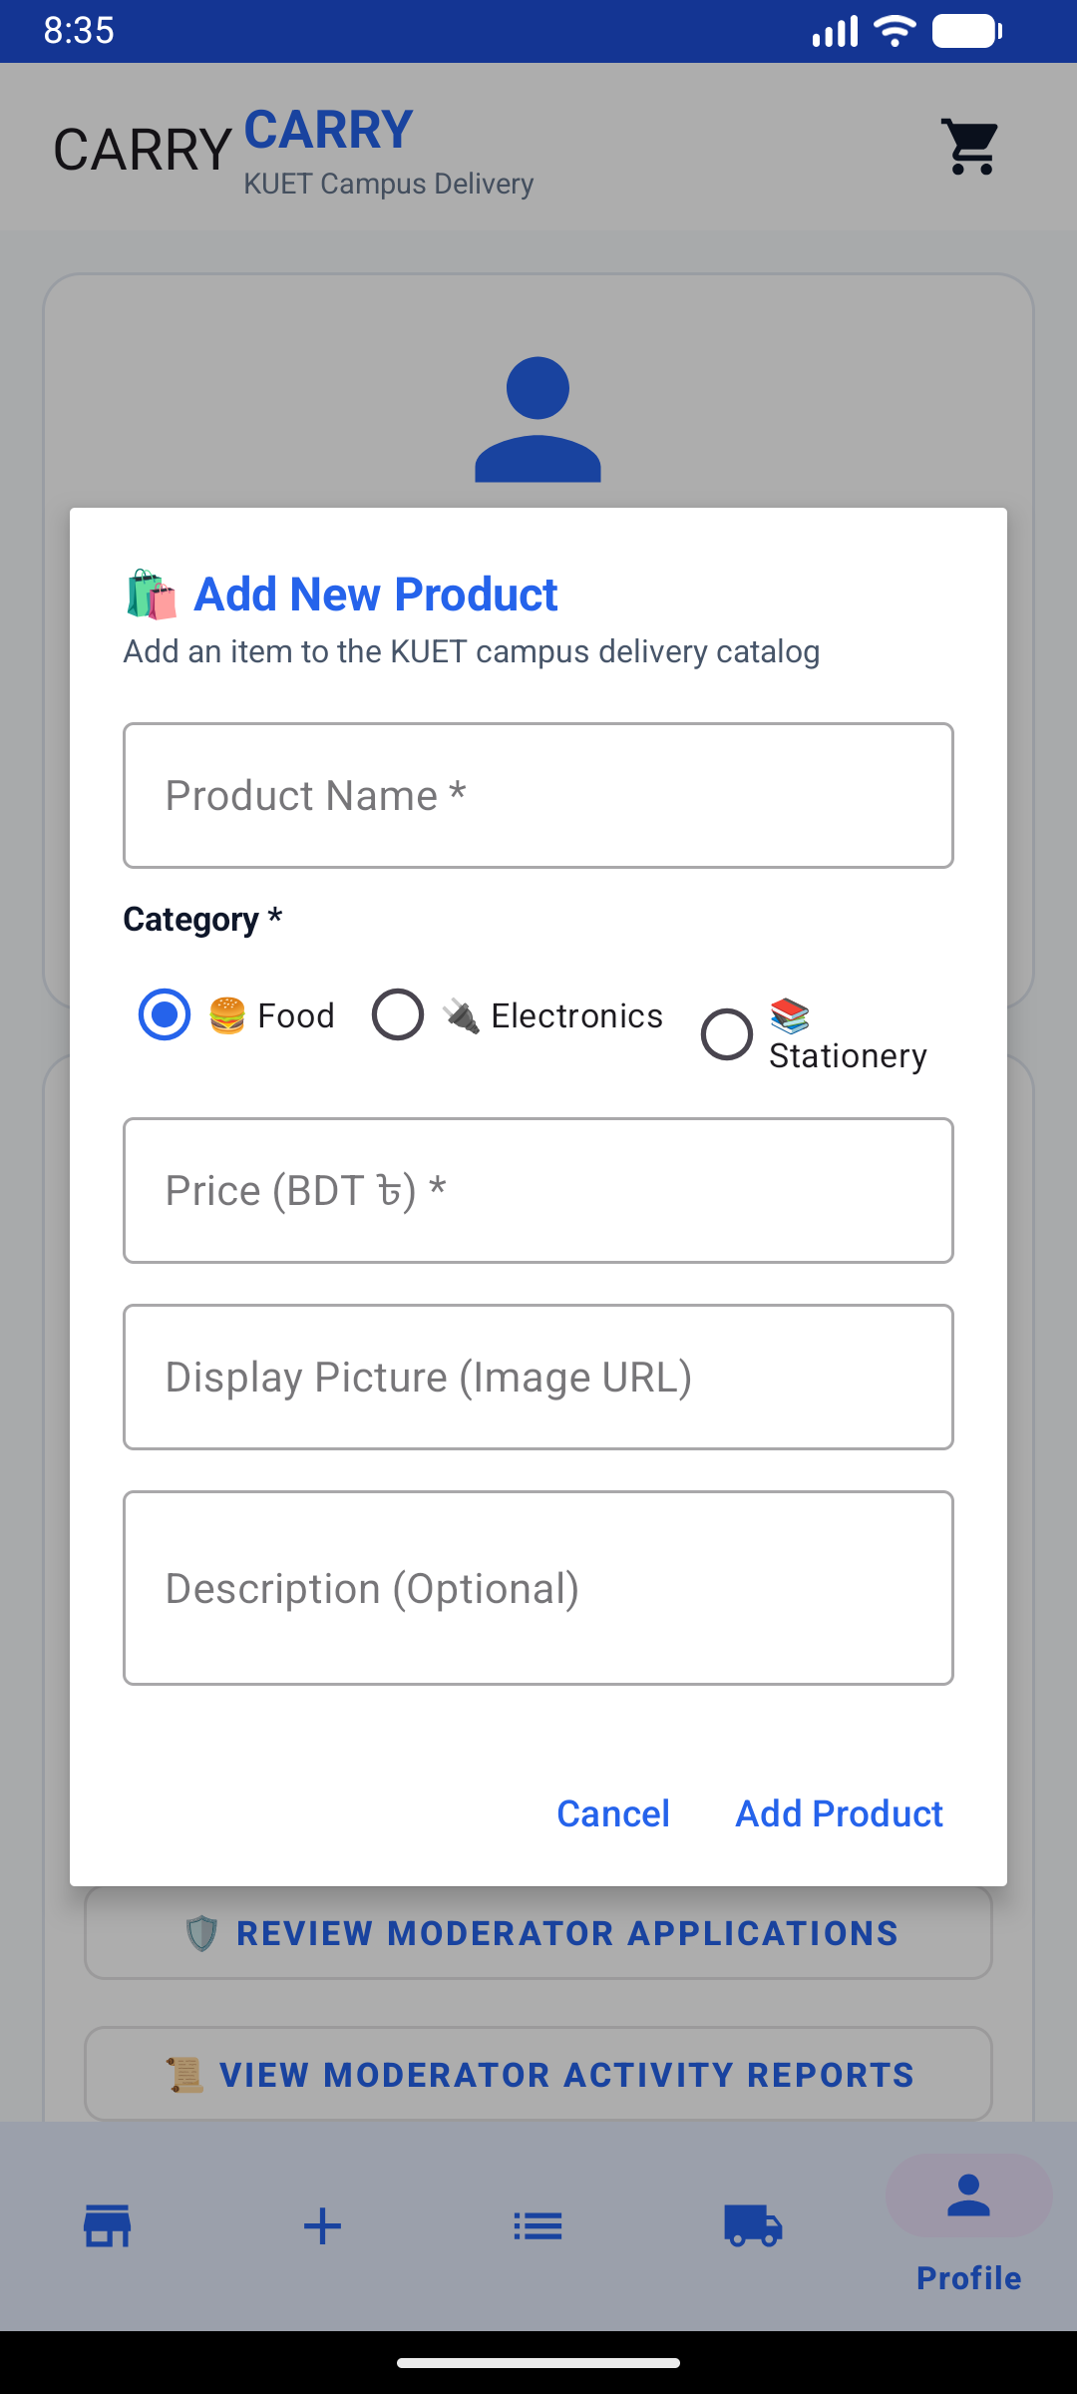 | 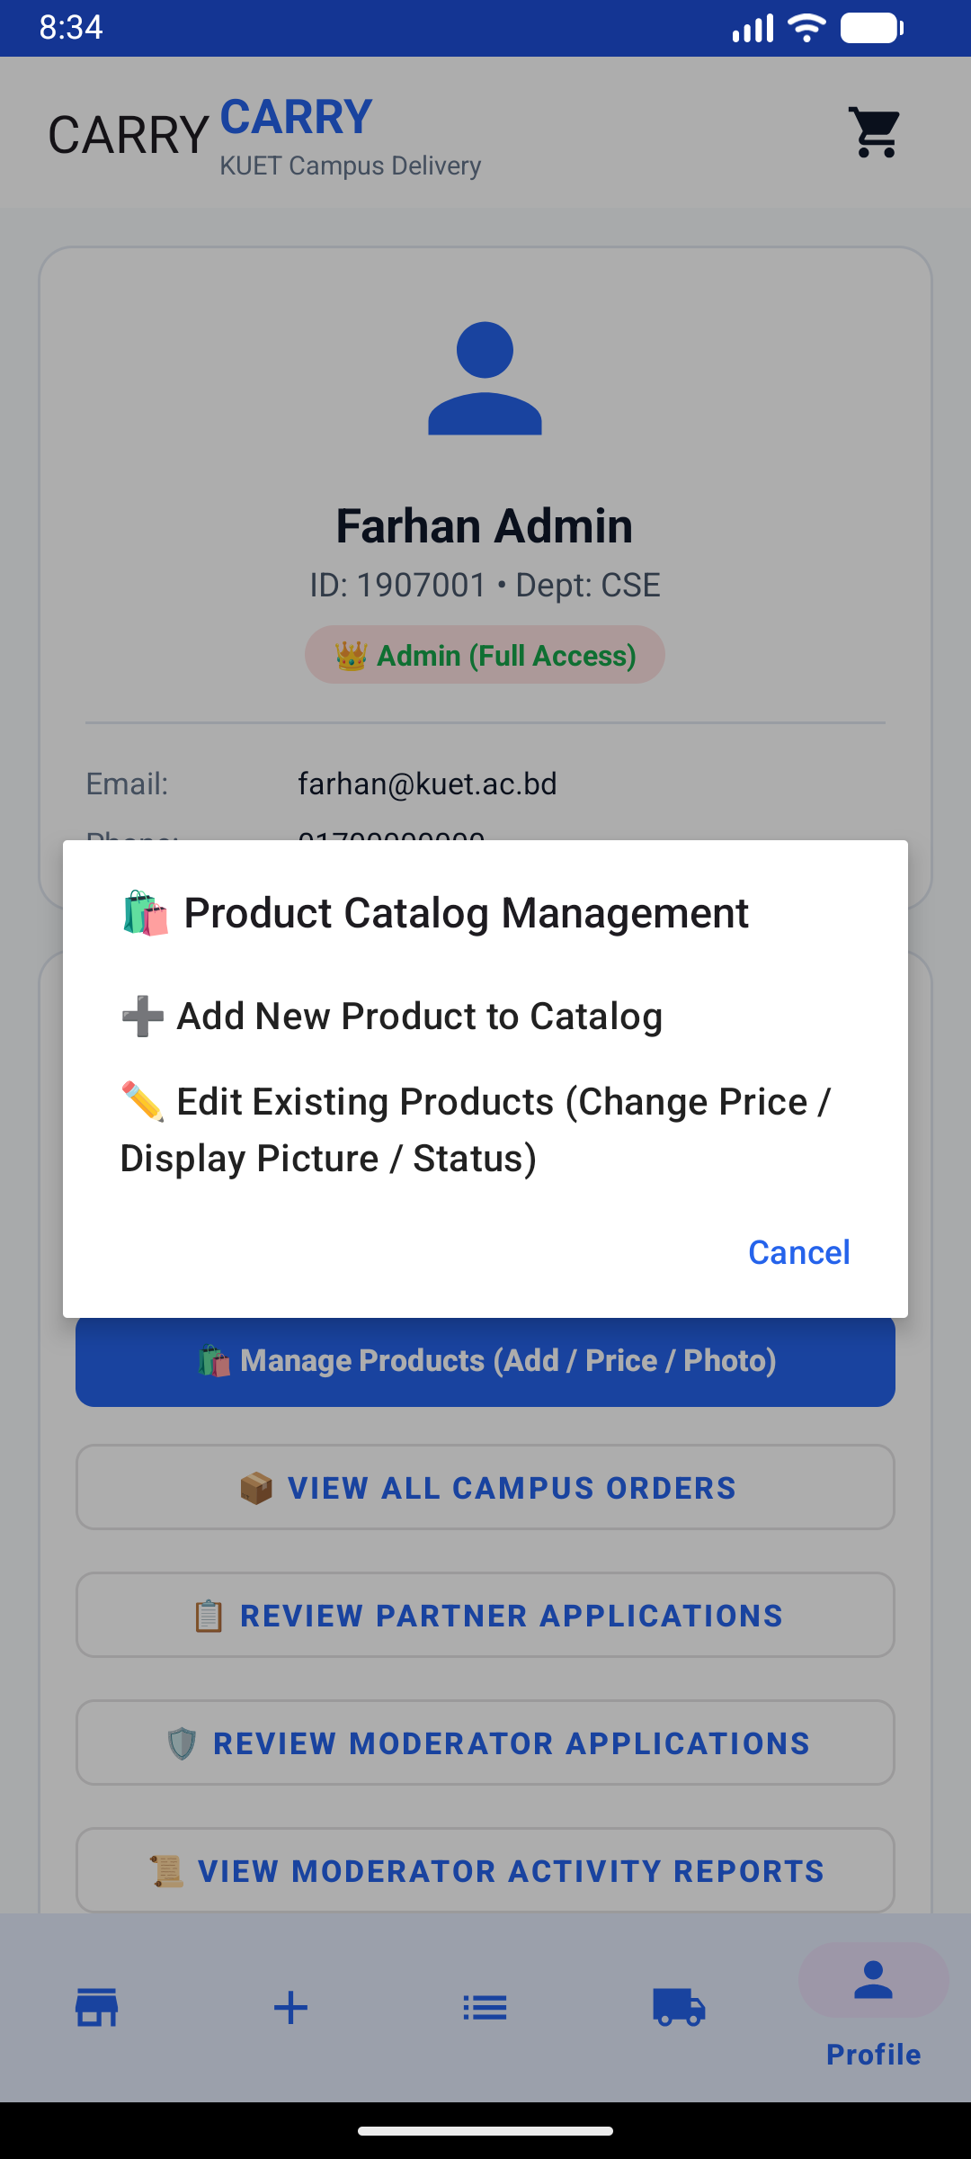
Figure 2.2a: Main Catalog  Full campus product browse | Figure 2.2b: Category Filter  Food items & delivery rates | Figure 2.2c: Add New Product  Admin dialog for catalog items | Figure 2.2d: Catalog Operations  Manage & edit product prices

2.3 Order Lifecycle, Live Deliveries & Real-Time Chat
Once an order is created, it transitions through a defined lifecycle (PENDING -> MATCHED -> COLLECTED -> DELIVERED). Delivery partners see assigned orders on their Deliveries dashboard, where they can broadcast live GPS coordinates. Customers and partners can coordinate directly through a real-time Firestore chat channel that alerts participants if the counterpart is not yet online.
- My Requests Tab: Track all active and completed requests with status badges and bKash payment verification.
- Deliveries Dashboard: Shows active trip status (In City, Returning, Done), matched orders, and GPS broadcast.
- Order-Scoped Chat: Low-latency Firestore messaging with status warning banner for offline recipients.
- Custom Order Posting: Request off-catalog items from Khulna with budget, pickup landmark, and upfront deposit.
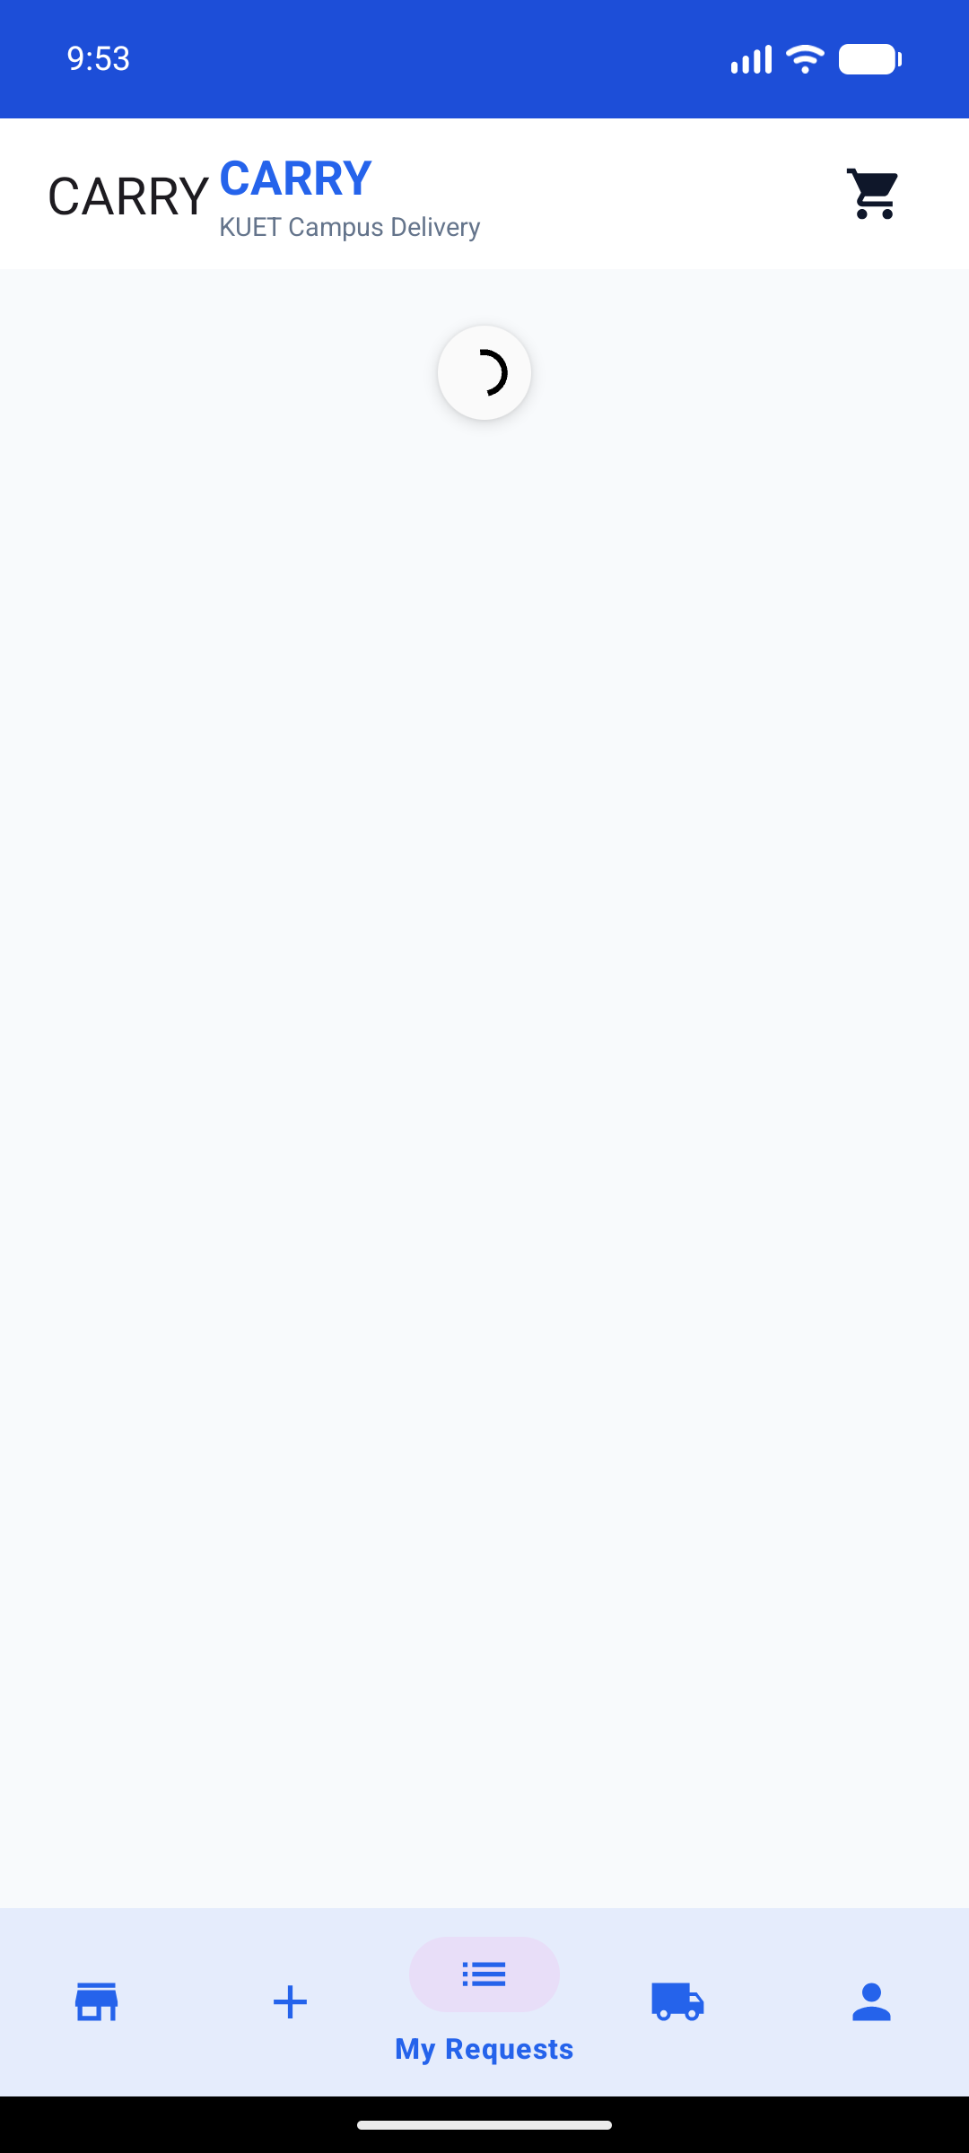 | 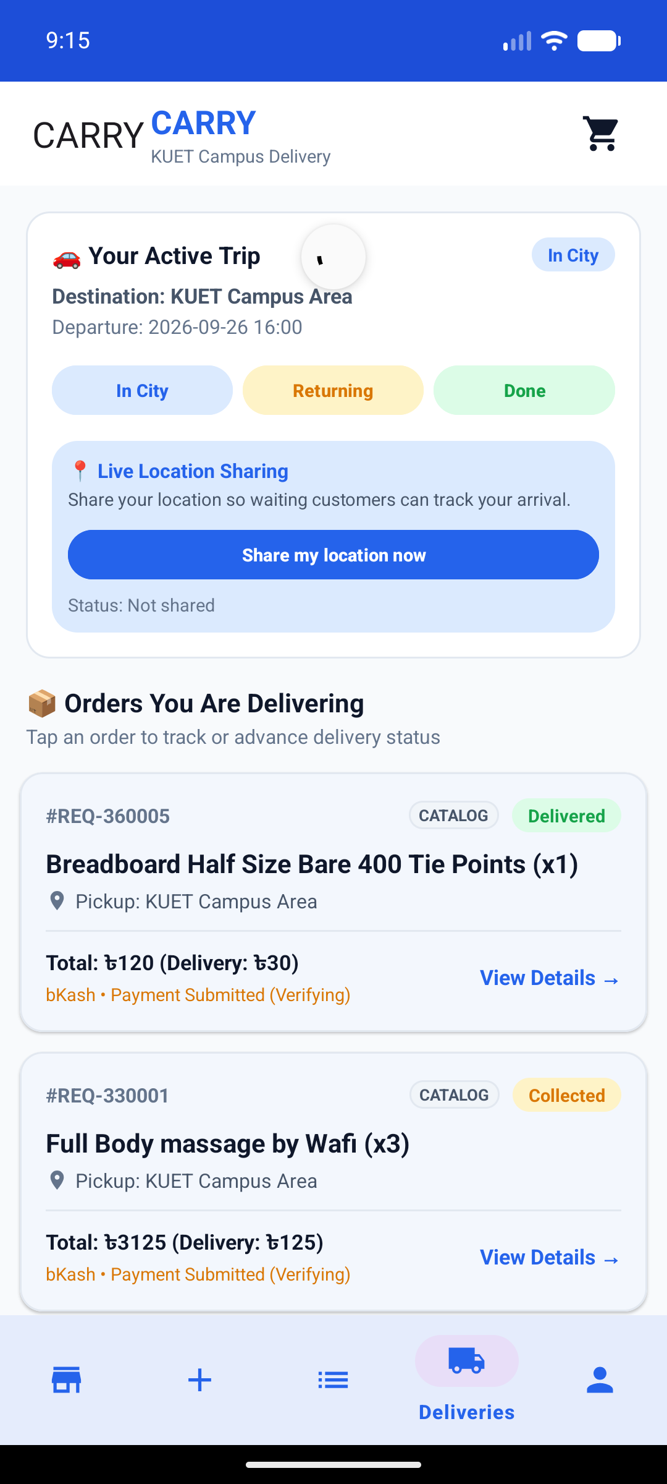 | 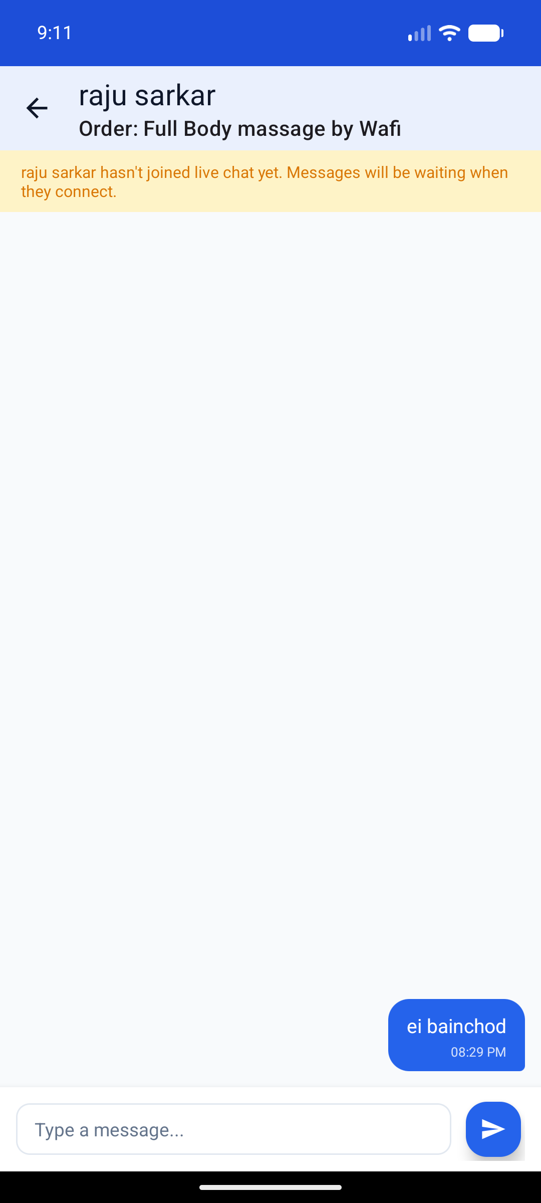 | 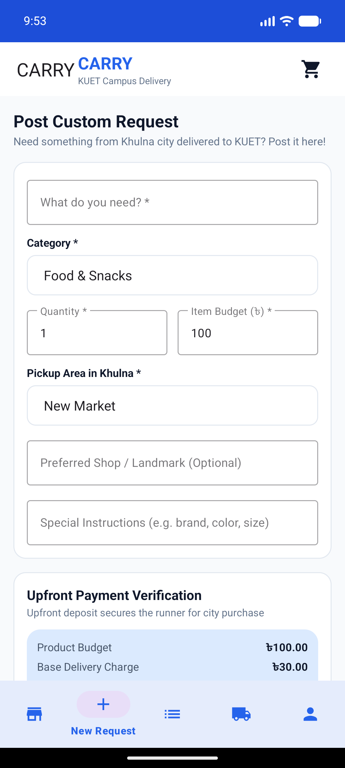
Figure 2.3a: My Requests  Customer active order list | Figure 2.3b: Deliveries Tab  Active trip & live GPS sharing | Figure 2.3c: Live Order Chat  Real-time Firestore messaging | Figure 2.3d: Custom Request  City item pickup with budget

2.4 Profile Administration & Full Management Operations
The Profile screen acts as the identity center for students and the operational command center for platform administrators. It displays academic verification details (Department, Student ID, Email, Phone), role permission badges, backend server environment toggles (Local vs Cloud Production), and full audit dashboards for user accounts and campus-wide orders.
- Profile & Roles: Visualizes name, department, contact info, and role privilege badge.
- Admin Authority Card: Centralized buttons for user management, catalog adjustments, and application approvals.
- User Account Management: Live listing of registered students with ID tags, email, and authority level.
- Order Details Modal: Audit modal displaying item summary, buyer name, matched trip ID, budget, and timestamp.
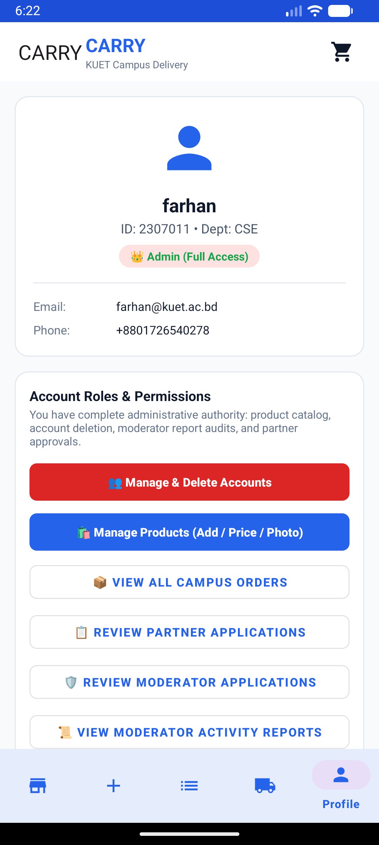 | 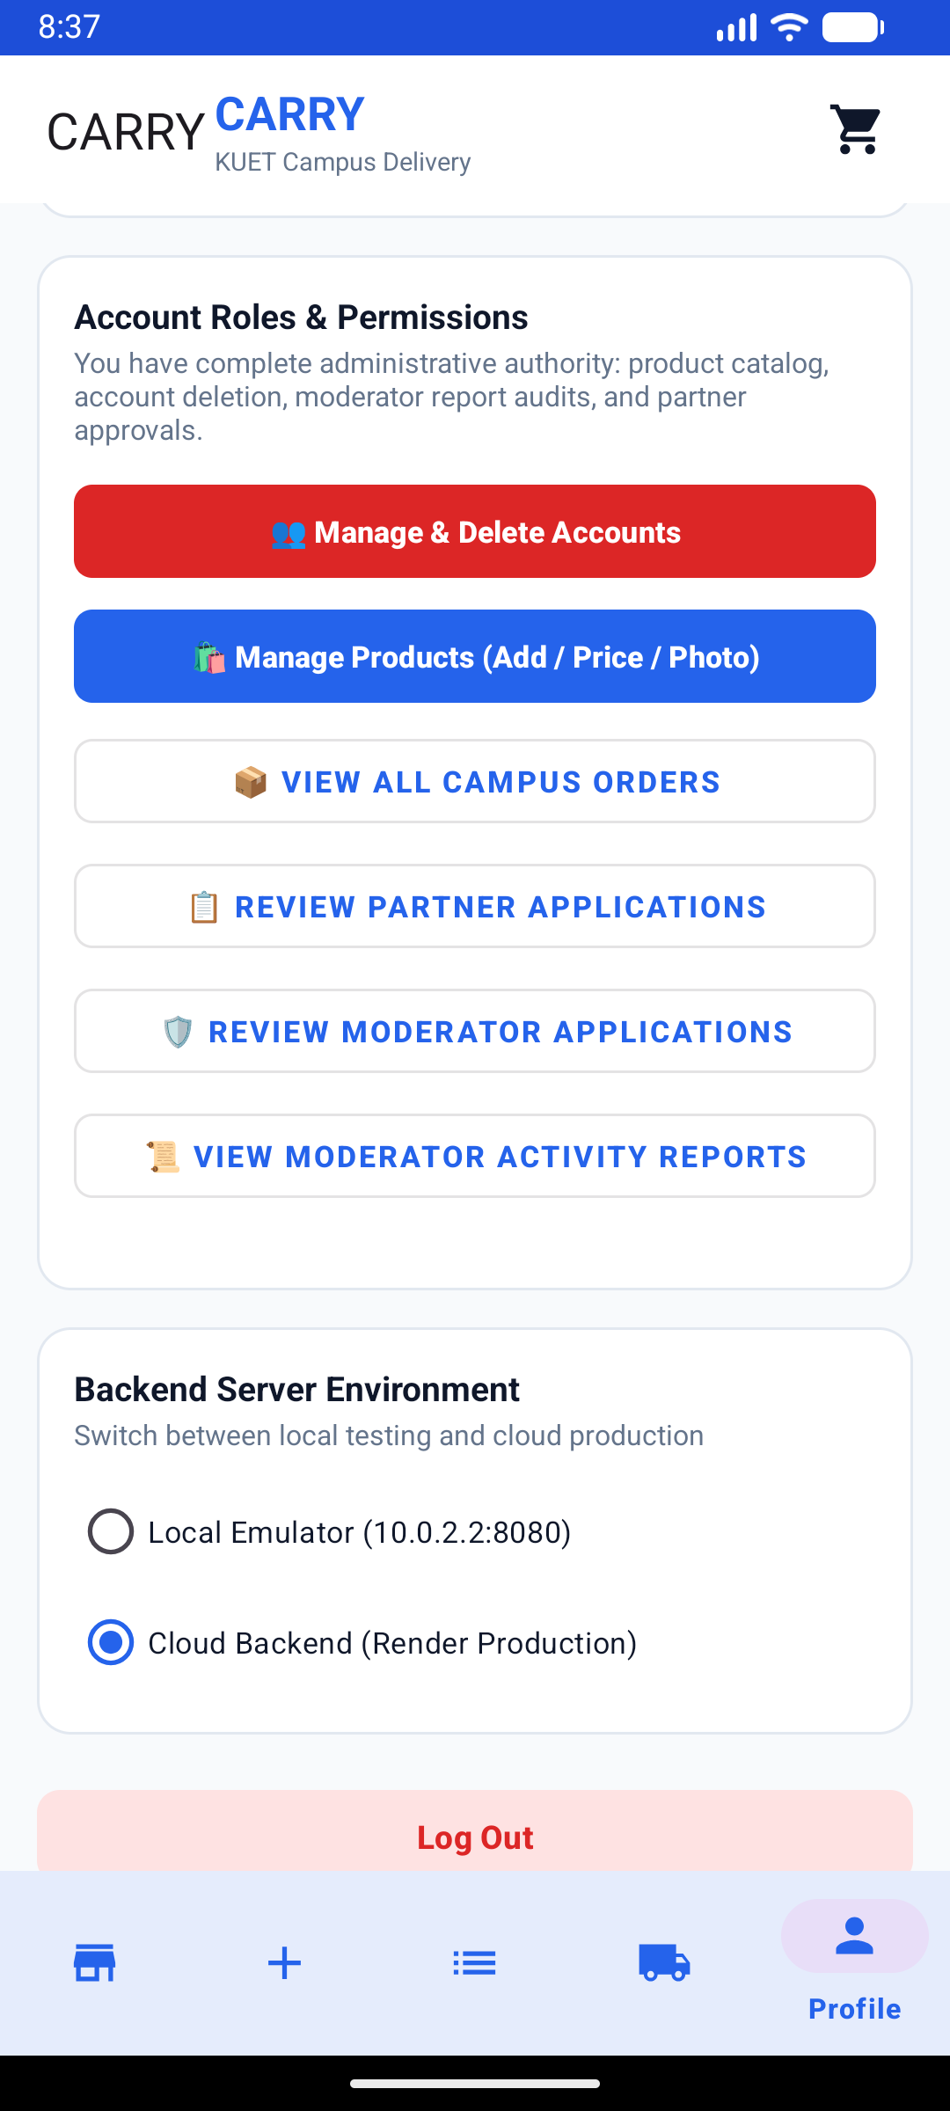 | 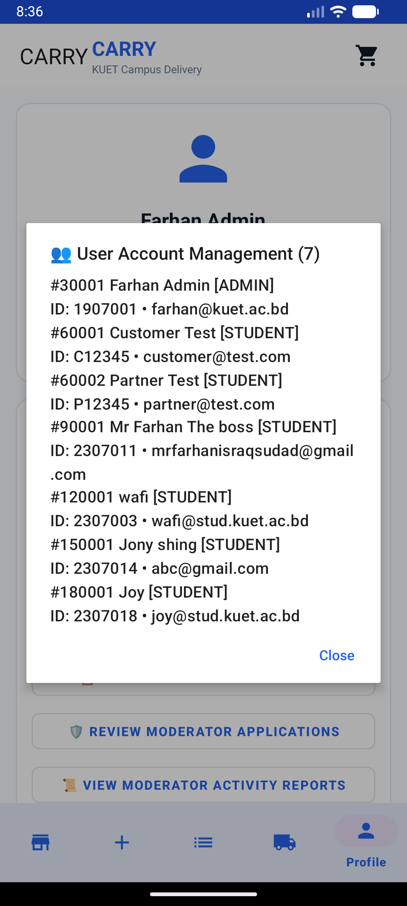 | 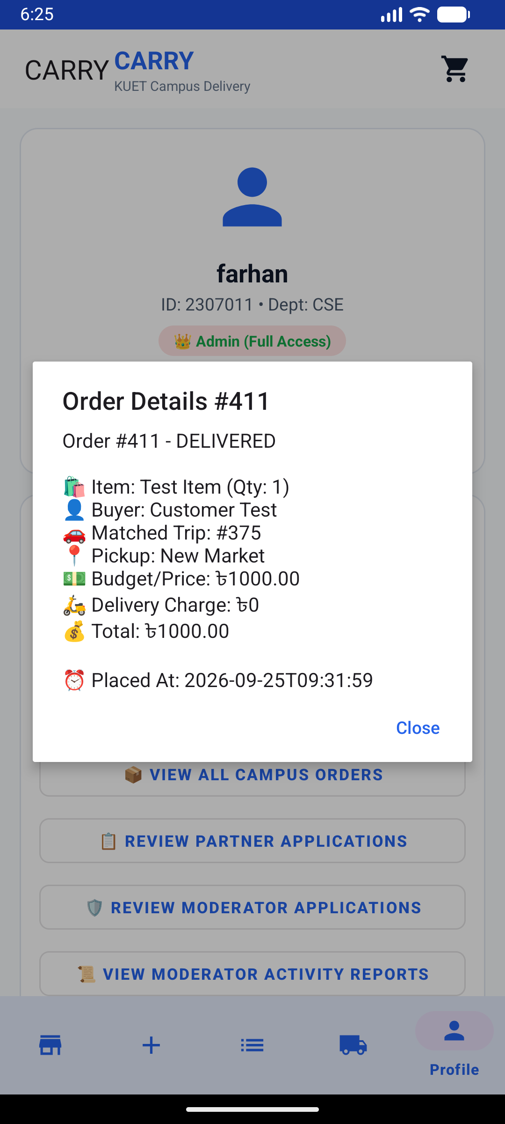
Figure 2.4a: Admin Profile  Verification & role controls | Figure 2.4b: Admin Center  Operations & report audit options | Figure 2.4c: User Management  Registered campus accounts | Figure 2.4d: Order Audit #411  Detailed delivery breakdown

3. 3D System Architecture
CARRY implements a decoupled, modern multi-tier architecture. The native Android application coordinates with two synchronized cloud backends: a high-throughput REST API for transactional business entities, and Google Firebase for real-time live events, chat, and cloud security enforcement.
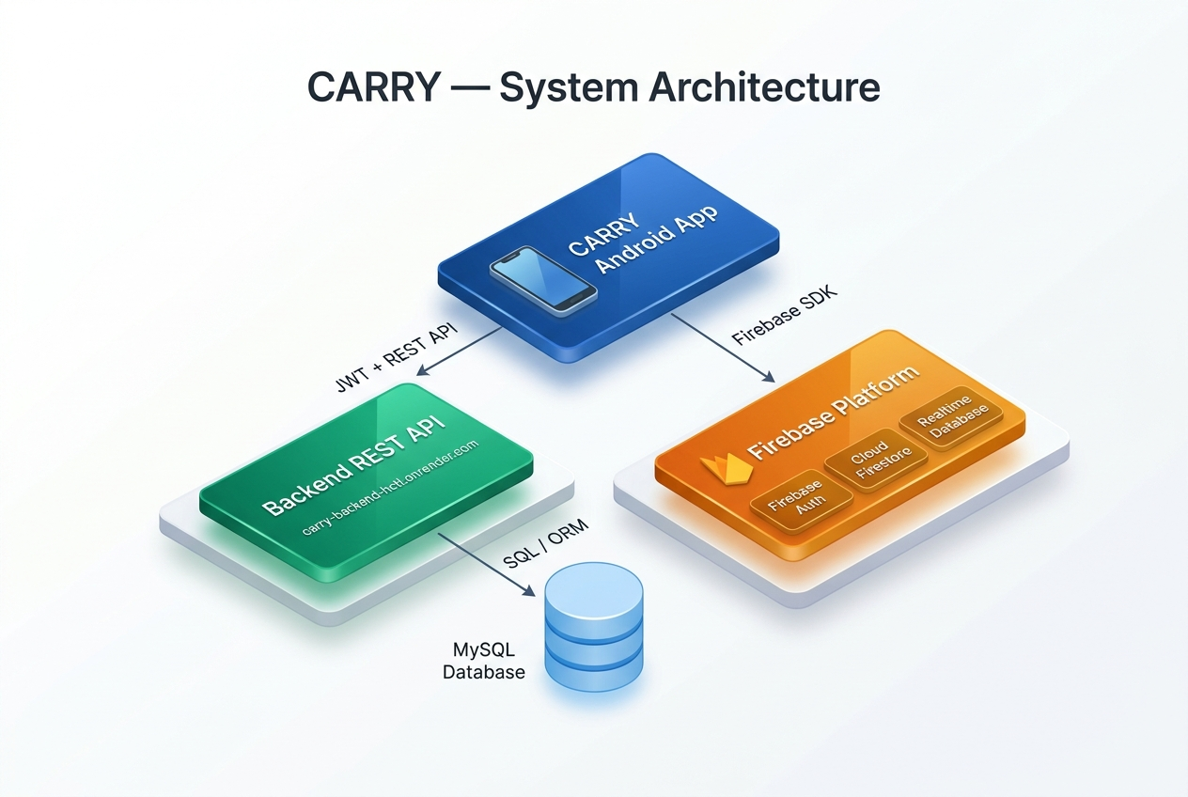
Figure 3: Clean 3D System Architecture Diagram — CARRY Android Platform

Architecture Tier Breakdown
Architecture Tier | Key Responsibilities & Components
UI Presentation Layer  (Android Jetpack) | Activities, Fragments, RecyclerViews, ViewBinding, and Material Components. Handles user gestures and updates UI state reacting to LiveData.
State & ViewModel Layer | Maintains UI state across orientation changes, sanitizes form inputs, and dispatches asynchronous tasks to repository classes without leaking context.
Network & Repository Layer | Retrofit 2 client with OkHttp interceptors providing JWT Bearer token authentication for all transactional REST requests.
Firebase Gateway Layer | Clean interface abstractions (ProfileStore, LiveStatusStore, ChatStore) isolating Firebase SDK implementations from the UI.
Cloud Backend REST API | Hosted cloud REST API managing core relational business logic, products, trips, orders, and user authentication backed by MySQL.
Firebase Cloud Infrastructure | Firebase Authentication, Cloud Firestore (chat & profiles), and Realtime Database (status nudges & driver GPS coordinates).

4. 3D Application Workflow
The CARRY application coordinates two parallel user flows that synchronize during order matching, status advancement, live location sharing, and messaging. The 3D flowchart below illustrates the complete journey from registration to order fulfillment.
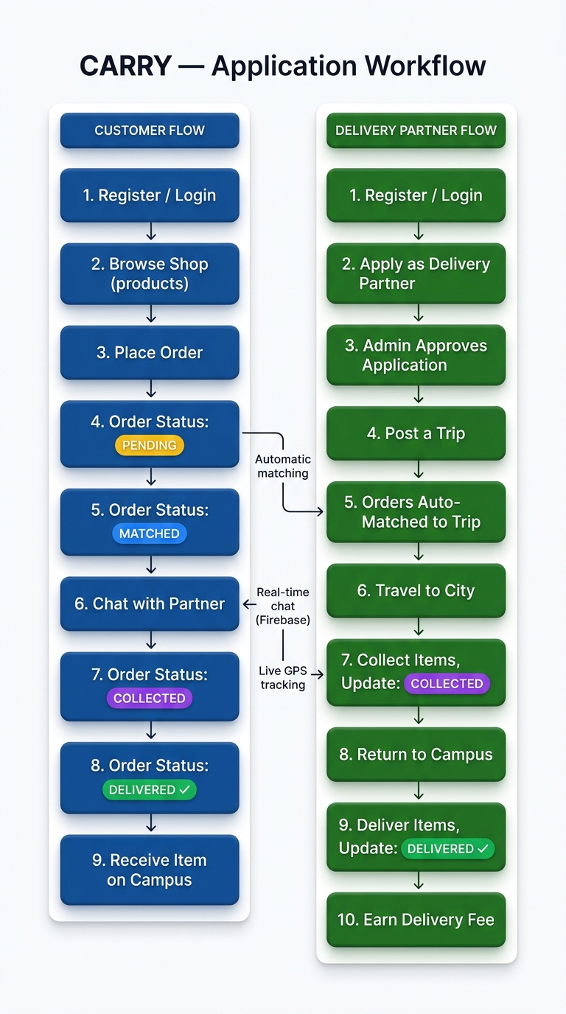
Figure 4: 3D Dual-Role Workflow Flowchart — Customer & Delivery Partner Lifecycles

Customer Journey vs. Partner Journey
Customer Workflow (Blue) | Delivery Partner Workflow (Green)
1. Register / Sign in with student email  2. Browse catalog or create custom request  3. Place order with bKash deposit verification | 1. Register / Sign in with student email  2. Apply as Delivery Partner from profile  3. Admin verifies and approves partner status
4. Order enters PENDING status queue  5. Automatically matched when a trip matches destination | 4. Post a scheduled trip to Khulna city  5. View automatically matched student orders
6. Open live chat to coordinate with partner  7. Receive live status updates & driver GPS | 6. Travel to city, purchase and collect items  7. Mark status: COLLECTED with live GPS broadcast
8. Meet partner at designated campus hall  9. Confirm item receipt; order marked DELIVERED | 8. Return to KUET campus with items  9. Hand over packages and mark DELIVERED  10. Receive delivery compensation

5. Backend REST API & Database Models
The core relational backend is deployed in the cloud at: https://carry-backend-hctl.onrender.com/. Communication is handled using standard HTTP verbs with JSON payloads. Every authenticated request attaches the JWT bearer token in the HTTP Authorization header.

Primary REST API Endpoints
HTTP Method | Resource Route | Functionality & Access
POST | /api/auth/register | Creates new student account with student ID and department.
POST | /api/auth/login | Authenticates user credentials and returns JWT bearer token.
GET | /api/users/me | Fetches logged-in student profile, contact info, and role.
GET | /api/products | Retrieves the active product catalog and category filters.
POST | /api/product-requests | Submits a new order with quantity and delivery budget.
GET | /api/product-requests/my | Retrieves all orders placed by the current student.
POST | /api/trips | Posts an upcoming delivery trip (restricted to approved partners).
GET | /api/trips | Lists all upcoming city trips available for matching.
PATCH | /api/product-requests/{id}/status | Advances order state (PENDING -> COLLECTED -> DELIVERED).
POST | /api/delivery-partner-applications | Submits student application for delivery partner accreditation.
GET | /api/admin/users | Retrieves all registered platform accounts (Admin only).

Representative JSON API Payloads
Authentication Response (POST /api/auth/login):
{
"token": "eyJhbGciOiJIUzI1NiJ9.eyJzdWIiOiJmYXJoYW5Aa3VldC5hYy5iZCIsImlhdCI6MTc5ND...",
"user": {
"id": 30001,
"fullName": "Farhan Admin",
"studentId": "1907001",
"email": "farhan@kuet.ac.bd",
"role": "ADMIN",
"department": "CSE"
}
}

6. Firebase Services Setup & Real-Time Sync
Firebase powers low-latency, real-time features across the Android application under Project ID 'carry-56e49'. The four key setup screens below demonstrate the production configuration in the Firebase Console: User Authentication registry, Email/Password sign-in provider, Realtime Database instance (carry-56e49-default-rtdb), and Cloud Firestore setup.
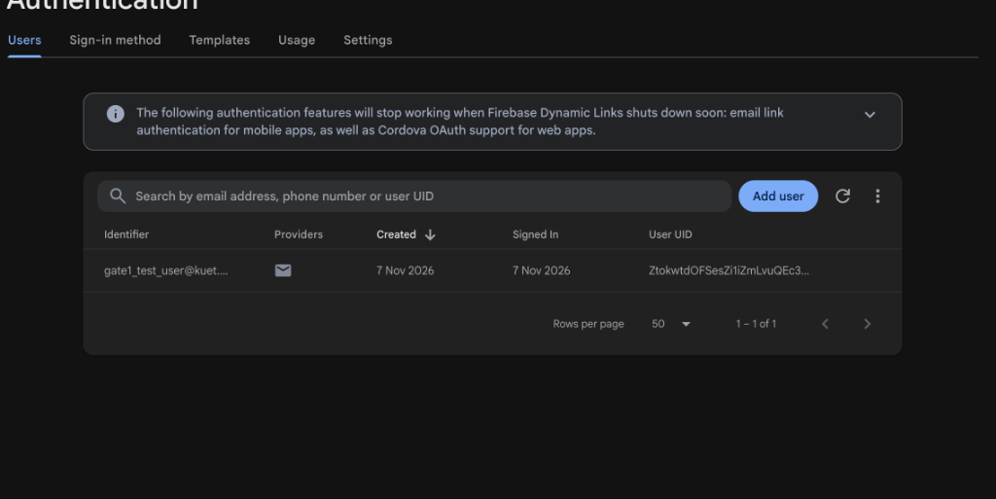 | 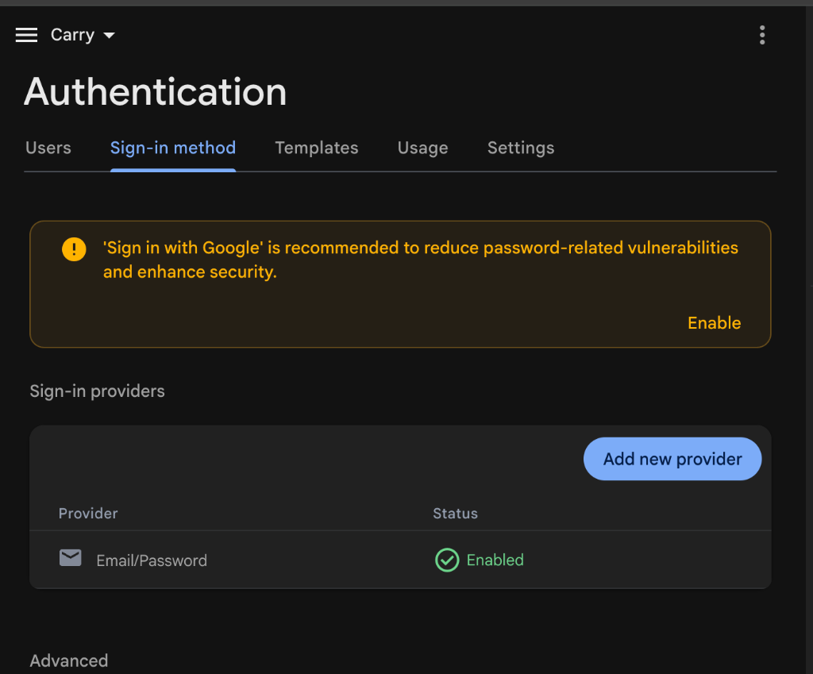
Figure 6a: Firebase Auth — Users Registry  Mirrored KUET student email accounts | Figure 6b: Auth Provider Setup  Email/Password sign-in enabled
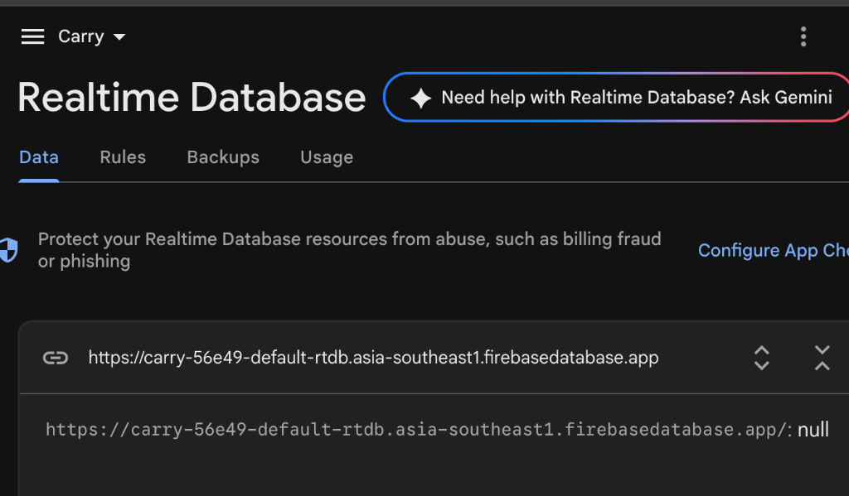 | 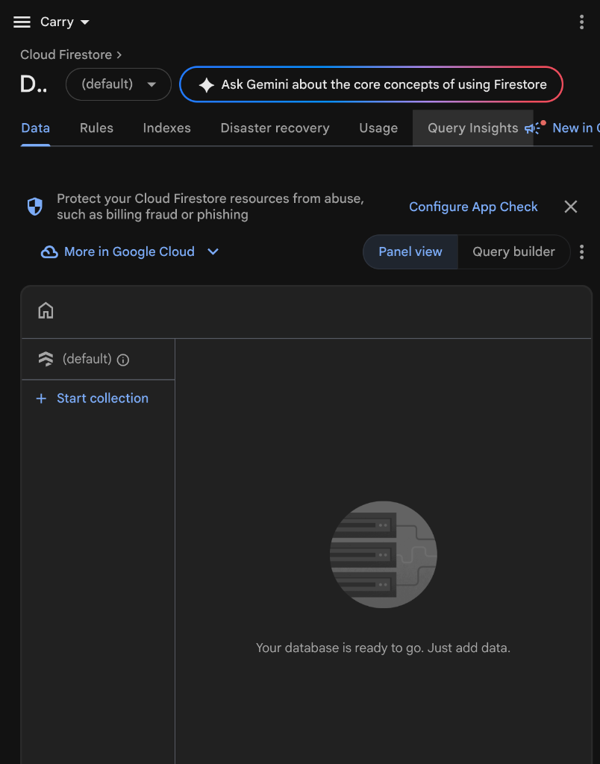
Figure 6c: Realtime Database  Nudge events & GPS live tracking | Figure 6d: Cloud Firestore Console  User profiles & chat message rooms

Cloud Data Schema Specifications
- Cloud Firestore `users/{firebaseUid}`: Stores student name, ID, department, phone, role, and Base64 photo.
- Cloud Firestore `chats/{requestId}/messages/{messageId}`: Holds senderId, messageText (1-500 chars), and timestamp.
- Realtime Database `orderEvents/{requestId}`: Low-latency status nudge payloads consumed by background listeners.
- Realtime Database `tripLocations/{tripId}`: Latitude, longitude, heading, and accuracy timestamp for live driver tracking.

7. Security Rules & Role-Based Access Control
CARRY adopts a defense-in-depth security approach. Data access is verified both at the application gateway level and enforced at the database layer via strict security rules:
- Dual-Token Validation: Every API call verifies a valid signed JWT bearer token; invalid tokens trigger immediate HTTP 401.
- Firestore Security Rules: Rules enforce that students can only read and write their own profile document. Chat message read and write access is strictly limited to the order's customer and matched delivery partner.
- Realtime Database Rules: Authenticated-only write access to `orderEvents` and `tripLocations` ensuring that location spoofing is prohibited.
- Zero-Cost Quota Guard: Client-side image scaling ensures profile photos never exceed 256x256 pixels, keeping all documents well under 100KB to prevent quota exhaustion.
- Admin Authority Boundaries: Administrative operations (user deletion, catalog management, application approvals) require both client-side role check and server-side authorization.

8. Project Summary & Conclusion
The CARRY Android project successfully delivers a complete, robust, and intuitive peer-to-peer delivery solution tailored to the KUET student community. Built entirely with pure Java for Android, the application combines responsive UI design, dependable REST backend communication, and instant real-time synchronization through Firebase.

Delivered Capabilities Summary
- 100% pure Java native Android application built with ViewBinding and MVVM architecture.
- Dual-backend synchronization between custom cloud REST services and Google Firebase.
- Comprehensive campus product catalog with category navigation and custom off-catalog city requests.
- End-to-end delivery partner matching, trip management, and order status lifecycle tracking.
- Order-scoped real-time messaging with live connection warnings and zero battery waste.
- Live GPS tracking for campus delivery partners integrated with Google Maps.
- In-app administration center for user auditing, catalog management, and role approvals.
- Hardened, production-ready Firebase security rules across all databases.

