PygameTkinterGUITools
Student Guide
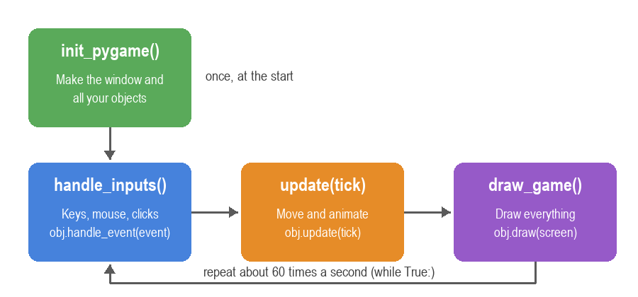
Buttons, menus, sprites, levels and effects for your pygame games.
One idea per page. Look at the picture, copy the code, then change it.

How to use this guide
Every page looks the same, so you always know where to look.
Each page shows one thing you can add to your game:
- A picture of what it looks like.
- The smallest code that makes it work.
- "Change it" ideas to try next.
- A "Watch out!" box with the most common mistake.
- The example file that shows it working.
The colour tells you WHERE the code goes
Your game has four functions. Each code box has a coloured tag:
init_pygame()
# make your objects here - runs ONCE at the start
handle_inputs()
# pass every event to your objects
update(tick)
# move and animate things - runs 60 times a second
draw_game()
# draw everything onto the screen

If a box says update(tick), put that code inside your update(tick) function. That's it!

Tip: Lines starting with # are comments. They explain the code - you don't have to type them.

1. Getting started

Add the library to your project, then learn the game loop that every program in this guide uses.

Add the library to your project
One file is all you need.
- Go to github.com/Mr-Foxs-git/PygameTkinterGUITools
- Click PygameTkinterGUITools.py, then the Download button (the arrow).
- Put the file in the SAME folder as your game's .py file.
- Add this line to the top of your game:
top of your file
import pygame as pg
from PygameTkinterGUITools import *

Watch out! If you see ModuleNotFoundError, the file is in the wrong folder, or its name has changed (e.g. PygameTkinterGUITools (1).py). Rename it back.

Tip: Copy examples/_template.py to start a new game - it already has the game loop.

The game loop
Every game runs these four steps, about 60 times a second.
top of your file
init_pygame()
while True:
tick = clock.tick(FPS) # ms since the last frame
handle_inputs()
update(tick)
draw_game()

Change it
- Try FPS = 30. Does your game feel different?

Watch out! Never put while loops or time.sleep() inside these functions - the whole game freezes. Use timers instead (page on after).
See the example: examples/_template.py

The four functions
This is the whole template. You fill in the gaps marked >>>.
init_pygame()
def init_pygame():
global screen, clock, play_button
pg.init()
screen = pg.display.set_mode((WIDTH, HEIGHT))
clock = pg.time.Clock()
# >>> make your objects here
play_button = Button(20, 20, text="Play", command=play)
handle_inputs()
def handle_inputs():
for event in pg.event.get():
if event.type == pg.QUIT:
pg.quit()
sys.exit()
play_button.handle_event(event)
update(tick)
def update(tick):
pass # >>> obj.update(tick)
draw_game()
def draw_game():
screen.fill((30, 30, 30))
play_button.draw(screen)
pg.display.flip()

Watch out! Every object you make needs to be added to global in init_pygame(), or the other functions can't see it.

2. Buttons and widgets

Widgets are the parts of a menu: text, buttons, text boxes, sliders and lists.
They work like tkinter. Every widget has the same three jobs: handle_event(event), update(tick) and draw(screen).

Label
Shows text: a score, a title or a hint.
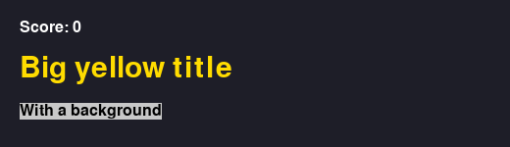
init_pygame()
score_label = Label(20, 20, "Score: 0")
title = Label(20, 60, "Big yellow title", fg=(255, 220, 0), font_size=32)
anywhere (e.g. in a command function)
score_label.config(text=f"Score: {score}") # change it later
draw_game()
score_label.draw(screen)

Change it
- Give it a background: bg=(40, 40, 120)
- Centre it: center=True

Watch out! Colours are (red, green, blue) with numbers from 0 to 255.
See the example: examples/label_example.py

Button
Runs a function when you click it.
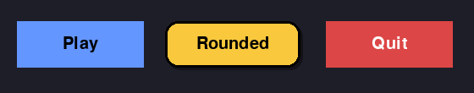
top of your file
def play():
print("Let's go!")
init_pygame()
play_button = Button(20, 20, 150, 50, "Play", command=play)
handle_inputs()
play_button.handle_event(event)
draw_game()
play_button.draw(screen)

Change it
- Colour it: bg=(220, 50, 50)
- Round corners: border_radius=12
- Grey it out: state="disabled"

Watch out! Write command=play, NOT command=play(). With the brackets, the function runs once straight away instead of when clicked.
See the example: examples/button_example.py

Hover
Buttons light up when the mouse is over them - for free.
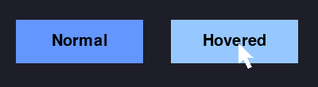
Change it
- Pick the hover colour: hover_bg=(120, 180, 255)

TextBox
Lets the player type, like a name.
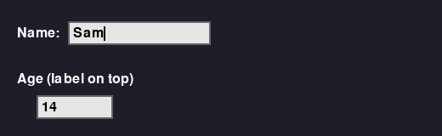
init_pygame()
name_box = TextBox(20, 20, max_chars=12, label="Name:", on_enter=start)
handle_inputs()
name_box.handle_event(event)
update(tick)
name_box.update(tick) # makes the cursor blink
draw_game()
name_box.draw(screen)
anywhere (e.g. in a command function)
name = name_box.get()

Watch out! Click the box first - it only takes typing when it has focus.
See the example: examples/textbox_example.py

Checkbutton and Radiobutton
Tick boxes (on/off) and pick-one-only choices.
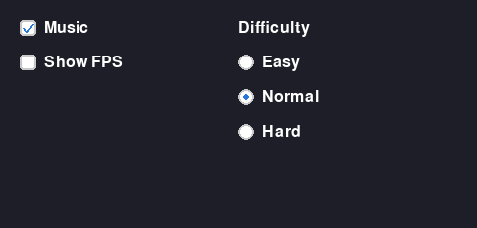
init_pygame()
music_on = BooleanVar(True)
level = StringVar("Normal")
music_box = Checkbutton(20, 20, "Music", variable=music_on)
easy = Radiobutton(200, 20, "Easy", variable=level, value="Easy")
hard = Radiobutton(200, 50, "Hard", variable=level, value="Hard")
anywhere (e.g. in a command function)
if music_on.get():
...
if level.get() == "Hard":
...

Watch out! Radiobuttons that share the SAME variable are one group. Give each group its own variable.
See the example: examples/checkbutton_radiobutton_example.py

Variables
A box that holds a value. Widgets linked to it update by themselves.
init_pygame()
volume = IntVar(50) # also StringVar, BooleanVar, DoubleVar
slider = Scale(20, 20, from_=0, to=100, variable=volume)
volume_label = Label(20, 70, textvariable=volume)
anywhere (e.g. in a command function)
volume.get() # read it
volume.set(80) # change it - the slider AND label move

Tip: Use a variable when two widgets show the same thing.

Scale and Spinbox
Pick a number by sliding or clicking arrows.
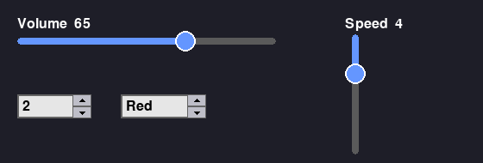
init_pygame()
players = IntVar(2)
picker = Spinbox(20, 20, from_=1, to=4, variable=players)

See the example: examples/scale_spinbox_example.py

Listbox and Combobox
Choose from a list. A Combobox drops down when you click it.
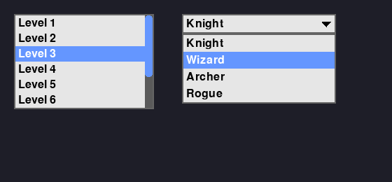
init_pygame()
levels = Listbox(20, 20, 200, rows=5, items=["Level 1", "Level 2", "Level 3"])
hero = Combobox(250, 20, 200, values=["Knight", "Wizard", "Archer"])
handle_inputs()
levels.handle_event(event)
hero.handle_event(event)
draw_game()
levels.draw(screen)
hero.draw(screen) # draw dropdowns LAST
anywhere (e.g. in a command function)
choice = hero.get()

Watch out! Draw a Combobox after everything else, or its open list hides behind other widgets.
See the example: examples/listbox_combobox_example.py

Message
Long text that wraps onto new lines - great for story and instructions.
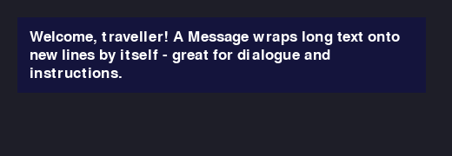
init_pygame()
intro = Message(20, 20, "Welcome, traveller! ...", width=400)

See the example: examples/message_example.py

Progressbar
Health bars, loading bars and energy meters.
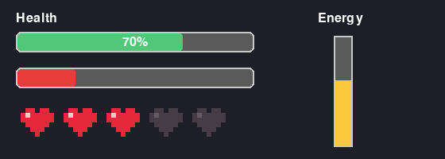
init_pygame()
health_bar = Progressbar(20, 20, 200, maximum=100, value=70)
anywhere (e.g. in a command function)
health_bar.config(value=40)

See the example: examples/progressbar_example.py

Tooltip
A little box that appears when the mouse rests on something.
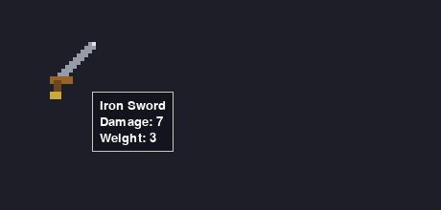
init_pygame()
tips = Tooltip()
tips.attach(sword, "Iron Sword\nDamage: 7")
update(tick)
tips.update(tick)
draw_game()
tips.draw(screen) # LAST

3. Laying out a menu

Instead of working out x and y for every widget, put them in rows and columns and let the library line them up.
This is just like tkinter: make a widget INSIDE a parent, then call .grid(), .pack() or .place().

Frame
A box that holds other widgets. Move or hide the frame and they all go with it.
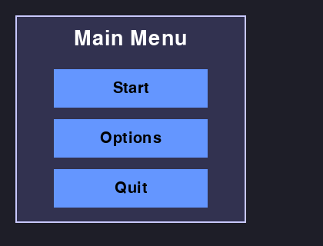
init_pygame()
menu = Frame(50, 50, 300, 220)
menu.add(Label(0, 0, "Main Menu"), Button(0, 40, text="Start"))
anywhere (e.g. in a command function)
menu.hide() menu.show()

See the example: examples/frame_example.py

grid - rows and columns
The easiest way to make a neat form.
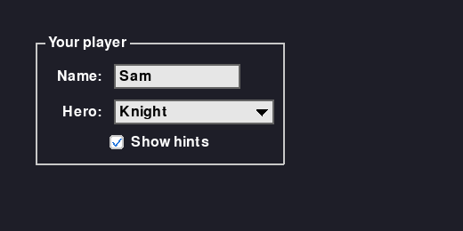
init_pygame()
root = Root(screen)
form = LabelFrame(root, text="Your player")
form.grid(row=0, column=0)
Label(form, text="Name:").grid(row=0, column=0)
TextBox(form).grid(row=0, column=1, sticky="w")
Label(form, text="Hero:").grid(row=1, column=0)
Combobox(form, values=["Knight", "Wizard"]).grid(row=1, column=1)
handle_inputs()
root.handle_event(event)
update(tick)
root.update(tick)
draw_game()
root.draw(screen)

Change it
- Stretch across: sticky="ew"
- Space around: padx=8, pady=4
- Span two columns: columnspan=2
See the example: examples/layout_example.py

The F1 debug view
Press F1 to SEE your rows, columns and mistakes.
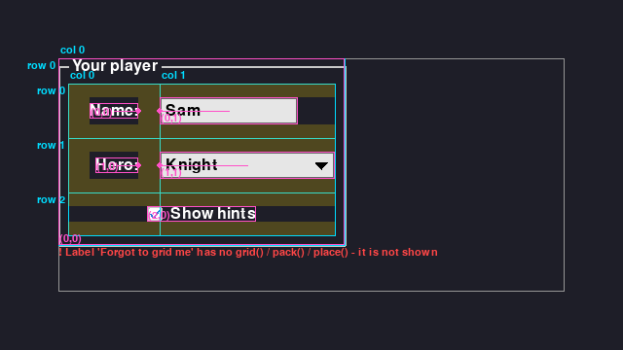
handle_inputs()
Debug.handle_event(event)

Watch out! Don't mix grid() and pack() inside the same frame. Pick one per frame.

Tip: Red text lists problems - like a widget you forgot to grid(), which is never shown.

LabelFrame and Notebook
A frame with a title, and pages with tabs.
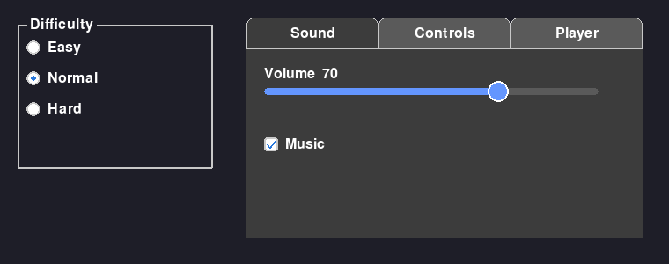
init_pygame()
group = LabelFrame(root, text="Difficulty")
tabs = Notebook(100, 50, 400, 300)
sound_tab = tabs.new_tab("Sound") # each tab is a Frame
Scale(sound_tab, from_=0, to=100).grid(row=0, column=0)

Popup
A window on top of the game: Game Over, Pause, Are you sure?
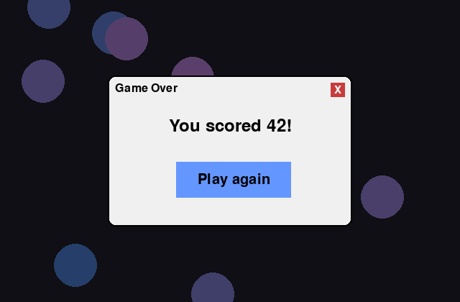
init_pygame()
popup = Popup(400, 300, 300, 200, "Game Over")
popup.add(Button(0, 60, text="Play again", command=restart))
anywhere (e.g. in a command function)
popup.show()
draw_game()
popup.draw(screen) # LAST

See the example: examples/popup_example.py

Question boxes
Ask Yes / No / Cancel with one line.
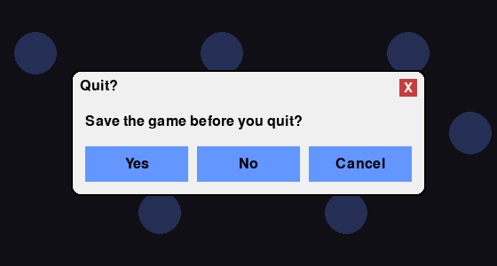
top of your file
def quit_answer(answer): # True (Yes), False (No) or None (Cancel)
if answer is not None:
pg.quit()
sys.exit()
handle_inputs()
if event.type == pg.KEYDOWN and event.key == pg.K_ESCAPE:
quit_box = askyesnocancel("Quit?", "Save before you quit?", command=quit_answer)
if quit_box:
quit_box.handle_event(event) # FIRST
draw_game()
if quit_box:
quit_box.draw(screen) # LAST

Change it
- Just Yes / No: askyesno(...)
- Just a message: showinfo("Saved", "Game saved!")
- Your own buttons: MessageBox("Shop", "Buy it?", buttons=("Buy", "No"), command=f)

Watch out! Set quit_box = None in init_pygame() (and add it to global), or the first frame crashes.
See the example: examples/shop_editor_example.py

ScrolledFrame
A frame with a scrollbar for long lists like level select.
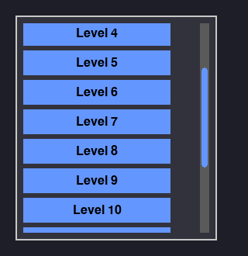
init_pygame()
levels = ScrolledFrame(root, width=250, height=300)
for i in range(10):
Button(levels, text=f"Level {i + 1}").grid(row=i, column=0)

Tip: Scroll with the mouse wheel, or drag the bar.
See the example: examples/scrolled_table_menu_example.py

4. Menus, tables and themes

Extra tools that make your game look finished.

Menu bar
File / Edit / View menus with keyboard shortcuts.
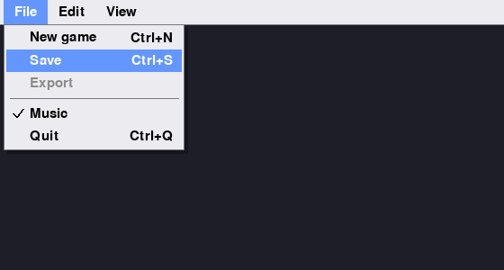
init_pygame()
menubar = Menu(root)
file_menu = Menu(menubar)
file_menu.add_command(label="Save", command=save, accelerator="Ctrl+S")
file_menu.add_separator()
file_menu.add_checkbutton(label="Music", variable=music_on)
menubar.add_cascade(label="File", menu=file_menu)
root.config(menu=menubar)

Tip: accelerator="Ctrl+S" really works - press it and save runs.
See the example: examples/scrolled_table_menu_example.py

Table
Rows and columns of data. Click a heading to sort.
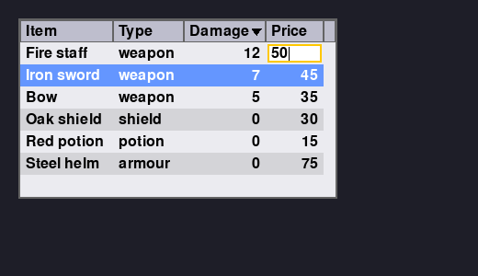
init_pygame()
items = Table(root, columns=["Item", "Type", "Price"], rows=8, editable=["Price"])
items.column("Price", type=int, anchor="e")
items.insert(["Iron sword", "weapon", 45])
anywhere (e.g. in a command function)
row = items.get_selected() # ['Iron sword', 'weapon', 45]

Tip: Double-click a Price cell to edit it. Enter saves, Escape cancels.

Tree table
Rows that open and close, like folders.
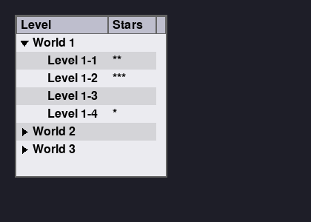
init_pygame()
tree = Table(root, columns=["Level", "Stars"], tree=True)
world = tree.insert(["World 1"], open=True)
tree.insert(["Level 1-1", "**"], parent=world)

See the example: examples/scrolled_table_menu_example.py

Spreadsheet table
Click a cell and just type - like Excel.
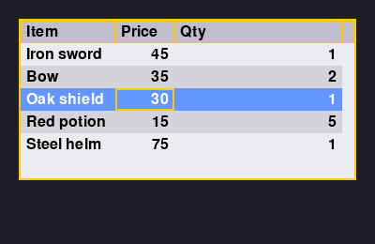
init_pygame()
shop = Table(root, columns=["Item", "Price", "Qty"], editable=["Price", "Qty"],
edit_mode="spreadsheet")
shop.column("Price", type=int)

Change it
- Double-click or F2 edits the old text
- Enter moves down, Tab moves right, arrows move around
- Colour the border: border_color=(255, 200, 0)
See the example: examples/shop_editor_example.py

Themes
Change the look of EVERY widget with one line.
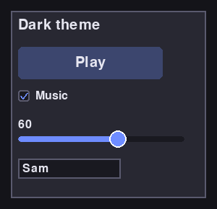
init_pygame()
style = Style()
style.theme_use("dark") # "light", "dark" or "retro"

Light theme
Bright and clean - the default:
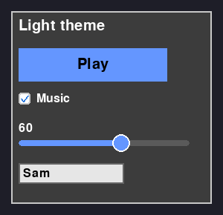

Your own styles
Make a style once, use it on many buttons.
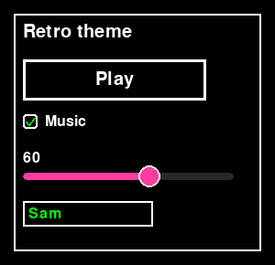
init_pygame()
style.configure("Button", border_radius=10) # every Button
style.configure("Danger.Button", bg=(200, 0, 0))
quit_button = Button(10, 10, text="Quit", style="Danger.Button")

See the example: examples/style_example.py

5. Keyboard, mouse and sound

Controls that feel right, and sounds that play at the right moment.

Pressed or held?
The most important idea for controls.
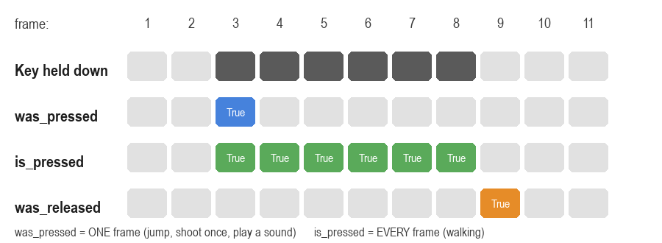
init_pygame()
keys = KeyboardInput()
keys.bind("jump", "space", "w")
keys.bind("right", "right", "d")
handle_inputs()
keys.handle_event(event)
update(tick)
keys.update(tick) # FIRST
if keys.was_pressed("jump"): # ONE frame only
jump()
if keys.is_pressed("right"): # EVERY frame it's held
player.move(5, 0)

Watch out! Use was_pressed for one-off things (jump, shoot once, menu). Use is_pressed for things that keep happening (walking).
See the example: examples/keyboard_sound_example.py

Mouse
Exactly the same idea as the keyboard.
init_pygame()
mouse = MouseInput()
handle_inputs()
mouse.handle_event(event)
update(tick)
mouse.update(tick)
if mouse.was_pressed("left"):
shoot_at(mouse.pos)

Sound effects
Play a sound - it never crashes, even with no speakers.
top of your file
init_audio() # BEFORE pg.init()
init_pygame()
jump_sound = SoundEffect("jump.wav")
coin_sound = SoundEffect("coin.wav")
update(tick)
if keys.was_pressed("jump"):
jump_sound.play()
coin_sound.play_on(player.collides_with(coin)) # once per touch

Watch out! play() inside is_pressed plays 60 times a second! Use was_pressed, or play_on.

Music
Background music that loops and fades between songs.
init_pygame()
Music.play("menu.wav")
anywhere (e.g. in a command function)
Music.switch("level.wav", fade_ms=800)
update(tick)
Music.update(tick)

See the example: examples/music_example.py

Game controller
Use an Xbox-style controller.
init_pygame()
pad = JoystickManager(0, debug=True) # prints button numbers
pad.bind_button("jump", 0)
pad.bind_axis("move_x", 0)
update(tick)
pad.update(tick)
speed = pad.get_axis("move_x") * 5 # -1.0 to 1.0

See the example: examples/joystick_debug.py

6. Sprites, levels and movement

Characters that walk, jump and chase, inside levels you draw in Tiled.

Sprites
A picture that can move and bump into things.
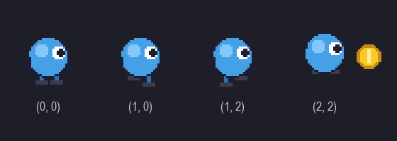
init_pygame()
player = SpriteObject(100, 100, image="player.png")
update(tick)
player.move(5, 0)
if player.collides_with(enemy):
lose_life()
draw_game()
player.draw(screen)

Change it
- Face left: player.flip_x = True
See the example: examples/sprite_example.py

Sprite sheets
Many frames in one picture. Each frame is (row, column).
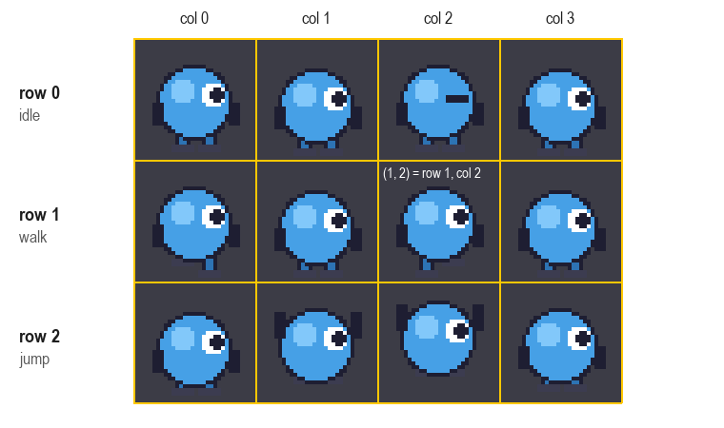
init_pygame()
anim = Animator("sheet.png", from_sheet=True, tile_width=32, tile_height=32,
rows=3, cols=4, scale=2)
anim.add_animation("walk", [(1, 0), (1, 1), (1, 2), (1, 3)])
player = SpriteObject(100, 100, animator=anim)
anywhere (e.g. in a command function)
anim.play("walk")

Watch out! Rows and columns start counting at 0, not 1.
See the example: examples/animator_example.py

Tiled levels
Draw your level in the free Tiled editor, then load it.
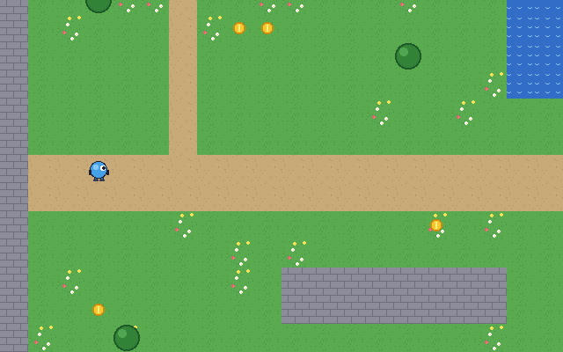
init_pygame()
level = TiledMap("level1.tmx")
camera = Camera(level.width, level.height, (WIDTH, HEIGHT))
camera.follow(player)
world = World(level, camera)
world.add_sprite(player)
update(tick)
world.update(tick)
draw_game()
world.draw(screen)

See the example: examples/tiled_example.py

Is my game lagging?
Press F1 to see the frame rate (FPS) and tiles drawn.
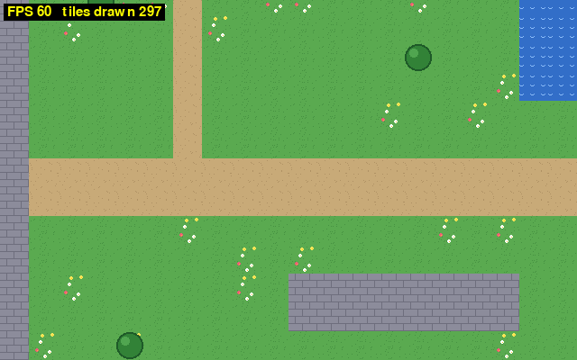
handle_inputs()
Debug.handle_event(event)

Watch out! Low FPS but few tiles drawn? Something in YOUR loop is slow - e.g. loading an image or a map every frame. Load everything in init_pygame().

Tip: 60 FPS = smooth. Big maps are fine - only the tiles on screen are drawn.

Tiled: walls and platforms
Draw boxes on an object layer and give them a Class.
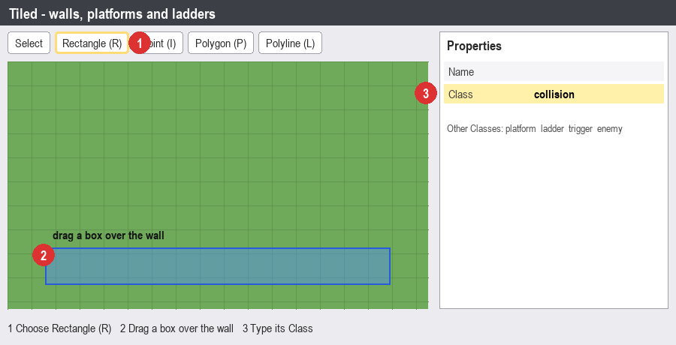
init_pygame()
walls = [o["rect"] for o in level.collision_objects]
enemies = level.objects_of_type("enemy")

Watch out! Spelling counts! Collision and collision are different Classes.

Tiled: drawing a path
Draw a Polyline for an enemy to walk along.
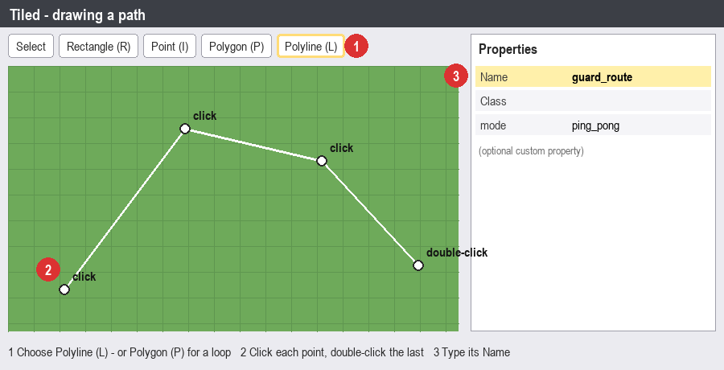
init_pygame()
route = level.get_path("guard_route")

Tip: Double-click to finish the line. A Polygon makes a loop.

Tiled: custom properties
Link an enemy to its path with a property.
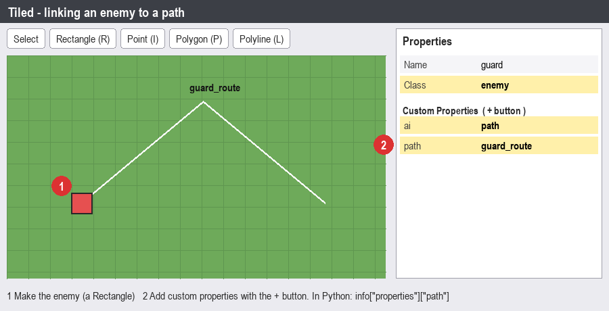
init_pygame()
for e in level.objects_of_type("enemy"):
route = level.get_path(e["properties"]["path"])

Platformer movement
Run, jump, land on platforms and climb ladders.
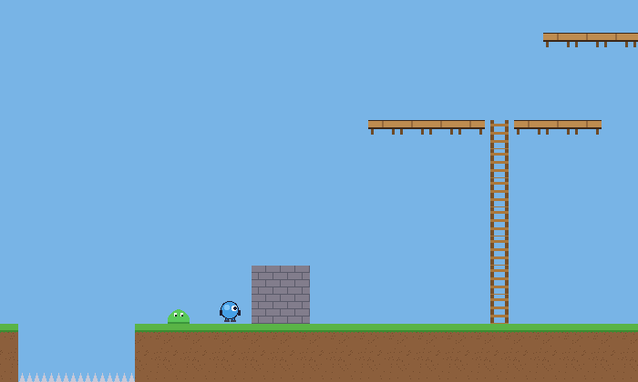
init_pygame()
body = PlatformerBody(player, solids=walls, platforms=planks, ladders=ladders)
update(tick)
body.move(keys.is_pressed("right") - keys.is_pressed("left"))
if keys.was_pressed("jump"):
body.jump()
if keys.was_released("jump"):
body.release_jump() # short tap = small jump
body.update(tick)

See the example: examples/platformer_example.py

Platformer debug view
Press F1 to see hitboxes, platforms and ladders.
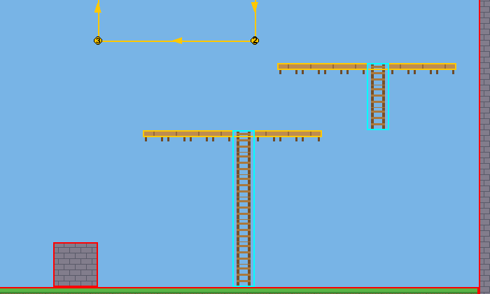

Tip: If your player falls through the floor, F1 shows you whether the floor is really in solids.

Top-down movement and enemies
Walk in 4 directions. Guards patrol, then chase you.
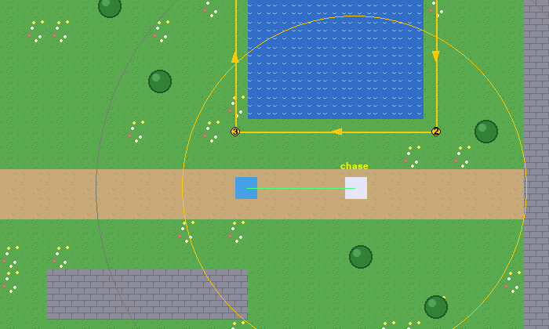
init_pygame()
body = TopDownBody(player, solids=walls, speed=200)
walk = PathFollower(guard, route, speed=90, wait=400)
brain = Chaser(guard, player, detect_range=220, solids=walls, idle=walk)
update(tick)
body.move(dx, dy)
body.update(tick)
brain.update(tick)

Tip: The yellow circle in F1 is how far the guard can see.
See the example: examples/topdown_ai_example.py

Drag and drop inventory
Drag items between a backpack and equipment slots.
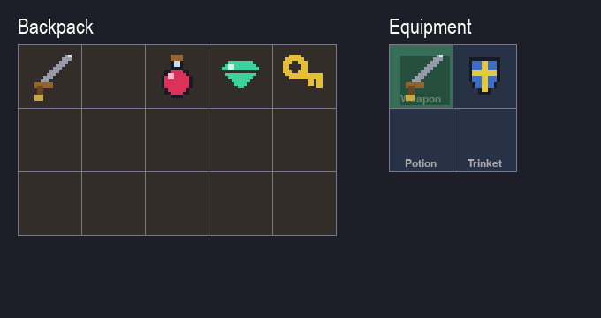
init_pygame()
bag = Grid(40, 120, cols=5, rows=3, cell_size=72)
gear = Grid(520, 120, cols=1, rows=2, cell_size=72)
gear.set_slot(0, 0, accepts="weapon", label="Weapon")
sword = DragObject(0, 0, 56, 56, image="sword.png", kind="weapon", grid=[bag, gear])
bag.place(sword, 0, 0)
items = DragGroup(sword)

See the example: examples/drag_grid_example.py

7. Combat and effects

Health, shooting, explosions - and snakes.

Health and shooting
Bullets, hit flashes and a health bar.
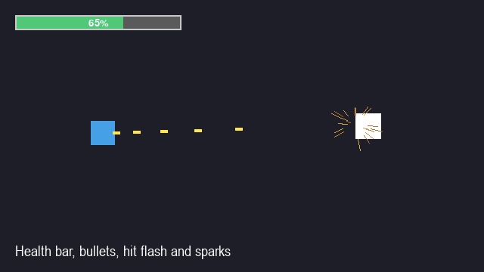
init_pygame()
player.health = Health(100, invincible_ms=800, on_death=game_over)
bullets = ProjectileGroup()
gun = Shooter(bullets, cooldown=150, speed=700, damage=10)
update(tick)
if mouse.is_pressed("left"):
gun.fire(player.rect.center, target=mouse.pos)
for hit in bullets.hits(enemies):
hit.target.health.damage(hit.damage)
flash(hit.target)

Tip: cooldown stops the gun firing 60 bullets a second.
See the example: examples/shooter_example.py

Particles
Explosions, sparks, smoke, fire, magic and confetti in one line.
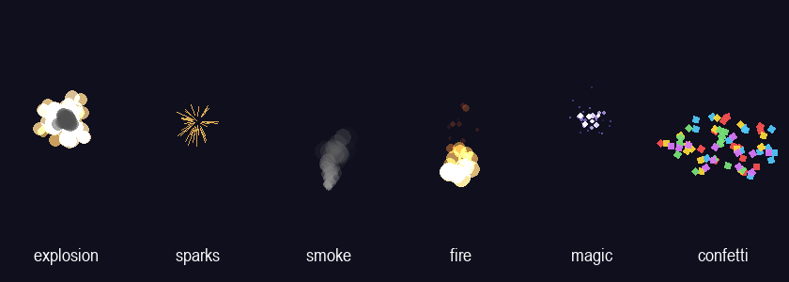
anywhere (e.g. in a command function)
Particles.explosion(enemy.rect.center)
update(tick)
Particles.update(tick)
draw_game()
Particles.draw(screen)

Change it
- Try Particles.sparks(pos) or Particles.confetti(pos)
See the example: examples/particles_example.py

Chain
Links that follow a leader - tails, worms, party members.
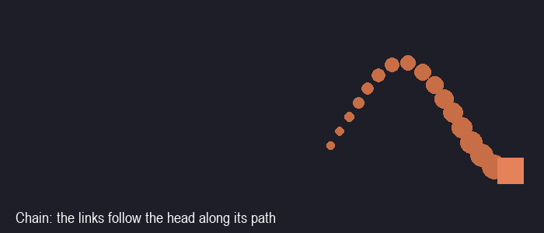
init_pygame()
worm = Chain(head, count=12, spacing=14, shrink=True)
update(tick)
worm.update(tick)
draw_game()
worm.draw(screen)

See the example: examples/chain_example.py

Snake
A Chain in grid mode is the classic Snake game.
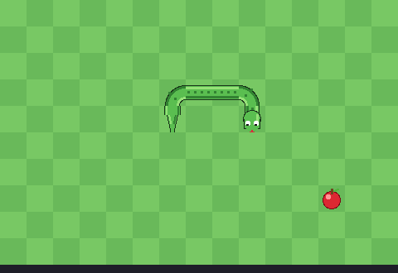
init_pygame()
snake = Chain(mode="grid", grid=board, head_cell=(5, 5), length=3,
images="snake_sheet.png")
update(tick)
if keys.was_pressed("left"):
snake.turn("left")
if snake.hits_self():
game_over()

Change it
- Eat food: snake.grow()
See the example: examples/snake_example.py

8. Bigger games

Menus, levels and saving.

Scenes
Split your game into a menu, the game and a game over screen.
init_pygame()
scenes = Scenes()
scenes.add("menu", start=menu_start, handle_event=menu_event,
update=menu_update, draw=menu_draw)
anywhere (e.g. in a command function)
scenes.switch("game_over", transition="fade")
handle_inputs()
scenes.handle_event(event)
update(tick)
scenes.update(tick)
draw_game()
scenes.draw(screen)

See the example: examples/scenes_example.py

Timers
Do something later - without freezing the game.
anywhere (e.g. in a command function)
after(2000, spawn_enemy) # once, in 2 seconds
blink_id = after_repeat(500, blink)
after_cancel(blink_id)
update(tick)
update_timers() # only if you are NOT using Scenes

Saving and high scores
Keep progress and scores after the game closes.
anywhere (e.g. in a command function)
save_data("save.json", level=level, coins=coins)
data = load_data("save.json", default={"level": 1})

scores = HighScores("scores.json", keep=10)
if scores.is_high_score(score):
scores.add(name, score)

Tip: A missing file just gives you the default - no crash.
See the example: examples/settings_menu_example.py

