Strategies for Success in Vector Fleet
A 200 m field and a 35 m/s gun. Current is added to each ship’s movement.
Every ship fires at 35.00 m/s. Use g = 9.8 m/s², and use meters. The map runs from −100 m to 100 m. 0° points along +x (right) and 90° points along +y (up). For a vector of speed v at angle θ, the components are v_{x} = v cos θ and v_{y} = v sin θ. A hit is a splash within 1 m of the target.
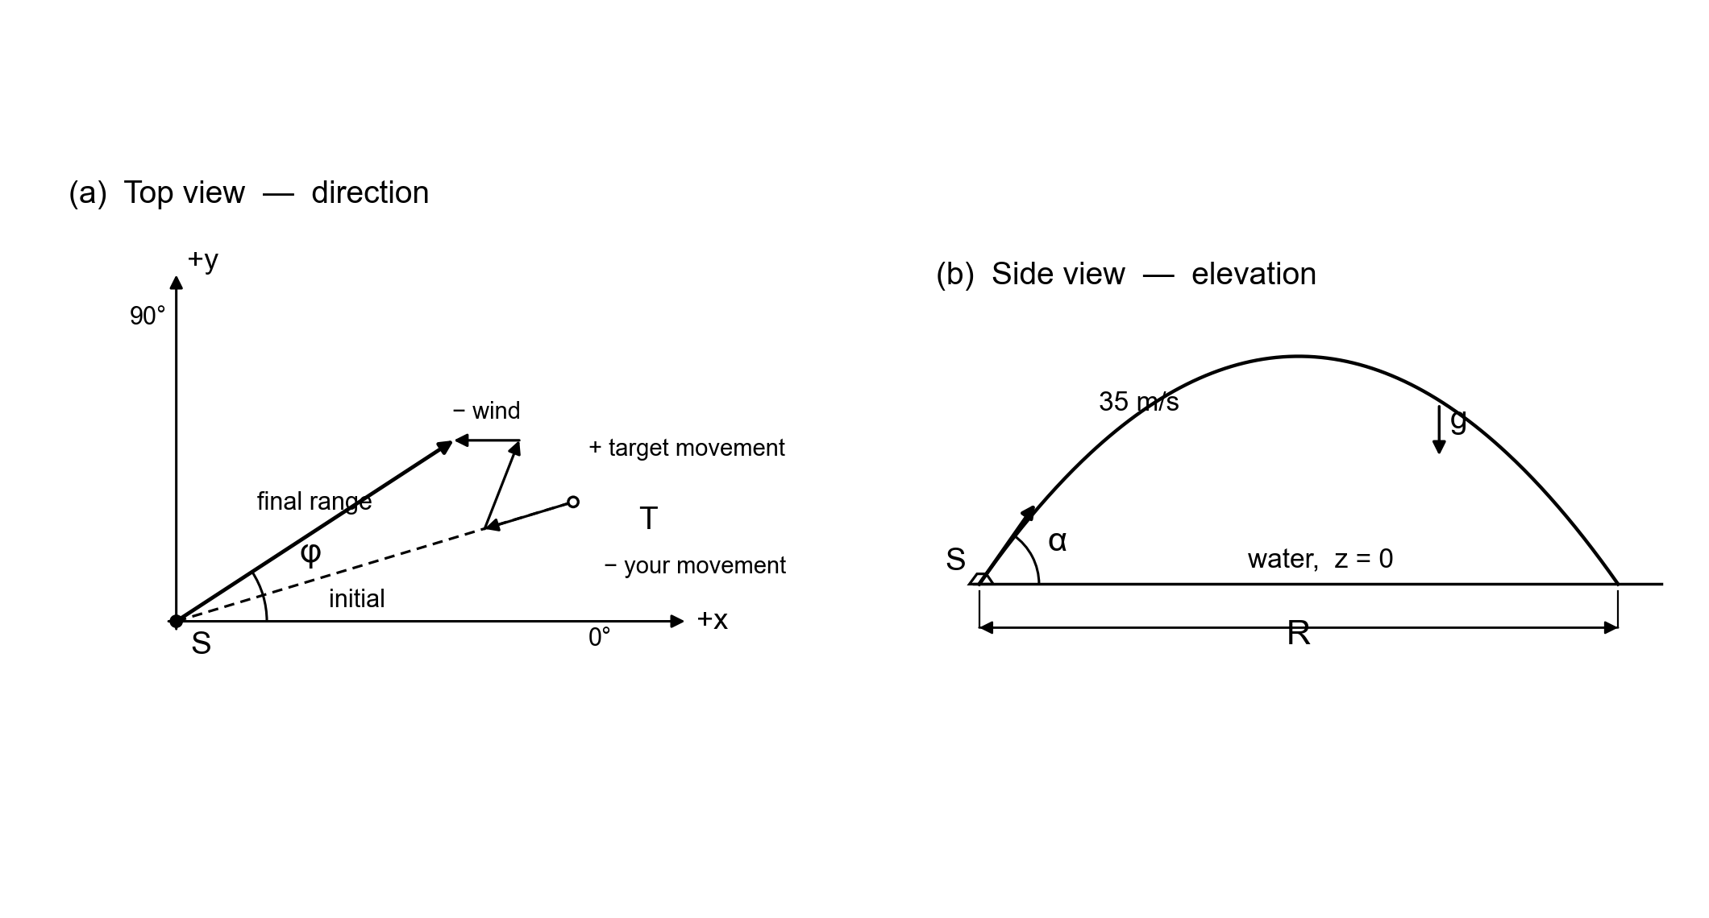
Figure 1. The dashed line is the initial distance. The three arrows are the corrections in step 6. The solid arrow is the direction you fire. The side view is the elevation.

The steps
- Choose a target within range. The farthest the gun can reach on still water is
d = v₀² / g = 35.00² / 9.8 = 125.00 m
That estimate ignores motion and wind. A target near 125 m can move out of range once you correct it.
- Find the distance between the ships. x and y are the differences in the coordinates.
x = x_{target} − x_{you} y = y_{target} − y_{you}
d = √(x² + y²)
- Find the elevation for that distance.
d = (v₀² / g) sin(2θ)
Solve for the low angle, the one at or below 45°:
θ = ½ sin⁻¹(d × 9.8 / 1225)
- Find the horizontal speed of the muzzle. This is the shell’s speed along the water from the gun alone, before your velocity and the wind.
v_{horizontal} = 35.00 cos θ
- Find the approximate time.
t = d / v_{horizontal}
This time is approximate. In the next step, multiply every velocity by it. Do not multiply the target’s starting coordinates by it.
- Add the current, then move the aim point. Add the current to each ship’s heading before you use the movement. θ_{h} is that ship’s heading and θ_{c} is the current’s direction.
v_{x} = v_{h} cos θ_{h} + v_{c} cos θ_{c}
v_{y} = v_{h} sin θ_{h} + v_{c} sin θ_{c}
Do that for your ship and for the target. The wind is separate. The target’s movement is added. Your movement and the wind are compensated by adding the opposite of each component:
x′ = x_{target} + (v_{target,x} − v_{you,x} − v_{wind,x}) t
y′ = y_{target} + (v_{target,y} − v_{you,y} − v_{wind,y}) t
- Find the new distance from your ship to the aim point (x′, y′), with d = √(x² + y²).
- Find the new elevation with the same formula as step 3, using this new distance.
- Find the direction.
direction = tan⁻¹(y / x)
x and y are the differences between you and the aim point. If x is negative, add 180°. If the calculator gives a negative angle and x is positive, add 360° instead. Adding 180° in that case aims the wrong way. You may also type the negative angle. The board reads −20° as 340°.
- Check the time, and repeat if you missed. Find the time again from the new distance and the new elevation, t = d / (35.00 cos θ). A careful first pass usually lands inside the 1 m window. When this new time is quite different from the time you used, repeat steps 6 through 9. A second pass covers most of the shots the first pass leaves outside 1 m.
Type the elevation in Elev ° and the direction in Dir °. Keep two decimal places. This procedure gives the low gun angle. The high gun angle is 90° minus that angle, and it needs its own time.

Example 1. Nothing is moving
You are at (0.00, 0.00) m and Blue is at (62.50, 0.00) m. Headings, current, and wind are zero. sin(2θ) = 62.50 × 9.8 / 1225 = 0.500, so the low elevation is 15.00°. The time is 1.849 s. Nothing is added in step 6, so the distance stays 62.50 m and the direction is 0.00°. Enter elevation 15.00° and direction 0.00°. The high elevation, 75.00°, also lands on Blue at direction 0.00°.

Example 2. Current, wind, and both ships moving
You are at (4.00, −2.00) m with heading 2.00 m/s @ 0.00°. Blue is at (34.00, 14.00) m with heading 1.00 m/s @ 90.00°. The current is 0.50 m/s @ 90.00°. The wind is 1.00 m/s @ 0.00°. The differences are x = 30.00 m and y = 16.00 m, so the distance is 34.00 m.
Current added to each heading:
 | vx (m/s) | vy (m/s)
Your movement | 2.00 | 0.50
Blue’s movement | 0.00 | 1.50
Wind | 1.00 | 0.00
The first elevation is 7.89° and the time is 0.981 s. The aim point moves to
x′ = 34.00 + (0.00 − 2.00 − 1.00)(0.981) = 31.06 m
y′ = 14.00 + (1.50 − 0.50 − 0.00)(0.981) = 14.98 m
From you at (4.00, −2.00), the new differences are x = 27.06 m and y = 16.98 m. The new distance is 31.95 m. The new elevation is 7.40° and the direction is tan⁻¹(16.98 / 27.06) = 32.11°. Both differences are positive, so do not add 180°. That first pass is about 0.20 m off Blue, inside the 1 m window, so those two angles hit.

