FILEuPLOADdemo.ASPX

<%@ Page Language="C#" AutoEventWireup="true" CodeBehind="FileUploadDemo.aspx.cs" Inherits="WebApp.FileUploadDemo" %>

<!DOCTYPE html>

<html xmlns="http://www.w3.org/1999/xhtml">
<head runat="server">
<title></title>
</head>
<body>
<form id="form1" runat="server">
<center>
<div>
<h1>File Upload</h1>
<table>
<tr>
<td>
<h3>Select Image File: </h3><br />
<asp:FileUpload ID="FileUpload1" runat="server" /><br />
<asp:Button ID="Button1" runat="server" Text="Upload Image" OnClick="Button1_Click" /><br />
<asp:Label ID="Label1" runat="server"></asp:Label><br />
</td>
<td>
<asp:Image ID="Image2" runat="server" height="170" Width ="170"/>
</td>
<td>
<h3>Select Document File: </h3><br />

<asp:FileUpload ID="FileUpload2" runat="server" /><br />
<asp:Button ID="Button2" runat="server" Text="Upload Document" OnClick="Button2_Click" /><br />
<asp:Label ID="Label2" runat="server"></asp:Label><br />
</td>
</tr>
</table>
</div>
</center>
</form>
</body>

FILEuPLOADdemo.aspx.cs

using System;
using System.Collections.Generic;
using System.IO;
using System.Linq;
using System.Web;
using System.Web.UI;
using System.Web.UI.WebControls;

namespace WebApp
{
public partial class FileUploadDemo : System.Web.UI.Page
{
protected void Page_Load(object sender, EventArgs e)
{

}

protected void Button1_Click(object sender, EventArgs e)
{
if (FileUpload1.HasFile)
{
FileUpload1.SaveAs(Server.MapPath("~/images/") + FileUpload1.FileName);
Image2.ImageUrl = "~/images/" + FileUpload1.FileName;
Label1.Text = "Image Upload Successfully !!";
}
else
{
Label1.Text = "Select image first!!";
}
}

protected void Button2_Click(object sender, EventArgs e)
{

string fn = Path.GetFileName(FileUpload2.PostedFile.FileName);

string fextn = Path.GetExtension(fn);

int size = FileUpload2.PostedFile.ContentLength;
if (FileUpload2.HasFile)
{
if (fextn.ToLower() != ".doc" && fextn.ToLower() != ".docx")
{
Label2.Text = "only doc and docx file allowed";
}
else if (size < 1024)
{
Label2.Text = "file should not be less than 1MB";
}
else
{
FileUpload2.SaveAs(Server.MapPath("~/Upload/" + fn));
Label2.Text = "File Uploaded";
}
}
else
{
Label2.Text = "Please Select File Before Uploading";
}
}
}
}

Output :

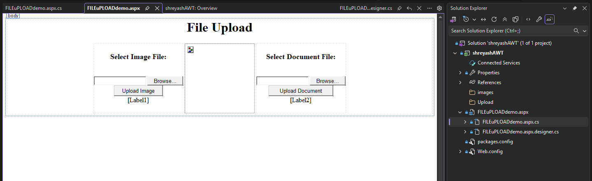.

Masterpage

Site1.Master

<%@ Master Language="C#" AutoEventWireup="true" CodeBehind="Site1.master.cs" Inherits="shreyashAWT.Site1" %>

<!DOCTYPE html>

<html>
<head runat="server">
<title></title>
<asp:ContentPlaceHolder ID="head" runat="server">
</asp:ContentPlaceHolder>
</head>
<body>
<form id="form1" runat="server">
<center>

<h1> BVIMIT </h1>
<p>
<asp:Image ID="Image1" runat="server" Height="280px"

ImageUrl="images/BVIMIT.jpg" width="345px" />
</p>
<asp:ContentPlaceHolder ID="ContentPlaceHolder1" runat="server">
</asp:ContentPlaceHolder>
</div>
</center>
</form>
</body>
</html>

