Handout-L3-NT006

(highlight the most important information)

**Auteur theory**, theory of filmmaking in which the director is viewed as the major creative force in a motion picture. Arising in France in the late 1940s, the auteur theory—as it was dubbed by the American film critic Andrew Sarris—was an outgrowth of the cinematic theories of André Bazin and Alexandre Astruc. A foundation stone of the French cinematic movement known as the nouvelle vague, or New Wave, the theory of director-as-author was principally advanced in Bazin’s periodical Cahiers du cinéma (founded in 1951). Two of its theoreticians—François Truffaut and Jean-Luc Godard—later became major directors of the French New Wave.

The auteur theory, which was derived largely from Astruc’s elucidation of the concept of caméra-stylo (“camera-pen”), holds that the director, who oversees all audio and visual elements of the motion picture, is more to be considered the “author” of the movie than is the writer of the screenplay. In other words, such fundamental visual elements as camera placement, blocking, lighting, and scene length, rather than plot line, convey the message of the film. Supporters of the auteur theory further contend that the most cinematically successful films will bear the unmistakable personal stamp of the director.

**Detailed questions**

1. What is auteurism?

The director is in total control and the soul creator of the film.

1. What is the influence of auterism?

Commercial studio want to attract new director and give more freedom for them to perform experiment techniques.

1. What is the transition sentence between auterism and the next part?

The professor discusses a master of the Auterism.

1. What are the jobs of Orson Welles and Gregg Toland separately?

OW is director while GT is the cinematographer.

1. What is deep focus cinematography?

Instead of blurring the background, deep focus shows everything in the background.

1. What is the story shown in this scene? What is the relationship between the four characters?

The boy’s mother want the boy to have a better life, while his father does not want the boy to leave. But his father does not have control in money so he can only watch his mother send him away.

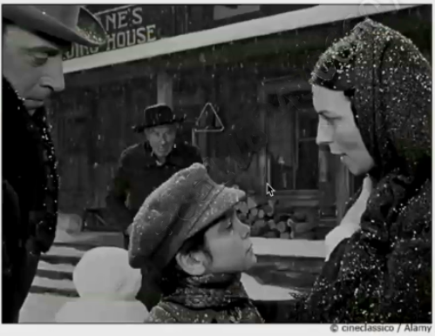

1. What’s the professor’s attitude towards Orson Welles being called auteur in *CitizenKane*?