Direction:

Divide yourself into two big groups A &B. A deals with C1&L1; B deals with C2&L3.

Then divide each A and B into smaller pairs. Each pair finish your work together. When all finish, share answers with the bigger group. Then we do jigsaw with A sharing with B.

C1: Perceive Q5

C2: Q4 (1’30’’)

How prolific as a writer:

L1:

<https://www.khanacademy.org/humanities/art-americas/british-colonies/early-republic/a/gilbert-stuarts-lansdowne-portrait>

1. Check out the vocabulary here:

* Commission
* Elite
* Prestigious
* State portrait [反： ]
* Address an audience –Q3
* Inkwell
* Civilian
* Does the name Gilbert Stuart ring a bell? Q6

2. Relisten and discuss the following questions.

1) How many parts can you divide the lecture into? What are the signals?

2)Work in pairs and finish the following chart. List the differences in each column.

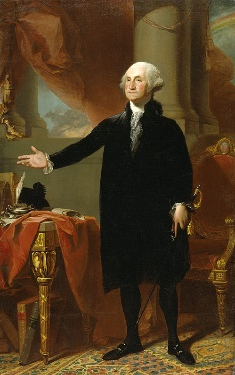

|  |  |
| --- | --- |
| Comparison & Contrast of the Portrait by Stuart and previous painters | |
| Stuart’s work | Previous works |
|  |  |
|  |  |
|  |  |
|  |  |
|  |  |

3) Analyze the questions: L1-3 5 6 and find the source text. Explain the key words.

L3:

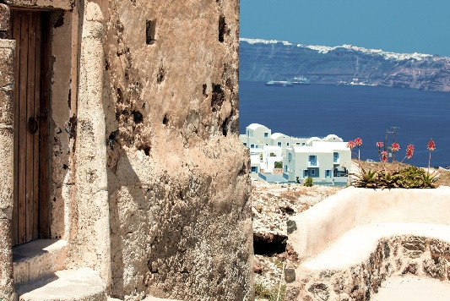 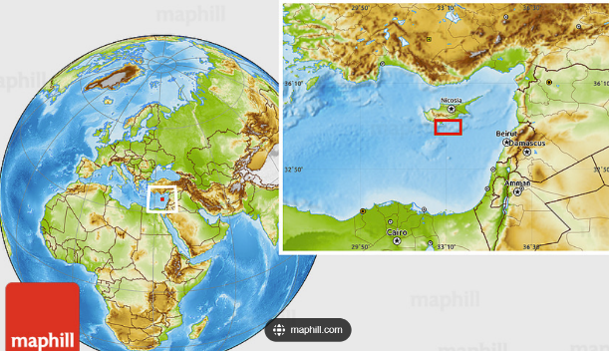

Historical Backgrounds

Crete Minoans

**Minoan**米诺文明,克里特文明(约在纪元前 3000 至 1100 年前后以克里特岛 (Crete) 为中心)

the ~ civilization 米诺文明

**Akrotiri**： the remains of an ancient Minoan city on the island of Thera in the Aegean Sea, where abundant pottery and frescoes of the second millennium B.C. have been excavated.

1. Check the vocabulary.

* Vital 至关重要的
* Draw attention to 吸引注意力
* Sewage system 污水系统
* Volcanic ash 火山灰
* In abundance 充足
* Emery 金刚砂

2. How many parts can we divide the lecture into? What are the signals?

First: introduction of Minoans

Second: Acroterie

Third: Abandonment myth

Fourth: Wealth, trade

Fifth: Emery, special trade

3. What’s the major geological features of Akrotiri?

Based on a volcano

4. Why were people rich in Akrotiri?

They have monopoly on Emery

5. What commodities did Akrotiri trade with Egypt?

Olive oil, Emery(金刚砂), Diorite(闪长岩)

6. What’s the purpose of Emery?

Make into prouder to polish stones

7. Analyze the questions 2, 4, 5, 6 and find the source texts. Explain the key words.

2. The professor

3.