

SCHOOL OF ARCHITECTURE, COMPUTING AND ENGINEERING

Computer Science and Informatics Subject Area

**Analysing the Energy Consumption of UPS Systems in Data Centre’s**

**Shakur McFarlane**

**U1505479**

A report submitted in part fulfilment of the degree of

BSc (Hons) in *Your* *Programme*

**Supervisor:** Rabih Bashroush

CN6103

30 April 2018

Abstract

This dissertation aims to improve UPS energy efficiency within data centres by creating a huge database filled with UPS data and also by analysing that data. Furthermore I have also decided to conduct this project even though huge companies can calculate their UPS efficiency, small to medium sized data centres won’t have the resources or the budget to do so. I have included a detailed literature review which explains why I am conducting my project and also the legal and ethical background information around my project. I then move onto the data collection process where I explain the process I took when collecting the data and also an image of the completed database. The data collected will then be used for three things. Firstly it will be used as a search tool so companies can search for their ideal UPS that will fit those best taking into account the efficiency, load and also the cost of the UPS. Secondly the data will be analysed so that UPS’s not on the database can be estimated, this will be done by comparing the model to a similar model within the database. Lastly companies looking to design and make UPS will be able to use the database to create the perfect model with the lowest cost but still be very efficient. Finally I will validate the database and explain how the data collected could increase the efficiency within data centres.

C

ontents

Abstract 2

Chapter 1: Introduction 5

1.1 Aims and Objectives 5

1.2 Project Rationale 5

1.3 Project Plan 6

1.4 Personal Development Plan 6

1.5 Proposed Solution 6

Chapter 2: Literature Review 8

2.1 Code of conduct 8

2.2 UPS in Data centres 9

2.3 Literature Conclusion 13

2.4 Legal 13

2.5 Ethical 13

Chapter 3: Methodology 14

Chapter 4: Data Collection 15

4.1 Research 15

4.2 Collection of Data 15

Chapter 5: Data Analysis 17

Chapter 6: Validation 59

6.1 Capacity (0 to 45) 59

6.2 Capacity (50 to 400) 60

6.3 Capacity (500+) 60

Chapter 7: Evaluation 62

Chapter 8: Conclusion 63

References 64

Appendix A - Initial Project Proposal 66

Appendix B - Final Project Proposal 67

Appendix C - Application for the Approval of Research Activities to be Attached (if needed) 69

Appendix D – Client Consent Form to be Attached (if needed) 70

Additional Appendices (as needed) 71

**List of figures**

Figure 1. Gantt chart 8

Figure 2. Task deadlines 8

Figure 3. Personal development plan 9

Figure 4. Average UPS efficiency 11

Figure 5. 1100 KVA double conversion UPS 12

Figure 6. 1000 KVA flywheel UPS efficiency 13

Figure 7. UPS efficiency 14

Figure 8. UPS Losses 14

Figure 9. AGILE Methodology 16

Figure 10. Data headings 1 17

Figure 11. Data headings 2 17

Figure 12. Normalisation 1 18

Figure 13. Normalisation 2 18

Figure 14. Normalisation 3 19

Figure 15. Excel Formula 20

Figure 16. Dataset in SAS 21

Figure 17. SAS Filter 21

Figure 18. SAS filter 2 22

Figure 19. SAS Filtered DATA 22

Figure 20. SAS analysis variables 23

Figure 21. SAS appearance 24

Figure 22. Box plot annotation 24

Figure 23. 0 to 45 Average 25

Figure 24. 0 to 45 Minimum 25

Figure 25. 0 to 45 Maximum 26

Figure 26. Standard deviation 27

Figure 27. 0 to 45 10% efficiency 28

Figure 28. 0 to 45 20% efficiency 29

Figure 29. 0 to 45 25% efficiency 30

Figure 30. 0 to 45 50% efficiency 31

Figure 31. 0 to 45 75% efficiency 32

Figure 32. 0 to 45 80% efficiency 33

Figure 33. 0 to 45 85% efficiency 34

Figure 34. 0 to 45 90% efficiency 35

Figure 35. 0 to 45 95% efficiency 36

Figure 36. 0 to 45 100% efficiency 37

Figure 37. 50 to 400 Average 38

Figure 38. 50 to 400 Minimum 38

Figure 39. 50 to 400 Maximum 39

Figure 40. 50 to 400 standard deviation 40

Figure 41. 50 to 400 10% efficiency 41

Figure 42. 50 to 400 20% efficiency 42

Figure 43. 50 to 400 25% efficiency 43

Figure 44. 50 to 400 50% efficiency 44

Figure 45. 50 to 400 75% efficiency 45

Figure 46. 50 to 400 80% efficiency 46

Figure 47. 50 to 400 85% efficiency 47

Figure 48. 50 to 400 90% efficiency 48

Figure 49. 50 to 400 95% efficiency 49

Figure 50. 50 to 400 100% efficiency 50

Figure 51. 500+ average 51

Figure 52. 500+ Minimum 51

Figure 53. 500+ Maximum 52

Figure 54. 500+ standard deviation 53

Figure 55. 500+ 10% efficiency 54

Figure 56. 500+ 20% efficiency 55

Figure 57. 500+ 25% efficiency 56

Figure 58. 500+ 50% efficiency 57

Figure 59. 500+ 75% efficiency 58

Figure 60. 500+ 80% efficiency 59

Figure 61. 500+ 85% efficiency 60

Figure 62. 500+ 90% efficiency 61

Figure 63. 500+ 95% efficiency 62

Figure 64. 500+ 100% efficiency 63

Figure 65. APC Smart-UPS VT 10kVA 400V w/3 Batt Mod Exp to 4, Start-Up 5X8, Int Maint Bypass, Parallel Capable 65

Figure 66. SmartOnline SVX Series 30kVA Modular, Scalable 3-Phase, On-line Double-Conversion 400/230V 50/60Hz UPS System 66

Figure 67. SmartOnline SVX Series 60kVA 400/230V 50/60Hz Modular Scalable 3-Phase On-Line Double-Conversion Small-Frame UPS System, 3 Battery Modules 66

Figure 68. PowerWave 6000 s3 60-120 KVA 67

Figure 69. Powerwave 6000 (500kva) 67

Figure 70. Candlestick chart 69

# Introduction

Since we live in a word with vast technology and everything being technology based there has to be somewhere to hold the data behind these huge servers, these are known as datacentres. Data centres size may vary depending on the data load and how big the servers are however many small to medium sized data centres don’t have the resources or neither the money to choose the best UPS system for them. This project I will be conducting involves u huge database of UPS information that will be analysed and compared so that companies can find the perfect UPS fit for them. I will be conducting this project with the intension to notify and increase the efficiency within data centres. This will be achieved as companies would be able to look through this huge database and based on their usage find the best UPS for them. Even though the database won’t have information on every UPS the database will also allow you to use the information of similar UPS to estimate how efficient that UPS will be.

## Aims and Objectives

By the end of this project I will hopefully be able to provide companies with information on how to obtain the best efficiency from their current ups system. I will accomplish this by analysing many ups so that I know how to get the most out of the ups. Once I have completed this I will be able to get the efficiency of ups even if they are not on the database by analysing similar models. Within this project I will carry out four aims which are:

* My first goal is to research uninterruptable power supplies and find the best way to capture the efficiency of UPS in a database. The research includes finding suitable headers for each of the columns within the database.
* My second goal is to start the data collecting process while checking for similarities between different models.
* My third goal is to analyse the data and explain how the information collected could be used to drive energy efficiency in data centres.
* My fourth and final goal is to validate the data collected within the database.

## Project Rationale

This project needs to be undertaken as many data centres don’t have the money or resources to work out how energy efficient their data centres are. This means that companies will be able to use the database to check how much they should be inputting in order to get the best possible output which will save huge amounts of energy within data centres. The database will also allow companies to check for similarities, so even if the make or model isn’t in the database you could find a similar model or make and get the information from there.

## Project Plan

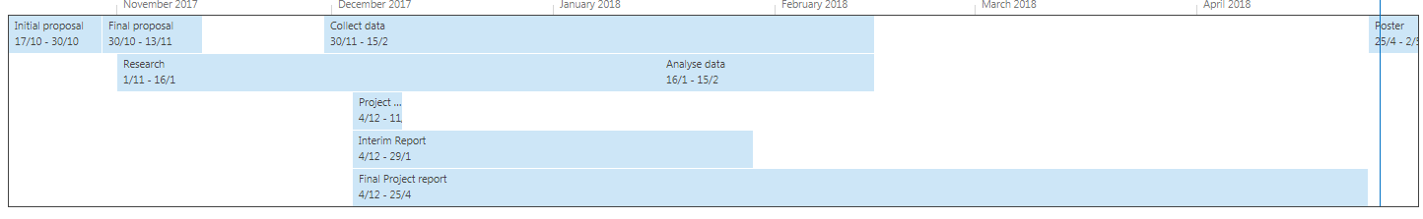

1. Gantt chart

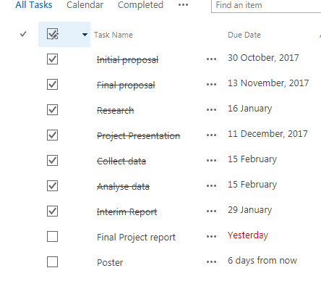

Here is a detailed view of my project plan and milestones within my project. As you can see I have a number of tasks that can be completed on its own however some tasks must be completed before I can start another. I have also included the necessary dates where I should start and finish the tasks as this is a very good way to make sure I manage my time consumption while it reminds me what tasks to complete next.

1. Task deadlines

## Personal Development Plan

|  |  |  |  |
| --- | --- | --- | --- |
| Skill I need to use | Skill known | How to acquire the skill | Duration to get the skill |
| Microsoft Excel | Yes | Secondary school | N/A |
| SAS | Partial | Third year course/ online webpages and manuals | 7 weeks |
| Microsoft word | Yes | Secondary School | N/A |
| Data mining | Partial | Third year course | 7 weeks |
| Literature review | No | Research/ practise | 4weeks |

1. Personal development plan

## Proposed Solution

I will solve the problem stated by first collecting a huge database with UPS models and their efficiency, and then analyse the data collected to check for similarities between different models based of the information within the database. Also companies will be able to use the database as a search tool when looking for the best UPS for their data centre. By the end of the project I hope to have a complete database full with UPS data. Using this data I also hope to identify similarities between different models by analysing the data.

I have decided to collect data using mainly the official websites for the product. I have also decided to compare the data collected looking at similarities rather than comparing the most efficient vs the least. I choose to do it this way as it saves me time and also as it’s the official website the information provided will be more reliable and trustworthy. The most important benefits of this method is that it saves time and also the information collected is trustworthy. Also when comparing data, this method is good as companies will be able to see which models will suite their company using the data load and efficiency.

# Literature Review

To start my literature review I wanted to firstly start by explaining what a UPS is and what types of projects have been related to this. A UPS stand for uninterruptible power supply and is a device that allows for a system such as a computer to run for a brief time while the main source is not working. UPS’s are also used to provide protection from power surges which will usually cause the power to shut down or turn off. There are six main types of UPS used which are standby, line interactive, standby on-line hybrid, standby-ferro, double conversion on-Line and lastly delta conversion on-Line. Below I have provided a brief explanation of these UPS types:

**Standby UPS-** This UPS is mainly used for personal computers, it switches to the battery as the backup source if the primary power source should fail. [1]

**Line Interactive-** Line interactive is most commonly used for small business, web and departmental servers. [1]

**Standby on-Line hybrid-** The standby on line hybrid ups is mainly used for UPS’s that operate under 10kva these are labelled “on-line”. [1]

**Standby-ferro-** The standby-ferro design was once a dominant leader of the UPS in the 3-15KVa.[1]

**Double conversion on-line-** Double conversion is the most common type of UPS above 10kva. [1]

**Delta conversion on-line-** This UPS was designed to eliminate the drawbacks of the double conversion UPS and is available from 5kvs to 1mw. [1]

Using this information, I can state that the types of UPS that would be used in data centres would be double conversion on line or delta conversion on-line. This is because double conversion is the most common UPS above 10kva and as Data centres are usually big this would be the most common used in datacentres. Also the UPS used in datacentres have to be online which both these types are, However, the delta conversion on-line is similar to the double conversion but better as it eliminates its drawbacks meaning this would also be used in data centres but will cost more.

## Code of conduct

### UPS code of conduct

The UPS code of conduct is a documentation that states manufactures of UPS’s must make sure they supply a UPS that energy supply is higher than the energy losses. This code of conduct was set out to limit energy loss from UPS which will also increase the quality of the UPS’s being released. To help address this issue of UPS efficiency all manufactures of UPS have been asked to sign this documentation. [3]

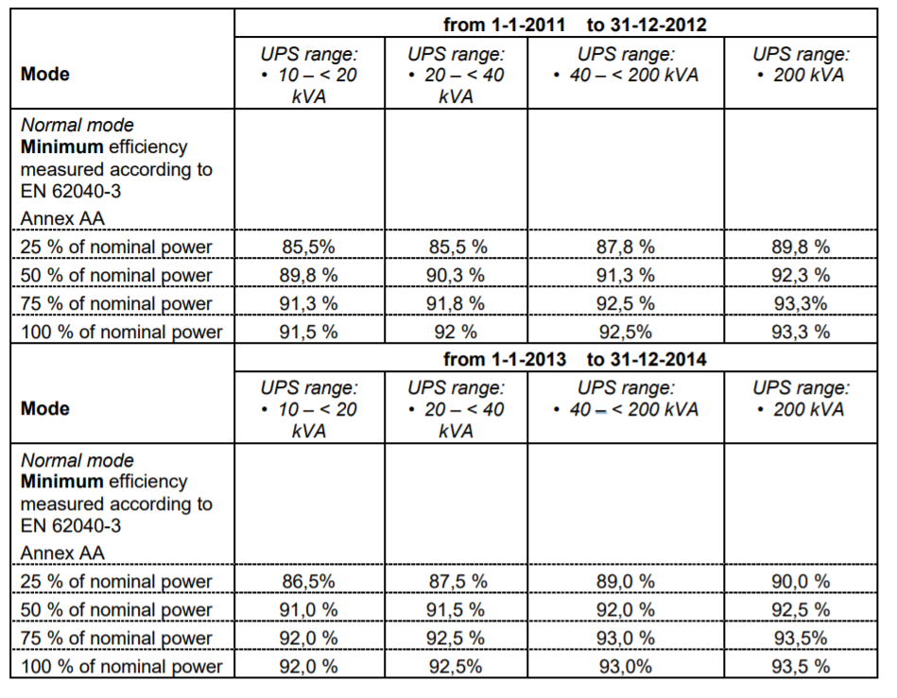[2]

1. Average UPS efficiency

The above image has been taking from CODE of CONDUCT on Energy Efficiency and Quality of AC Uninterruptible Power Systems (UPS) [2] And shows an average UPS efficiency that use double conversion topology, for different ranges which from the table shows an increase in efficiency from the years 2011 to 2014.

### Data centres code of conduct

Like the UPS code of conduct the code of conduct for data centres aims at increasing efficiency within data centres to decrease environmental impacts in a cost-effective manner. The code of conduct for data centres was launched in 2008 with its main aim being increasing energy efficiency which was predicted to reach 100 TWh in the year 2020. This code of conduct is a voluntary initiative aimed to bring different stakeholders together and parties that have signed will be expected to follow the rules of this code of conduct.

## UPS in Data centres

Above I have explained and separately both UPS and datacentres, however within my project I will be focusing of UPS within datacentres. Only specific UPS are found within datacentres as some have different purposes and are not able to work in a Datacentre.

### Comparison between Double Conversion online UPS and Flywheel UPS Technologies in terms of Efficiency and cost in a Medium Data Centre

This was an article which aimed at comparing double conversion online UPS and flywheel UPS in terms of their efficiency. Within this article it stated that the reason for them comparing these two was because they are the most commonly used for protecting loads within datacentres. Also these two types of UPS aim to support medium sized datacentres to provide 1500kw of cooling capacity to the data halls while supporting a 1500kw load. Double conversion UPS is clearly the most reliable mode of operation and the one in which Data centre Operators have traditionally insisted their systems operate in, this works by the inverter supplying energy from the mains through the rectifier, which charges the batteries continuously when the AC-input supply voltage goes outside UPS presents tolerances or fails, the inverter and battery continue to support load power [5].

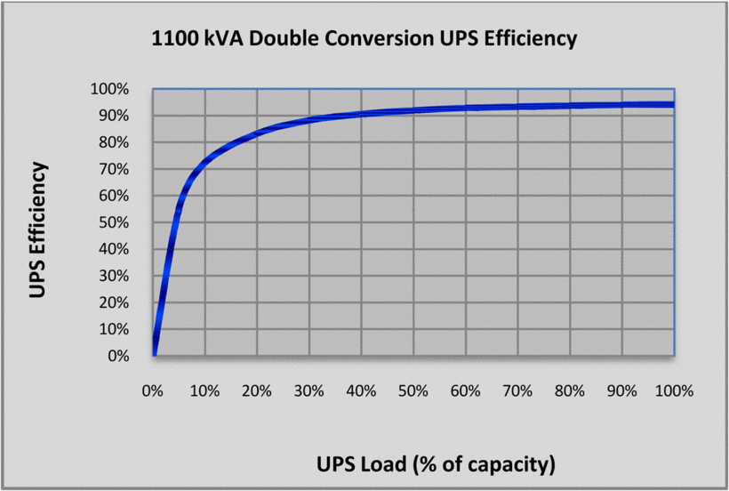

1. 1100 KVA double conversion UPS

However a percentage of Datacentre operators opposed to the traditional static UPS system with its requirement of large battery capacity have embraced flywheel technology. the flywheel technology performances as a ‘mechanical battery’ simply convert and store electrical energy into kinetic energy, then gives up its stored energy in the form of electrical power when a discharge of energy is required, it reverses the flow of energy and slows down as it [5].

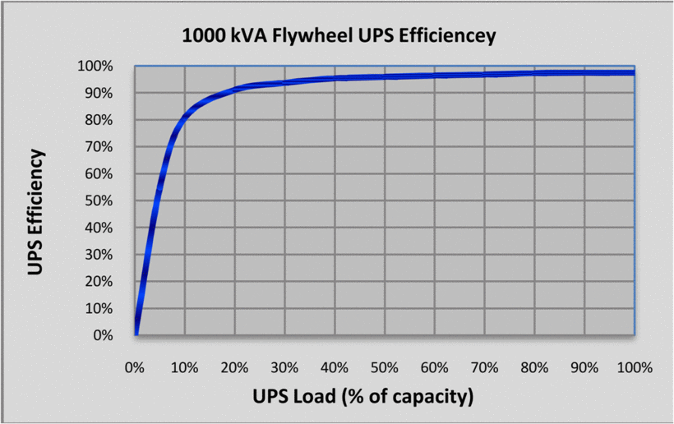

1. 1000 KVA flywheel UPS efficiency

From this article it is clear to see that flywheels provide better efficiency and costs across the board than double conversion UPS with batteries [5]. However since double conversion online is a traditional way this may not result in many data centre operators changing.

### Increasing Hyper scale Data Center Efficiency

The ideal power utilisation efficiency (PUE) is one, meaning that all of the data centre power is used for information technology. Typically PUE values range from 1.1 being the most efficient to two or greater being the least efficient data centres. This means that there are opportunities for efficiency improvements to lower this range. As a data point, in 2014, data centres in the United States consumed an estimated 70 billion kWh, representing roughly 1.8% of the total U.S. electricity consumption [6]. Based on this article it shows that there is a clear increase in energy loss in data centres that is only predicted to increase in the coming of years. Hopefully the completion of my project will help to reduce the energy loss within data centres and make them more efficient.

### Modeling UPS Efficiency as a Function of Load

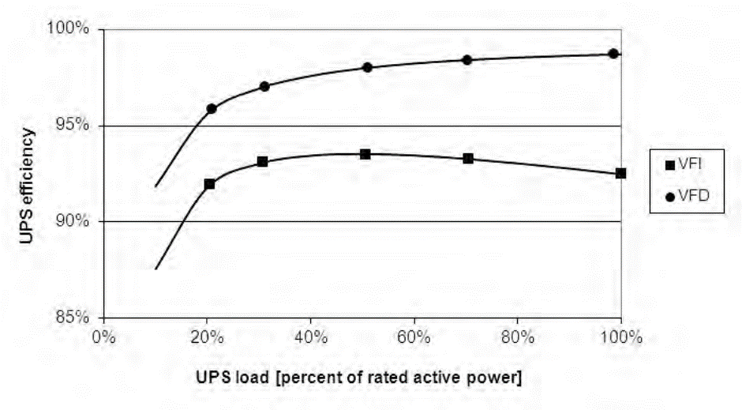In general, UPS efficiency tends to be substantially flat for mid to high loads, while it decreases significantly at lower loads (and drops sharply at very low loads). Once the efficiency curves are known, UPS can be selected to operate at the most efficient load point [7].

1. UPS efficiency

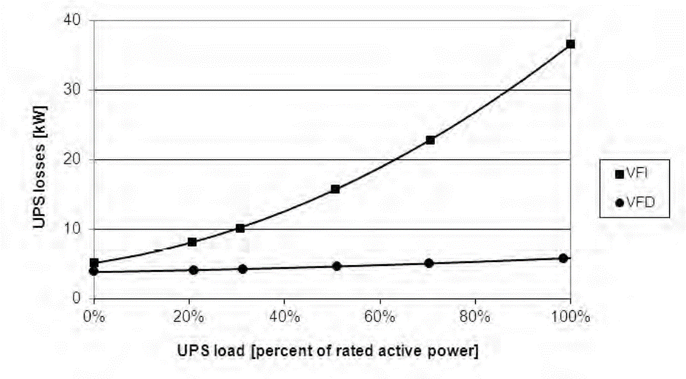The above image shows an interpolated model and measured points for UPS efficiency of a 500 kVA UPS in Voltage frequency independent (VFI) and voltage frequency dependant (VFD) [7]. As you can see from the image UPS efficiency tends to be substantially flat for mid to high loads, however it decreases tremendously at lower loads.

1. UPS Losses

This image shows the UPS energy loss of a 500kVA in VFI and VFD operation [7]. Like most hardware products energy loss can be affected by various factors such as technology or topology. By looking at this image it is clear that there is a huge difference in UPS losses between VFI and VFD.

## Literature Conclusion

From my literature review findings it is clear for me to see that there are many articles and previous projects that relate to mine, however none are conducting in the same method as me. Also since these project are similar I can also use these projects to help with mine, for example after my data collection process I will know that when looking for a very efficient UPS it will be a flywheel UPS.

## Legal

Since this project I will be collecting free information available to anyone there will be no legal obligations for me. This is because all information or data collected will be free and I won’t need permission or to request for any specific information. However if I was asking for personal information towards a certain company this would bring in a legal factor and I would have to make sure this is resolved before completing my project. Once my project has been completed the database would also be free to use and anyone will also have access to the database to find the perfect UPS system for them.

## Ethical

For my project I have decided on one clear factor and that is to get my data directly from the main source. This means rather than me going to companies that sell a range of UPS I will go the owners of that product. By doing this it insures that the information and data collected are correct as other companies may not have the correct information or may not have the data I need. Also this way allows me to collect numerous amounts of data from that company without having to keep on switching sites which makes it an essential part of my project and also makes it a lot faster process.

# Research

## Methodology

The methodology which I have chosen to use in this project is the agile model. This is mainly due to the way it works as it allows you to go over previous step and edit them even after having moved on. For my project I will have to collect data then analyse them which will involve a lot of going over the data and making slight changes or noticing that the data was inputted wrongly.

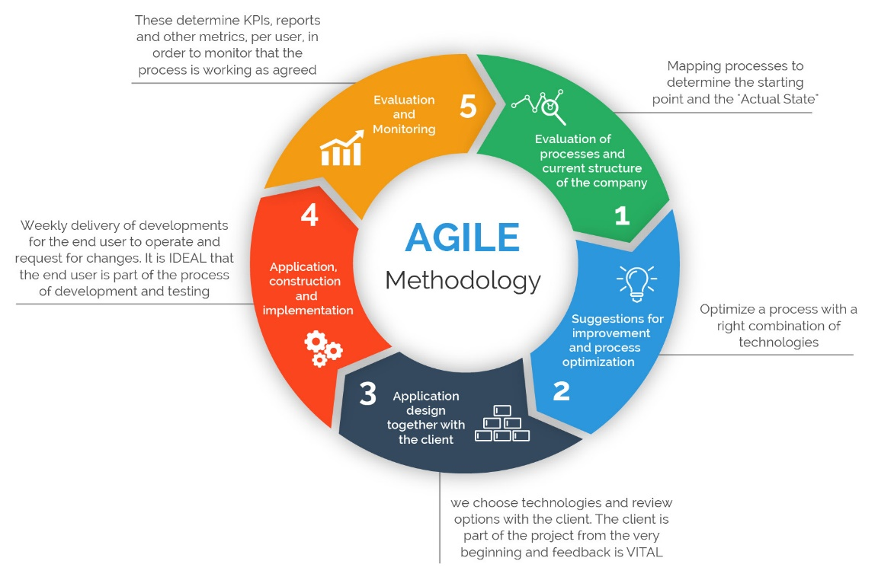[10]

1. AGILE Methodology

As you can see from the above image agile is a cycled process which allows people to go back to the previous step which other models don’t [11]. I decided not to choose waterfall model as the tasks I have to do will take a considerable amount of time with a lot of concentration and still mistakes will arise. I will also need to normalise the data I collected which will result in me returning to the data collection process before moving onto the analysis step, this could take several times as you want the data to be perfect for the analysis stage.

## Tools

For this project the main tools that will be used is excel and SAS. Excel is a very important part of this project as this is where the data will be collected, stored and analysed using excel. After the data has been collected it will then need to be normalised in order for the analysis stage to proceed in SAS and excel. SAS will be used to further analyses the data and include information which is not included in the excel analysis. Another tool used in this project is google and Ieeexplore which were both used for research which was done in the literature review.

# Data Collection

Before I start collecting data I will need to firstly complete some research so that I know what information I will need to collect and what not to. I will also need to decide on the correct labels for the data I will be collecting for example will I be collecting efficiency going up in 10s or 20s etc.

## Research

To begin my research I will need to know what information I will be collecting about the UPS, this will make my data collection process much easier as I will be able to skim through and collect the information which is key for me. I did this by looking at different UPS specs and comparing them this way I learnt what information is vital for a UPS and the extras.



1. Data headings 1

Using the specs decided that for the set of columns these will be the necessary columns for the Up data collection. The first three columns is a vital factor as people would want to know the make and model but also the capacity of the UPS otherwise the efficiency readings will be invalid.



1. Data headings 2

The next few columns consists of manufacturing date, warrantee duration and capacity efficiency. I decided to include these as the user or viewer of the data would want to know if it’s a current model and also how much warrantee the product has. Also the efficiency is a very key factor as this states what point the UPS is most efficient which will save data centres a lot of energy waste. All of these columns are very useful and will be taken into consideration if a user was looking to buy a new UPS system.

## Collection of Data

Since the columns have been decided on I will now start the collection process which involves me looking and finding different UPS systems which are used in datacentres and have efficiency readings. This stage is very difficult as some UPS companies don’t give a full efficiency reading and prefer to say “performs up to 95%” this made it very difficult to collect data using the fields I had created and left me with some missing fields.

After collecting all my data I will need to move onto the analysis of the data however I realised that in the capacity section of the data collected some of the fields have different power rating. This would make the analysis of the data very difficult and would make graphs very hard to read for both me and another user.

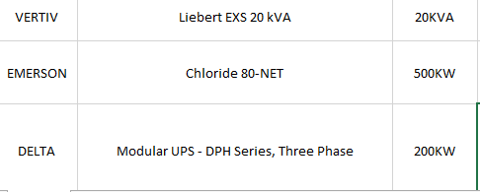

1. Normalisation 1

As you can see from the above image there are two different power ratings. For me to fix this problem I will need to make sure all the power ratings are the same for example converting them to all KVA. Since most of the data collected is already KVA I decided to convert them all, I did this by using a power converter which is available on google [8]. This allowed me to type in the KW rating and it will automatically calculate or convert it into KVA and then I will just need to input this into the data.

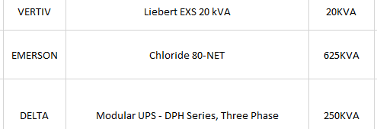

1. Normalisation 2

Above is an image of the same data after it has been converted, as you can see the data is now all the same power rating and is now ready to be analysed.

Another problem I encountered with the data is that the capacity section has numbers as well as letters which the analysis system I will use won’t see them as numbers. This meant that when I went to create a graph it saw all the capacity numbers differently instead of sorting them into categories such as 50KVA then 60KVA. To solve this problem I decided to put in the capacity heading field KVA in brackets so it read “capacity (KVA)”. I then removed the KVA next to the numbers so that the field was just numbers instead of numbers and letters.

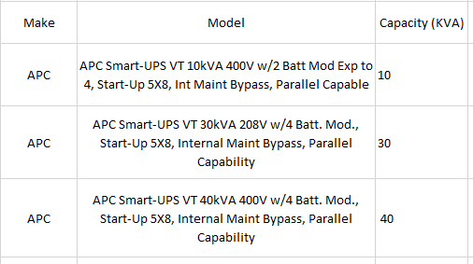

As you can see from the image all the fields are just numbers. This will allow the systems to pick up on this and will make it easier to analyse.

1. Normalisation 3

# Data Analysis

After normalising the data I needed to conduct some analysis on the data collected. I decided that the best way for me to do this is to firstly split the data up by the capacity. This left me with three different categories the first being UPS between 0-45, 50-400 and 500+. By doing this I am narrowing down the data to make it more accurate when looking for averages and standard deviations. After splitting the data up I will then continue on and look for their averages, minimums, maximums and standard deviations between them. Once completed this should be a tool which companies can use to work out how efficient their UPS by using the average for their capacity size.

To work these out I will be using Microsoft excel formulas as this is a quick and easy way. To calculate the average you simple enter “=Average (h6:h38)” what this is telling excel to do is to calculate the average for the cells located between h6 and h38. The average is very important and will be used so that companies can look at the standard operating efficiency and work out whether or not theirs work the same. Similar to the average the minimum maximum and standard deviation works the same but with a slightly different formula.



1. Excel Formula

Looking at the above code there is a clear correlation between each code as the only thing changing is the name for each formula.

After completing these I will be creating a box plot using a program called SAS enterprise guide. The box plot will allow users to see exactly where there system should be for each efficiency and will allow them to pick the perfect capacity for their load. When conducting a box plot this will also give me information such as the standard deviation and average which I will be matching against mine to see if I was correct. The system needs to conduct this otherwise it cannot create the box plot with no information therefore it uses the standard deviation and average to plot the graph. To accomplish this task I must first import the data and change the capacity field to a number field, this allows me to conduct the box plot with the right information used to gain the perfect box plots needed and it also enables me to filter the data using the capacity field.

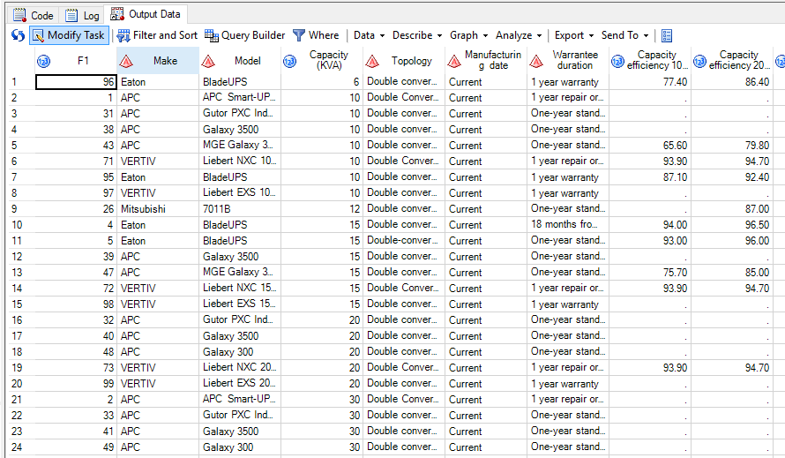

1. Dataset in SAS

I will then need to conduct a filter so that the only data showing will be from the range I want for example 0 to 45. This will give me a list of data that only includes numbers between the numbers specified beforehand. To do this you need to select filter and sort then transfer all the variables into the selected section like shown below. 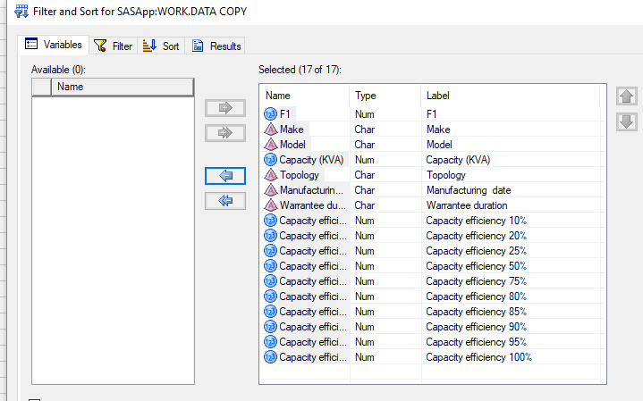

1. SAS Filter

After this you will then need to filter out the data by selecting the filter tab then selecting capacity and the data you want to filter out. For example I wanted to filter all the capacities below 45, as you can see below I have the filter and the data produced.

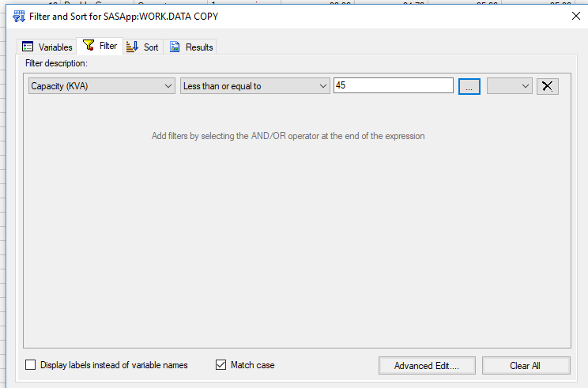

1. SAS filter 2

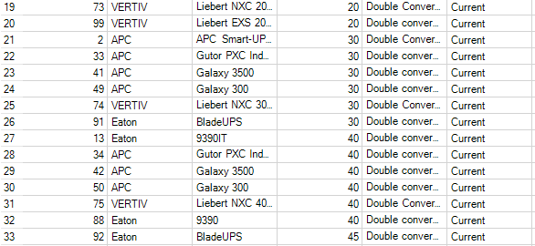

1. SAS Filtered DATA

Above is the data output for the filter I just created this allows the user to just run analysis on the data collected instead of running analysis on all the data collected. This is a very vital step as the data will be split into 3 different categories before being analysed. The next step to conduct is to analyse the data and put the data into a box plot. This is done by selecting data then describe then distribution analysis. You will then need to select the variables you want to be used for the analysis.

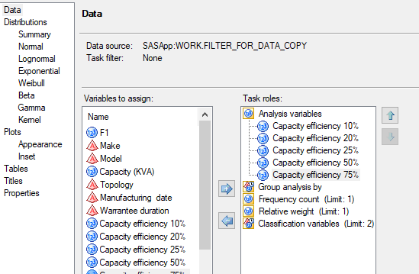

1. SAS analysis variables

As you can see the data that will be selected is the capacity efficiency percentages from 10% till 100%. For this analysis I did not need to select a group analysis as I don’t want it to separate them into different capacities rather than a whole. You will then need to select the plots and select the plots useful for you then click run.

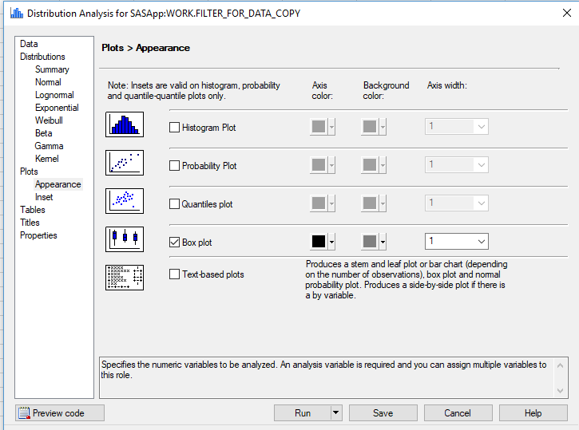

1. SAS appearance

What this box plot does is it splits the data up into 4 different quartiles with each having their own median. This means that even though we already have an overall average we can also get an average for the lower datasets and the higher ones. [9]

Here is the upper half median.

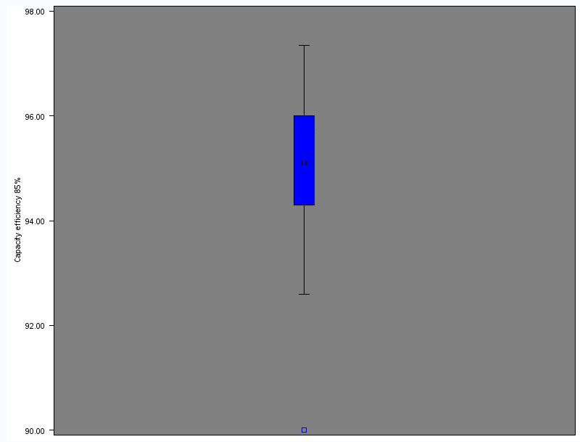



Here is the median for the lower half.

This is the median for the whole dataset

This is the range of the dataset.



This is the 2nd quartile

This is the 3rd quartile

This is the 4th quartile

Here is the 1st quartile

1. Box plot annotation

### Capacity (0 to 45)

This is the lowest capacity range which will be analysed but it still has a lot of UPS that will fall into this range. This range was chosen as it very low and a lot of companies UPS systems will fall into this especially small datacentre users and maybe some medium datacentres.

#### Average:



1. 0 to 45 Average

From the chart above you can see that there is a clear curve starting at a low on 10% then going to a high around 85% before slightly lowering when hitting full capacity. This tells me and other UPS users that the best capacity to operate in would be from 80% to 90% as this is when the UPS systems are most efficient.

#### Minimum:



1. 0 to 45 Minimum

Similar to the average the efficiency starts of very low then builds up although this is the minimum there is still a clear difference below 50% considered to above. Using this information it is evident that no Data centre should operate UPS below 25% load as this is where most of the waste occurs. Although the average graph has a clear curve this graph is more of a build-up until 50% capacity then it stays at a constant efficiency.

#### Maximum:



1. 0 to 45 Maximum

The above images is firstly the data for the maximum for the capacity load 0 to 45 KVA. The data shows that above 80% the maximum efficiency you can get from a UPS is 99% efficiency, however below that the efficiency ratings are very different ranging from 99% to a low 94%. This may not sound like a huge difference but datacentres will be looking to get the most out of their UPS system so missing out on an extra 5% could be vital and save the company huge sums in the long run.

#### Standard deviation (SD):

This is a very important tool which I will be focusing on a lot when conducting my analysis this is because it uses the average and create a boundary around this that shows where the UPS systems should be. The lower the SD the more precise the readings will be for efficiency this will make it easier for users to work out where their UPS system is even if it’s not included in the initial data collection.



1. Standard deviation

This chart is very important as it gives us an indication if the data is wrong or not enough where included. As you can see at 10% this was the highest range because I had the lowest amount of figures for this field resulting the standard deviation being so huge. This would not be an okay deviation to look at when looking for your average efficiency as the range is not precise enough. On the other hand at 100% efficiency it has the lowest range and therefore the most accurate for matching up your efficiency average. If your UPS falls below the standard deviation this shows that the UPS is below average for that capacity and if the other way round it means its above average.

#### SAS (Box plot)

When conducting this stage I had a few problems and couldn’t figure out how to have all the box plots on one graph therefore I split it up into efficiency measures for example one for 10% another for 25% and so on.

##### Capacity (10%)

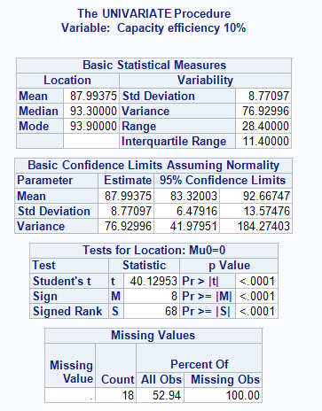

Above is a screenshot of the data that is also outputted in order to plot the graph. As you can see it has all the relevant information such as the standard deviation, mean and also the amount of missing values in the data set.

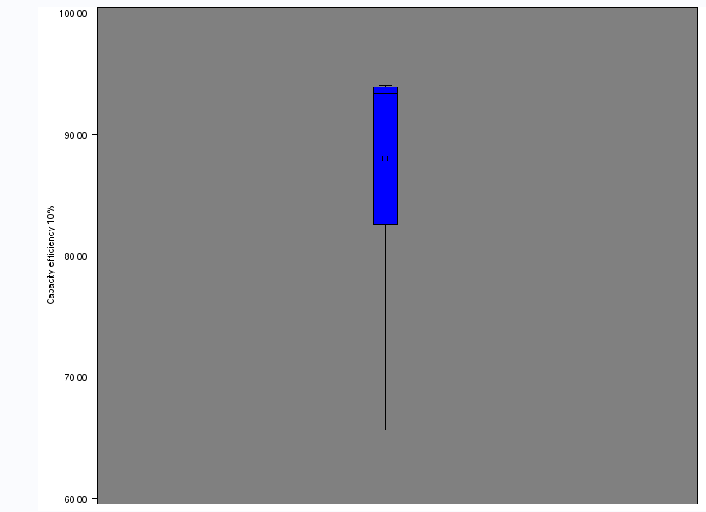

1. 0 to 45 10% efficiency

Above is the outputted box plot graph with all the relevant information as you can see this range will be used when people want to see how efficient their UPS is. This range is quite big as there were a lot of missing values which resulted in the standard deviation being very high.

##### Capacity (20%)

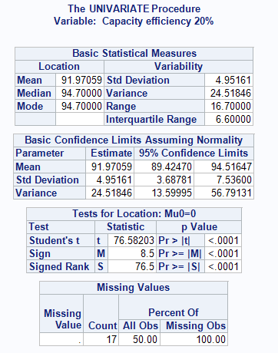

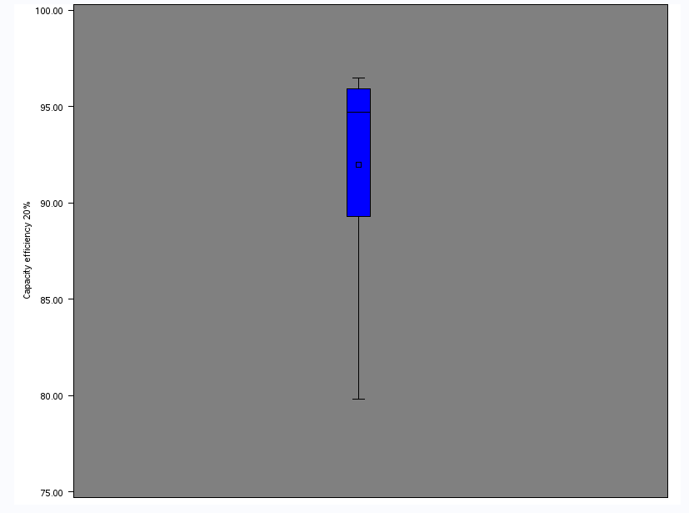

1. 0 to 45 20% efficiency

The above images are indications that the more information you have the lower the standard deviation should be for the UPS system. Although it has gone down from 8 to 4 this would still not be very accurate when looking for the correct efficiency and as you can see it has 17 missing data which affect the standard deviation. This is evident in the graph as the deviation is considerable lower and therefore the graph is more accurate.

##### Capacity (25%)

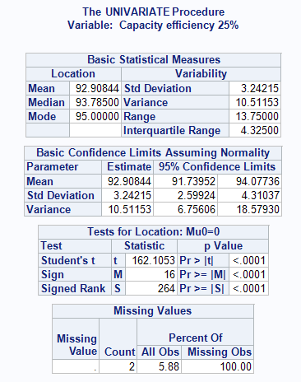

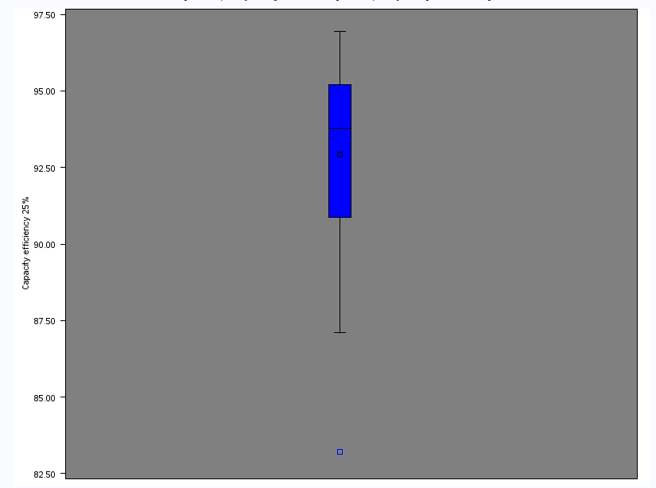

1. 0 to 45 25% efficiency

Even though the data is only missing two fields the standard deviation is still high at 3.1. This is because UPS systems usually have very different starting points and only start to correlate one hitting 50% and above. This is not the case with all UPS systems however with most they will be very similar.

##### Capacity (50%)

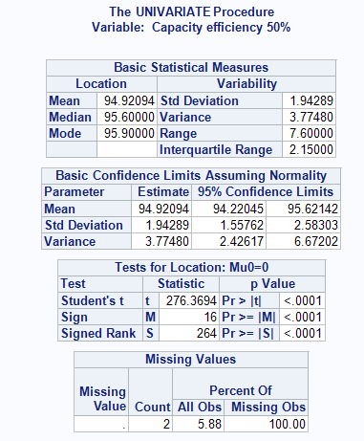

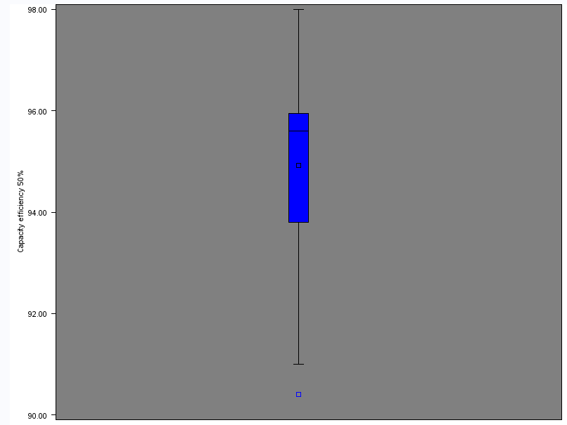

1. 0 to 45 50% efficiency

Looking at the results the UPS systems seem to be getting closer with their efficiency readings and is resulting in the standard deviation going lower and lower. The data is only missing 2 slots which means that the standard deviation is very accurate as it’s under 2 rather than at 10% or 20%.

##### Capacity (75%)

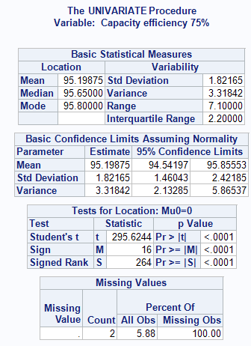

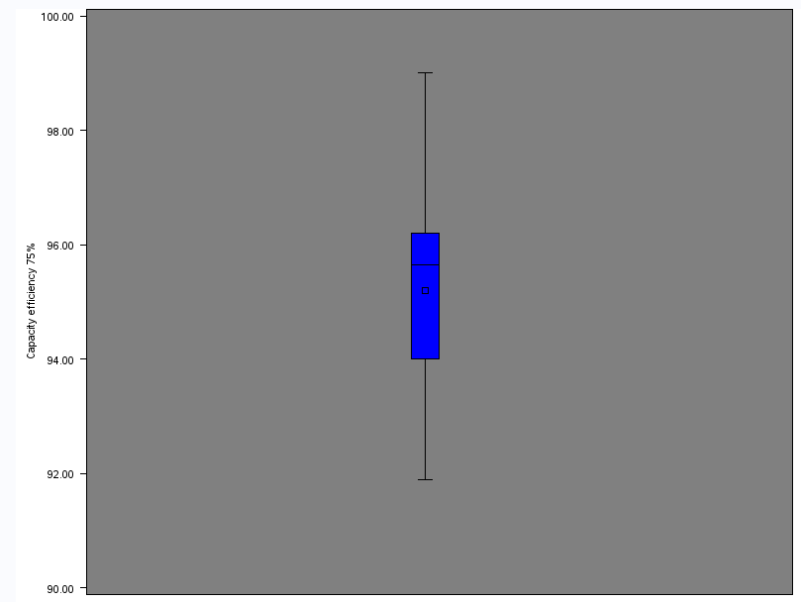

1. 0 to 45 75% efficiency

When the capacity is at 75% you can see that the efficiency is very high looking at the graph as it ranges from 94 to 96 which means all if your Ups is between this range it is considered average. The chart could not only be used to see if your UPS is average but also to see if you can be operating at a better efficiency by changing the current load capacity.

##### Capacity (80%)

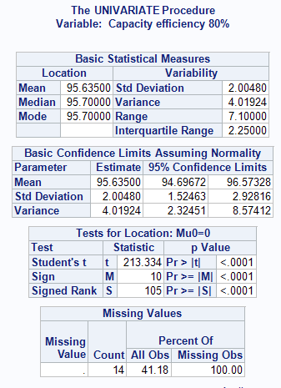

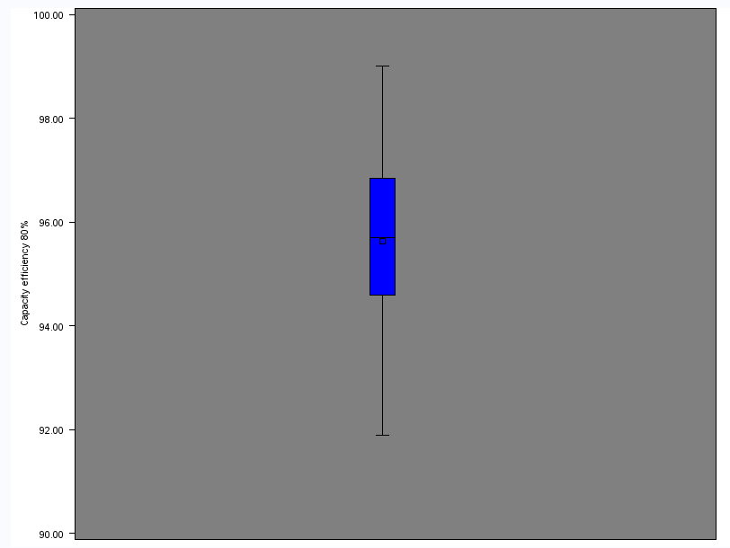

1. 0 to 45 80% efficiency

Above is the box plot for the efficiency when it’s at 80% load capacity. 80% percent load capacity is usually one of the highest points when looking at the efficiency vs the load. This means at 80% load your UPS will most likely operate at its highest efficiency which means the lowest amount of waste.

##### Capacity (85%)

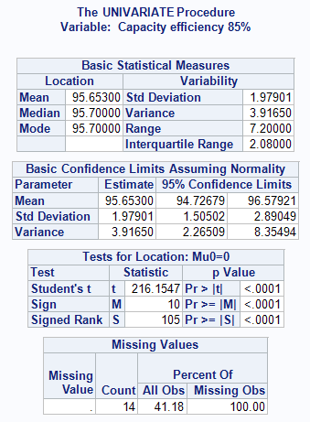

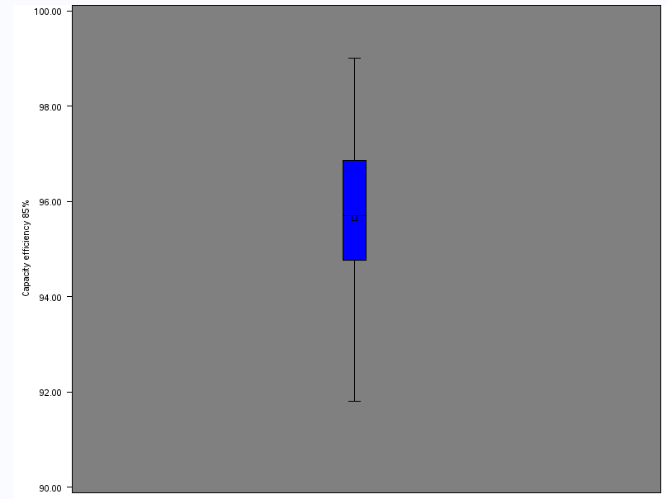

1. 0 to 45 85% efficiency

The above graph and image represents the information and data when the UPS is at 85% capacity load. This is a very high range and as you can see it usually is from 95% to 97% this means it’s currently operating with only 3% waste which is considered a very efficient UPS. Looking at the standard deviation vs the amount of missing data you can see that the ranges are very narrow as it still has a very low standard deviation.

##### Capacity (90%)

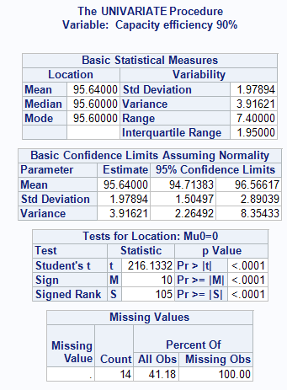

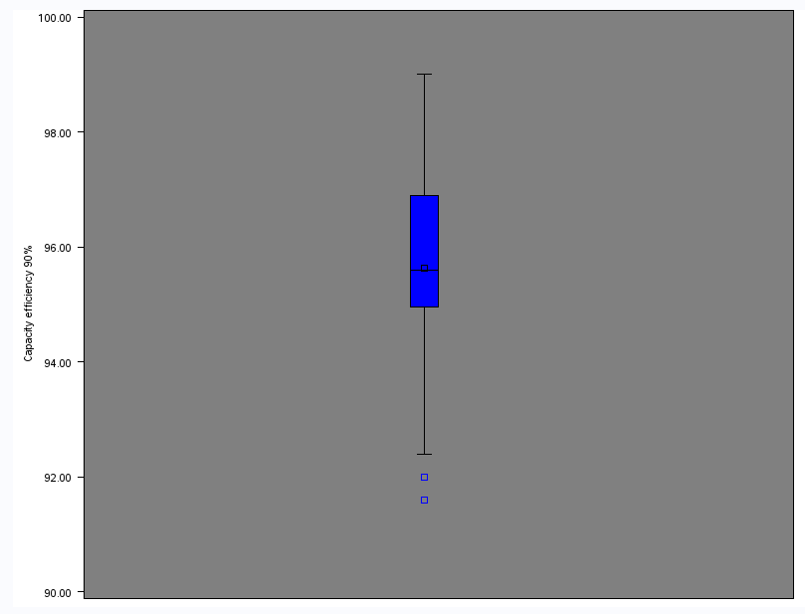

1. 0 to 45 90% efficiency

This is the graph for 90% capacity load and as you can see the standard deviation is very low even though it has 14 missing cells. This means that the data where using has a low deviation from each other which will help companies when looking for the average range for the UPS systems.

##### Capacity (95%)

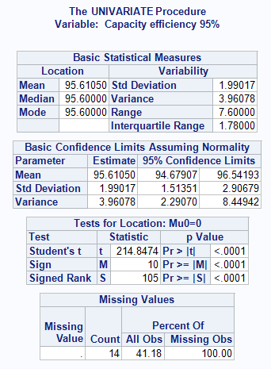

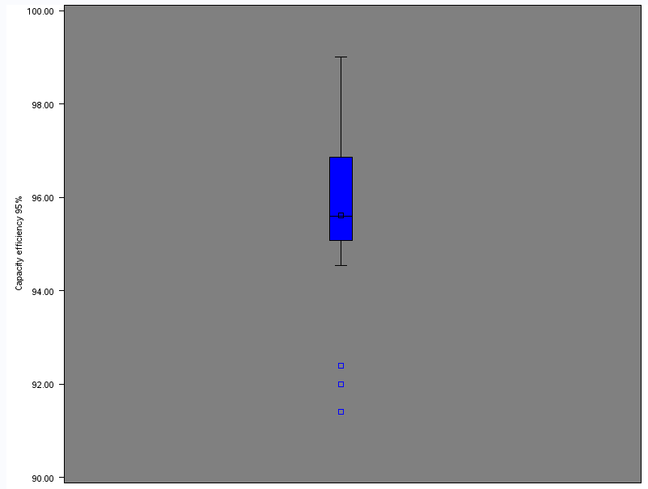

1. 0 to 45 95% efficiency

This is almost at max capacity load which would mean it should be fairly high however not as high as the 75% range to 85% as this is the highest range associated with UPS systems. However when looking at the data presented on the graph it is evident that most UPS system still operate at a very high efficiency.

##### Capacity (100%)

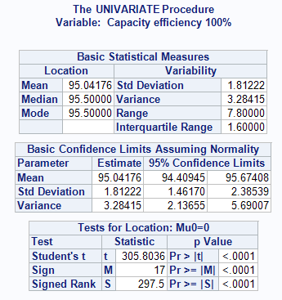

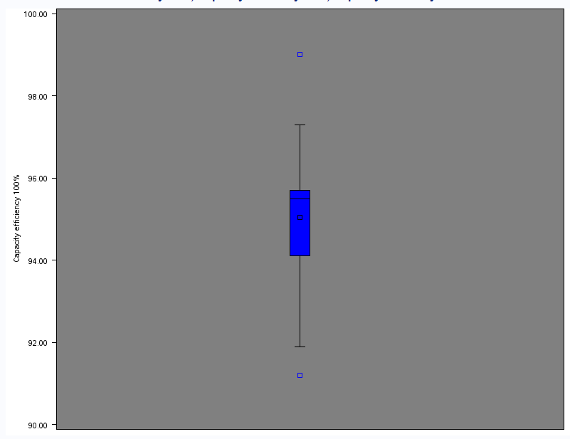

1. 0 to 45 100% efficiency

### Capacity (50 to 400)

Although this range is quite big it is set up for medium to big datacentres as they will be using UPS associated with this range. Doing it this way allows companies to get an exact point as they already know what category their UPS is in.

#### Average:



1. 50 to 400 Average

From the above chart 3 things are evident, the first being that no matter how big the capacity size of the UPS it is generally going to have a very low efficiency point working at 10% to 25%. Another being that the UPS in this category work best and have the highest efficiency when the load is at 75% to 85%. Lastly after reaching 50% load the efficiency is very similar and doesn’t go up or down by a lot.

#### Minimum:



1. 50 to 400 Minimum

Above is an image for the minimum for the capacity load 50 to 400. From the graph we are able to see that at 75% and 85% efficiency load it still manages to operate above 90% efficiency. Taking this into consideration this would be the ideal load for this capacity.

#### Maximum:



1. 50 to 400 Maximum

The maximum graph is a good way to see if you have any wrong figures among any of the percentages. Any wrong figures will also show up and be evident in the other graphs conducted. However this graph is a good way to see how efficient can the best UPS be given it being within this capacity range.

#### Standard deviation (SD):



1. 50 to 400 standard deviation

Standard deviation graph is not only used so that companies can see if their UPS operates within this, but it’s also used to see if some figures are incorrect. If the standard deviation is very high this may indicate that some fields are incorrect and need to be changes. From this chart you can see that from 50% onward the standard deviation is very low and in fact is below 2.

#### SAS (Box plot)

To plot the graph you will need to separate the data again so that only capacities between 50 and 400 are present. Once this has been completed you can conduct the necessary analysis on the data provided all the data is correct.

##### Capacity (10%)

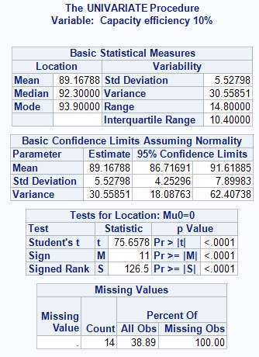

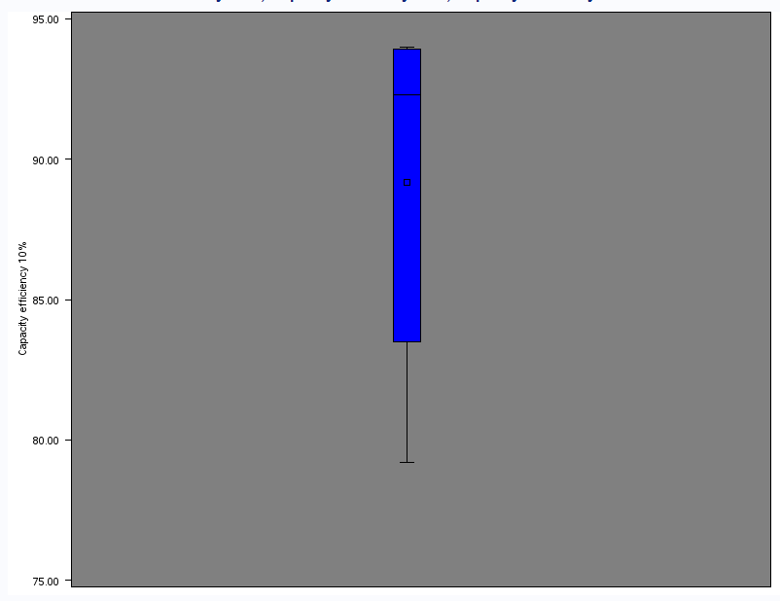

1. 50 to 400 10% efficiency

Above is a box plot for the capacity efficiency when it’s at 10%. From this you can see that it has a very big range compared to other efficiency capacities. This is because UPS efficiency tends to starts of very differently and as no one should be operation their UPS at this efficiency.

##### Capacity (20%)

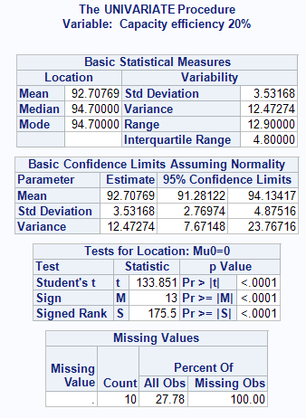

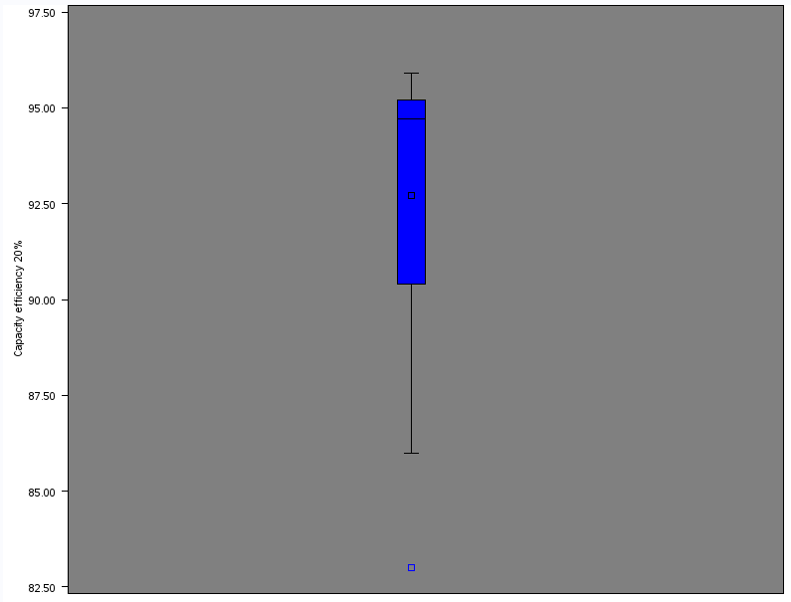

1. 50 to 400 20% efficiency

This has a slightly better range than at 10% however it is still low and the standard deviation is at 3 which is accurate but not as accurate as it could be. This is mainly due to the missing fields as there are 14 missing fields for this data.

##### Capacity (25%)

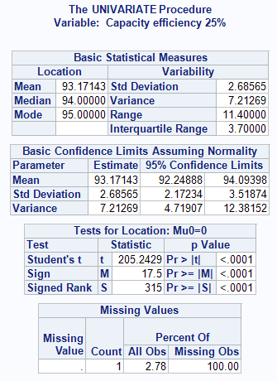

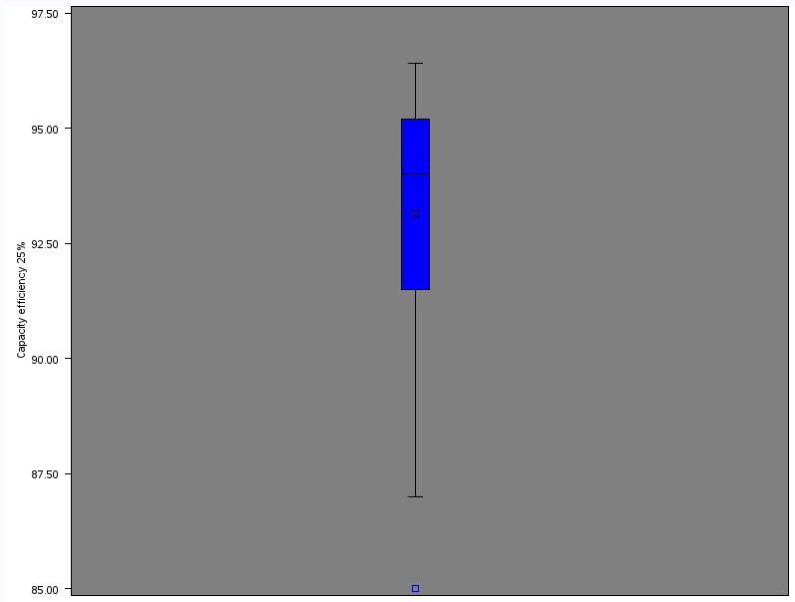

1. 50 to 400 25% efficiency

At 25% this shows that the systems will usually operate within the average – or + the standard deviation. So in this case this would be 93 – 2.6 = 90.4 then 93+ 2.6 = 95.6 which means that this will be the range companies use to work out if their UPS works at an average efficiency

##### Capacity (50%)

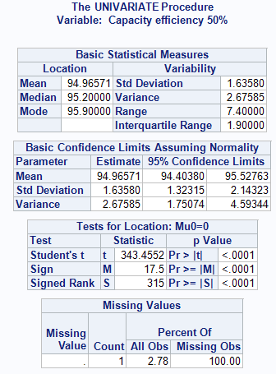

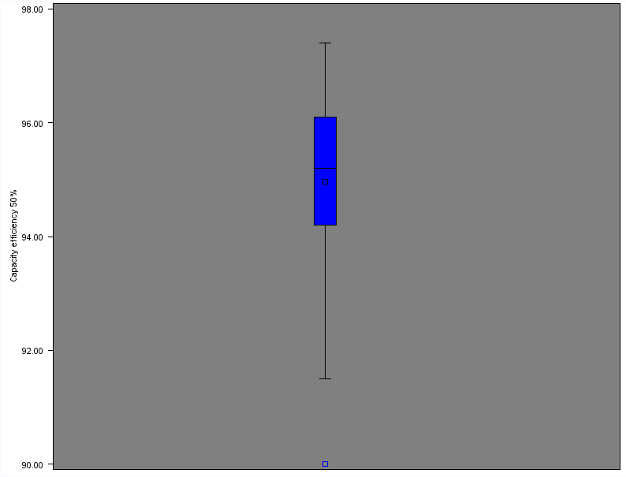

1. 50 to 400 50% efficiency

Using this information we can work out the average range for the systems, this will be 94.9-1.6 = 93.3 and 94.9+1.6= 98.5. This means that if your UPS system falls from 93 and 96.5 this will be the average range for a UPS to operate within with the capacity load at 50%.

##### Capacity (75%)

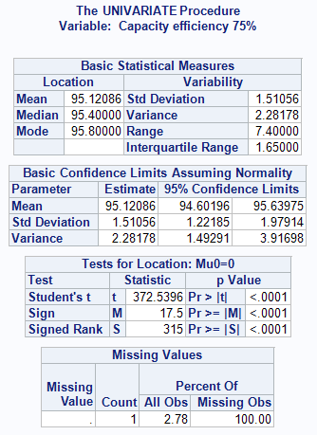

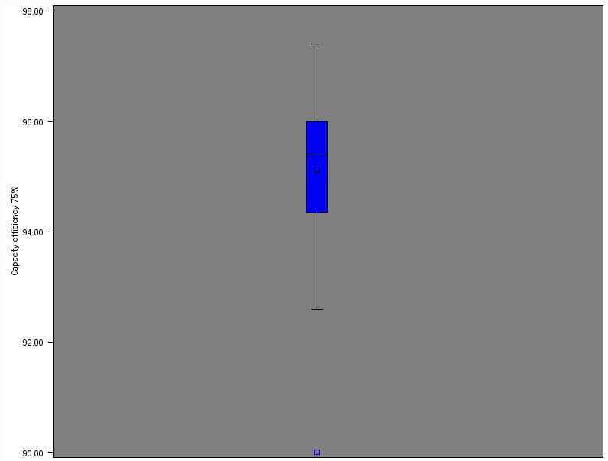

1. 50 to 400 75% efficiency

At 75% this is one of the highest operating points for an UPS however some companies only choose to operate below 50% capacity and use two UPS system. This means if one stops working the other is able to take both the loads. This means that some companies will rather operate at 50% which is slightly lower efficiency.

##### Capacity (80%)

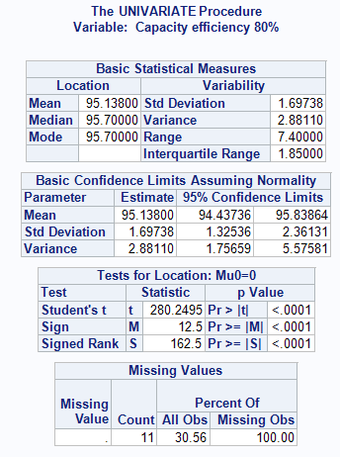

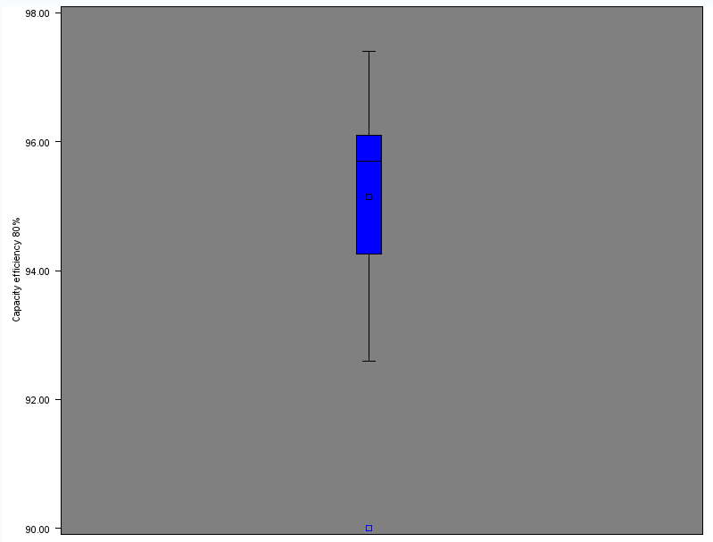

1. 50 to 400 80% efficiency

Although there is 11 missing values it still hasn’t affected the standard deviation or mean which will be used to compare the systems. This is because the data used are very similar meaning that the range between each figure remains low causing it to have a low standard deviation.

##### Capacity (85%)

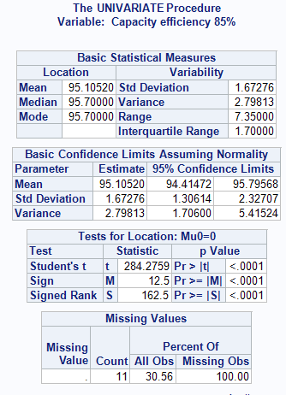



1. 50 to 400 85% efficiency

At 85% it has the second highest average which is at 95.1%.Using this it is clear that if you was to operate a UPS with this capacity you should operate it at 85% load or 80% to get the most out of the UPS.

##### Capacity (90%)

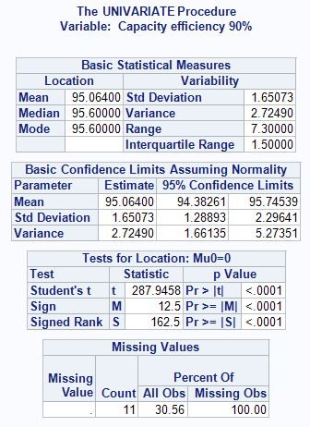

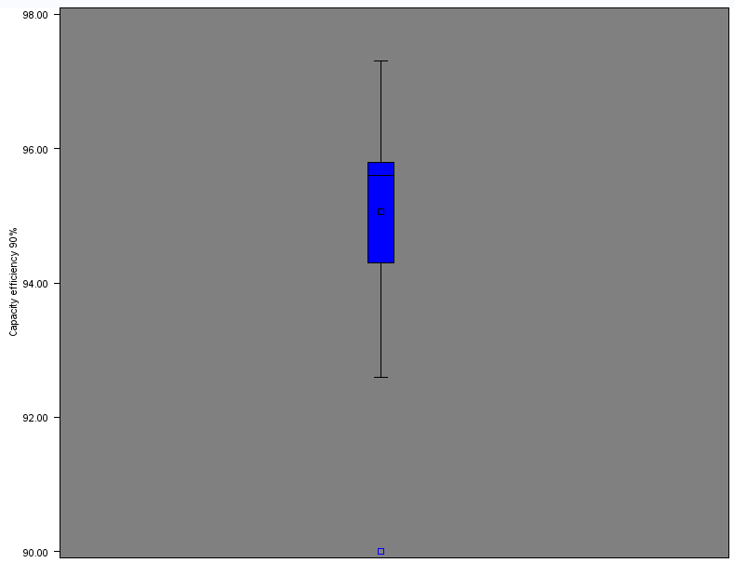

1. 50 to 400 90% efficiency

Evidently from the above graph and table you can see that it takes a slight fall when looking at the efficiency figures compared to the figures at 85%. Compared to the first capacity (0 to 40) this range is slightly higher even though it’s missing 11 values from the data.

##### Capacity (95%)

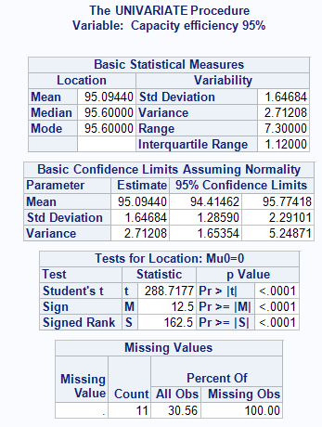

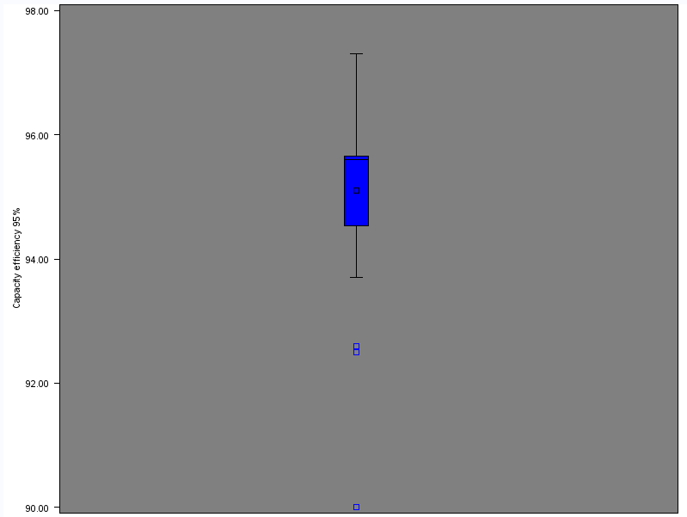

1. 50 to 400 95% efficiency

This is the capacity range for 95%. This will be slightly lower than 85% due to the efficiency data going slightly lower when near 100%.

##### Capacity (100%)

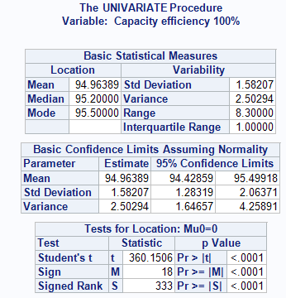

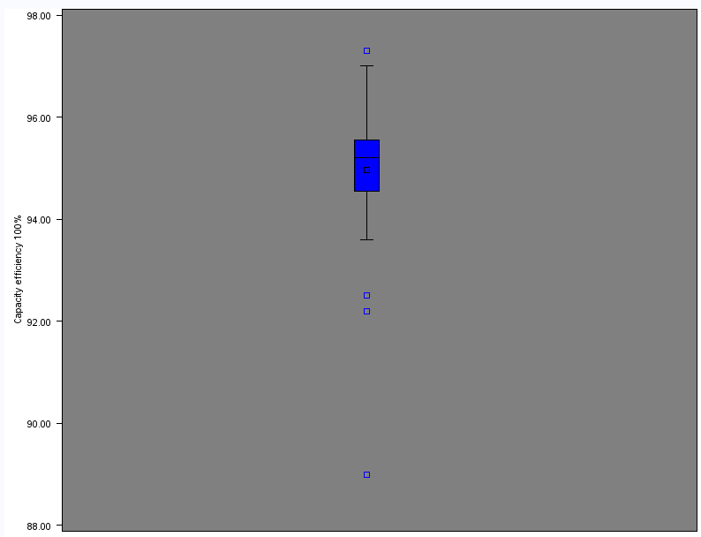

1. 50 to 400 100% efficiency

At full load you can see that the data is still high operation at from 94% to above 96% which is very efficient for any UPS.

### Capacity (500+)

This is the final group of data which will be analysed as it’s the largest set within the dataset. This will be analysed as most medium to big datasets will use UPS with this type of capacity as they will be using very big load capacities which UPS with small load capacities can’t do.

#### Average



1. 500+ average

Here is the average for the 500+ capacity where the data is slightly different compared to the other groups that were analysed. As you can see usually the best average capacity would be from 75% to 85%. However on this graph its 50% to 75% that they operate at its highest efficiency, this is very good as it allows companies to combine two UPS at 50% load while still getting the best efficiency from both.

#### Minimum



1. 500+ Minimum

From this minimum chart it is clear to see that the 500+ UPS operate entirely different from the other sets. This is shown as even if you are operating you UPS at 20% load on the worst UPS for efficiency you are still managing to get over a 90% efficiency. This allows big companies to use multiple UPS systems to insure that if one fails the load will be transferred to another without going over the capacity limit.

#### Maximum



1. 500+ Maximum

The above chart shows that even at 10% load capacity you are still able to get a 94% efficiency reading from the 500+ capacity. Although this is the maximum no other group of UPS systems could get this at 10% capacity as the other systems seem to work best from 75% and above whereas 500+ capacity can give a very high efficiency at almost any percentage load.

#### Standard deviation



1. 500+ standard deviation

This capacity group also gives the lowest standard deviation ranges and even manages to get lower than 1 from 50% to 75%. Using these figures will be very good as they it will give a very low but accurate range of average for other systems to follow. This means that when checking your UPS efficiency, you will be able to see instantly if it’s within the average range or not.

#### SAS (Box plot)

To complete the final part of the analysis phase the data must be separated again into the capacity above 500. This is done by creating another filter with the setting greater than 500 which will exclude all the numbers below this and only show data with a higher or equal to capacity.

##### Capacity (10%)

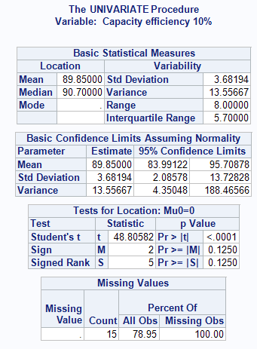

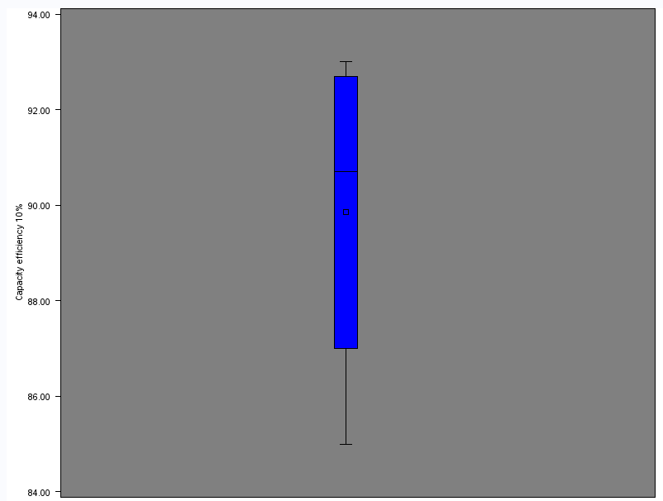

1. 500+ 10% efficiency

Above is the box plot when the load is at 10%. This has a very high range and a low standard deviation taking into consideration that it’s missing 15 values of data.

##### Capacity (20%)

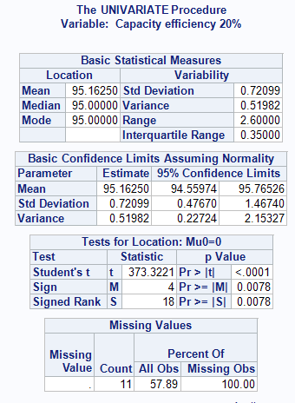

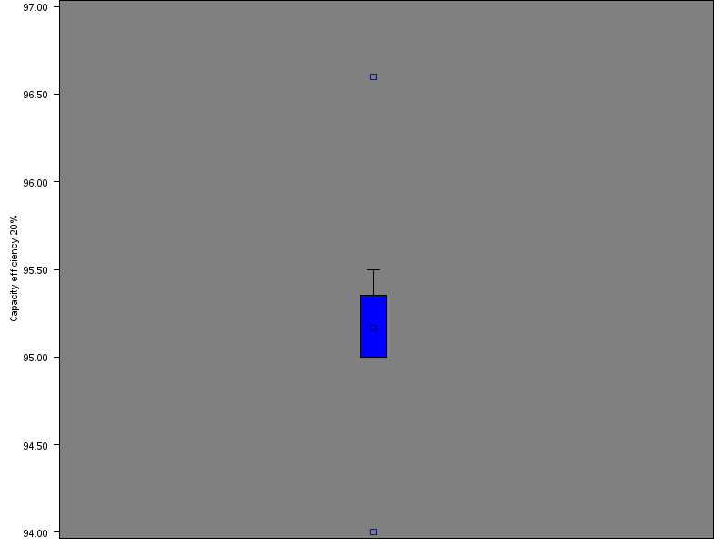

1. 500+ 20% efficiency

This is a very different box plot as it shows that all the data fits into the box range for the lower half of the box.

##### Capacity (25%)

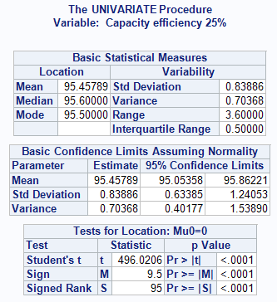

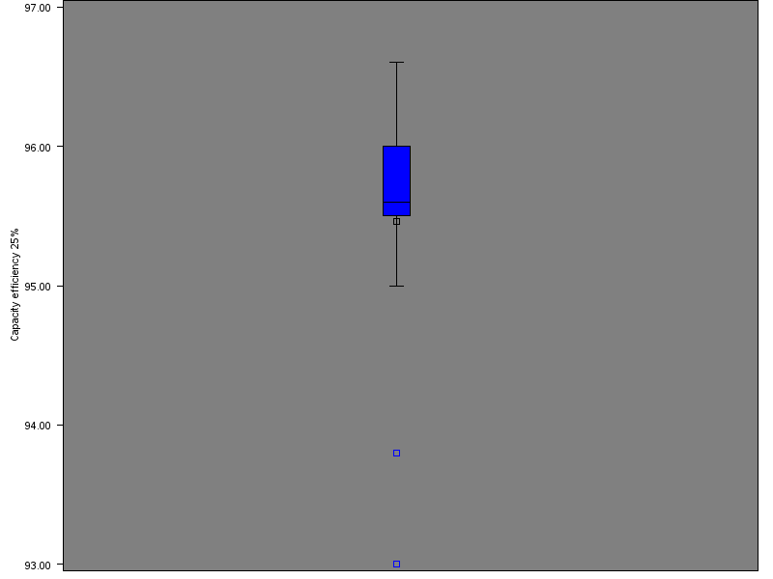

1. 500+ 25% efficiency

AS you can see from the above graph the range of the data is at a very high efficiency rate even though the load is only at 25%. This causes the median to be very low within the box as the averages are very close to one another.

##### Capacity (50%)

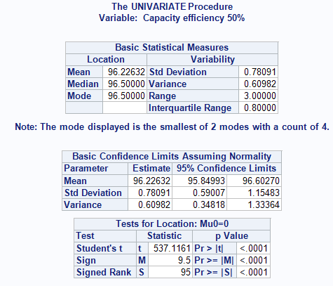

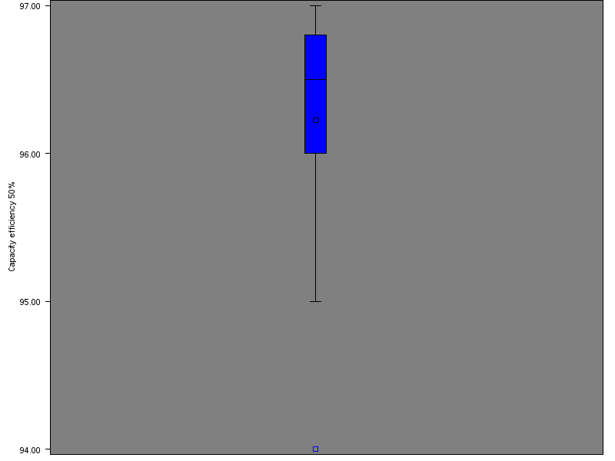

1. 500+ 50% efficiency

This has a very high efficiency reading with the average being higher than 96% and the load only being at 50%

##### Capacity (75%)

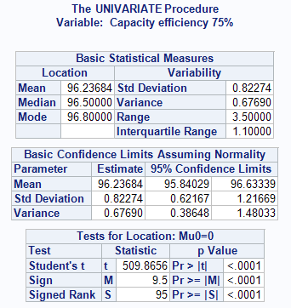

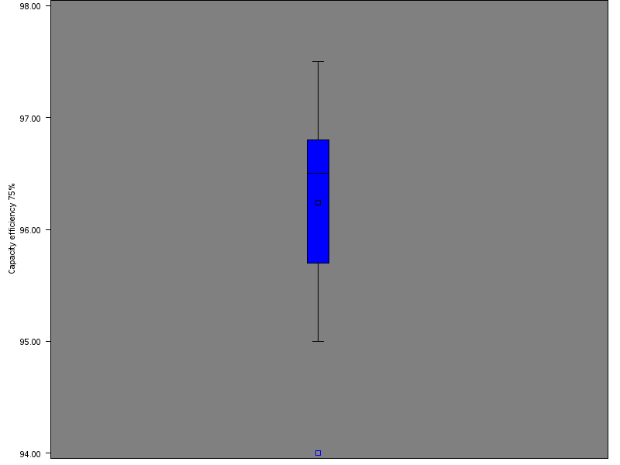

1. 500+ 75% efficiency

At this load capacity you can see by the box plot that it is at one of the highest efficiency points compared to the other capacity loads within the 500+ capacity group.

##### Capacity (80%)

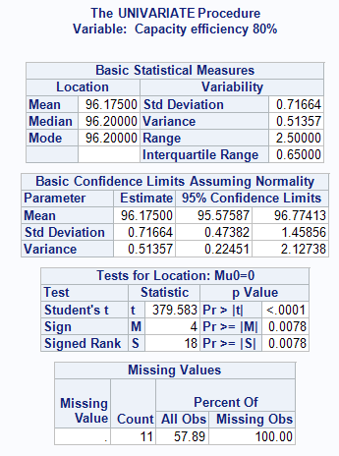

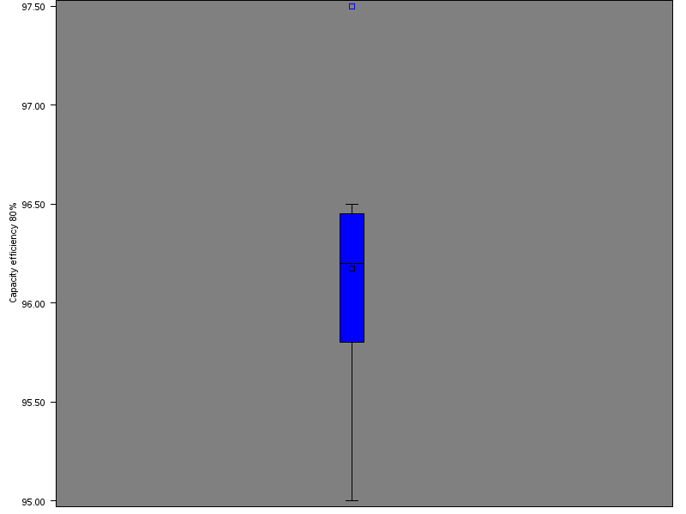

1. 500+ 80% efficiency

As you can see from this graph although the average is very high the range of data is very big going from 96.5% all the way to 95%.

##### Capacity (85%)

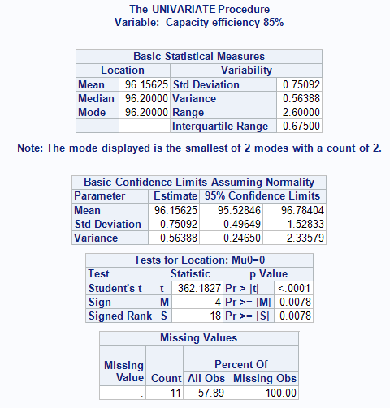

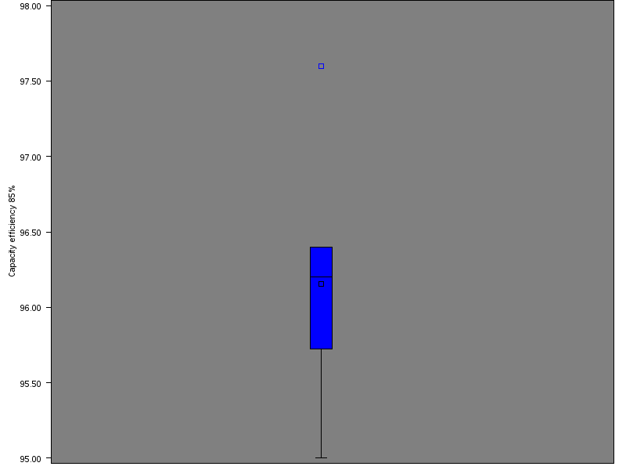

1. 500+ 85% efficiency

This graph shows the efficiency for the capacity load if it was at 85% and as you can see there is no data present outside of the box for the upper half.

##### Capacity (90%)

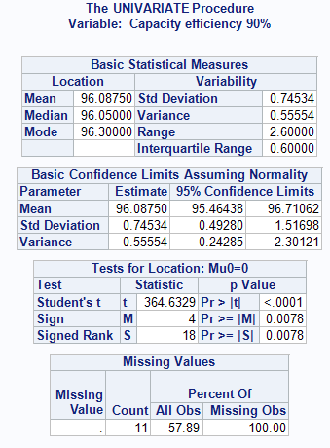

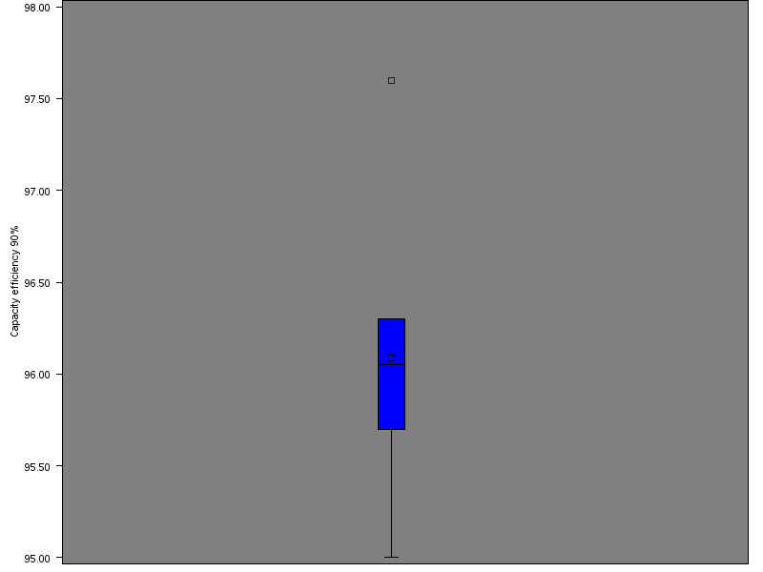

1. 500+ 90% efficiency

Above is a box plot for the efficiency capacity if the load was to be a 90%.

##### Capacity (95%)

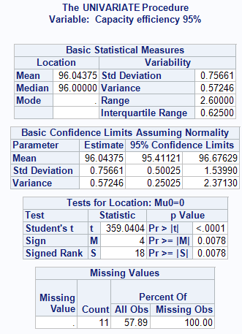

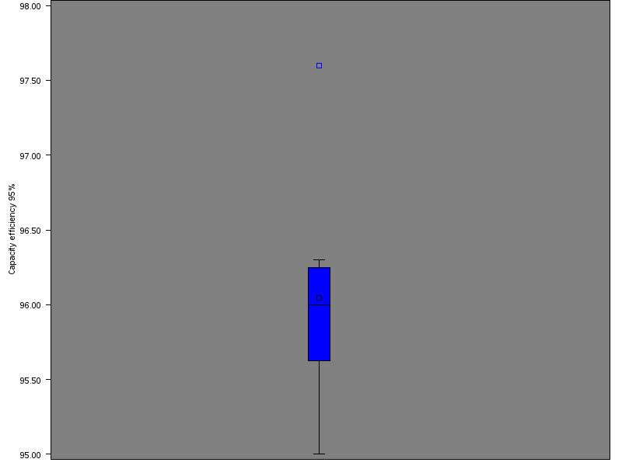

1. 500+ 95% efficiency

As you can see from the range of data on the box plot the data has dropped compared to the efficiency readings at 75% or 80%.

##### Capacity (100%)

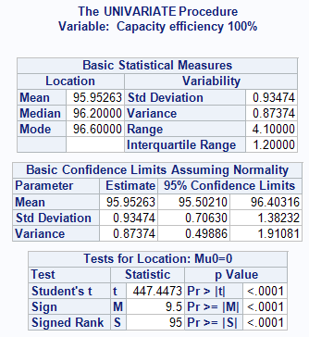

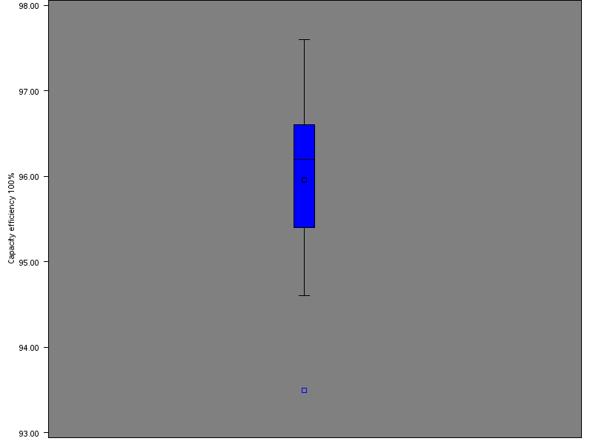

1. 500+ 100% efficiency

This is the box plot of the load at full capacity which would usually be slightly lower than 95% however in this case the range is slightly higher.

# Validation

To validate my analysis, you will need to get different UPS systems that are not in the dataset and see if they fit within the average range. Since there are 3 different groups this will be conducted slightly different as all groups must be tested to see how accurate the reading are. After this the next step is to calculate the percentage of UPS systems that fit into this range from the data selected outside of the dataset used.

## Capacity (0 to 45)

The first UPS which I have chosen is the APC Smart-UPS VT 10kVA 400V w/3 Batt Mod Exp to 4, Start-Up 5X8, Int Maint Bypass, Parallel Capable. This was chosen because it gives us a reading at a certain efficiency point which will be used to see if it fits within the specified range.

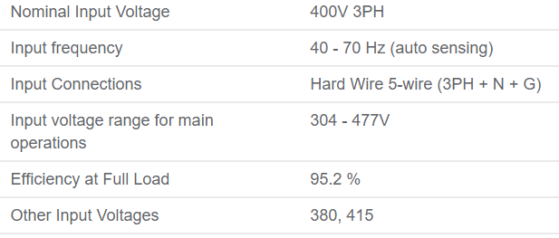

1. APC Smart-UPS VT 10kVA 400V w/3 Batt Mod Exp to 4, Start-Up 5X8, Int Maint Bypass, Parallel Capable

Above is the print screen to show the efficiency of this UPS. As you can see it doesn’t have the efficiency points for every load capacity however this one point can still be used to compare. To work out if this fits into the range you must get the average for the 0 to 45 capacity range when the load is at 100% then – and + the standard deviation to the range. This will be 94.9 – 1.6 = 93.3 this is the lower range and the upper range is 94.9 + 1.6= 96.5. As the efficiency of this UPS at full load is 95.2 this that it falls between the average range for this capacity.

Another UPS system that will be used for validation is SmartOnline SVX Series 30kVA Modular, Scalable 3-Phase, On-line Double-Conversion 400/230V 50/60Hz UPS System. This UPS was chosen as it has the efficiency reading when at full load like the first UPS used to validate.

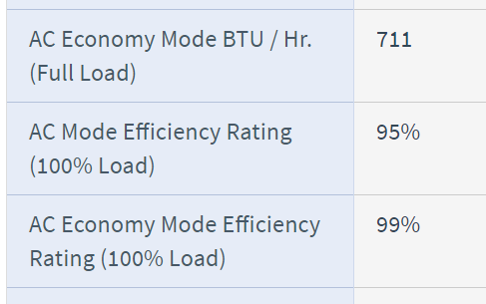

1. SmartOnline SVX Series 30kVA Modular, Scalable 3-Phase, On-line Double-Conversion 400/230V 50/60Hz UPS System

As you can see from the efficiency on ac mode it fits in with the average efficiency for the capacity at 100% load. This means that so far for this capacity group it has a 100% rate of UPS being within the average of the datasets.

## Capacity (50 to 400)

The UPS chosen to test this capacity range is the SmartOnline SVX Series 60kVA 400/230V 50/60Hz Modular Scalable 3-Phase On-Line Double-Conversion Small-Frame UPS System, 3 Battery Modules. This UPS was chosen due to it being within this range capacity and having the relevant information to test this efficiency point.

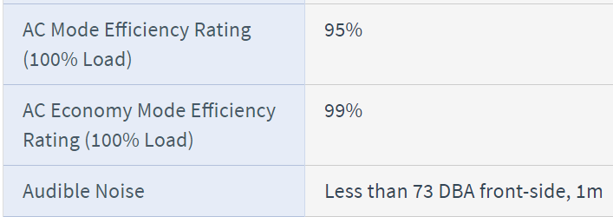

1. SmartOnline SVX Series 60kVA 400/230V 50/60Hz Modular Scalable 3-Phase On-Line Double-Conversion Small-Frame UPS System, 3 Battery Modules

From the above image it states that at 100% capacity it performs at a 95% efficiency on ac mode. To see if this fits into the average for this capacity group we do 94.96- 1.58=93.38 then 94.96 + 1.58= 96.54. Now we have our range for this group it is clear that the 95% that this UPS provides is within the average range for this set capacity.

Another UPS being used to test the efficiency is the PowerWave 6000 s3 60-120 KVA. This UPS has the data for each KVA rating and has the efficiency readings for 25%, 50%, 75% and 100%.

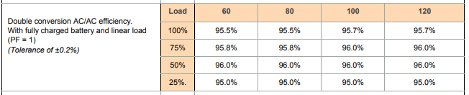

1. PowerWave 6000 s3 60-120 KVA

For this UPS we can split it up into load instead of capacity. To calculate the first efficiency which is for load when at 25% this range will be 93.17 – 2.68=90.49 then 93.17 +2.68= 95.85. Using this range we can see that all the load capacity efficiency fits within this average range. The next range is for 50% capacity the average range for this will be 94.97 – 1.63= 93.34 then 94.97+1.63=96.6. As you can see from the above table all the efficiency points when at 50% load are all on 96% this is within the average range for this load. At 75% load the average range for this will be 95.12 – 1.51=93.61 then 95.12+ 1.51=96.63. Looking at the table above all efficiency ratings at 75% fit within this average range for this capacity group. The last load is when at 100% at this range is between 93.38 and 96.54 as you can see at 100% load all figures fit within the average range for this capacity.

## Capacity (500+)

The first UPS which will be used to test the analysis is the Powerwave 6000 (500kva). With this UPS we will be able to test 4 different efficiency capacities as this supplies us with the efficiency when at 25%, 50%, 75% and at full load.



1. Powerwave 6000 (500kva)

Since we can test 4 different capacities it would be best to start with the lowest being 25%. The range for this is be 95.49-1.15=94.34 then 95.49+1.15=96.64 and as you can see this fits within the average range when the capacity is at 25%. The second range would be 96.28- 0.87= 95.41 then 96.28+0.87= 97.15 this means that for this capacity the data falls within the average when at 50% capacity. The third range that will be tested is for the capacity range at 75% which will be 96.29-0.94=95.35 then 96.29 + 0.94=97.23 this shows that at 75% capacity it just about falls within the average range while being at this capacity. The last capacity being tested is at full load and the range for this is 95.99-1.04=94.95 then 95.99+1.04=97.03 as the efficiency at 100% capacity is 95% this proves that the efficiency average are very accurate for the 500+kva group.

# Evaluation

My project aim was to be able to provide a system or dataset that allows companies to check their UPS efficiency and work out what type of UPS will best suite them. Considering this objective a data set was created on excel with important information being includes such as the UPS capacity then the efficiency for that capacity. This data was then split into different groups depending on the UPS capacity to help the data centre sizes for example small data centres would look in the lowest capacity group. These data groups were then analysed to obtain certain information such as the average and standard deviation this was then used to show the average range so that companies can see if their UPS fits within this range. After this was completed then next stage was to validate my findings, which was done by comparing other UPS to see if they fit within the average range for that capacity.

This was successful as I was able to create a database in which companies can use to get information about their current UPS and Other UPS, which could be used to determine if they should change UPS system. Although this project was a success there were many other things that could have been done given more time and resources which would have helped the project. The first improvement that could have been done was to do with the dataset. As there was only 101 different UPS on the dataset this meant that some records didn’t have enough information which lead to the standard deviation becoming high. If more data was present this may have decreased the gap between the data which would have improved the standard deviation and the average for this data.

Another improvement would come in the analysis stage and would have been to add a candle stick chart. A candle stick chart is a chart that uses information such as the average and standard deviation to create a perfect range for the average. On this graph all capacity percentages would have been present for each capacity group with the average range plotted on the graph like the one below.

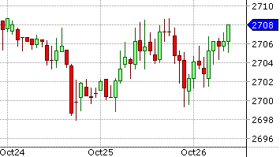

1. Candlestick chart

Using a candle stick chart would have allowed me to have 3 different diagrams, 1 for each capacity group. Once all graphs were done all that would have been left to do is analyse the data and annotate the graph. This would have allowed companies to use both the dataset and the candlestick chart to decide whether their UPS was efficient enough or not.

The last improvement that could have been made is adding more UPS in the validation of this project. This way we would have had a better idea on how accurate the diagrams, average and standard deviations were. Also using this data, we would have been able to give a percentage to back up the point in the validation section. For example, for capacity 0 to 45 the graphs are 100% accurate.

# Conclusion

I started the project with the introduction which outlined the aims and objective of the project explaining what will take place within this report. This spoke about all aspect of the report mentioning the data analysis and validation. This was then followed by my literature review which gathered all background information for my project so that I know what has been done and how my project is different from these other projects. Within the literature review I explained the use of conduct for UPS and for datacentres which specifies that they must be above a certain efficiency for the datacentres. After this I then included a personal development plan explaining what skills I need and if I have the skill already and if not how long it took to obtain. This covered all the skills that this project would need to be completed and how long it would take to get them. The last paragraphs within the literature review was for the legal and ethical purposes for my project explaining any copyright issues or operating in the wrong way.

The next stage of my project was the research stage which included me finding the correct fields for the dataset. To complete this I had to research to find which fields were most important for the UPS and what efficiency ratings would be best. After this the next stage was to move onto the data collection process which was to search for different UPS systems and obtain the information which I had decided to in my research stage. For this stage I collected over 100 different UPS systems which had different capacities and different efficiency ratings.

Then the data had to be analysed but before this could take place the data had to be normalised and split into different capacity groups for the analysis stage. After this was completed the data for each capacity group needed to be analysed by obtaining information such as the average, minimum, maximum, and standard deviation. Using this information this would allow you to work out each average range for each capacity and other information such as the highest or lowest efficiency for that capacity. Once this had been completed the analysis for this had to be verified, which was done by using additional UPS systems which was not included in the dataset to see if their efficiency fit within the average range for that capacity. This was a very important step as it showed how accurate the data was and also how accurate the analysis on the data was.

The Results of the analysis of the data will allow different companies to use the data to check their UPS system to find out different things. The first being how efficient their UPS system is this would be done using the average range, make and model. The second being to measure their current UPS if they have the information needed about their UPS system. The Last thing being how they could improve their current efficiency by looking at their current load and capacity then picking out the best UPS for them.

References

1. *Schneider-electric.co.uk. (2018). Different Types of UPS Systems. [online] Available at: https://www.schneider-electric.co.uk/en/faqs/FA157448/ [Accessed 26 Jan. 2018]. [1]*
2. *E3p.jrc.ec.europa.eu. (2018). Cite a Website - Cite This For Me. [online] Available at: https://e3p.jrc.ec.europa.eu/sites/default/files/documents/publications/code_of_conduct_ups_16032011.pdf [Accessed 26 Jan. 2018]. [2]*
3. *EU Science Hub. (2018). Code of Conduct for AC Uninterruptible Power Systems - EU Science Hub - European Commission. [online] Available at: https://ec.europa.eu/jrc/en/energy-efficiency/code-conduct/ups [Accessed 26 Jan. 2018]. [3]*
4. *EU Science Hub. (2018). Code of Conduct for Energy Efficiency in Data Centres - EU Science Hub - European Commission. [online] Available at: https://ec.europa.eu/jrc/en/energy-efficiency/code-conduct/datacentres [Accessed 26 Jan. 2018]. [4]*
5. *Ieeexplore.ieee.org. (2018). Comparison between Double Conversion Online UPS and Flywheel UPS technologies in terms of efficiency and cost in a medium Data Centre - IEEE Conference Publication. [online] Available at: http://ieeexplore.ieee.org/xpls/icp.jsp?arnumber=7339903 [Accessed 26 Jan. 2018]. [5]*
6. *Ieeexplore.ieee.org. (2018). Increasing Hyperscale Data Center Efficiency: A Better Way to Manage 54-V\/48-V-to-Point-of-Load Direct Conversion - IEEE Journals & Magazine. [online] Available at: http://ieeexplore.ieee.org/stamp/stamp.jsp?tp=&arnumber=8231285 [Accessed 26 Jan. 2018]. [6]*
7. *Ieeexplore.ieee.org. (2018). Modeling UPS efficiency as a function of load - IEEE Conference Publication. [online] Available at: http://ieeexplore.ieee.org/stamp/stamp.jsp?tp=&arnumber=6036560 [Accessed 26 Jan. 2018]. [7]*
8. *Solar, B. (2018). Power Calculator, convert kVA to kw, kW to kVA, watts and volts - Bundu Power Online Tools. [online] Bundupower.co.za. Available at: https://www.bundupower.co.za/calculator.php [Accessed 10 Apr. 2018]. [8]*
9. Khan Academy. (2018). *Reading box plots*. [online] Available at: https://www.khanacademy.org/math/probability/data-distributions-a1/box--whisker-plots-a1/v/reading-box-and-whisker-plots [Accessed 14 Apr. 2018]. [9]
10. *Bjork, A. (2018). What is Agile? | Agile Methodology. [online] Visual Studio. Available at: https://www.visualstudio.com/learn/what-is-agile/ [Accessed 16 Apr. 2018]. [10]*
11. *The Official 360logica Blog. (2018). The Importance of Different Agile Methodologies Included in Agile Manifesto - The Official 360logica Blog. [online] Available at: https://www.360logica.com/blog/the-importance-of-different-agile-methodologies-included-in-agile-manifesto/ [Accessed 16 Apr. 2018]. [11]*

Appendix A - Initial Project Proposal

Project (CN6103) Initial Proposal Form

Program: Computing for business Year: 2017

Semester: 3rd

Student Number: 1505479

Proposed Title: Improving efficiency within data centres (Uninterruptable power supply)

Proposed Aim:

1) My first goal is to research uninterruptable power supplies and find the best way to capture the efficiency of UPS in a database. The research includes finding suitable headers for each of the columns within the database.

2) My second goal is to start the data collecting process while checking for similarities between different models.

3) My third goal is to analyse the data and explain how the information collected could be used to drive energy efficiency in data centres.

4) My fourth and final goal is to validate the data collected within the database.

Rationale:

This project needs to be undertaken as many data centres don’t have the money or resources to work out how energy efficient their data centres are. This means that companies will be able to use the database to check how much they should be inputting in order to get the best possible output which will save huge amounts of energy within data centres. The database will also allow companies to check for similarities, so even if the make or model isn’t in the database you could find a similar model or make and get the information from there.

Supervisor:

Appendix B - Final Project Proposal

Project (CN6103) Final Proposal Form

Programme: Computing for business Year: 3rd

Semester: 1st

Student Number: 1505479

Proposed Title: Analysing the Energy Consumption of UPS Systems in Data Centre’s

Proposed Aim:

By the end of this project I will hopefully be able to provide companies with information on how to obtain the best efficiency from their current ups system. I will accomplish this by analysing many ups so that I know how to get the most out of the ups. Once I have completed this I will be able to get the efficiency of ups even if they are not on the database by analysing similar models

Objectives:

1) My first goal is to research uninterruptable power supplies and find the best way to capture the efficiency of UPS in a database. The research includes finding suitable headers for each of the columns within the database.

2) My second goal is to start the data collecting process while checking for similarities between different models.

3) My third goal is to analyse the data and explain how the information collected could be used to drive energy efficiency in data centres.

4) My fourth and final goal is to validate the data collected within the database.

Rationale:

This project needs to be undertaken as many data centres don’t have the money or resources to work out how energy efficient their data centres are. This means that companies will be able to use the database to check how much they should be inputting in order to get the best possible output which will save huge amounts of energy within data centres. The database will also allow companies to check for similarities, so even if the make or model isn’t in the database you could find a similar model or make and get the information from there.

Facilities required:

In order for me to complete my project I will need either SQL or Microsoft access to store the data collected into. I will also use excel to first store the data in before transferring it into the database. The last software I will use will be Matlab which will be used to analyse the data to work out similarities between different UPS models.

Reference: Shehabi, A., Smith, S.J., Horner, N., Azevedo, I., Brown, R., Koomey, J., Masanet, E., Sartor, D., Herrlin, M., Lintner, W. 2016. United States Data Center Energy Usage Report. Lawrence Berkeley National Laboratory, Berkeley, California. LBNL-1005775

Supervisor:

Appendix C - Application for the Approval of Research Activities to be Attached (if needed)

Appendix D – Client Consent Form to be Attached (if needed)

Additional Appendices (as needed)