Practical-1
Develop a web service for calculator application to implement simple arithmetic operations. Use WSDL for these web services to show output.
A] Creating a Web Service
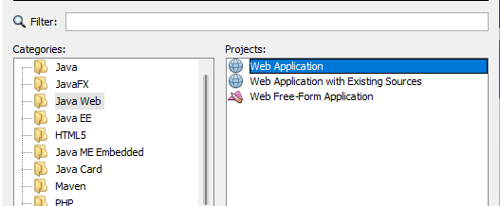
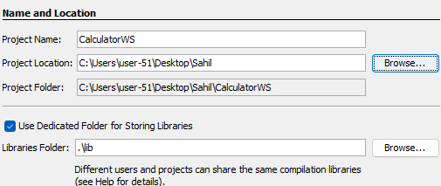
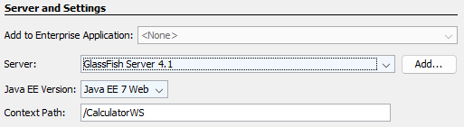
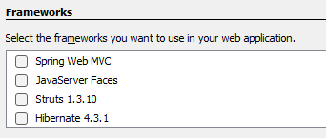
Don’t choose anything and click finish
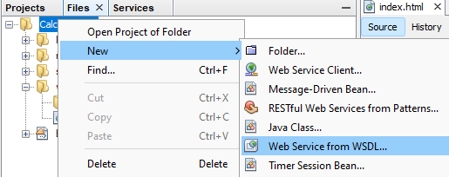
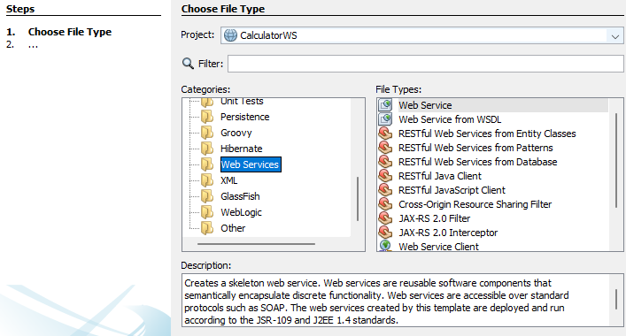

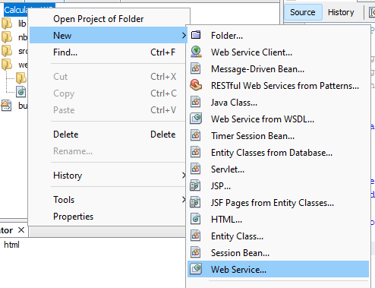
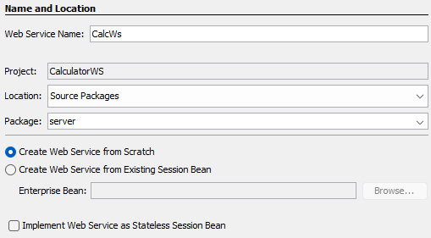
How to add a webservice
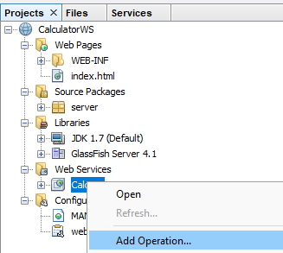
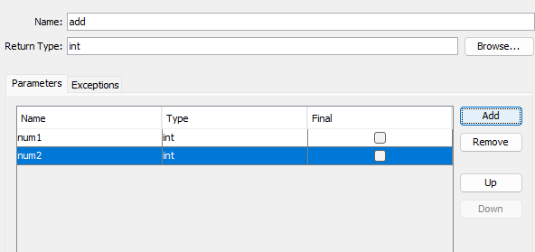
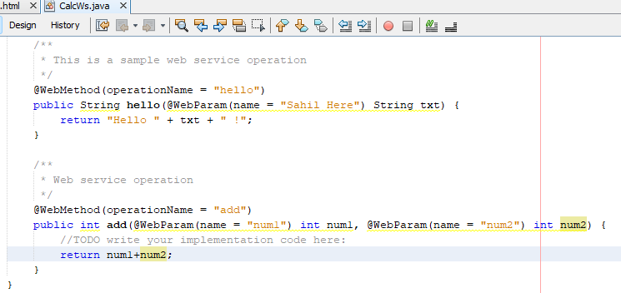

CalculatorWS > Clean build and run > Deploy > Then
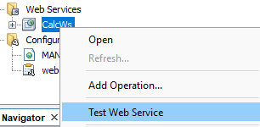
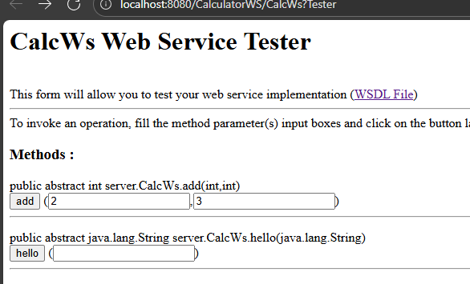
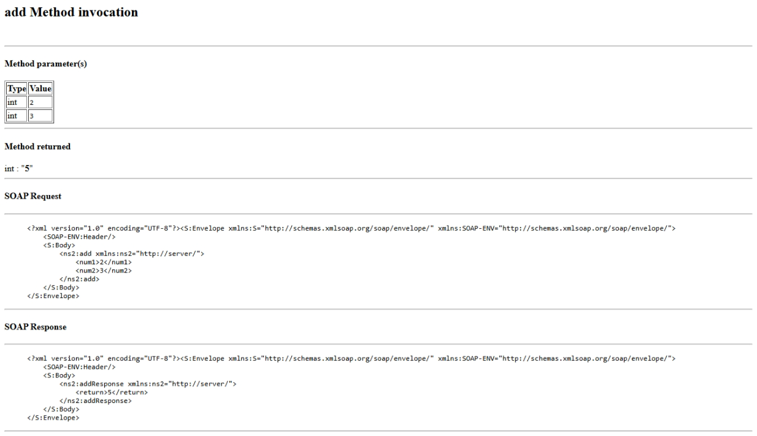
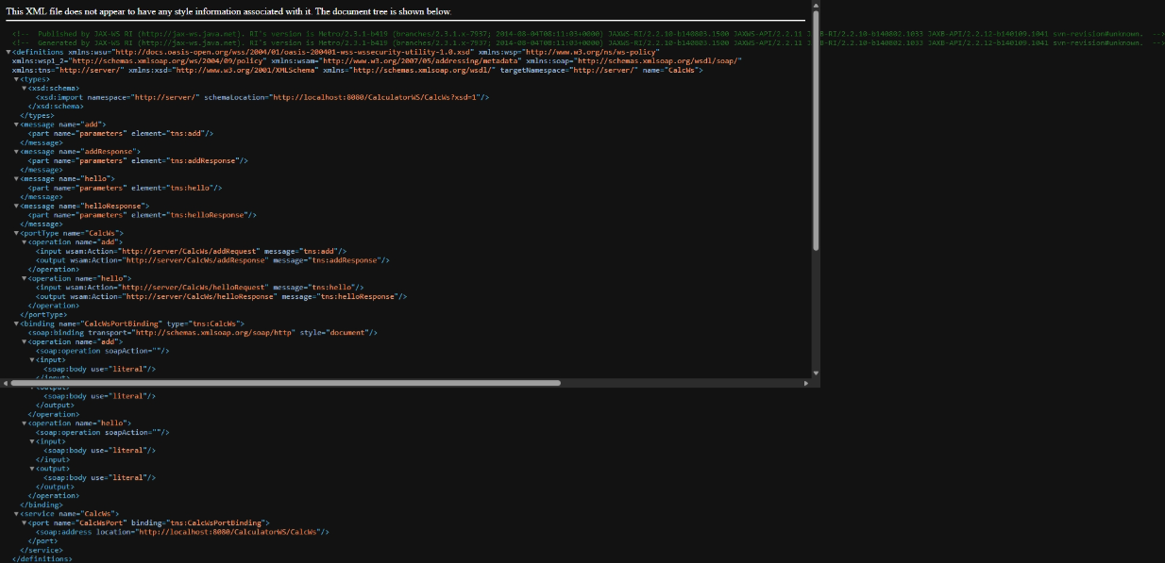
B] Creating a Client
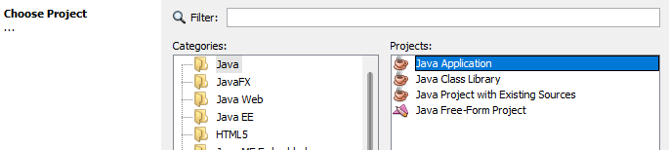
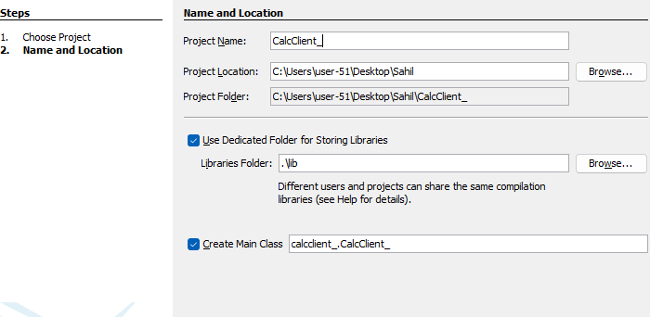
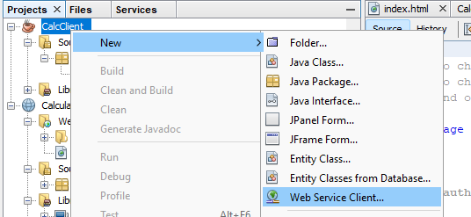
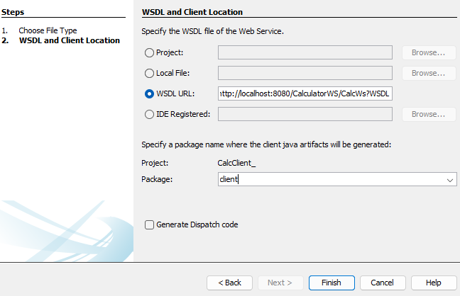
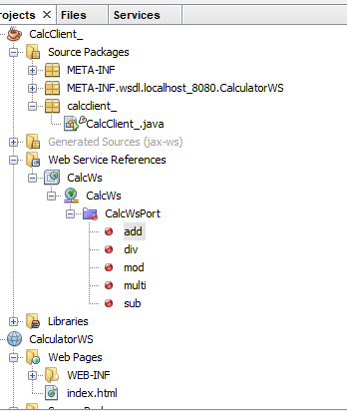
Drag and drop the add, div.. file inside CalcClient_.java

Code
package calcclient_;
public class CalcClient_ {
public static void main(String[] args) {
int Addition = add(30,65);
System.out.println("Addition result is : "+Addition);

int Subtraction = sub(30,65);
System.out.println("Subtraction result is : "+Subtraction);

int Multiplication = multi(30,65);
System.out.println("Multiplication result is : "+Multiplication);

int Division = div(30,65);
System.out.println("Division result is : "+Division);

int Mod = mod(30,65);
System.out.println("Mod result is : "+Mod);
}
private static int add(int num1, int num2) {
client.CalcWs_Service service = new client.CalcWs_Service();
client.CalcWs port = service.getCalcWsPort();
return port.add(num1, num2);
}

private static int sub(int num1, int num2) {
client.CalcWs_Service service = new client.CalcWs_Service();
client.CalcWs port = service.getCalcWsPort();
return port.sub(num1, num2);
}

private static int multi(int num1, int num2) {
client.CalcWs_Service service = new client.CalcWs_Service();
client.CalcWs port = service.getCalcWsPort();
return port.multi(num1, num2);
}

private static int mod(int num1, int num2) {
client.CalcWs_Service service = new client.CalcWs_Service();
client.CalcWs port = service.getCalcWsPort();
return port.mod(num1, num2);
}

private static int div(int num1, int num2) {
client.CalcWs_Service service = new client.CalcWs_Service();
client.CalcWs port = service.getCalcWsPort();
return port.div(num1, num2);
}

}
Output:
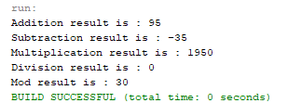

Write up
SOAP Message Format (Short Write-Up)
SOAP (Simple Object Access Protocol) is an XML-based messaging protocol used to exchange data between applications over the internet. A SOAP message is always structured in a strict XML format and typically sent over HTTP or SMTP.
A SOAP message has four main parts:
- Envelope - The root element that defines the message structure and identifies it as a SOAP message.
- Header (optional) - Contains metadata such as authentication, transaction information, or routing instructions.
- Body - The actual data or function call being sent. This section contains request or response information.
- Fault (optional) - Used to report errors that occur during message processing.
SOAP messages are designed to be platform-independent, language-independent, and follow strict standards, making them suitable for enterprise applications.

WSDL (Web Services Description Language)
WSDL is an XML-based document that describes a web service. It tells clients what a service does, where it is located, and how to interact with it.
A WSDL file defines:
- Types - Data types used in the service.
- Messages - The input and output data for operations.
- PortType (Interface) - The operations (functions) the service provides.
- Binding - The communication protocol and data format (e.g., SOAP).
- Service - The actual endpoint (URL) where the service is accessible.
WSDL acts as a contract between client and server, allowing applications to auto-generate code to interact with a web service.

