Practical-10
Aim: Gitops and ArgoCd working
Starting minikube
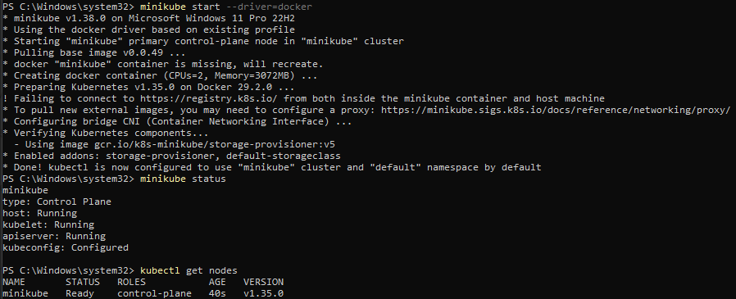

Installing ArgoCD
Create a namespace
kubectl apply -n argocd -f https://raw.githubusercontent.com/argoproj/argo-cd/stable/manifests/install.yaml
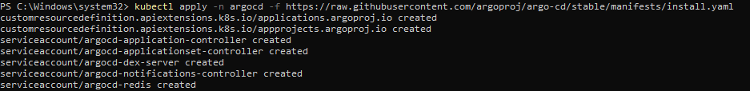
Check the pods
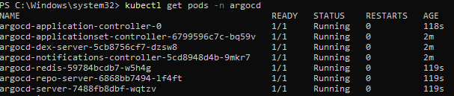
We will do the port forwarding to make it accessible from everywhere within the network
Go to http://localhost:8080
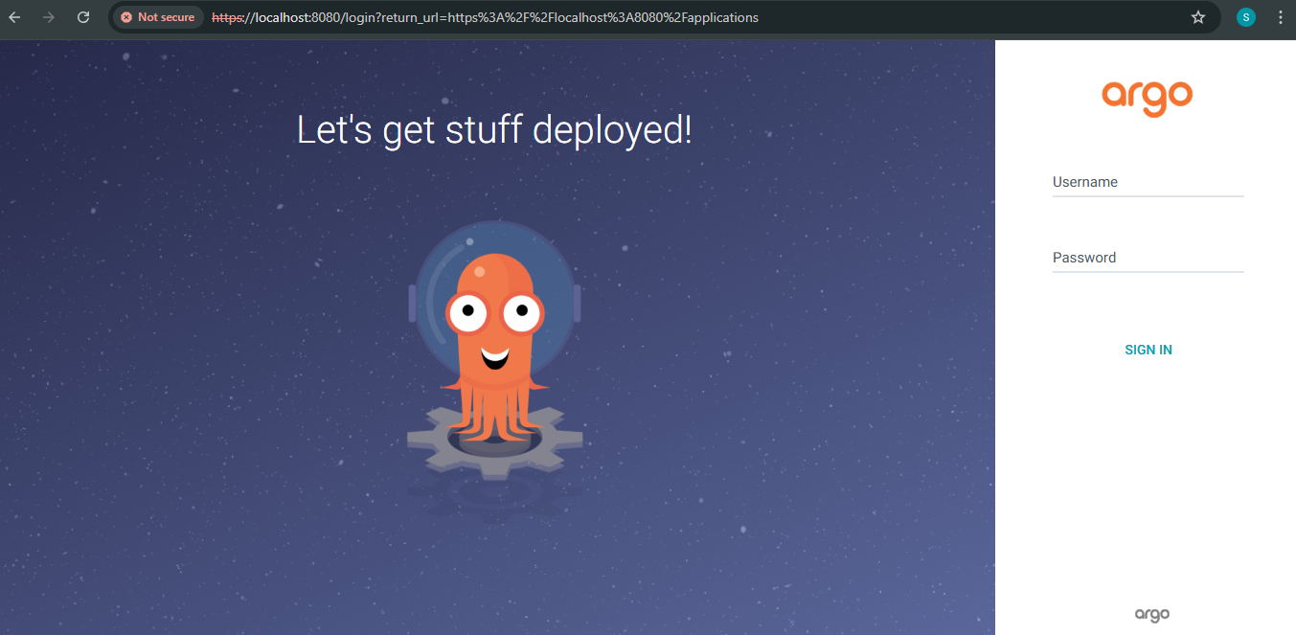

Generating the password for argocd web UI
Password (base64 decode): NE-oz0ZkHjWQqzlV

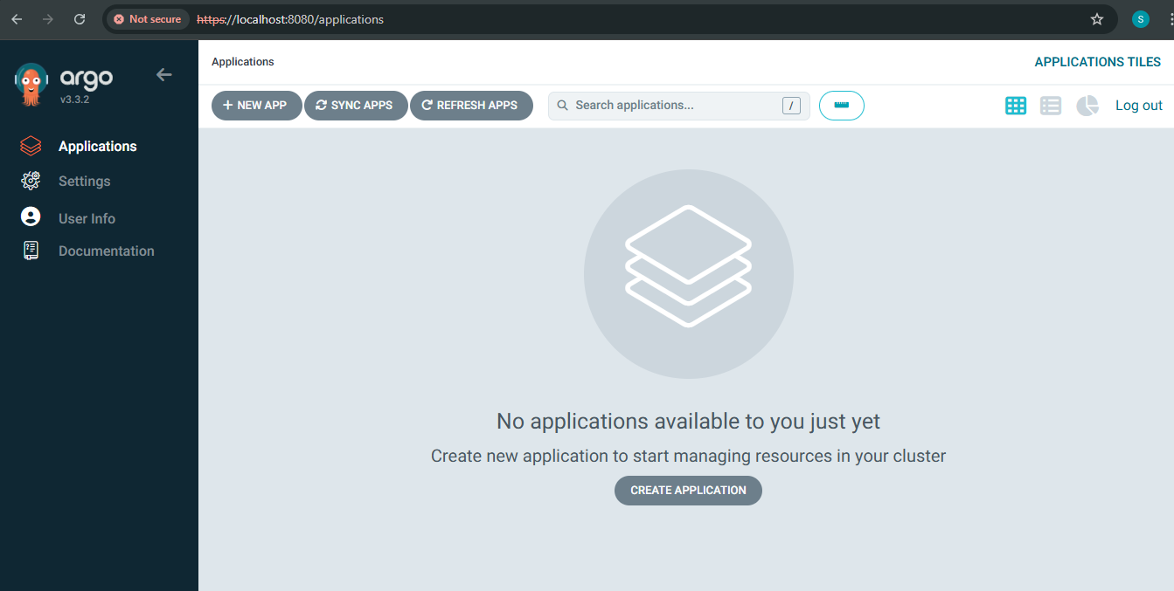

Create a new app
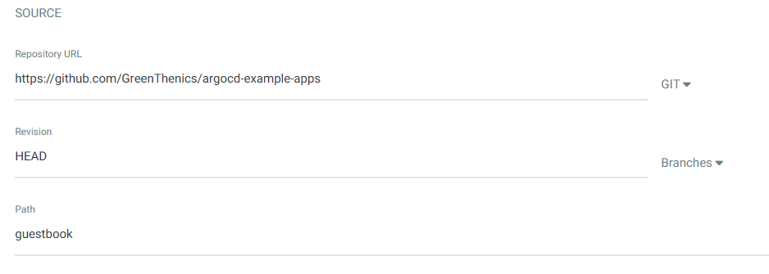
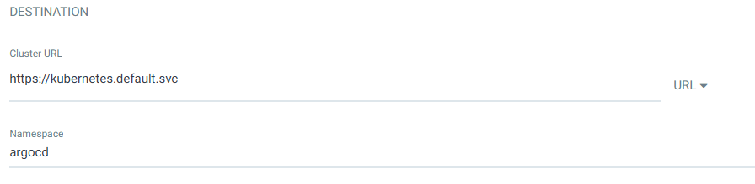
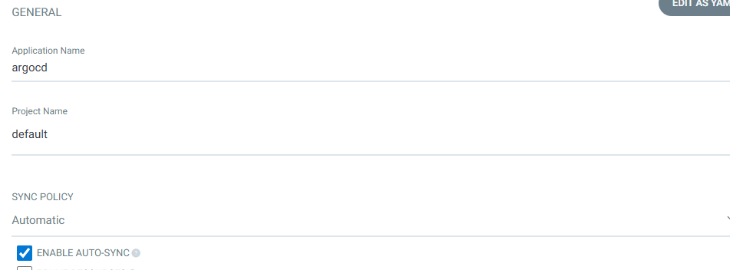
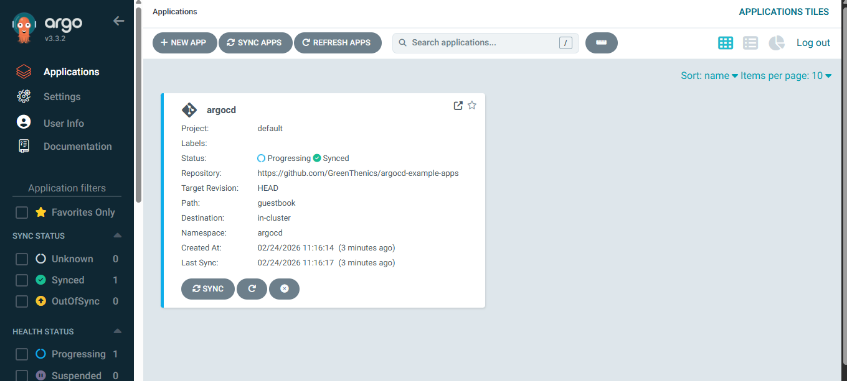
Do some changes(do any kind of error) in the repo and then refresh the argocd you will get the “OutOfSync”
