Practical-2
Aim: Web Service Jax-ws
Create a web service for UGC that contains a method which accepts college name as parameter and returns the NAAC rating. The college names and their ratings are stored in database. Design a Application client and Web Client(Servlet) to test the above web service
1] App Client – UGC NAAC scoring service
File Structure
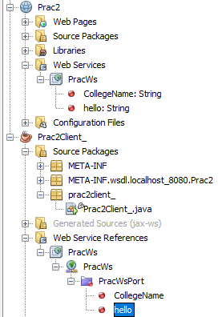
PracWs.java
package server;

import javax.jws.WebService;
import javax.jws.WebMethod;
import javax.jws.WebParam;

@WebService(serviceName = "PracWs")
public class PracWs {

@WebMethod(operationName = "hello")
public String hello(@WebParam(name = "name") String txt) {
return "Hello " + txt + " !";
}

@WebMethod(operationName = "CollegeName")
public String CollegeName(@WebParam(name = "Name") String Name) {
//TODO write your implementation code here:
String Collegen = Name;
if(Collegen.equals("Jaihind")){
return "A++";
}else if(Collegen.equals("Mithibai")){
return "A+";
}else if(Collegen.equals("Xaviers")){
return "A++";
}else{
return "Enter a valid college name";
}
}
}

Prac2Client_.java
public class Prac2Client_ {
public static void main(String[] args) {
String college = collegeName("Xaviers");
System.out.println("College NAAC grade is : "+college);
}

private static String collegeName(java.lang.String name) {
client.PracWs_Service service = new client.PracWs_Service();
client.PracWs port = service.getPracWsPort();
return port.collegeName(name);
}
}

Writeup
1. Java SE Client
A Java SE client is a standalone Java application that accesses a JAX-WS web service. The client uses proxy classes (stubs) generated from the WSDL document using the wsimport tool. This type of client runs outside a web or enterprise container and is commonly used for desktop or command-line applications.
2. Java EE Client
A Java EE client runs inside an enterprise environment such as a web application or an EJB container. The client may be implemented as a Servlet, JSP, or EJB component. JAX-WS supports dependency injection in Java EE clients using the @WebServiceRef annotation, making service access easier and container-managed.
3. Dynamic Client
A dynamic client does not require pre-generated stub classes. Instead, the client creates a service instance dynamically at runtime using the Service class and the WSDL URL. This approach is useful when the WSDL is available only at runtime or when greater flexibility is required.
4. Web-Based Client
A web-based client accesses the JAX-WS web service through HTTP using a browser or web interface. Typically, a servlet or server-side component acts as an intermediary between the browser and the SOAP-based web service. This type of client is platform independent and suitable for web applications.
5. Non-Java Client
JAX-WS web services can also be consumed by non-Java clients developed using technologies such as .NET, PHP, Python, or C++. These clients use the WSDL document to generate their own client-side code. This demonstrates the platform and language independence of JAX-WS web services.

