Practical-3
Aim: Jax Rs
Create a new Java Web Application
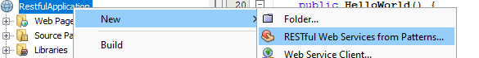
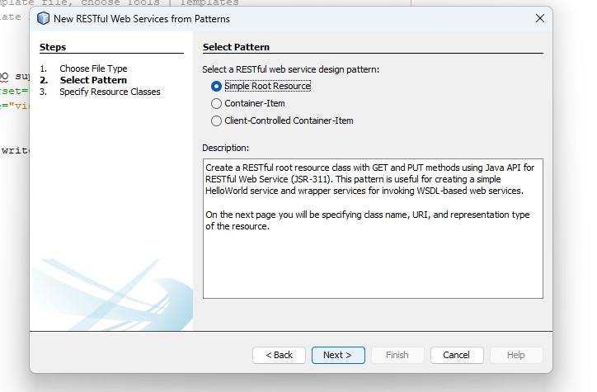
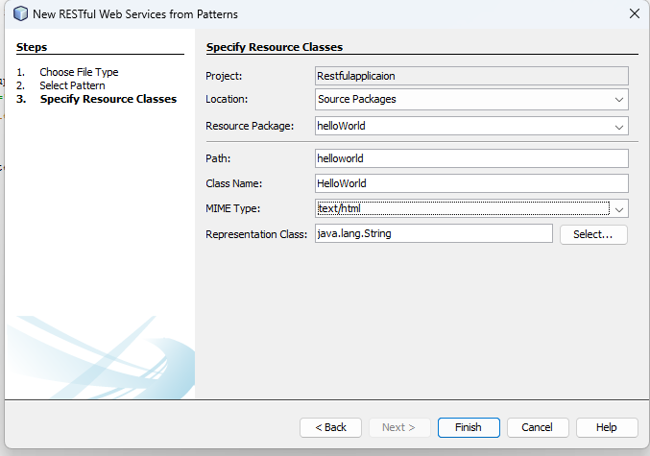
A] Update a existing string using PUT HTTP method
Code:
package helloWorld;

import javax.ws.rs.core.Context;
import javax.ws.rs.core.UriInfo;
import javax.ws.rs.PathParam;
import javax.ws.rs.Consumes;
import javax.ws.rs.PUT;
import javax.ws.rs.Path;
import javax.ws.rs.GET;
import javax.ws.rs.Produces;
import javax.ws.rs.core.MediaType;
import javax.ws.rs.core.Response;

@Path("helloworld")
public class HelloWorld {

@Context
private UriInfo context;

public HelloWorld() {
}

@GET
@Produces("text/html")
public String getHtml() {
return "<html><body><a href='https://evil.com/'><h1>Hello, World!</h1></a></body></html>";
}

@PUT
@Path ("{id}")
@Consumes(MediaType.APPLICATION_JSON)
@Produces(MediaType.TEXT_PLAIN)
public Response updateMessage(@PathParam("id") String id, String content) {
String result = "Updated Message ID: "+id+" with "+content;
return Response.ok(result).build();
}
}

Output:
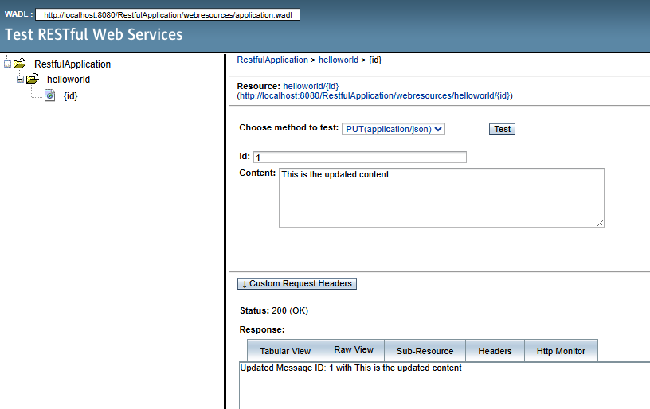
B] Create a restful webservice to take a choice from user and to convert it to uppercase or lowercase
Code:
package str;

import javax.ws.rs.core.Context;
import javax.ws.rs.core.UriInfo;
import javax.ws.rs.PathParam;
import javax.ws.rs.Consumes;
import javax.ws.rs.PUT;
import javax.ws.rs.Path;
import javax.ws.rs.GET;
import javax.ws.rs.Produces;
import javax.ws.rs.QueryParam;

@Path("strings")
public class StringDemo {

@Context
private UriInfo context;

public StringDemo() {
}

@GET
@Path ("upper")
@Produces("text/plain")
public String toUpperCase(@QueryParam("text")String text) {
return text.toUpperCase();
}

@GET
@Path ("lower")
@Produces("text/plain")
public String toLowerCase(@QueryParam("text")String text) {
return text.toLowerCase();
}

@PUT
@Consumes("text/plain")
public void putText(String content) {

}
}

Output:
Upper
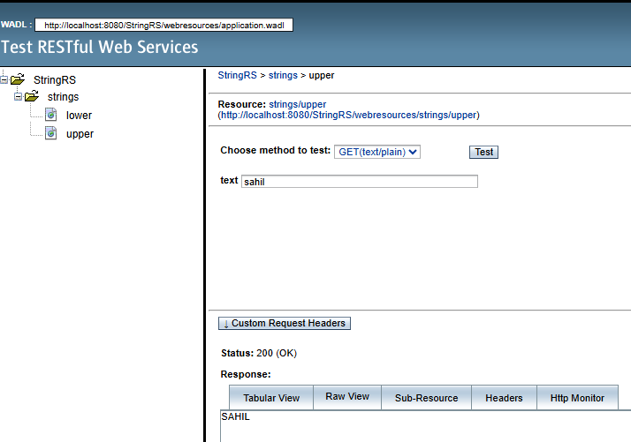
Lower
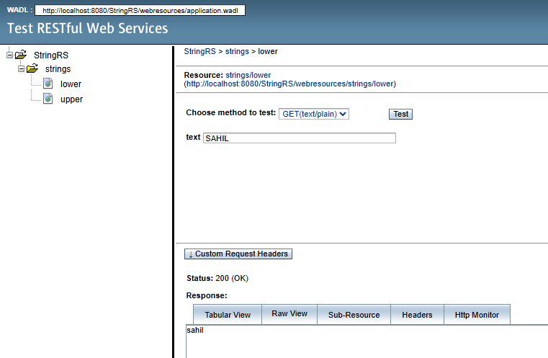

Write Up
Different Types of Annotations in JAX-RS
- @Path: Specifies the URI path template for a resource class or method. It can be used at both class and method levels to define the complete URI.
- @ApplicationPath: Used on a class that extends javax.ws.rs.core.Application to define the base URI for all resources within the application.
- @GET: Indicates that the method responds to HTTP GET requests, typically used for retrieving data.
- @POST: Indicates that the method responds to HTTP POST requests, typically used for creating new resources.
- @PUT: Indicates that the method responds to HTTP PUT requests, typically used for updating existing resources.
- @DELETE: Indicates that the method responds to HTTP DELETE requests, typically used for removing resources.
- @PathParam: Extracts a value from a URI template portion of the path.
- @QueryParam: Extracts a value from the request URI query parameters (e.g., ?name=value).
- @Context: Injects useful contextual information, such as HttpServletRequest, HttpHeaders, or UriInfo.
- @Produces: Defines the media types the resource can return to the client (e.g., "application/json", "application/xml").
- @Consumes: Defines the media types the resource can accept from the client in the request body.

