Practical-4
Aim: Jax RS Client For Hello World and String Conversion RS Services
Creating REST Client
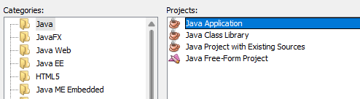
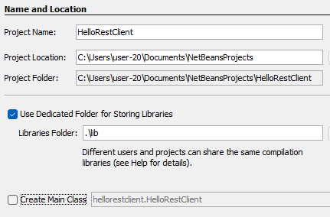
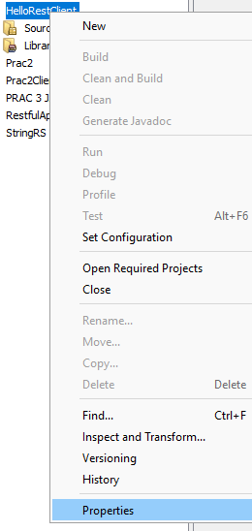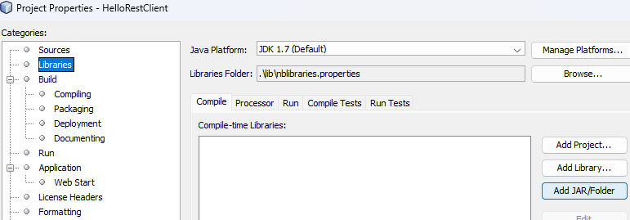

Java Lib required
- javax.ws.rs-api.jar
- Jersey-client.jar
- Jersey-common.jar
- org.glassfish.jersey.media.jersey-common.jar
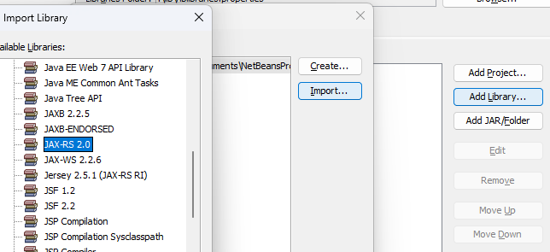
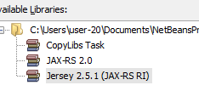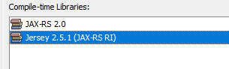
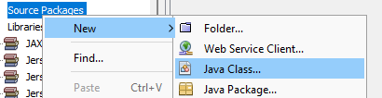
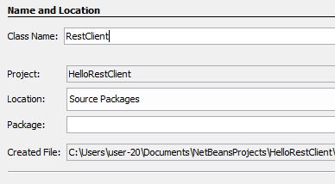
RestfulApplication → JAX-RS web service
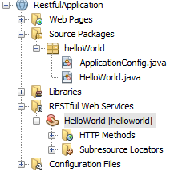
Run this web service
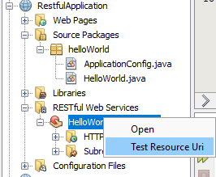
http://localhost:8080/RestfulApplication/webresources/helloworld
HelloRestClient → Java REST client
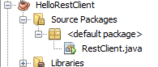
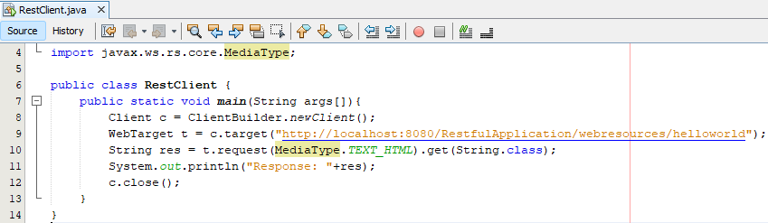

Output:
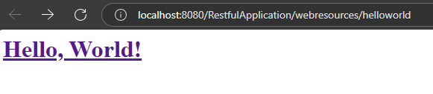

StringRS – Another Web Application
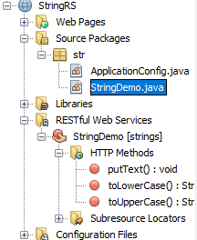
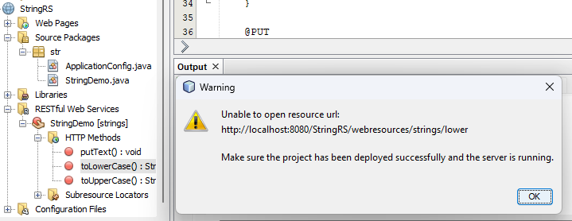
Copy both uri of lower upper and paste in the code

Code:
import javax.ws.rs.client.Client;
import javax.ws.rs.client.ClientBuilder;
import javax.ws.rs.client.WebTarget;
import javax.ws.rs.core.MediaType;

public class RestClient {
public static void main(String args[]){
Client c = ClientBuilder.newClient();
WebTarget lower = c.target("http://localhost:8080/StringRS/webresources/strings/lower").queryParam("text", "YOHOHO");
WebTarget upper = c.target("http://localhost:8080/StringRS/webresources/strings/upper").queryParam("text", "hehe");
String res1 = lower.request(MediaType.TEXT_PLAIN).get(String.class);
String res2 = upper.request(MediaType.TEXT_PLAIN).get(String.class);
System.out.println("Response: "+res1+" "+res2);
c.close();
}
}

After this Clean and build (StringRS) > deploy (optional)
Clean and build (HelloRestClient) > Run

Output:
