Practical-5
Aim: Using Docker
1] Create a python application by creating a image and running it in the command prompt
Create a python file
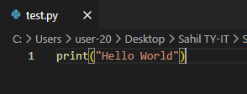

Create a Dockerfile
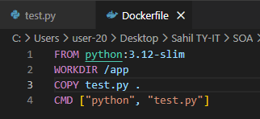
Save it as “Dockerfile” (Type - All files)
Write these commands
Building an image
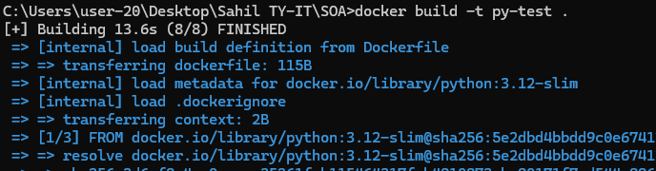
Running an image
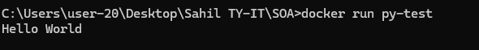

2] Run a mysql:8.0 container and create a database and table, insert values in the table and show the values and exit from the container using commands
Pull mysql:8-oracle
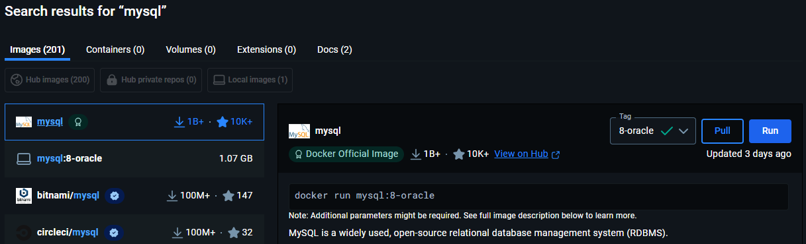
OR
docker pull mysql:8.0

Run mysql using docker
docker run -d --name mydemo -p 3306:3306 -e MYSQL_ROOT_PASSWORD=student123 mysql:8-oracle
docker exec -it mydemo mysql -uroot -pstudent123
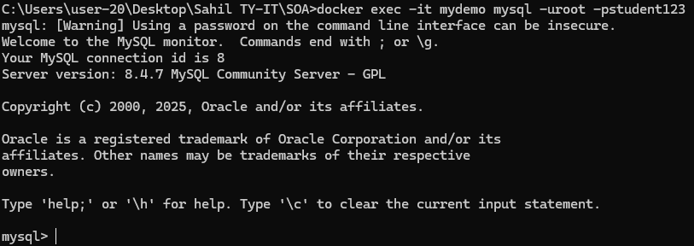
Created Db
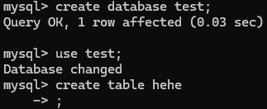

Inserting values
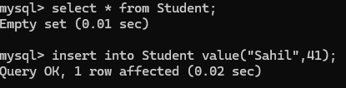
Created table
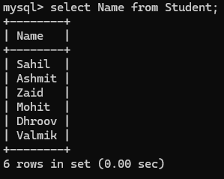

Writeup
What Dockerfile?
It helps in creating layers in an image.

What’s Alphine?
Light-weight linux version

