Practical-6
Aim: Create a Restful API Microservice and Create a Docker Image of the Microservice
Create a Java Web App
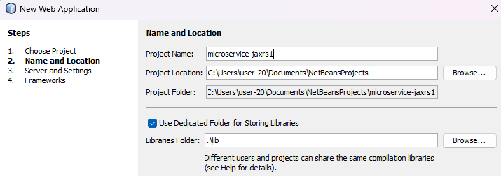
Keep rest all bydefault
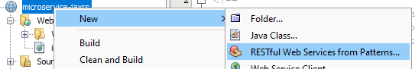
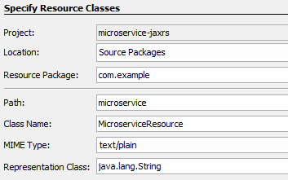
Deploy the service then
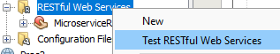
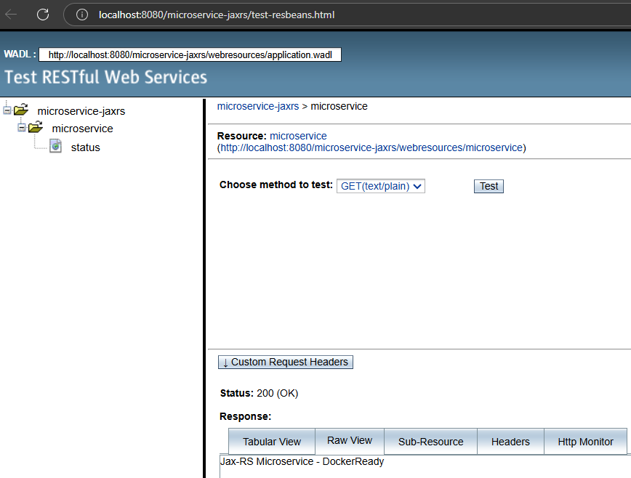
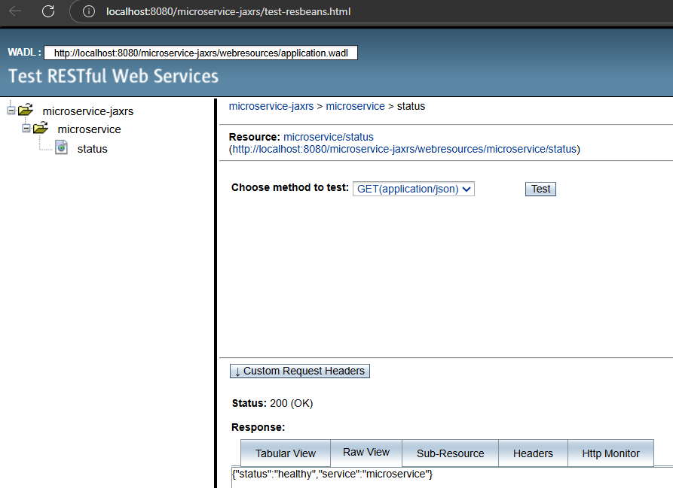
We can view the WAR (Web Archive File) – It is needed to create an image
