Practical-8
Aim: Kubernetes Installation and Working
Enable Hypervisor
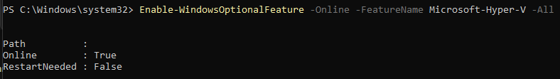
Install kubectl
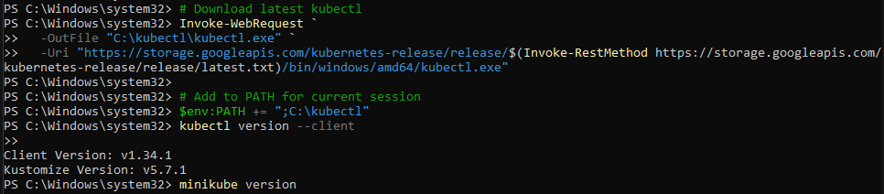
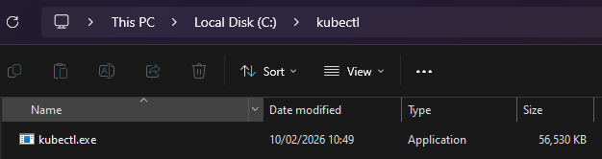
Install minikube
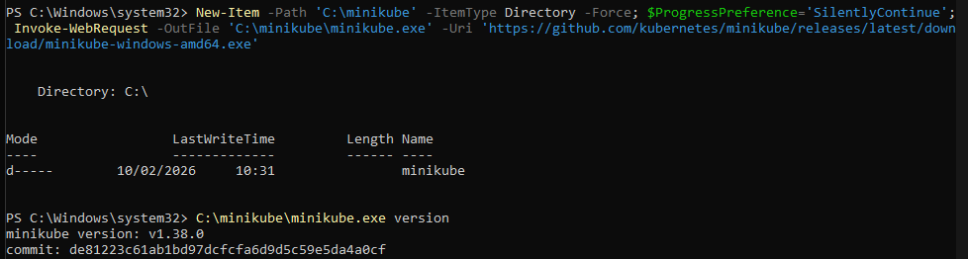
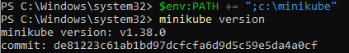
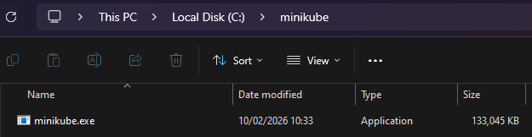
OR
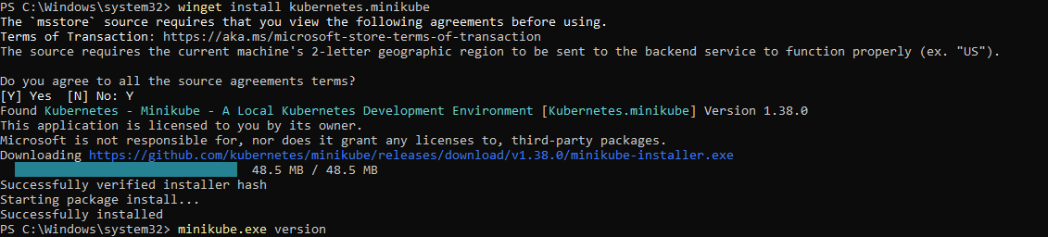
Start minikube
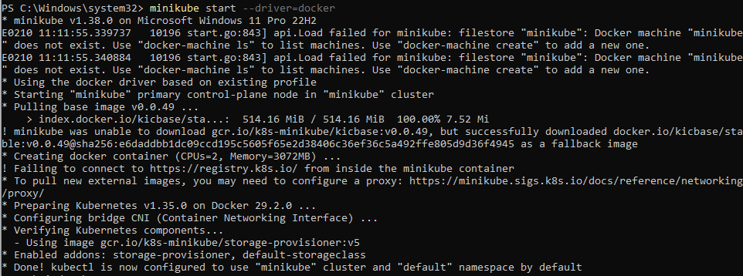
Check the running status
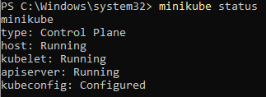
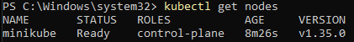

Deploying Application inside minikube
Why minikube? To create a single node cluster in kubernetes
Now the app is deployed inside kubernetes
Now Deploying and Accessing the app outside the Kubernetes

