Practical-9
Aim:
Create kafka folder
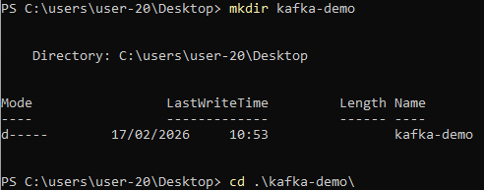
Download zookeeper and kafka image by creating a .yaml file
version: '3.8'
services:
zookeeper:
image: confluentinc/cp-zookeeper:7.6.0
container_name: zookeeper
environment:
ZOOKEEPER_CLIENT_PORT: 2181
ZOOKEEPER_TICK_TIME: 2000
ports:
- "2181:2181"
kafka:
image: confluentinc/cp-kafka:7.6.0
container_name: kafka
depends_on:
- zookeeper
ports:
- "9092:9092"
environment:
KAFKA_BROKER_ID: 1
KAFKA_ZOOKEEPER_CONNECT: zookeeper:2181
KAFKA_ADVERTISED_LISTENERS: PLAINTEXT://localhost:9092
KAFKA_OFFSETS_TOPIC_REPLICATION_FACTOR: 1
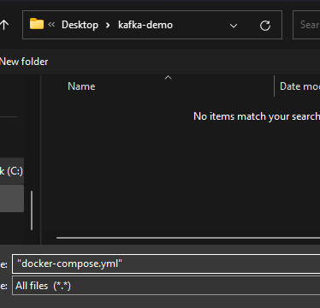
docker compose -f docker-compose.yml up -d
OR
docker compose up -d
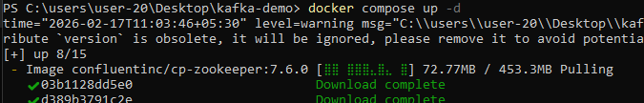

Now we will create Topic
docker exec -it kafka kafka-topics --create --topic quick-demo --bootstrap-server localhost:9092 --partitions 1 --replication-factor 1 .
Now create producer and consumer
docker exec -it kafka kafka-topics --describe --topic quick-demo --bootstrap-server localhost:9092
(2 terminals both the command should be running on them)
Produce messages
Consume messages

