Practical-6
Aim: Design and Implement Scrolling Technique
1] Design food delivery application and implement vertical and horizontal scrolling both
Create a new design>> Select Frame>> Android Compact
Click on frame again and in that add rectangle and let it go out of frame (overflow) but the frame size should not go outside the main android compact frame.
Same again create a new frame and add any shape and overflow it.
After adding in both frames individually in each frame select all the shapes through shift and then shift+A.
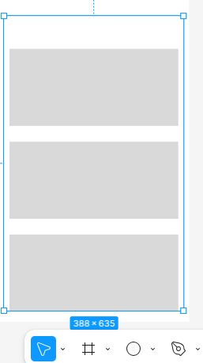

Below is the hierarchy and the frame size
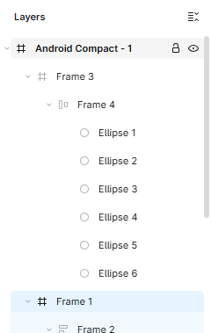
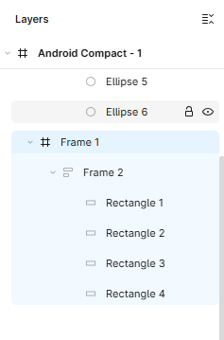
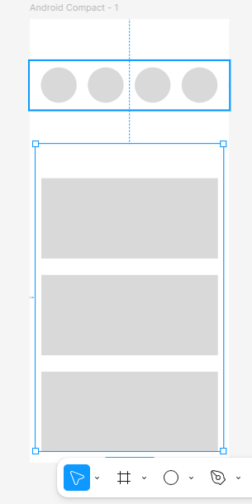
Then select the frames for which you want to give scrolling.
Go to Prototype>>Select Frame>> Overflow (Vertical/Horizontal)
Also can give interaction and on the clip content option
Don’t give any scrolling option to android compact screen
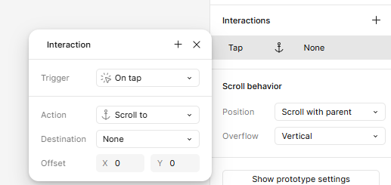
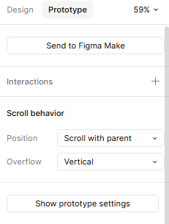

Click on preview to check
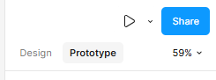

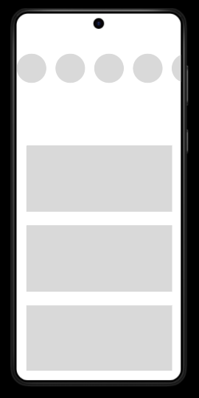

Select frame
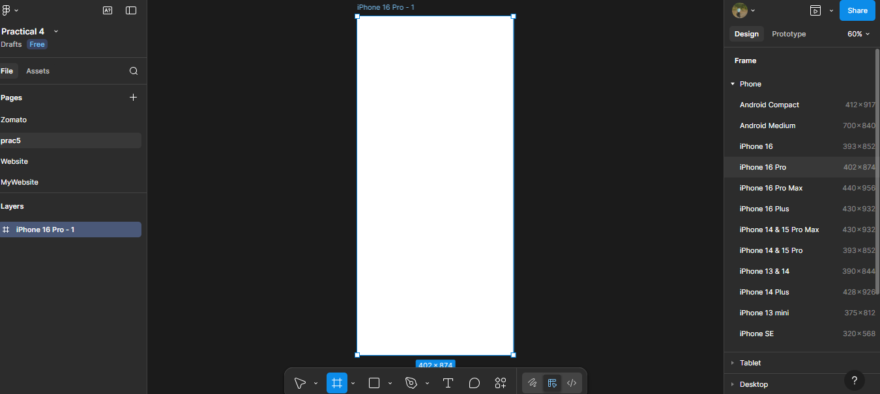
In Design tick clip content
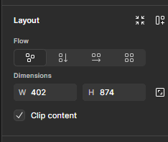

In Prototype select Vertical for main Frame
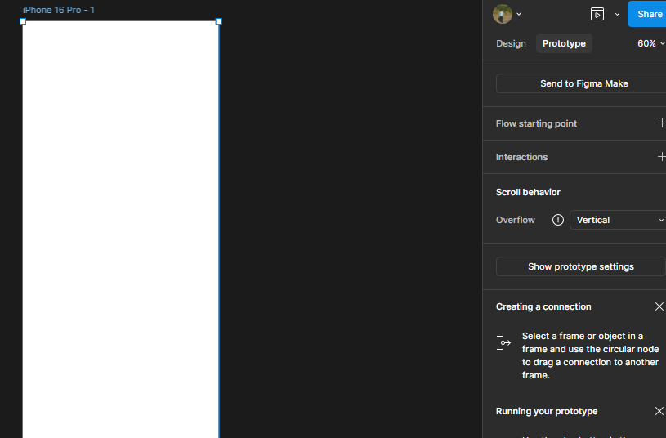
Design till here and group all

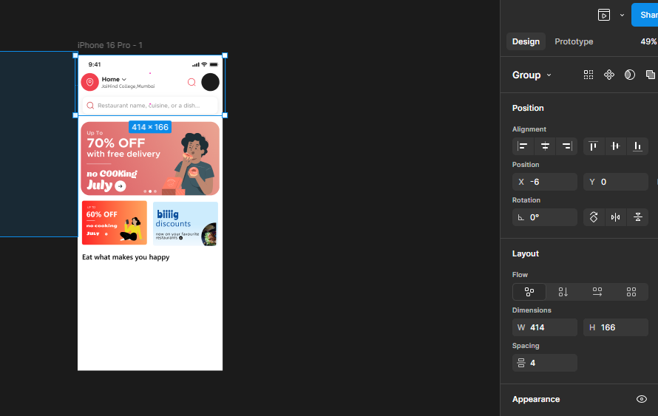
Add frame for horizontal scrolling
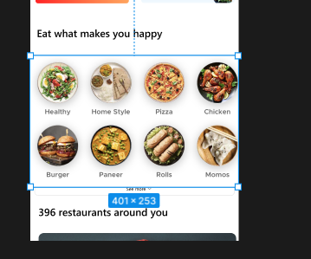
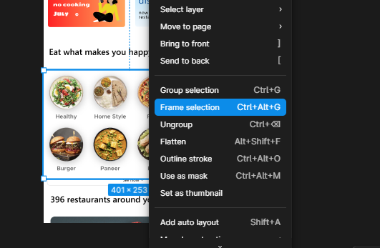
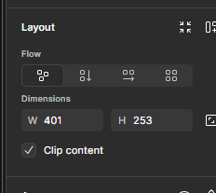
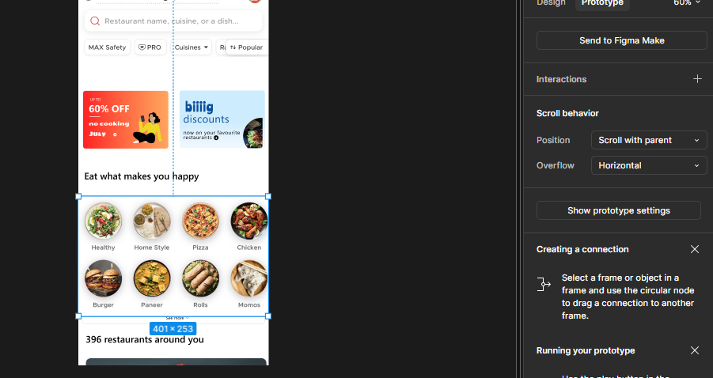
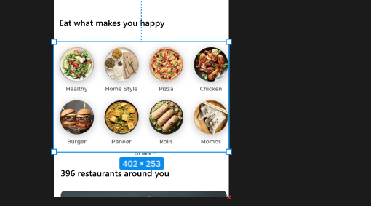
Crop till the frame