Practical-8
Aim: Bottom and Side Navigation
Navbar
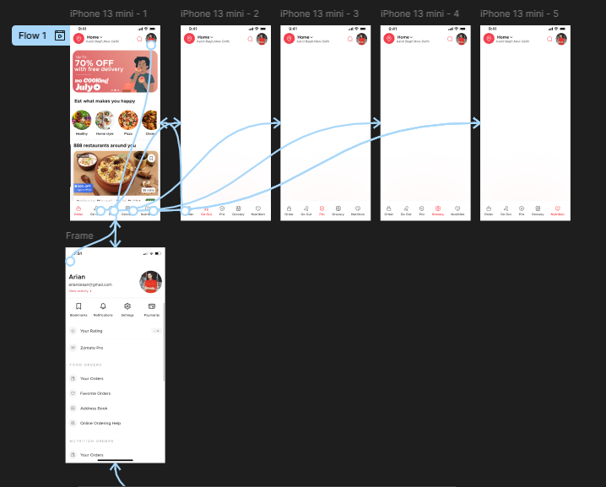

Hamburger
