Practical-10
Aim: Micro-Animation for user interface
Create minimum 5 micro animations including:
- Progress Bar effect
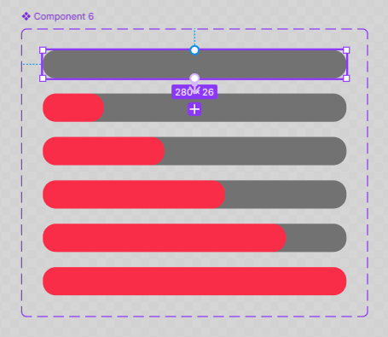
- Waiting for response effect

- Status Bar animation
- Welcome screen animation
- Button Hover effect

