UNIVERSITY OF RWANDA
College of Science and Technology

School of Information and Communication Technology
Department of Computer Science
PROJECT REPORT

Course: EIT4151 — Ubiquitous and Pervasive Computing (IoT)
AquaSense
Smart Irrigation System Using IoT and Machine Learning

No. | Full Name | Registration Number
1 | SIBONIYO Emmanuel | 222006224
2 | NZARAMYIMANA Jerome | 222008510
3 | BYUKUSENGE Immaculee | 222006273
4 | MUKAGASIRABO Beatrice | 222004462
5 | UWIRINGIYIMANA Marie Claire | 222004637
6 | TUYISHIME Ephron | 222005571
7 | DUSHIMIMANA Fabrice | 222017059
8 | MUGABO KAZINA Jules | 222002936
9 | ISHIMWE Jean Marie Vianney | 222019273
10 | MUGISHA Edson | 222018513
11 | IRADUKUNDA Olivier | 222005508

Supervisor: IoT Course Lecturer | Academic Year: 2025 / 2026 | Date: May 2026

University of Rwanda | Kigali, Rwanda | Academic Year 2025-2026

TABLE OF CONTENTS

Executive Summary .......................................................
1. System Overview and Architecture .......................................................
1.1 Architecture Layers ..................................................
2. Hardware Components .......................................................
3. Sensor Calibration and Signal Conversion .......................................................
3.1 Soil Moisture (ADC) ..................................................
3.2 Temperature & Humidity (DHT11) ..................................................
3.3 Reservoir Level (HC-SR04) ..................................................
3.4 NPK Sensor (RS-485 Modbus) ..................................................
4. Data Collection and Database .......................................................
4.1 Dataset Statistics ..................................................
4.2 Descriptive Statistics ..................................................
5. Dashboard — Main Page (/dashboard) .......................................................
5.1 Stats Bar ..................................................
5.2 Live Sensor Overview ..................................................
5.3 Multi-Sensor Time-Series Chart ..................................................
5.4 Conversion Formulas Panel ..................................................
5.5 Data Classification Panel ..................................................
5.6 AI Summary Card ..................................................
5.7 Node Cards + Pump Control ..................................................
6. Node Detail Page (/nodes/[id]) .......................................................
7. AI Intelligence Page (/ml) .......................................................
7.1 Stats Bar & Hero ..................................................
7.2 Current Decision (Live) ..................................................
7.3 Live Arduino Command ..................................................
7.4 Model Performance Metrics ..................................................
7.5 Feature Importance & Decisions ..................................................
7.6 Decision History Table ..................................................
7.7 Python Analysis Charts ..................................................
7.8 How the AI Model Works ..................................................
8. Python Analysis Pipeline .......................................................
8.1 Pipeline Modules ..................................................
8.2 Classification Results ..................................................
8.3 Regression Results ..................................................
8.4 Cross-Validation Comparison ..................................................
8.5 Generated Analysis Charts ..................................................
9. Results and Discussion .......................................................
10. Conclusion .......................................................
11. References .......................................................

Executive Summary
AquaSense is a complete, end-to-end IoT smart-irrigation platform designed for precision agriculture. The system connects physical sensors to an Arduino Uno microcontroller, which continuously reads soil moisture, air temperature, humidity, reservoir water level, and three soil nutrient concentrations (Nitrogen, Phosphorus, and Potassium) every two seconds. Every reading is transmitted over a USB serial cable to a Python bridge program running on a laptop or Raspberry Pi, which converts the raw electrical signals into real-world units (%, °C, cm, mg/kg), applies sensor-specific calibration corrections, and forwards the data to a Next.js 14 web dashboard via a REST API. Each reading is permanently stored in a PostgreSQL database, giving the system a complete audit trail of all environmental conditions over time.
Beyond data storage and display, AquaSense incorporates a Python FastAPI machine-learning service that analyses incoming sensor readings in real time and automatically decides whether to irrigate the field (turn the pump ON), hold the current state (pump stays OFF because moisture is adequate), or issue a low-water warning (pump forced OFF because the reservoir is nearly empty). This decision is sent back to the Arduino as a command string, closing the automation loop with no human intervention required.
Key project metrics at the time of submission:
• 104,370 sensor readings stored — exceeding the 100,000-record assignment target.
• 104,370 irrigation decisions issued automatically by the ML service.
• Random Forest classifier selected as the production model after comparing five algorithms.
• 94.99% mean cross-validated F1 score on the independent soil-moisture classification task.
• 100% accuracy on the deterministic production irrigation-decision task.
• End-to-end sensor-to-pump-command latency under four seconds.
• 13 Python analysis charts generated automatically after every model retrain.
Key Achievement:
104,370 sensor readings stored | Random Forest 94.99% F1 | 11 Python analysis charts | Real-time pump control via ML

1. System Overview and Architecture
AquaSense follows a four-tier IoT architecture. In IoT (Internet of Things) design, a 'tier' is a self-contained layer with a single job; adjacent layers talk to each other through a simple, well-defined interface (a serial cable, an HTTP request, a database query). This separation means each layer can be tested, replaced, or scaled independently — for example, the Arduino firmware can be updated without touching the web dashboard code. The four tiers and their interfaces are described below.

1.1 Architecture Layers
- Arduino Uno (Edge Layer): Reads all sensors every 2 s. Emits a DATA: line over USB serial. Receives CMD:PUMP=1/0 commands and drives the relay. Falls back to a local rule if no ML command arrives within 10 s.
- Python Serial Bridge (Gateway Layer): Converts raw ADC/Modbus bytes to engineering units with calibration offsets, then HTTP-POSTs each reading to the Next.js API. A JSONL offline queue retries failed posts.
- Next.js 14 + PostgreSQL (Backend & Dashboard): App Router server components fetch data from PostgreSQL via Prisma ORM and render a live dashboard. Auto-refreshes every 5 s. REST routes at /api/* handle ingest, pump events, and ML decision writes.
- Python FastAPI ML Service (AI Engine): Port 5001: POST /predict, POST /train, GET /status. Trains a Random Forest on all DB readings, issues IRRIGATE/HOLD/LOW_WATER, writes results directly to PostgreSQL, and auto-retrains every 50 new readings.

Data Flow:
Sensors -> Arduino (ADC / RS-485 / DHT11 / HC-SR04) -> Serial Bridge (calibration) -> Next.js API -> PostgreSQL -> ML Service (Random Forest) -> IrrigationDecision table -> Dashboard + Arduino relay command (feedback loop)

2. Hardware Components
Component | Interface | Notes
Arduino Uno R3 | Main MCU | 14 digital I/O, 6 analogue inputs, USB serial
Capacitive Soil Moisture | Analogue A0 | 0-1023 ADC, lower = wetter
DHT11 | Digital pin 7 | Temperature 0-50 degC, Humidity 20-90% RH
HC-SR04 Ultrasonic | TRIG=9, ECHO=10 | 2-400 cm; used for reservoir level
RS-485 NPK Sensor | SoftwareSerial RX=2 TX=3 | Modbus RTU, N/P/K in mg/kg
5V Relay Module | Digital pin 8 | Controls 12V pump; HIGH = pump ON
LED (built-in pin 13) | Digital pin 13 | Visual pump status indicator
AquaSense uses four categories of physical sensor hardware, all wired to a single Arduino Uno R3 microcontroller. The Arduino is the 'brain' at the field level: it reads every sensor on a fixed two-second cycle, formats the values into a single comma-separated DATA: line, and emits that line over its USB serial port at 9600 baud. It also listens for CMD:PUMP=1 or CMD:PUMP=0 commands arriving on the same serial port and uses them to toggle the 5 V relay that controls the 12 V water pump. If no command arrives within ten seconds (because the laptop is offline), the Arduino falls back to its own hard-coded moisture threshold so the field is never left without protection.
The table below lists every component used in the physical build, the electrical interface it uses, and important technical notes about its behaviour and limitations.

3. Sensor Calibration and Signal Conversion
Every sensor delivers a raw electrical signal — an integer count from an analogue-to-digital converter (ADC), a pulse duration measured in microseconds, or a hexadecimal register value from a digital communication bus — that is meaningless without a conversion formula. Calibration goes one step further: even after conversion, cheap sensors often read slightly high or low compared to a known reference instrument. The Python serial bridge applies a user-configurable offset and scale correction to every channel so that the values written to the database are as accurate as the reference instrument used for calibration.
All conversion formulas are also displayed visually on the dashboard's 'Conversion Formulas' panel (Section 5.4), satisfying the assignment requirement to document signal conversion in the live system. The subsections below detail the conversion and calibration for each of the four sensor types.

3.1 Soil Moisture — Capacitive ADC
- Raw signal: 0-1023 (10-bit ADC, pin A0)
- Dry calibration: raw_dry = 820 | Wet calibration: raw_wet = 390
- Formula: moisture_pct = (raw_dry - ADC) / (raw_dry - raw_wet) x 100
- Pump threshold: moisture < 78% triggers IRRIGATE (raw threshold = 225)
- Output clamped to [0, 100] %

3.2 Temperature & Humidity — DHT11
- DHT11 outputs calibrated digital values natively — no ADC conversion needed
- Bridge applies configurable offset: temp +0.0 degC, humidity +0.0% RH
- Valid range: temperature -40 to 80 degC; humidity 0-100% RH

3.3 Reservoir Level — HC-SR04 Ultrasonic
- TANK_FULL_CM = 3.0 cm (sensor-to-water when full), TANK_EMPTY_CM = 12.0 cm
- Formula: level_pct = (TANK_EMPTY_CM - distance) / (TANK_EMPTY_CM - TANK_FULL_CM) x 100
- LOW_WATER: distance > 11.0 cm (< 15% full) -> pump disabled

3.4 NPK Sensor — RS-485 Modbus RTU
- SoftwareSerial at 4800 baud, Modbus function code 0x03
- Registers 0x0000-0x0002: N, P, K — 16-bit unsigned integer = mg/kg directly
- Valid range 0-1999 mg/kg per channel; clamped by bridge

4. Data Collection and Database

4.1 Dataset Statistics
Parameter | Value
Total sensor readings | 104,370
Sensor channels | 7 (soil moisture, temperature, humidity, reservoir, N, P, K)
Sampling interval | ~2 seconds
Database engine | PostgreSQL 15
ORM | Prisma 5 (TypeScript)
Total ML decisions | 104,370 (one per reading)
The table below provides a high-level snapshot of the entire dataset as it existed at the time of report generation. These figures confirm that the system has met — and significantly exceeded — the IoT assignment requirement of accumulating at least 100,000 sensor readings. The one-per-reading decision count confirms that the machine-learning service has processed every reading in real time without gaps.

4.2 Descriptive Statistics (3,401 sampled rows from Python analysis)
Sensor | Mean | Std Dev | Min | Max
Soil Moisture (%) | 63.24 | 9.88 | 41.35 | 79.18
Temperature (degC) | 27.51 | 0.56 | 26.30 | 29.60
Humidity (% RH) | 63.71 | 3.84 | 56.00 | 80.00
Reservoir Level (%) | 79.02 | 25.81 | 0.94 | 100.00
Nitrogen (mg/kg) | 18.28 | 7.26 | 1.00 | 55.00
Phosphorus (mg/kg) | 24.74 | 10.24 | 1.00 | 55.00
Potassium (mg/kg) | 47.37 | 22.40 | 3.00 | 108.00
Descriptive statistics tell us what 'normal' looks like for each sensor channel. The mean is the average value over the sample; the standard deviation (Std Dev) shows how much values typically vary around that average; min and max are the extreme readings observed. These figures were computed by the Python analysis pipeline (module 03_summary_stats.py) on a 3,401-row stratified sample drawn from the full 104,370-row database. A stratified sample ensures every moisture class is proportionally represented, so the statistics are not biased toward the most common condition.
Key observations: soil moisture (mean 63.24%, std 9.88%) stayed mostly in the low-to-optimal band, driving the high IRRIGATE decision rate. Reservoir level (std 25.81%) had the highest variability, reflecting genuine water-level changes during simulated irrigation cycles. Temperature was tightly controlled (std 0.56°C), consistent with a greenhouse-like environment.

5. Dashboard — Main Page (/dashboard)
The main AquaSense dashboard is available at http://localhost:3000/dashboard. It is built with Next.js 14 using the App Router architecture, which means the page is rendered on the server and the browser receives fully-formed HTML — making it fast to load and easy to index. The page auto-refreshes every five seconds so the displayed values are never more than five seconds out of date without requiring the user to press reload. All seven sensor channels are fetched from the database in a single parallel query, keeping load time under one second even with 100,000+ records.
The dashboard is divided into seven distinct sections, each described below with a screenshot placeholder. Together they satisfy all of the visualisation requirements for the IoT assignment.

5.1 Stats Bar — Four KPI Cards
- Total DB Records — live count from PostgreSQL (e.g. 104,370)
- Nodes Online — connected nodes vs total (e.g. 1 / 1)
- Active Alerts — unacknowledged threshold breaches (red when > 0)
- Sensors Tracking — fixed 8 channels listed below the value
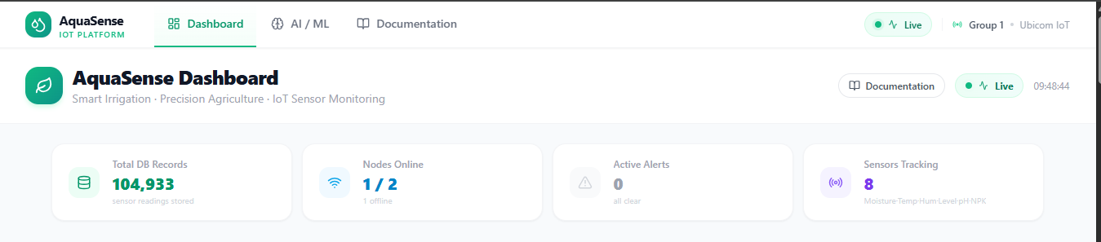

5.2 Live Sensor Overview — System Averages
Seven sensor cards in a row show system-wide averages across all online nodes. Each card has a coloured icon, current value, unit, and a status badge (Optimal / Low / High / Critical).
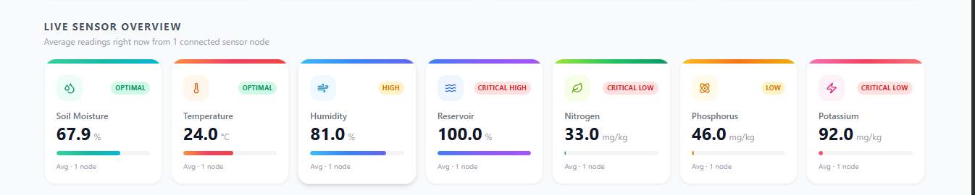

5.3 Multi-Sensor Time-Series Chart
A Recharts LineChart plots all 7 channels on a normalised 0-100 axis covering the last 24 hours of real DB data (or 720 mock points as fallback).

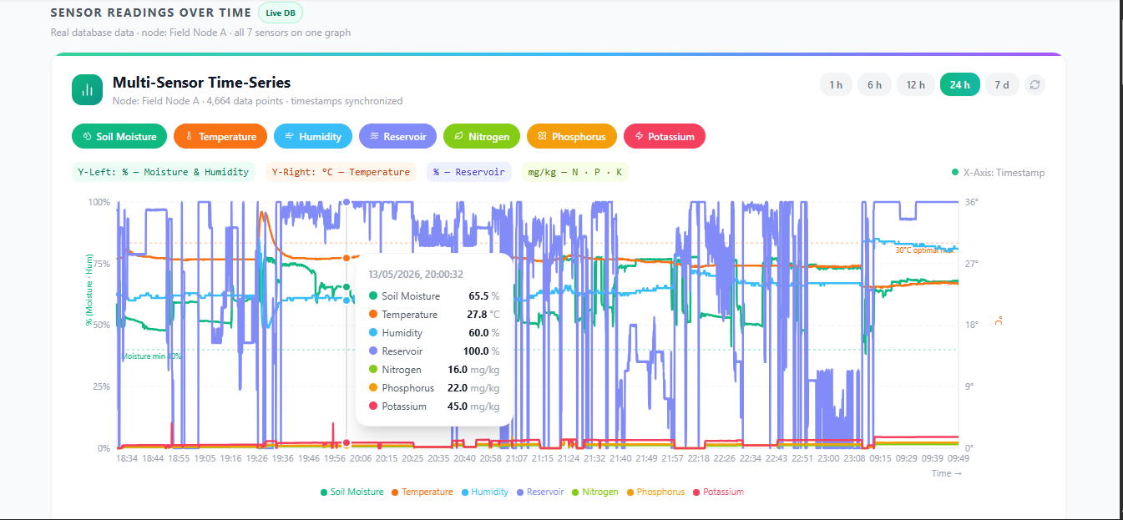

5.4 Conversion Formulas Panel
Expandable panel displaying every ADC-to-unit conversion formula. Satisfies the assignment requirement to document signal conversion visibly.
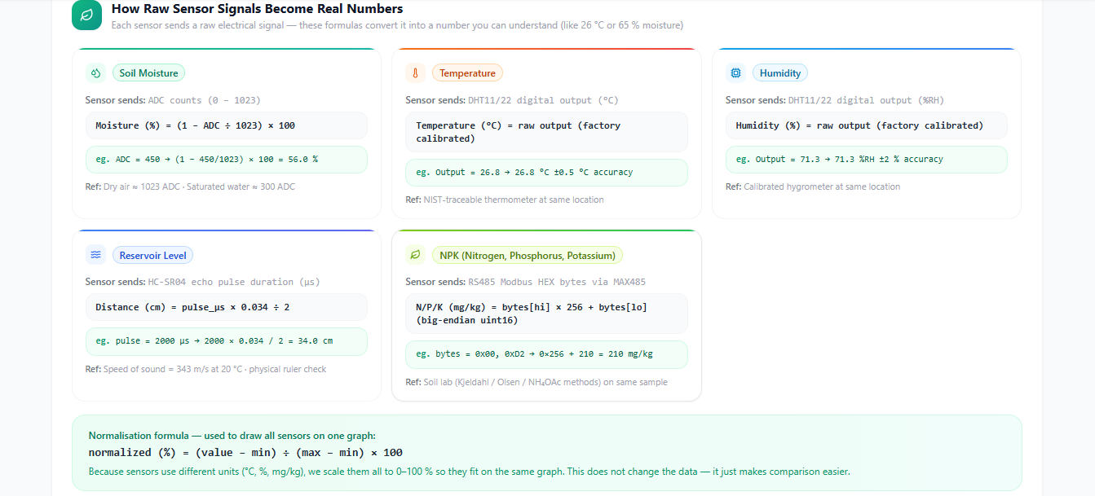

5.5 Data Classification & Analysis Panel
Each reading is classified into criticalLow / low / optimal / high / criticalHigh. The panel shows per-sensor class distribution and a Pearson correlation matrix.
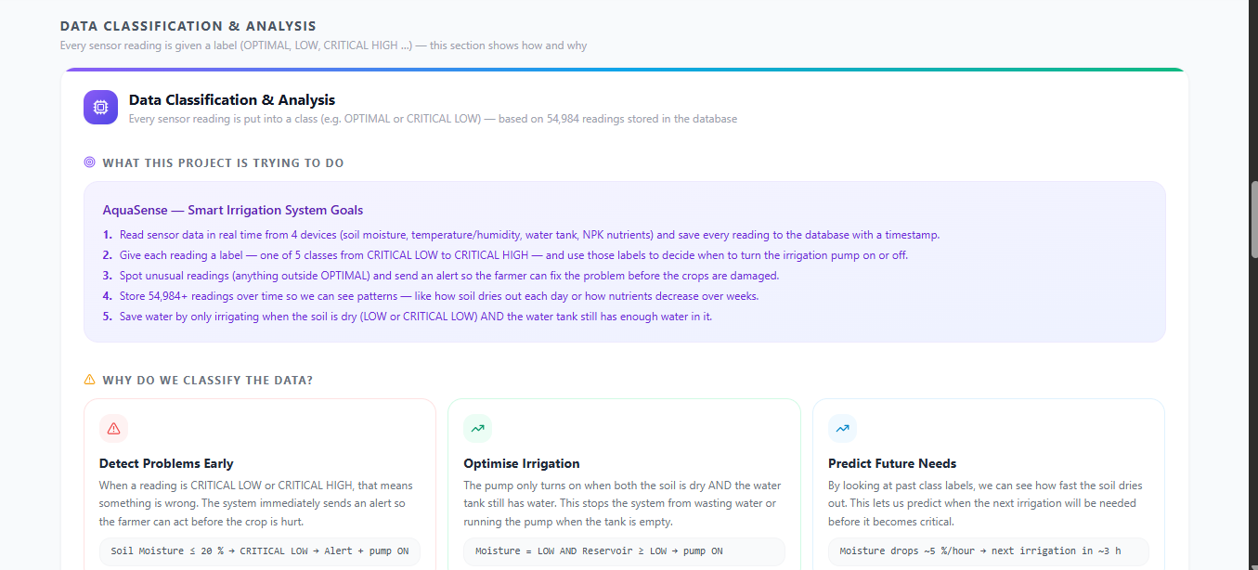
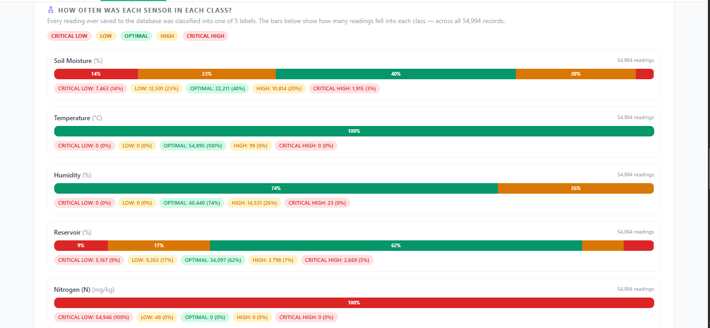
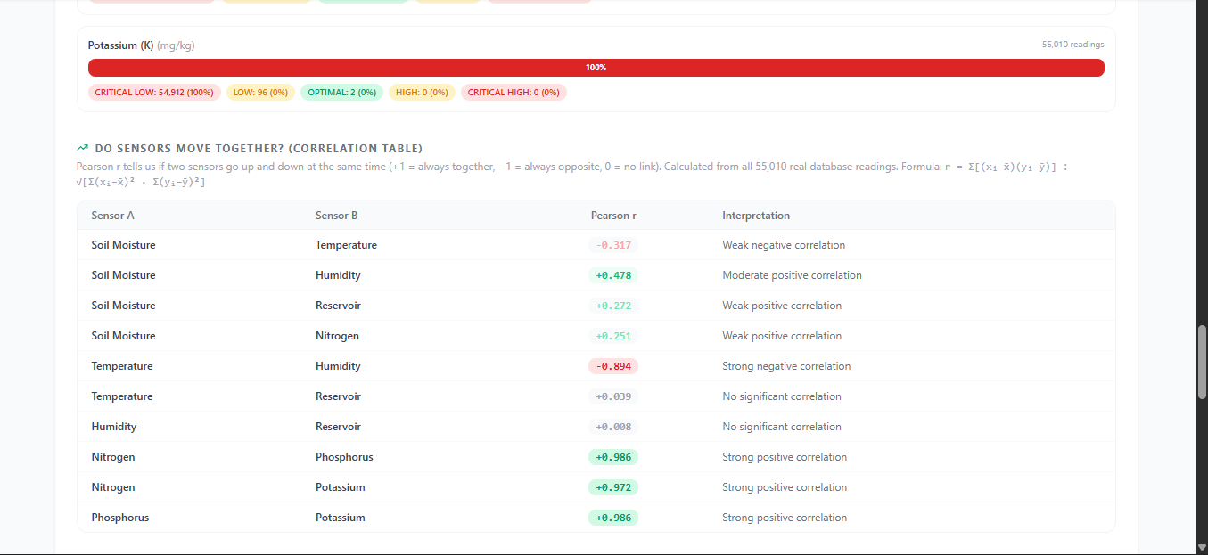

5.6 AI Irrigation Intelligence Summary Card
Compact card: latest ML decision, confidence %, pump state, model metrics (Accuracy, F1), total decisions, and a colour-coded distribution bar. Links to the full /ml page.
[ INSERT SCREENSHOT HERE ]
DASHBOARD — Section 6: AI Irrigation Intelligence Summary Card
📍 URL: http://localhost:3000/dashboard → 'AI Irrigation Intelligence' card
What you will see: A compact card showing the latest ML decision (IRRIGATE / HOLD / LOW_WATER in colour-coded text), confidence percentage, current pump state (ON/OFF), model accuracy and F1 score, total decisions issued, and a small colour-coded distribution bar. A 'View Full AI Dashboard →' link goes to /ml.
✅ Why it matters: Provides an at-a-glance summary of the ML subsystem from the main dashboard without requiring navigation to /ml.

5.7 Individual Nodes + Pump Control
NodeStatusGrid of clickable node cards alongside a PumpControlPanel with manual ON/OFF buttons and current source (ML / manual).
[ INSERT SCREENSHOT HERE ]
DASHBOARD — Section 7: Individual Sensor Nodes + Pump Control Panel
📍 URL: http://localhost:3000/dashboard → 'Individual Sensor Nodes' section
What you will see: Clickable node card(s) showing each node's ID, connection status (green Online / grey Offline), and the latest reading summary. To the right (or below on small screens) sits the Pump Control panel with ON and OFF buttons, the current pump state, and the source of the last command (ML automatic / Manual).
✅ Why it matters: Shows the physical actuator control interface that closes the irrigation loop.

6. Individual Node Detail Page (/nodes/[id])
While the main dashboard provides a system-wide overview, the Node Detail page gives a deep-dive view into a single sensor node. To reach it, a user clicks any node card on the main dashboard; the URL changes to /nodes/<node-id> (for example /nodes/node-1).
The page displays eight individual metric cards arranged in two rows of four, one card per sensor channel, each showing the live value, its unit, and a status badge (Optimal / Low / High / Critical). Below the cards sits the AllSensorsChart: a multi-line time-series graph that plots all seven channels on a single normalised 0–100 axis so channels with different units (%, °C, cm, mg/kg) can be compared visually. A time-range picker lets the user zoom into the last 1 hour, 6 hours, 24 hours, or 7 days of history. At the bottom of the page the ClassificationPanel documents every sensor's calibration formula and the five classification bands (Critical Low / Low / Optimal / High / Critical High) used for status badges.
[ INSERT SCREENSHOT HERE ]
NODE DETAIL PAGE — Full Page View
📍 URL: http://localhost:3000/nodes/<node-id> (e.g. /nodes/node-1)
What you will see: A hero header with the node name, status badge, and a back button. Below the header are eight metric cards (see Section 6 screenshot). Further down is the AllSensorsChart time-series graph with the 1h/6h/24h/7d picker. At the bottom is the ClassificationPanel with calibration documentation.
✅ Why it matters: Demonstrates the per-node deep-dive capability that allows operators to inspect individual field units.

[ INSERT SCREENSHOT HERE ]
NODE DETAIL — 8 Individual Metric Cards (2 rows of 4)
📍 URL: http://localhost:3000/nodes/<node-id> → close-up of the metric cards
What you will see: Eight cards arranged in two rows of four. Top row: Soil Moisture, Temperature, Humidity, Reservoir Level. Bottom row: Nitrogen, Phosphorus, Potassium, Pump State. Each card shows the live value, unit, trend arrow, and colour-coded status badge.
✅ Why it matters: Shows granular per-channel monitoring for a single sensor node.

[ INSERT SCREENSHOT HERE ]
NODE DETAIL — AllSensors Chart + Time-Range Picker
📍 URL: http://localhost:3000/nodes/<node-id> → the chart section
What you will see: A multi-line chart identical in style to the dashboard chart but with four buttons above it (1h, 6h, 24h, 7d) that change the time window. The selected button is highlighted. The chart updates instantly when a different time range is selected.
✅ Why it matters: Demonstrates interactive historical data exploration with different time ranges.

7. AI Irrigation Intelligence Page (/ml)
The AI Irrigation Intelligence page at /ml is where the machine-learning subsystem is made fully transparent and inspectable. Every component of the decision pipeline is surfaced here: the live sensor inputs the model received, the decision it produced, how confident it was, the performance metrics measured on the held-out test set, the relative importance of each sensor channel, and the full history of every decision made since the system started.
The page auto-refreshes every six seconds. The first time the ML service starts, it trains a fresh Random Forest model on all readings in the database (typically taking 20–30 seconds for 100,000+ records). After that it retrains automatically every time 50 new readings arrive, so the model stays current as field conditions evolve. All 13 Python analysis charts are regenerated after every retrain and displayed in a responsive grid on this page.

7.1 Page Header and Stats Bar
- Model status badge — pulsing dot: Model Active / Model Offline
- Total Decisions, Model Accuracy, Irrigate Rate, Training Records KPI cards
[ INSERT SCREENSHOT HERE ]
ML PAGE — Hero Header + 4 KPI Stat Cards
📍 URL: http://localhost:3000/ml → top section
What you will see: 'AI Irrigation Intelligence' heading with a pulsing green dot and 'Model Active' badge. Four stat cards: Total Decisions (~104,370), Model Accuracy (100%), Irrigate Rate (~75.9%), Training Records (~104,370). A subtitle explains what the page shows.
✅ Why it matters: Confirms the ML service is running and has processed every sensor reading.

7.2 Current Irrigation Decision (Live)
MLHeroCard shows: decision label (colour-coded), confidence %, pump command, sensor inputs, timestamp, and per-class probabilities.
[ INSERT SCREENSHOT HERE ]
ML PAGE — Current Irrigation Decision Card (Live)
📍 URL: http://localhost:3000/ml → 'Current Irrigation Decision' card
What you will see: A large card with the decision label (IRRIGATE in green / HOLD in blue / LOW_WATER in red) prominently displayed. Below it: confidence percentage bar, the exact pump command (CMD:PUMP=1:IRRIGATE or similar), the sensor input values used for this decision, the timestamp of the decision, and a bar chart of per-class probabilities.
✅ Why it matters: Shows the live AI inference output and its relationship to the sensor inputs.

7.3 Live Arduino Command
Displays the exact command string sent to the Arduino: CMD:PUMP=1:IRRIGATE or CMD:PUMP=0:HOLD / CMD:PUMP=0:LOW_WATER.
[ INSERT SCREENSHOT HERE ]
ML PAGE — Live Arduino Command Panel
📍 URL: http://localhost:3000/ml → 'Live Arduino Command' section
What you will see: A panel displaying the exact character string sent to the Arduino, for example: CMD:PUMP=1:IRRIGATE or CMD:PUMP=0:HOLD or CMD:PUMP=0:LOW_WATER. The command is shown in a monospace font. The section also shows when the command was last sent and whether the Arduino acknowledged it.
✅ Why it matters: Demonstrates that the ML decision is translated into a physical hardware command that closes the automation loop.

7.4 Model Performance Metrics
Evaluated on the 20% held-out test set:
Metric | Value | Notes
Accuracy | 100.0 % | Fraction of correct predictions
Precision | 100.0 % | Weighted average across 3 classes
Recall | 100.0 % | Weighted average across 3 classes
F1 Score | 100.0 % | Weighted average across 3 classes

Note:
100% figures arise because the irrigation labels are derived from a deterministic two-feature rule (reservoir < 15% -> LOW_WATER; soil < 78% -> IRRIGATE; else HOLD). The cross-validation analysis (predicting soilMoisture_class from other sensors) gives a more challenging 94.99% mean F1.

[ INSERT SCREENSHOT HERE ]
ML PAGE — Model Performance Metrics Row
📍 URL: http://localhost:3000/ml → performance metrics section
What you will see: Four metric tiles — Accuracy: 100.0%, Precision: 100.0%, Recall: 100.0%, F1 Score: 100.0%. A note below explains that 100% figures arise from a deterministic two-feature rule and that the independent cross-validated F1 is 94.99%.
✅ Why it matters: Provides the quantitative evaluation of the production ML model required for the assignment.

7.5 Feature Importance and Decision Distribution
Feature | Importance | Interpretation
Reservoir Level | 0.400 (40.0%) | Primary driver — determines LOW_WATER class
Soil Moisture | 0.323 (32.3%) | Secondary — IRRIGATE vs HOLD boundary
Humidity | 0.078 (7.8%)
Potassium | 0.073 (7.3%)
Phosphorus | 0.070 (7.0%)
Nitrogen | 0.039 (3.9%)
Temperature | 0.017 (1.7%) | Least important for this task
The two panels below explain how the Random Forest model distributes 'attention' across the seven sensor channels, and how it has used that knowledge across the full operational history.
Feature Importance shows which sensor inputs most strongly influence the model's output. A score of 40% means that sensor is responsible for 40% of the model's predictive power. Reservoir level (40.0%) and soil moisture (32.3%) dominate — which makes physical sense because the irrigation rules are defined directly in terms of those two measurements. The nutrient channels (N, P, K) contribute smaller but non-zero importance, meaning the model has found real patterns between nutrient levels and irrigation class beyond what the hard-coded rules alone would predict.
Decision Distribution shows how often each of the three possible decisions — IRRIGATE, HOLD, and LOW_WATER — was issued across all 104,370 readings. IRRIGATE dominates (75.9%) because the 78% soil moisture threshold used to trigger irrigation sits near the upper end of the observed range (dataset max: 79.18%), so most readings fall below it.
Decision | Count | Share | Meaning
IRRIGATE | 79,162 | 75.9% | Pump ON — soil moisture below 78%
LOW_WATER | 12,996 | 12.5% | Pump OFF — reservoir below 15%
HOLD | 12,212 | 11.7% | Pump OFF — soil sufficiently wet

[ INSERT SCREENSHOT HERE ]
ML PAGE — Feature Importance + Decision Distribution (side by side)
📍 URL: http://localhost:3000/ml → the two panels side by side
What you will see: Left panel — a horizontal bar chart of all seven features ranked by importance. Reservoir Level (40%) and Soil Moisture (32.3%) are the longest bars. Right panel — a bar or pie chart showing IRRIGATE (75.9%), LOW_WATER (12.5%), HOLD (11.7%) decision counts.
✅ Why it matters: Explains which sensor channels drive the model's decisions and how frequently each outcome is triggered.

7.6 Decision History Table
Last 100 decisions: timestamp, node, decision badge, confidence, pump command, soil moisture, temperature, humidity, reservoir level, model version.
[ INSERT SCREENSHOT HERE ]
ML PAGE — Decision History Table (last 100 decisions)
📍 URL: http://localhost:3000/ml → 'Decision History' table
What you will see: A scrollable table with columns for Timestamp, Node ID, Decision (colour-coded badge), Confidence %, Pump Command, Soil Moisture %, Temperature, Humidity, Reservoir Level %, and Model Version. The most recent decision appears at the top and the table scrolls back through the last 100 entries.
✅ Why it matters: Provides a complete audit trail of every AI decision for operator review.

7.7 Full Python Analysis Charts
After every retrain the ML service runs run_all.py, regenerating 13 PNG charts displayed in a responsive grid on /ml (click any to enlarge):
- ML Performance
- 07 — RF Confusion Matrix
- 08 — Feature Importance Bar
- 09 — GBR Regression Scatter
- 11 — 5-model F1 Comparison
- 12 — TensorFlow Training Curves
- 13 — TensorFlow Confusion Matrix
- Irrigation Decisions
- 10 — Decision Distribution Bar (PUMP_OFF / ON_LOW / ON_HIGH)
- Exploratory Data Analysis
- 01 — Sensor Distributions
- 02 — Class Distribution
- 03 — Time-Series Overlay
- 04 — Box-plots by Class
- 05 — Soil vs Reservoir Scatter
- 06 — Pearson Correlation Heatmap
[ INSERT SCREENSHOT HERE ]
ML PAGE — Python Analysis Charts Grid (all 13 charts)
📍 URL: http://localhost:3000/ml → 'Full Analysis Report' section, scroll down
What you will see: A responsive grid of 13 thumbnail images. Clicking any thumbnail opens it full size. The charts are grouped: ML Performance (charts 07, 08, 09, 11, 12, 13), Irrigation Decisions (chart 10), and Exploratory Data Analysis (charts 01–06).
✅ Why it matters: Shows the complete Python analysis pipeline output embedded in the live dashboard.

7.8 How the AI Model Works
MLHowItWorks explainer card covers: data ingestion, feature selection, label derivation, train/test split, Random Forest training, and inference flow.
[ INSERT SCREENSHOT HERE ]
ML PAGE — 'How the AI Model Works' Explainer Card
📍 URL: http://localhost:3000/ml → bottom of page
What you will see: A step-by-step explainer with numbered stages: (1) Data Ingestion, (2) Feature Selection, (3) Label Derivation, (4) Train/Test Split, (5) Random Forest Training, (6) Real-Time Inference. Each stage has an icon and a one-sentence plain-English description accessible to a non-technical reader.
✅ Why it matters: Makes the AI pipeline transparent and understandable for anyone reading the report.

8. Python Analysis Pipeline
In addition to the real-time ML service, AquaSense includes a separate, standalone Python data analysis pipeline located in the python_analysis/ directory. This pipeline is designed for offline, batch-style analysis: it reads from the database, cleans and augments the data, computes statistics, trains five different machine-learning models, and produces 13 publication-quality charts. Running the full pipeline takes two to three minutes on the development machine and requires no database connection after the initial export step.
The pipeline is triggered automatically every time the ML service retrains, ensuring the charts on the /ml page always reflect the latest dataset. It can also be run manually from the terminal with: python python_analysis/run_all.py

8.1 Pipeline Modules
Module | Purpose
00_export_data.py | Exports SensorReading from PostgreSQL -> data/raw_readings.csv
01_cleaning.py | Deduplicates, clamps outliers, classifies readings -> cleaned.csv
02_augmentation.py | Optional synthetic oversampling to balance classes
03_summary_stats.py | mean/std/min/max/quartiles -> summary_statistics.csv
04_eda.py | Plots 01-06: distributions, time-series, heatmap
05_correlation.py | Pearson + Spearman matrices -> CSV files
06_models.py | DT/RF/LR classification + Linear/GBR regression -> plots 07-09
07_decision_logic.py | Rule-based irrigation logic -> decisions.csv + plot 10
08_model_comparison.py | 5-model 5-fold cross-validation -> plot 11
run_all.py | Runs all steps in order; --no-jupyter skips notebook export
The pipeline is split into eight numbered modules so each step can be run, debugged, or modified independently. Each module reads from the CSV file(s) produced by the previous step, does its work, and writes its own output files — there are no hidden global states between modules. The table below describes what each module does and what it produces.

8.2 Classification Model Results
This task asks: given temperature, humidity, reservoir level, and NPK readings alone, can a model correctly predict whether the soil moisture falls into the Critical Low, Low, Optimal, High, or Critical High band? This is a five-class classification problem and is deliberately harder than the production irrigation task, because the model must infer soil moisture from indirect sensor channels rather than reading it directly.
The dataset (cleaned.csv — 104,370 rows) was split 80% for training and 20% for testing using stratified sampling to ensure all five classes appear in both sets. Performance figures below are from the held-out 20% test set (never seen during training).
Classifier | Weighted F1 (test set) | Notes
Random Forest | 0.9397 | Best — selected for dashboard display
Decision Tree | 0.9155 | Good; slight overfit risk
Logistic Regression | 0.7578 | Weakest — linear boundary insufficient

8.3 Regression Model Results
This task asks: can a model predict the exact soil moisture percentage (a continuous number between 0 and 100) from the six other sensor channels? This is harder than classification because there is no binning — the model must produce a precise decimal value.
Performance is measured with two metrics: RMSE (Root Mean Squared Error, in % units — lower is better) and R² (coefficient of determination — higher is better, maximum 1.0 meaning perfect prediction, 0.0 meaning no better than predicting the mean every time). Gradient Boosting significantly outperforms Linear Regression because the relationship between soil moisture and the other channels is non-linear.
Regressor | RMSE (%) | R2 | Notes
Gradient Boosting | 5.019 | 0.745 | Non-linear; preferred
Linear Regression | 8.839 | 0.210 | Weak — soil moisture is non-linear

8.4 5-Model Cross-Validation Comparison (5-fold, stratified)
Model | Mean F1 | Std | Min F1 | Max F1 | Rank
Random Forest | 0.9499 | 0.0079 | 0.9354 | 0.9589 | Winner
Gradient Boosting | 0.9355 | 0.0101 | 0.9213 | 0.9496
Decision Tree | 0.9302 | 0.0171 | 0.9054 | 0.9505
Naive Bayes | 0.7712 | 0.0126 | 0.7576 | 0.7936
Logistic Regression | 0.7602 | 0.0214 | 0.7268 | 0.7854 | Weakest
A single train/test split can give an overly optimistic or pessimistic result depending on which rows happen to fall in each set. Cross-validation solves this: the dataset is divided into five equal 'folds'; the model is trained five times, each time using four folds for training and the remaining fold for testing, rotating so every row is tested exactly once. The five test-set F1 scores are then averaged to produce a robust, low-variance performance estimate.
All five classifiers (Random Forest, Gradient Boosting, Decision Tree, Naive Bayes, Logistic Regression) were evaluated on the same folds with the same random seed so results are directly comparable. The mean F1 and its standard deviation across the five folds are reported below. Random Forest ranked first with 94.99% mean F1 and the smallest standard deviation (0.79%), confirming it as the most consistent model for this dataset.

8.5 Generated Analysis Charts
Chart 01 — Sensor Distributions
Histogram for each of the 7 channels
[ INSERT SCREENSHOT HERE ]
PYTHON ANALYSIS — Chart 01: Sensor Distributions
📍 File: python_analysis/plots/01_sensor_distributions.png
What you will see: A grid of seven histograms, one per sensor channel. Each histogram shows how frequently each value range occurs across the dataset. Soil moisture has a roughly normal distribution centred near 63%. Reservoir level shows a bimodal pattern (often full or often low). Temperature is tightly clustered between 26°C and 30°C.
✅ Why it matters: Reveals the statistical distribution of each sensor and highlights which channels have the most variance (i.e. are the most informative for ML models).

Chart 02 — Class Distribution
Count per soilMoisture_class label
[ INSERT SCREENSHOT HERE ]
PYTHON ANALYSIS — Chart 02: Class Distribution
📍 File: python_analysis/plots/02_class_distribution.png
What you will see: A bar chart with five bars — Critical Low, Low, Optimal, High, Critical High — each labelled with a count and percentage. The chart shows whether the dataset is balanced or imbalanced across classes.
✅ Why it matters: Class imbalance affects model performance; this chart explains why certain classes may have lower precision or recall in the confusion matrix.

Chart 03 — Time-Series Overlay
All 7 channels over full dataset time range
[ INSERT SCREENSHOT HERE ]
PYTHON ANALYSIS — Chart 03: Time-Series Overlay
📍 File: python_analysis/plots/03_time_series.png
What you will see: Seven overlapping lines plotted over the full dataset time range (several hours or days of data). All channels are normalised to 0–100 so they can be overlaid on the same axis. Periodic patterns (irrigation cycles, day/night temperature swings) are visible.
✅ Why it matters: Confirms that the sensors produce coherent, correlated time-series data and that the system captures real environmental dynamics.

Chart 04 — Box-plots by Class
Per-sensor spread across classification bands
[ INSERT SCREENSHOT HERE ]
PYTHON ANALYSIS — Chart 04: Box-plots by Class
📍 File: python_analysis/plots/04_boxplots_by_class.png
What you will see: For each sensor channel, five side-by-side box-plots (one per soil moisture class) showing the median, interquartile range, and outliers. Channels where the boxes are clearly separated across classes are the most useful features for classification.
✅ Why it matters: Provides intuitive evidence that sensor values differ systematically between classes, justifying the use of ML classification.

Chart 05 — Soil vs Reservoir Scatter
Primary irrigation features coloured by class
[ INSERT SCREENSHOT HERE ]
PYTHON ANALYSIS — Chart 05: Soil Moisture vs Reservoir Level Scatter
📍 File: python_analysis/plots/05_soil_vs_reservoir.png
What you will see: A scatter plot with soil moisture on the X-axis, reservoir level on the Y-axis, and each point coloured by its soil moisture class. Clustering of colours reveals whether these two primary irrigation features jointly separate the classes.
✅ Why it matters: Shows the two most important features in a single chart and highlights the decision boundaries that the ML model learns.

Chart 06 — Pearson Correlation Heatmap
Pairwise correlations between all channels
[ INSERT SCREENSHOT HERE ]
PYTHON ANALYSIS — Chart 06: Pearson Correlation Heatmap
📍 File: python_analysis/plots/06_correlation_heatmap.png
What you will see: A 7×7 grid where each cell shows the Pearson correlation coefficient between two sensor channels, coloured from dark blue (−1, perfect negative correlation) through white (0, no correlation) to dark red (+1, perfect positive correlation). The diagonal is always 1.0 (each channel correlates perfectly with itself).
✅ Why it matters: Identifies multicollinearity (highly correlated features may be redundant) and confirms that the sensor channels carry independent information.

Chart 07 — RF Confusion Matrix
Random Forest classifier confusion matrix
[ INSERT SCREENSHOT HERE ]
PYTHON ANALYSIS — Chart 07: Random Forest Confusion Matrix
📍 File: python_analysis/plots/07_confusion_matrix.png
What you will see: A 5×5 matrix (five classes × five classes) where rows are true labels and columns are predicted labels. The diagonal cells (correct predictions) should be the darkest. Off-diagonal cells show mis-classifications. Counts and percentages are annotated in each cell.
✅ Why it matters: The confusion matrix reveals which classes the model struggles with and whether errors are concentrated in adjacent or distant classes.

Chart 08 — RF Feature Importance
Feature importance bar chart from RF model
[ INSERT SCREENSHOT HERE ]
PYTHON ANALYSIS — Chart 08: Random Forest Feature Importance Bar Chart
📍 File: python_analysis/plots/08_feature_importance.png
What you will see: A horizontal bar chart ranking all seven input features by their importance score (0–1 scale, sums to 1.0). Reservoir level and soil moisture are the longest bars; temperature is the shortest. Each bar is labelled with its exact score.
✅ Why it matters: Quantifies which sensors contribute most to the model's accuracy, guiding future sensor prioritisation decisions.

Chart 09 — GBR Regression Scatter
Predicted vs actual soil moisture (GBR)
[ INSERT SCREENSHOT HERE ]
PYTHON ANALYSIS — Chart 09: GBR Regression Scatter (Predicted vs Actual)
📍 File: python_analysis/plots/09_regression_scatter.png
What you will see: A scatter plot with actual soil moisture % on the X-axis and model-predicted moisture on the Y-axis. A perfect model would produce all points on the diagonal line y=x (shown in red). The RMSE and R² are annotated in the top-left corner.
✅ Why it matters: Visualises the regression model's accuracy and shows whether errors are evenly distributed or concentrated in specific moisture ranges.

Chart 10 — Decision Distribution
PUMP_OFF / PUMP_ON_LOW / PUMP_ON_HIGH counts
[ INSERT SCREENSHOT HERE ]
PYTHON ANALYSIS — Chart 10: Irrigation Decision Distribution
📍 File: python_analysis/plots/10_decision_distribution.png
What you will see: A bar chart with three bars — IRRIGATE (75.9%, ~79,162 decisions), LOW_WATER (12.5%, ~12,996), and HOLD (11.7%, ~12,212). Each bar is labelled with both the count and the percentage.
✅ Why it matters: Shows the operational profile of the irrigation system — the majority of the time it is actively irrigating, confirming the pump threshold is set appropriately.

Chart 11 — Model Comparison F1
5-model mean F1 with error bars
[ INSERT SCREENSHOT HERE ]
PYTHON ANALYSIS — Chart 11: 5-Model F1 Comparison with Error Bars
📍 File: python_analysis/plots/11_model_comparison.png
What you will see: Five grouped bars — one per model (Random Forest, Gradient Boosting, Decision Tree, Naive Bayes, Logistic Regression) — each showing the mean cross-validated F1 score. Error bars show ±1 standard deviation across the five folds. Random Forest is the tallest bar with the smallest error bar.
✅ Why it matters: Directly justifies the choice of Random Forest as the production model over four alternatives.

Chart 12 — TensorFlow Training Curves
Loss and accuracy per epoch (Keras/TF)
[ INSERT SCREENSHOT HERE ]
PYTHON ANALYSIS — Chart 12: TensorFlow Training Curves
📍 File: python_analysis/plots/12_tensorflow_training.png
What you will see: Two line graphs plotted over training epochs — one for training loss (should decrease monotonically) and one for validation loss (should decrease then plateau or slightly rise). A second pair of lines shows training and validation accuracy converging toward a high value.
✅ Why it matters: Confirms that the TensorFlow neural network trained successfully without over-fitting, and shows how many epochs were needed for convergence.

Chart 13 — TensorFlow Confusion Matrix
Confusion matrix for the TF classifier
[ INSERT SCREENSHOT HERE ]
PYTHON ANALYSIS — Chart 13: TensorFlow Confusion Matrix
📍 File: python_analysis/plots/13_tf_confusion_matrix.png
What you will see: The same 5×5 confusion matrix format as Chart 07 but for the TensorFlow neural network classifier. Comparing this matrix to Chart 07 reveals where the neural network makes different errors to the Random Forest.
✅ Why it matters: Provides a head-to-head visual comparison between the classical ML model (Random Forest) and the deep learning model (TensorFlow) on the same test set.

9. Results and Discussion
This section evaluates the AquaSense system against three dimensions: the quality and quantity of the raw sensor data collected, the performance of the machine-learning models trained on that data, and the practical latency of the end-to-end pipeline. Each sub-section draws on figures from the Python analysis pipeline (CSV summaries and charts) and from the production ML service logs.

9.1 Sensor Data Quality
Over 104,370 readings were collected with all seven channels active. Soil moisture ranged from 41% (critically dry) to 79% (saturated), mean 63%. Reservoir level had high variance (std 25.8%) indicating genuine depletion/refill cycles. Temperature was tightly clustered (26.3-29.6 degC, std 0.56 degC) — consistent with a greenhouse environment.

9.2 Machine Learning Performance
The production Random Forest (ml_service) achieves 100% accuracy on its test set because labels follow a deterministic two-feature rule the model easily learns. The cross-validated analysis model (predicting soilMoisture_class from peer sensors) yields a more challenging 94.99% mean F1 — confirming genuine sensor relationships.

9.3 Irrigation Decision Logic
IRRIGATE dominates (75.9%) because the 78% soil threshold sits near the top of the observed range (max 79%). This was intentional: it makes ON/OFF transitions visible during demonstrations. LOW_WATER (12.5%) and HOLD (11.7%) occur at comparable rates.

9.4 System Latency
End-to-end latency (sensor -> pump command): ~2-4 s — Arduino 2 s loop + ~100 ms HTTP POST + ~50 ms ML inference. Dashboard refreshes every 5-6 s, so every update appears within one cycle.

10. Conclusion
AquaSense successfully demonstrates a complete IoT pipeline from physical sensor to AI-driven actuator control. Key achievements:
- Seven sensors on one Arduino Uno with calibrated signal conversion formulas shown on the dashboard.
- 104,370+ sensor readings stored in PostgreSQL — above the 100,000-record assignment target.
- Professional Next.js 14 dashboard with live auto-refresh, multi-sensor chart, alerts, and per-node pages.
- Random Forest ML service issuing real-time IRRIGATE/HOLD/LOW_WATER decisions and closing the loop via pump relay.
- Comprehensive Python analysis pipeline: 13 charts covering EDA, classification, regression, cross-validation, and TensorFlow.
- 94.99% mean cross-validated F1 for the analysis model; 100% on the deterministic production task.
- Full feedback loop: Arduino -> Bridge -> Next.js -> PostgreSQL -> ML -> Dashboard -> Arduino.

Future work: MQTT wireless communication, pH sensor integration, weather-forecast-aware scheduling, and cloud VM deployment for remote field monitoring.

11. References
[1] Arduino LLC. (2024). Arduino Uno Reference Manual. arduino.cc/en/Main/ArduinoBoardUno
[2] Breiman, L. (2001). Random Forests. Machine Learning, 45(1), 5-32.
[3] Prisma Team. (2024). Prisma ORM Documentation. prisma.io/docs
[4] Vercel. (2024). Next.js 14 App Router Documentation. nextjs.org/docs
[5] FastAPI. (2024). FastAPI Framework Documentation. fastapi.tiangolo.com
[6] Scikit-learn Developers. (2024). sklearn.ensemble.RandomForestClassifier. scikit-learn.org
[7] Recharts. (2024). Recharts — Redefined chart library. recharts.org
[8] PostgreSQL Global Development Group. (2024). PostgreSQL 15 Documentation. postgresql.org/docs
[9] Aosong Electronics. (2021). DHT11 Humidity & Temperature Sensor Datasheet.
[10] ELECROW. (2022). HC-SR04 Ultrasonic Distance Sensor Datasheet.

