U.S. Superstore Sales Analysis
Regional performance, customer contribution, product leaders, and sales trends | 2014–2017
PROJECT OVERVIEW
This project reviews nearly four years of U.S. Superstore transactions to show where revenue is strongest, which customer segments contribute profit, which products and customers lead sales, and how results change over time. The completed workbook includes the original practice sheets, a formula-linked analysis tab, and a finished report dashboard.
TOTAL SALES  $2,297,201 | TOTAL PROFIT  $286,397
UNITS SOLD  37,873 | SALES RECORDS  9,994

Executive summary
The dataset records $2,297,201 in sales and $286,397 in profit, for a 12.5% overall profit margin. The West is the largest region at $725,458; California is the leading state, and New York City, New York, is the top city-state market.
Consumer customers contribute $134,119, or 46.8% of total profit. Technology leads the three product categories in sales at $836,154. Annual sales rose from $484,247 in 2014 to $733,215 in 2017, while November is the strongest month when all four years are combined.

Scope and method
The source sheet contains 9,994 transaction lines spanning 2014–2017, 49 states, 531 distinct city names, 793 customers, and 1,862 distinct product IDs. Revenue and profit are summed from the line-level fields. Product and customer rankings use total sales; segment contribution uses total profit. State and city rankings use sales, with city matched to state so identically named places stay separate. Monthly totals combine the same calendar month across the four years; the workbook also keeps the year-by-month values and quarterly totals for comparison.
All amounts are in U.S. dollars. The ranking lists describe this supplied dataset snapshot; the workbook keeps the calculations visible on its Analysis tab.

Regional and customer-segment performance
The West and East together account for 61.1% of sales. The Consumer segment produces the largest share of profit, though profit contribution should be read alongside the sales mix and not as a measure of customer count.
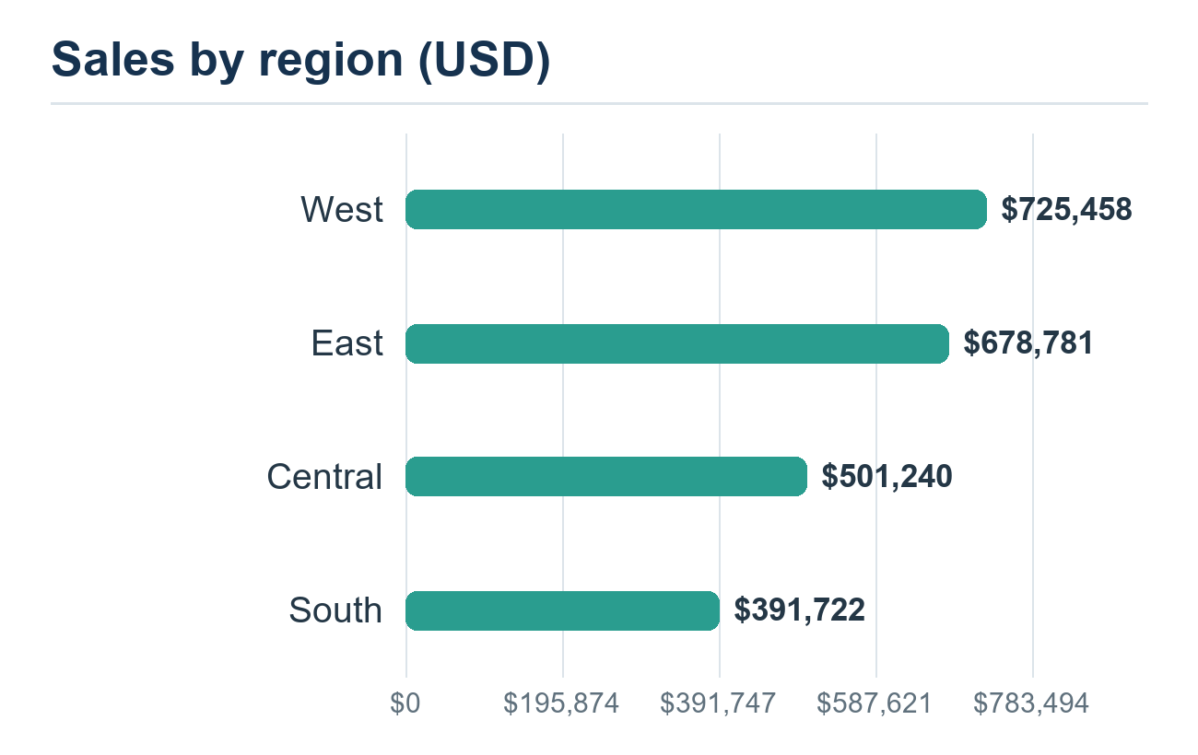 | 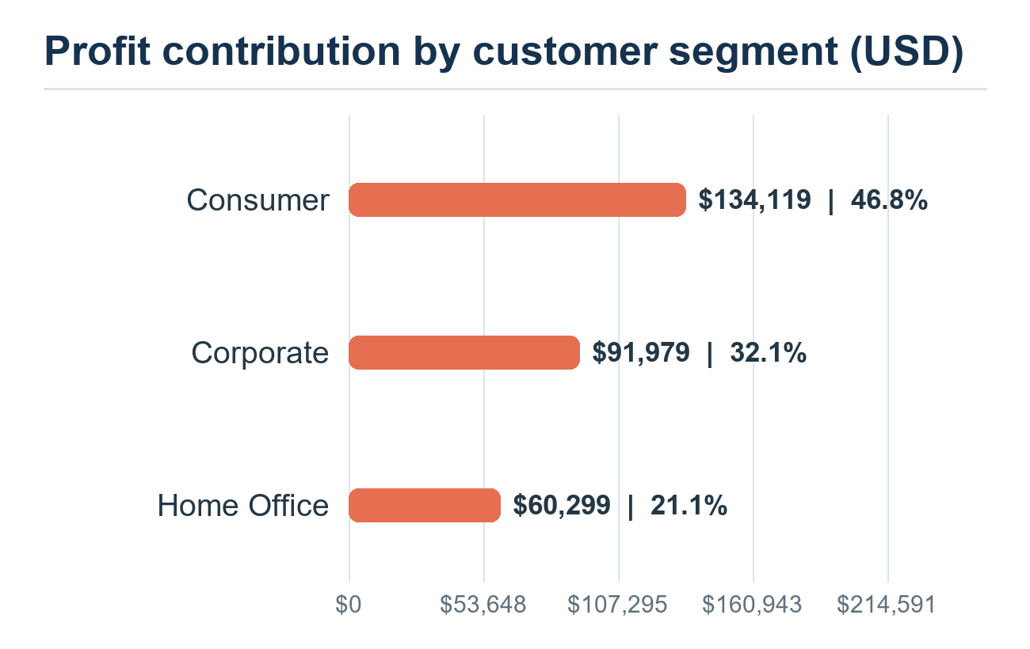
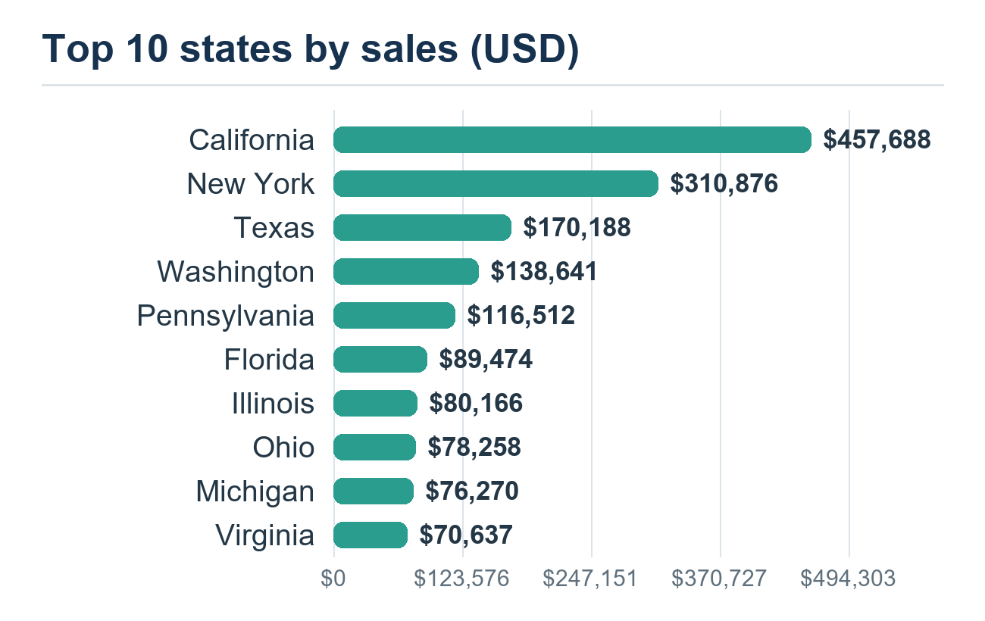 | 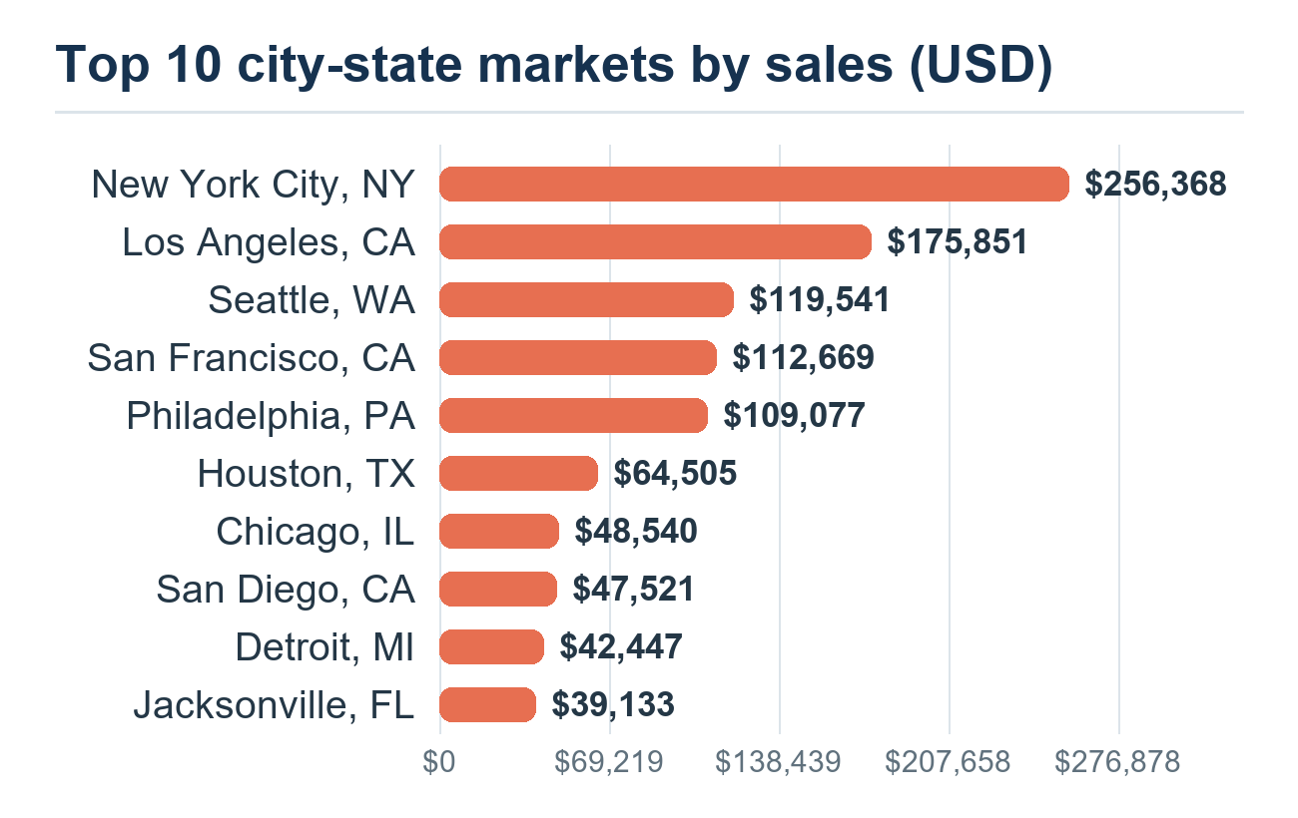
California generates $457,688 in sales, followed by New York at $310,876 and Texas at $170,188. At city level, New York City leads with $256,368, ahead of Los Angeles at $175,851. The state and city views add geographic detail to the regional comparison.

Top revenue drivers: products and customers
The leading product is the Canon imageCLASS 2200 Advanced Copier at $61,600. The top ten products generate 10.6% of total revenue, showing that sales are spread across a broad catalog. Sean Miller leads customer sales at $25,043; the top ten customers together account for 6.7% of revenue.
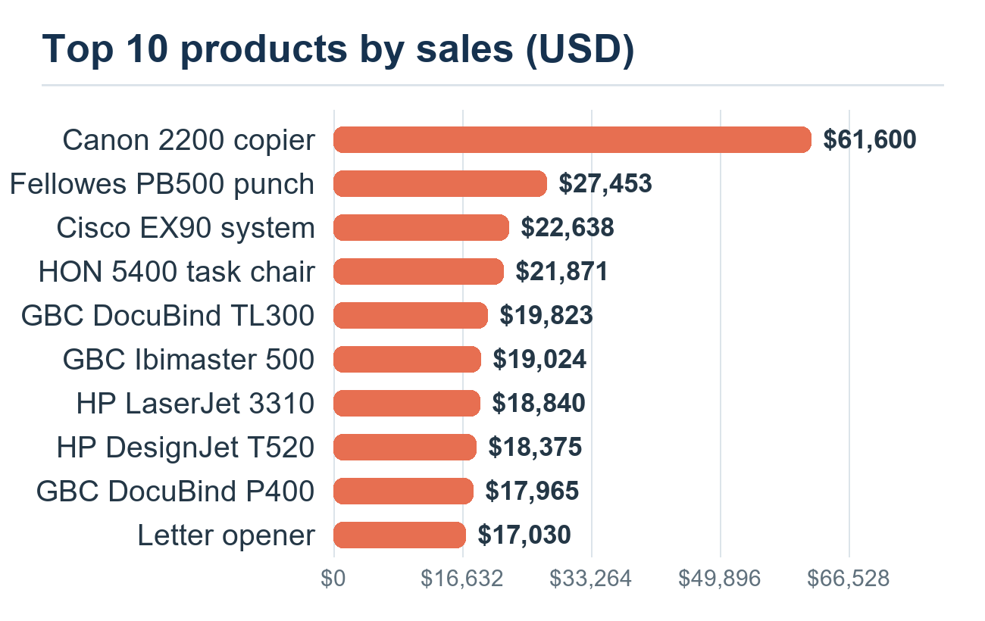 | 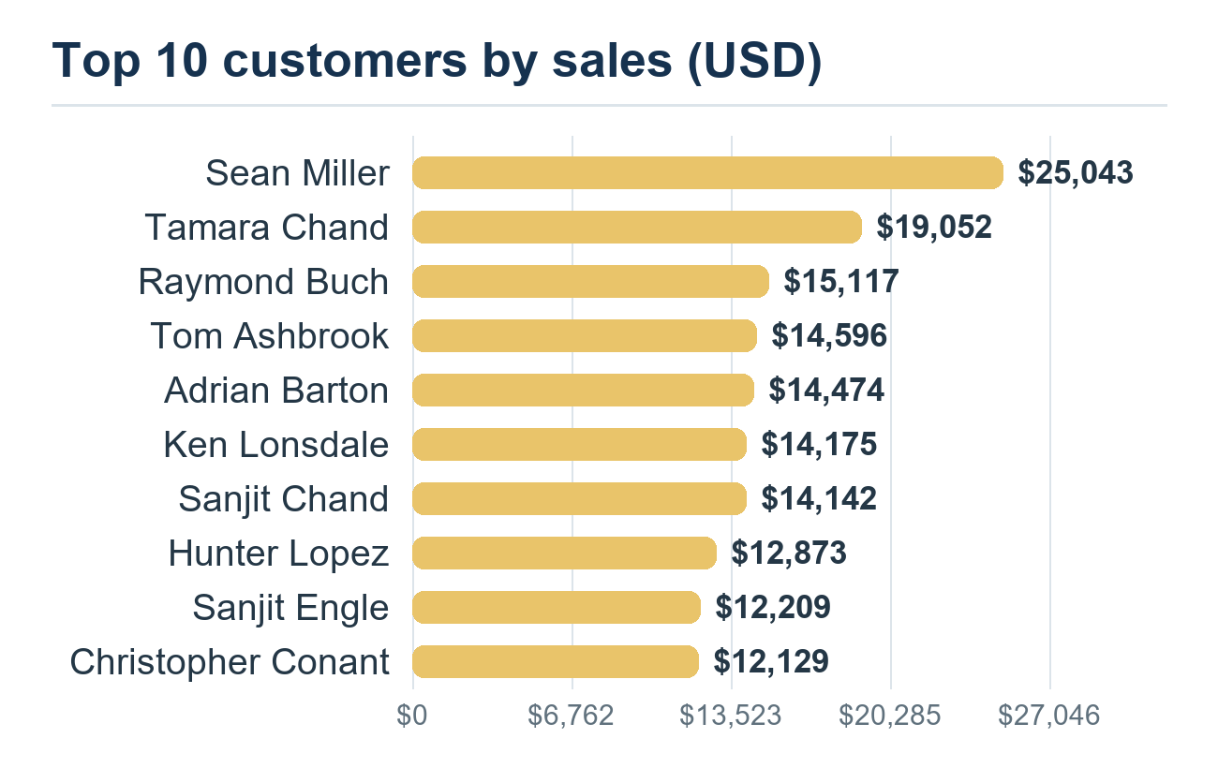
# | Top products | Sales | # | Top customers | Sales
1 | Canon imageCLASS 2200 Advanced Copier | $61,600 | 1 | Sean Miller (SM-20320) | $25,043
2 | Fellowes PB500 Electric Punch Plastic Comb Binding Machine with Manual Bind | $27,453 | 2 | Tamara Chand (TC-20980) | $19,052
3 | Cisco TelePresence System EX90 Videoconferencing Unit | $22,638 | 3 | Raymond Buch (RB-19360) | $15,117
4 | HON 5400 Series Task Chairs for Big and Tall | $21,871 | 4 | Tom Ashbrook (TA-21385) | $14,596
5 | GBC DocuBind TL300 Electric Binding System | $19,823 | 5 | Adrian Barton (AB-10105) | $14,474
6 | GBC Ibimaster 500 Manual ProClick Binding System | $19,024 | 6 | Ken Lonsdale (KL-16645) | $14,175
7 | Hewlett Packard LaserJet 3310 Copier | $18,840 | 7 | Sanjit Chand (SC-20095) | $14,142
8 | HP Designjet T520 Inkjet Large Format Printer - 24" Color | $18,375 | 8 | Hunter Lopez (HL-15040) | $12,873
9 | GBC DocuBind P400 Electric Binding System | $17,965 | 9 | Sanjit Engle (SE-20110) | $12,209
10 | High Speed Automatic Electric Letter Opener | $17,030 | 10 | Christopher Conant (CC-12370) | $12,129
Product bars use concise display labels for readability; the complete product names and IDs are retained in the workbook Analysis tab.

Sales trends over time
Sales softened slightly in 2015, then grew in each of the next two years. Fourth-quarter sales were the strongest quarter in every year, with 2017 Q4 reaching $280,054. The monthly chart sums each calendar month across 2014–2017; November leads at $352,461, followed by December at $325,294 and September at $307,650. February is the lowest month at $59,751.
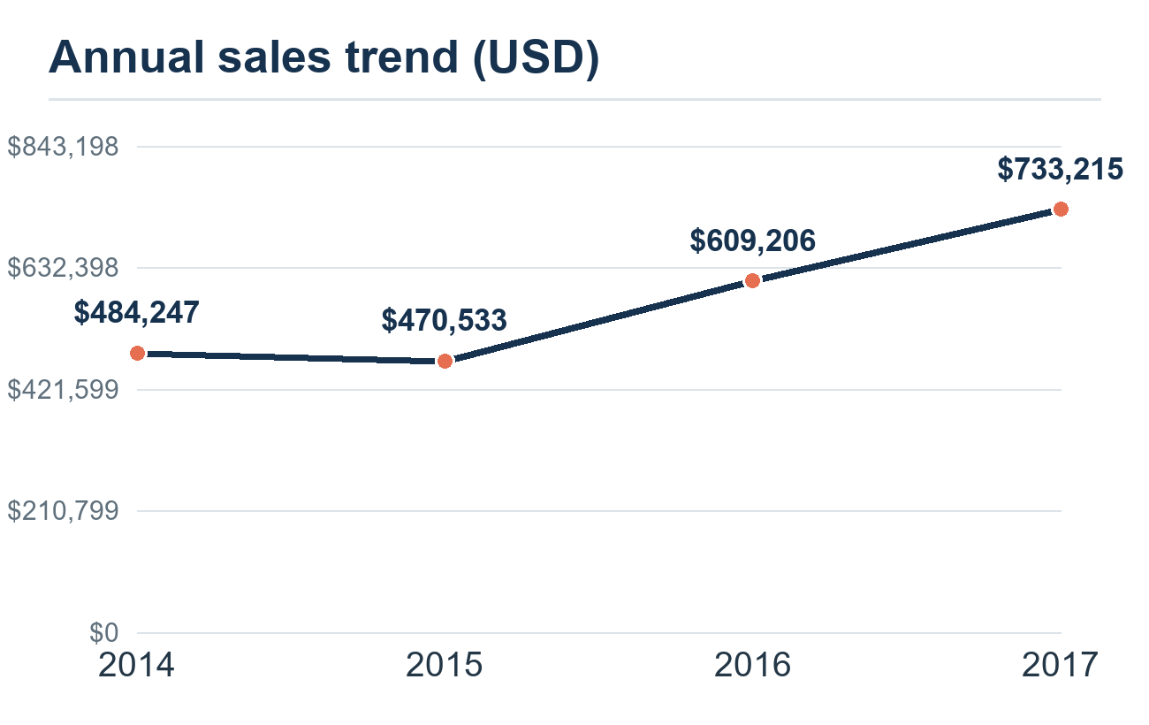 | 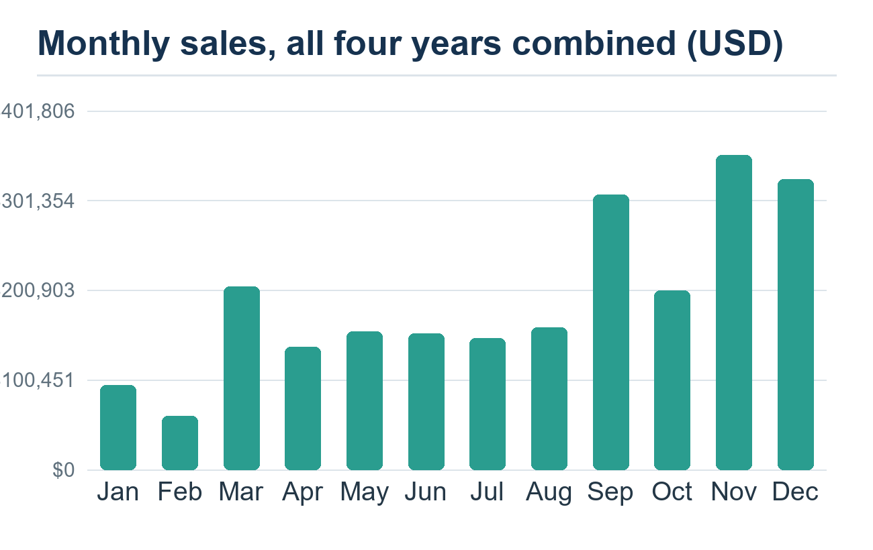

Quarterly sales (USD)
Year | Q1 | Q2 | Q3 | Q4
2014 | $74,448 | $86,539 | $143,633 | $179,628
2015 | $68,852 | $89,124 | $130,260 | $182,297
2016 | $93,237 | $136,082 | $143,787 | $236,099
2017 | $123,145 | $133,764 | $196,252 | $280,054

What to take forward
- Use the regional, state, and city views to focus follow-up on the West and the largest markets, while retaining visibility on the smaller South region.
- Review profit alongside sales before using the product and customer leaders to shape promotions; the rankings answer revenue questions and do not imply that the highest-selling items are the most profitable.
- Plan for the recurring late-year lift shown in Q4 and November–December, and compare monthly values by year in the workbook before making staffing or inventory decisions.

Project coverage
Requested analysis | Status
Sales by region | Included
Profit contribution by customer segment | Included
Top 10 products by sales | Included
Top 10 customers by sales | Included
Sales trend by year | Included
Sales volume by month | Included; calendar months combined across 2014–2017

