FL-01 — AI Workflow Audit
Peter Maged | FlyRank ML Internship — General AI Fluency Track

1. Recurring Task Audit
Below are the recurring tasks from my actual week — the FlyRank ML internship (refresh-opportunity scoring), university coursework, and personal side projects (embedded systems / Arduino). Each is classified into one of four modes, with a one-line reason.
Recurring Task | Classification | Why (one line)
Writing/refactoring code for the ML pipeline (feature prep, model training) in the internship notebooks and scripts | Collaborate with AI | I work step by step with AI on pandas/sklearn code, but I own the logic and validate every result myself.
Reviewing my code before committing/pushing to GitHub | Just me | I'm responsible for code quality and making sure nothing sensitive gets committed — CI blocks datasets, but the final judgment call is mine.
Framing the weekly research question / ML task (e.g. w01, w02 notebooks) | Collaborate with AI | AI helps me phrase the question and hypothesis, but choosing the lane and the metric that matters is my decision.
Summarizing technical articles or the FlyRank SEO research doc | Delegate to AI with review | AI drafts a quick summary; I verify the numbers and conclusions before I use them anywhere.
Writing docstrings / inline comments for scripts like ml_utils.py | Delegate to AI with review | AI proposes clear wording; I check it actually matches what the function does.
Debugging failures in the ML pipeline (run_all.py, scripts/01-05) | Collaborate with AI | I share the traceback and context, then test each proposed fix myself locally.
Tracking weekly internship deadlines and submissions | Just me | Time management and prioritization is a personal decision, not something to hand off.
Drafting commit messages for each weekly submission | Delegate to AI with review | AI suggests clear phrasing; I confirm it actually describes the diff before committing.
Writing EDA "verdicts" in the signal-audit report (auditing-signals) | Collaborate with AI | I have to understand the data and judge the signal myself; AI helps me organize and phrase the write-up.
Building and testing an Arduino/embedded side project on real hardware | Just me | Physical wiring and hands-on testing can't be delegated — AI can explain a library, but the circuit has to work in my hands.
Backing up notebooks (Save a copy in Drive/GitHub after each Colab session) | Fully automate | It's a routine mechanical step with no judgment involved.
Preparing practice questions before a university exam or quiz | Delegate to AI with review | AI generates practice questions quickly; I check they're accurate and actually relevant.
Drafting status updates/messages to the internship team or mentor | Delegate to AI with review | AI helps with wording; I review tone and content before sending anything.

Count: 13 tasks — 3 marked "Just me" (code review before push, deadline tracking, hardware testing).
2. Three Target Tasks (reused in FL-02 – FL-04)
These three recur every week of the internship, so they're the ones worth deliberately improving over the next few assignments.

1. Writing EDA "verdicts" in the signal-audit report
- Every claim is backed by an actual number or chart from the data — no conclusion stated without visible evidence.
- Re-running the same audit on the same data produces the same verdict (no cherry-picking).
- A teammate reading only the verdict section (not the code) understands what signal was tested and why it passed/failed.

2. Debugging failures in the ML pipeline
- The original error is gone and `python scripts/run_all.py` completes end-to-end with no new errors.
- outputs/ (charts, model_report.md, refresh_queue_sample.csv) regenerate correctly and match expected shape/columns.
- I can explain in one sentence why the bug happened, not just that the fix worked.

3. Framing the weekly research question / ML task
- The question is testable against a specific, named metric.
- It's answerable with data that actually exists in the internship warehouse (checked, not assumed).
- Someone else on the team understands the question on first read, without needing me to explain it.

3. Claude Project Setup
Project instructions used (Claude → Projects → Project instructions):
I am Peter Maged, an undergraduate student in Cairo interested in AI, web development, computer vision, embedded systems (Arduino), and software engineering. I'm currently doing an ML internship at FlyRank (refresh-opportunity scoring for SEO content) that involves Python, pandas/scikit-learn, Jupyter/Colab notebooks, and a git-based workflow.
Help me with clear, practical, step-by-step answers. When you give me code, tell me exactly which file it belongs in, state your assumptions, and suggest how I can test it. When something is project-specific and you're not sure, ask instead of guessing.
My current goals: improving how I work with AI day to day, building stronger portfolio projects, writing clearer documentation, and getting more comfortable deploying web/AI applications. Prefer free, local, or low-cost tools when possible.

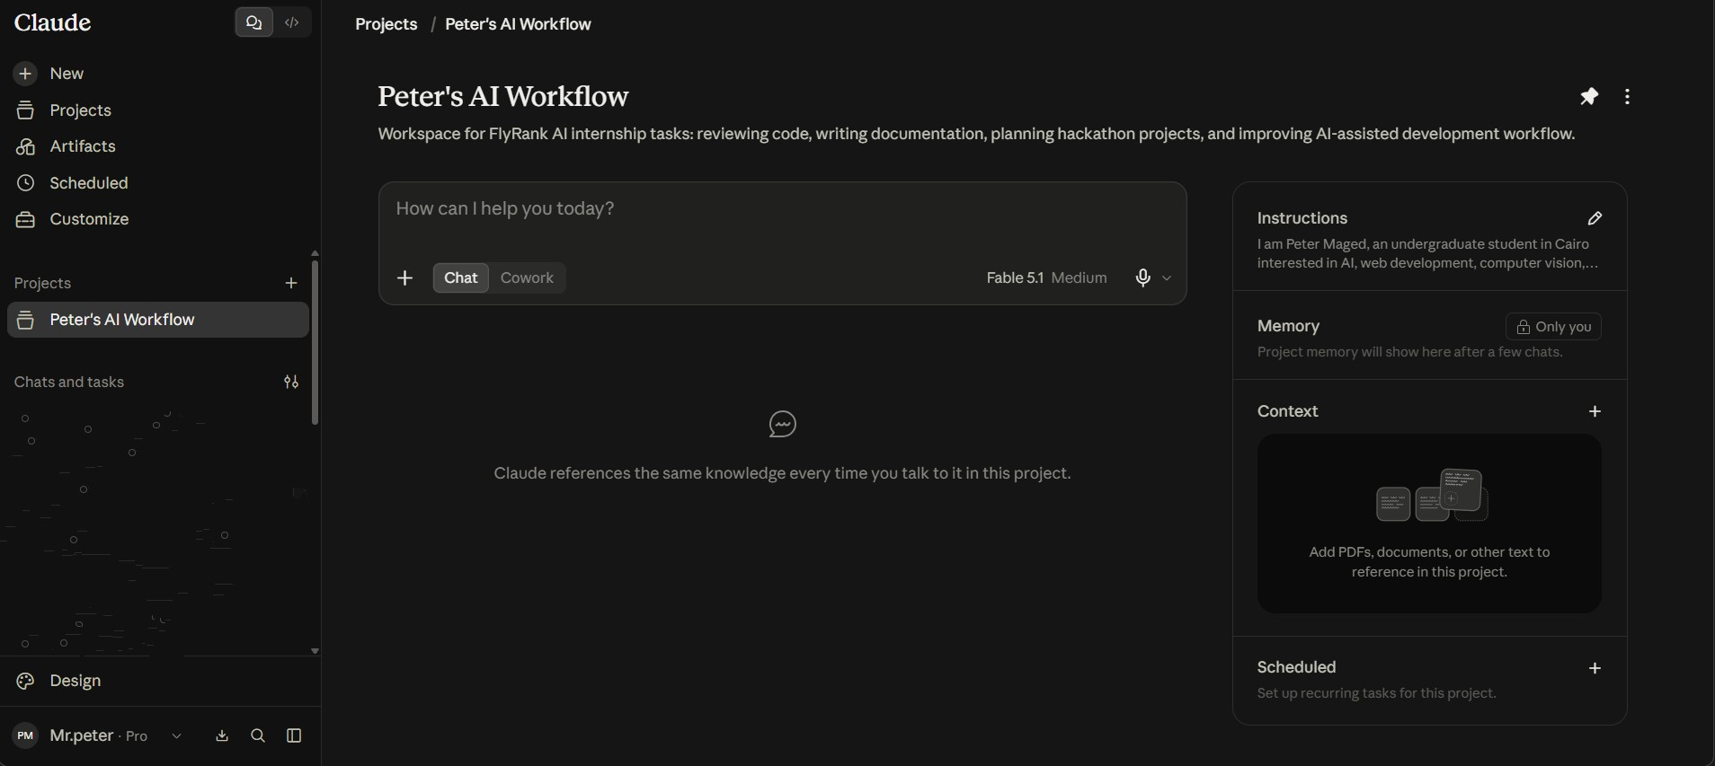

4. Toolkit & Academy
- Accounts created: Claude, ChatGPT, Anthropic Academy.
- Course: AI Fluency: Framework & Foundations — completed 15/15 lessons (100%), certificate issued July 20, 2026.
