Portfolio Sitemap — Feedback (Bank HR Target)
Review of the HERO → WORK → ABOUT → CONTACT sitemap, pressure-tested against a bank HR recruiter as the reader.

Good sitemap to start from — it’s lean, which is right. But when tested against this specific reader (a bank HR recruiter, not an engineer), a few things crack. Walking through it page by page, then the open questions needed before locking it.

The core tension first
The claim is "hands-on builder who ships real projects." The reader is someone who screens for roles at a bank. Those two things only connect if the recruiter can quickly answer: “Which of our open roles does this person fit, and is he safe to put in front of a hiring manager?” Bank HR is not evaluating the code. They are pattern-matching the candidate to a job description and checking for professionalism, clarity, and fit. Every page has to serve that, not just "look at what I built."

HERO — needs a rewrite
"AI/Embedded student who builds real projects" has two problems. "Embedded" signals hardware, which a bank recruiter has almost no role for — it may actually push the resume toward the "not for us" pile. And it does not say what the candidate wants. A recruiter should not have to guess whether this is an internship, a graduate program, or a data role.
A stronger shape: [what you are] + [what you build that a bank uses] + [what you’re looking for and when].
Something like "AI & software engineering student building working ML pipelines and web apps. Seeking a data/AI internship in banking, summer 2027." Add a "Connect on LinkedIn" button here too — don’t make the one action wait until the last page. Recruiters bounce early.

WORK — earning its place, but curate for the reader
This is the proof and it stays. But:
- Lead with ML and web/full-stack. Move Arduino/embedded to the bottom or cut it entirely for this version of the site. If one hardware project stays, frame it around the transferable skill ("built and debugged a system end-to-end under deadline"), not the hardware.
- Hackathons are strong evidence for the claim — deadlines, teamwork, shipping. But label the outcome (placed? demo’d? finished?), because HR reads outcomes, not effort.
- Every project card should have the same three lines: what problem, what was built, what it proves. Plus a link to a live demo or repo — "testable" is part of the claim, so make it testable in one click.
- Cap it at 3–4 projects. Ten projects reads as "student who dabbles"; four polished ones read as "builder."

ABOUT — keep, but it’s doing more work than expected
For an engineering audience, ABOUT is filler. For HR it’s where trust lives: university, degree, expected graduation, availability, languages, and one sentence on why banking. A recruiter will wonder why an AI/embedded student is targeting a bank — answer it before they ask. Consider moving ABOUT above WORK, or merging a short version of it into the hero, depending on the answers to the open questions below.

CONTACT — right action, wrong framing
"Connect on LinkedIn" is correct as the one action. But two things are missing that bank HR will expect:
- A downloadable CV (PDF). HR runs on CVs; a portfolio without one creates friction and they’ll go find one elsewhere or drop the candidate.
- The LinkedIn profile itself has to match the site — same headline, same top projects, same "seeking X." The portfolio is the hook; LinkedIn is where they actually decide to click "Connect." If those disagree, the action dies on the LinkedIn side.

What’s missing
A short SKILLS/FIT block, written in the bank’s vocabulary: Python, SQL, data pipelines, model evaluation, APIs, Git, plus anything like cloud or Excel. Not a badge wall — a scannable list a recruiter can match against a job spec in five seconds. This can live inside ABOUT or as a strip under the hero.

Revised sitemap proposed
HERO (claim + target role + Connect button) → WORK (3–4 curated projects, ML/web first, each with demo link) → ABOUT + SKILLS (credentials, why banking, availability, skills in HR language) → CONTACT (Connect on LinkedIn + CV download)
Same page count, different emphasis.

Before locking this — open questions
- Which roles at a bank are actually being targeted — data science/ML, software engineering, IT, quant? This decides which projects lead and how the hero reads.
- Internship or graduate program, and availability — expected graduation year?
- Why a bank specifically? Is there a real reason (fintech interest, a specific bank’s program, family expectations, stability)? The honest answer shapes the ABOUT sentence.
- Is there a current CV, and does the LinkedIn profile already exist in decent shape?
- Is embedded/Arduino something wanted in the career long-term, or just what’s been built so far? If the former, worth discussing whether a bank is even the right target — better to raise that now than in week 6.

Attachments

Original sitemap sketch
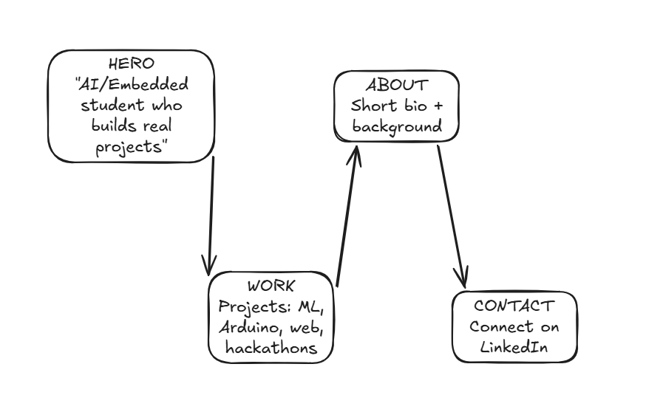

Conversation screenshot
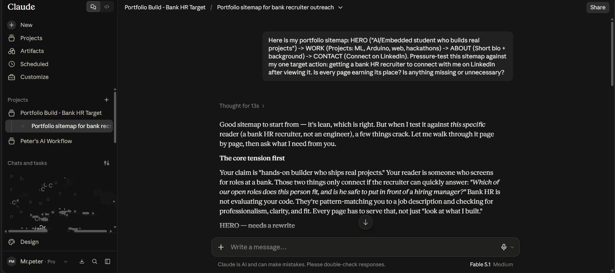

References
Sitemap diagram (Excalidraw): open link
Full conversation (Claude share): open link

