**MINI PROJECT – II**

**(Session 2018-19)**

**Logistics App**

**SYNOPSIS**

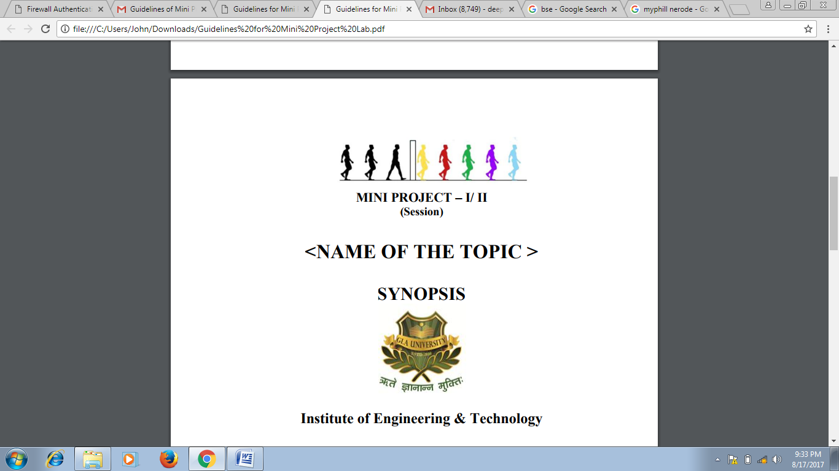

**Institute of Engineering & Technology**

**Team Members**

Gagan Saxena (161500210)

Rajeev Pachauri (161500433)

Prakhar Srivastava (161500392)

Siddhant Bansal (161500557)

**Supervised By**

Mr. Neeraj Khanna

Technical Trainer

Department of Computer Engineering & Applications

**Group Information:**

**Student 1:**

Gagan Saxena

C (24)

9458615139

[gagan.saxena_cs16@gla.ac.i](mailto:gagan.saxena_cs16@gla.ac.in)n

**Student 2:**

Prakhar Srivastava

D (45)

9648100199

[prakhar.srivastava_cs16@gla.ac.in](mailto:prakhar.srivastava_cs16@gla.ac.in)

**Student 3:**

Rajeev Pachauri

E (47)

8194040282

[rajeev.pachauri_cs16@gla.ac.in](mailto:rajeev.pachauri_cs16@gla.ac.in)

**Student 3:**

Siddhant Bansal

F (58)

8476022132

[siddhant.bansal_cs16@gla.ac.in](mailto:siddhant.bansal_cs16@gla.ac.in)

**Project Proposal:**

It is a type Android based Application which is related to Transport service. It is created specifically for distribution companies and delivery services. With this app, effortlessly manage your shipment, vehicles, and drivers. What's more, with automated email/SMS notifications and full mobile support, your logistical operations are guaranteed to be smooth. It is app like in which you can search nearby transport service or vehicles. In this app you can book vechile by seen the details of driver and vehicle details also.

**Benefits Of Application :**

* View the list of orders and detailed information on each.
* Track and evaluate delivery progress.
* Observe orders and estimated routes on the map.
* Receive push-notifications on relevant events regarding orders, routes, and delivery process.
* Make a detailed route to an order using external navigational applications.

**Broad Requirements:**

Hardware Requirement :

* Laptop (i5 processor with minimum 8GB RAM)
* Smartphone with Android OS
* Internet facility
* OTG Cable

Software Requirements:-

* Android Studio 3.0.2
* Photoshop (For logo)
* Google Chrome
* Web server
* Vysor
* Other Tools

________________________________________________________________________