## Logistic Services

A project report

submitted in partial fulfillment of the requirements for the degree of

## Bachelor of Technology

in

## Computer Science & Engineering

by

#### Pratyush Priyadarshi

Under the Guidance of



# Declaration of Academic Ethics

I declare that this written submission represents my ideas in my own words and where others’ ideas or words have been included, I have adequately cited and referenced the original sources. I declare that I have properly and accurately acknowledged all sources used in the production of this project report.

I also declare that I have adhered to all principles of academic honesty and integrity and have not misrepresented or fabricated or falsified any idea/data/fact/source in my submission. I understand that any violation of the above will be a cause for disciplinary action by the Institute and can also evoke penal action from the sources which have thus not been properly cited or from whom proper permission has not been taken when needed.

Date: 23 June, 2022 Pratyush Priyadarshi

# Acknowledgment

We would like to thank **Mr. Abhishek Malviya** for granting me the honour of being a member of Biomedical group and their invaluable help and guidance. I would like to express my deep sense of gratitude to **Aman**, **Vinit** & **Sanchi** for their important help and technical suggestions. I am grateful to Tarun, Shreyash and Vivekanand for their unconditional support at all times. I would like to thank all members of CSE lab who have directly or indirectly contributed in my project work and maintained a friendly atmosphere in the lab. Finally I would like to thank my family and my friends for their constant moral support. [1] [2]

# Abstract

We are seeing the rapid growth of the Indian transport industry and it is a business game among a few new service providers, technologies and infrastructure that will determine whether the transport industry can help its customers reduce their travel and transportation costs and pro- vide efficient services or not? Constantly changing government policies in particular in terms of taxation and management of service providers will play a important key role in this cost-cutting approach.

In India, communication between the various spheres of government requires a host of permits from many officials and services which is a great pain that creates a barrier to the multi-model system. At the SME level, the goal of Indian logistics is moving forward reduce cycle times to focus value on their customers. Therefore, best practices and strategies are used by companies to improve their decision-making process.

This paper provides an overview of these issues and issues with the help of basic research; I also outlined some of the major challenges with the help of the second information mentioned in several journals, articles and testimonials, and suggested interesting steps that some organi- zations are taking to compete more effectively in managing their transportation system.

The approach adopted in this paper includes extensive research and reviews that are relevant to personal collaboration and consideration by various relevant planning organizations. Logistic is defined as moving objects and equipment in which they will be used. In construction, proper logistic management provides a quality impact on construction.

Therefore, logistic management depends on the system of operations and providers. Delivery of all construction materials and equipment on site must be timely and in the right place. Flow performance and the delivery process of the building materials is important to make the con- struction build well without dealing with problems occurring.

# Table Of Content

List of Figures viii

1. Introduction 1
   1. Objective 2
2. SDLC Model Used : Evolutionary Model 3
   1. Requirements Gathering Phase 4
   2. Planning Phase 4
   3. Design Phase 4
   4. Development Phase 5
   5. Testing Phase 5
   6. Evaluation Phase 6
3. Requirement Gathering and Analysis 7
   1. Requirement Gathering 7
   2. Requirement Analysis 7
   3. System Requirement 8
4. Designing 9
   1. Flow Chart 10
   2. Use Case Diagram 12
   3. Entity Relationship Diagram 14
   4. Data Flow Diagram 16
      1. Levels in Data Flow Diagrams (DFD) 16
5. Implementation Phase 20

|  |  |  |  |
| --- | --- | --- | --- |
| 5.1 | Project Module View . . . . . . . . . . . . . . . . . . . . . . . . . . . . . . | .20 | |
|  | 5.1.1 Home page . . . . . . . . . . . . . . . . . . . . . . . . . . . . . . . | .20 | |
|  | 5.1.2 Services . . . . . . . . . . . . . . . . . . . . . . . . . . . . . . . . . | .22 | |
|  | 5.1.3 About Us . . . . . . . . . . . . . . . . . . . . . . . . . . . . . . . . | .25 | |
|  | 5.1.4 Contact Us . . . . . . . . . . . . . . . . . . . . . . . . . . . . . . . | .26 | |
|  | 5.1.5 Admin . . . . . . . . . . . . . . . . . . . . . . . . . . . . . . . . . | .27 | |
|  | 5.1.6 User . . . . . . . . . . . . . . . . . . . . . . . . . . . . . . . . . . . | .31 | |
| **6 Testing**  6.1 Types Of Testing . . . . . . . . . . . . . . . . . . . . . . . . . . . . . . . . | | .35 | **35** |
| 6.1.1 Unit Testing . . . . . . . . . . . . . . . . . . . . . . . . . . . . . . . | | .36 |  |
| 6.1.2 Integration Testing . . . . . . . . . . . . . . . . . . . . . . . . . . . | | .37 |  |
| 6.1.3 System Testing . . . . . . . . . . . . . . . . . . . . . . . . . . . . . | | .38 |  |
| **7 Conclusion** | |  | **39** |
| **8 Future Enhancement** | |  | **40** |
| **A Publication** | |  | **41** |
|  | |  |  |
|  | |  |  |
|  | |  |  |
|  | |  |  |
|  | |  |  |
|  | |  |  |
|  | |  |  |
|  | |  |  |

# List of Figures

* 1. Evolutionary model 3
  2. Stages of SDLC Models 6
  3. Flow Chart 11
  4. Use Case Diagram 13
  5. ER Diagram 15
  6. DFD-level 0 16
  7. DFD-level 1 Admin 17
  8. DFD-level 1 User 18
  9. Home Page 20
  10. Home Page 21
  11. Home Page 21
  12. Services 22
  13. Clearance and Forwarding 22
  14. Road Trucking 23
  15. Import and Export of Goods 23
  16. Warehousing 24
  17. Supply Chain Consultancy 24
  18. About Us 25
  19. About Us 25
  20. Contact Us 26
  21. Contact Us 26
  22. Admin Registration 27
  23. Admin Login 27
  24. Admin Dashboard 28
  25. Booking Details 28
  26. Update Payment Status 29
  27. Update Delivery Status 29
  28. User Details 30
  29. Delete User 30
  30. User Registration 31
  31. User Login 31
  32. User Dashboard 32
  33. Booking 32
  34. Payment 33
  35. Booking Details 33
  36. Cost Calculator 34
  37. Builty 34
  38. Unit Testing 36
  39. Integration Testing 37
  40. System Testing 38

**Chapter 1 Introduction**

Transport authorities consider all resources that provide costs. It shows an special character in creating the item tailored to the needs of the customers. And it includes successful mixing of provider, creating, item storage and stores and corporate functions to multiple levels, from strategic level through strategy to performance level.

In modern times, technological advances and the complexity of logistics processes have emerged logistics software and specialized transport firms that accelerate the action- resource develop- ment in the supply chain. One reason why big internet retailers like Amazon have it coming to dominate the retail space is a new invention and efficiency of their products on all supply chain links. Manufacturing companies may choose to offer their products to managers cialists or carry equipment inside to do so. Logistics is a challenging and impor- tant task because it works as a merger or border integration work. It connects providers with customers and brings together organizations that work everywhere company. The global commodity market is booming and a variety of transport providers to meet the needs of foreign trading companies international trade. Words used to identify those companies that international shipping may be confusing. Best known as exporters, this term does not necessarily define the depth and range of services provided by the sector. transport manager, Non- Vessel Owner Carrier (NVOCC), compiler, supply chain manager and information vendor in some recent terms used to highlight the scope of services.

Shippers have become a mystery and they know the needs of their customers. They have real- ized that international transport solu- tions they are partnership with the customer. Against the background of international trade and electronic communications, the industry operates at all levels transport chain, which provides an important service to large and small companies.

## Objective

* + - A satisfied customer is the key to complete asset management success. With with the advent of the latest technology, it is possible to carry several logistics tasks even at the last minute. The goal is to avoid any superstitious rituals accumulate with the eagerness of customer needs. The management company must be capable of converting operational capabilities from self-defense mode with rapid change in responding effectively to cus- tomer needs depending on delivery needs.
    - There is a temporary gap and a gap between production and consumption. The goal of Logistics to fill this vacancy. In the past, the main goal of logistics was to address local distance by increasing transport efficiency and reducing delivery time goods.
    - Improving the efficiency of both entry and exit will remain open on top of inventory management service. They will need to provide appropriate transportation costs and re- ductions in overhead costs, inventory, and the costs thereof of all or der processing. As they work with links attached to the transport provider, various storage performance in storage areas can be improved in a meaningful way.
    - These are inbound transit, outbound transport, and retreat. Information about these three supply chain guidelines it is important to know, especially for people who are inclined in the transport industry in the Philippines. [3]

# Chapter 2

**SDLC Model Used : Evolutionary Model**

Evolutionary model are a mixture of the Iterative and Incremental model of the sdlc cycle. Bringing to your system up with a big and bang release, bringing it up with a growing process over all the time it is an act done on this model. Some prerequisites and the building the ideas need to be the met.

It is suitable for all software products with a set of features redesigned during development based on user feedback and all other features. The evolutionary development model divides the development cycle into smaller incremental waterfall models, giving users access to the product at the end of each cycle. Therefore, software products change over time.

The flexibility model proposes the division of labor into smaller segments, prioritizing and de- livering those components to each customer. The size of pieces is large, and the release amount is personalized for every customer. Customers’ confidence grows as they receive measurable goods or services from the start of the project to ensure and validate their needs.

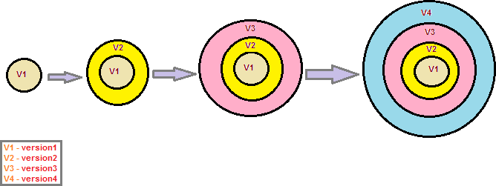

Figure 2.1: Evolutionary model

## Requirements Gathering Phase

Software program requirements to be advanced are gathered. those necessities will be in a language that the client / person is familiar with. certain area terms are endorsed. Defining requirements is considered a part of planning to decide what the utility need to do and its neces- sities. as an instance, a social networking app might also require the capability to communicate with a chum. The setup manner may also require a seek feature. requirements include defining the assets had to construct a assignment. for example, a crew may increase a custom manu- facturing system control software. system is a need in this procedure. throughout this section, all crucial statistics is amassed from the customer to improve the product as predicted. Any misunderstandings ought to be resolved at this degree best.

## Planning Phase

The planning section of the SDLC is where a challenge plan is evolved that identifies, priori- tizes, and affords the activities and resources had to construct a project structure. That being stated, this step concludes with an in depth project plan. earlier than we begin with the making plans segment, the exceptional tip we can come up with is to make the effort and get a right un- derstanding of the existence cycle of application development. The planning stage (also called as the chance degree) is exactly as it sounds like: this is when the programmers plan the next assignment. It allows you to define the difficulties and breadth of any existing programs, as well as determine the reason for their applications. with the aid of building an powerful framework for the future development cycle, they may discover troubles before they have an effect on de- velopment. And to help secure the support and resources they want to make their plan work. perhaps most importantly, the making plans segment units out a assignment plan, which can be of substantial significance if the improvement is a industrial product that should be marketed over a time period.

## Design Phase

In the layout segment, you and the developer crew decide what your software program wishes, what it’s going to appear like, and what the development timeline will appear like. Time to create a workflow map, decide which statistics (s) to apply, and create a statistics model. The

layout level is a essential precursor to the principle engineer level. builders will first display the info of the entire application, next to positive features. commonly they’ll convert the SRS report they created right into a logical structure that can be used later inside the programming language. overall performance, education, and upkeep packages will all be designed so that engineers realize what to do in each section of the subsequent cycle. once finished, the improvement managers will prepare a design file that will be displayed in all subsequent sections of the SDLC.

## Development Phase

The goal of the development phase is to transform a system prototype during the design phase into a functional information system that meets all the requirements of a written plan. At the end of this section, your application will enter the testing phase. The developer actually writes the code and builds the programme according to earlier design papers and certain details during the development phase. This is where you need a Solid Security Application Testing or SAST tool. The software code for the product is based on the specifications in the project documentation. Theoretically, all previously published plans should simplify the actual development phase. Engineers use a variety of tools such as editors, editors, and interpreters according to the coding rules defined by the organization. Editing languages can include native languages such as C ++ and PHP.

## Testing Phase

The testing phase of the software development lifecycle (SDLC) focuses on research and discov- ery. During the testing phase, engineers discovered that the code and programs were tailored to the customer’s needs. Software development is not the end.Now we’d like to check that there’s no disruption which the end-user expertise isn’t affected. throughout the testing phase, engi- neers test the code with a exactitude toothbrush to spot defects or bugs that require to be tracked, fixed, and retested later.It is important that all software meets the quality standards mentioned above in the SRS documentation. Depending on the skill of the developer, the complexity of the software, and the needs of the end user, the test can be too short or too long.

## Evaluation Phase

This part shows whether the plan meets the real requirements and goals. This is where you test if your system is weak. The goal of the testing phase of system development life cycle is to use system and educate the end users of the system. After testing, the entire software design is built together. Various modules or comes are integrated into the most ASCII text file through the developer’ efforts, sometimes through bugs or learning tools that catch them. the knowledge system is integrated with the placement and at last installed. when passing this stage, the software package is in theory prepared available and may be created accessible to any finish user.

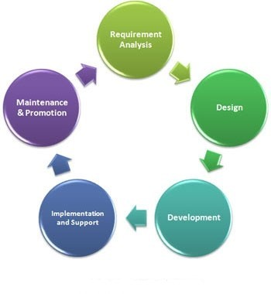

Figure 2.2: Stages of SDLC Models

# Chapter 3

**Requirement Gathering and Analysis**

During this part, all vital info is collected from the client to enhance the merchandise as ex- pected.Any misunderstandings must be resolved at this degree only. The Business Analyst and Project Manager installation a assembly with the client to acquire all of the info which include what the client desires to build, who could be the cease user. Before constructing a product simple knowledge or product information could be very important.

## Requirement Gathering

In this section, we have tried to gather information from vendors and managers about their knowledge while satisfying the needs of clients by planning, managing and implementing ef- fective mobility and storage of related data, products and services from one location to another. Based on the information collected and personal observation, we have come to the conclusion that Logistics management plays an important role in the transportation industry in the new global economic climate for businesses to thrive.

## Requirement Analysis

* + - Able to login and book their shipment.
    - Able to calculate their shipment price.
    - Able to check their booking status.
    - Able to check their payment status.
    - Able to track their shipment.
    - Able to print the invoice.
    - Able to send a feedback form.

## System Requirement

#### Software Requirements :

1.MySQL database 2.Xampp server 3.Any code editior

4.An Internet connection

#### Hardware Requirements :

1.4GB RAM

2.1 CPU Core

3.x86 64-bit CPU (Intel / AMD architecture)

4.20 GB HDD Storage

# Chapter 4 Designing

Designing is a way of converting user requirements into a specific type, which helps the editor to write code and use the software.It is chargeable for representing the client’s requirement, as described withinside the SRS document (Software Requirements Specification), right into a form, i.e. smooth to apply the usage of programming language. The software program layout section is step one withinside the SDLC (Software Design Life Cycle), which shifts the focal point from the trouble area to the answer area. In software program development, we view the machine as a hard and fast of additives or modules with a described conduct and limitations.

Design is the procedure of figuring out and explaining software program answers to a fixed of 1 or greater problems. One of the important thing additives of software program layout is to investigate software program requirements (SRA). The SRA is a part of a software program improvement software that calculates the statistics utilized in software program engineering.

It is vital to note, however, that the planning method isn’t continuously an easy process; the design model will be compared to the plans of a house builder. It begins with representing the essence of the item to be engineered (e.g., the availability of a three-dimensional house); slowly, the object is refined to supply direction for building individual details (e.g., plumbing lay). Similarly, a package-based model offers a spread of pc software ideas.

In all engineering fields, design is the most important step in creating or using a product. For example, consider building a building. It is unthinkable for builders to go into the field and start building before detailed designs are developed by the engineer. In fact, constructing a building without pre-design can be dangerous and can lead to serious problems that could endanger human life. In fact, it can be said to be the most important stage of the whole process.

## Flow Chart

Flowchart may be an imagination algorithm. Program planners usually use it as a tool for draw- back solving. It uses the symbols connected between them to point the flow of knowledge and processing. A flow diagram is a diagram showing a process, system or laptop algorithm.They are wide utilized in many fields to write, study, edit, develop and communicate processes that are typically advanced in clear, easy-to-understand diagrams. Flowcharts, typically spelled as flow charts, use rectangles, ovals, diamonds and lots of alternative shapes to explain the sort of action, in addition as connecting arrows to outline flow and sequence. He will move from simple, hand-drawn charts to intensive computer-generated diagrams showing multiple steps and methods.

Considering all the various sorts of flowcharts, they’re one amongst the foremost standard styles within the world for each technical and non-technical folks in several fields. Flowcharts are typ- ically said by special names adore method Flowchart, method Flowchart, Activity Flowchart, Business method Map, Business method Model and Notation (BPMN), or Flowchart. pro- cess diagram (PFD). concerning different popular diagrams, such as Diagram knowledge Flow (DFD) and Integrated Language Activity Drawing (UML).

Flowchart Charts and Definitions - Provides a visible illustration of go with the drift chart sym- bols and their proposed use in expert workflow diagrams, fashionable go with the drift procedure diagrams and hyperlinks to a well-evolved internet site structure, and their relevance to grow- ing on line coaching projects. . Flowchart is a graphical illustration of a logical collection of machine steps. Flowcharts use easy geometric shapes to show techniques and arrows to signify relationships and processing / go with the drift of data.

In Our project we start from Requirement Gathering in which we meet with user for there re- quirement whole project require then we analysis then write a paper at last take feedback from the user in other hand we think about software requirement.Second part is design in which we design the UI of project and take feedback from design team.Third part is coding and fourth part is testing at the time of testing we test the system for the correct output.

At last we delivery the product the user and is there any new requirement the we work on that module and update the previous version and delivery the new version.

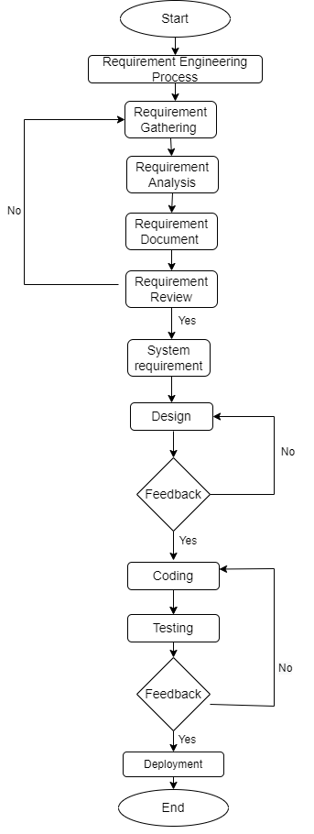

Figure 4.1: Flow Chart

## Use Case Diagram

The application case diagram is used to show the changeable nature of the system. It integrates system performance by integrating user situations, characters, and their relationships. Model the functions, services, and functions required by a small app / program. Demonstrates a high level of system performance and also tells how the user manages the system.The main purpose of the user interface is to display the dynamic feature of the system. It accumulates a system requirement, which includes both internal and external influences. It appeals to the people, the use cases, and a few things that recruit actors and objects that are responsible for the use of the action drawings. It represents how a foreign business can interact with the system component. The application case diagram is used to shows the dynamic behavior of the system. It integrates system performance by integrating user situations, characters, and their relationships. Model the functions, services, and functions required by a small app / program. Demonstrates a high level of system performance and also tells how the user manages the system.

The main purpose of a user case diagram is to identify a dynamic feature of the system. It accumulates a system requirement, which includes both internal and external influences. It appeals to the people, the use cases, and a few things that recruit actors and objects that are responsible for the use of the action drawings. It represents how a foreign business can interact with the system component.

After that, we will add actors who will work with the program. Characters are a person or thing that calls for system performance. It could be a system or an independent business, so much so that it requires the business to be compliant with the operating system in which it will participate. Once both the characters and the operating conditions have been registered, the relationship between the character and the use of the case / system is checked. Indicates the number of times a character interacts with the system. Basically, the character can interact multiple times with the application or system over a period of time.

A user case diagram showing the Online Shopping website is provided below. The maximum use is as follows; View Items, Buy, Checkout, Client Register. Utility Case View is used by the customer searching and viewing products.

* + - User
      * User can login.
      * User can book their shipment.
      * User can check their booking status.
      * User can check their delivery status.
    - Admin
      * Admin can login.
      * Admin can update booking status.
      * Admin can update delivery status.
      * Admin can calculate damage prediction.
      * Admin can remove emp/user.

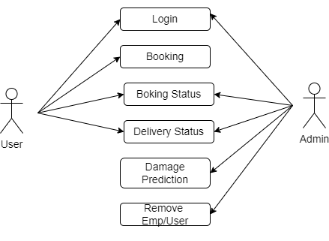

Figure 4.2: Use Case Diagram

## Entity Relationship Diagram

ER diagram stands for relationship Diagram, conjointly referred to as ERD, a diagram that shows the connection of a group of companies hold on on a website. In different words, ER diagrams facilitate make a case for the logical structure of information. ER diagrams are created supported 3 main concepts: Organization, Attributes, and Relationships.

ER drawings comprise numerous symbols the usage of packing containers to symbolize com- mercial enterprise, ovals to explain functions, and diamond systems to symbolize relationships. At first glance, an ER diagram appears very just like a flowchart. However, ER diagrams com- prise many unique capabilities and their definitions make this version unique. The reason of an ER diagram is to symbolize the shape of a commercial enterprise shape.

ER Modeling enables you to research information desires systematically so that it will produce a nicely-designed website. consequently, it’s miles considered the quality practice to complete ER modeling before the usage of your database.

for instance, the inventory software used in a retail keep will have a website that monitors gad- gets along with purchase, object, item kind, source object and amount of objects.There are three basic elements in the ER diagram: business, characteristic, relationships. There are additional factors primarily based on key elements. they’re a weak business, a fee-delivered fee, a deriva- tive high-quality, a vulnerable dating, and a recurring relationship. Cardinality and ordinality are other definitions utilized in ER diagrams to further define relationships.

ER Diagram is used show relation Between tables.Logistics has a a table name users which have entity phone, userid, email, name in which userid is primary key.Logistic has booking ta- ble which have itemid, from, to weight, price, itemtype etc entity.Logistic run by admin which have password, adminid, emaiid, name.

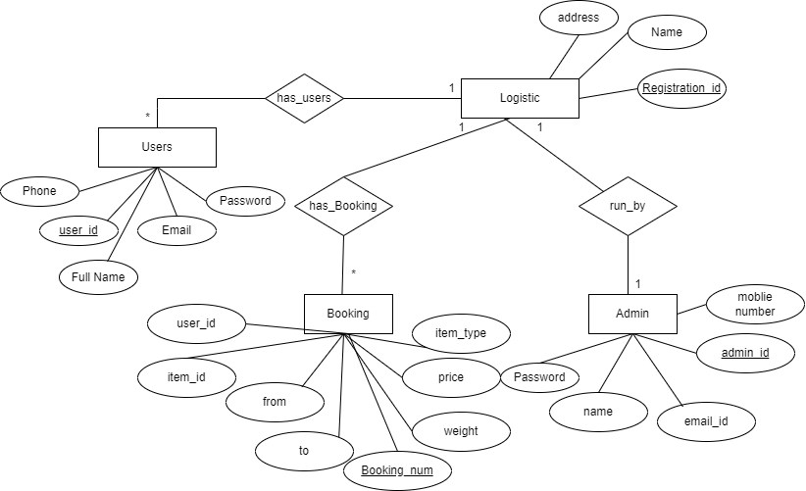

Figure 4.3: ER Diagram

## Data Flow Diagram

Records float Diagram (DFD) is a preferred diagram of data that flows within a machine. A smooth and clear DFD can display an appropriate amount of machine requirement according to photograph. it could be manual, automatic, or a aggregate of both.indicates how statistics enters and exits the system, what adjustments information, and wherein the information is stored.

DFD may be used to create a system or software at any level of inaccessibility. In fact, DFDs can be divided into levels that represent the flow of information and performance information. Standards in DFD are numbered 0, 1, 2 or higher. Here, we will see primarily three levels in the data flow diagram, namely: DFD level 0, DFD level 1, and DFD level 2.

### Levels in Data Flow Diagrams (DFD)

#### 0-Level DFD

Additionally referred to as a basic gadget model, or contextual diagram represents the complete requirement of the software program as a unmarried input and output facts marked with incom- ing and outgoing arrows. The system then decomposes and is defined as a DFD with a couple of bubbles.

DFD layers Drawings of the glide data of the drawing may be made in a few layers placed with in side the nest. Flowing diagrams are typically designed using easy symbols collectively with square, oval or round patterns, records or outside business enterprise, and arrows are frequently used to indicate the movement of information from one step to each other.

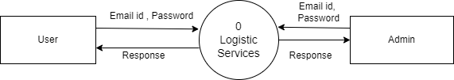

Figure 4.4: DFD-level 0

#### 1-Level Data Flow Diagram - Admin

In 1-Level DFD for admin there are mainly five type of process in which admin can register with correct data and it is store in database.In onther process admin can login by providing correct data which is checked in database the is provide dashboard for admin in which admin can update payment status, update delivery status, and check booking and cancellation table.

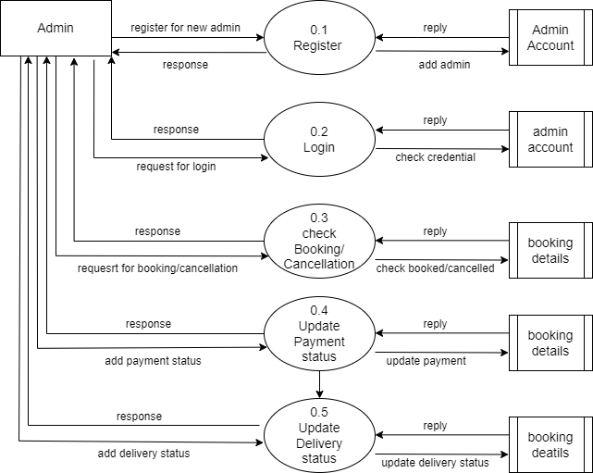

Figure 4.5: DFD-level 1 Admin

#### 1-Level Data Flow Diagram - User

In 1-Level DFD for user there are mainly five type of process in which user can register with correct data and it is store in user database.In other process user can login by providing correct data which is checked in database the is provide user dashboard for user in which admin can make payment , chcek delivery status, and booking and cancellation item.

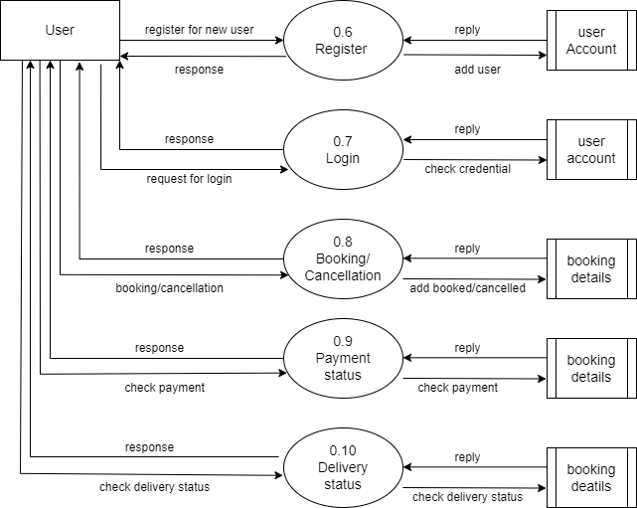

Figure 4.6: DFD-level 1 User

# Chapter 5 Implementation Phase

Implementation section is the maximum critical segment of the evolutionary version. here, the real implementation and coding technique is accomplished. All planning, specification, and layout documents up to this point are coded and applied into this venture.

The implementation phase represents the time at which a project is created or implemented.

## Project Module View

### Home page

This is our main page of our web-site which indicates the overall the idea about website.

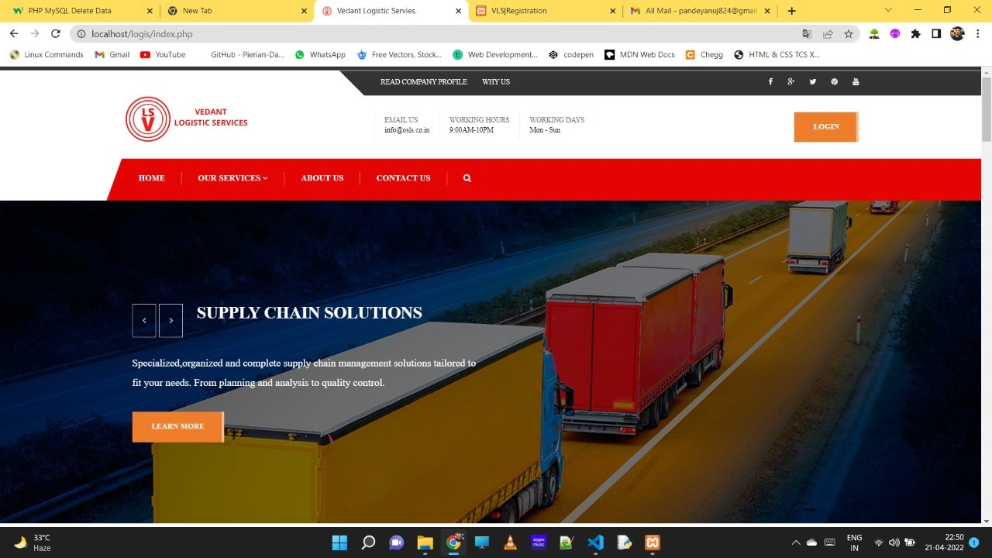

Figure 5.1: Home Page

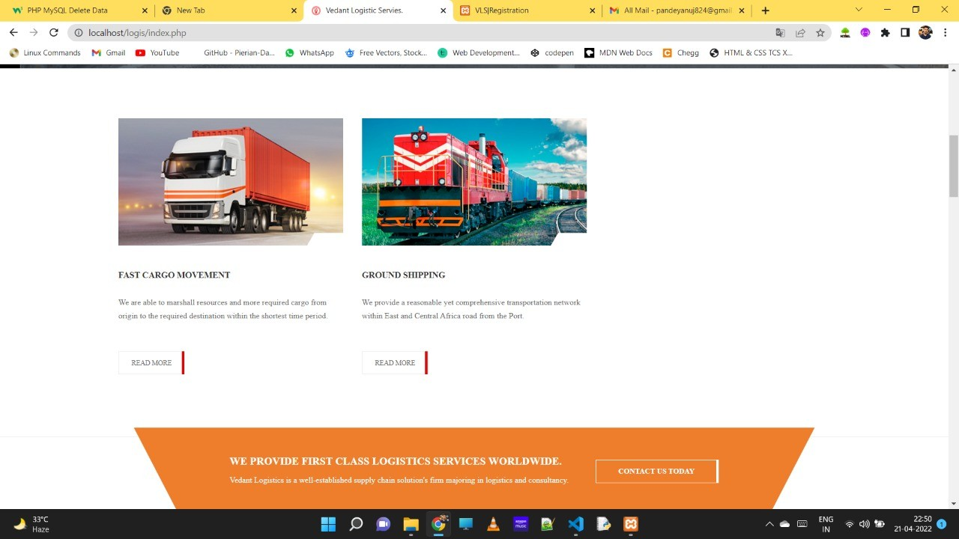

Figure 5.2: Home Page

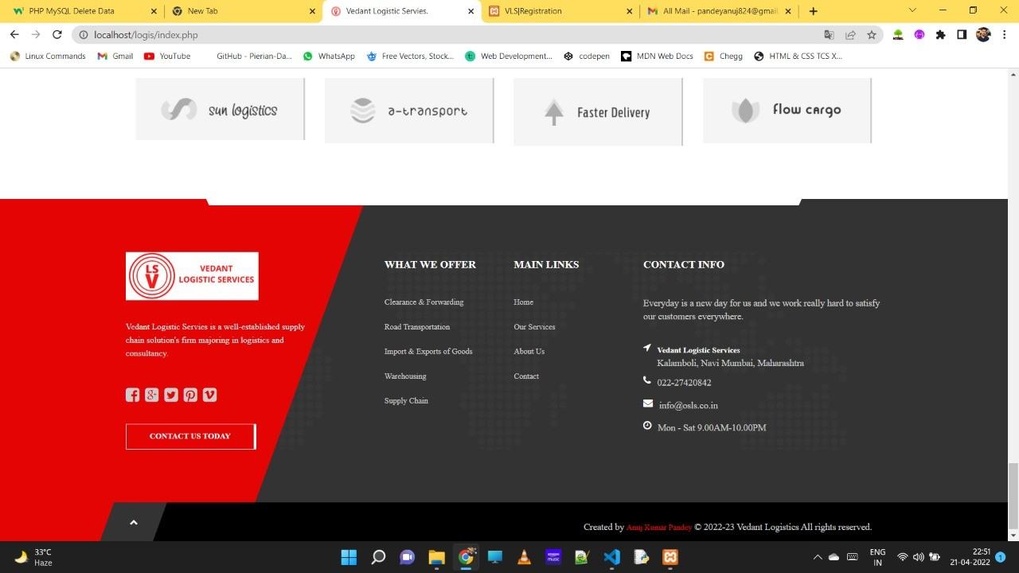

Figure 5.3: Home Page

### Services

This page used to provide the details about our services.

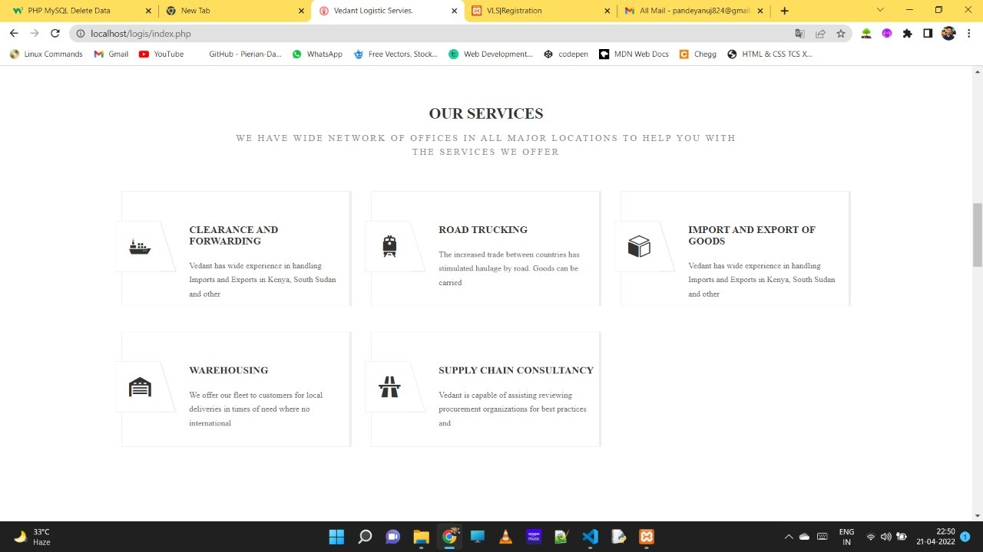

Figure 5.4: Services

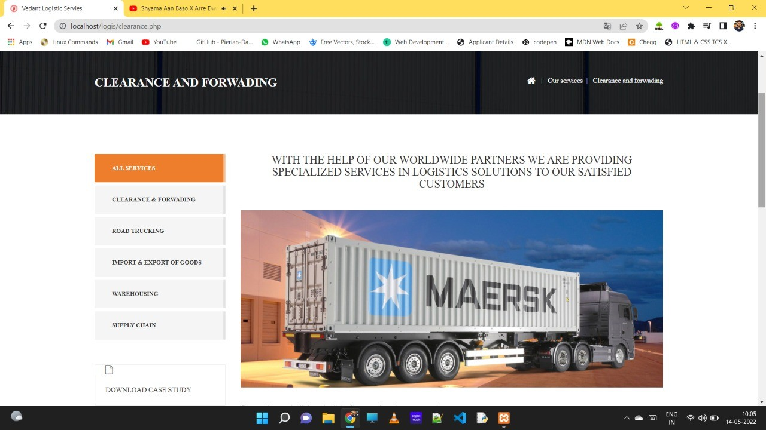

Figure 5.5: Clearance and Forwarding

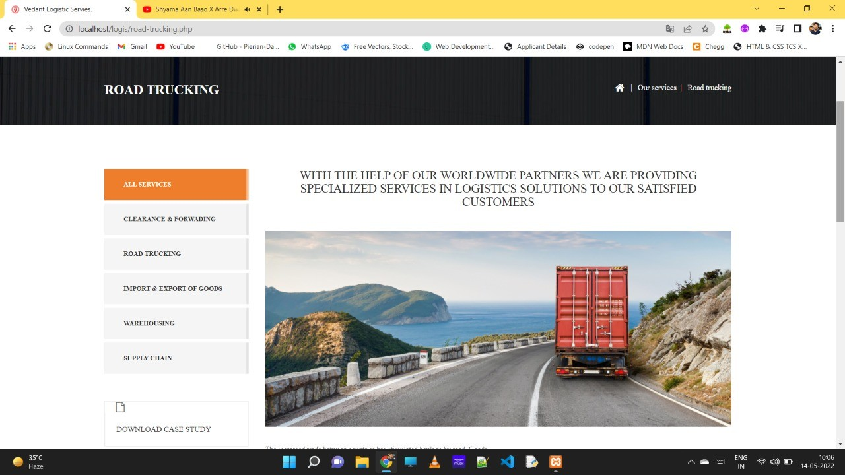

Figure 5.6: Road Trucking

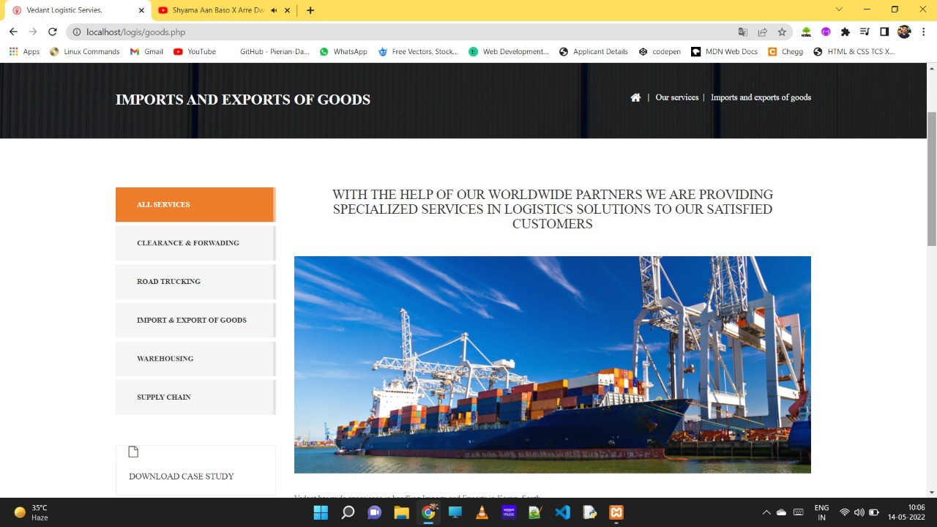

Figure 5.7: Import and Export of Goods

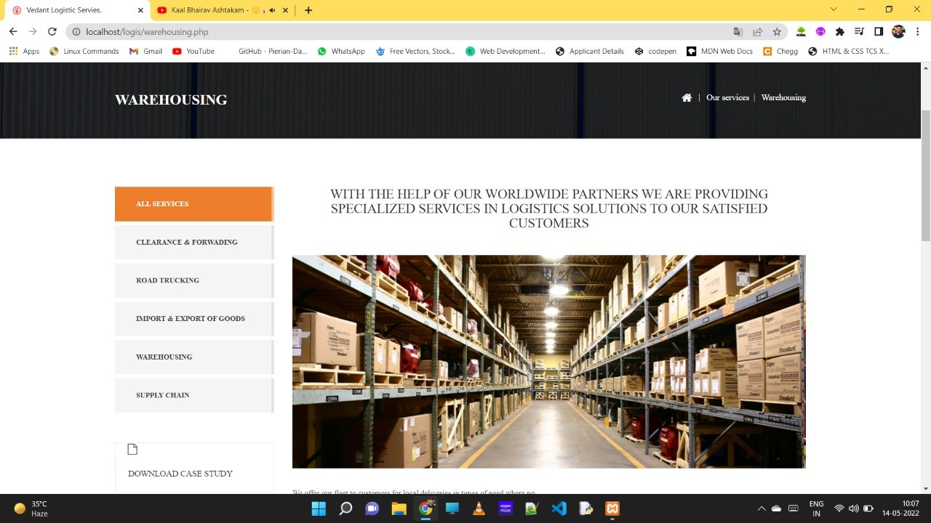

Figure 5.8: Warehousing

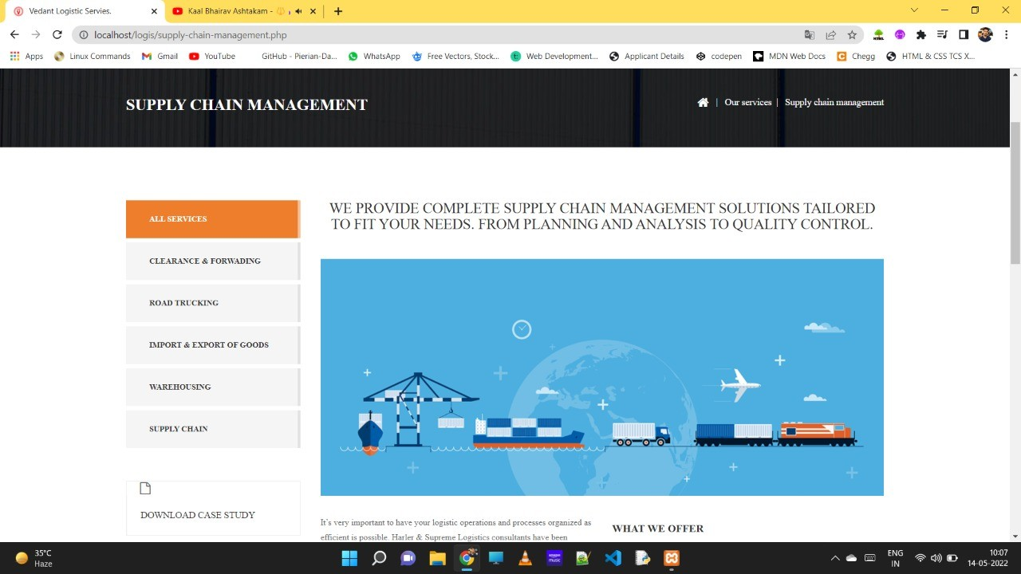

Figure 5.9: Supply Chain Consultancy

### About Us

This page is used provide about us and our company.

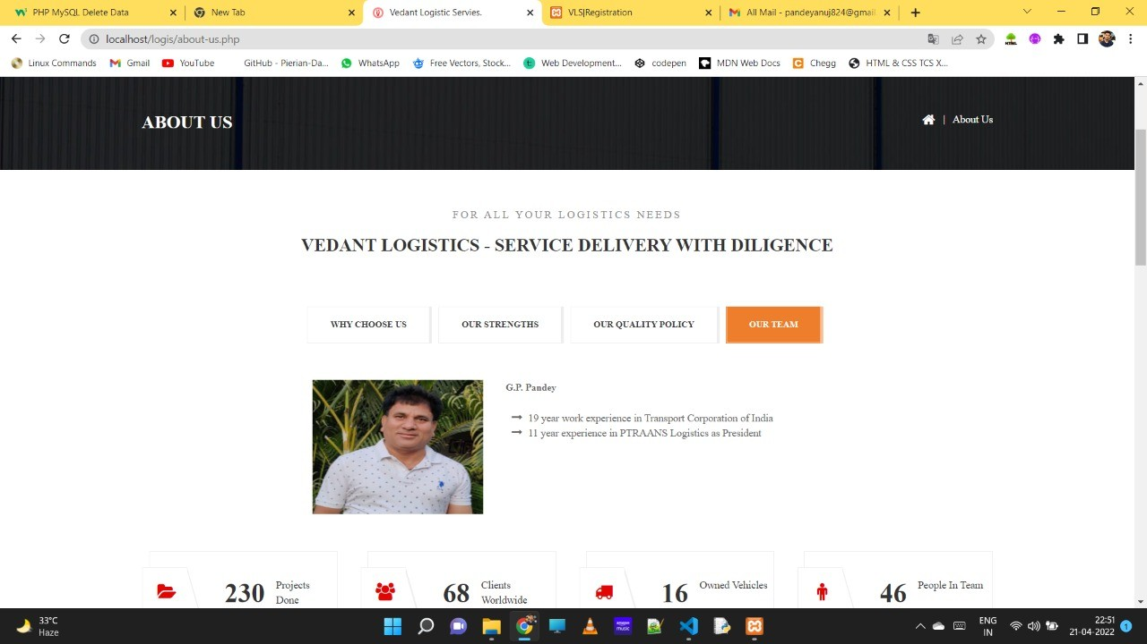

Figure 5.10: About Us

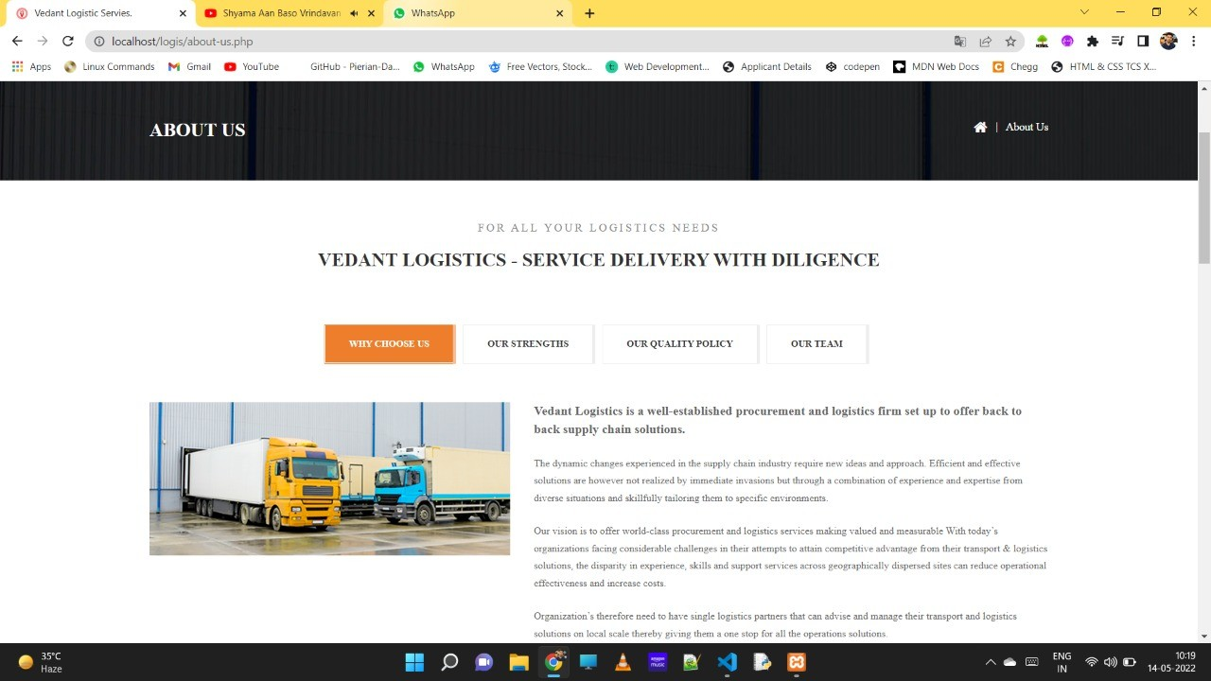

Figure 5.11: About Us

### Contact Us

This page provide the details about address, Mobile No. and so on.

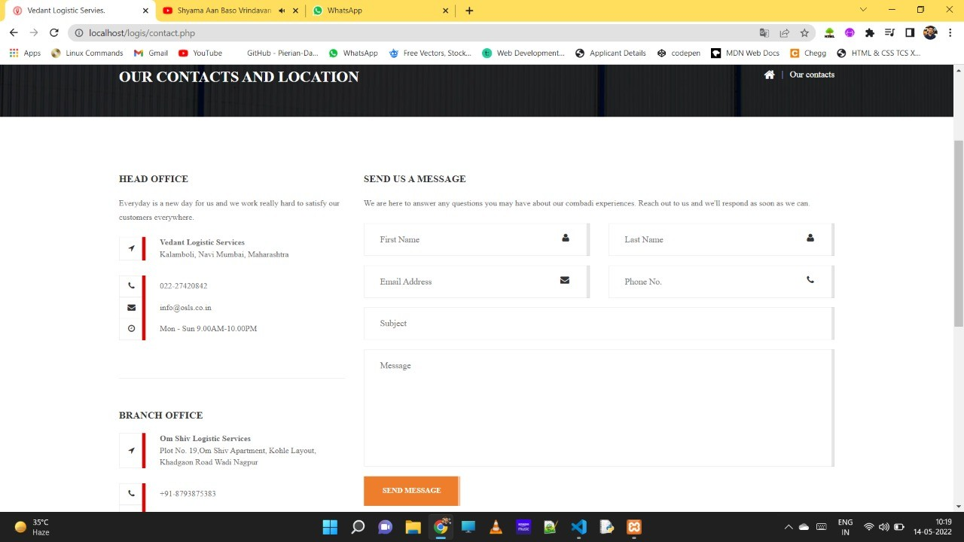

Figure 5.12: Contact Us

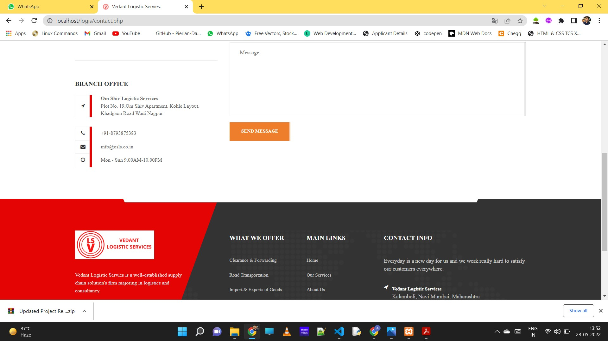

Figure 5.13: Contact Us

### Admin

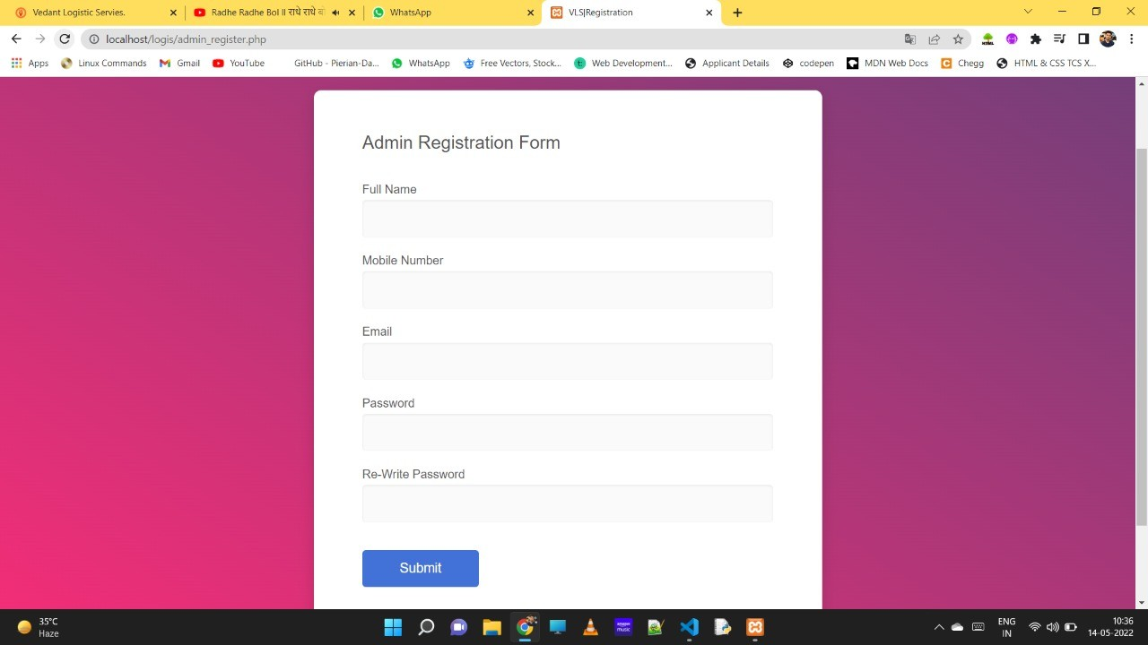

Figure 5.14: Admin Registration

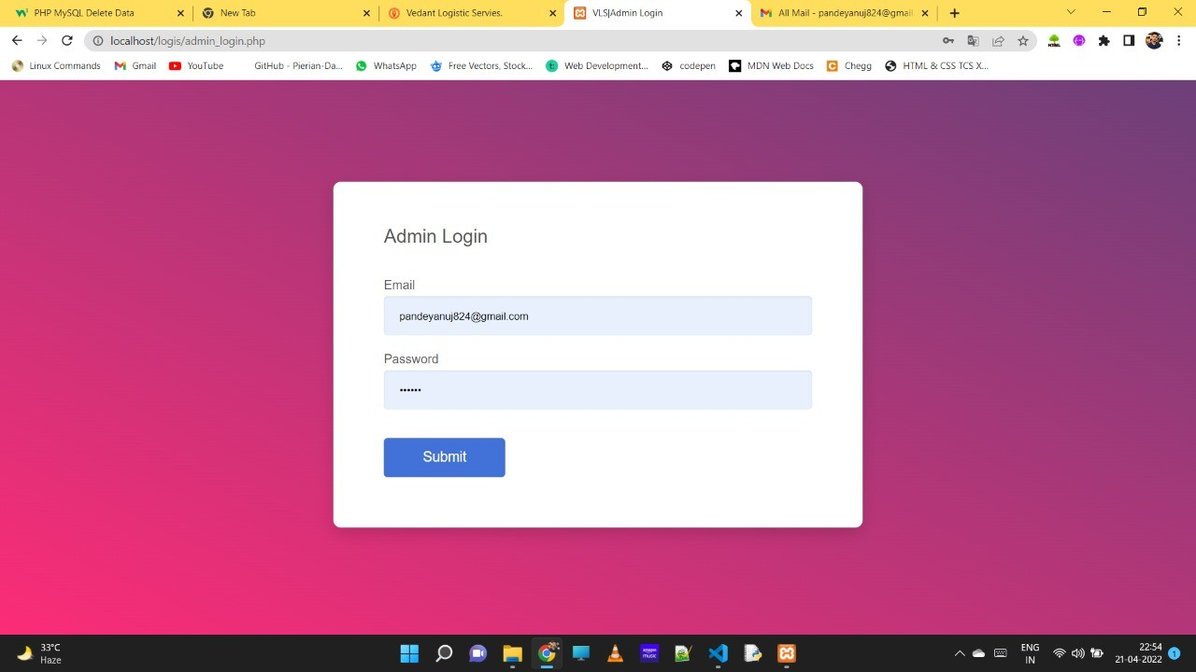

Figure 5.15: Admin Login

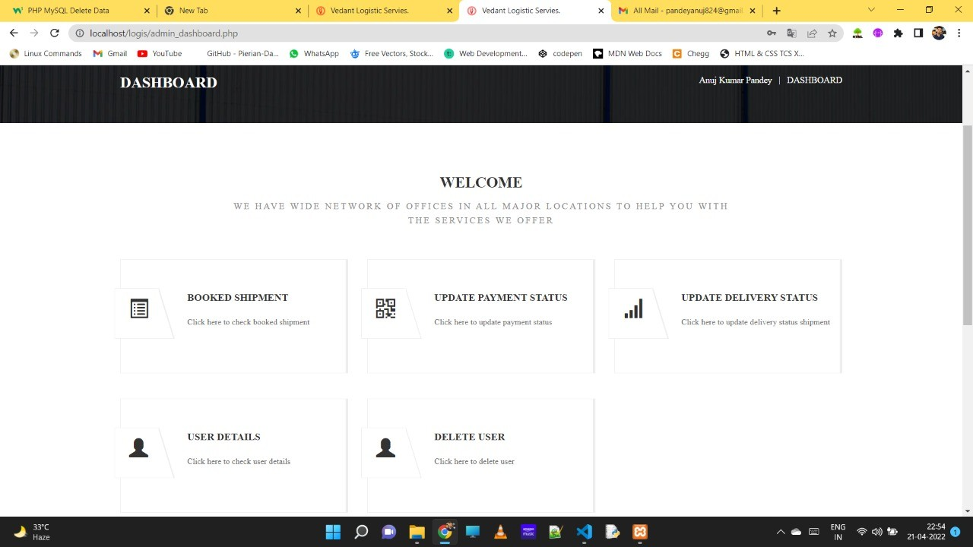

Figure 5.16: Admin Dashboard

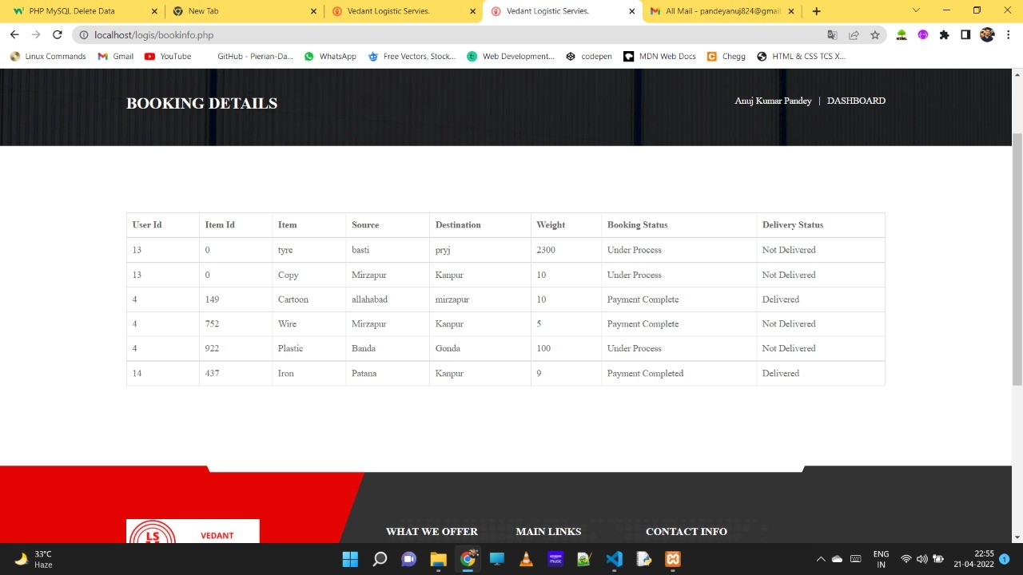

Figure 5.17: Booking Details

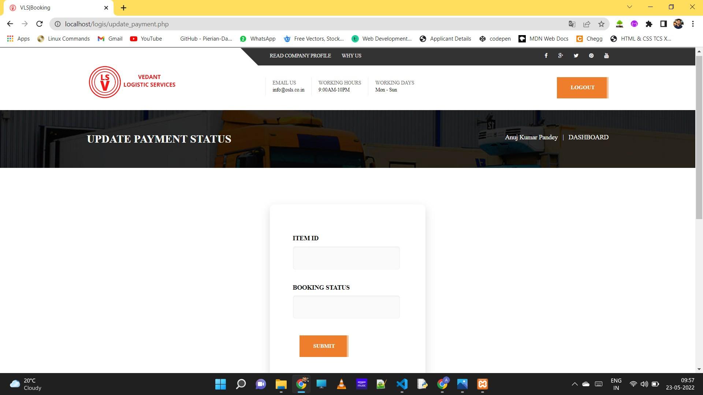

Figure 5.18: Update Payment Status

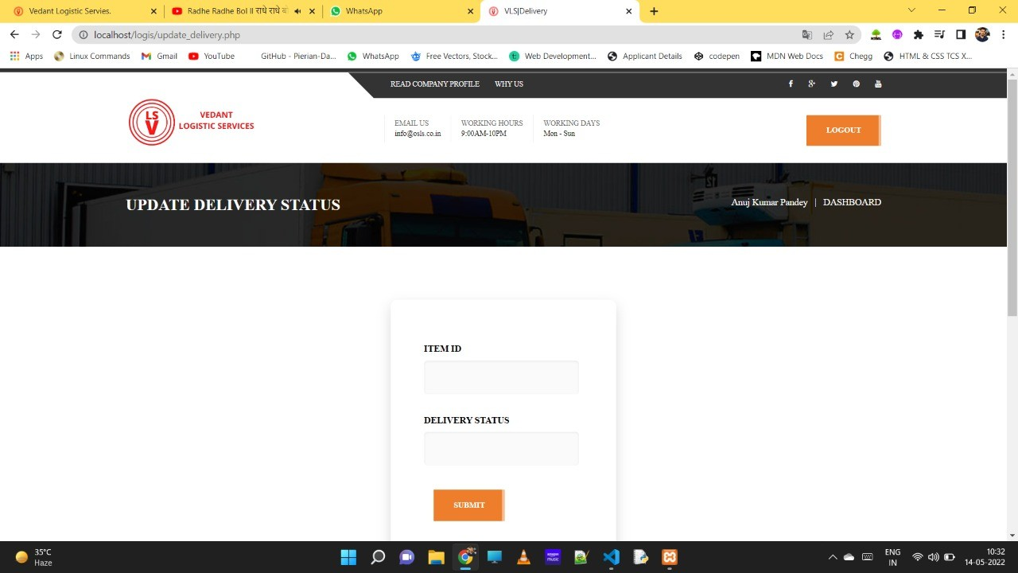

Figure 5.19: Update Delivery Status

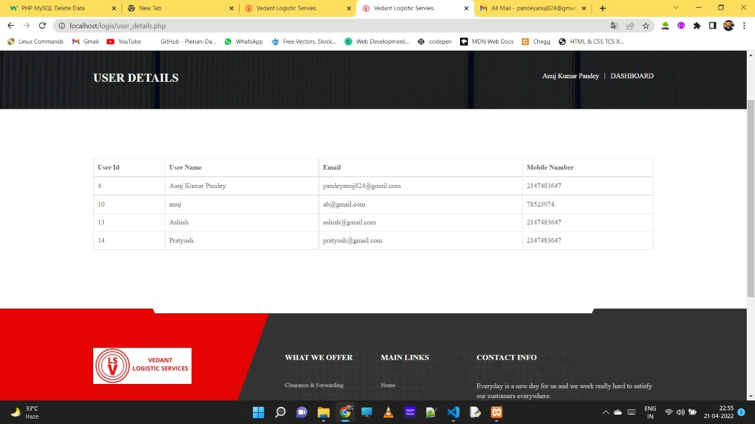

Figure 5.20: User Details

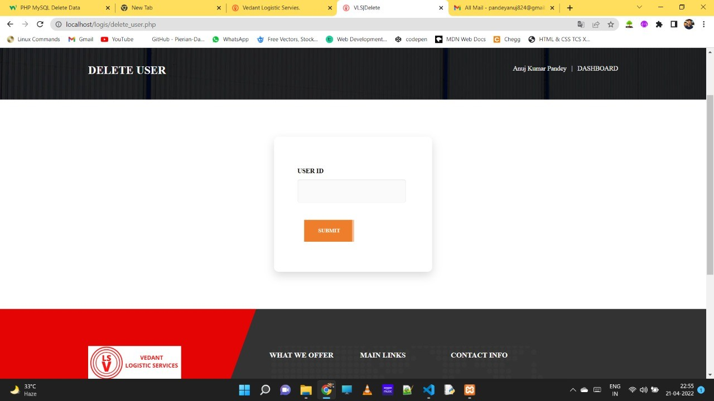

Figure 5.21: Delete User

### User

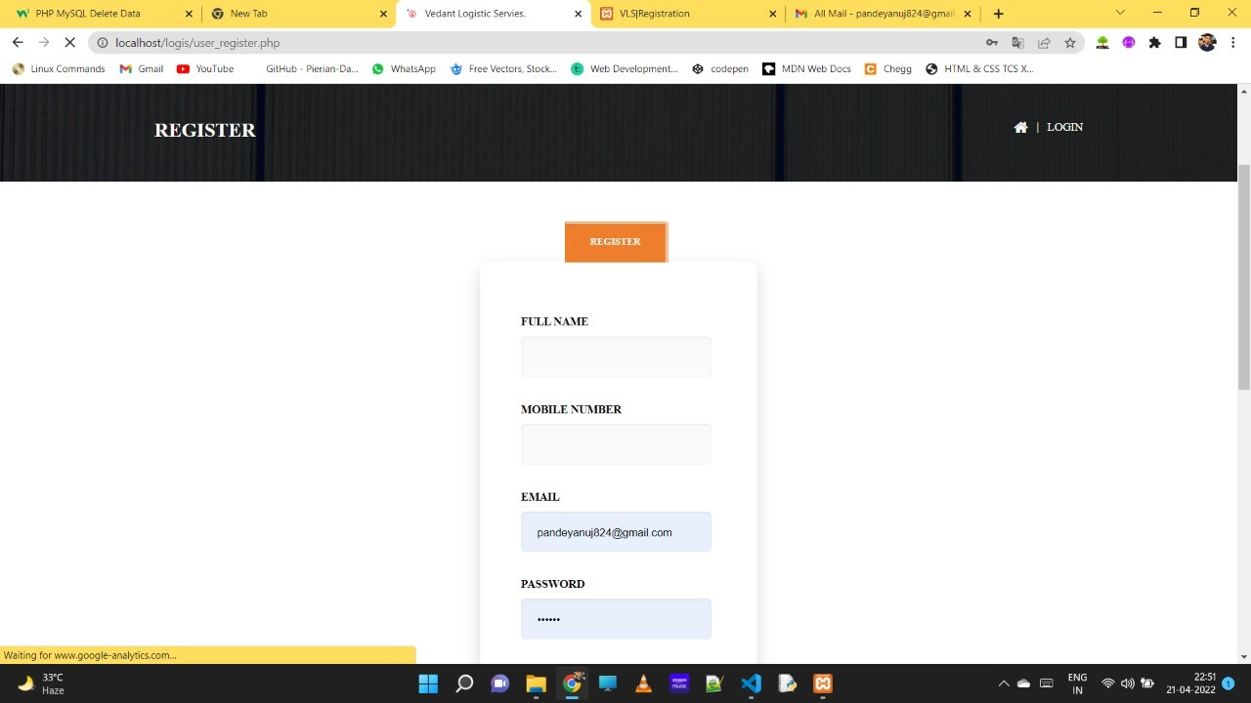

Figure 5.22: User Registration

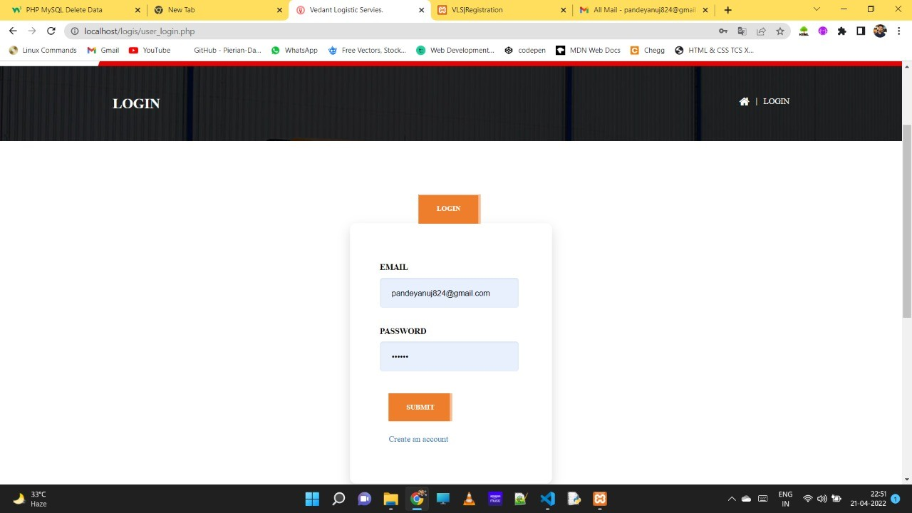

Figure 5.23: User Login

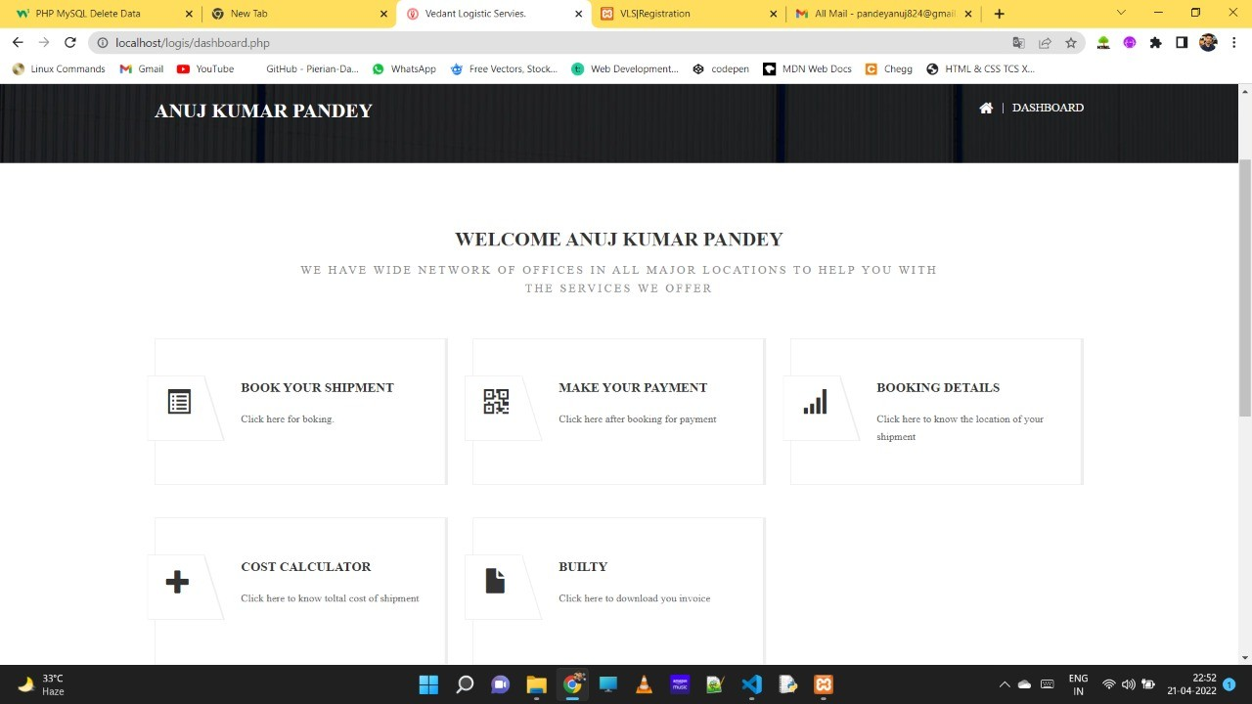

Figure 5.24: User Dashboard

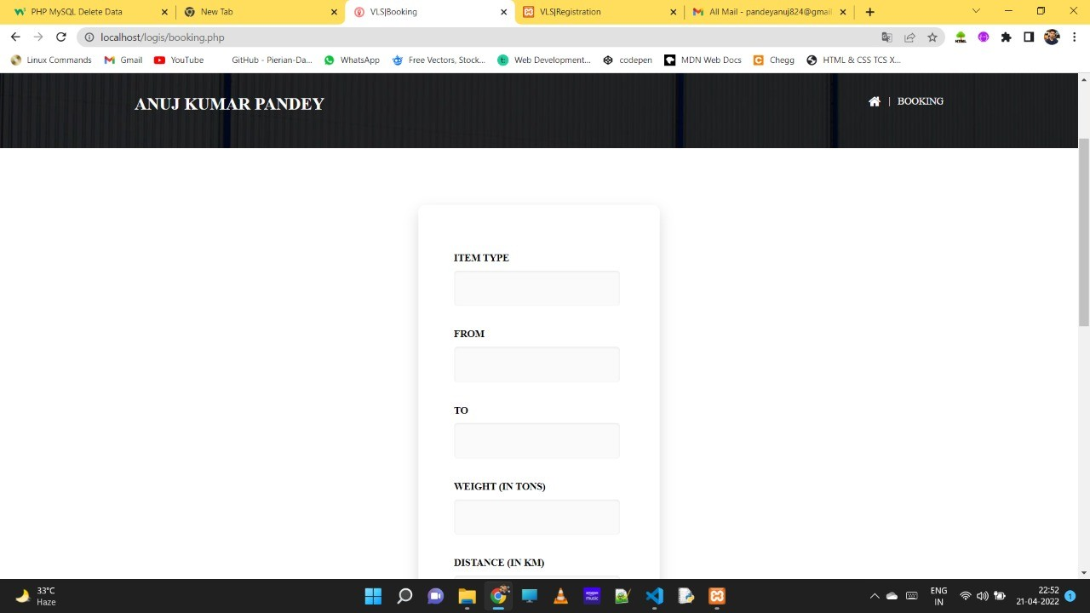

Figure 5.25: Booking

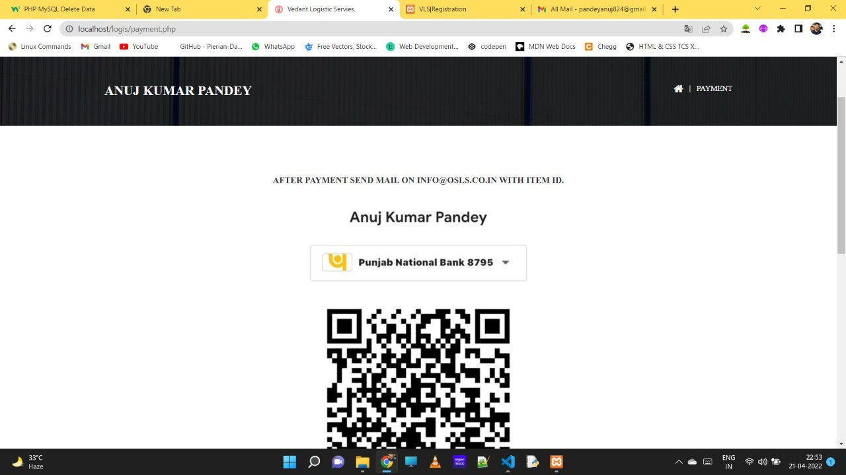

Figure 5.26: Payment

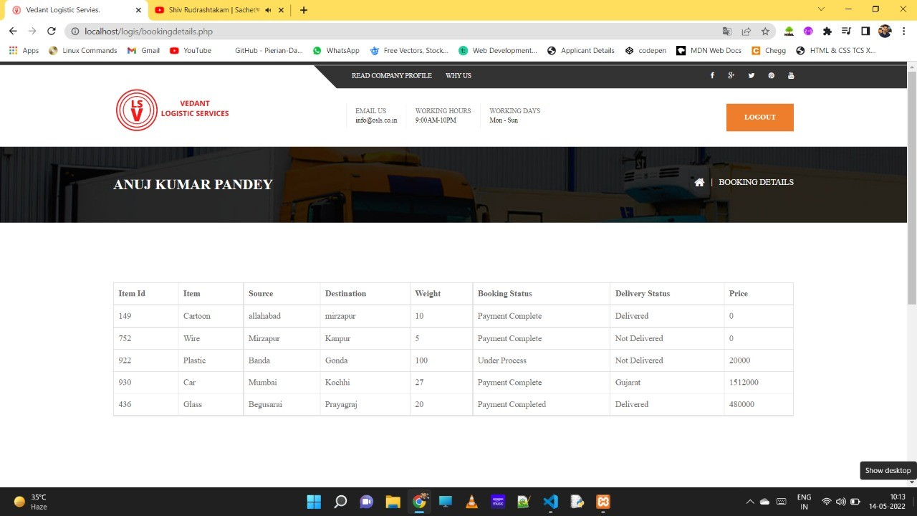

Figure 5.27: Booking Details

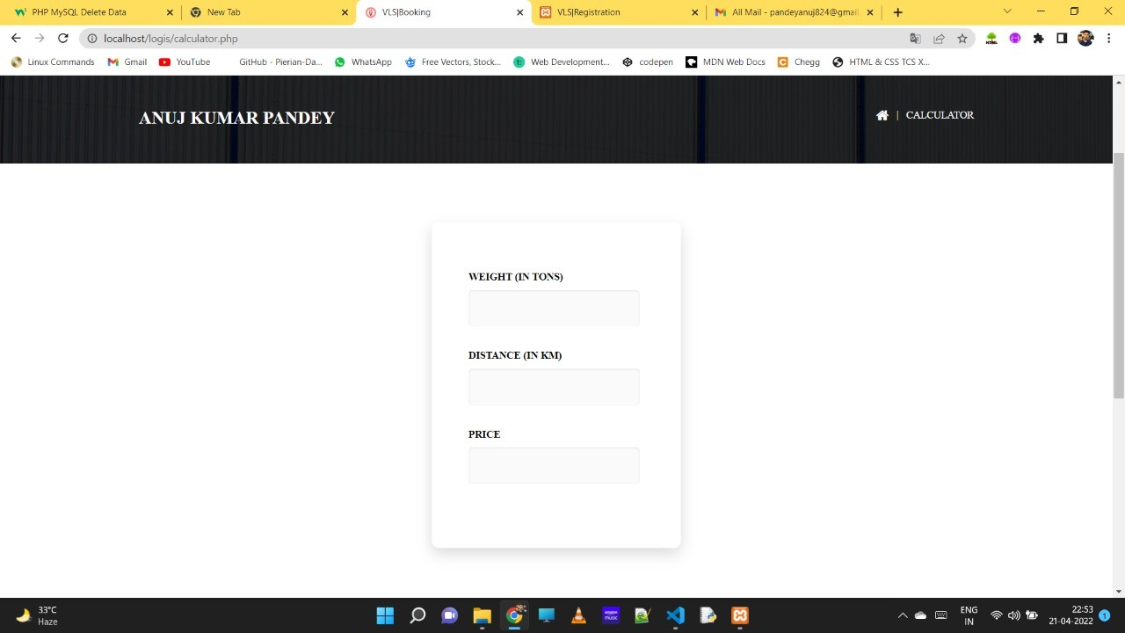

Figure 5.28: Cost Calculator

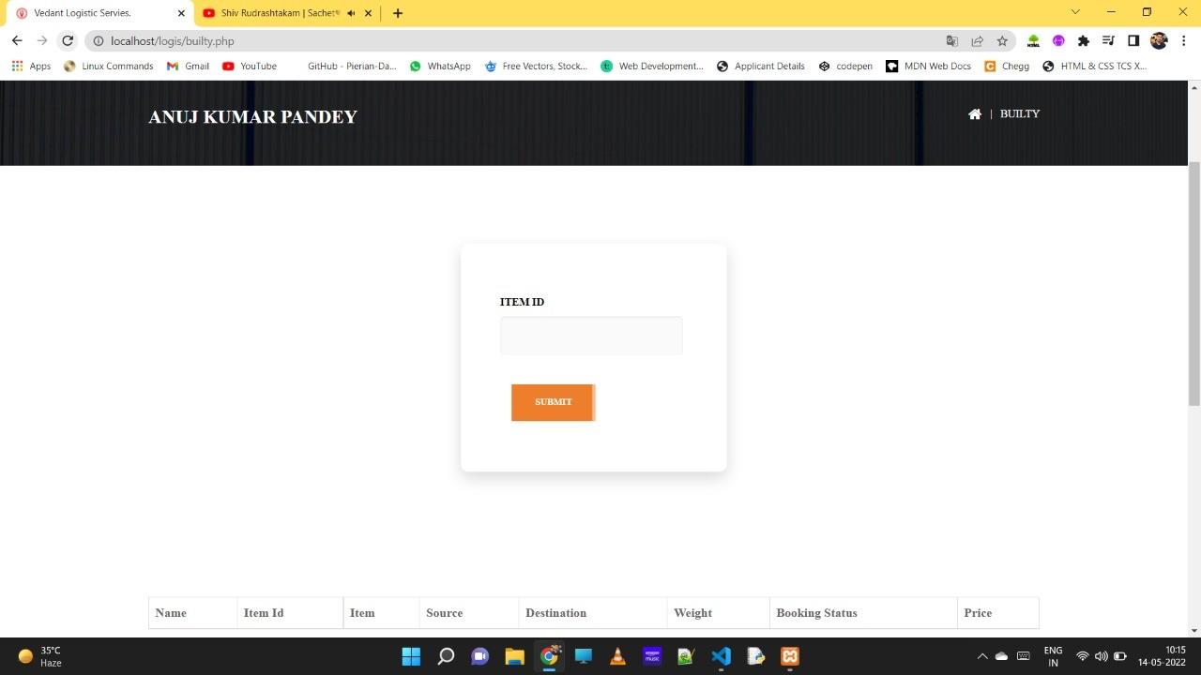

Figure 5.29: Builty

# Chapter 6 Testing

Trying out is method of comparing a item of software to sense variations among given enter to predicted solution, also to assess the feature of a software program object. checking out assesses the satisfactory of the product. software trying out is a technique that should be finished in the course of the development system. software program testing can be said as the method to verify and validate that a software and an application is computer virus free, which meets the technical as a requirements of guided by way of their design or development which meets the consumer requirements correctly and effectively with managing all of the wonderful and boundary cases. The system and software trying out targets not simplest at locating faults within the present software program that also locating measures to enhance the software in the usuage of efficiency, accuracy and its value. It in particular goals of measuring specification, of the functionality and its performance of a software programs and application.

## Types Of Testing

Following types of testing are performed while development of Course Management System Website:

### Unit Testing

It is a type of the software testing that examines particular software units or parts.

The aim is to ensure that each part of the software works as intended. The small test table portion of any of the software is a unit. It usually only had one or a few inputs and only one output. A unit of the procedural programming might be in a single programme, function, method, or anythng else. The smallest unit in objet-oriented programming is a method, which might be from a base/super class, abstract class. which derived/child class. (Some of the people see it as an application’s module for a single unit.)

This is avoided because that module will most likely include numerous individual components.) Frameworks for unit testing, drivers, stubs, and mock/fake objects which are all used.

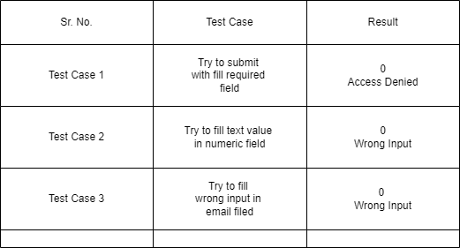

Figure 6.1: Unit Testing

### Integration Testing

Individual software module is attached and tested as a check via integration testing (also called is integration testing, abbreviated IT).Integration testing is to see whether or not a system or element complies with given purposeful requirements. It takes place among unit checking out and validation checking out. Integration checking out takes unit-examined modules as input, collects them into larger aggregates, applies checks defined in an incorporated check plan to the ones aggregates, and presents the incorporated device geared up for integration checking out as an output.

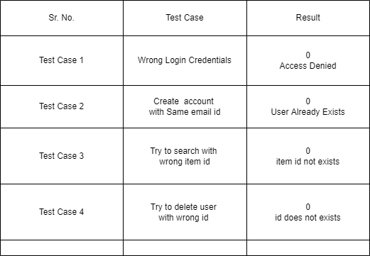

Figure 6.2: Integration Testing

### System Testing

System testing is stage to checking out that verify the whole and absolutely integrated software program product.

Goal of a machine take a look at is to assess the stop-to-last system specs. typically, the software is simplest 1 detail of a larger personal computer based fully device.

In the long run, the software is matched with other Application/Physical systems.

Device attempting out is clearly a sequence of diverse checks whose sole motive is to workout the complete computer-based totally gadget.

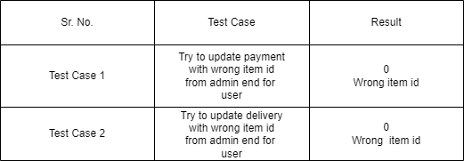

Figure 6.3: System Testing

# Chapter 7 Conclusion

Transport and transportation systems join interdependent relationships that strength manage- ment requires transport to carry out their day-to-day operations and in the interim, a good trans- portation system can recover transport development and traffic environment. As transportation integrates high costs among the related mechanisms of the transport system, improving the com- petence of transport can change the overall presentation of the transport system. Transportation theatres a key role in the transport system and its purposes come from various stages of trans- port procedures. Without a transport link, a influential transport strategy cannot make its volume fully operational. A comprehensive carriage system review may help to combine welfares from different operating conditions to overawed their current vulnerabilities. The appraisal of trans- port plans provides a clear summary of transport applications in transport services. Preparation improvements will still be strong in the coming periods and transport concepts may be applied to extra fields.

Logistics is a very large area and is even more important in today’s world where commercial and goods are global, a product shaped in one country is integrated and packaged in another and consumed in a different country. Transport, manufacturing, transportation, supply chain, ware- house, information system and production planning are the mainstay of the entire economy. From farming production to mobile phones and pcs, supply chain and logistic are desirable by all countries. The E-commerce industry to the industrial industry in shipping companies all require a large supply chain and balanced minds to improve competence and quality.

# Chapter 8

**Future Enhancement**

* + - * Live Tracking : The tracking system works with the destination and informs the customer of the destination. The tracking system provides a transparent product environment that combines trust between the seller-customer relationship. With the growth of our eco- nomic community, there has been rapid development in the transportation industry. In today’s fast-growing and complex system, managing the transport process, reducing costs and providing real-time data to users is of paramount importance.
      * Payment Gateway : The payment gateway is basically an intermediary between the user and the bank.The gate is responsible for transferring payment information, such as debit or credit card data, between the payment portal and the information processing bank. . Payment gates still have a lot of room for improvement and many opportunities to surprise us, either happily or otherwise. Considering the importance of payment gateways in all industries from FinTech to Logistics and Education, those opportunities are worth your attention.
      * Transportation Availability: Four main modes of transport are truck, ship, train and air; also known as road, sea, rail and air transport. By moving the goods from the destination to the desired location, transportation provides an important service to link the company to its suppliers and customers. It is an important function in the transport industry, which supports local economic and time resources.

# Appendix A Publication

The part of the project is published in *International Research Journal of Modernization in Engineering Technology and Science*.

1.Anuj Kumar Pandey, Anurag Singh, Pratyush Priyadarshi, and Pushpam Kumari, “Logis- tics Services” in 2022 International Research Journal of Modernization in Engineering Technology and Science (IRJMETS) e-ISSN (2582-5280), pp 1934-1937, 2022.

# Bibliography

[1]J. Johanan, T. Khan, and R. Zea, *Web Developer’s Reference Guide*. Packt Publisher, 2016. [2]Marijn and Haverbeke, *Eloquent Java Script: A modern introduction to programming*. No

Strach Press, 2018.

[3]Duckett and John, *Web Design with HTML, CSS, JAVASCRIPT and jQuery set*. Wiley IN, 2014.

[4]P. D. Dutonde, S. S. Mamidwar, M. S. Korvate, S. Bafna, and P. D. D. Shirbhate, “Web- site developmemt technologies: A review,” *International Journal for Research in Applied Science Engineering Technology (IJRASET)*, vol. 10, no. 5, pp. 359–366, 2022.

[5]“Web Development.” [https://www.freecodecamp.org/news/tag/ web-development/](https://www.freecodecamp.org/news/tag/web-development/). [Online; accessed 1-Apr-2022].