|  |  |  |
| --- | --- | --- |
| obstructive | ** | supportive |
| complicated | ***** | easy |
| inefficient | ***** | efficient |
| confusing | **** | clear |
| boring | *** | exciting |
| not interesting | *** | interesting |
| conventional | ** | inventive |
| usual | ** | leading edge |

**Website Reviewed**[**:** https://www.premierleague.com/](:%20https:/www.premierleague.com/)

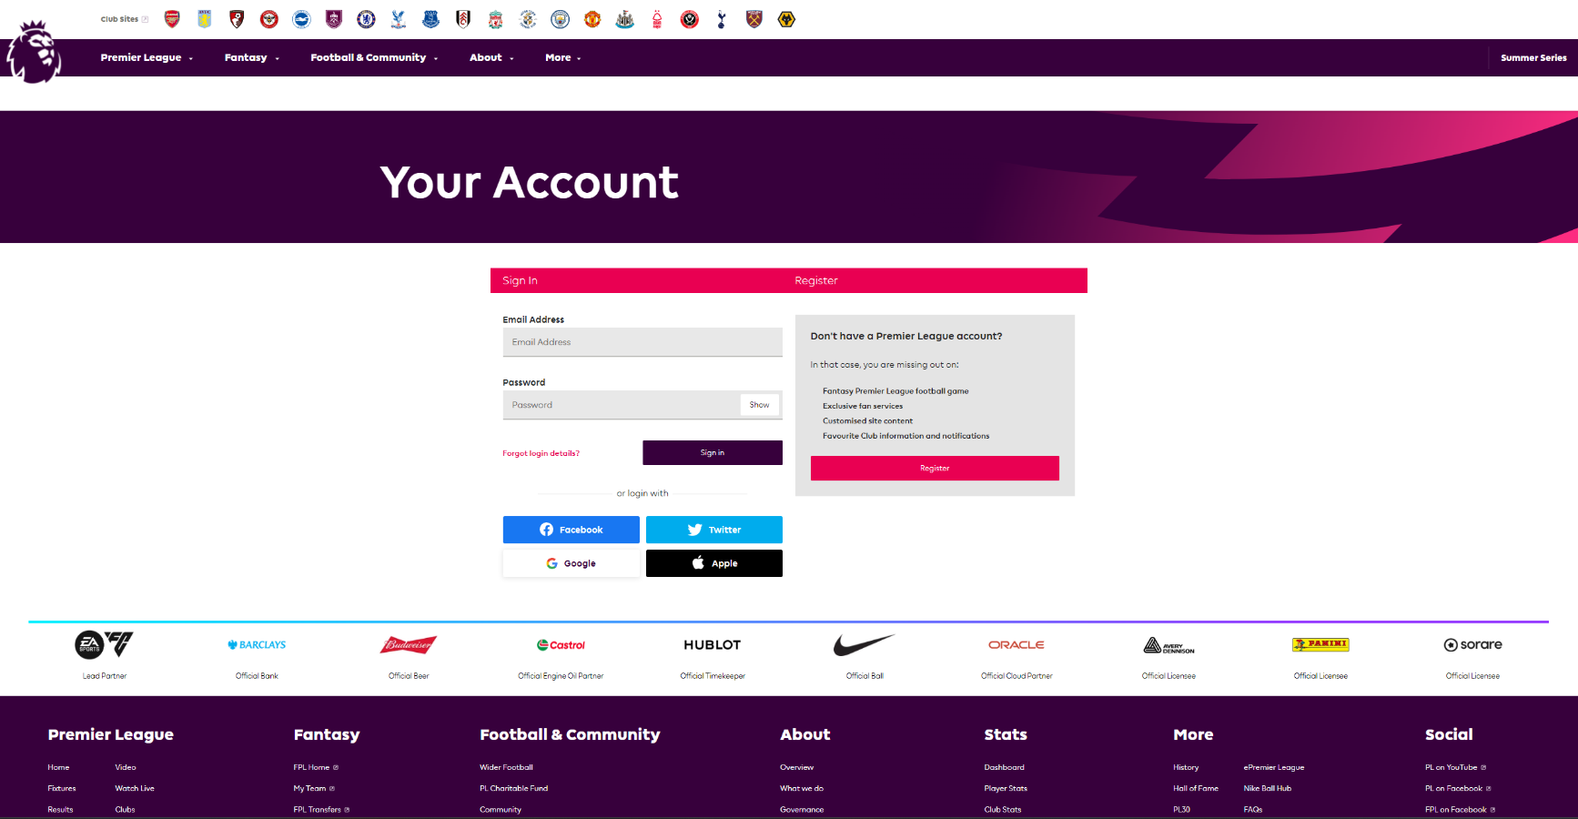

Obstructive{2]:

Too much going on for a login page with sponsors and adds displayed on a large portion of the screen and the register and sign in section is not clearly enough differentiated.

Conventional[2]:  
Uses Jakob’s law here by keeping the design similar to all other login pages, with a simple box for the email and one for the password.

Usual[2]:  
Uses usual technology of an email and password to log in, and the ability to use other accounts to perform the sign in.