**ASSESSMENT**

**Sign-up Page:**

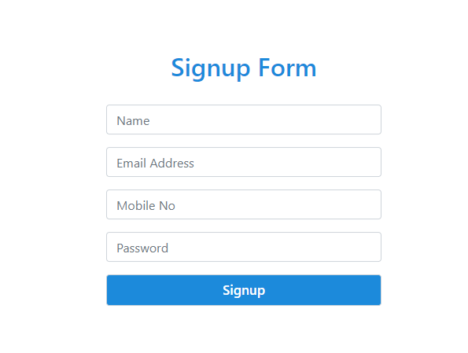

**Registered Page:**

