IT21067242

Fernando M.R.R.

7. The number 1,783 comes from the filtering process done by yolo_filter_boxes, which takes in box_confidence, boxes, and box_class_probs. The process likely applies a confidence threshold, keeping only those boxes that meet the criteria

**Maximum**: 1805

**Minimum:** 0

8. Multi-Scale Detection

Efficiency

Handling Aspect Ratios

Improved Training

Method Used to Determine the Sizes of Anchor Boxes:

typically determined using **k-means clustering**

**10.**

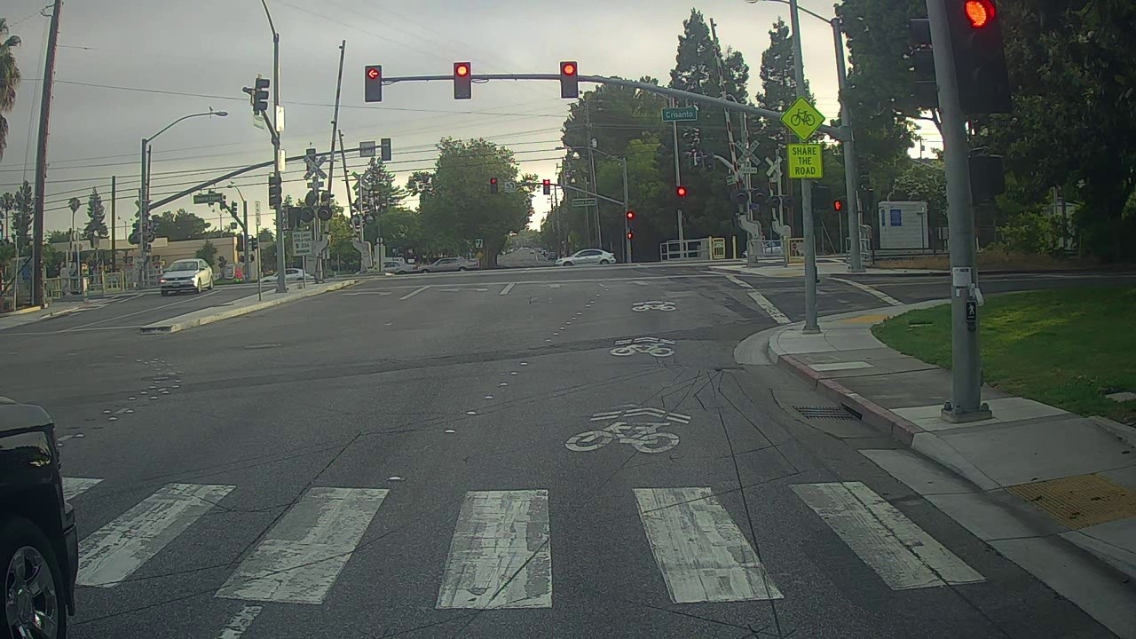

Traffic light is not identified

Cars are not identified

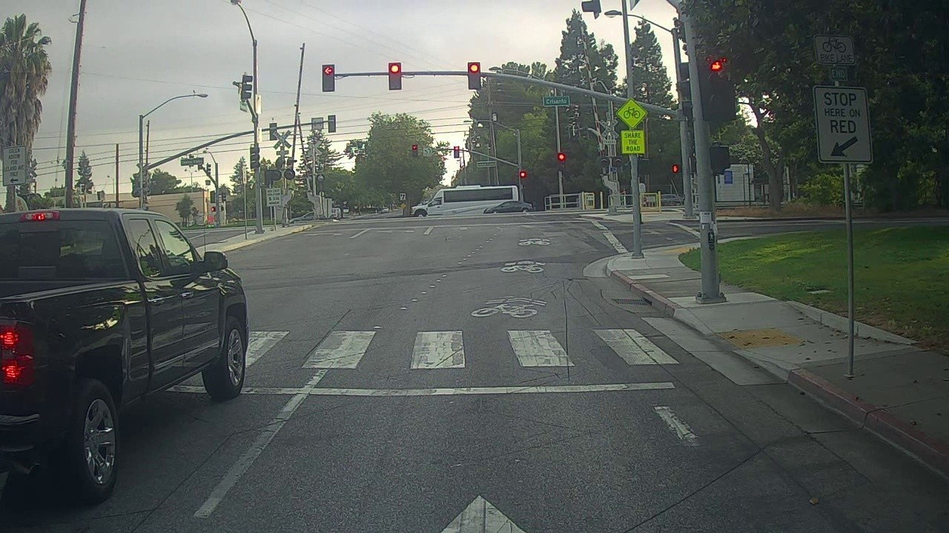 Traffic light is not identified

Cars are not identified

Jeep is not identified

Bus is not identified

**11.**

**A.**

No improvement

B.

No improvement

C.



no improvement