APNIESTATE
Complete User Journey & Screen-by-Screen Walkthrough Manual
A Plain-English Operating Guide for Demo Video Creators, Real Estate Builders, Project Managers, Site Engineers, Accountants, CRM Managers, and Telecallers
Platform Type | Enterprise Construction ERP + Real Estate Sales CRM (Unified Single Database)
Supported Roles | Platform Admin, Builder / MD, Project Manager, Site Supervisor, Accountant, CRM Manager, Telecaller
Dual-Engine Architecture | Engine 1: Construction Execution & Sites (ERP) | Engine 2: Property Sales & Leads (CRM)
Document Purpose | Button-by-button operating tutorial and video recording guide with key business benefits
Confidentiality | Proprietary & Confidential · Designed for Apniestate Ecosystem

Chapter 1: Executive Overview & The Dual-Engine Platform
Welcome to Apniestate. This document is written in simple, sensible, non-technical language so that anyone—can instantly understand how the entire system works, know exactly which button to click next on every page, and explain the concrete business benefits to any client or investor.

1.1 The Big Picture: Why Real Estate & Construction Needs Apniestate
In traditional real estate and construction companies, daily operations are chaotic because teams use 5 completely disconnected tools:
- 1. WhatsApp Chaos: Site supervisors post daily attendance and material needs on informal WhatsApp groups, where messages get lost.
- 2. Paper Muster Fraud: Workers and petty contractor attendances are kept in paper muster rolls, leading to ghost workers and inflated wage bills.
- 3. Disconnected Excel Sheets: Project managers maintain milestone schedules and material estimates in disconnected Excel spreadsheets.
- 4. Delayed Billing: Accountants receive physical vendor invoices weeks late, resulting in double payments and unexpected budget overruns.
- 5. Lead Leakage: Sales teams write prospective homebuyer inquiries in diaries or personal phones, causing 40% to 60% of marketing leads to slip away.
Apniestate replaces all these disconnected tools with a single unified cloud platform. From the moment an ad click generates a lead, to the day that customer signs their booking agreement, all the way to casting the concrete slab on the 10th floor and paying the cement supplier—every single rupee, worker, material bag, and lead is tracked under one roof.
1.2 The Dual-Engine Platform: ERP Mode vs CRM Mode
The biggest architectural innovation of Apniestate is its Dual-Engine Switcher. Real estate businesses consist of two completely different worlds that must talk to each other:
- Engine 1: ERP Mode (Site & Operations) — Construction Execution, Project Milestones, BOQ (Bill of Quantities), Material Procurement, Inventory, Gate Deliveries (GRN), Site Labour Register, Heavy Equipment, Cashbook, Vendor Dues, and Daily Progress Reports (DPR).
- Engine 2: CRM Mode (Sales & Customers) — Real Estate Sales, Marketing Campaigns, Automated Round-Robin Lead Distribution, Visual Kanban Pipeline, 1-Click WhatsApp Property Sharing, Site Visit Schedules, Channel Partner (Broker) Commissions, and Flat/Villa Booking.
🎬 VIDEO CREATOR ACTION TIP (WHAT TO TOUCH NOW): The 1-Click Mode Toggle Pill in Sidebar
Look at the top of the left sidebar. You will see a sleek pill toggle labeled [ERP] and [CRM]. Clicking 'CRM' transforms the sidebar into the Sales Command Center with zero page reloads. Clicking 'ERP' instantly returns to construction operations. In your demo video, always showcase this toggle—it demonstrates that the builder doesn't need to purchase two separate expensive software licenses!

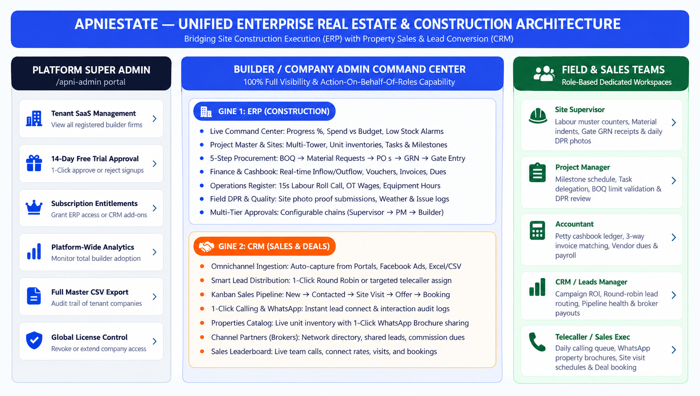
Figure: Unified Platform Architecture connecting Platform Admin, Builder Command Center (ERP & CRM Engines), and Field Roles.
1.3 The 7 Roles in the Apniestate Ecosystem
Apniestate provides personalized, secure workspaces tailored to every stakeholder. No one gets overwhelmed by screens they don't need:
- 1. Platform Super Admin (/apni-admin): Master administrator of the entire SaaS platform. Approves builder trial signups, monitors tenant subscriptions, and exports global records.
- 2. Builder / Company Admin: Company Owner / Managing Director. Has 100% universal visibility, final commercial authority, approval control, and can act on behalf of any absent role.
- 3. Project Manager (PM): The execution commander. Oversees project timelines, validates material indents against BOQ budgets, delegates site tasks, and inspects daily work progress.
- 4. Site Supervisor: The field site engineer. Uses a fast mobile interface to mark 15-second labour attendance, raise material indents, verify truck deliveries at the gate, and upload daily site photos.
- 5. Accountant: Financial guardian. Manages the daily petty cashbook, performs 3-way invoice matching (PO vs Goods Received Note vs Bill), tracks supplier aging dues, and logs payments.
- 6. CRM / Leads Manager: Head of Sales. Imports leads from portals, distributes leads to telecallers via Round Robin, tracks the deal pipeline, and manages broker commissions.
- 7. Telecaller / Sales Executive: Frontline sales closer. Works from a daily calling queue, clicks to call or WhatsApp clients, shares floor plans from the live property catalog, and books site visits.
Chapter 2: The Core Superpowers ('The WOW Factors for Any Demo')
When showing Apniestate to builder clients, executives, or investors, these 5 standout superpowers will instantly prove the platform's value. Make sure every demo video prominently highlights these features:
Superpower 1: Live Project Command Center & Automated Risk Radar
Instead of static dashboards with vanity charts, Apniestate's Command Center features an active intelligence engine that scans the database in real time. It calculates:
- Remaining Budget Balance: Shows the exact remaining rupee balance out of the approved project budget, updated the second an expense or invoice is logged.
- Today's Labour Wage Cost: Calculates the total wage liability for the day based on attendance marked on site.
- Interactive Low-Stock Warning: Alerts the builder when stock of critical materials (like cement or steel) drops below the safe reorder threshold, with a direct 1-click button jumping to the inventory reorder screen.
- Procurement Delay Alarms: Flags delayed vendor shipments past their promised delivery date.
- Material Usage vs Planned Variance: Compares actual material used on site against the planned BOQ quantities, instantly highlighting waste or theft.
🌟 UNIQUE BUSINESS BENEFIT & WOW FACTOR: Instant Client Impressing Tip
Show how clicking the amber 'Low Stock Reorder Warning' card immediately opens the exact material inventory row with prefilled reorder details. This shows that the software doesn't just report problems—it solves them in one click!

Superpower 2: 15-Second Labour Counter & Instant Daily Wage Muster
On construction sites, recording daily labour is historically the #1 source of fraud and contractor disputes. Apniestate transforms this into a 15-second mobile roll call:
- Visual Skill Cards: Each worker skill has a dedicated card with clear icons (Mistri 🧱, Carpenter 🪚, Helper 👷, Electrician ⚡, Painter 🖌️, Plumber 🚰, Welder 🔥, Bar Bender 🏗️).
- One-Tap Counters: The supervisor simply taps [+] or [-] for Present, Half Day, and Overtime hours. No typing required.
- Instant Cost Engine: As counters are tapped, the system multiplies headcount by preset category daily rates and displays the exact daily labour expenditure in real time.
- 1-Click PDF Muster Roll: With one tap on [Export PDF], the system creates an official, printable muster roll complete with date, project name, category breakdown, and signature lines.
Superpower 3: 5-Step Closed-Loop Procurement Protection
Construction companies lose 5% to 15% of their total project cost to ghost orders, duplicate billing, and diverted materials. Apniestate enforces a strictly verified 5-step loop:
- 1. Requirement: Site Supervisor requests 100 bags of cement via mobile indent.
- 2. PM Audit: Project Manager audits requirement against BOQ limits and approves.
- 3. Order (PO): Purchase team creates an official Purchase Order (PO) locking vendor price.
- 4. Gate GRN Inspection: When the truck arrives, the gate supervisor inspects bags, enters delivered count, and snaps a photo of the vendor's signed delivery challan (GRN).
- 5. 3-Way Match Payment: Stock increases automatically; the Accountant releases payment only after 3-way matching the PO, delivery photo, and vendor invoice.
Superpower 4: 1-Click WhatsApp Property Sharing & Omnichannel CRM
Speed is everything in real estate sales. If a prospective buyer inquires about a 3BHK flat, making them wait 2 hours for an email brochure kills the deal:
- Zero Lead Leakage: Inquiries from Facebook Ads, Google campaigns, 99acres, and MagicBricks flow into Apniestate instantly with zero manual data entry.
- Automated Round-Robin: Deals out leads equally to logged-in telecallers like a deck of cards, ensuring no sales executive hoovers up all the hot prospects.
- 1-Click WhatsApp Dispatch: From the property catalog, telecallers tap [Share via WhatsApp]. The system generates a formatted message with unit floor plan, carpet area, and brochure link, opening WhatsApp Web or Mobile directly.
Superpower 5: Universal 'Admin Action on Behalf of Any Role'
In real-world construction, site supervisors often work in remote basements with poor cellular signal, or non-technical foremen may struggle with forms. Apniestate gives the Builder and Admin universal override capability:
- Site Attendance Override: The Builder can open the Labour Register, select any site, and mark attendance on behalf of the supervisor.
- Emergency Procurement: The Builder can create material requests, approve purchase orders, or log cash vouchers directly without needing staff passwords.
- Transparent Audit Trail: The system permanently records who performed the action while attributing the data to the correct site and project.
👑 BUILDER / ADMIN SUPERPOWER (ACTION ON BEHALF): Why Builders Love This Feature
Traditional ERPs lock features behind rigid roles. If the Site Engineer is sick, work stops. In Apniestate, the business owner retains supreme authority to keep projects moving from any computer or mobile device.

Chapter 3: Platform Super Admin Panel (/apni-admin)
The Platform Super Admin panel is the central control room for Apniestate platform administrators. It is completely isolated from builder workspaces and accessed via the secure route: /apni-admin/login.
3.1 Screen Tour: Super Admin Dashboard (/apni-admin/dashboard)
Upon logging in, the platform administrator is presented with a bird's-eye view of all registered construction firms and real estate builder companies:
- Total Builders KPI: Total registered companies across the entire SaaS platform.
- Paid Subscriptions KPI: Number of firms with active commercial billing plans.
- Active Trials KPI: Companies currently testing the software under an authorized trial period.
- Pending Approvals KPI: New builder signups waiting for administrator verification and onboarding review.
3.2 Buttons & Exact Step-by-Step Actions
To manage tenant companies, the administrator interacts with these exact controls:
- Filter Tabs [ALL / PENDING / ACTIVE / EXPIRED]: Click [PENDING] to isolate newly signed-up builders requesting software access.
- Approve Trial Button (Green Checkmark Icon): Located in the action column of each pending builder row. Touching this button changes the company status from PENDING_TRIAL to TRIAL_ACTIVE, unlocks both ERP and CRM workspaces for 14 days, and sends a welcome notification.
- Reject Trial Button (Red Cross Icon): Prompts confirmation and resets invalid or spam registrations back to NONE status, blocking platform access.
- Export CSV Button: Located in the top right navigation bar. Clicking this button downloads a complete, formatted spreadsheet containing all company names, owner phones, GST numbers, subscription statuses, and registration dates.
- Logout Button (Top Right): Clears admin authorization tokens and returns to the secure login screen.
🎬 VIDEO CREATOR ACTION TIP (WHAT TO TOUCH NOW): Demonstrating Tenant Control in Video
Show the Super Admin dashboard for 10-15 seconds at the start or end of your video. Point out the [Approve] button and explain: 'Every builder gets verified by our central team to guarantee enterprise security and dedicated onboarding.'

Chapter 4: Builder & Company Admin Journey (Master Panel)
The Builder / Company Admin panel is the ultimate command center of Apniestate. The company owner or managing director has complete, unrestricted access across all projects, financial accounts, construction sites, and sales pipelines.
4.1 Global Navigation, Project Switcher & Header Controls
The top header bar remains accessible across all screens and provides vital global controls:
- Project Switcher Dropdown: Located at the top left of the header. Clicking this button opens a dropdown list of all company construction projects (e.g. 'Emerald Heights Phase 1', 'Silver Oak Residency'). Selecting a project instantly recalibrates the entire workspace to show only that project's finances, materials, workers, and tasks.
- Status Badges: Next to the project title, the system displays live state pills: PLANNING (Purple), ACTIVE (Green), ON HOLD (Amber), or COMPLETED (Slate). This provides immediate visual reassurance of project health.
- ERP / CRM Mode Toggle Pill: Located in the top left sidebar. Allows the builder to toggle between ERP Mode (Construction & Sites) and CRM Mode (Real Estate Sales & Lead Conversion) in a single click with zero page reloads.
- Floating Action Button (FAB): A circular action button fixed at the bottom-right of every screen. Touching it reveals 6 instant shortcuts: [Create Project], [Create Task], [Mark Attendance], [Create DPR], [Record Expense], and [Req Material].
🎬 VIDEO CREATOR ACTION TIP (WHAT TO TOUCH NOW): Video Recording Tip for the Header
Start your screen recording by clicking the Project Switcher dropdown and switching between two projects. Show how all the graphs and numbers update in real time. Then click the [CRM] toggle pill on the sidebar to demonstrate that this single software handles both construction and property sales.

4.2 Screen 1: Project Command Center (/dashboard)
The Project Command Center is the default home screen. It gives the builder a 360-degree real-time pulse of the active construction project:
- Progress Hero Card: A prominent royal-blue card showing overall project completion percentage (e.g. '42%'), total budget utilized against sanctioned budget (e.g. '₹1.8 Cr of ₹4.5 Cr used'), a pill showing exact remaining budget (e.g. 'Rem: ₹2.7 Cr'), local site weather (e.g. '32°C Clear · Good visibility'), and the targeted completion date.
- Today's Pulse Row: Three quick stat cards showing: (1) Workers Today (headcount on site right now), (2) Today's Spend (petty cash and materials spent today in ₹), and (3) Pending Material (requisitions awaiting authorization).
- Project Intelligence Hub: Three intelligent metric cards: (1) Budget Balance (remaining spend headroom), (2) Today's Labour Cost (exact wage liability calculated from morning attendance), and (3) Payments Due (total value of unpaid vendor invoices awaiting disbursement).
- Interactive Risk Warning Radar: High-priority alert cards that demand immediate action: (1) Low Stock Reorder Warning (items below safety thresholds with direct link to inventory), (2) Procurement Delay Warning (purchase orders past delivery dates), and (3) Milestone Delay Warning (construction milestones running behind schedule).
- Material Usage vs Planned Variance: Progress bars comparing actual cement, steel, or sand consumed on site against original BOQ planned engineering limits. Items exceeding 90% turn bright red.
- Needs Attention Section: Direct shortcuts with colored left borders linking to pending items: [Material Requests Pending], [Vendor Payments Due], and [Attendance Not Submitted].
- Quick Actions Grid: Six quick-action buttons: [Add Expense], [Material Request], [Attendance], [Daily Progress], [Purchase], and [Finance].
🌟 UNIQUE BUSINESS BENEFIT & WOW FACTOR: Why the Command Center Impresses Builders
Most builders manage projects by calling 10 different people every morning. Show them that on this one screen, they know exactly how many workers are on site, how much money was spent today, what materials are running out, and whether any milestone is delayed—before their morning coffee!

4.3 Screen 2: Projects Master & Project Detail Hub (/projects & /projects/:id)
Navigating to [Projects] on the sidebar displays the master list of all company construction ventures, while clicking on any project card opens its multi-tabbed operational detail hub:
- '+ New Project' Button: Located in the top right. Touching this button opens a modal requesting: Project Name, Description, Start & End Dates, Sanctioned Budget in ₹, Status, Address, and City. Clicking [Save Project] creates the project container instantly.
- Project Filter & Search: Filter tabs [ALL / ACTIVE / PLANNING / ON_HOLD / COMPLETED] and a real-time search bar to find projects by name or location.
Inside the Project Detail Hub Tabs (/projects/:id):
- Tab 1: Overview — Displays key project dates, budget vs actual cost, assigned Project Manager, Site Supervisor, and an interactive budget distribution pie chart (Materials, Labour, Equipment, Overhead, Subcontract).
- Tab 2: Milestones — Lists all major construction stages (e.g. Foundation, Ground Floor Slab, Brickwork, Plastering, Finishing). Shows target dates, weightage percentage, completion status, and the [+ Add Milestone] button.
- Tab 3: Sites (Towers / Blocks) — Displays individual construction blocks or towers (e.g. Tower A, Tower B, Club House, Underground Reservoir). Shows site phase, progress %, assigned site supervisor, and the [+ Add Site] button.
- Tab 4: Tasks — Task delegation matrix. Tasks can be filtered by site and assignee. Displays priority badges (URGENT in red, HIGH in orange, MEDIUM in blue), due dates, and the [+ Add Task] button.
- Tab 5: Finance — Category-wise financial ledger displaying planned budget allocations versus actual expenditures, with the [+ Add Budget] button.
- Tab 6: Timeline — Interactive Gantt-style schedule tracking project velocity against calendar deadlines.
- Tab 7: Units (Property Inventory) — Real estate inventory management. Lists all flats, villas, and commercial shops in the project with unit number, carpet area, configuration (2BHK, 3BHK, Villa), base price, and status (Available, Booked, Sold), complete with the [+ Add Unit] button.
4.4 Screen 3: Procurement & Purchase Workspace (/purchase)
Materials account for 60% to 70% of total construction costs. The Purchase Workspace features a 5-step visual workflow tracker bar: [1. Requirement] $\rightarrow$ [2. PM Review] $\rightarrow$ [3. Order] $\rightarrow$ [4. Received] $\rightarrow$ [5. Inventory].
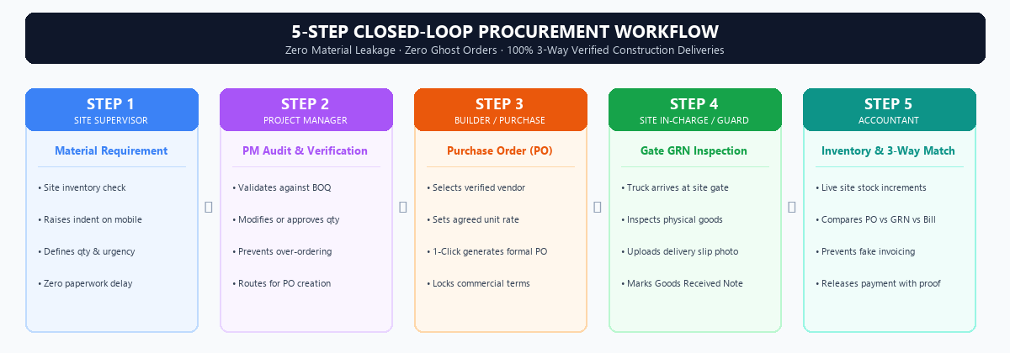
Figure: The 5-Step Closed-Loop Procurement Flow eliminating ghost orders and material theft.
The workspace is organized into 7 functional sub-tabs:
- 1. BOQ (Bill of Quantities): Master Bill of Quantities. Displays planned materials, planned quantities, estimated unit rates, and total budget. Buttons include: [+ Add BOQ Item], [Import BOQ from Excel] (drag and drop spreadsheet import), and [Export BOQ].
- 2. Requirements (Material Requests): Lists indents submitted by site supervisors. Shows requested item, quantity, unit, urgency badge, and site name. Action buttons: [Approve], [Modify Quantity], [Reject], and [Convert to Order].
- 3. Quotations: Comparison sheet of quotes received from multiple suppliers for bulk purchases (cement, steel, sand).
- 4. Orders (Purchase Orders): Directory of issued Purchase Orders. Shows PO number, vendor name, total value, promised delivery date, and status. Touching [+ Create Order] generates a formal order; touching [Download PDF] creates a branded PO ready for WhatsApp or email dispatch to the vendor.
- 5. Received (Gate GRN Inspection): Gate delivery log (Goods Received Notes). When a material truck arrives, the gate supervisor verifies the physical delivery against the PO, records received count, uploads a photo of the signed delivery challan, and touches [+ Receive Goods].
- 6. Inventory (Site Stock): Live warehouse stock across all sites. Displays quantity on hand, unit, reorder threshold, and low-stock warning chips. Touching [Consume Material] logs daily usage to a specific site tower.
- 7. Vendors Master: Supplier master directory containing vendor name, contact person, phone number, GST registration, performance rating, and total pending payment dues. Touching [+ Add Vendor] registers a new vendor.
🌟 UNIQUE BUSINESS BENEFIT & WOW FACTOR: Closed-Loop Security Benefit
Point out that a Purchase Order cannot be paid by accounts unless there is a physical Gate GRN delivery photo uploaded by the site guard. This completely eliminates fake vendor bills!

4.5 Screen 4: Finance & Cashflow Workspace (/finance)
The Finance Workspace gives the builder absolute control over cashflow, expenses, supplier liabilities, and contractor billing:
- 1. Cashbook: Site petty cashbook ledger. Displays opening balance, daily cash inflows (transfers from main builder account), cash outflows (site emergency expenses), and live closing balance. Touching [+ Add Cash Entry] opens a modal to record Cash In / Cash Out with voucher number, category, and receipt photo.
- 2. Expenses: Master project expenditure log. Tracks expenses across categories (Labour, Fuel, Transport, Safety, Government Fees). Touching [+ Record Expense] opens a modal with tax fields and attachment uploads.
- 3. Invoices: Vendor tax invoices and customer billing records. Displays invoice number, vendor name, invoice date, due date, amount, and payment status (Paid, Partial, Unpaid). Touching [+ Add Invoice] registers a new bill.
- 4. Budgets: Visual expenditure tracking comparing actual spend against approved budget caps for Materials, Labour, Equipment, Overhead, and Subcontract. Over-budget categories glow red.
- 5. Dues (Vendor Payables): Comprehensive aging analysis of vendor payables categorized into 0-30 Days, 30-60 Days, and 60+ Days overdue. Touching [Pay Vendor] on any row pre-fills the payment disbursement modal.
4.6 Screen 5: Operations Workspace (/operations)
The Operations Workspace manages the daily on-ground engine of the construction site across two tabs: Labour Register and Equipment:
- 1. Labour Register: Visual attendance roll call. Features worker category cards with emojis (Mistri 🧱, Carpenter 🪚, Helper 👷, Electrician ⚡, Painter 🖌️, Plumber 🚰, Welder 🔥, Bar Bender 🏗️). The supervisor or builder taps [+] and [-] counters for Present, Half Day, and OT Hours. The system automatically computes daily labour expenditure in real time. Buttons include: [Save Today's Attendance], [Export PDF] (generates official muster roll), and [+ Add Category].
- 2. Equipment Register: Heavy machinery and fleet tracker (JCB, Excavator, Crane, Concrete Mixer, Generator). Tracks daily working hours, idle hours, breakdown maintenance status, diesel fuel filled in litres, and operator name.
4.7 Screen 6: Field Progress & Daily Progress Reports (/progress)
Tracking physical site work on a daily basis prevents multi-month project delays. The Progress Workspace provides 4 dedicated sub-tabs:
- 1. Timeline: Gantt-style timeline displaying milestone progress against target completion dates.
- 2. Milestones: Comprehensive milestone list with completion percentages and target deadlines.
- 3. DPR (Daily Progress Report): Daily Progress Report hub. Displays daily site diary submissions. The supervisor selects the site, types today's work summary (e.g. '8th floor column rebar completed; curing ongoing on 7th floor'), selects completion percentage, uploads up to 4 site photos, and touches [Submit DPR].
- 4. Calendar: Interactive monthly calendar displaying work days, milestone deadlines, labour turnout peaks, and concrete pouring schedules.
4.8 Screen 7: Approval Center (/approvals)
To prevent unauthorized spending and ensure financial compliance, Apniestate features a centralized Approval Center:
- Pending Approvals Tab: Central queue showing all pending items awaiting executive sanction: Expenses, Purchase Orders, Leave Requests, Material Indents, Budget Adjustments, and Invoices.
- Approval Chains Tab: Configurable approval workflows (e.g., Level 1: Site Supervisor Review $\rightarrow$ Level 2: Project Manager Audit $\rightarrow$ Level 3: Builder Final Sanction). Touching [+ Configure Chains] allows the builder to customize approval rules per project.
- Audit Logs Tab: Permanent, tamper-proof record of who approved what, on what date, at what time, complete with remarks.
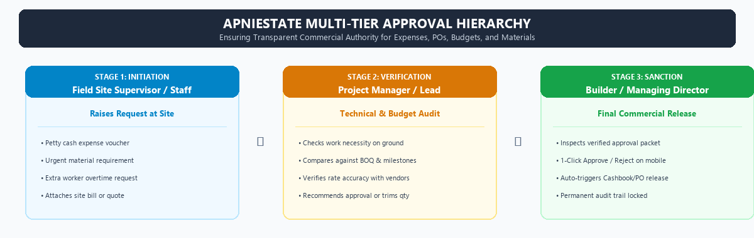
Figure: Multi-Tier Approval Hierarchy ensuring transparent commercial authority.
4.9 Screen 8: User Management & Role Delegation (/users)
The Builder manages the entire company team from the [Users] screen:
- '+ Add User' Button: Touching this button opens a modal requesting: Full Name, Email / Username, Password, Primary Role (Project Manager, Site Supervisor, Accountant, CRM Manager, Telecaller, Worker, Vendor), Project Assignments, and a toggle for CRM Sales Access.
- Manage Access Modal: Touching the settings icon on any user row allows the builder to reassign projects or change CRM permissions with zero delay.
4.10 Screen 9: Documents Vault & Milestone Analytics (/documents & /reports)
The Intelligence hub stores all project documentation and analytical reports:
- Documents Vault (/documents): Cloud file repository organized by folders: Architectural CAD Drawings, Structural Layouts, Government RERA Sanctions, Vendor Contracts, Delivery Slips, and Site Photos. Features upload, download, and permission controls.
- Reports & Analytics (/reports): Comprehensive executive dashboards: Cost vs Budget Variance Report, Labour Productivity Analytics, Material Wastage Analysis, and Milestone Velocity Reports, exportable to PDF and Excel.
4.11 Screen 10: The Universal Builder Superpower — Action on Behalf of Any Role
In construction, field conditions are unpredictable. A site supervisor might lose mobile battery, an accountant may be on leave, or a telecaller might be traveling. Apniestate empowers the Builder and Admin with Universal Action on Behalf:
- Marking Site Attendance: The Builder can open the Labour Register, select Tower B, and tap worker counters on behalf of the site supervisor.
- Raising Material Indents: The Builder can raise urgent material requisitions directly from the Command Center FAB button.
- Submitting DPR Reports: The Builder can upload site inspection photos and submit DPR reports.
- Financial Overrides: The Builder can record cash expenses or release vendor payments immediately without waiting for clerical staff.
👑 BUILDER / ADMIN SUPERPOWER (ACTION ON BEHALF): Why This Is a Game-Changer in Demo Videos
Show how the Builder can perform any site action directly. Explain to the audience: 'You are never held hostage by an absent employee or a lost phone. As the business owner, you hold complete operational sovereignty over your entire enterprise!'

Chapter 5: Project Manager (PM) Journey
The Project Manager (PM) is the field commander responsible for delivering construction projects on time, within budget, and to architectural specifications. In Apniestate, the PM's interface focuses on milestone execution, material audit, and quality inspection.
5.1 The Project Manager's Daily Operating Rhythm
The Project Manager follows a structured daily routine across 6 core steps:
Step 1: 08:30 AM — Command Center & Morning Labour Pulse
- Morning Review: Open Command Center (/dashboard). Inspect the [Workers Today] count to confirm adequate labour turnout across masonry, carpentry, and electrical trades. Review site weather conditions and today's planned activities.
Step 2: 10:00 AM — Material Indent Audit Against BOQ Limits
- Audit & Trim: Navigate to Purchase $\rightarrow$ Requirements (/purchase?tab=requests). Review all material requests submitted by site supervisors. For each request, compare requested quantities against the original Bill of Quantities (BOQ). If a supervisor requests 120 bags of cement when only 80 are needed for the current slab, the PM touches [Modify Quantity] to trim the excess, then touches [Approve]. This prevents over-ordering and site clutter.
Step 3: 11:30 AM — Milestone Tracking & Task Delegation
- Schedule Control: Open Projects $\rightarrow$ Project Detail Hub (/projects/:id) and inspect the [Milestones] and [Tasks] tabs. Check column casting velocity against the target calendar. If rebar binding is lagging, the PM touches [+ Add Task], sets priority to [URGENT], assigns the task to the site supervisor with a 24-hour deadline, and adds a reminder.
Step 4: 02:00 PM — Document & Drawing Verification
- Blueprint Verification: Open Documents (/documents). Download the latest structural drawings uploaded by consulting architects. Verify slab reinforcement schedules directly from an iPad or laptop, ensuring the site team uses the latest approved revisions rather than outdated paper prints.
Step 5: 05:30 PM — DPR Inspection & Photo Audit
- Quality Sign-Off: Navigate to Progress $\rightarrow$ DPR (/progress?tab=dpr). Review Daily Progress Reports submitted by all site supervisors. Inspect uploaded high-resolution site photos to confirm curing, shuttering alignment, and safety compliance before signing off.
Step 6: 06:30 PM — Level-2 Approval Clearance
- Approval Escalation: Open Approval Center (/approvals). Review petty cash expense vouchers and emergency contractor bills submitted during the day. As Level-2 authority, touch [Approve] to route validated packets to the Builder for final financial release.
🌟 UNIQUE BUSINESS BENEFIT & WOW FACTOR: PM Efficiency Benefit
Traditional Project Managers spend 3 hours every day chasing supervisors for progress updates. In Apniestate, all data flows directly into their dashboard in real time, saving 15+ hours of administrative overhead every week.

Chapter 6: Site Supervisor (Site Engineer) Journey
The Site Supervisor is the on-ground engine of construction. They work outdoors amidst concrete dust, machinery noise, and worker chatter. Apniestate provides a lightning-fast, mobile-first interface designed for quick taps with zero complicated typing.
6.1 The 5-Step Daily Site Supervisor Routine
Step 1: 08:00 AM — 15-Second Morning Labour Roll Call
- Navigation: Open Operations $\rightarrow$ Labour Register (/operations?tab=labour).
- Visual Cards: The screen displays visual worker cards with icons: Mistri 🧱, Carpenter 🪚, Helper 👷, Electrician ⚡, Painter 🖌️, Plumber 🚰, Welder 🔥, Bar Bender 🏗️.
- One-Tap Counters: Tap [+] on Mistri until it shows 8, tap [+] on Helper until 14. If 2 carpenters arrived for a half-day shift, tap [+] under [Half Day]. If overtime is scheduled, tap [+] under [OT Hours].
- Instant Wage Cost: Notice the total daily wage cost updating in real time at the bottom of the screen.
- Save & Export: Touch the green [Save Today's Attendance] button. If a labour contractor requires a physical paper copy, touch [Export PDF] to instantly generate a branded, formatted muster roll sheet complete with signature boxes.
Step 2: 10:30 AM — Raising a Material Indent
- Navigation: When site supplies run low, navigate to Purchase $\rightarrow$ Requirements (/purchase?tab=requests).
- Action: Touch the [+ New Request] button.
- Form Fields: Select material (e.g. 'Grade 53 OPC Cement'), enter quantity (e.g. '100 Bags'), select Urgency ([HIGH] or [URGENT]), specify delivery location (e.g. 'Tower A Basement'), and touch [Submit Request]. The request instantly alerts the Project Manager.
Step 3: 01:00 PM — Gate GRN Goods Inward Inspection
- Navigation: When the cement delivery truck arrives at the site gate, open Purchase $\rightarrow$ Received (/purchase?tab=received).
- Matching PO: Touch [+ Receive Goods]. Select the matching Purchase Order (PO) from the dropdown.
- Physical Count: Count the physical bags unloaded. Enter delivered quantity. If 95 bags arrived instead of 100, enter '95' and add a remark '5 bags broken/rejected'.
- Proof Upload: Tap [Upload Challan Photo] to take a picture of the vendor driver's signed delivery slip using your phone camera. Touch [Confirm Receipt]. Site stock increments automatically, and the Accountant is notified.
Step 4: 03:30 PM — Machinery Usage & Diesel Logging
- Machinery Tracking: Open Operations $\rightarrow$ Equipment (/operations?tab=equipment). Select the active machinery (e.g. 'JCB Excavator #2'). Enter working hours (e.g. '6.5 hrs'), idle hours (e.g. '1 hr'), and diesel filled (e.g. '40 Litres'). Touch [Save Equipment Log]. This prevents diesel pilferage.
Step 5: 06:00 PM — End-of-Day Daily Progress Report (DPR)
- Navigation: Navigate to Progress $\rightarrow$ DPR (/progress?tab=dpr).
- Summary: Select site tower, type a concise summary (e.g. 'Cast 5th floor column group C; curing completed on 4th floor slab; steel rebar delivery received').
- Progress %: Select overall completion percentage slider (e.g. '65%').
- Site Photos: Touch [Upload Photos] to attach 2-4 pictures of completed work directly from your camera.
- Final Submission: Touch [Submit DPR]. The report is logged permanently and alerts the Project Manager and Builder.
🎬 VIDEO CREATOR ACTION TIP (WHAT TO TOUCH NOW): Video Recording Tip for Site Supervisor
Show the Labour Register on a mobile screen. Tap the [+] buttons rapidly to show how fast attendance can be taken, then immediately click [Export PDF] to show the generated muster sheet. This is one of the most visual and impressive moments in any demonstration video!

Chapter 7: Accountant Journey
The Accountant is the financial guardian of the real estate enterprise. In Apniestate, the Accountant ensures strict cashflow compliance, eliminates duplicate vendor billing through 3-way matching, manages aging liabilities, and controls operational budgets.
7.1 The Accountant's Step-by-Step Operating Workflow
Step 1: Daily Petty Cashbook Ledger (/finance?tab=cashbook)
- Overview: Open Finance $\rightarrow$ Cashbook. Review the live closing balance of site petty cash.
- Cash Inflow: When the builder transfers ₹50,000 to the site account, touch [+ Add Cash Entry], select [Cash In], enter amount, voucher reference, and touch [Save].
- Cash Outflow: When site emergency items are bought (binding wire, safety helmets, water tanker), touch [+ Add Cash Entry], select [Cash Out], categorize the expense, enter voucher number, attach receipt photo, and touch [Save]. Closing cash updates automatically.
Step 2: 3-Way Invoice Matching & Bill Verification (/finance?tab=invoices)
- Navigation: When a material supplier submits a tax invoice, navigate to Finance $\rightarrow$ Invoices.
- 3-Way Match: The Accountant performs the 3-Way Verification: (1) Check approved Purchase Order rate $\rightarrow$ (2) Check Gate GRN delivered count and delivery challan photo $\rightarrow$ (3) Check vendor invoice amount.
- Record Bill: Touch [+ Add Invoice]. Enter Invoice Number, Vendor Name, Bill Date, Due Date, Taxable Amount, GST amount, and upload bill PDF. Mark status as [UNPAID]. If invoice numbers differ from the PO rate or GRN count, the system flags a commercial mismatch.
Step 3: Master Expense Logging (/finance?tab=expenses)
- Expense Entry: Navigate to Finance $\rightarrow$ Expenses. Record operational costs such as site electricity bills, municipal water charges, crane operator salaries, and structural consultant fees. Touch [+ Record Expense], select expense category, enter amount, attach invoice, and route for Level-1 approval.
Step 4: Vendor Dues & Aging Payment Disbursement (/finance?tab=dues)
- Aging Matrix: Open Finance $\rightarrow$ Dues. Review the aging table categorizing liabilities into: Current (0-30 Days), Due (30-60 Days), and Overdue (60+ Days).
- Payment Action: When the Builder approves payment for a vendor, touch the [Pay Vendor] button on that vendor's row.
- Disbursement: Select payment method (NEFT / RTGS, Cheque, UPI), enter bank transaction reference, amount paid, and touch [Record Payment]. Vendor ledger balance is reduced instantly, and a receipt is generated.
Step 5: Budget Monitoring & Cost Compliance (/finance?tab=budgets)
- Cost Radar: Open Finance $\rightarrow$ Budgets. Inspect the visual utilization bars for Materials, Labour, Equipment, Overhead, and Subcontract. If actual expenditures cross 85% of allocated funds, the bar turns amber; at 100%, it turns bright red. The Accountant flags budget overruns before checks are issued.
🌟 UNIQUE BUSINESS BENEFIT & WOW FACTOR: 3-Way Matching Benefit
Explain that Apniestate makes it impossible to pay for materials that never arrived at the site. The Accountant has the original Purchase Order, the gate guard's challan photo, and the vendor's tax invoice all visible on a single screen before releasing funds.

Chapter 8: CRM & Leads Manager Journey
The CRM & Leads Manager is the revenue architect of the real estate firm. In Apniestate, the sales workspace is activated instantly by clicking the [CRM] toggle pill on the sidebar. The CRM Manager ensures zero lead leakage, automated distribution, pipeline velocity, and broker network growth.
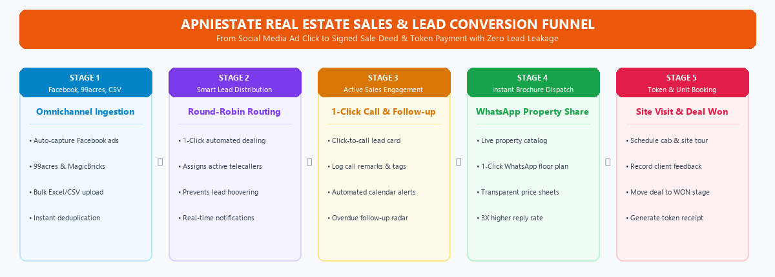
Figure: The Real Estate CRM Lead-to-Booking Funnel from ad click to signed deed.
8.1 The CRM Manager's Step-by-Step Operating Workflow
Step 1: Omnichannel Lead Ingestion & Bulk Import (/crm?tab=leads)
- Automated Webhooks: Inbound buyer inquiries captured from Facebook Lead Ads, Google Ads, 99acres, and MagicBricks flow directly into the Leads Bank with zero delay.
- Bulk Spreadsheet Import: For leads collected from property expos or walk-in registers, touch the [Import Leads] button at the top of the Leads tab. Drag and drop any Excel (.xlsx) or CSV file. The system automatically deduplicates existing phone numbers and creates clean lead cards.
Step 2: Smart Automated Lead Distribution (Round-Robin)
- Action: Touch the [Distribute Leads] button located in the Leads tab toolbar.
- Distribution Modes: Select unassigned leads. Choose between two intelligent distribution methods: (1) Round Robin (automatically deals out leads equally across all active telecallers like cards in a deck), or (2) Targeted Allocation (assign high-budget luxury inquiries directly to senior sales closers). Touch [Assign Leads]. Telecallers receive instant mobile notifications.
Step 3: Visual Kanban Pipeline Oversight (/crm?tab=pipeline)
- Kanban Stages: Open the Sales Pipeline tab. The screen displays a visual Kanban board with drag-and-drop columns: [New Lead] $\rightarrow$ [Contacted] $\rightarrow$ [Interested] $\rightarrow$ [Site Visit Scheduled] $\rightarrow$ [Site Visit Done] $\rightarrow$ [Negotiation] $\rightarrow$ [Deal Won] $\rightarrow$ [Lost].
- Stage Progression: Each card displays customer name, budget in ₹, preferred configuration (2BHK, 3BHK, Villa), and assigned executive. Dragging a card from 'Contacted' to 'Site Visit Scheduled' automatically prompts for visit date and transportation details.
Step 4: Channel Partner (Broker) Management (/crm?tab=channel-partners)
- Overview: Navigate to the Channel Partners tab. Real estate brokers drive up to 50% of property sales.
- Register Partner: Touch [+ Add Partner]. Record Agency Name, Contact Person, Phone, RERA Registration Number, and agreed commission percentage (e.g. '2.5%').
- Commission Ledger: The directory tracks leads submitted by each broker, deals successfully closed, commission amounts earned, and pending brokerage payouts.
Step 5: Team Performance & Live Leaderboard (/crm?tab=team)
- Sales Velocity: Open the CRM Team tab. The manager monitors live metrics for every telecaller and sales executive: (1) Total Calls Made Today, (2) Connect Rate %, (3) Follow-ups Completed, (4) Site Visits Booked, and (5) Deals Closed. High-performing executives are highlighted on the leaderboard.
Step 6: Marketing ROI Analytics (/crm?tab=reports)
- Campaign ROI: Open the Reports tab. The analytics engine shows cost per lead, conversion rate per marketing channel, and loss reason breakdowns (e.g., 'Budget Mismatch 45%', 'Location Preference 30%'). This enables the builder to stop wasting money on ineffective ads.
🌟 UNIQUE BUSINESS BENEFIT & WOW FACTOR: Round-Robin Lead Fairness Benefit
In traditional real estate firms, sales executives argue over who gets the best leads. Demonstrate how Apniestate's 1-click Round-Robin deals out leads with absolute algorithmic fairness, boosting team morale and closing speed!

Chapter 9: Telecaller & Sales Executive Journey
The Telecaller / Sales Executive is the front-line voice of the real estate builder. In Apniestate, the telecaller's workspace is stripped of administrative clutter and optimized for rapid calling, active relationship tracking, instant WhatsApp property sharing, and booking flat/villa units.
9.1 The Telecaller's Daily Calling & Closing Workflow
Step 1: Start of Day Calling Queue (/crm?tab=followups)
- Prioritized Queue: Open the Follow-ups tab. The screen immediately displays the day's prioritized calling queue organized into: [Today's Calls], [Overdue Follow-ups], and [Upcoming Calls]. The executive never has to guess who to dial next.
Step 2: 1-Click Dialing & WhatsApp Engagement
- Lead Detail: Click on any lead card to open the Lead Detail Modal.
- Instant Connect: Touch the blue [Call] phone icon to initiate an immediate phone call. Touch the green [WhatsApp] chat icon to open a pre-formatted WhatsApp chat directly with the customer.
Step 3: Logging Call Outcomes & Setting Next Reminder
- Outcome Status: During or immediately after the call, select the call outcome from the dropdown: [Interested], [Call Back Later], [Ringing - No Answer], [Budget Mismatch], or [Site Visit Requested].
- Next Follow-up: In the calendar picker, set the next follow-up date and time (e.g. 'Tomorrow at 04:00 PM'). Type brief customer notes (e.g. 'Looking for 3BHK East-facing unit on 7th floor or above; budget ₹95 Lakhs'). Touch [Save Follow-up]. The lead is rescheduled automatically.
Step 4: 1-Click WhatsApp Property Brochure Sharing (/crm?tab=properties)
- Property Inventory: When the prospective buyer asks for property plans, navigate to the Properties Catalog tab.
- 1-Click Share: Locate the matching unit (e.g. 'Tower A - Unit 702 - 3BHK Luxury - 1,450 sq.ft.'). Touch the green [Share via WhatsApp] button.
- Instant Dispatch: The system opens WhatsApp with a prefilled message containing the floor plan layout, carpet area breakdown, list of project amenities (swimming pool, gym, clubhouse), and pricing sheet link. This instant response wows the buyer.
Step 5: Scheduling a Site Visit (/crm?tab=activities)
- Visit Scheduling: When the buyer agrees to visit the construction project, touch [+ Add Activity] and select [Site Visit].
- Calendar Sync: Record the agreed date, time, number of family members attending, and whether site pickup is required. The visit syncs to the company calendar and alerts the site sales office.
Step 6: Closing the Deal & Booking the Unit (/crm?tab=customers)
- Navigation: When the buyer decides to book a unit and pays the booking token, navigate to the Customers tab.
- Deal Booking: Touch [+ Add Deal]. Select the customer name, pick the exact unit number from live inventory (e.g. 'Tower A - Flat 702'), enter the agreed final price, enter the booking token received (e.g. '₹2,00,000'), and select the construction-linked payment plan.
- Inventory Lock: Touch [Save Deal]. The unit status in the master inventory immediately switches from 'Available' to 'Booked', preventing double booking. The deal moves to [WON], and a formal booking receipt is generated.
🎬 VIDEO CREATOR ACTION TIP (WHAT TO TOUCH NOW): Video Recording Tip for Telecallers
Record the screen while clicking [Share via WhatsApp] on a property card. Show how WhatsApp opens with a rich brochure message in less than 2 seconds. Any real estate sales manager watching your video will be blown away by this feature!

Chapter 10: Master Permissions & Role Capabilities Matrix
To provide complete clarity on role separation, security boundaries, and operational authority, the following matrix details exact permissions across all 25+ core modules in Apniestate:
Module / Feature | Super Admin | Builder / MD | Project Manager | Site Supervisor | Accountant | CRM Manager | Telecaller
Platform Trial & Tenant Approval | FULL | NONE | NONE | NONE | NONE | NONE | NONE
Project Command Center & Intelligence | VIEW | FULL | VIEW | NONE | VIEW | NONE | NONE
Project Creation & Site Setup | NONE | FULL | EDIT | NONE | NONE | NONE | NONE
Milestones Schedule & Task Delegation | NONE | FULL | FULL | VIEW | NONE | NONE | NONE
BOQ Master (Excel Import / Export) | NONE | FULL | EDIT | VIEW | VIEW | NONE | NONE
Material Indents (Requisitions) | NONE | FULL | APPROVE | CREATE | VIEW | NONE | NONE
Purchase Order (PO) Creation & PDF | NONE | FULL | CREATE | NONE | VIEW | NONE | NONE
Gate GRN Inspection & Challan Photo | NONE | FULL | VIEW | CREATE | VERIFY | NONE | NONE
Warehouse Inventory & Stock Consumption | NONE | FULL | VIEW | CONSUME | VIEW | NONE | NONE
Labour Muster Roll & PDF Export | NONE | FULL | VIEW | MARK | VIEW | NONE | NONE
Heavy Equipment & Diesel Fuel Log | NONE | FULL | VIEW | LOG | VIEW | NONE | NONE
Daily Progress Reports (DPR) & Photos | NONE | FULL | REVIEW | SUBMIT | NONE | NONE | NONE
Petty Cashbook Inflow / Outflow | NONE | FULL | VIEW | NONE | FULL | NONE | NONE
Expense Vouchers & Tax Invoices | NONE | FULL | VERIFY | NONE | FULL | NONE | NONE
Vendor Invoices & 3-Way Match | NONE | FULL | VIEW | NONE | FULL | NONE | NONE
Vendor Dues & Payment Releases | NONE | FULL | NONE | NONE | RECORD | NONE | NONE
Approval Chains Configuration | NONE | FULL | NONE | NONE | NONE | NONE | NONE
User Management & Role Assignment | NONE | FULL | NONE | NONE | NONE | NONE | NONE
Inbound Lead Ingestion & CSV Import | NONE | FULL | NONE | NONE | NONE | FULL | NONE
Automated Round-Robin Lead Routing | NONE | FULL | NONE | NONE | NONE | FULL | NONE
Visual Kanban Sales Pipeline | NONE | FULL | NONE | NONE | NONE | FULL | OWN LEADS
1-Click Call & WhatsApp Connect | NONE | FULL | NONE | NONE | NONE | FULL | FULL
Property Catalog & WhatsApp Share | NONE | FULL | VIEW | NONE | NONE | FULL | SHARE
Channel Partner (Broker) Directory | NONE | FULL | NONE | NONE | VIEW | FULL | NONE
Team Performance Leaderboard | NONE | FULL | NONE | NONE | NONE | FULL | VIEW OWN
Documents Cloud Vault | VIEW | FULL | FULL | UPLOAD | VIEW | VIEW | VIEW
Action on Behalf of Other Roles | FULL | FULL | NONE | NONE | NONE | NONE | NONE

Summary of Matrix: The Platform Super Admin controls tenant access. The Builder/MD holds universal authority across every module and can act on behalf of any absent team member. Department leads (PM, Accountant, Site Supervisor, CRM Manager, Telecaller) operate within focused, highly efficient workspaces designed specifically for their daily tasks.

