APNI VIDYA
Smart Evaluation System & Learning Management Platform
COMPLETE USER JOURNEY & VIDEO DEMO MASTER MANUAL
Plain-English Operating Guide for Institute Admins, Teachers & Students

Target Audience: Non-Technical Video Creators & Admin Teams | Platform Scope: Institute Admin, Teacher & Student Panels
Core Superpower: AI Question Paper Parser + Anti-Cheat Exam | Purpose: Step-by-Step Button-by-Button Journey (Zero Guesswork)

1. Executive System Overview (The Big Picture)
Apni Vidya is a complete, all-in-one education management and AI-powered evaluation ecosystem built specifically for coaching centers, schools, and tutoring academies. In traditional institutes, staff lose hours daily juggling separate tools: WhatsApp for class links, physical registers for attendance, Google Forms for tests, and paper slips for fee receipts. Apni Vidya replaces all of that with a single, beautifully organized system.

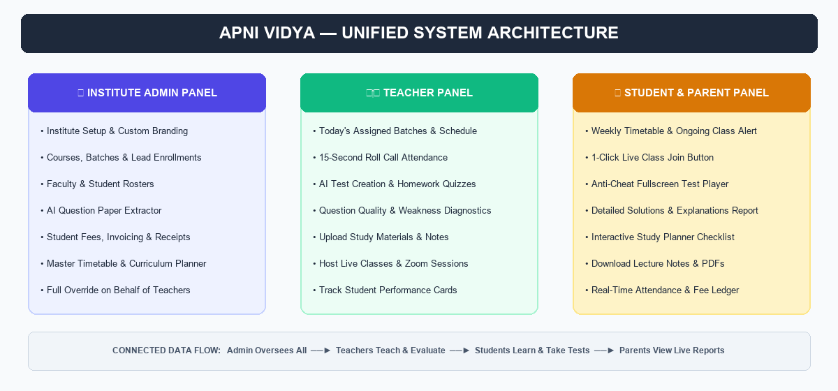
Figure 1.1: Unified Architecture Connecting Institute Admin, Teachers, and Students

The 4 Standout Superpowers to Highlight in Any Video
- 1. AI Document Parser (PDF to Online Exam in 30 Sec): Teachers or admins simply drop an existing question paper (.pdf or .docx). The system instantly detects all questions, multiple-choice options (A, B, C, D), correct keys, and marks. No manual typing required!
- 2. Anti-Cheat Exam Player with Real-Time Timer: When students take exams, the system enforces fullscreen focus. If a student tries to switch browser tabs, minimize the window, or copy text, instant warnings are triggered. Repeated violations auto-submit the exam.
- 3. Question Quality & Weakness Diagnostics: Instead of just scores, the platform calculates empirical difficulty (Easy, Medium, Hard) based on how all students answered. Questions with unusually high failure rates are automatically flagged with warning badges for teacher review.
- 4. 'Admin on Behalf of Teacher' Capability: Real coaching institutes have busy or non-technical faculty. The Institute Admin has full delegation power to create tests, upload lecture notes, schedule timetables, and mark roll-call attendance for any teacher's batch.

2. Institute Admin Panel: Screen-by-Screen User Journey
The Institute Admin Panel (/admin) is the supreme command center. The sidebar is structured into 6 clear functional sections: People, Academics, Operations, Finance, Communication, and Settings. Below is the exact step-by-step walkthrough of what buttons to click, what each screen displays, and the key benefits to mention in your demo video.

Step 2.1: The Command Center (Dashboard Overview)
📍 Screen Location: Sidebar → Click 'Dashboard' (/admin)
What You See on Screen: Welcome banner with current date; 4 headline stat cards (Active Students, Total Faculty, Active Batches, Total Fee Collections); revenue collection chart; today's class schedule preview.
Exact Buttons to Touch & Actions:
- Point to the top header Search Bar: Searches across all students, batches, and courses instantly.
- Click the ☀️ / 🌙 Dark Mode Toggle in top right: Demonstrates the sleek, modern dark mode interface.
- Click shortcut buttons like + Create Test or + Add Student to demonstrate rapid navigation.
★ WHY THIS IMPRESSES VIEWERS: Gives the institute director a complete 360-degree overview of their academy in 5 seconds without touching a single paper register.

Step 2.2: Student Directory & Profile Management
📍 Screen Location: Sidebar → Under 'People' → Click 'Students' (/admin/students)
What You See on Screen: Comprehensive student database table with columns for Student Name, Email, Phone Number, Assigned Batch, and Active Status.
Exact Buttons to Touch & Actions:
- Click the primary blue button + Add Student: A modal pops up asking for Name, Email, Phone, Parent Mobile, and Batch assignment.
- Type student info and click Save Student: Instantly creates the record and generates student login credentials.
- Click on any student row: A side profile drawer slides out showing their personal attendance percentage and past test performance cards.
★ WHY THIS IMPRESSES VIEWERS: Centralized student records. Never lose a parent's contact number or confuse which student belongs to which batch.

Step 2.3: Faculty & Teachers Management
📍 Screen Location: Sidebar → Under 'People' → Click 'Teachers' (/admin/teachers)
What You See on Screen: Grid of all faculty members showing their avatar, email, mobile phone, and assigned subjects (Physics, Mathematics, Chemistry, Biology, etc.).
Exact Buttons to Touch & Actions:
- Click + Add Teacher: Enters Teacher Name, Email, Phone, and Subjects taught.
- Click Create Teacher Account: Grants the teacher access to their dedicated teacher portal.
- Show assigned subject tags beneath each teacher card.
★ WHY THIS IMPRESSES VIEWERS: Clear faculty accountability. Manage visiting guest lecturers and full-time faculty in one organized place.

Step 2.4: Public Admission Links & Enrollment Requests
📍 Screen Location: Sidebar → Under 'People' → Click 'Enrollments' (/admin/enrollments)
What You See on Screen: Queue of incoming student admission applications submitted online through the institute's public admissions URL.
Exact Buttons to Touch & Actions:
- Point to the Copy Public Admission Link button: Explain that the institute can paste this link on WhatsApp, Instagram, or their website.
- On any pending applicant card, point to the green Approve button: 1-click automatically converts the lead into an active student and assigns them to a batch.
- Point to the red Reject button for archiving ineligible applications.
★ WHY THIS IMPRESSES VIEWERS: Automates student admissions. Prospective students apply from home via mobile, and the admin enrolls them with a single click.

Step 2.5: Academic Programs & Batch Organization
📍 Screen Location: Sidebar → Under 'Academics' → Click 'Courses' and 'Batches'
What You See on Screen: Courses Page (/admin/courses) defines broad programs (e.g. 'Class 10 CBSE Board', 'JEE Main 2026'). Batches Page (/admin/batches) defines specific classroom cohorts (e.g. 'Morning Droppers Batch').
Exact Buttons to Touch & Actions:
- On Batches page, click + Create Batch.
- Select the parent Course, name the batch, set start/end dates, max capacity (e.g. 40 seats), and assign a Lead Teacher.
- Click Save Batch: Establishes the cohort so all future tests, attendance, and notes are targeted precisely to these students.
★ WHY THIS IMPRESSES VIEWERS: Flawless academic segmentation. Students only see learning materials and tests meant for their specific syllabus cohort.

Step 2.6: Weekly Schedule & Master Timetable
📍 Screen Location: Sidebar → Under 'Academics' → Click 'Timetable' (/admin/timetable)
What You See on Screen: Interactive 7-day weekly schedule matrix (Monday to Sunday) with color-coded subject cards (Physics blue, Chemistry orange, Math purple).
Exact Buttons to Touch & Actions:
- Choose the target batch from the Select Batch dropdown.
- Click + Add Slot on any day column (e.g., Tuesday 10:00 AM – 11:30 AM).
- Select Subject, assigned Teacher, and Room / Classroom Number.
- Click Save Slot: The weekly schedule instantly reflects on the teacher's and students' dashboards.
★ WHY THIS IMPRESSES VIEWERS: Eliminates room clashes and teacher confusion. Students can always verify what books to bring and when classes begin.

Step 2.7: Curriculum Pacing & Study Planner
📍 Screen Location: Sidebar → Under 'Academics' → Click 'Study Planner' (/admin/planner)
What You See on Screen: Chapter-by-chapter curriculum milestones organized by week and target completion dates.
Exact Buttons to Touch & Actions:
- Click + Add Milestone.
- Enter Milestone Title (e.g. 'Optics — Ray Diagrams & Lens Formula'), assign target batch, and set completion deadline.
- Click Save Milestone: Appears as an interactive daily checklist in the student portal.
★ WHY THIS IMPRESSES VIEWERS: Guarantees timely syllabus completion. Parents and students always know exactly what topic is being covered this week.

Step 2.8: Digital Library & Study Materials
📍 Screen Location: Sidebar → Under 'Academics' → Click 'Materials' (/admin/materials)
What You See on Screen: Filterable repository of lecture notes, PDF problem sheets, formula handbooks, and recorded lecture video links.
Exact Buttons to Touch & Actions:
- Click + Upload Material.
- Select Material Kind: PDF Document, Notes, or Video Link.
- Select the target Batch and Subject, attach the file, and click Publish Material.
★ WHY THIS IMPRESSES VIEWERS: Replaces messy WhatsApp chats. Students have 24/7 lifetime access to neatly categorized study resources.

Step 2.9: 15-Second Daily Attendance Taking
📍 Screen Location: Sidebar → Under 'Operations' → Click 'Attendance' (/admin/attendance)
What You See on Screen: Batch selector and Date picker (defaults to today); student roster table with photos, roll numbers, and 3 status buttons: Present (P), Absent (A), Late (L).
Exact Buttons to Touch & Actions:
- Click the magic shortcut button Mark All Present: All students turn green in one tap!
- Click on the 1 or 2 absent students: Their badge toggles to bright red Absent.
- Click Save Attendance Sheet: Attendance is locked, and real-time attendance percentage updates across student and parent portals.
★ WHY THIS IMPRESSES VIEWERS: Cuts roll-call time from 10 minutes to 15 seconds. Completely removes paper registers and manual monthly calculations.

Step 2.10: The Star Feature — Tests & AI Document Parser
📍 Screen Location: Sidebar → Under 'Operations' → Click 'Tests' (/admin/tests)
What You See on Screen: List of all assessments with test duration, total marks, scheduled attempt windows, submission counts, average class score, and a slide-out Batch Analytics & Item Quality Drawer on the right.

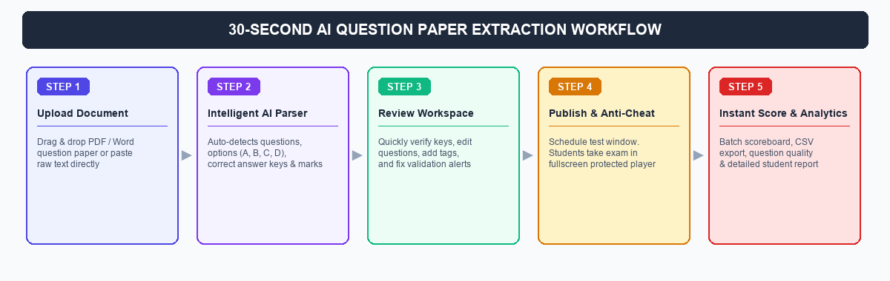
Figure 2.1: Step-by-Step AI Question Paper Extraction and Evaluation Pipeline
How to Demonstrate the Test Creator in the Video (Follow Exactly):
- Click the top-right button `+ Create Test` to open the creator modal.
- Fill in test title (e.g. 'Physics Mechanics Diagnostic Quiz'), select the Batch, set Duration (e.g. 30 mins), and Marks per Question.
- Select the `Upload File` tab and drag-and-drop a sample question paper (.pdf or .docx). Alternatively, paste text into `Paste Text`.
- Click `Extract Questions with AI`: Point out the 3-second extraction spinner as the AI scans the document.
- Show the `Review Questions Workspace`: Point out how the AI detected question text, all 4 options (A, B, C, D), and pre-selected answer keys.
- Show the validation status bar at top: `Total Questions`, `Valid`, and `Needs Review`. Show how clicking any option radio button instantly validates the question.
- Click the blue button `Publish Assessment`: The test goes live immediately for students!
How to Demonstrate Batch Analytics & Item Quality:
- On the Tests table, click `Analytics` on any completed test: The Analytics Drawer slides open.
- Show `Overview Tab`: Point out Average Score %, Pass Rate %, Participation Turnout, and the Score Distribution Histogram.
- Show `Question Quality Tab`: Point out the empirical difficulty tag (Easy, Medium, Hard) and highlight problematic questions tagged with `⚠️ High Failure Rate`.
- Show `Scoreboard Tab`: Ranks all students, displays their completion time and anti-cheat violations. Click `Export CSV` to download the Excel gradebook in 1 click.
★ CORE SHOWSTOPPER BENEFIT: Saves teachers 2–3 hours of tedious data entry per exam while giving institute management actionable diagnostic data to prevent student dropouts.

Step 2.11: Live Interactive Online Classes
📍 Screen Location: Sidebar → Under 'Operations' → Click 'Live Classes' (/admin/live-classes)
What You See on Screen: Schedule of active and upcoming live video sessions, assigned teacher, start time, and meeting status.
Exact Buttons to Touch & Actions:
- Click + Schedule Live Class.
- Enter Class Topic, select target Batch, set Date & Time, and paste the meeting link (Zoom, Google Meet, or YouTube Live).
- Point to the green Start Class button: Launches the live lecture immediately.
★ WHY THIS IMPRESSES VIEWERS: No more searching through chat groups for meeting links. Students join directly with 1 click from their personal dashboard.

Step 2.12: Student Fees & Automated Invoicing
📍 Screen Location: Sidebar → Under 'Finance' → Click 'Student Fees' (/admin/fees)
What You See on Screen: Financial summary cards: Total Expected Revenue, Total Collected, and Total Outstanding/Overdue Dues. Detailed student fee ledger table.
Exact Buttons to Touch & Actions:
- Click + Create Fee Structure: Enter Title (e.g. 'Term 1 Tuition Fee'), Amount (e.g. ₹15,000), Due Date, and assign it to a Batch.
- Click Save & Assign: Automatically applies the fee schedule to all enrolled students in that batch.
- Click Record Payment on any student: Enter payment received (e.g. ₹5,000 via UPI) and click Submit Payment.
- Click the Receipt (Download) icon: Generates a professional printable payment receipt instantly.
★ WHY THIS IMPRESSES VIEWERS: Stops financial fee leakage and replaces paper receipt books. Admins can identify unpaid dues in seconds.

Step 2.13: Announcements & Custom Institute Branding
📍 Screen Location: Sidebar → Under 'Communication' → Click 'Announcements' & 'Settings' → 'Institute'
What You See on Screen: Official noticeboard feed and Institute Profile settings (Logo upload, Institute Name, Address, Contact details).
Exact Buttons to Touch & Actions:
- On Announcements: Click + New Announcement, type the message, choose Target (All Academy or Specific Batch), and click Publish.
- On Institute Profile: Show how uploading the academy logo and name automatically white-labels the student portal, exam reports, and fee receipts.
★ WHY THIS IMPRESSES VIEWERS: Reinforces the academy's brand identity. Makes any coaching center look like a modern, technologically advanced institution.

⭐ Special Highlight: What the Institute Can Do on Behalf of Teachers
In many institutes, teachers are focused entirely on classroom teaching or are uncomfortable with computer software. Apni Vidya solves this by giving the Institute Admin full delegation override. The table below illustrates every action an admin can execute on behalf of any teacher without needing their login credentials:
Teacher Function | What Admin Can Do on Their Behalf | Where in Admin Panel
Creating Tests & Quizzes | Admin can upload the teacher's question paper, review the keys, and launch the test under that teacher's batch. | Operations → Tests
Marking Attendance | If a teacher is absent or forgets roll call, Admin can open the batch sheet and mark attendance with 1 click. | Operations → Attendance
Uploading Study Notes | Admin can upload teacher notes, PDF worksheets, and reference video links directly to the batch library. | Academics → Materials
Setting Syllabus Milestones | Admin can create weekly lesson plans and chapter deadlines in the Study Planner. | Academics → Planner
Rescheduling Lectures | Admin can modify the timetable and assign substitute teachers when a faculty member is on leave. | Academics → Timetable
Scheduling Live Meets | Admin can create and schedule Zoom/Meet links for any teacher's upcoming lecture. | Operations → Live Classes

3. Teacher Panel: Step-by-Step Classroom Journey
The Teacher Panel (/teacher) is designed to be lightweight, focused, and distraction-free. Teachers are not burdened with financial or billing data; instead, they have rapid tools to run their classes, mark attendance in seconds, and track student comprehension.
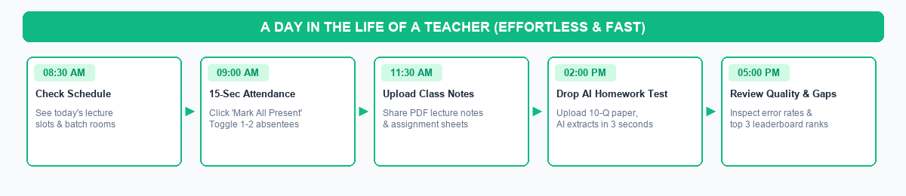
Figure 3.1: A Day in the Life of a Teacher on Apni Vidya

Step 3.1: Teacher Dashboard Overview
📍 Screen Location: Sidebar → Click 'Dashboard' (/teacher)
What You See on Screen: Today's active schedule, cards for assigned batches, upcoming tests, and quick action shortcuts.
Exact Buttons to Touch & Actions:
- Log in and check today's assigned lecture times and classroom numbers.
★ WHY THIS IMPRESSES VIEWERS: Gives teachers instant clarity on their daily teaching schedule without checking noticeboards.

Step 3.2: 15-Second Daily Attendance
📍 Screen Location: Sidebar → Click 'Attendance' (/teacher/attendance)
What You See on Screen: Student roster for the teacher's assigned batch.
Exact Buttons to Touch & Actions:
- Select batch from dropdown.
- Click Mark All Present: All students turn green.
- Click on the 1 or 2 absent students to turn them red.
- Click Save Attendance: Complete in under 15 seconds!
★ WHY THIS IMPRESSES VIEWERS: Maximizes actual teaching time by eliminating 10 minutes of manual paper roll call.

Step 3.3: Creating Homework Tests with AI
📍 Screen Location: Sidebar → Click 'Tests' (/teacher/tests)
What You See on Screen: Test management and AI Question Extractor.
Exact Buttons to Touch & Actions:
- Click + Create Test.
- Drop homework PDF or Word document.
- Click Extract Questions with AI.
- Review questions, verify answer keys, set 20 min timer, and click Publish Assessment.
★ WHY THIS IMPRESSES VIEWERS: Teachers can create high-quality homework quizzes in 30 seconds between classes.

Step 3.4: Diagnosing Student Weaknesses (Question Quality)
📍 Screen Location: Sidebar → Click 'Tests' → Click 'Analytics' on any test
What You See on Screen: Empirical difficulty metrics and Question Quality analytics.
Exact Buttons to Touch & Actions:
- Click Question Quality Tab.
- Review which questions had high error rates (e.g., 'Question #4 has a 78% failure rate!').
- Check the Scoreboard to see the top 3 performers and weak students who need extra tutoring.
★ WHY THIS IMPRESSES VIEWERS: Enables data-driven teaching. In the very next class, the teacher knows exactly which formula or concept needs re-explaining.

Step 3.5: Sharing Class Notes & Materials
📍 Screen Location: Sidebar → Click 'Study Materials' (/teacher/materials)
What You See on Screen: Upload interface for PDFs, lecture notes, and video references.
Exact Buttons to Touch & Actions:
- Click + Upload Material.
- Attach handwritten notes PDF or homework sheet.
- Select batch and click Upload: Students receive the notes immediately.
★ WHY THIS IMPRESSES VIEWERS: Keeps all study materials organized permanently by batch and subject.

4. Student & Parent Panel: Learning & Testing Journey
The Student Panel (/student) is the learner's digital classroom. It is optimized for both desktop and mobile screens, giving students an engaging, gamified experience with real-time timetable alerts, an anti-cheat exam player, and instant step-by-step test solutions.
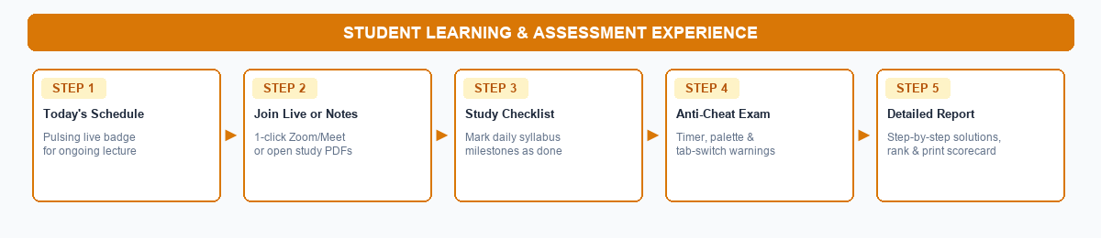
Figure 4.1: Complete Student Learning, Testing & Evaluation Journey

Step 4.1: Student Home & Live Schedule Alert
📍 Screen Location: Sidebar → Click 'Dashboard' (/student)
What You See on Screen: Personalized greeting; 3 KPI cards (Attendance %, Average Test Score %, Pending Fee Status); Today's Schedule with an active pulsing indicator for the currently ongoing class; recent test performance table.
Exact Buttons to Touch & Actions:
- Point out the pulsing green live indicator showing that a class is currently in session.
- Point to personal attendance % and average test marks.
★ WHY THIS IMPRESSES VIEWERS: Keeps students punctual and organized. Students always know what class is happening right now.

Step 4.2: Weekly Timetable Routine
📍 Screen Location: Sidebar → Click 'Timetable' (/student/timetable)
What You See on Screen: Clean 7-day schedule color-coded by subject with start/end times, teacher names, and room numbers.
Exact Buttons to Touch & Actions:
- Demonstrate how students can check tomorrow's lectures and verify room numbers.
★ WHY THIS IMPRESSES VIEWERS: Prevents forgotten books and missed lectures.

Step 4.3: The Fullscreen Exam Player Experience
📍 Screen Location: Sidebar → Click 'Tests' → Click 'Start Assessment' (/play-test/:id)
What You See on Screen: Protected fullscreen test environment.
Exact Buttons to Touch & Actions:
- Click Start Assessment: Browser enters focused exam mode.
- Point to the Digital Countdown Timer at top: Displays exact minutes and seconds remaining; auto-submits when time expires.
- Point to the Question Palette: Shows question numbers color-coded (Green for Answered, Yellow for Marked for Review, Gray for Unvisited).
- Demonstrate Anti-Cheat Integrity System: Explain that if a student switches tabs, minimizes the window, or attempts copy-paste, an immediate warning modal pops up. Exceeding warnings automatically submits the test.
- Click Submit Test: A confirmation modal confirms answered vs unanswered questions before final submission.
★ WHY THIS IMPRESSES VIEWERS: Guarantees exam integrity. Parents and teachers can trust that test scores represent authentic student knowledge.

Step 4.4: Detailed Evaluation Report & Solutions
📍 Screen Location: Test Results → Click 'View Detailed Report' (/report/:id)
What You See on Screen: Comprehensive performance scorecard.
Exact Buttons to Touch & Actions:
- Show overall percentage, marks, and rank badge.
- Show quick question filter buttons: All, Correct (Green), Wrong (Red), Skipped (Gray).
- Show step-by-step solutions under each question: Displays the student's marked answer, the correct answer, and an in-depth conceptual explanation.
- Click Print Report button at top: Instantly generates a clean, printable PDF report card for parents.
★ WHY THIS IMPRESSES VIEWERS: Turns testing into a learning opportunity. Students immediately understand why an answer was wrong and how to solve it correctly.

Step 4.5: Interactive Study Planner Checklist
📍 Screen Location: Sidebar → Click 'Study Planner' (/student/planner)
What You See on Screen: Checklist of assigned chapter milestones and daily revision tasks.
Exact Buttons to Touch & Actions:
- Demonstrate checking off a finished study topic: Checkbox turns green with a strikethrough.
★ WHY THIS IMPRESSES VIEWERS: Builds daily self-study discipline and gives students a visual sense of accomplishment.

Step 4.6: Study Materials & Notes Downloads
📍 Screen Location: Sidebar → Click 'Study Material' (/student/materials)
What You See on Screen: Categorized library of PDF lecture notes, formula sheets, and video links.
Exact Buttons to Touch & Actions:
- Filter by subject (e.g. Physics) and click to view or download the lecture PDF.
★ WHY THIS IMPRESSES VIEWERS: Instant access to class notes anytime, anywhere, on any device.

Step 4.7: Gamified Leaderboard & Peer Motivation
📍 Screen Location: Sidebar → Click 'Leaderboard' (/student/leaderboard)
What You See on Screen: Top 3 podium with Gold, Silver, and Bronze trophies; batch rankings.
Exact Buttons to Touch & Actions:
- Show student's rank among peers in the batch.
★ WHY THIS IMPRESSES VIEWERS: Fosters healthy academic motivation and pushes students to prepare harder for upcoming quizzes.

Step 4.8: Fee Status & Payment Receipts
📍 Screen Location: Sidebar → Click 'Fee Status' (/student/fees)
What You See on Screen: Transparent breakdown of total course fees, amount paid, balance due, and past installment receipts.
Exact Buttons to Touch & Actions:
- Click Download Receipt for any past payment.
★ WHY THIS IMPRESSES VIEWERS: Complete financial transparency for parents, avoiding fee disputes.

5. Master Feature Matrix: All 3 Panels at a Glance
Capability / Feature | 🏢 Institute Admin | 👨‍🏫 Teacher | 🎓 Student & Parent
Dashboard | Academy revenue, students, faculty stats | Today's teaching schedule & batches | Pulsing live class alert, attendance & scores
Attendance | Mark any batch, edit past sheets | 1-click roll call for assigned batches | Personal attendance calendar & %
Test Creation | Upload PDF/Word, AI extraction, publish | Upload PDF/Word, AI extraction, publish | Take test in fullscreen anti-cheat player
Test Evaluation | Batch scoreboard, CSV export, quality stats | Question Quality analytics & weak areas | Detailed step-by-step solutions & rank
Timetable | Master scheduler for all rooms & batches | View assigned weekly lecture routine | View weekly timetable & ongoing class
Study Materials | Upload files & links for any batch | Upload class notes & homework PDFs | Download & view study materials
Study Planner | Set academy-wide curriculum pacing | Set batch chapter deadlines | Interactive daily study checklist
Live Classes | Schedule Zoom/Meet links for any class | Launch and host live video meets | 1-click 'Join Live Class' button
Fee Management | Create fee structures, collect, receipts | Hidden for financial privacy | View balance due & download receipts
Institute Branding | Custom logo, institute name, admission links | View-only institute profile | Branded reports and exam sheets

6. Golden Recording Tips for the Video Creator
- Start with the Universal Pain Point: Open your video by explaining how exhausting it is for teachers to type 50 questions, 200 options, and marking keys into a computer by hand.
- Deliver the 30-Second 'WOW' Moment: Go to /admin/tests, click `+ Create Test`, upload a PDF question paper, and hit `Extract Questions with AI`. Pause for 2 seconds to let the viewer see every question and option automatically formatted on screen!
- Demonstrate the Anti-Cheat Protection: Show the Student Test Player (/play-test/:id). Purposefully switch browser tabs to trigger the warning popup modal. This proves to coaching owners that online tests on this platform cannot be easily cheated on.
- Show the Detailed Solution Report: Submit the test and display the color-coded question breakdown (Green = Correct, Red = Wrong) and the in-depth step-by-step explanations. Click `Print Report` to show the printable PDF scorecard.
- Reassure Non-Technical Staff: Emphasize that the Institute Admin can perform any task on behalf of teachers. Even if a faculty member never opens a computer, the institute can still run the entire system effortlessly.

