Name: Kunal Singh
Enrollment No: 22324025
Branch: BS-MS Physics
Project: Stock Sentiment Analysis Using Machine Learning

PROBLEM STATEMENT:The project aims to develop a sentiment analysis model to predict the movement of stock prices based on textual data from news articles, social media posts, and other sources of financial news and opinions. By analyzing the sentiment expressed in these texts, the model will seek to uncover insights into investor sentiment and market sentiment, which can be valuable indicators for making informed trading decisions.

STEPS
Step1->Collecting Dataset
Step2->Performing sentiment Analysis to label the dataset
Step3->Finding buy, sell point, Sharp Ratio, maximum Drawdowns , no. of trades, Win ratio
Step4->Converting the textual dataset into vectors.
Step5->Training the model
Step6->Evaluation and Plotting
Step7->Hyper tuning and comparing results using different machine learning model

STEP 1:
In this project the headlines are extracted from FINVIZ.
It has headlines from many sites and is more consistent. This consistency improves sentiment analysis.
The data for META and Tesla is taken from FINVIZ.
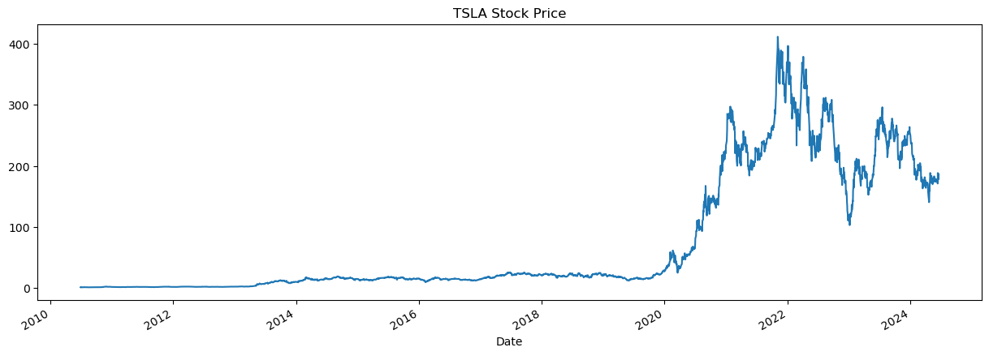
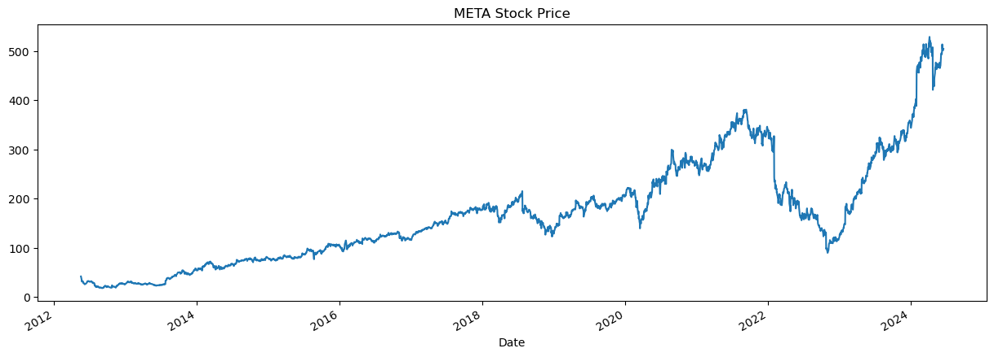
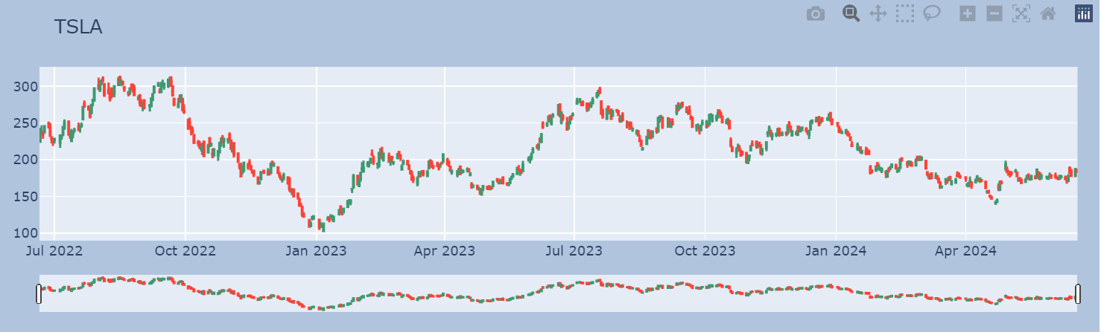
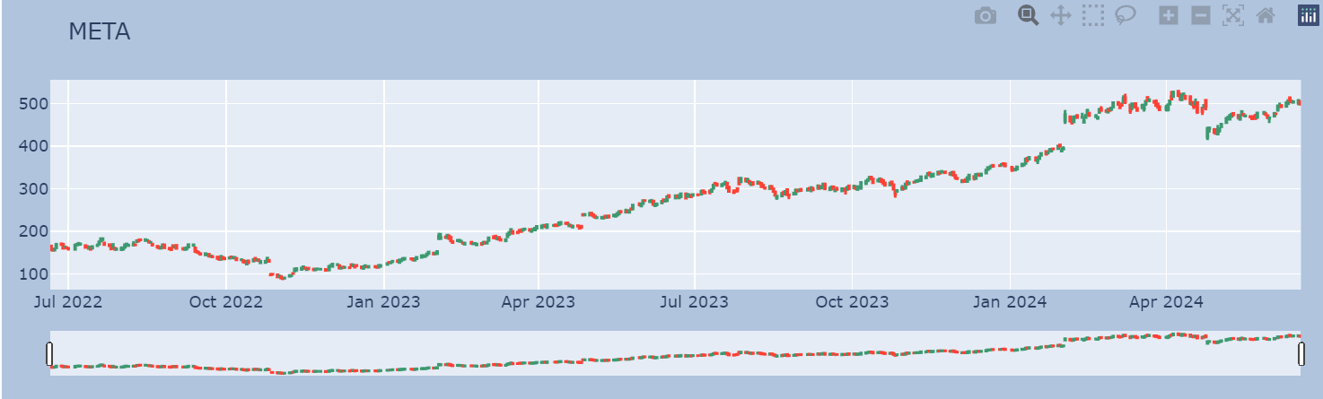

Since FINVIZ has various restrictions involved on scrapping.
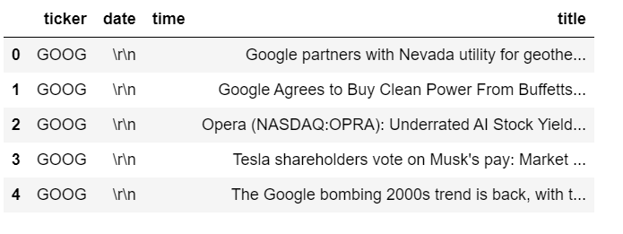
This was the type of data I was getting after scrapping. Therefore in this code HTML files for META and tesla at various points have been downloaded.

HTML files.
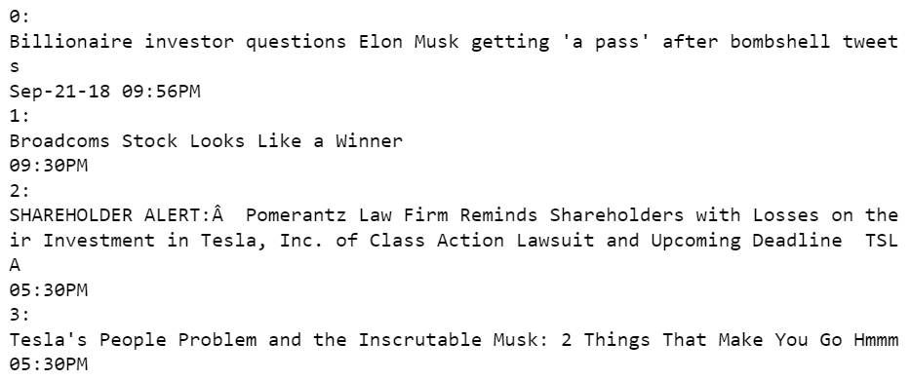

Scraping the textual Data.
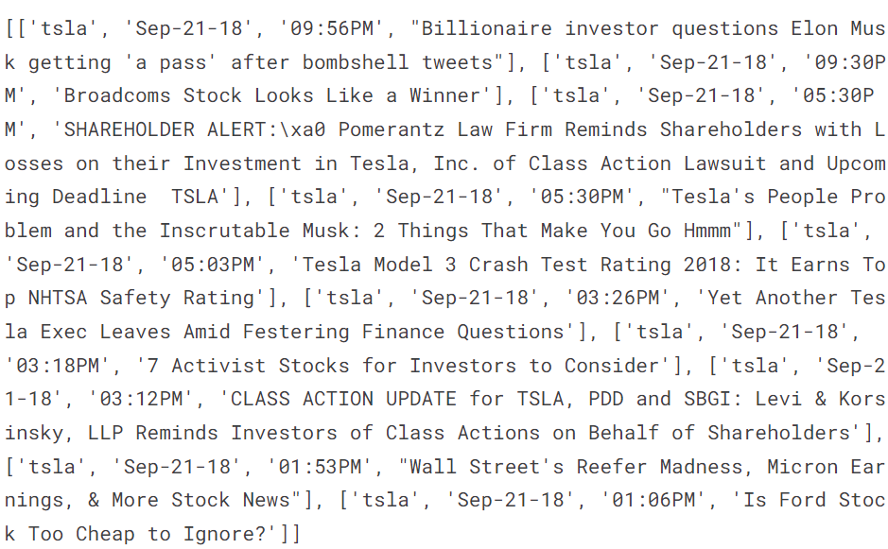

STEP 2:
Performing sentiment analysis to label the data with neutral, negative and positive sentiments. As sentiment analysis is very context dependent we added some words with their score from our side.
new_words = {
'crushes': 10,
'beats': 5,
'misses': -5,
'trouble': -10,
'falls': -100,
}

With these words included we updated the lexicon.
NLTK VADER is used for sentiment Analysis.
What is Sentiment Analysis?
Sentiment analysis is the process of analyzing digital text to determine if the emotional tone of the message is positive, negative, or neutral. It is a natural language processing (NLP) technique used to identify the emotional tone behind a body of text, such as customer feedback, social media posts, or reviews. The goal of sentiment analysis is to help organizations understand the opinions and emotions expressed in text data, which can be used to inform business decisions, improve customer service, and enhance marketing strategies.
What is VADER?
VADER stands for Valence Aware Dictionary and Sentiment Reasoner. It’s a tool used for sentiment analysis, which is basically a way to figure out if a piece of text is expressing positive, negative, or neutral emotions.
Using Vader we assigned polarity to each headline.
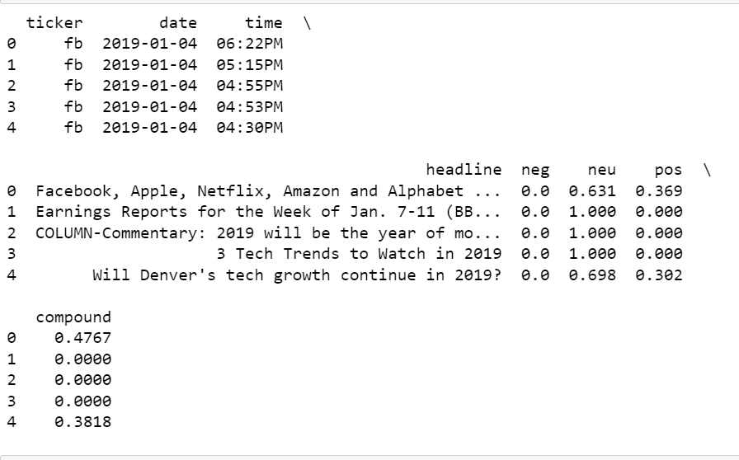
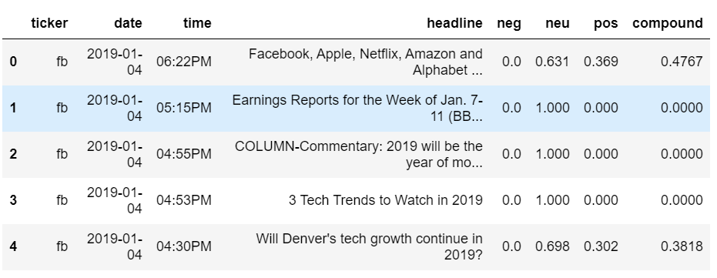
Plotting the sentiments
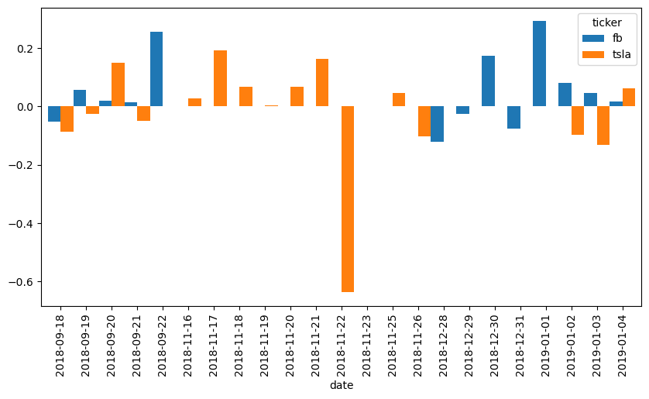
Checking for only one single day
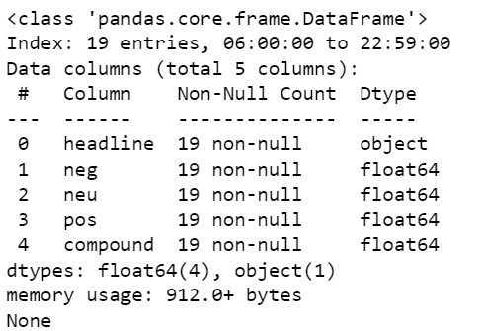
Plotting this single day data.
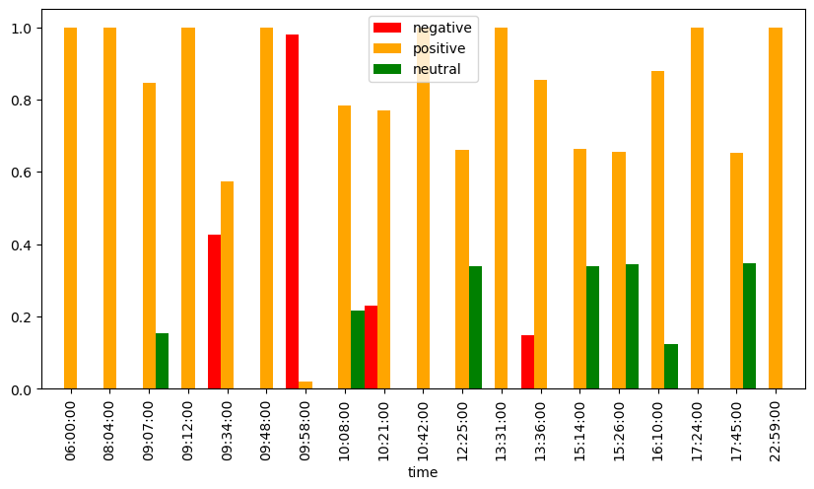
Labeling the dataset with neutral, negative and positive and then dividing the dataset of two stocks.
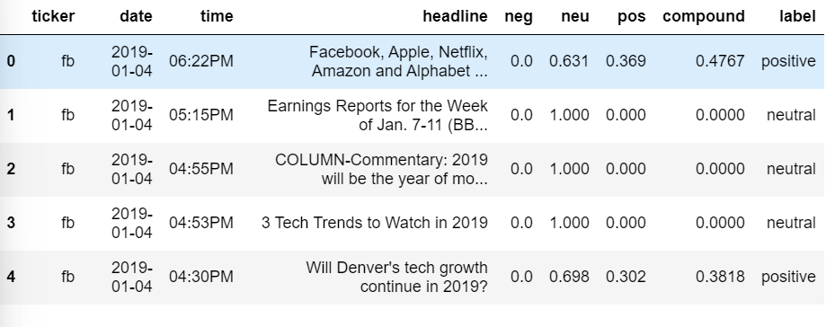
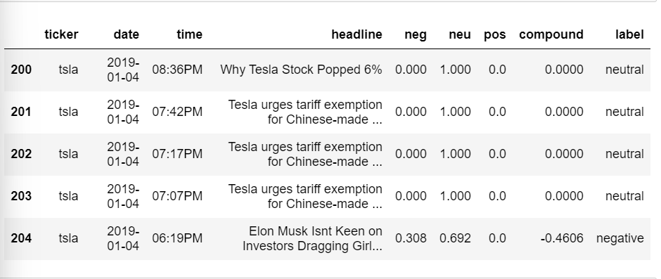

STEP 3:

1. Sharpe Ratio
The Sharpe ratio measures the risk-adjusted return of an investment or trading strategy.
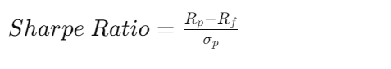

2. Maximum Drawdown
Maximum drawdown measures the largest loss from a peak to a trough of a portfolio's value. It is typically expressed as a percentage:
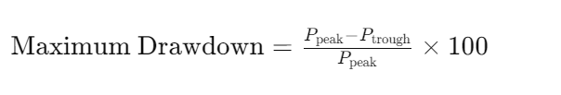

3. Number of Trades Executed
Simply counts the total number of buy and sell transactions executed during the trading period.

4. Win Ratio

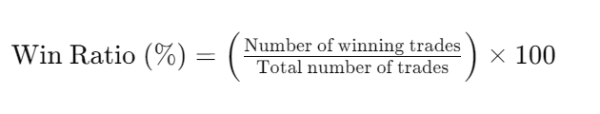
Win ratio measures the percentage of winning trades out of total trades executed:

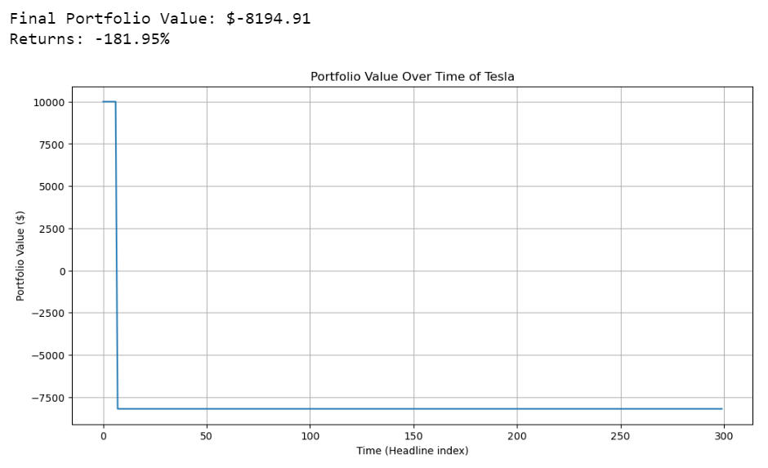
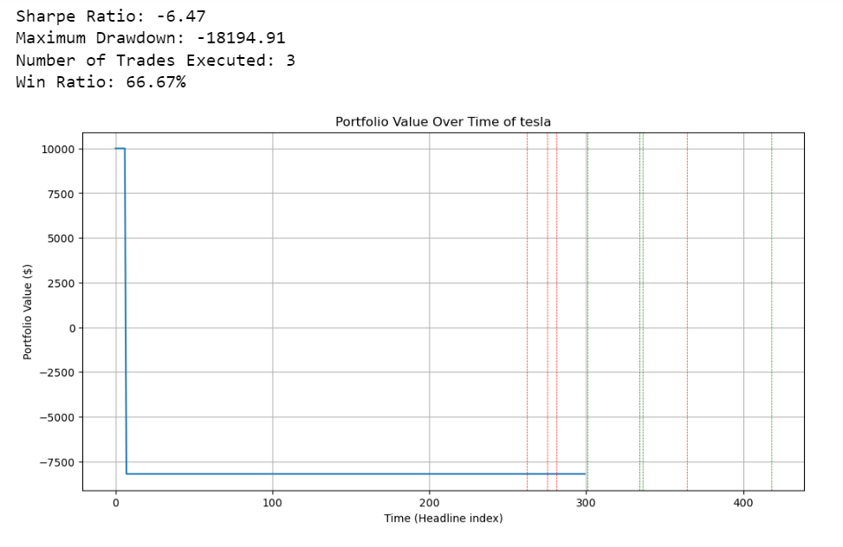

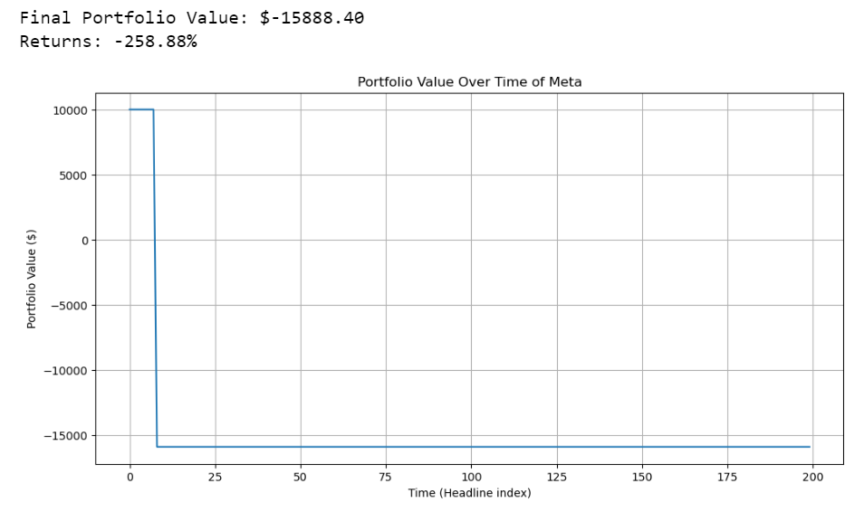
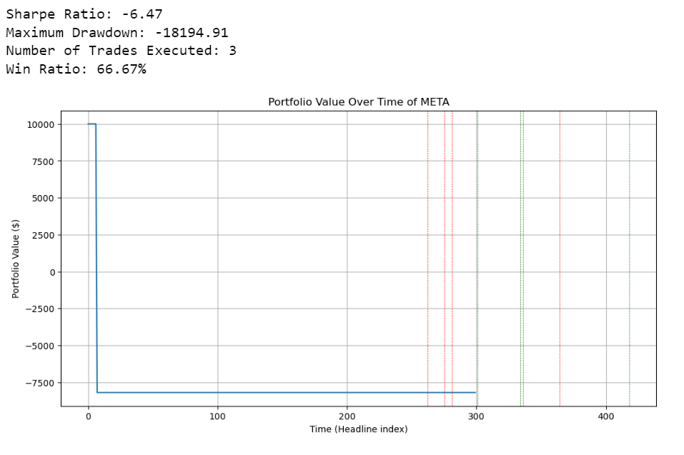
STEP 4:
For training the dataset the headlines were converted into vectors and the above labeling is used for supervised learning. To achieve this task the headline text was tokenized.
TESLA:
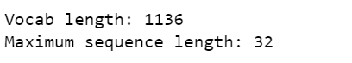
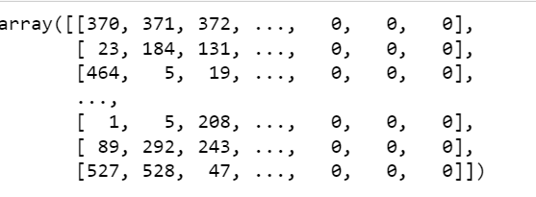
META:
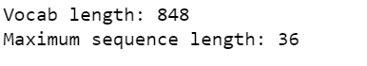
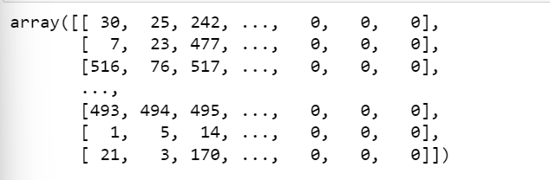
STEP 5:
What is a neural network?
A neural network is a machine learning program, or model, that makes decisions in a manner similar to the human brain, by using processes that mimic the way biological neurons work together to identify phenomena, weigh options and arrive at conclusions.
Why neural network?
Ability to Capture Non-linear Relationships. Neural networks, especially deep neural networks (DNNs), can capture complex patterns and non-linear relationships in data. In NLP, language is inherently non-linear and nuanced, with dependencies that are often contextual and multi-layered. DNNs with multiple hidden layers can learn hierarchical representations of language, enabling them to model intricate linguistic features.
Training the neural network on both stocks’ datasets separately.
STEP 6:
To find better accuracy, the model was run for different number of epochs and number of dense layers and optimizer was also varied.
TESLA
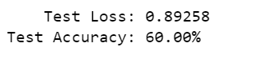
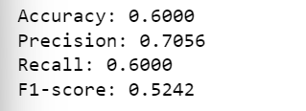
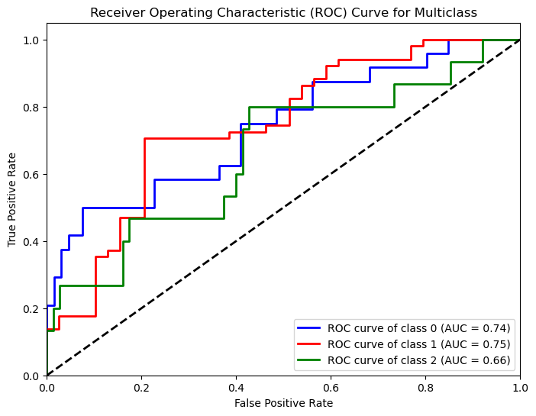
META
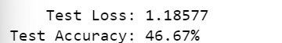
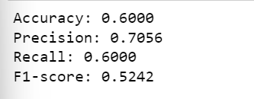

STEP 7:
TESLA
Model: Neural Network
Accuracy: 0.6000
Precision: 0.7056
Recall: 0.6000
F1-score: 0.5242

Model: Logistic Regression
Accuracy: 43.33%
Precision: 42.44%
Recall: 43.33%
F1 Score: 41.80%

Model: Support Vector Classifier
Accuracy: 46.67%
Precision: 75.11%
Recall: 46.67%
F1 Score: 29.70%

Model: Random Forest
Accuracy: 48.33%
Precision: 49.82%
Recall: 48.33%
F1 Score: 43.81%

Model: Gradient Boosting
Accuracy: 48.33%
Precision: 47.28%
Recall: 48.33%
F1 Score: 45.23%

Model: K-Nearest Neighbors
Accuracy: 51.67%
Precision: 52.04%
Recall: 51.67%
F1 Score: 48.93%

Model: Decision Tree
Accuracy: 40.00%
Precision: 40.53%
Recall: 40.00%
F1 Score: 40.10%

BEST MODEL AND PARAMETERS
SVC (C=1, gamma=1)
{'C': 1, 'gamma': 1, 'kernel': 'rbf'}

META
Model: Neural Network
Accuracy: 0.6000
Precision: 0.7056
Recall: 0.6000
F1-score: 0.5242
Model: Logistic Regression
Accuracy: 43.33%
Precision: 42.44%
Recall: 43.33%
F1 Score: 41.80%

Model: Support Vector Classifier
Accuracy: 46.67%
Precision: 75.11%
Recall: 46.67%
F1 Score: 29.70%

Model: Random Forest
Accuracy: 46.67%
Precision: 46.67%
Recall: 46.67%
F1 Score: 39.85%

Model: Gradient Boosting
Accuracy: 48.33%
Precision: 47.28%
Recall: 48.33%
F1 Score: 45.23%

Model: K-Nearest Neighbors
Accuracy: 51.67%
Precision: 52.04%
Recall: 51.67%
F1 Score: 48.93%

Model: Decision Tree
Accuracy: 40.00%
Precision: 39.75%
Recall: 40.00%
F1 Score: 39.82%

