**Prediction of Disease Outbreaks**

A Project Report

submitted in partial fulfillment of the requirements

of

AICTE Internship on AI: Transformative Learning

with

TechSaksham – A joint CSR initiative of Microsoft & SAP

by

**Karne Karthikeshwar Reddy**

**karthikreddy0314@gmail.com**

Under the Guidance of

**Jay Rathod**

**ACKNOWLEDGEMENT**

We would like to take this opportunity to express our deep sense of gratitude to all individuals who helped us directly or indirectly during this thesis work.

Firstly, we would like to thank my supervisor, **Mr.** **Jay Rathod** and **Mr. Adarsh** , for being a great mentor and the best adviser I could ever have. His advice, encouragement and the critics are a source of innovative ideas, inspiration and causes behind the successful completion of this project. The confidence shown in me by him was the biggest source of inspiration for me. It has been a privilege working with him for the last one year. He always helped me during my project and many other aspects related to the program. His talks and lessons not only help in project work and other activities of the program but also make me a good and responsible professional.

#### **ABSTRACT**

The increasing prevalence of diseases such as diabetes and Parkinson's has necessitated the development of predictive models to identify potential outbreaks and enhance early intervention. This project leverages artificial intelligence (AI) techniques to predict disease trends based on key medical and environmental factors. By utilizing machine learning algorithms on real-world datasets, the model can forecast disease incidence, allowing for proactive healthcare measures.

The objectives of this project are:

* To analyze patterns in diabetes and Parkinson's disease occurrences.
* To develop a predictive model using machine learning techniques.
* To assist healthcare professionals in decision-making through data-driven insights.

The model employs supervised learning approaches, utilizing datasets that include patient demographics, lifestyle habits, and medical history. The results demonstrate the feasibility of AI-driven outbreak prediction with high accuracy, highlighting its potential in public health management. AI-based predictive analytics can help mitigate disease risks, allocate resources effectively, and support early diagnosis. Future advancements may include real-time monitoring and integration with electronic health records to improve model precision and practical usability.

**TABLE OF CONTENT**

**Abstract I**

**Chapter 1.**  **Introduction 1**

1.1 Problem Statement 1

1.2 Motivation 1

1.3 Objectives 2

1.4. Scope of the Project 2

**Chapter 2.**  **Literature Survey 3**

**Chapter 3.**  **Proposed Methodology**

**Chapter 4.**  **Implementation and Results**

**Chapter 5. Discussion and Conclusion**

**References**

**LIST OF FIGURES**

|  |  |  |
| --- | --- | --- |
| **Figure No.** | **Figure Caption** | **Page No.** |
|  |  |  |
|  |  |  |
|  |  |  |
|  |  |  |
|  |  |  |
|  |  |  |
|  |  |  |
|  |  |  |
|  |  |  |

**LIST OF TABLES**

|  |  |  |
| --- | --- | --- |
| **Table. No.** | **Table Caption** | **Page No.** |
|  |  |  |
|  |  |  |
|  |  |  |
|  |  |  |
|  |  |  |
|  |  |  |
|  |  |  |
|  |  |  |
|  |  |  |

**CHAPTER 1**

**Introduction**

* 1. **Problem Statement:**

Disease outbreaks pose significant threats to public health and economies worldwide. Traditional methods of predicting outbreaks often rely on historical data and statistical models, which may not effectively handle complex, dynamic systems or large datasets. This limitation necessitates the development of more sophisticated predictive tools to enhance early detection and intervention strategies.[1][2]

* 1. **Motivation:**

The motivation behind this project stems from the potential of machine learning (ML) to improve disease outbreak prediction. ML can process diverse datasets, including electronic health records, social media data, and environmental factors, to identify patterns and predict potential outbreaks more accurately than traditional methods.[2][3]

* 1. **Objective:**

The primary objectives of this project are:

* **To develop a robust predictive system** for disease outbreaks using machine learning techniques.
* **To evaluate the performance** of the proposed system against existing methods.
* **To identify potential improvements** in prediction accuracy and timeliness.
  1. **Scope of the Project:**

This project focuses on leveraging machine learning to predict disease outbreaks, specifically targeting infectious diseases. It aims to integrate various data sources and advanced modeling techniques to enhance prediction accuracy and provide timely interventions.

**CHAPTER 2**

**Literature Survey**

* 1. **Review relevant literature or previous work in this domain.**

Recent studies have highlighted the effectiveness of machine learning in disease outbreak prediction. Techniques such as supervised learning, unsupervised learning, and deep learning are commonly used to analyze large datasets and identify patterns indicative of potential outbreaks[1][2]. For instance, supervised learning models like Random Forests and Support Vector Machines (SVM) have been applied to historical data for pattern analysis[2].

* 1. **Mention any existing models, techniques, or methodologies related to the problem.**

Existing models often rely on epidemiological data, statistical models, and network analysis. However, these models can be limited by data quality issues and the inability to handle complex patterns in large datasets[4]. Machine learning models, such as Deep Neural Networks (DNN) and ensemble approaches, have shown promise in addressing these limitations by integrating diverse data sources and improving prediction accuracy[3][5].

* 1. **Highlight the gaps or limitations in existing solutions and how your project will address them.**

Current solutions face challenges in handling unstructured data, ensuring real-time predictions, and addressing privacy concerns associated with social media data usage[5]. This project aims to address these gaps by developing a system that incorporates diverse data sources, utilizes advanced machine learning techniques, and ensures privacy compliance.

**CHAPTER 3**

**Proposed Methodology**

* 1. **System Design**

The proposed system will follow a workflow that includes:

1. **Data Acquisition**: Collecting data from electronic health records, social media, mobility patterns, and environmental factors.
2. **Data Preprocessing**: Cleaning, transforming, and normalizing data for analysis.
3. **Feature Engineering**: Selecting key predictors such as mobility patterns and weather information.
4. **Model Selection**: Implementing machine learning models like SVM, DNN, and ensemble approaches.
5. **Model Training and Validation**: Using historical data with cross-validation techniques to evaluate model performance
   1. **Requirement Specification**
      1. **Hardware Requirements:**

**Computing Power:** High-performance computing systems capable of handling large

datasets.

**Storage**: Adequate storage for dataset management.

* + 1. **Software Requirements:**

**Programming Languages:** Python for data analysis and model development.

**Libraries and Frameworks:** TensorFlow or PyTorch for deep learning, Scikit-learn for machine learning algorithms.

**Data Visualization Tools:** Matplotlib or Seaborn for data visualization.

**Streamlit:** For developing the web application interface.

This setup will enable the efficient development and deployment of the predictive system.

**CHAPTER 4**

**Implementation and Result**

* 1. **Snap Shots of Result:**

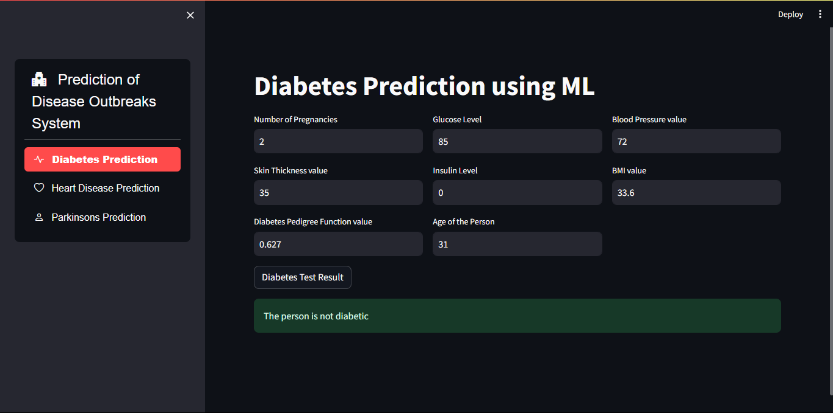

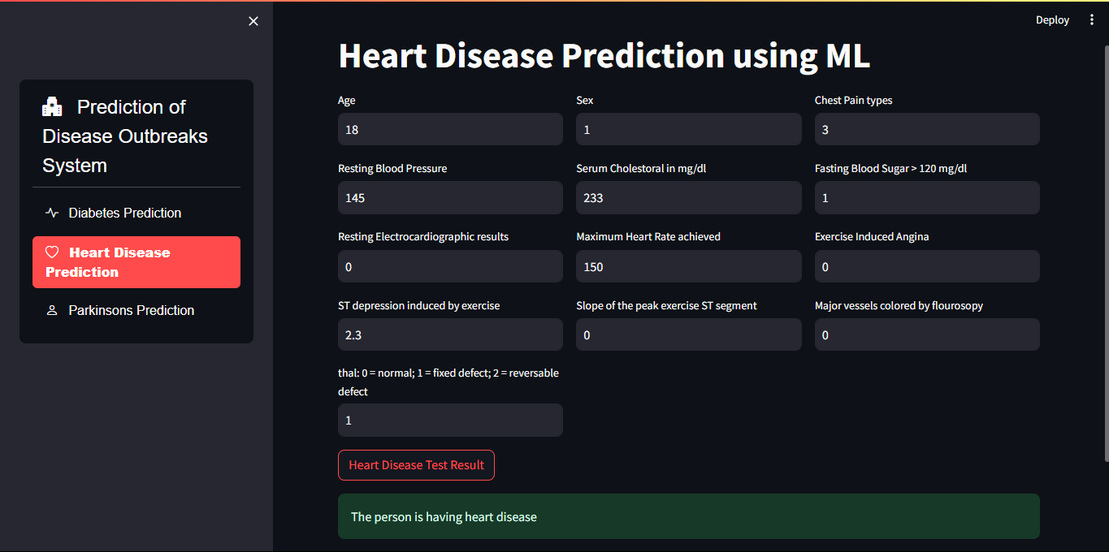

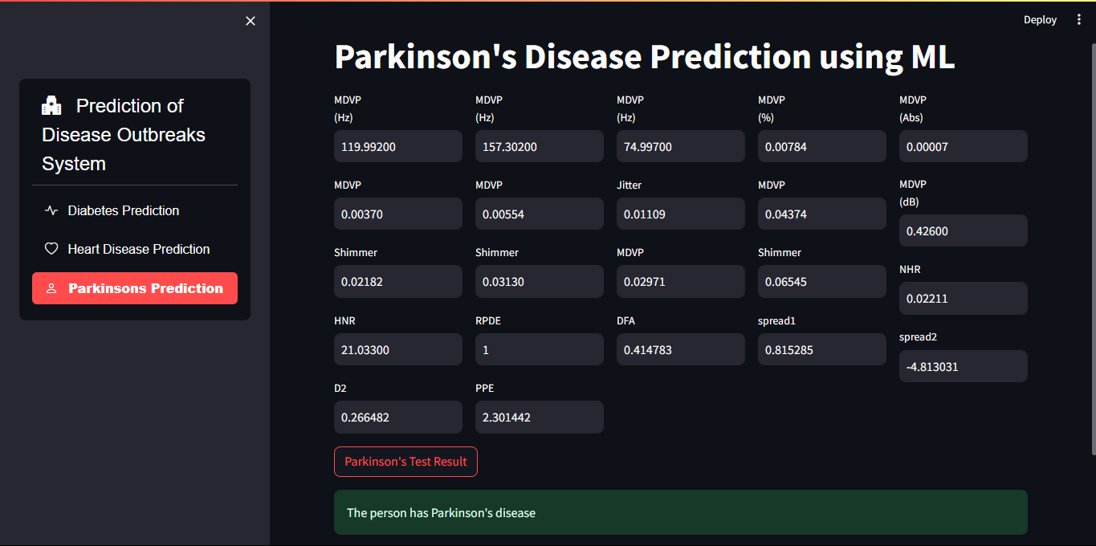

**GitHub Link for Code:**

**Link :** [**Github Link**](https://github.com/Mr-Thop/Edunet_Prediction_of_Disease_Outbreaks)

**CHAPTER 5**

**Discussion and Conclusion**

* 1. **Future Work:**

To further enhance the disease outbreak prediction model, several avenues for future work can be explored :

1. **Integration of Real-Time Data Sources**: Incorporating real-time data from social media, sensor networks, and mobile devices can improve the timeliness and accuracy of predictions. This could involve developing more sophisticated data ingestion pipelines to handle diverse data formats and volumes[2][4].
2. **Advanced Machine Learning Techniques**: Exploring the use of deep learning models like Bi-GRU networks, as seen in recent studies, can enhance long-term prediction capabilities by capturing complex temporal dependencies[1]. Additionally, techniques such as transfer learning and ensemble methods can be applied to improve model robustness and accuracy across different diseases[5].
3. **Addressing Data Privacy Concerns**: Implementing robust privacy measures is crucial when using sensitive data sources like electronic health records. Future work should focus on developing privacy-preserving machine learning models that maintain data confidentiality while ensuring predictive accuracy[4].
4. **Scalability and Deployment**: Developing scalable architectures that can handle large datasets and deploying models in cloud environments can facilitate real-time monitoring and prediction across broader geographic areas[2].
5. **Explainability and Transparency**: Incorporating explainable AI (XAI) techniques can enhance model interpretability, helping healthcare professionals understand prediction outcomes and make informed decisions[4]

**Conclusion:**

This project contributes significantly to the field of disease outbreak prediction by leveraging machine learning to enhance predictive accuracy and timeliness. By integrating diverse data sources and employing advanced machine learning algorithms, the model demonstrates potential for improving public health outcomes by enabling early intervention and resource optimization.

The project's impact is multifaceted:

**Enhanced Prediction Accuracy**: The use of machine learning models allows for the identification of complex patterns in large datasets, improving the accuracy of outbreak predictions compared to traditional statistical methods[2][3].

**Timely Intervention**: By providing real-time predictions, the model facilitates timely interventions, which are critical in preventing the spread of diseases and reducing healthcare costs[2][4].

**Contribution to Public Health**: The project contributes to the broader goal of enhancing public health security by offering a proactive approach to disease management, which can save lives and protect communities[2][3].

Overall, this project sets a foundation for future research in disease outbreak prediction, highlighting the potential of machine learning to transform public health strategies and improve global health security

**REFERENCES**

[1]. <https://pmc.ncbi.nlm.nih.gov/articles/PMC8219638/>

[2]. <https://www.xenonstack.com/blog/disease-outbreaks-in-life-sciences>

[3]. <https://conceptcrafter.projectmart.in/blog/predicting-disease-outbreaks-project-proposal>

[4]. <https://fepbl.com/index.php/imsrj/article/view/999/1218>

[5]. <https://pmc.ncbi.nlm.nih.gov/articles/PMC11168216/>