SMART WASTE SORTING BIN
HK$1,000 LEAN PROTOTYPE · VERSION 2.0
Standalone edge AI: ESP32-S3-CAM + MobileNetV2 + sensor fusion
420 × 420 × 900 mm · 4 × 8.7 L · BOM HK$866 · total ≈ HK$996
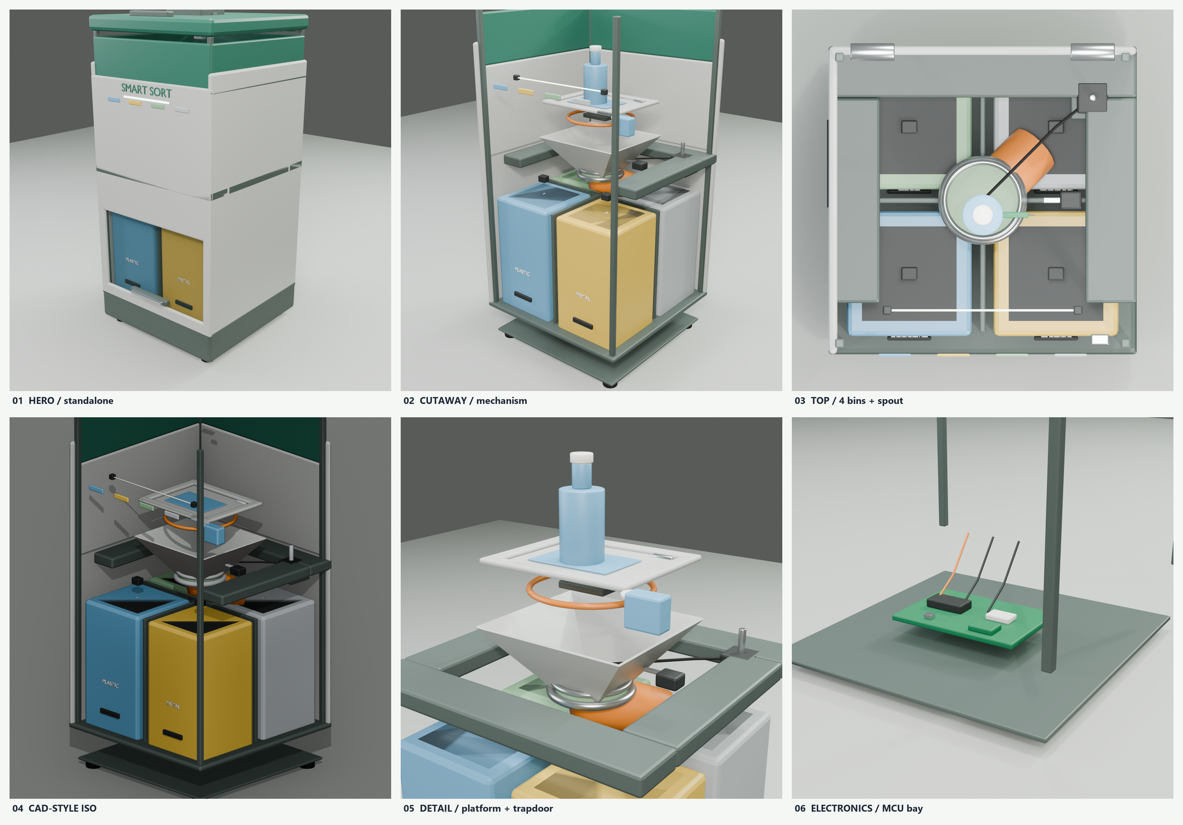
Standalone: no laptop, no cloud, no agent. MobileNetV2 runs on the ESP32-S3-CAM; WiFi AP is only for optional phone monitoring.

1. Why this version is feasible
The previous HK$1,000 sketch used a 28BYJ-48 stepper and a tilting load-cell tray. Both are marginal: the 28BYJ-48 has only ~0.033 N·m, and a tilting tray side-loads the load cell. This version fixes both.
- NEMA 17 (0.45 N·m) with 3:1 GT2 belt gives 1.35 N·m at the spout; required ≈ 0.34 N·m. Safety factor ≈ 4.
- Fixed weigh platform + small trapdoor: the 5 kg load cell never carries the servo or door side-load. The MG996R only pulls the door; a spring closes it.
- Top clearance is 225 mm (tray 635 mm, lid underside 860 mm), enough for an upright 500 mL bottle (~200 mm).
- Four standard 170 × 170 × 300 mm bins, no corner notches; spout rotates above the bins.
- 12 V 3 A adapter + 5 V buck: no Li-ion pack, no charging risk, no BMS cost.
Edge AI: ESP32-S3-CAM (8 MB PSRAM, 16 MB flash) runs MobileNetV2 0.35/0.5 at 96–128 px, INT8. MobileNetV2 1.0 at 224 px is too slow/large for this board; use transfer learning on the 0.35/0.5 backbone and fuse camera + weight + moisture + IR. No laptop, cloud or agent is used at run time.

2. Dimensions and capacity
Item | Value
Overall | 420 W × 420 D × 900 H mm
Bins | 4 × 170 × 170 × 300 mm; ≈ 8.7 L each
Total capacity | ≈ 34.7 L
Weigh platform | 220 × 180 mm fixed frame; 180 × 140 mm trapdoor
Funnel / spout | 220 × 200 → 75 mm; 75 mm elbow, outlet radius 100 mm
Max item | ≈ 500 mL bottle / 330 mL can; ≤ 0.5 kg
Cycle time | ≈ 6–10 s
Target accuracy | ≥ 80–85% on a 50-item local dataset

3. Internal structure
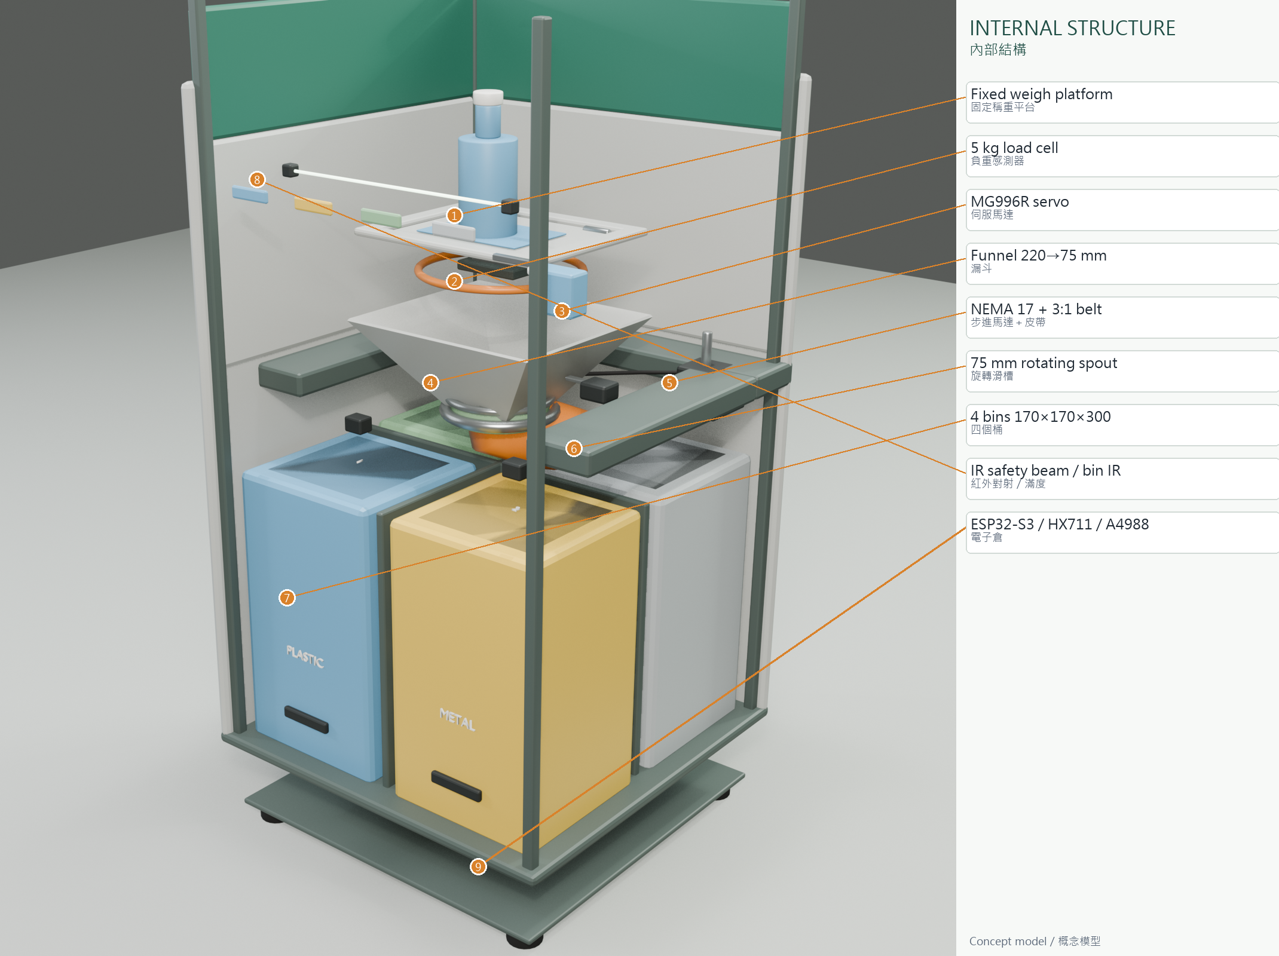
Figure 1. Internal structure: fixed platform, trapdoor, load cell, servo, funnel, NEMA 17 spout drive, bins, IR sensors and MCU bay.
The load path is deliberate: item → trapdoor → fixed platform → single 5 kg load cell → mid-frame. The servo and hinge are mounted on the platform frame, not on the load cell. When the trapdoor opens, the item falls through the funnel and the rotating spout into the selected bin. The spring closes the door when power is removed.
Why the trapdoor matters
A tilting tray changes the load-cell geometry and adds side-load. The fixed platform keeps weighing repeatable; the trapdoor only moves after the weight is recorded. This is the main mechanical fix for feasibility.

4. Sensors and MCU locations
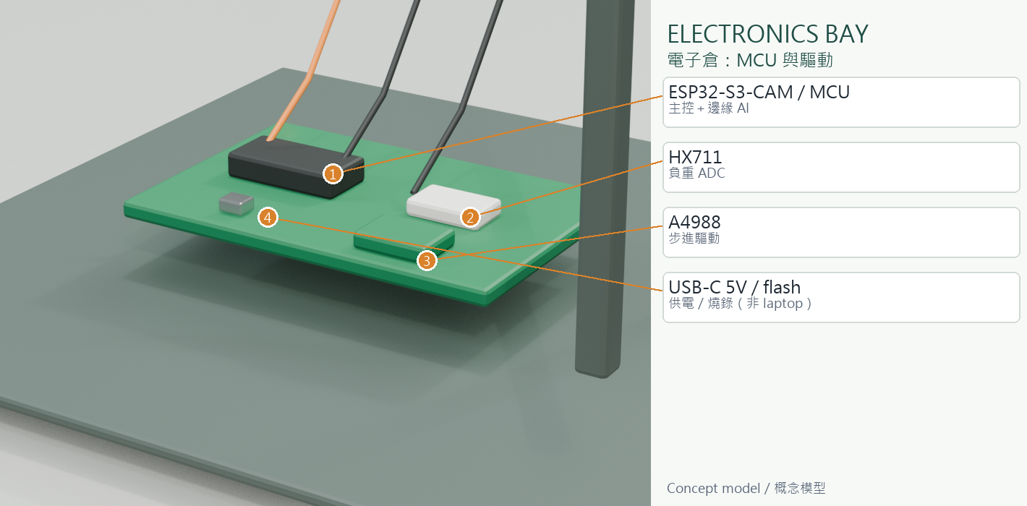
Figure 2. Electronics bay: ESP32, HX711, A4988, USB link and wiring.
Device | Location | Interface
ESP32-S3-CAM | Lid underside, looking down | On-device inference
IR safety beam | Hopper mouth | GPIO
5 kg load cell | Under fixed platform | HX711
Moisture pad | On trapdoor | ADC / ESP32
Metal coil | Under platform (fixed) | Digital
4 × IR bin-full | Mid-frame above each bin | GPIO
NEMA 17 + A4988 | Right of spout / base | STEP/DIR/EN
MG996R | Platform side | PWM
ESP32-S3 / HX711 / A4988 | Base electronics bay | —
Home switch | Beside spout | GPIO
OLED 0.96" | Front panel | I2C
microSD | ESP32-S3-CAM / base | SPI
12 V 3 A + 5 V buck | Base, rear | Power

5. BOM (HKD)
Item | Qty | Unit | Total
ESP32-S3-CAM | 1 | 120 | 120
OLED 0.96" | 1 | 20 | 20
microSD 16 GB | 1 | 15 | 15
5 kg load cell + HX711 | 1 | 35 | 35
NEMA 17 stepper | 1 | 75 | 75
A4988 driver | 1 | 18 | 18
MG996R servo | 1 | 35 | 35
IR break-beam | 1 | 15 | 15
Capacitive moisture | 1 | 15 | 15
4 × IR bin-full | 4 | 5 | 20
Microswitches | 3 | 3 | 9
12 V 3 A adapter | 1 | 45 | 45
5 V 3 A buck | 1 | 18 | 18
Plywood / acrylic | 1 | 160 | 160
3D-printed brackets | 1 | 45 | 45
Bins (reused) | 4 | 9 | 36
Hinges / screws / feet | 1 | 60 | 60
Wire / connectors | 1 | 45 | 45
Labels / tape | 1 | 20 | 20
Misc / spare | 1 | 15 | 15
Subtotal |  |  | 866
15% contingency |  |  | 130
TOTAL |  |  | ≈ 996

6. Operation
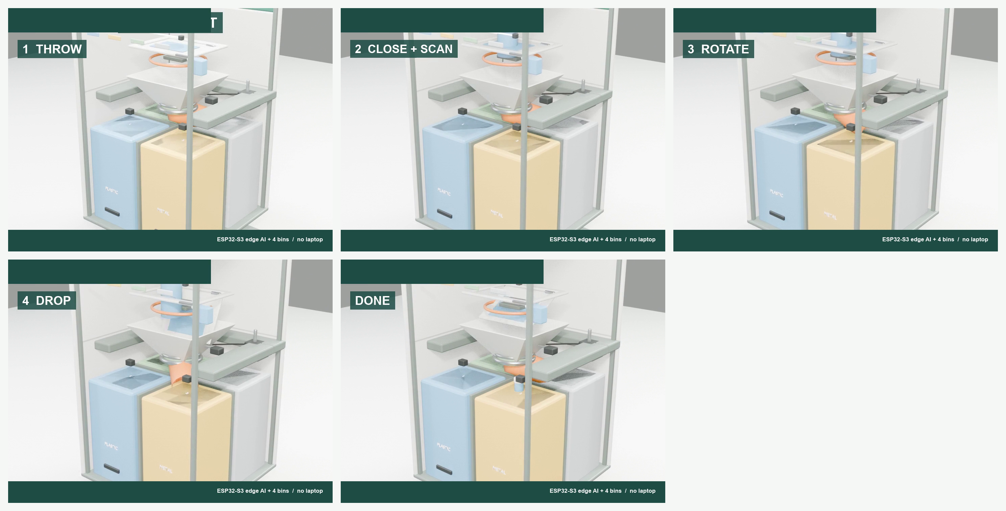
Figure 3. Operation storyboard: throw, close/scan, rotate, drop, done.
1. Lid is open; the bottle is thrown in and lands on the closed trapdoor.
2. Lid closes; ESP32-S3-CAM captures, MobileNetV2 runs on-board; weight/moisture/IR are fused.
3. The on-board classifier picks a bin; the ESP32 rotates the spout.
4. MG996R opens the trapdoor; the item falls through funnel and spout.
5. Spring closes the door; spout homes; app records the event.

7. Build and test notes
- Build the bin frame and 2 × 2 bins first; fit the platform and trapdoor before the lid.
- Bench-test NEMA 17 + A4988 at 0.8 A, 1/8 microstep, 3:1 belt; home switch repeatability ±2 steps.
- Calibrate the 5 kg cell with 0/100/500/1000 g; place the item within 60 mm of platform centre.
- Test 20 dry cycles, then 20 real items, then wet waste. Record jam rate, cycle time, accuracy.
- Never run with the lid or bin drawer open; keep the 12 V fuse and e-stop.

8. Limitations
- Standalone edge AI, but not full MobileNetV2: 0.35/0.5 at 96–128 px INT8; accuracy must be validated on your own 4-class dataset.
- Single load cell: off-centre items can add ±5–10 g error.
- IR bin-full sensors are fixed-height switches, not continuous level sensors.
- DIY metal coil is confirmatory; transparent plastic vs glass remains hard.
- Blender model is a concept/visualisation mesh, not a manufacturing CAD file.

