SMART WASTE
SORTING BIN
Engineering Design Package · Version 1.0
A low-cost, vision-assisted, four-stream sorting bin
for a final-year engineering project
Four streams: plastic bottle · metal · wet · dry/other
480 × 480 × 940 mm · ≈ 42.8 L · ≈ HK$4,050
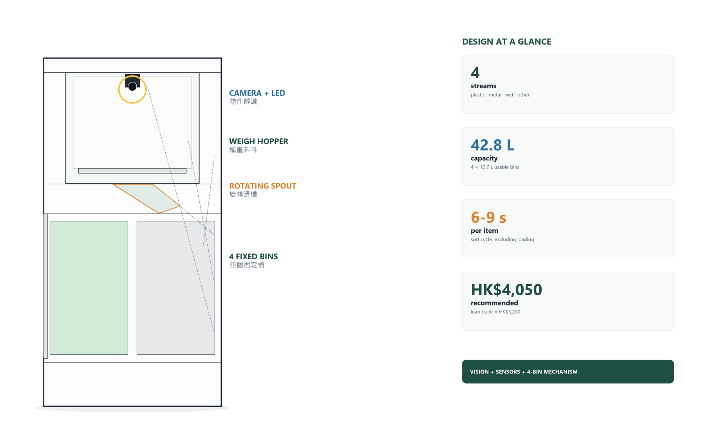
Design overview · 設計概覽
Document | Engineering design package / 工程設計方案
Version / date | 1.0 / 29 October 2026
Prepared for | Final-year engineering project (CCIT4080-style)
Design status | Design baseline — build and verify before submission
Language | English
This is a design and build guide, not a submission-ready report. Build, test, photograph and write up your own results. Prices are indicative and must be verified. Safety notes are mandatory reading.
Design at a glance · 設計一覽
Application | Indoor, one item at a time, four streams
Streams | Plastic bottle · metal · wet · dry/other
Size / mass | 480 × 480 × 940 mm; ≈ 22–26 kg empty
Capacity | 4 × 10.7 L usable; ≈ 42.8 L total
Cycle | 6–9 s typical; ≤ 10 s target
Accuracy | ≥ 85% overall on a 50-item mixed test
Control | Raspberry Pi Zero 2 W (vision/app) + ESP32 (real-time)
Power | 12 V 6 Ah Li-ion (BMS) or 12 V 5 A adapter
Cost | ≈ HK$4,050 recommended; ≈ HK$3,200 lean
Safety | Fused; e-stop; lid/drawer/door interlocks; spring-closed door
Why this design
Low torque, compact  The bins stay fixed; only a 0.35 kg spout rotates. No 15 kg carousel, no 700 mm round enclosure. | Safe by default  No actuator moves unless the lid, drawer and door are closed. The e-stop cuts actuator 12 V, not the controllers. | Buildable and repairable  Plywood, standard bins, 3D-printed brackets and off-the-shelf electronics. Bins and liner lift out for cleaning.
Build roadmap
1 | Frame + drawer | Weeks 3–6 | Cut, assemble, fit bins
2 | Hopper + spout | Weeks 5–8 | Load cells, door, bearing
3 | Electronics + firmware | Weeks 7–10 | Bench test every sensor
4 | Vision + integration | Weeks 10–14 | Dataset, model, first sort
5 | Test + report | Weeks 15–24 | 50-item test, video, report

How to use this document
This package is deliberately more detailed than a typical project proposal. It gives you a complete, buildable design, the reasoning behind each choice, a costed bill of materials, dimensioned drawings, wiring tables, firmware/software architecture, calibration steps, a test plan and a schedule.
Read it in three passes.
1. Pass 1 — understand the machine (Sections 1–3). Read the problem, requirements, concept comparison and system overview. This is the material you need for your proposal presentation.
2. Pass 2 — build it (Sections 4–6). Use the drawings, cut list, pin table and build sequence. Do not order every part before you have checked the dimensions against your own bin and camera.
3. Pass 3 — prove it (Sections 7–9). Use the test plan, risk register and schedule. Your marks come from evidence of design decisions, build progress, testing and evaluation — not from a perfect-looking CAD model.
What is fixed and what you should verify
Fixed design intent | Verify before cutting or ordering
Four streams: plastic bottle, metal, wet, dry/other | Your local bin sizes and available plastics
Top-loading weigh hopper with bottom door | Camera field of view with your actual lens
Four fixed bins + rotating spout | Bin supplier dimensions (the 190 × 190 mm internal size is nominal)
Raspberry Pi + ESP32 two-processor architecture | Local price and availability; a Pi 4 is a drop-in upgrade
12 V SELV power, fused, e-stop | Battery certification and charger compatibility
Target cost ≤ HK$4,500 | Current street prices; use the lean substitutions if needed

A note on academic integrity. Use this as an engineering reference. Measure your own parts, keep a logbook, record failures, and write your report in your own words. If your course requires disclosure of AI-assisted drafting, disclose it. Do not present a design you did not build and test as completed.
About the drawings
Figures in this document are A4 overviews. Full-resolution PNGs are in 02_Drawings; print Figures 3–5 at A3 when you need to read every dimension. The text tables are the authoritative build data.

Safety first. The prototype uses 12 V, but a Li-ion pack can deliver very high fault current. Use a certified pack with a BMS, a fuse, a main switch and an e-stop. Do not charge the pack unattended inside the bin. Do not put sharp, hot, medical, or liquid waste into the prototype. This is an indoor demonstration machine, not a certified appliance.

Contents
1. Project definition
2. Design exploration and decisions
3. System overview
4. Mechanical design
5. Electrical design
6. Firmware and software
7. Cost, procurement and resources
8. Build, test and evaluation plan
9. Limitations, future work and conclusion
Appendix A. Full bill of materials
Appendix B. Cut list
Appendix C. Pin and connector schedule
Appendix D. Serial protocol and API
Appendix E. Test record templates
Appendix F. References
Quick navigation
If you need to… | Read
Explain the project in a proposal | Sections 1–3, Figures 1–2, BOM summary
Buy parts this week | Section 7, Appendix A, Appendix B
Cut and assemble the frame | Section 4, Figures 2–5, Appendix B
Wire the electronics | Section 5, Figures 6–7, Appendix C
Write the firmware/software | Section 6, Figure 8, Appendix D
Plan the tests and report | Section 8, Appendix E

1. Project definition

1.1 The problem
Hong Kong’s waste problem is not only about landfill space. It is also about contamination: recyclables placed in the wrong bin, or food-soiled materials placed in recycling, reduce the value of the whole collection and can send an entire load to landfill. A well-designed bin cannot fix the whole system, but it can remove one common barrier — the user has to make a quick, confident decision at the point of disposal.
Most existing public bins are passive. They rely on labels, colours and the user’s knowledge. Research on recycling behaviour consistently shows that confusion about materials, unclear labels and inconvenience are major causes of contamination. A bin that sees the item, weighs it, checks moisture/metal, decides a stream, and records the event can make sorting more reliable and produce useful data for the building or campus. For Hong Kong waste and recycling context, see [1].
The project is a good final-year engineering vehicle because it combines:
- mechanical design (drawer, hopper, door, rotating spout, load path);
- embedded systems (ESP32, sensors, stepper/servo, safety interlocks);
- computer vision (dataset, transfer learning, TFLite);
- app/cloud/data (local web app, database, optional cloud sync);
- engineering evaluation (accuracy, cycle time, jam rate, cost, usability).
The design in this package is intentionally low-cost and repairable. It uses plywood, standard plastic bins, 3D-printed brackets, a Raspberry Pi Zero 2 W, an ESP32 and off-the-shelf sensors. It does not use a industrial PLC, a 6-axis robot, or a custom injection-moulded enclosure.

1.2 Project goal and objectives
Goal: design, build and evaluate a low-cost smart bin that sorts one item at a time into four streams — plastic bottle, metal, wet waste, and dry/other — using a camera and a small sensor suite, with a phone app that records each event.
ID | Objective | How it will be measured
O1 | Classify four streams with at least 85% overall accuracy | 50-item mixed test, three runs, confusion matrix
O2 | Complete a sort cycle in 10 s or less (excluding user loading) | Stopwatch/log timestamps over 50 cycles
O3 | Achieve at least 90% successful sorts without a jam or manual reset | 50-cycle reliability test
O4 | Estimate bin fill level within ±10% of the measured fill height | Compare ToF estimate with ruler at 25%, 50%, 75%, 100%
O5 | Keep the build cost at or below HK$4,500 | Final BOM with receipts
O6 | Prevent actuator motion when the lid, drawer or hopper door is open; stop within 100 ms on e-stop | Interlock test, 10 trials each
O7 | Record time, class, confidence, weight, moisture, metal flag, bin ID and fill level; export CSV | App/database inspection
O8 | Produce a repeatable build and test record suitable for the final report | Logbook, photos, test sheets, code repository

Non-goals for version 1.0: paper/glass as separate streams, compaction, odour control, outdoor weatherproofing, multiple items at once, sharp/medical waste, and a certified safety rating. These are future work, not failures.

1.3 Scope and operating envelope
Item | Design value | Reason
Waste streams | Plastic bottle, metal, wet, dry/other | Four bins; simple, visible, useful
Item size | ≤ 250 mm long, ≤ 110 mm diameter | Fits the 110 mm spout and 290 × 240 mm door
Item weight | ≤ 1.5 kg | Keeps door servo torque and load cells comfortable
Loading | One item at a time, indoor, manual lid | Simple, safe, demonstrable
Bin capacity | ≈ 10.7 L usable per bin; ≈ 42.8 L total | 190 × 190 × 360 mm internal minus 80 × 80 mm notch
Cycle time | 6–9 s typical; ≤ 10 s target | Camera + inference + 90° spout move
Power | 12 V 6 Ah Li-ion (BMS) or 12 V 5 A adapter | Portable demo; bench testing
Environment | 10–35 °C, dry indoor | Prototype, not outdoor
Users | One user at a time; standing height | Loading lip ≈ 900 mm

1.4 Requirements

Functional requirements
ID | Requirement | Acceptance
FR1 | Detect that an item has been placed in the hopper | ToF + weight; event within 1 s
FR2 | Capture a well-lit image of the item | Camera sees the full hopper floor; no clipping
FR3 | Classify into four streams plus an “unsure” outcome | Confidence and class returned by the model
FR4 | Fuse vision with weight, moisture and metal evidence | Decision table produces one bin or “ask user”
FR5 | Rotate the spout to the selected bin | ±3° repeatability; home verified
FR6 | Open the hopper door, dump the item, close it | 100 cycles without a jam; door limit confirmed
FR7 | Confirm the item left the hopper | Drop beam or door/weight change
FR8 | Measure and display bin fill level | Four ToF sensors; % and alert at 90%
FR9 | Record each event with timestamp, class, confidence, weight, moisture, metal, bin and fill | SQLite row; CSV export
FR10 | Provide a manual sort override in the app | User selects bin after confirmation
FR11 | Show status without a screen | RGB LED bar + buzzer + app
FR12 | Support safe stop and recovery | E-stop, lid/drawer interlocks, re-home

Non-functional requirements
ID | Requirement | Target
NFR1 | Cost | ≤ HK$4,500 recommended build; lean build ≤ HK$3,300
NFR2 | Buildability | Hand tools + local cutting/3D printing; no welding
NFR3 | Maintainability | Bins and hopper liner removable without tools; sensors replaceable
NFR4 | Safety | 12 V SELV; fused; e-stop; no motion with guards open; rounded edges
NFR5 | Reliability | ≥ 90% successful cycles over 50 items; no missed steps after homing
NFR6 | Usability | Loading height 850–950 mm; one-hand lid; clear labels; app instructions
NFR7 | Noise | < 65 dB(A) at 1 m during a cycle
NFR8 | Hygiene | Smooth wipe-clean liner; drip tray; no sharp internal corners
NFR9 | Privacy | Camera images processed locally; no faces stored; optional cloud opt-in
NFR10 | Documentation | Drawings, BOM, pin map, calibration and test records

Constraints and assumptions
- The bin is built in a school workshop or at home with hand tools; tolerance is ±2 mm, not machine-shop precision.
- The camera looks down through a fixed lid; ambient light is controlled by a ring light.
- The user closes the lid before sorting; the machine refuses to move if the lid is open.
- The prototype is demonstrated indoors on a level floor.
- The app runs on a phone/laptop on the same Wi-Fi network; cloud is optional.
- The design uses metric fasteners and mm dimensions.

1.5 Success criteria
A successful prototype is not “the model trains to 99% on my dataset”. It is a machine that:
1. sorts a mixed set of 50 real items with ≥85% overall accuracy and no unsafe behaviour;
2. completes ≥90% of cycles without a jam;
3. records every event correctly;
4. can be built and repaired by one student with the specified tools;
5. stays within the budget;
6. produces evidence — photos, logs, confusion matrix, timings, failure notes — that you can defend in the report and viva.

1.6 Standards, safety and academic context
This is a prototype, not a certified product. Still, design to good practice:
- Electrical: 12 V SELV; fuse on the battery positive; separate buck converters; strain relief; no exposed conductors; e-stop in the actuator supply.
- Battery: certified 3S pack with BMS; charge outside the enclosure; fire-resistant bag; no unattended charging.
- Machinery: guard the lid hinge, drawer, door and spout; limit switches; no operation with guards open; round or cover sharp edges.
- Hygiene: removable PP liners; silicone seals; drip tray; clean after wet-waste tests; gloves.
- Data: local-first; no personal data; camera images can be deleted; app access on a private network.
- Academic: cite sources; keep a logbook; record failures; do not claim features you did not test.

2. Design exploration and decisions

2.1 Design drivers
The design was driven by six constraints, in this order:
1. Buildable by a beginner. Hand tools, local cutting, 3D-printed brackets, standard plastic bins. No welding, no custom gears, no high-voltage wiring.
2. Low cost. Target under HK$4,500 including battery and camera. Reuse where sensible; spend money on the parts that affect reliability (bearing, load cells, stepper, power).
3. Safe to demonstrate. The user must not be able to reach the sorting mechanism while it moves. The machine must fail safe on power loss or e-stop.
4. Reliable sorting. A simple, slow, repeatable mechanism is better than a fast, jam-prone one.
5. Maintainable and cleanable. Bins and hopper liner must come out without tools; wet waste must not reach electronics.
6. Good enough to evaluate. The design must produce measurable data: accuracy, cycle time, jam rate, fill-level error, cost.

2.2 Concept options
Four mechanisms were considered. The scores are 1 (poor) to 5 (good) for this project, not absolute engineering quality.
Criterion | A. Rotating bin carousel, fixed chute | B. Fixed bins, rotating spout | C. X–Y gantry over bins | D. Manual bins with app guidance
Mechanical complexity | Medium | Medium | High | Low
Motor torque needed | High (moves all bins + waste) | Low (moves only the spout) | Medium | None
Footprint | Large (round carousel ≥ 600 mm) | Compact (480 × 480 mm) | Large (rails) | Compact
Jam/spill risk | Medium–high (waste shifts) | Low–medium | Medium | None
Bin standardisation | Standard bins on a tray | Standard bins with a corner notch | Standard bins | Standard bins
Build cost | Medium | Low–medium | High | Lowest
Demonstrability | Good | Excellent (visible spout move) | Good | Weak (no automation)
Score | 3.4 | 4.6 | 2.6 | 2.0

Selected: B — four fixed bins and a rotating spout.

Why not rotate the bins?
A 2 × 2 tray of four 10 L bins plus waste can weigh 10–15 kg. Rotating that mass needs a large bearing, a geared motor with high torque, and a round enclosure large enough for the tray diagonal. A 480 mm square tray has a 679 mm diagonal, so it cannot rotate inside a 480 mm square bin. The enclosure would grow to at least 650–700 mm, which is heavy, expensive, and awkward to demonstrate. Waste can also shift and spill during rotation. The rotating-spout concept moves only a 0.3–0.5 kg elbow; the bins stay still, the drawer stays simple, and the enclosure stays compact.

Why not a gantry?
An X–Y gantry is flexible but needs two axes, rails, belts, limit switches and a rigid frame. It is harder to align, more expensive, and adds two more failure modes. For four fixed positions, a single rotary axis is the right kinematic choice.

Why not just manual bins with an app?
That is cheaper, but it does not meet the project’s engineering objective: the system must act on the classification. A display-only bin would also be hard to justify as a final-year engineering prototype. The selected design keeps the app as a record/override, not as the sorter.

2.3 Why two processors?
The original sketch suggested an ESP32-CAM as the only controller. That is possible, but it is a poor fit for a beginner building a four-class vision system with motors and many sensors.
Criterion | ESP32-CAM only | Raspberry Pi only | Pi Zero 2 W + ESP32
Camera | Good, but fixed-focus and limited memory | USB camera, easy | USB camera + UVC
AI | TFLite Micro; hard to train/deploy | Python/TFLite; easy | Easy on Pi
Real-time motion | Good | Linux jitter; possible but risky | Deterministic on ESP32
Pin count | Few; camera uses many pins | Enough, but 3.3 V and power limits | ESP32 handles I/O
App/cloud | Limited | Easy | Easy on Pi
Debugging | One binary | One Python app | Clear split; serial log
Cost | Lowest | Medium | Medium
Verdict | Cheap but risky | Simple but less robust | Selected

The Pi handles the camera, inference, database, web app and optional cloud. The ESP32 handles sensors, debouncing, stepper/servo timing, interlocks and fault handling. They talk over USB serial using newline-delimited JSON. This split is also a good story for the report: Linux for high-level work, a microcontroller for real-time work.
A Pi 4 (2 GB) is a drop-in upgrade if the Zero 2 W is too slow for your model. The serial protocol and wiring do not change.

2.4 Why no screen?
A screen adds cost, power, a cut-out, glare, and a cleaning problem in a wet-waste bin. The user already carries a phone. The bin needs only:
- a three-colour LED bar (idle, scanning, sorted, error, bin full);
- a buzzer for confirmation/fault;
- a phone PWA for detail, history and manual override.
This keeps the front panel simple and hygienic. If your supervisor wants a display, a 0.96-inch OLED can be added on I2C for status text, but it is not required.

2.5 Key design decisions
Decision | Options considered | Selected | Why
Item handling | Tilting tray / sliding plate / bottom door | Bottom door | Item sits still for weighing and imaging; door drops it cleanly; spring can close on power loss
Bin arrangement | 2 × 2 fixed / circular carousel / linear | 2 × 2 fixed | Compact, standard bins, simple drawer, low torque
Spout | Rotating elbow / swinging arm / fixed chute | Rotating elbow | One axis, 90° positions, visible, low torque
Bin level | Ultrasonic ×4 / ToF ×4 / one sensor on a arm | ToF ×4 | Narrow beam, no acoustic cross-talk, small window, I2C
Item presence | Camera only / ToF / weight only | ToF + weight | Camera can be fooled by a shadow; weight confirms a real item
Metal | Vision only / inductive proximity / coil | Vision + coil confirmation | A small inductive sensor only sees metal at its face; a coil sees a can anywhere on the door
Wet/dry | Vision only / capacitive pad / conductivity | Vision + capacitive pad | The pad is cheap and gives a physical moisture cue; vision handles the rest
Lid | Manual / servo / linear actuator | Manual with gas strut | Fewer actuators, safer, cheaper; the user must close it before sorting
Power | 12 V adapter / 12 V Li-ion / 5 V USB | 12 V Li-ion + adapter | Portable demo; adapter for bench testing

2.6 The one-sentence design
A top-loading, lidded bin weighs and photographs one item on a spring-closed hopper door, uses a Pi-hosted MobileNetV2 classifier plus moisture/metal/weight evidence to choose one of four streams, rotates a 110 mm spout to the matching fixed bin, drops the item through a funnel, and records the event in a phone app.

2.7 What could go wrong — and the design response
Failure | Design response
Item jams in funnel | 110 mm outlet, 59° walls, smooth joints, drop-confirmation beam, access panel, optional vibration motor
Transparent bottle confused with glass/metal | Local dataset, diffuse lighting, confidence threshold, metal coil, manual override
Wet waste contaminates sensor | Moisture pad under replaceable HDPE; coil and ToF fixed to frame, not door; drip tray; wipe-clean liner
Spout misses bin | Home switch each cycle, 3:1 belt, always approach clockwise, ±3° repeatability, 190 mm bin opening
Load cell drift | Tare each cycle; 4-cell platform; shielded cable; no pipe/cable bypassing the hopper
Lid opened during motion | Reed switch + software interlock; actuators stop; re-home required
Battery fault | Certified pack, BMS, fuse, main switch, e-stop, charge outside, fire bag
Pi crashes | ESP32 stops and shows fault; no motion without a valid SORT command; watchdog
User puts in a 2 L bottle | Label and app warning; 110 mm spout limits size; test with typical 500 mL–1.5 L items

3. System overview

3.1 Architecture
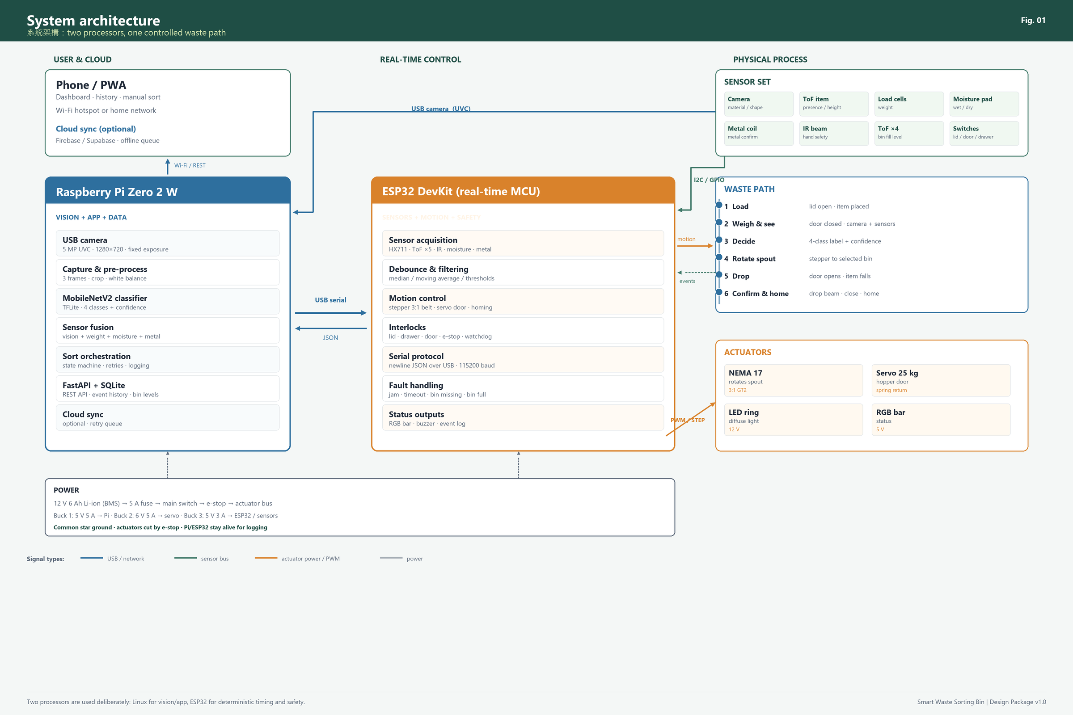
Figure 1. System architecture: sensors and actuators around the ESP32, vision/app/data on the Raspberry Pi, and a single controlled waste path.
The system has five layers:
1. Physical: lid, hopper, door, funnel, spout, four bins, drawer.
2. Sensing: camera, item ToF, four load cells, moisture pad, metal coil, IR beam, four bin ToF sensors, switches.
3. Real-time control: ESP32 — sampling, debouncing, motion, interlocks, fault handling.
4. Vision and application: Raspberry Pi — camera capture, MobileNetV2 inference, sensor fusion, SQLite, FastAPI, PWA.
5. User/cloud: phone browser on the local network; optional Firebase/Supabase sync.
The important architectural rule: the ESP32 never moves an actuator without an explicit, validated command. If the Pi crashes or the USB cable falls out, the ESP32 goes to a safe state, not into a random sort.

3.2 Operating sequence
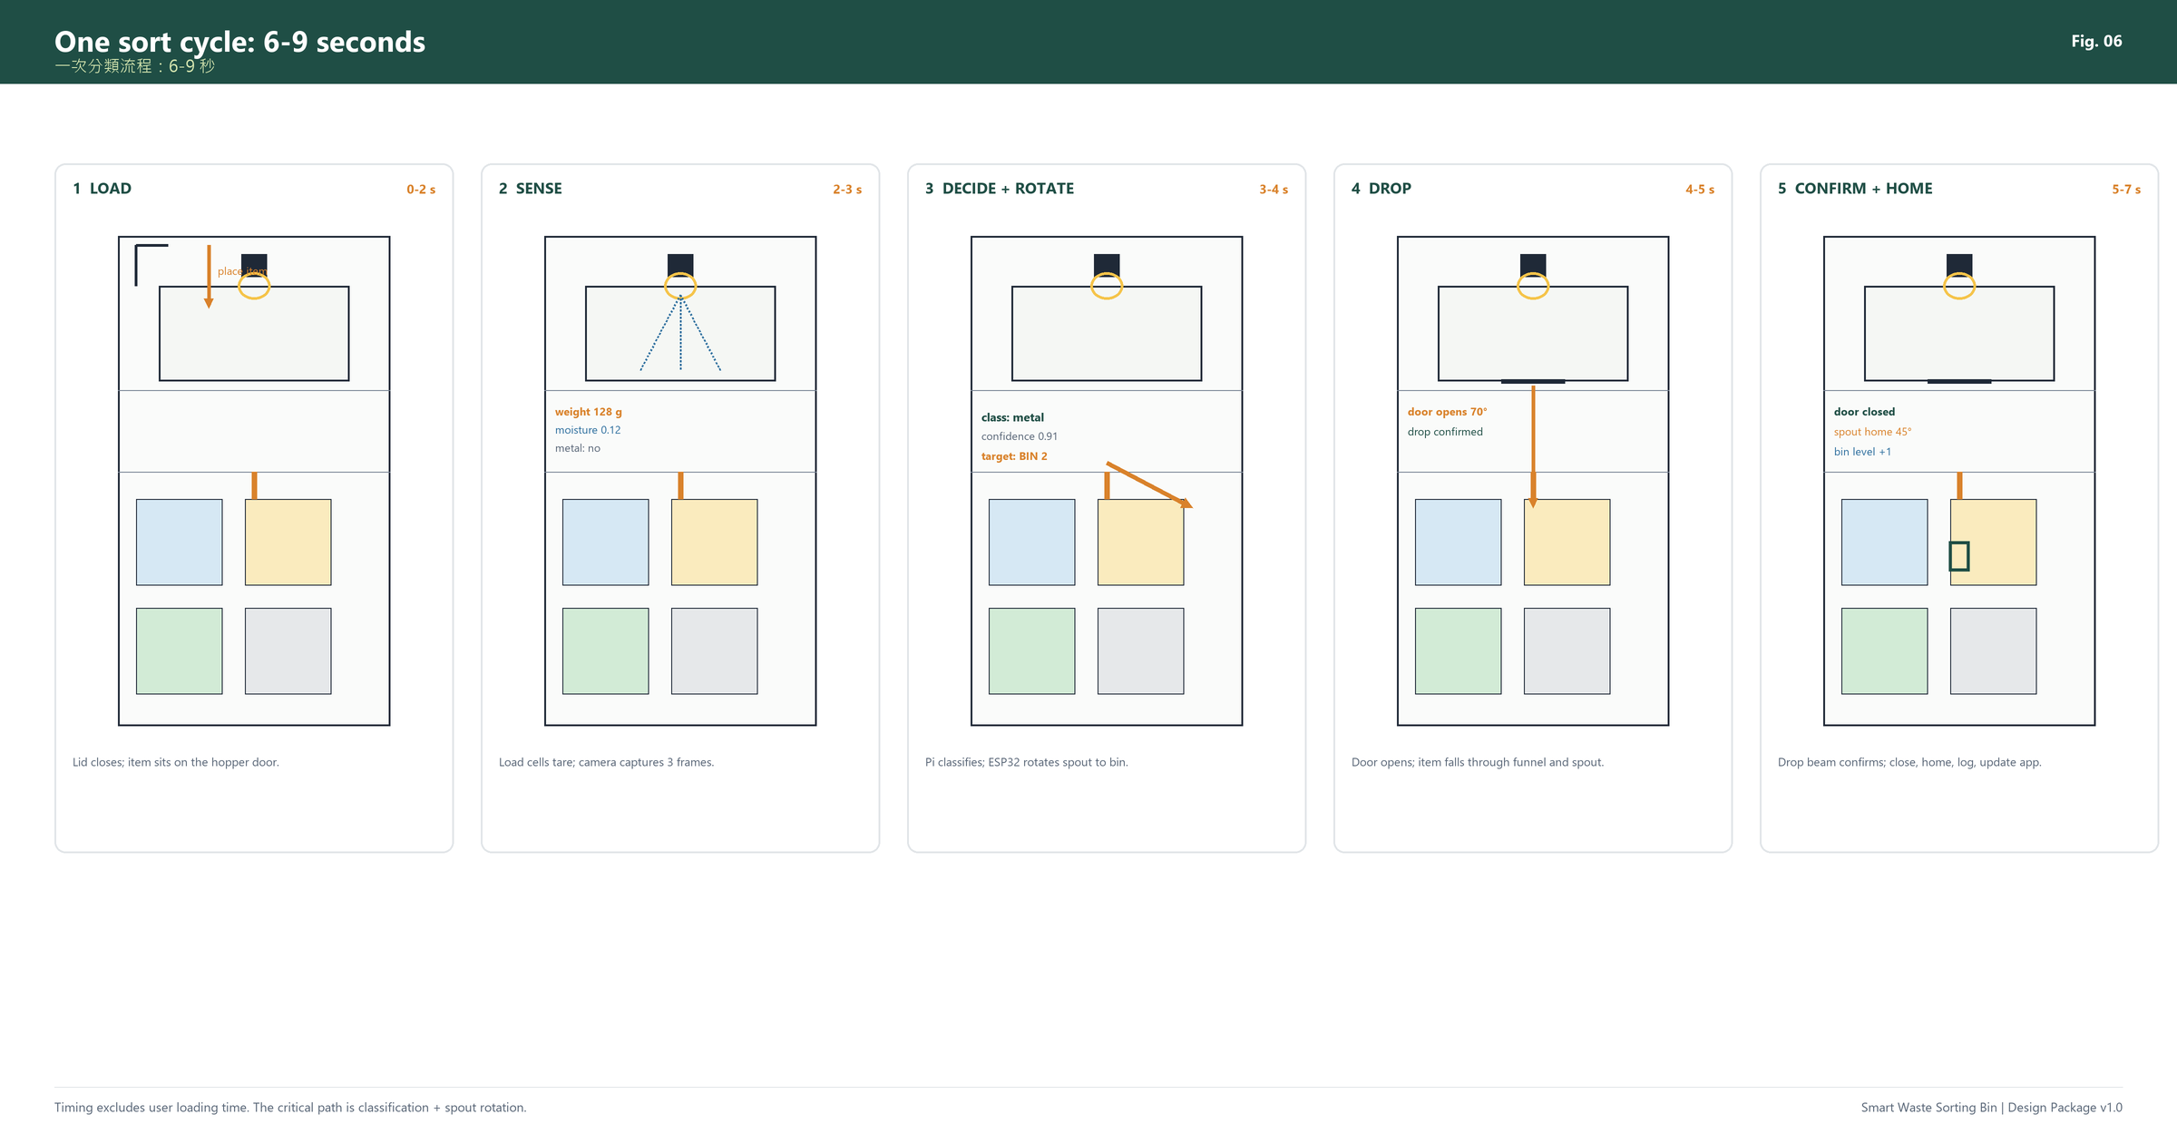
Figure 2. One sort cycle. The user loads and closes the lid; the machine weighs, images, decides, rotates, drops, confirms and homes.
Step | User action | Machine action | Typical time
1 | Lift lid, place one item on the hopper door, close lid | Lid switch confirms; IR beam clear; LED blue | 0–2 s (user)
2 | Wait | ToF detects item; load cells tare and weigh; camera captures 3 frames | 1–2 s
3 | Wait | Pi classifies; fuses sensors; chooses bin or asks for help | 1–2 s
4 | Wait | ESP32 rotates spout to target; verifies home/position | 1–2 s
5 | Wait | Door opens 70°; item falls; drop beam confirms | 1–2 s
6 | Wait | Door closes; spout homes; app updates | 1–2 s
7 | Open lid, remove bin when full | Bin-level alert; drawer slides out | As needed

Total machine time: 6–9 s typical. The target is ≤10 s excluding user loading.

3.3 Subsystems
Subsystem | Main parts | Responsibility
Structure | Plywood frame, drawer, slides, lid, hinges | Hold everything rigid; allow bin access; guard moving parts
Weigh hopper | 4 × 5 kg cells, HX711, door, servo, spring | Hold item still; measure weight; drop item
Sorting | Funnel, bearing, spout, NEMA 17, A4988, belt | Direct item to the selected bin
Bins | 4 × 10.7 L PP bins, notched corners, drawer | Collect four streams; lift out for emptying
Vision | USB camera, LED ring, item ToF | Capture a consistent image; detect presence/height
Moisture/metal | Capacitive pad, inductive coil | Add physical evidence to the classifier
Bin level | 4 × VL53L1X ToF | Estimate fill; alert at 90%
Safety | Reed/micro switches, IR beam, e-stop, fuse | Prevent motion when open; cut actuators
Control | Pi Zero 2 W, ESP32, buck converters | Vision, app, real-time I/O
App/data | FastAPI, SQLite, PWA | Status, history, manual sort, CSV export

3.4 Specifications at a glance
Parameter | Value
Overall size | 480 W × 480 D × 940 H mm
Loading height | ≈ 900 mm
Empty mass | ≈ 22–26 kg
Bins | 4 × 190 × 190 × 360 mm internal; ≈ 10.7 L usable each
Total capacity | ≈ 42.8 L
Max item | 250 mm long × 110 mm diameter × 1.5 kg
Sorting time | 6–9 s typical; ≤ 10 s target
Classification | 4 classes + “unsure”; MobileNetV2 on Pi
Power | 12 V 6 Ah Li-ion (BMS) or 12 V 5 A adapter
Peak power | ≈ 35 W
Battery life | ≈ 2–4 h continuous demo; days in standby
Display | RGB LED bar + buzzer + phone PWA
Cost | ≈ HK$4,050 recommended; ≈ HK$3,200 lean; ≈ HK$4,800 enhanced

3.5 Physical layout
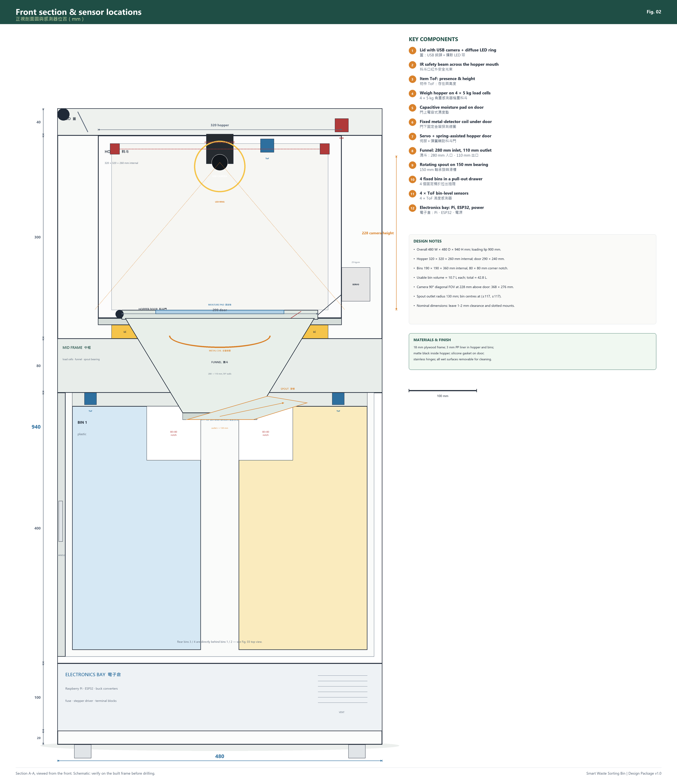
Figure 3. Front section with dimensions and sensor locations. The hopper floats on four load cells; the spout rotates under the funnel; four bins sit in a pull-out drawer.
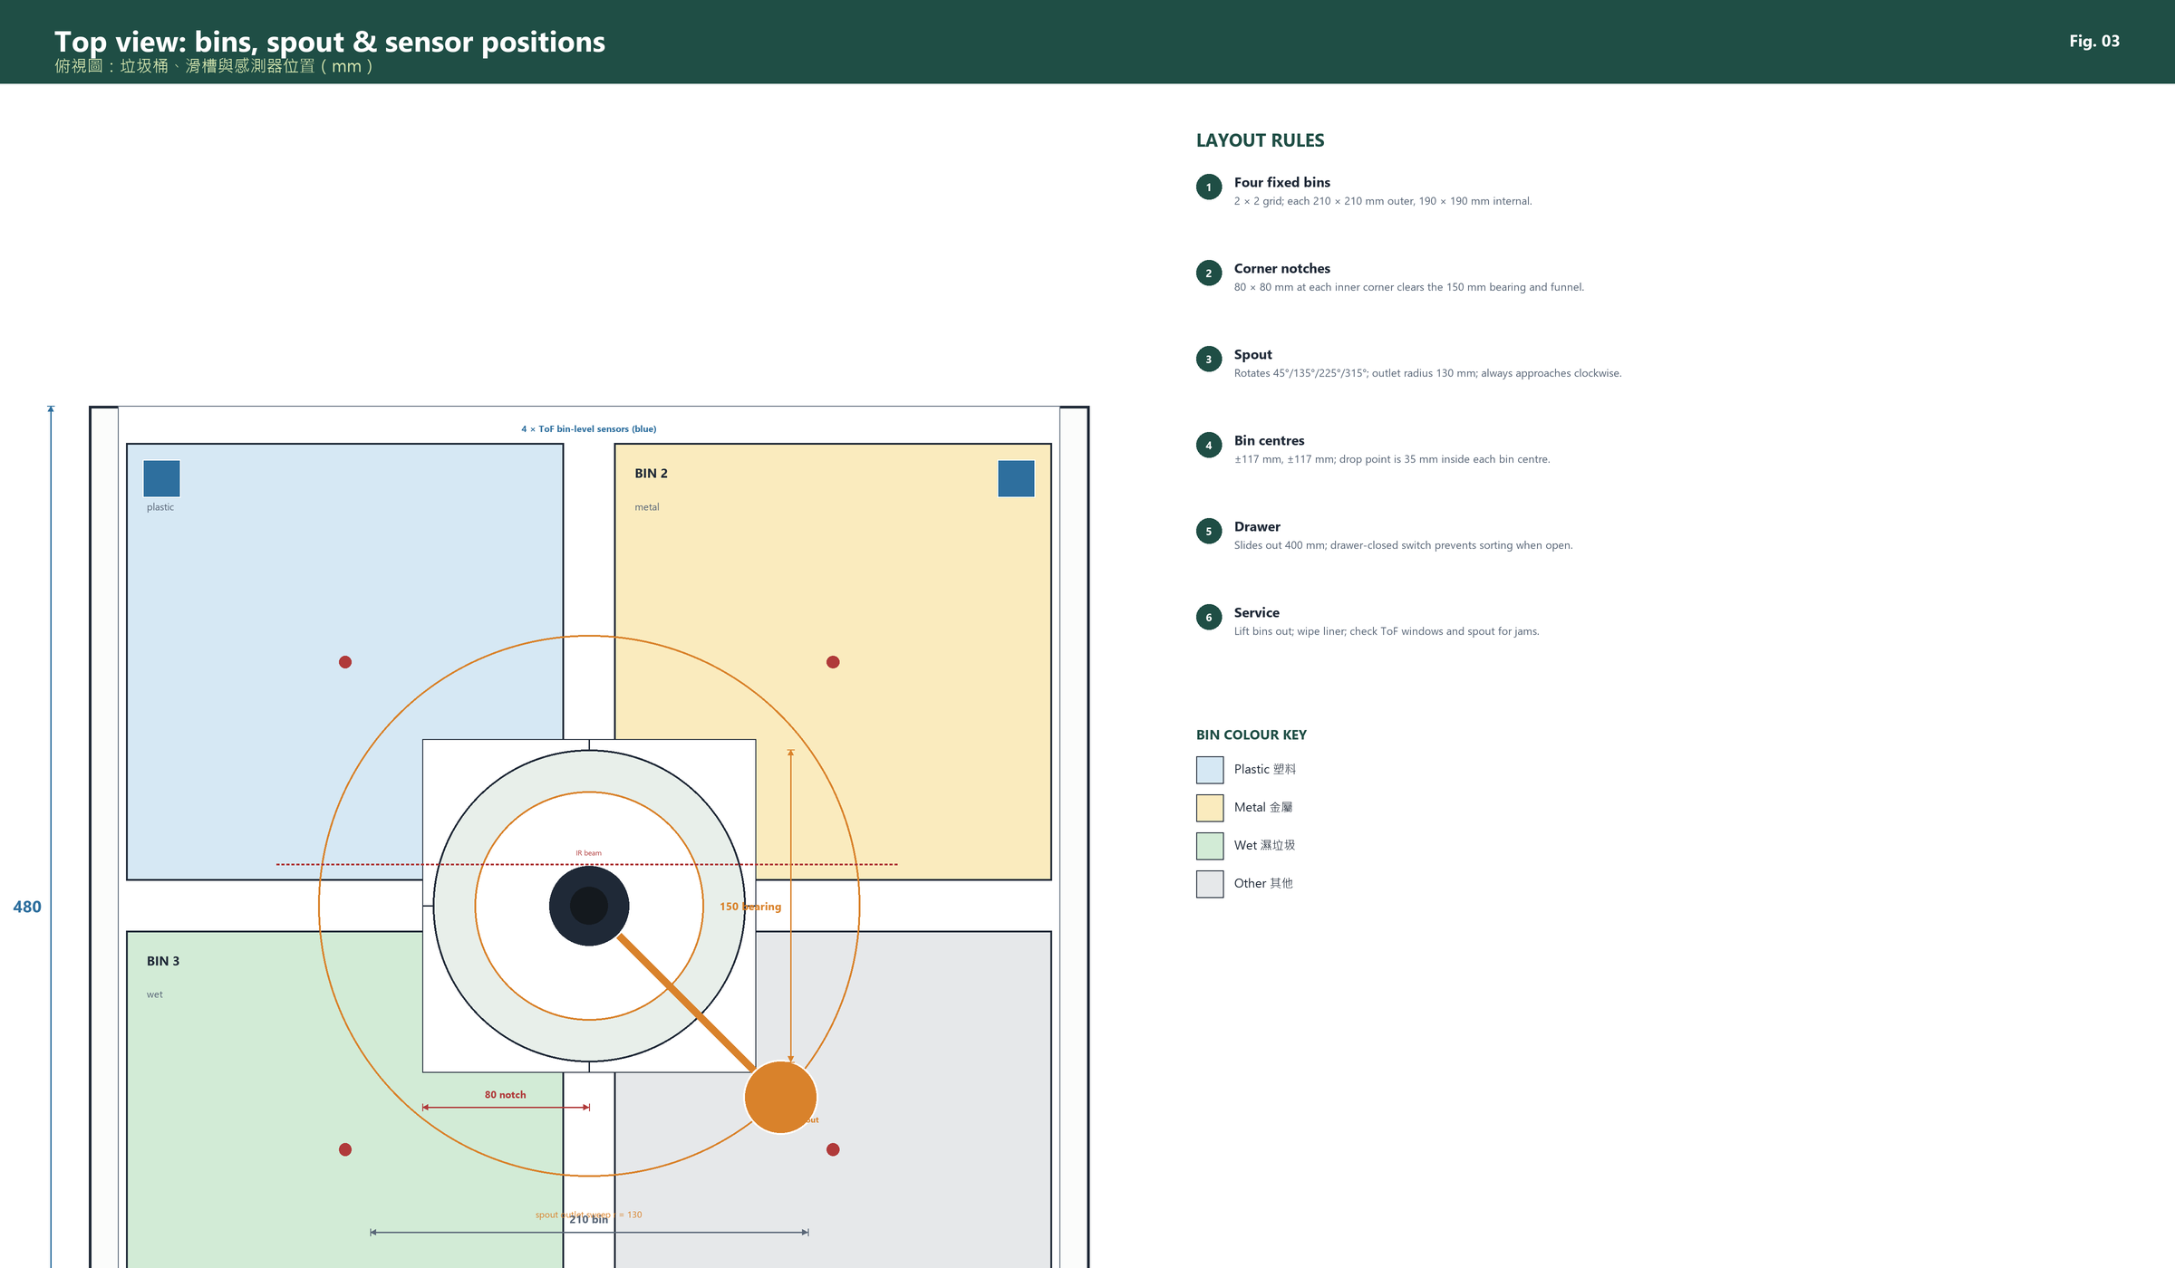
Figure 4. Top view: 2 × 2 bins, 80 × 80 mm corner notches, 150 mm bearing, 130 mm spout radius, and the four ToF bin-level sensors.
The layout is deliberately layered:
- Top: lid, camera, LED ring, item ToF, IR beam.
- Upper middle: weigh hopper, door, moisture pad, metal coil, load cells.
- Lower middle: funnel, bearing, rotating spout, four bin ToF sensors.
- Bottom: four bins in a drawer, then the electronics bay.
This keeps wet waste above the electronics, but the electronics bay is still sealed and ventilated separately. The hopper liner and bins are removable for cleaning.

3.6 Materials and finish
Part | Material | Reason
Frame, drawer, lid | 18 mm plywood, sealed | Cheap, stiff, easy to cut; paint/seal for humidity
Hopper liner, bins | 3 mm PP or food-grade plastic | Wipe-clean, tough, low friction
Spout | 110 mm PVC 45° elbow | Smooth, cheap, available; sand internal joints
Funnel | 3 mm PP welded/bolted or PETG print | Smooth 59° walls; replaceable
Brackets | PETG 3D print | Camera, sensors, bearing collar, servo mount
Hinges | Stainless steel | Wet environment
Seals | Closed-cell silicone | Door and lid; not on load cells
Labels | Printed vinyl + icons | Colour + text + icon for accessibility

3.7 User journey
1. User approaches; LED bar is green (idle).
2. User lifts the lid; LED turns white/blue.
3. User places one item on the hopper door and closes the lid.
4. LED pulses blue; app shows “scanning”.
5. Machine weighs and photographs; LED pulses amber.
6. Spout rotates; a short whirr; LED stays amber.
7. Door opens/closes; item drops; LED turns green; short beep.
8. App shows class, confidence, weight and bin.
9. If the bin is 90% full, LED turns orange and app shows “empty bin 2”.
10. If the machine is unsure, LED turns white and app asks the user to choose; the item stays in the hopper until the user confirms.

4. Mechanical design

4.1 Overall dimensions and frame
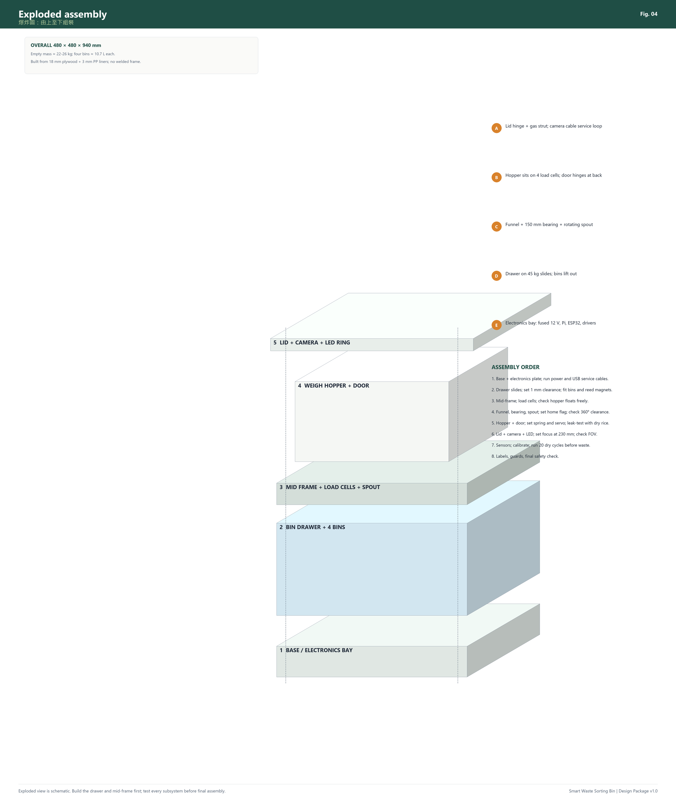
Figure 5. Exploded assembly. Build from the base up; test the drawer, hopper and spout before final assembly.
The bin is a 480 × 480 × 940 mm plywood box with four functional layers. The dimensions are chosen around standard 12 L plastic bins and a 110 mm PVC spout, not around a fancy enclosure.
Layer | Height (mm) | What is inside | Access
Feet | 20 | Rubber feet, floor clearance | Bottom
Electronics bay | 100 | Pi, ESP32, bucks, fuse, driver, terminals | Rear/front vented panel
Bin drawer | 400 | 4 bins, drawer slides, drip tray | Pull-out front
Mid-frame | 80 | Load cells, funnel, bearing, spout | Top/inside
Weigh hopper | 300 | Hopper, door, moisture pad, metal coil | Lift lid
Lid | 40 | Camera, LED ring, item ToF, reed switch | Hinged at back
Total | 940

Frame construction: 18 mm plywood panels joined with M4 screws and 20 × 20 mm aluminium angle or wooden cleats. Seal all internal surfaces with a water-resistant varnish or self-adhesive PP sheet. Do not rely on glue alone for the load-bearing joints; use screws and cleats.
Why plywood rather than 2020 extrusion: plywood is cheaper, easier to cut, and dampens vibration. It is also easier to repair. The trade-off is that wood moves with humidity; seal it and use slotted holes for the mid-frame and load-cell mounts so you can re-align.
Access: the front drawer holds all four bins. The electronics bay has a separate vented cover; do not put the electronics in the bin drawer. The hopper liner lifts out; the lid is held open by two 60 N gas struts or a friction stay.

4.2 Bin drawer and bins
The top view in Figure 4 shows the 2 × 2 layout and the corner notches. The key dimensions are:

Geometry
- Bin outer size: 210 × 210 × 380 mm.
- Bin internal size: 190 × 190 × 360 mm.
- Each bin has an 80 × 80 mm notch cut into its inner top corner. The four notches create a 160 × 160 mm clear central area for the 150 mm bearing and the funnel.
- Bin centres: (±117, ±117) mm from the drawer centre. The outer footprint is 444 × 444 mm.
- Drawer: 456 × 456 × 380 mm outer, on a pair of 450 mm three-fold slides rated ≥45 kg. Clearance: 6 mm per side.
- Drawer front: 480 × 400 mm, with a handle and a magnetic catch.
Capacity calculation:
V = (190 × 190 - 80 × 80) × 360 = 10.69 × 10^6 mm³ ≈ 10.7 L
Four bins give ≈ 42.8 L. That is enough for a demonstration and a few days of light household use. If you need more capacity, increase the bin height to 450 mm; the frame height becomes 1030 mm, which is still usable.

Bin fabrication
The cheapest route is to buy four 12 L PP storage boxes of approximately 190 × 190 mm internal and cut the notch. Cutting a notch in a moulded bin leaves an open edge; seal it with a PP patch and neutral silicone, or 3D-print a corner insert that closes the notch. A neater route is to fabricate the bins from 3 mm PP sheet: bottom, four walls, and a notch wall. This is more work but gives a clean, sealed bin.
Do not use cardboard or bare wood for the bins; wet waste will destroy them.

Drawer details
- Slides: one pair, 450 mm, 45 kg rated, mounted at the drawer sides. The drawer must not tip when pulled fully out; add a stop or a support foot.
- Bin locating: 20 mm plywood cleats or 3D-printed corner blocks; leave 2 mm clearance so the bins drop in.
- Bin-present detection: a reed switch on the fixed frame and a small magnet on each bin. This avoids wiring to the moving drawer. The reed closes when the bin is inserted; the ESP32 reads it through a PCF8574.
- Drawer-closed switch: a lever microswitch on the frame; the machine refuses to sort if the drawer is open.
- Drip tray: a 456 × 456 mm PP tray with a 20 mm lip, removable. Drill a few 6 mm drain holes in the drawer bottom and put a absorbent pad under the tray.
- Label each bin on the front and top: colour + icon + English/Chinese text. Do not rely on colour alone.

Cleaning
Lift the bins out; wipe the drawer and drip tray with a disinfectant wipe. Remove the hopper liner and wash it in warm soapy water. Do not hose the electronics bay. Let everything dry before reassembly.

4.3 Weigh hopper and door

Load path
The hopper is a 360 × 360 × 300 mm plywood box with a 320 × 320 × 260 mm PP liner. It sits on a 360 × 360 mm support plate, which rests on four 5 kg load cells at a 300 × 300 mm bolt pattern. The load cells are bolted to the mid-frame. The hopper must be free to move vertically but restrained horizontally:
- use M5 shoulder screws or dowel pins through oversized holes for horizontal location;
- leave 0.5–1 mm vertical clearance;
- do not connect the hopper to the frame with a rigid pipe, cable gland, or earth strap that bypasses the cells;
- route the servo and sensor cables with a service loop so they do not carry load.
Capacity check: hopper + door + servo + liner ≈ 3.5 kg tare; item ≤ 1.5 kg; four 5 kg cells give 20 kg capacity. Even with an off-centre item, each cell sees less than 5 kg. The safety factor is >4.
Resolution: HX711 at 10 Hz or 80 Hz; with 5 kg cells, 1 g resolution is achievable after calibration. Use a 10-sample median and a 5-sample moving average. Tare at the start of every cycle.

Door
- Door: 290 × 240 mm, 6 mm PP or plywood, hinged at the back.
- Opening: 70°; the item slides out because the hopper floor slopes 5° toward the door.
- Seal: closed-cell silicone gasket around the door; the door must not leak rice or crumbs into the mid-frame.
- Actuation: 25 kg·cm metal-gear servo (DS3225MG or equivalent), mounted outside the hopper on a bracket. A 50 mm arm pulls a 1 mm stainless cable; a spring returns the door closed.
- Spring: a tension spring or a torsion spring at the hinge. On power loss, the spring closes the door. The servo only pulls it open.
- Limit switch: a lever microswitch confirms “door closed”. The machine will not weigh or rotate unless the door is closed.
- Hinge: stainless piano hinge or two nylon bushes; no metal particles near the metal coil.
Torque check: door mass ≈ 0.5 kg at 0.145 m → 0.71 N·m; item 1.5 kg at 0.145 m → 2.13 N·m; total ≈ 2.84 N·m. A 25 kg·cm servo is 2.45 N·m at the shaft. With a 50 mm arm and a cable attached 145 mm from the hinge, the mechanical advantage is 145/50 = 2.9, so the available door torque is ≈ 7.1 N·m; safety factor ≈ 2.5. The spring assists closing and carries the door when power is off. If you regularly sort 1.5 kg items, upgrade to a 35 kg·cm servo or a 12 V worm-gear motor.
Do not rely on the servo to hold the door closed when idle; use the spring and a mechanical stop so the servo can be disabled.

Moisture pad
A capacitive soil-moisture sensor is mounted under a 1.5 mm HDPE cover on the door, at the centre. The item rests on the cover; water from wet waste changes the capacitance. The sensor is not in direct contact with waste, so it is easy to clean.
- Cut a 60 × 30 mm window in the door, mount the sensor PCB flush, and seal the edges with neutral silicone.
- Cover with a replaceable 1.5 mm HDPE sheet; tape the edges with PP tape.
- Route the 3-wire cable along the hinge with a silicone service loop.
- Calibrate dry (air) and wet (damp sponge) and set a threshold with hysteresis (e.g., wet > 0.65, dry < 0.45).
- Replace the cover if it is scratched or stained.
Limitation: a dry plastic bottle with a wet label may read “wet”; a wet item inside a sealed bag may read “dry”. The moisture sensor is evidence, not a verdict. The vision model and weight are the primary classifiers.

Metal coil
A DIY inductive metal-detector kit is mounted on the fixed mid-frame, centred under the hopper door, facing up. The coil is 150 mm diameter, wound with 30 turns of 0.5 mm enamelled copper wire, and tuned to the kit. The door is 6 mm PP; the field passes through it. The item can be anywhere on the door within the coil area.
- Keep the coil at least 40 mm from steel screws, the load cells, and the servo; use nylon standoffs.
- Shield the coil with aluminium foil only on the back, not the front; ground the foil to the module ground.
- Calibrate with the hopper empty, then with a known can at the centre and at the edge.
- The module output is digital (metal/no metal); the ESP32 reads it through a GPIO or the PCF8574.
- If the coil is unreliable, leave it out and rely on vision + weight; document the limitation honestly.
Why not a small inductive proximity sensor? A typical LJ12A3-4-Z/BX only detects metal within 4 mm of its face. A can lying 50 mm away on the door will not be detected. A large coil is the only low-cost way to cover the door area.

4.4 Funnel, bearing and rotating spout

Funnel
- Inlet: 280 × 260 mm, matching the door opening.
- Outlet: 110 mm diameter.
- Height: 140 mm; wall angle ≈ 59° from horizontal.
- Material: 3 mm PP, welded or bolted with silicone seals; or PETG printed in four sections and solvent-welded.
- The funnel must be smooth inside; sand all joints and avoid ledges where a bottle cap can catch.
- The funnel is fixed to the mid-frame, not the hopper. The hopper door drops the item into the funnel; the funnel does not touch the hopper.
Why 110 mm? A typical 500 mL PET bottle is 60–65 mm diameter; a 1.5 L bottle is 85–90 mm; a 330 mL can is 66 mm. A 110 mm outlet passes these with clearance. A 2 L bottle (≈110 mm) is tight; label the bin as “≤1.5 L” and test.

Bearing and spout
- Bearing: 150 mm OD lazy Susan bearing, 5 mm thick, mounted on the mid-frame around the funnel outlet.
- Spout: 110 mm PVC 45° elbow, cut and sanded; the upper opening is centred under the funnel outlet; the lower outlet is at radius 130 mm.
- Collar: 3D-printed PETG ring clamped to the bearing inner ring; the elbow is fixed to the collar with stainless screws and silicone.
- Drive: NEMA 17 stepper, 3:1 GT2 belt (20T motor, 60T spout), 200 mm belt. The stepper is mounted on the mid-frame with a slotted bracket for belt tension.
- Home: a slotted optical switch or lever microswitch at 45° (bin 1). A flag on the collar interrupts the switch.
- Positions: bin 1 = 45°, bin 2 = 135°, bin 3 = 225°, bin 4 = 315°. Always approach the target clockwise to remove backlash.
- Guard: a clear 3 mm PP ring around the spout, with a 20 mm gap for inspection; it prevents fingers from reaching the pinch point.
Geometry check: bin centres are at (±117, ±117) mm, radius 165 mm. The spout outlet is at 130 mm, so the drop point is 35 mm inside the bin centre. The bin opening is 190 mm, so the drop is well inside. The 80 × 80 mm notches give clearance for the 150 mm bearing and the 110 mm outlet.
Stepper calculation:
- Spout + collar mass ≈ 0.35 kg; centre of mass at 0.13 m → 0.45 N·m.
- Bearing friction + belt preload ≈ 0.08 N·m; acceleration ≈ 0.05 N·m.
- Required ≈ 0.58 N·m. NEMA 17 (0.45 N·m) × 3:1 = 1.35 N·m; safety factor ≈ 2.3.
- Steps: 200 full steps/rev × 8 microsteps × 3 = 4800 steps/rev; 90° = 1200 steps.
- Speed: 1200 steps/s with acceleration limiting; 90° move ≈ 1.0 s + 0.3 s acceleration.
- Current: 0.8 A; A4988 Vref = 0.64 V with Rs = 0.1 Ω. Use 1/8 microstep.
Homing: on boot and after any fault, rotate clockwise until the home switch triggers, then back off 20 steps and approach slowly. This gives repeatable home without a encoder.

4.5 Lid, camera and lighting

Lid
- 480 × 480 mm, 18 mm plywood with a 3 mm acrylic window or a camera hole.
- Hinged at the back with a stainless piano hinge; two 60 N gas struts or a friction stay hold it open.
- A closed-cell foam gasket seals against the top frame to block ambient light.
- A magnetic reed switch detects “lid closed”. The machine will not sort if the lid is open.
- A front handle and a clear “OPEN / CLOSE” label.

Camera
- 5 MP USB UVC camera, 90° diagonal field of view, manual focus, 1 m cable.
- Mounted on the underside of the lid, centred over the hopper, lens 228 mm above the door.
- 3D-printed bracket with a 30 mm hole; the lens sits behind a 2 mm clear acrylic window (anti-glare, replaceable).
- USB cable routed through a 25 mm grommet at the hinge, with a 300 mm service loop and a strain relief. USB is used instead of a Pi camera ribbon because it survives repeated lid motion and is easy to replace.
Field of view check: a 90° diagonal lens on a 4:3 sensor gives about 77° horizontal and 62° vertical. At 228 mm:
W = 2 × 228 × tan(38.5^°) ≈ 368 mm, H = 2 × 228 × tan(31^°) ≈ 276 mm
The hopper is 320 × 260 mm, so the camera sees the whole door with a small margin. If your lens is 75°, raise the camera to 260 mm or use a wider lens; check with a printed grid before cutting the lid.

Lighting
- 12 V 3 W LED ring, 80 mm inner diameter, 6000 K, CRI > 90, with a white acrylic diffuser.
- Mounted around the camera, 20 mm above the lens; the ring is always on during capture (not PWM-dimmed) to avoid flicker.
- Matte black inside the hopper; no shiny screws or labels in the field of view.
- If plastic bottles glare, add a circular polarizer film or move the ring further from the lens. Fix the camera exposure and white balance in software; do not rely on auto-exposure.

4.6 Sensor placement
Sensor | Location | Orientation | Range / interface | Why there
USB camera | Lid centre, 228 mm above door | Down | 0.2–2 m / USB | Full view of item; fixed geometry
Item ToF (VL53L0X) | Lid, 60 mm from camera | Down | 30–1000 mm / I2C | Confirms item presence and height; robust to shadows
IR break-beam | Hopper mouth, 20 mm below top lip | Across opening | 0–300 mm / GPIO | Detects a hand or protruding item; safety
Load cells ×4 | Under hopper support plate | Vertical | 0–5 kg each / HX711 | Weight; confirms real item; class prior
Moisture pad | Door centre, under HDPE | Up | Capacitive / ADC | Wet vs dry evidence
Metal coil | Mid-frame under door | Up | 150 mm coil / digital | Metal confirmation anywhere on door
Bin ToF ×4 | Mid-frame, outer corner of each bin | Down | 40–2000 mm / I2C | Fill level; no cross-talk
Lid reed | Front lip | — | Digital / PCF8574 | Lid closed interlock
Door switch | Hopper front | — | Digital / PCF8574 | Door closed before weigh/move
Drawer switch | Bin frame | — | Digital / PCF8574 | Drawer closed interlock
Spout home | Mid-frame at 45° | — | Digital / PCF8574 | Home reference
Bin present ×4 | Fixed frame, one per bin | — | Reed / PCF8574 | Refuses to sort into a missing bin
SHT31 | Bin section back wall | — | I2C | Temperature/humidity log (optional)
E-stop | Front panel | — | NC + opto / GPIO | Cuts actuator 12 V; status to ESP32

Placement rules:
- Keep the camera and item ToF away from the LED ring’s direct reflection; use a diffuser and a matte black surround.
- Keep the load-cell cables away from the stepper and servo cables; cross at 90° if unavoidable.
- Mount the bin ToF sensors at the outer corners of each bin, outside the spout’s swept area, so falling waste cannot hit them. Use a 1 mm clear window and a small hood.
- Do not mount the metal coil on the hopper; it must not affect the load cells.
- Put the SHT31 away from the wet bin and the electronics heat.

4.7 Actuator and structure sizing
Item | Calculation | Result
Load cells | 4 × 5 kg = 20 kg; tare 3.5 kg; item 1.5 kg; off-centre factor 1.5 | Safety factor >4
Door servo | 2.84 N·m load; 2.45 N·m servo × 2.9 mechanical advantage ≈ 7.1 N·m | Safety factor ≈ 2.5
Stepper | 0.58 N·m required; 0.45 N·m × 3 = 1.35 N·m | Safety factor ≈ 2.3
Spout bearing | 0.35 kg spout + 1.5 kg item; 150 mm lazy Susan rated >10 kg | Adequate
Lid struts | 2 × 60 N; lid ≈ 2 kg | Holds lid open; check closing force
Drawer slides | 45 kg pair; drawer + bins + waste ≈ 12–18 kg | Safety factor >2.5

Deflection check: the 18 mm plywood mid-frame spans 480 mm and carries the hopper (≈5 kg) plus a 1.5 kg item. The deflection is small (<1 mm) for a 480 mm span with 18 mm plywood; if you use 12 mm plywood, add a centre rib. The bin drawer bottom must be stiff enough not to sag under 15 kg; use 18 mm plywood or add a 20 × 40 mm rib.

4.8 Tolerance, alignment and adjustment
- Bin locating: use cleats with 2 mm clearance; the bins must drop in without force but not move when the drawer closes.
- Spout alignment: slot the stepper bracket by 5 mm for belt tension; slot the bearing mount by 3 mm for centring. Check the drop point with a laser pointer or a plumb line.
- Hopper: slot the load-cell mounting holes by 2 mm; shim the support plate so the door is level within 1 mm.
- Lid: use a hinge with 2 mm adjustment; the gasket should compress evenly.
- Camera: print a grid target at the door height and check that the whole hopper is inside the frame; adjust the bracket height by ±10 mm.
- Homing: after assembly, home 20 times and record the switch position; repeatability should be within ±2 steps.

4.9 Build sequence
1. Cut and seal the plywood. Label every panel with its part number. Drill pilot holes before assembly.
2. Build the base and electronics bay. Fit the vent, cable glands, power switch, e-stop and service USB port. Do not install electronics yet.
3. Fit the drawer slides and drawer. Check that the drawer pulls out 400 mm without tipping. Fit the drip tray and bin cleats.
4. Make the bins. Cut the 80 × 80 mm notches; seal the cut edges; fit handles and labels. Check that all four drop into the drawer.
5. Build the mid-frame. Mount the load cells, funnel, bearing and spout. Check that the spout rotates 360° without hitting anything.
6. Build the hopper. Fit the door, hinge, gasket, servo, spring, moisture pad and metal coil. Check that the door closes squarely and the spring closes it with power off.
7. Fit the hopper to the mid-frame. Check that it floats freely on the load cells; no cable or pipe should bypass the cells.
8. Fit the lid. Mount the camera, LED ring, item ToF and reed switch. Set the camera height and focus. Check the field of view with a grid.
9. Wire the electronics on the bench. Test each sensor and actuator separately before installing them in the bin.
10. Install the electronics. Use the acrylic mounting plate; label every cable; strain-relieve; keep power and signal separate.
11. Calibrate. Load cells, moisture, metal, bin ToF, camera exposure, spout home.
12. Dry-run. Run 20 cycles with empty/dry items; then 20 with rice; then 20 with real dry recyclables; only then test wet waste.

4.10 Cut list
The full cut list is in Appendix B. Key panels:
Part | Size (mm) | Qty | Material
Base | 480 × 480 | 1 | 18 mm plywood
Base front/back | 480 × 100 | 2 | 18 mm plywood
Base sides | 444 × 100 | 2 | 18 mm plywood
Bin section sides | 480 × 400 | 2 | 18 mm plywood
Bin section back | 444 × 400 | 1 | 18 mm plywood
Bin section top/bottom | 480 × 480 | 2 | 18 mm plywood
Drawer bottom | 456 × 456 | 1 | 18 mm plywood
Drawer sides | 456 × 360 | 2 | 18 mm plywood
Drawer front | 480 × 400 | 1 | 18 mm plywood
Hopper support plate | 360 × 360 | 1 | 18 mm plywood
Mid-frame | 480 × 480 | 1 | 18 mm plywood
Lid | 480 × 480 | 1 | 18 mm plywood + 3 mm acrylic
Hopper door | 290 × 240 | 1 | 6 mm PP/plywood
Spout guard | 300 × 200 | 1 | 3 mm PP
Drip tray | 456 × 456 | 1 | 3 mm PP

Cutting tips: cut the drawer and bins first, then fit the frame around them. Leave 1–2 mm clearance; you can shim but you cannot shrink. Drill pilot holes for all screws; plywood splits easily.

4.11 Safety guards and pinch points
- Lid hinge: cover the hinge line with a 3 mm PP strip; add a gas strut or friction stay so the lid cannot fall on a hand.
- Drawer: add a stop so it cannot be pulled completely out; a 45 kg slide pair is strong enough, but the bin can tip if the drawer is overloaded.
- Hopper door: the door closes with a spring; keep fingers out of the 70° arc. The lid must be closed to run, so the user cannot reach the door during motion.
- Spout: a clear PP guard ring around the rotating spout; a 20 mm inspection gap. The spout is inside the bin section and the drawer must be closed to run.
- E-stop: mushroom head, red, latching, on the front panel; label “STOP MOTION / 停止動作”. It cuts 12 V to the stepper, servo and LED; the Pi/ESP32 stay on 5 V for logging.
- Fuse: 5 A blade fuse within 150 mm of the battery positive.
- Edges: round or cover all plywood edges; seal them so they do not swell.
- Lifting: the empty bin is 22–26 kg; lift with two people or use the base handles. Do not lift by the lid.

4.12 Cleaning and maintenance
Task | Frequency | Method
Empty bins | When 90% full | Lift out; rinse; dry
Wipe hopper liner | After wet waste | Warm soapy water; dry fully
Clean camera window | Weekly | Microfibre + lens cleaner; no solvent
Check spout/funnel | Weekly | Remove guard; inspect for jam; wipe
Check load cells | Monthly | Verify tare; check cables; no debris
Check door gasket | Monthly | Replace if torn; silicone-safe cleaner
Check battery | Each use | Voltage; swelling; BMS; charge outside
Check fasteners | Monthly | M4/M5 screws; drawer slides; hinge
Recalibrate | After moving or major repair | Load cell, moisture, bin ToF

Spare parts to keep: one servo, one A4988, one HX711, one ToF sensor, fuses, silicone gasket, PP sheet offcuts. These are cheap and save a demo.

5. Electrical design

5.1 Power architecture
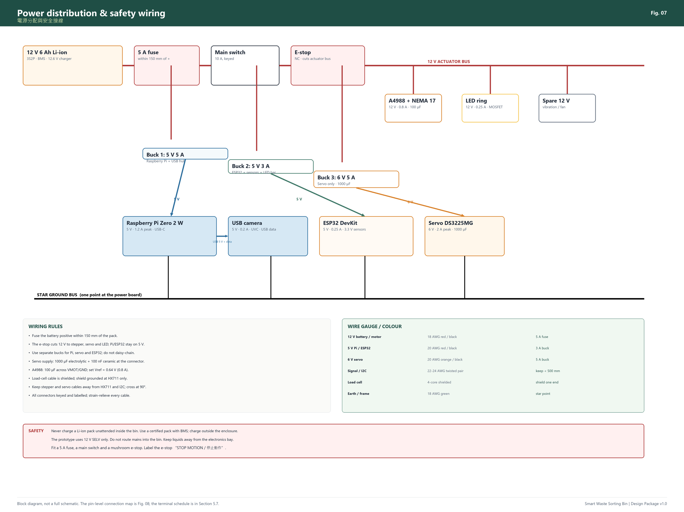
Figure 6. Power distribution and safety wiring. The e-stop cuts the 12 V actuator bus; the Pi and ESP32 stay alive on their own 5 V rails for logging.
Rail | Source | Loads | Notes
12 V | 3S Li-ion pack (12.6 V max) or 12 V 5 A adapter | A4988 VMOT, LED ring, spare | 5 A fuse; main switch; e-stop
5 V 5 A | Buck 1 | Raspberry Pi Zero 2 W, USB camera | 5.1 V; 5 A; heatsink
5 V 3 A | Buck 2 | ESP32, sensors, LED bar | 5 V; 3 A; separate from Pi
6 V 5 A | Buck 3 | DS3225MG servo | 1000 µF at servo; 6.0–6.8 V
3.3 V | ESP32 regulator | I2C sensors, HX711, PCF8574 | Do not exceed 300 mA total

Power budget (peak):
Load | Voltage | Current | Power
Raspberry Pi Zero 2 W | 5 V | 1.2 A | 6 W
USB camera | 5 V | 0.2 A | 1 W
ESP32 + sensors | 5 V | 0.25 A | 1.25 W
Servo (peak) | 6 V | 2.0 A | 12 W
Stepper | 12 V | 0.8 A | 9.6 W
LED ring | 12 V | 0.25 A | 3 W
LED bar + buzzer | 5 V | 0.1 A | 0.5 W
Peak |  |  | ≈33 W

A 12 V 6 Ah pack (≈72 Wh) gives about 2 h at 50% duty, or 4 h at 25% duty. The Pi alone draws ≈0.6–1.2 A at 5 V; use a 5 A buck with a heatsink, not a small LM2596.
Do not power the servo from the Pi’s 5 V rail. Servo inrush causes brownouts and SD-card corruption. Use a separate 6 V buck, a 1000 µF electrolytic, and a common ground.

5.2 Battery and adapter safety
- Use a factory-assembled 3S2P 18650 pack with a BMS, 12.6 V, 6 Ah, with a matching 12.6 V charger. Do not solder loose 18650 cells unless you are trained and supervised.
- Mount the pack in a rigid, vented enclosure away from the hopper and bins. Add a 5 A fuse on the positive lead within 150 mm of the pack.
- Add a main switch that disconnects the pack; a keyed switch is better for a public demo.
- Charge the pack outside the bin, on a non-flammable surface, with a fire-resistant bag nearby. Do not charge unattended.
- If the pack swells, gets hot, or smells sweet, stop using it and dispose of it at a recycling point.
- For bench testing, use a 12 V 5 A CE/BS-marked adapter instead of the battery. It is safer and removes battery anxiety from long tests.

5.3 ESP32 pin allocation
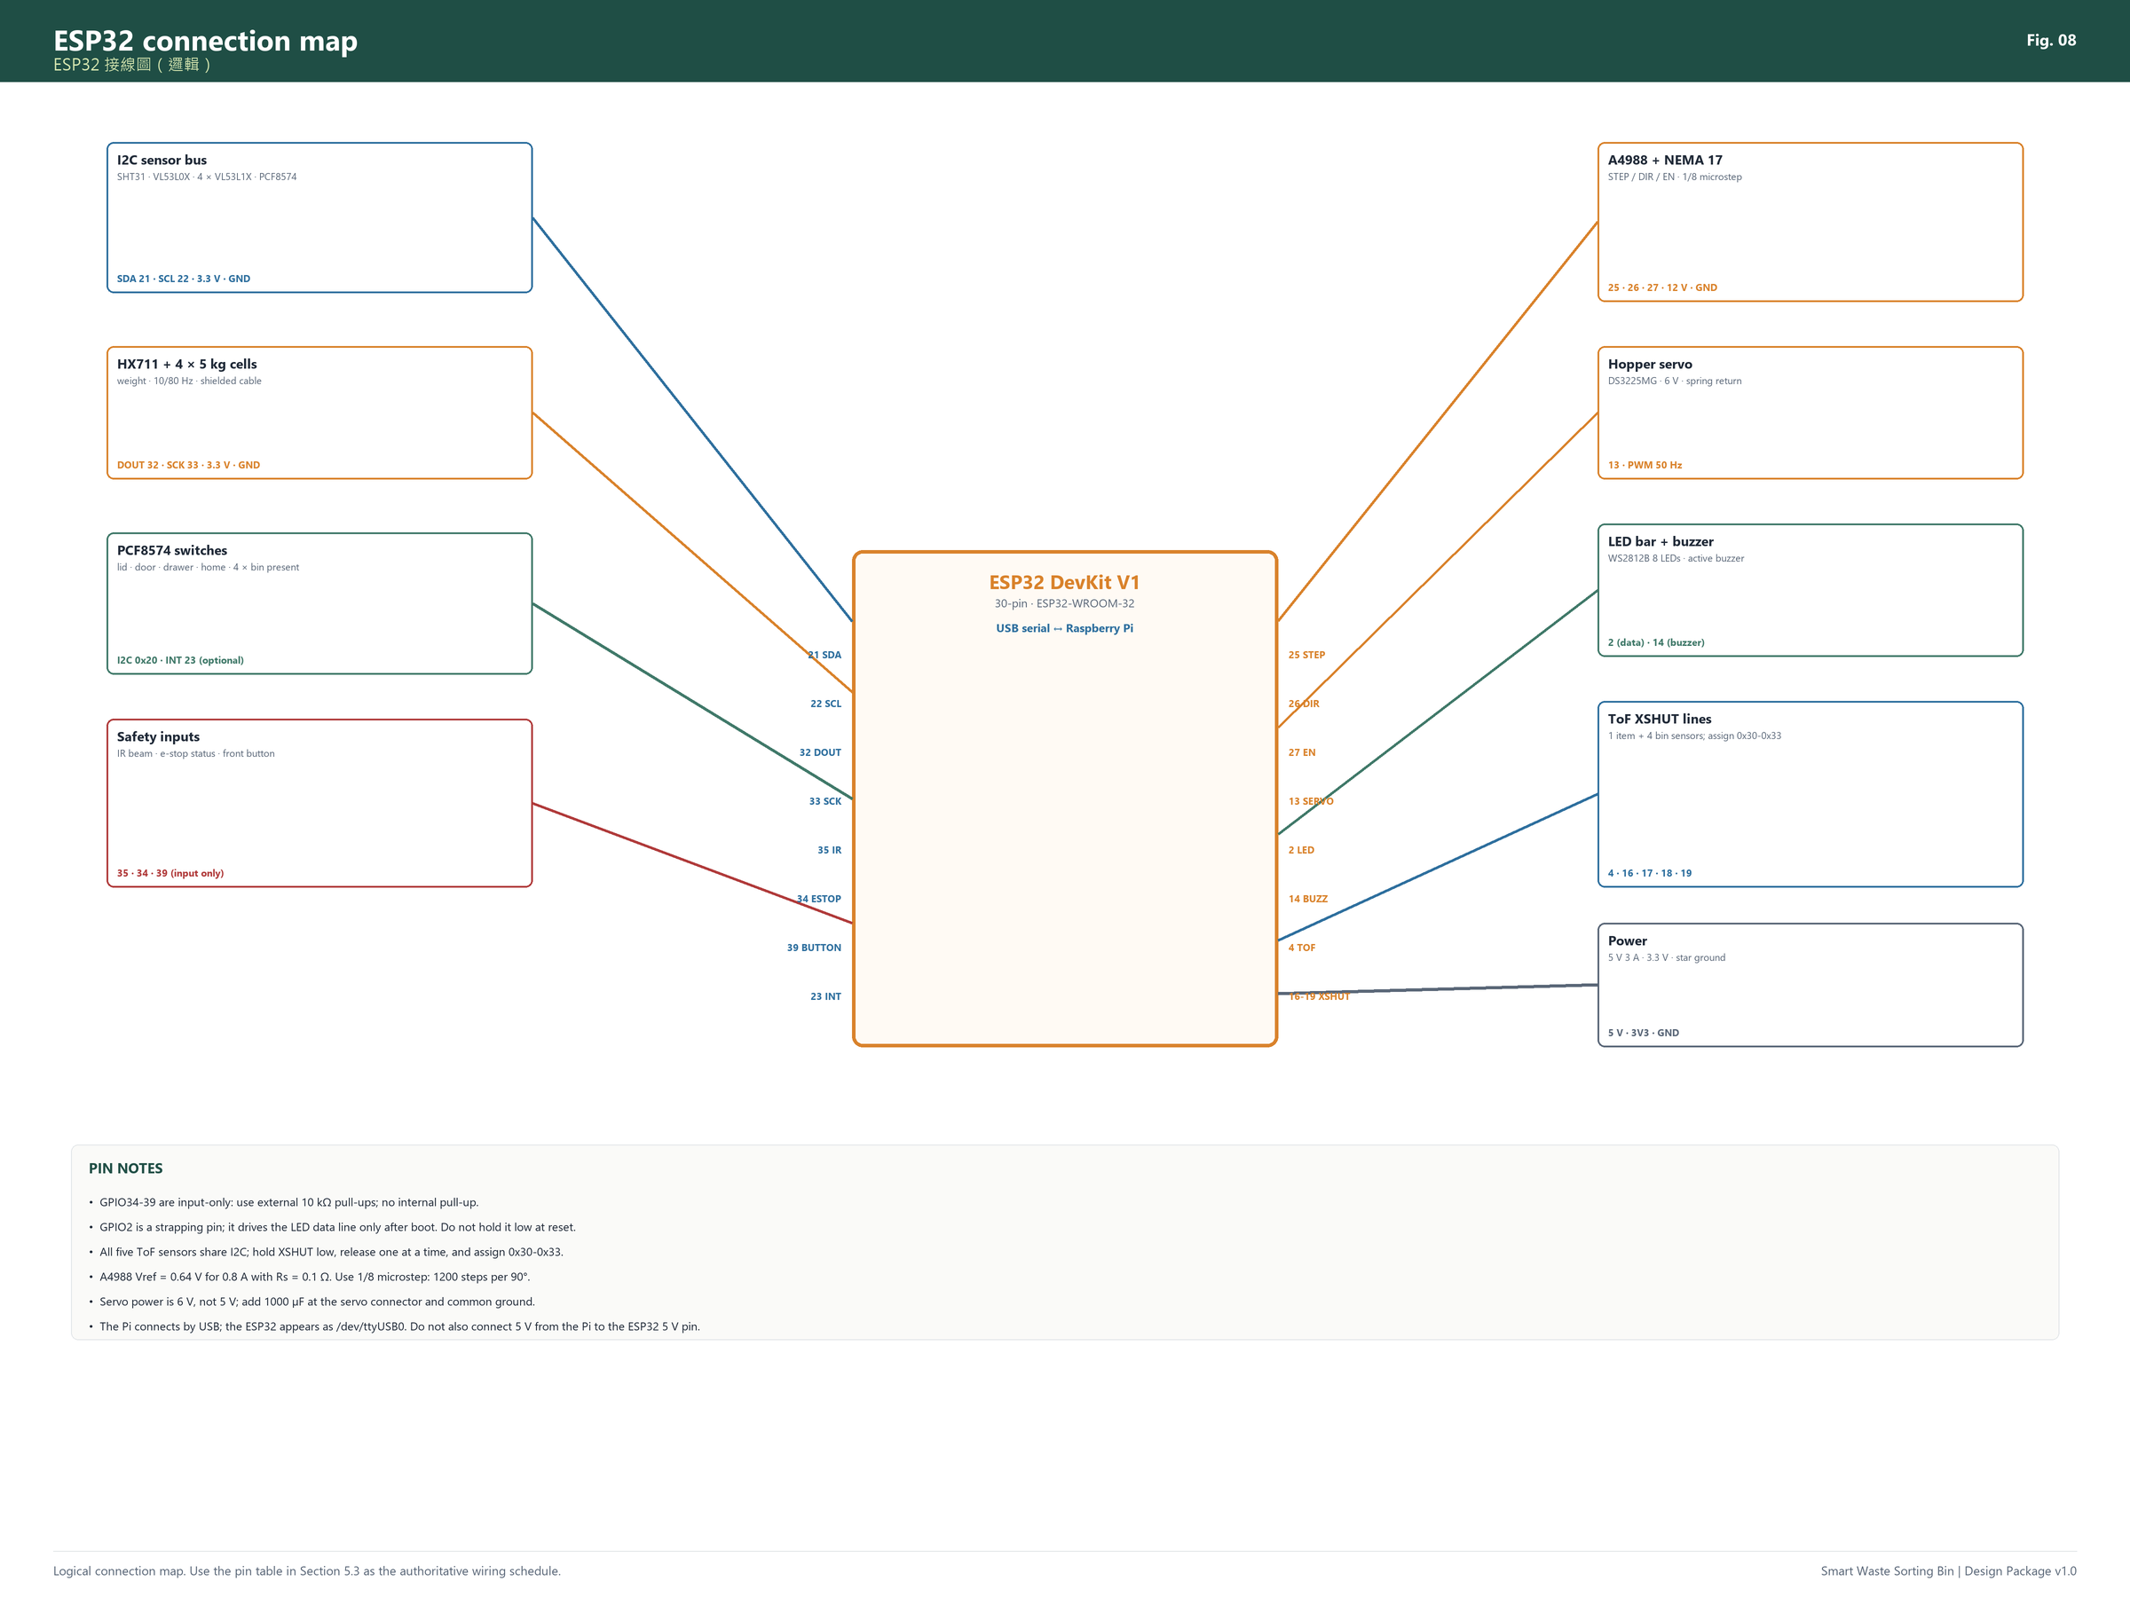
Figure 7. Logical ESP32 connection map. Use the table below as the authoritative pin schedule.
Signal | ESP32 pin | Type | Device / bus | Notes
I2C SDA | GPIO21 | Bidirectional | SHT31, VL53L0X, 4 x VL53L1X, PCF8574 | 4.7 k pull-up to 3.3 V; assign ToF addresses with XSHUT
I2C SCL | GPIO22 | Bidirectional | Same I2C bus | Keep leads < 500 mm; twisted pair
HX711 DOUT | GPIO32 | Input | HX711 | 10 Hz or 80 Hz; shielded cable
HX711 SCK | GPIO33 | Output | HX711 | Keep away from stepper wires
Stepper STEP | GPIO25 | Output | A4988 STEP | 1/8 microstep; 1200 steps per 90 deg
Stepper DIR | GPIO26 | Output | A4988 DIR | Direction; always approach target clockwise
Stepper EN | GPIO27 | Output | A4988 EN | Active low; disable when idle to reduce heat
Hopper servo | GPIO13 | PWM 50 Hz | DS3225MG signal | 6 V supply; common ground; 1000 uF
IR receiver | GPIO35 | Input only | TSOP38238 OUT | External 10 k pull-up; 100 nF decoupling
E-stop status | GPIO34 | Input only | Optocoupler / divider | External 10 k pull-up; low = pressed
Front button | GPIO39 | Input only | Push button to GND | External 10 k pull-up; debounce 30 ms
WS2812 data | GPIO2 | Output | LED bar DIN | 330 ohm series; 5 V supply; level 3.3 V works
Buzzer | GPIO14 | Output | Active buzzer | NPN transistor if > 20 mA
Item ToF XSHUT | GPIO4 | Output | VL53L0X XSHUT | Pull low to reset; release after boot
Bin 1 ToF XSHUT | GPIO16 | Output | VL53L1X #1 | Assign address 0x30
Bin 2 ToF XSHUT | GPIO17 | Output | VL53L1X #2 | Assign address 0x31
Bin 3 ToF XSHUT | GPIO18 | Output | VL53L1X #3 | Assign address 0x32
Bin 4 ToF XSHUT | GPIO19 | Output | VL53L1X #4 | Assign address 0x33
PCF8574 INT | GPIO23 | Input | PCF8574 INT | Optional; polling is acceptable
Spare / fan | GPIO12 | Output | Fan MOSFET | Avoid strapping conflict; fan on during sorting

Important pin notes:
- GPIO34–39 are input-only and have no internal pull-ups. Fit external 10 kΩ pull-ups to 3.3 V for the IR receiver, e-stop status and front button.
- GPIO2 is a strapping pin. It drives the WS2812 data line after boot; do not hold it low during reset. If your board has an onboard LED on GPIO2, it may flicker at boot; that is normal.
- GPIO12 is a strapping pin; avoid using it for a switch that can be low at boot. It is used here only for the optional fan MOSFET.
- The ESP32 ADC is non-linear; for the moisture sensor, use a calibrated threshold, not an absolute voltage. Better: use a capacitive-to-digital sensor (FDC2214) if you need higher stability.
- All five ToF sensors share I2C. Hold XSHUT low, release one at a time, and assign addresses 0x30–0x33. The item ToF can stay at 0x29.
- The PCF8574 handles slow switches; polling at 20 Hz is enough. The INT line is optional.

5.4 Raspberry Pi connections
The Pi has only one USB data port on the Zero 2 W. Use a micro-USB OTG hub with two ports: one for the USB camera, one for the ESP32. The camera and ESP32 together draw <500 mA; a passive hub is usually fine. If the camera disconnects, use a powered hub.
- Pi power: 5 V 5 A buck into the USB-C power port (or the 5 V GPIO pins with a proper cable; the USB-C port is safer).
- Camera: USB UVC, 1280 × 720 or 1920 × 1080; test both.
- ESP32: USB serial; appears as /dev/ttyUSB0 or /dev/ttyACM0.
- Fan: 5 V 40 mm fan on the electronics bay; connect to 5 V or a MOSFET on GPIO12.
- Do not connect the Pi’s 5 V to the ESP32’s 5 V pin if the ESP32 is also powered by its own buck. Choose one source. The simplest is: Pi USB powers the ESP32; the ESP32’s 5 V pin is not connected to the buck.

5.5 Sensor interfaces

HX711 and load cells
- Four 5 kg half-bridge cells wired in a combinator; red E+, black E−, white A−, green A+.
- HX711 to ESP32: VCC 3.3 V, GND, DT→GPIO32, SCK→GPIO33.
- Shield: connect to GND at the HX711 end only; leave the load-cell end floating.
- Mount the HX711 away from the stepper driver; use a 100 nF decoupling capacitor.
- Calibration: known masses 0, 100, 500, 1000, 1500 g; linear regression; store the scale factor in NVS.

ToF sensors (VL53L0X / VL53L1X)
- VIN 3.3 V, GND, SDA/SCL, XSHUT to a GPIO.
- 4.7 kΩ pull-ups to 3.3 V on SDA/SCL; many breakout boards already include them. Do not parallel too many 4.7 kΩ resistors; if you have five boards, remove duplicates or use 10 kΩ.
- Address assignment at boot: hold all XSHUT low; release item ToF (0x29); release bin 1 and set 0x30; bin 2 → 0x31; bin 3 → 0x32; bin 4 → 0x33.
- Mount bin ToF at the outer corner of each bin, angled 10–15° toward the centre; the beam should hit the waste surface, not the bin wall. Calibrate empty distance and set full at 80% of bin height.

Ultrasonic alternative (budget)
If you use HC-SR04 instead of VL53L1X:
- 5 V supply; echo is 5 V, so use a 1 kΩ/2 kΩ divider to 3.3 V.
- Trigger sequentially, 20 ms apart, to avoid cross-talk.
- Mount at the bin corner with a foam cone; the wide beam may see the bin wall. Calibrate per bin.
- Cost saving ≈ HK$140, but reliability is lower in a narrow bin with soft waste.

IR break-beam
- 940 nm IR LED + TSOP38238 receiver; modulate the LED at 38 kHz with ESP32 LEDC.
- Emitter: 3.3 V through 68–100 Ω; receiver: 3.3 V, GND, OUT→GPIO35 with 10 kΩ pull-up and 100 nF decoupling.
- Align across the hopper mouth; the beam should be broken by a hand but not by the closed lid.
- Test under sunlight and LED ring light; the 38 kHz modulation rejects ambient light.

Moisture pad
- Capacitive soil-moisture sensor, 3.3 V, analog output to GPIO36 (ADC1_CH0).
- Power the sensor from 3.3 V only during measurement to reduce corrosion; use a MOSFET or a GPIO-controlled load switch if needed.
- Calibrate dry/wet; use hysteresis; map to a 0–1 moisture score, not a binary “wet” unless the score is stable.
- The sensor is under HDPE; do not expose the PCB directly to waste.

Metal coil
- DIY kit output: digital (HIGH = metal). Power 3.3–5 V; check the kit’s output voltage before connecting to ESP32.
- If the output is 5 V, use a divider or a 3.3 V-compatible module.
- Mount the coil on nylon standoffs; keep it away from the load cells and stepper.
- Calibrate with the hopper empty and with a can at the centre/edge. Record detection rate; if <80%, treat it as optional evidence.

Switches and PCF8574
- PCF8574 at 0x20; SDA/SCL; A0–A2 to GND.
- P0 lid reed, P1 door switch, P2 drawer switch, P3 spout home, P4–P7 bin present 1–4.
- Switches to GND; PCF8574 has weak pull-ups; add 10 kΩ external pull-ups if cables are long.
- Debounce 30 ms in firmware; a lid bounce must not trigger a false “closed”.

5.6 Actuator drivers

Stepper (A4988)
- VMOT 12 V + 100 µF electrolytic; VDD 3.3 V; GND common.
- STEP→GPIO25, DIR→GPIO26, EN→GPIO27.
- 1/8 microstep; Vref = 0.64 V for 0.8 A with Rs = 0.1 Ω.
- Heat sink; do not touch the driver after a long move. Disable (EN high) when idle to reduce heat.
- Use acceleration limiting; a sudden 1200-step move can stall. Start at 400 steps/s, accelerate to 1200 steps/s.

Servo (DS3225MG)
- 6 V from Buck 3; 1000 µF electrolytic + 100 nF ceramic at the connector.
- Signal→GPIO13; 50 Hz; 500–2500 µs.
- Do not power from the ESP32 5 V pin. Common ground with ESP32.
- Set the closed position first, then the open position; use a limit switch to confirm closed, not the servo’s internal position.
- Add a spring to close on power loss; the servo only pulls open.

LED ring and LED bar
- LED ring: 12 V, 0.25 A, switched by an IRLZ44N MOSFET; gate→GPIO12 through 100 Ω, 10 kΩ pull-down. Always-on during capture; no PWM flicker.
- WS2812B bar: 5 V, data→GPIO2 through 330 Ω; 1000 µF bulk capacitor; common ground. Limit brightness to 30% to reduce current and heat.

5.7 Wiring and connector schedule
From | To | Cable | Connector | Notes
Battery + | Fuse | 18 AWG red | Blade fuse holder | Within 150 mm of pack
Fuse | Main switch | 18 AWG red | Spade | 10 A switch
Main switch | E-stop | 18 AWG red | Spade | NC contact
E-stop | 12 V bus | 18 AWG red | Terminal block | Actuator bus
12 V bus | A4988 VMOT | 18 AWG red/black | Screw terminal | 100 µF local
12 V bus | Buck 1/2/3 | 18 AWG red/black | Screw terminal | Fused individually? Add 2 A fuses if possible
Buck 1 5 V | Pi USB-C | 20 AWG red/black | USB-C | 5.1 V
Buck 2 5 V | ESP32 5 V | 20 AWG red/black | JST-XH | Do not backfeed
Buck 3 6 V | Servo | 20 AWG orange/black | JST-Futaba | 1000 µF
Pi USB | Camera | USB cable | USB-A/micro-B | 1 m, service loop
Pi USB | ESP32 | USB cable | USB-A/micro-B | Data + 5 V; choose one source
ESP32 | HX711 | 4-core shielded | JST-XH | DT/SCK
ESP32 | I2C bus | 4-core shielded | JST-XH | SDA/SCL/3V3/GND
ESP32 | PCF8574 | 4-core | JST-XH | I2C
ESP32 | A4988 | 4-core | JST-XH | STEP/DIR/EN/GND
ESP32 | Servo | 3-core | JST-Futaba | 6 V/GND/SIG
ESP32 | E-stop status | 2-core | JST-XH | Opto output
Hopper | Mid-frame | 6-core | Aviation plug | Servo, moisture, door switch, coil
Lid | Base | USB + 4-core | Grommet | Camera, ToF, LED, reed

Label both ends of every cable with the signal name and connector number. Use ferrules on stranded wire; do not tin wires into screw terminals (they cold-flow and loosen).

5.8 Noise, grounding and cable routing
- Use a star ground at the power distribution board. Connect the Pi, ESP32, bucks, drivers and sensors to this point; do not daisy-chain ground through signal cables.
- Keep the stepper and servo cables at least 50 mm from the HX711 and I2C cables. Cross at 90° if they must cross.
- Use shielded cable for the load cells; ground the shield at the HX711 end only.
- Twist SDA/SCL with GND; keep I2C leads <500 mm. If you need longer, lower the I2C clock to 50 kHz or use a bus extender.
- Add a 100 nF ceramic + 10 µF electrolytic at each sensor breakout; add a 1000 µF at the servo.
- Do not route the camera USB cable parallel to the stepper cable; separate by 50 mm or use a ferrite bead.
- The 12 V and 5 V wires should be separate twisted pairs; keep the battery leads short.

5.9 Electronics enclosure and ventilation
- Mount the Pi, ESP32, bucks, driver and terminals on a 3 mm acrylic plate in the base bay.
- Add a 40 mm 5 V fan with a dust filter; intake low, exhaust high. Do not blow air over the load cells.
- Separate the battery compartment from the electronics with a 3 mm FR4/plywood barrier; vent both.
- Use cable glands for every cable entering the bay; leave a drip loop so water cannot run into the box.
- Put a service USB port and a power switch on the front; label them.
- Keep the 12 V and 5 V fuses accessible without removing the electronics.

5.10 Bench test before assembly
Test each subsystem on the bench, with no waste:
1. Power: 12 V bus, 5 V rails, 6 V rail; check polarity and voltage before connecting loads.
2. ESP32: blink, serial monitor, I2C scan; confirm all addresses.
3. HX711: raw counts; place 100 g, 500 g, 1 kg; check linearity.
4. ToF: read distance with a wall and a bin; check all five addresses.
5. IR beam: break with a card; check debounce.
6. Moisture: dry/wet sponge; record raw values.
7. Metal: can at centre/edge; record detection.
8. Stepper: 10 moves to each position; check home repeatability.
9. Servo: 20 open/close cycles; check door limit and spring.
10. E-stop: press while moving; confirm actuators stop and ESP32 reports the fault.
Only after all ten pass should you install the electronics in the bin.

6. Firmware and software

6.1 Division of responsibility
Layer | Raspberry Pi | ESP32
Boot | Linux, Python service | Arduino/PlatformIO firmware
Camera | Capture, exposure, crop | —
AI | MobileNetV2 TFLite inference | —
Fusion | Rules + confidence | —
Sensors | — | HX711, ToF, IR, moisture, metal, switches
Motion | Sends target bin | Stepper, servo, homing, limits
Safety | Monitors heartbeat | Interlocks, watchdog, e-stop
Data | SQLite, API, cloud | Event log, settings in NVS
UI | FastAPI + PWA | LED bar + buzzer

6.2 Serial protocol
Newline-delimited JSON at 115200 baud, USB CDC. Every message is one line. The Pi sends commands; the ESP32 sends events and acknowledgements. A heartbeat every 2 s; if the Pi misses 3 heartbeats, the ESP32 goes to SAFE.
Pi → ESP32
{"cmd":"HELLO","v":1}
{"cmd":"SORT","bin":2,"id":"20261029-001","timeout_ms":8000}
{"cmd":"HOME"}
{"cmd":"STATUS"}
{"cmd":"STOP"}
{"cmd":"TARE"}
{"cmd":"CAL","sensor":"moisture","value":0.42}
ESP32 → Pi
{"evt":"READY","fw":"1.0.0","home":true}
{"evt":"ITEM","weight_g":128.4,"moisture":0.12,"metal":false,"tof_mm":180}
{"evt":"SORTING","bin":2,"steps":1200}
{"evt":"DONE","bin":2,"ms":4210,"drop":true}
{"evt":"ERROR","code":"JAM","msg":"drop beam not broken","bin":2}
{"evt":"BIN","levels":[12,45,80,3],"present":[true,true,true,true]}
{"evt":"HEARTBEAT","ms":123456}
Error codes: LID_OPEN, DRAWER_OPEN, DOOR_OPEN, NO_BIN, BIN_FULL, JAM, TIMEOUT, ESTOP, HOME_FAIL, PI_LOST.

6.3 ESP32 state machine
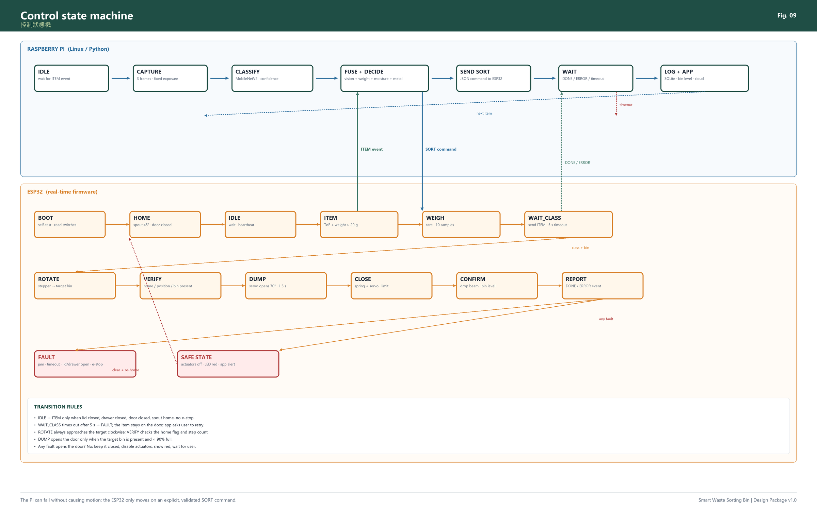
Figure 8. Control state machine. The Pi decides; the ESP32 executes only after validating interlocks and a target bin.
The firmware is a non-blocking state machine. Do not use delay() for more than 1 ms in the main loop; use millis() timers.
States:
- BOOT: self-test, read switches, check e-stop.
- HOME: rotate clockwise to home, close door, verify drawer/lid.
- IDLE: heartbeat, read sensors, wait for a valid item.
- ITEM: ToF + weight confirm; send ITEM event.
- WEIGH: tare, wait for stable weight, send weight.
- WAIT_CLASS: wait for SORT or STOP; 5 s timeout.
- ROTATE: move stepper to target; verify home flag/step count.
- DUMP: open door, wait 1.5 s, check drop beam.
- CLOSE: close door, verify limit, home spout.
- REPORT: send DONE/ERROR, update bin levels.
- FAULT/SAFE: actuators off, LED red, wait for user.
Transition guards:
- IDLE → ITEM only if lid closed, drawer closed, door closed, spout home, no e-stop, no fault.
- WAIT_CLASS → ROTATE only if bin present, bin <90% full, target 1–4.
- ROTATE → DUMP only if home flag/step count within ±5 steps and door closed.
- DUMP → CLOSE after 1.5 s or drop beam; if no drop, retry once, then FAULT.
- Any state → FAULT on e-stop, lid open, drawer open, or Pi heartbeat lost.
- FAULT → HOME only after the user clears the fault and presses the front button.

6.4 Motion control
- Use AccelStepper or a simple step timer with acceleration.
- Steps per 90°: 1200 (1/8 microstep, 3:1 belt).
- Positions: bin 1 = 0, bin 2 = 1200, bin 3 = 2400, bin 4 = 3600 (relative to home at 45°).
- Always approach clockwise: compute delta = (target - current + 4800) % 4800; move delta steps clockwise.
- Speed: start 400 steps/s, accelerate to 1200 steps/s, decelerate before target.
- After move, hold torque for 300 ms, then disable the driver (EN high) to reduce heat. The 3:1 belt and bearing friction hold position; if the spout drifts, keep the driver enabled at 50% current.
- Home: move clockwise until the switch triggers; back off 20 steps; approach at 200 steps/s; set zero.
- Stall detection: A4988 has no StallGuard. Use the home switch and a timeout; if the move does not finish in 4 s, FAULT.

6.5 Sensor acquisition and filtering
Sensor | Rate | Filter | Calibration
HX711 | 10 Hz | median of 10 + moving average 5 | scale factor, tare
ToF item | 20 Hz | median 5 | offset at door
ToF bins | 2 Hz each | median 5 | empty/full distance
Moisture | 5 Hz | moving average 10 | dry/wet thresholds
Metal | 10 Hz | 3-of-5 majority | centre/edge can
Switches | 50 Hz | 30 ms debounce | lid/door/drawer/home
SHT31 | 0.2 Hz | none | optional

Weight stability: read 10 samples at 10 Hz; if the standard deviation is <2 g, accept the mean; otherwise wait up to 1 s. Tare with the door closed and the hopper empty at boot and before each cycle.

6.6 Safety and fault handling
- E-stop: hardware cuts 12 V to stepper/servo/LED; the ESP32 reads the status via an optocoupler and goes to SAFE. The Pi logs the event.
- Lid/drawer/door: read every 50 ms; if open during motion, stop the stepper immediately (disable), close the door if possible, set FAULT.
- Watchdog: ESP32 task watchdog 5 s; Pi heartbeat 2 s; if lost, SAFE.
- Brownout: ESP32 brownout detector on; if the 5 V rail drops, reset and home. The Pi should use a UPS or a 5 V 5 A buck with bulk capacitance.
- Jam: if the drop beam is not broken within 2 s, retry the door once; if still no drop, FAULT and app message “open lid, clear funnel”.
- Bin full/missing: refuse to sort; keep the item on the door; app asks the user to empty/replace the bin.
- Power loss: spring closes the door; the spout stays; on reboot, home and check for an item. If the weight is >20 g, ask the user to remove it.

6.7 Vision pipeline
1. Capture: 3 frames at 1280 × 720, fixed exposure/gain/white balance; wait 200 ms after the LED ring is on.
2. Pre-process: crop the hopper region (not the whole frame), resize to 224 × 224, normalize; optional brightness/contrast check.
3. Inference: MobileNetV2 TFLite; output 4 class probabilities + confidence.
4. Temporal vote: average the 3 frames; if the top class is consistent in ≥2 frames, accept; otherwise lower confidence.
5. Fusion: combine with weight, moisture, metal; see 6.9.
6. Decision: if confidence ≥0.70 and the sensor evidence agrees, sort; if 0.50–0.70, use sensor rules; if <0.50, ask the user.
7. Log: store the class, confidence, top-2 classes, weight, moisture, metal, bin, time, image path (optional).
Performance target: Pi Zero 2 W, MobileNetV2 1.0 at 224 × 224, TFLite float16: 150–400 ms per frame; 3 frames + pre-processing <1.5 s. If slower, use MobileNetV2 0.5 at 160 × 160 or a Pi 4.

6.8 Dataset and training
- Classes: plastic_bottle, metal, wet, other. Add an unsure outcome in software; do not train a fifth class unless you have enough data.
- Quantity: 300–500 images per class, captured with the actual camera, lid, LED ring and hopper. Include different positions, orientations, crushed/uncrushed, labels, transparent bottles, cans, food containers, wet waste in bags, dry paper/glass/fabric.
- Split: 80% train, 10% validation, 10% test; split by physical item, not by frame, to avoid leakage.
- Augmentation: flip, rotate ±20°, brightness/contrast ±15%, slight blur, random crop; do not use extreme colour shifts that break material cues.
- Training: transfer learning from ImageNet MobileNetV2; freeze base, train dense head 10 epochs, fine-tune last 30 layers 10 epochs; Adam 1e-4 then 1e-5; class weights; early stopping.
- Conversion: TFLite float16; optionally int8 with a representative dataset. Test on the Pi, not just on the laptop.
- Evaluation: confusion matrix, per-class precision/recall/F1, overall accuracy; test with 50 physical items, 3 trials each. Report the confusion matrix in the final report.
- Dataset hygiene: keep a CSV with filename, class, item ID, lighting, notes. Do not train on the test items. Take photos of failures; they are the most useful data.

6.9 Fusion rules
Start with vision; use sensors to confirm or override only when the evidence is strong.
Condition | Decision
Vision confidence ≥0.75 and top class agrees with sensors | Top class
Vision says metal, coil detects metal, weight >15 g | Metal
Vision says plastic, coil no metal, weight <120 g, moisture <0.4 | Plastic
Moisture >0.65 and vision says wet/other | Wet
Vision says wet but moisture <0.35 and weight <80 g | Re-check; likely other
Vision confidence <0.50 | Ask user; default to other after 10 s
Coil metal but vision says plastic and weight >150 g | Metal (confidence boost)
Bin full/missing | Refuse; ask user

Do not hard-code “metal = heavy” or “wet = heavy”; a full plastic bottle can be heavy, and a dry paper cup can be light. Use weight as a prior, not a rule.

6.10 Database schema
CREATE TABLE events (
id INTEGER PRIMARY KEY AUTOINCREMENT,
ts TEXT NOT NULL,
class TEXT NOT NULL,
confidence REAL,
weight_g REAL,
moisture REAL,
metal INTEGER,
bin INTEGER,
bin_level INTEGER,
image_path TEXT,
status TEXT,
error_code TEXT
);
CREATE TABLE bins (
id INTEGER PRIMARY KEY,
name TEXT,
level_pct INTEGER,
present INTEGER,
last_emptied TEXT
);
CREATE TABLE settings (
key TEXT PRIMARY KEY,
value TEXT
);
Use SQLite in WAL mode; write one row per event; keep images only if disk allows. Export CSV from the app.

6.11 API and app
FastAPI endpoints:
Method | Path | Purpose
GET | /api/status | Current state, bin levels, battery, last event
GET | /api/events?limit=50 | Recent events
POST | /api/sort | Manual sort {bin:1..4} (confirmation required)
POST | /api/calibrate | Start tare/moisture/ToF calibration
GET | /api/export.csv | Download events
GET | /api/health | Pi/ESP32 heartbeat

PWA screens:
1. Dashboard: big status, four bin bars, battery, last sort, “Open lid” instruction.
2. History: table with time, class, weight, confidence, bin; filter; CSV export.
3. Manual sort: choose bin; confirmation; only when an item is present.
4. Settings: bin names, thresholds, Wi-Fi, calibration, cloud opt-in.
5. Alerts: bin full, jam, lid/drawer open, e-stop, low battery.
The PWA can be served by the Pi at http://smartbin.local:8000. If there is no network, the Pi runs a Wi-Fi hotspot SmartBin and the user opens http://192.168.4.1:8000. This is the most reliable demo setup.

6.12 Cloud (optional)
- Local-first: SQLite is the source of truth; cloud is a copy.
- Use Firebase Firestore or Supabase free tier; sync events when online; queue offline.
- Do not stream camera images to the cloud by default; privacy and bandwidth.
- Secure the API with a token; do not expose the Pi to the public internet without a VPN.
- For the final demo, local Wi-Fi is enough; cloud is a bonus, not a dependency.

6.13 Repository structure
smart-bin/
firmware/
esp32/
src/main.cpp
src/config.h
src/sensors.cpp
src/motion.cpp
src/protocol.cpp
pi/
app/
main.py
vision.py
fusion.py
db.py
serial_link.py
static/
models/
mobilenetv2_waste.tflite
data/
events.db
hardware/
drawings/
bom.xlsx
pinmap.csv
docs/
README.md
calibration.md
test-records/
Use git from day one; commit weekly; tag the version you demo.

6.14 Key code sketches
ESP32: non-blocking state machine (skeleton)
enum State { BOOT, HOME, IDLE, ITEM, WEIGH, WAIT_CLASS, ROTATE, DUMP, CLOSE, REPORT, FAULT };
State state = BOOT;
uint32_t tState = 0;
void loop() {
readSwitches();
if (estopPressed() || lidOpen() || drawerOpen()) enterFault("INTERLOCK");
switch (state) {
case IDLE:
if (itemPresent() && weightG() > 20) { sendItem(); state = WAIT_CLASS; tState = millis(); }
break;
case WAIT_CLASS:
if (millis() - tState > 5000) enterFault("TIMEOUT");
break;
case ROTATE:
if (stepper.distanceToGo() == 0) { verifyPosition(); state = DUMP; tState = millis(); }
stepper.run();
break;
case DUMP:
if (millis() - tState > 1500) { closeDoor(); state = CLOSE; }
break;
// ...
}
}
Pi: sort request
def sort_item(frame):
probs = model.predict(preprocess(frame))
cls, conf = top_class(probs)
weight = esp32.last_item["weight_g"]
moisture = esp32.last_item["moisture"]
metal = esp32.last_item["metal"]
decision = fuse(cls, conf, weight, moisture, metal)
if decision is None:
return ask_user(probs)
esp32.send({"cmd": "SORT", "bin": decision.bin, "id": event_id})
return wait_for_done(timeout=10)
Pi: serial link
import serial, json, threading
ser = serial.Serial("/dev/ttyUSB0", 115200, timeout=0.1)
def reader():
for line in ser:
try:
msg = json.loads(line.decode().strip())
events.put(msg)
except json.JSONDecodeError:
log.warning("bad line: %r", line)
threading.Thread(target=reader, daemon=True).start()

6.15 Calibration procedures

Load cells
1. Warm up 5 min; hopper empty; door closed.
2. Send TARE; record raw counts.
3. Place 100 g, 500 g, 1000 g, 1500 g at the centre; record raw counts.
4. Fit weight = (raw - offset) / scale; check error <±5 g.
5. Repeat with a 500 g mass at four corners; error <±10 g.
6. Store the scale factor in NVS; re-tare every cycle.

Moisture
1. Dry the pad; record raw ADC (air).
2. Put a damp sponge (not dripping) on the pad; record raw ADC.
3. Put a dry plastic bottle on the pad; record raw ADC.
4. Set wet threshold halfway between dry and wet with 0.15 hysteresis.
5. Repeat 5 times; if the readings overlap, increase the cover thickness or use a better sensor.

Metal
1. Empty hopper; tune the kit until the output is stable (no metal).
2. Place a steel can at the centre; adjust sensitivity until detection.
3. Test at four edges; record detection.
4. Test an aluminium can, a plastic bottle, and a wet sponge; record false positives.
5. If false positives >10%, reduce sensitivity or omit the coil.

Bin ToF
1. Empty bin; record distance to bottom.
2. Put a flat board at 25%, 50%, 75%, 100% of bin height; record distance.
3. Fit a linear map fill% = a * distance + b; check ±10%.
4. Repeat for each bin; store per-bin calibration.

Camera
1. Print a grid target at the door plane.
2. Set manual exposure, gain and white balance under the LED ring.
3. Check the full hopper is in frame; adjust height/focus.
4. Capture 20 images of the same item; check brightness variation <10%.
5. Re-check after changing the lid or LED.

7. Cost, procurement and resources

7.1 BOM summary
Group | Cost (HKD) | Share
Structure | 1,395 | 34%
Motion | 490 | 12%
Sensing | 1,030 | 25%
Power | 700 | 17%
Assembly | 435 | 11%
Total (recommended) | 4,050 | 100%

The full BOM is in Appendix A and in the separate Smart_Waste_Sorting_Bin_BOM.xlsx. Prices are indicative Hong Kong/Taobao street prices in October 2026; verify before ordering. Add 15% contingency for shipping, broken parts and replacements.

7.2 Budget tiers
Build | Changes | Estimated cost
Lean | HC-SR04 instead of 4 × VL53L1X; 12 V adapter instead of battery; reuse donor bins; plywood offcuts; no gas struts; no SHT31; no metal kit | ≈ HK$3,200
Recommended | As listed in Appendix A; battery + adapter; 4 × VL53L1X; metal kit; gas struts | ≈ HK$4,050
Enhanced | Pi 4 2 GB; aluminium frame; spare servo/stepper; 5 MP camera with better lens; UPS | ≈ HK$4,800

The recommended build is the best balance for a final-year demo. The lean build is acceptable if budget is tight, but the ultrasonic bin sensors and vision-only metal detection will be less reliable; document that as a limitation.

7.3 Procurement and lead times
Item | Where | Lead time | Notes
Raspberry Pi Zero 2 W | HK reseller / online | 1–2 weeks | Buy two if possible; one spare
USB camera | Computer shop / Taobao | 1 week | Check UVC and 90° FOV
NEMA 17, A4988, GT2 | Taobao / robot shop | 1–2 weeks | Order spare A4988
Load cells, HX711 | Taobao | 1–2 weeks | Buy 6 cells, match them
ToF sensors | Taobao | 1–2 weeks | Buy 1 spare VL53L1X
12 V Li-ion pack | Battery specialist | 1–2 weeks | Certified pack + charger
Plywood/PP | Local shop | 2–3 days | Cut to the cut list
3D printing | School/lab/online | 2–5 days | PETG, 30% infill
Fasteners | Local hardware | Same day | Buy 20% spares

Order early: the battery, Pi, camera and ToF sensors are the long-lead items. If they are delayed, build the frame and drawer first; they do not depend on electronics.

7.4 Cost-saving and reuse
- Use offcuts or donated plywood; paint/seal them.
- Reuse 12 L food containers or cat-litter buckets as bins; cut the notch.
- Use a phone as a camera? Not recommended: mounting, focus, exposure and USB tethering are unreliable. A HK$120 USB camera is worth it.
- Use a 12 V adapter for bench testing; buy the battery only for the final demo.
- 3D-print brackets at school; avoid expensive online printing.
- Buy a kit of M4/M5 screws instead of individual packs.
- Skip the SHT31 and metal kit if budget is tight; they are optional evidence.

7.5 Tools
ID | Tool | Description | Qty | Cost (HKD)
T-01 | Soldering iron + stand + solder | 烙鐵＋架＋焊錫 | 1 | 180
T-02 | Digital multimeter | 數位萬用表 | 1 | 150
T-03 | Wire strippers / crimping tool | 剝線鉗／壓線鉗 | 1 | 120
T-04 | Electric drill + bits + hole saw | 電鑽＋鑽頭＋孔鋸 | 1 | 350
T-05 | Jigsaw or circular saw | 曲線鋸或圓鋸 | 1 | 300
T-06 | Screwdriver and hex key set | 螺絲批及內六角套裝 | 1 | 120
T-07 | Digital calipers | 數位卡尺 | 1 | 80
T-08 | Hot glue gun | 熱熔膠槍 | 1 | 80
T-09 | Safety glasses and gloves | 護目鏡及手套 | 1 | 60
T-10 | Li-ion fire bag | 鋰電池防火袋 | 1 | 80

If the lab already has these, budget only for consumables (solder, blades, drill bits, tape). Add a fire-resistant Li-ion bag and safety glasses; they are not optional.

7.6 Procurement risks
Risk | Mitigation
Pi Zero 2 W out of stock | Pi 4 2 GB or Pi 3 A+; same code, more power
Camera FOV wrong | Test with a phone/printed grid before cutting the lid; buy a 90° lens
Load cells mismatched | Buy 6 from the same batch; calibrate each; use 4 closest
Battery shipping delay | Use 12 V adapter for development; borrow a pack for demo
3D printer unavailable | Plywood brackets or laser-cut acrylic; redesign tabs
Prices over budget | Lean substitutions; reuse; 15% contingency

8. Build, test and evaluation plan

8.1 Schedule
The project runs from November 2026 to late April 2027. This schedule assumes one student working ~10–12 hours/week, with lab access. Adjust to your actual timetable.
Weeks | Dates | Tasks | Milestone
1–2 | 2–15 Nov 2026 | Finalise design; BOM; order long-lead parts; proposal slides | Proposal ready
3–4 | 16–29 Nov | Cut frame/drawer; build bins; bench electronics | Frame and drawer
5–6 | 30 Nov–13 Dec | Hopper, door, load cells, spout, bearing | First mechanical assembly
7–8 | 14–27 Dec | ESP32 firmware; sensors; stepper/servo; serial protocol | Subsystems work on bench
9–10 | 28 Dec–10 Jan 2027 | Dataset collection; model training; interim report | Interim report 1st submission
11–12 | 11–24 Jan | Integrate vision; first end-to-end sort | First automatic sort
13–14 | 25 Jan–7 Feb | Calibration; 4-class test; fix jams | 50% target accuracy
15–16 | 8–21 Feb | PWA; bin levels; cloud; progress review prep | App dashboard
17–18 | 22 Feb–7 Mar | 50-item test; reliability; safety; video | Test report v1
19–20 | 8–21 Mar | Refinement; enclosure; labels; user test | Demo-ready
21–22 | 22 Mar–4 Apr | Final testing; report draft; poster | Report draft
23–24 | 5–18 Apr | Final report; video; presentation; buffer | Submission ready
— | 27 Apr 2027 | Final deadline | Submit

Buffers: 1 week after the first assembly; 1 week after the first end-to-end sort; 1 week before the final deadline. Do not compress testing.

8.2 Work breakdown and milestones
Work package | Output | Depends on
WP1 Requirements and concept | Requirement table, concept selection | —
WP2 Mechanical design | Drawings, cut list, BOM | WP1
WP3 Mechanical build | Frame, drawer, bins, hopper, spout | WP2, parts
WP4 Electronics | Power, sensors, drivers, wiring | WP2, parts
WP5 Firmware | ESP32 state machine, serial protocol | WP4
WP6 Vision | Dataset, model, TFLite on Pi | WP3, camera
WP7 Integration | End-to-end sort | WP3–WP6
WP8 App/data | PWA, SQLite, CSV, optional cloud | WP5, WP7
WP9 Test/evaluation | Accuracy, cycle time, jam rate, safety | WP7, WP8
WP10 Documentation | Report, poster, video, demo | All

8.3 Test plan

Unit tests
ID | Test | Procedure | Pass criterion
UT1 | Load cell linearity | 0/100/500/1000/1500 g | error ≤ ±5 g
UT2 | Load cell corner error | 500 g at four corners | error ≤ ±10 g
UT3 | ToF bin level | 25/50/75/100% boards | error ≤ ±10%
UT4 | Moisture | dry/wet sponge, 5 repeats | clear separation
UT5 | Metal | can centre/edge, plastic control | ≥80% detection, ≤10% false
UT6 | Stepper home | 20 homes | ±2 steps
UT7 | Stepper position | 20 moves to each bin | ±3°
UT8 | Servo door | 100 cycles | no jam; limit switch every time
UT9 | IR beam | hand/card, 20 trials | 100% detection
UT10 | E-stop | press during move, 5 trials | stop <100 ms; fault logged

Integration tests
ID | Test | Procedure | Pass criterion
IT1 | Load → weigh → class | 10 items per class | event within 2 s; weight ±5 g
IT2 | Class → rotate → drop | 40 items | correct bin ≥85%; no jam
IT3 | Bin full | Fill bin to 95% | refuse; app alert
IT4 | Missing bin | Remove bin 2 | refuse; app alert
IT5 | Lid/drawer open | Open during cycle | stop; fault; no motion
IT6 | Pi disconnect | Unplug USB during idle | ESP32 safe; no motion
IT7 | Power loss | Switch off during cycle | door closes; reboot safe

System test
- 50 mixed items, 3 runs, random order; record class, confidence, weight, moisture, metal, bin, time, success, jam, notes.
- Compute overall accuracy, per-class recall, confusion matrix, mean cycle time, 95th percentile, jam rate.
- Measure noise at 1 m; measure power; measure battery life.
- User test: 3–5 users, first-time use, task completion, SUS score, comments.

Test record template
# | Item | True class | Predicted | Confidence | Weight (g) | Moisture | Metal | Bin | Time (s) | Result | Notes
1

8.4 Risk register
ID | Risk | Likelihood | Impact | Mitigation
R1 | Metal detection unreliable | High | Medium | Vision + weight fusion; coil optional; document
R2 | Transparent plastic vs glass | High | Medium | Local dataset; confidence threshold; manual override
R3 | Wet sensor fouling | Medium | High | Replaceable HDPE cover; clean; calibrate
R4 | Item jams in funnel | Medium | High | 110 mm outlet; 59° walls; drop beam; access panel
R5 | Stepper misses steps | Medium | Medium | 3:1 belt; current limit; home each cycle
R6 | Load cell drift | Medium | Medium | Tare each cycle; shielded cable; quality cells
R7 | Battery safety | Low | High | Certified pack; fuse; charge outside; fire bag
R8 | Camera glare | High | Medium | Diffuse ring; matte black; polarizer
R9 | Lid cable wear | Medium | Medium | USB cable; service loop; strain relief
R10 | Schedule slip | High | High | Order early; build frame first; cut scope to lean
R11 | Cost overrun | Medium | Medium | 15% contingency; reuse; lean BOM
R12 | User confusion | Medium | Medium | Labels; LED; app instructions; user test

8.5 Mapping to the FYP assessment
Assessment area | Evidence in this package
Problem, goals, objectives | Section 1; problem statement; SMART objectives
Feasibility and proposed solution | Sections 2–3; concept comparison; BOM; schedule
Requirements | Section 1.4; FR/NFR tables; acceptance criteria
Detailed design | Sections 4–6; drawings; calculations; pin map; state machine
Implementation | Build sequence; code sketches; calibration; photos/logs
Testing and evaluation | Section 8; unit/integration/system tests; metrics
Schedule and resources | Sections 7–8; BOM; 24-week plan; risk register
Final report/presentation | Use the figures and tables; add your own results

What to photograph for the report: cut parts, frame assembly, drawer, hopper, load cells, spout, wiring, sensor mounts, first sort, failures, final demo, app screens, test setup. Keep a logbook with dates and decisions.

8.6 What to do if you run out of time
Prioritise in this order:
1. Safe mechanical build with manual bin selection (no AI) — demonstrates mechanism.
2. Load cells + bin levels + app logging — demonstrates sensors/data.
3. Vision classification with manual confirm — demonstrates AI.
4. Full automatic sort — the ideal.
A working, well-tested 3-stream sorter is better than an unfinished 4-stream sorter. Document what is not finished honestly.

9. Limitations, future work and conclusion

9.1 Limitations
- One item at a time. Multiple items or a bag will confuse the classifier and may jam.
- Size/weight limit. 110 mm spout, 1.5 kg door; 2 L bottles and heavy bags are out.
- Metal detection is confirmatory. The DIY coil is not a certified detector; aluminium foil and thin cans may be missed.
- Wet/dry is evidence, not truth. A wet label on a dry bottle or a sealed wet bag can mislead.
- Dataset bias. Accuracy depends on the items you collect; a new building’s waste may differ.
- No glass/paper separation. They go to “other”; this is a deliberate scope choice.
- No compaction/odour control. The bin fills; wet waste may smell; clean regularly.
- Battery life. 2–4 h continuous; not a full-day public bin.
- Prototype safety. Not certified; do not use unattended in public.

9.2 Future work
- Add a fifth bin for paper/glass; increase spout positions to 5.
- Use a Pi 4 or Jetson Nano for a larger model / real-time detection.
- Add a load-cell-based “fill mass” estimate and compaction.
- Add a UV-C or ozone module for odour (with safety interlocks).
- Add a solar panel and battery management for outdoor use.
- Add a QR/NFC user ID and gamification for recycling behaviour.
- Add a cloud dashboard for a building manager; predict fill and optimize collection.
- Improve the metal detector with a proper eddy-current front end.
- Add a self-test routine and remote diagnostics.

9.3 Conclusion
This package gives you a complete, buildable design: a 480 × 480 × 940 mm bin, four 10.7 L bins, a 320 × 320 mm weigh hopper, a 110 mm rotating spout, a Pi + ESP32 control stack, a camera-based classifier, and a phone app. It is deliberately low-cost, repairable, and safe enough for an indoor final-year demonstration.
The hard parts are not the CAD: they are dataset quality, jam-free mechanics, and honest testing. Build the frame and drawer first, get the sensors working on the bench, then integrate vision. Keep the scope tight, document every failure, and let the test data tell the story. A well-tested 85% system with clear limitations is a stronger FYP than an untested 99% claim.

Appendix A. Full bill of materials
The table below is the recommended build. Prices are indicative Hong Kong/Taobao street prices in October 2026, in HKD. Add 15% for shipping, tax and spares. The editable workbook is Smart_Waste_Sorting_Bin_BOM.xlsx.
BOM notes
- “Core” items are needed for the four-stream sorter. “Optional” items improve evidence or reliability but can be omitted in the lean build.
- Buy six load cells and match the four closest; load cells from different batches can have different sensitivity.
- Buy one spare A4988, HX711 and ToF sensor. They are cheap and save a demo.
- The battery is the highest-risk purchase. Use a certified pack with a BMS and a matching charger; do not buy loose cells.
- The 3D-printed parts are: camera bracket, sensor mounts, spout collar, servo bracket, bin corner inserts, cable clips. Budget 1 kg PETG.
ID | Item | Specification | Qty | Unit (HKD) | Total (HKD) | Priority
STRUCTURE · HK$1,395
S-01 | Plywood sheet, 18 mm | 1220 x 2440 mm, B/BB or marine ply | 1 | 380 | 380 | Core
S-02 | PP / acrylic sheet, 3 mm | 600 x 400 mm, food-contact PP preferred | 4 | 45 | 180 | Core
S-03 | Piano hinge, 500 mm | Stainless steel, 32 mm open width | 2 | 25 | 50 | Core
S-04 | Drawer slides, 450 mm | 3-fold, 45 kg rated, pair | 2 | 60 | 120 | Core
S-05 | Gas strut, 60 N | 250 mm extended, 10 mm ball ends | 2 | 40 | 80 | Core
S-06 | Rubber feet | 30 mm diameter, M6 thread | 4 | 5 | 20 | Core
S-07 | Fixings assortment | M4/M5 bolts, nuts, washers, inserts, angle brackets | 1 | 150 | 150 | Core
S-08 | Silicone seal strip | 10 x 3 mm, self-adhesive, 3 m | 1 | 30 | 30 | Core
S-09 | Storage bins, 12 L | Approx. 190 x 190 x 360 mm, PP, 4 pcs | 4 | 40 | 160 | Core
S-10 | PETG filament | 1.75 mm, 1 kg, black | 1 | 120 | 120 | Core
S-11 | Adhesive and sealant | Epoxy, acrylic cement, neutral silicone | 1 | 60 | 60 | Core
S-12 | Matte black paint | 400 ml, low sheen | 1 | 45 | 45 | Core
MOTION · HK$490
M-01 | NEMA 17 stepper motor | 42BYGH40, 1.7 A, 0.45 N·m, 1.8 deg | 1 | 85 | 85 | Core
M-02 | Stepper driver A4988 | With heatsink; 1/8 microstep | 1 | 20 | 20 | Core
M-03 | GT2 pulley set | 20T motor, 60T shaft, 200 mm belt | 1 | 55 | 55 | Core
M-04 | Lazy Susan bearing | 150 mm OD, 5 mm thick | 1 | 30 | 30 | Core
M-05 | Ball bearings 608ZZ | 8 x 22 x 7 mm | 4 | 5 | 20 | Core
M-06 | Metal-gear servo, 25 kg·cm | DS3225MG or equivalent, 6.8 V | 1 | 95 | 95 | Core
M-07 | Servo horn, spring and cable set | Aluminium horn, 0.8 x 20 x 80 mm spring, 1 mm cable | 1 | 35 | 35 | Core
M-08 | PVC elbow 110 mm, 45 deg | DWV or pressure pipe, outlet 110 mm | 1 | 40 | 40 | Core
M-09 | Funnel sheet / printed funnel | PP sheet or PETG print; inlet 280 x 260, outlet 110 mm | 1 | 60 | 60 | Core
M-10 | Micro switches | SPDT, 5 A, lever | 3 | 10 | 30 | Core
M-11 | Vibration motor, 12 V | 10 mm coin, 3-5 V or 12 V via driver | 1 | 20 | 20 | Optional
SENSING · HK$1,030
E-01 | USB camera, 5 MP | UVC, 90 deg diagonal FOV, manual focus, 1 m cable | 1 | 120 | 120 | Core
E-02 | Raspberry Pi Zero 2 W | Quad-core Cortex-A53, 512 MB RAM | 1 | 180 | 180 | Core
E-03 | microSD card, 32 GB | Class 10 / A1 | 1 | 60 | 60 | Core
E-04 | ESP32 DevKit V1 | 30-pin, ESP32-WROOM-32, USB | 1 | 45 | 45 | Core
E-05 | Load cell set, 5 kg | 4 x half-bridge 5 kg + combinator + HX711 | 1 | 100 | 100 | Core
E-06 | VL53L0X ToF sensor | I2C, up to 2 m, item presence | 1 | 30 | 30 | Core
E-07 | VL53L1X ToF sensor | I2C, up to 4 m, 4 pcs for bin levels | 4 | 50 | 200 | Core
E-08 | IR break-beam set | 940 nm LED + TSOP38238 receiver, 38 kHz | 1 | 25 | 25 | Core
E-09 | SHT31 temperature/humidity | I2C, +/-2% RH | 1 | 50 | 50 | Optional
E-10 | Capacitive moisture sensor | Corrosion-resistant PCB, analog | 1 | 30 | 30 | Core
E-11 | DIY metal detector kit | 3-5 V kit, 60 mm coil; add 150 mm custom coil | 1 | 40 | 40 | Optional
E-12 | PCF8574 I2C expander | 8-bit, address 0x20 | 1 | 15 | 15 | Core
E-13 | Reed switch and magnet set | NC/NO, 4 sets | 1 | 30 | 30 | Core
E-14 | Push button, e-stop, power switch | 22 mm, 1 NO/1 NC, 10 A | 1 | 70 | 70 | Core
E-15 | WS2812B LED bar, 8 LEDs | 5 V, IP30, diffused | 1 | 25 | 25 | Core
E-16 | Piezo buzzer | 3.3-5 V active | 1 | 10 | 10 | Core
POWER · HK$700
P-01 | 12 V 6 Ah Li-ion pack with BMS | 3S2P 18650, certified assembly, 12.6 V charger | 1 | 350 | 350 | Core
P-02 | 12 V 5 A bench adapter | 5.5 x 2.1 mm plug, CE/BS marked | 1 | 80 | 80 | Core
P-03 | Buck converter 12 V -> 5 V 5 A | XL4015 or similar, heatsink | 1 | 45 | 45 | Core
P-04 | Buck converter 12 V -> 6 V 5 A | XL4015 or similar, heatsink | 1 | 40 | 40 | Core
P-05 | Buck converter 12 V -> 5 V 3 A | LM2596 or similar | 1 | 25 | 25 | Core
P-06 | Fuse holder and 5 A fuses | Blade type, inline | 1 | 25 | 25 | Core
P-07 | Power distribution board | Screw terminals, busbars | 1 | 50 | 50 | Core
P-08 | 12 V relay module | 30 A automotive relay, 5 V coil | 1 | 25 | 25 | Core
P-09 | DC jacks, switch, wiring | 18 AWG silicone wire, 2 m red/black | 1 | 60 | 60 | Core
ASSEMBLY · HK$435
A-01 | Perfboard / interface PCB | 100 x 150 mm, 2.54 mm pitch | 2 | 20 | 40 | Core
A-02 | Connectors and ferrules | JST-XH, Dupont, WAGO, ferrules | 1 | 90 | 90 | Core
A-03 | Shielded load-cell cable | 4-core shielded, 1 m | 1 | 30 | 30 | Core
A-04 | Cable glands and spiral wrap | PG7/PG9, 2 m wrap | 1 | 50 | 50 | Core
A-05 | Heat-shrink and sleeving | Assorted | 1 | 30 | 30 | Core
A-06 | Fan, 40 mm 5 V | With filter | 1 | 30 | 30 | Core
A-07 | Acrylic mounting plate | 3 mm, 300 x 200 mm | 1 | 30 | 30 | Core
A-08 | Labels and signage | Bilingual bin labels, safety labels, QR code | 1 | 45 | 45 | Core
A-09 | Velcro, tape, cable clips | Assorted | 1 | 50 | 50 | Core
A-10 | Bin liners / cleaning kit | Compostable liners, wipes, gloves | 1 | 40 | 40 | Core
TOTAL HK$4,050

Appendix B. Cut list
Nominal dimensions in mm. Add 1–2 mm clearance where parts meet; sand to fit. Seal all plywood edges.
ID | Part | Material | Size (mm) | Qty | Notes
C-01 | Base panel | 18 mm plywood | 480 x 480 | 1 | Electronics bay floor; 20 mm feet
C-02 | Base front/back | 18 mm plywood | 480 x 100 | 2 | Electronics bay; vent holes
C-03 | Base sides | 18 mm plywood | 444 x 100 | 2 | Between front and back
C-04 | Bin section sides | 18 mm plywood | 480 x 400 | 2 | Left/right; drawer opening
C-05 | Bin section back | 18 mm plywood | 444 x 400 | 1 | Fixed back
C-06 | Bin section top/bottom | 18 mm plywood | 480 x 480 | 2 | Mid-frame and bin top
C-07 | Drawer bottom | 18 mm plywood | 456 x 456 | 1 | 4 bin pockets; 6 mm clearance
C-08 | Drawer sides | 18 mm plywood | 456 x 360 | 2 | Bin retaining walls
C-09 | Drawer front | 18 mm plywood | 480 x 400 | 1 | Handle and latch
C-10 | Hopper sides | 18 mm plywood | 360 x 300 | 2 | Support frame; PP liner inside
C-11 | Hopper front/back | 18 mm plywood | 324 x 300 | 2 | Front has door opening
C-12 | Hopper support plate | 18 mm plywood | 360 x 360 | 1 | Rests on 4 load cells; 180 mm center hole
C-13 | Hopper door | 6 mm PP/plywood | 280 x 240 | 1 | Silicone gasket; hinge at back
C-14 | Lid | 18 mm plywood + 3 mm acrylic | 480 x 480 | 1 | Camera hole 30 mm; LED ring recess
C-15 | Mid-frame | 18 mm plywood | 480 x 480 | 1 | Load cells and spout bearing; 200 mm center hole
C-16 | Funnel walls | 3 mm PP | 4 pieces, 280 x 150 | 4 | 60 deg; outlet 110 mm
C-17 | Spout guard | 3 mm PP | 300 x 200 | 1 | Clear guard around rotating spout
C-18 | Drip tray | 3 mm PP | 456 x 456 | 1 | Removable; 20 mm lip

Cutting order
1. Cut the drawer bottom and sides first; check the bins fit.
2. Cut the bin-section sides/back/top/bottom around the drawer.
3. Cut the base and electronics bay.
4. Cut the mid-frame and hopper support plate; drill the load-cell holes.
5. Cut the lid and hopper panels.
6. Cut the PP liners and drip tray.
7. Dry-assemble; mark and drill pilot holes; then seal and paint.

Appendix C. Pin and connector schedule
Signal | ESP32 pin | Type | Device / bus | Notes
I2C SDA | GPIO21 | Bidirectional | SHT31, VL53L0X, 4 x VL53L1X, PCF8574 | 4.7 k pull-up to 3.3 V; assign ToF addresses with XSHUT
I2C SCL | GPIO22 | Bidirectional | Same I2C bus | Keep leads < 500 mm; twisted pair
HX711 DOUT | GPIO32 | Input | HX711 | 10 Hz or 80 Hz; shielded cable
HX711 SCK | GPIO33 | Output | HX711 | Keep away from stepper wires
Stepper STEP | GPIO25 | Output | A4988 STEP | 1/8 microstep; 1200 steps per 90 deg
Stepper DIR | GPIO26 | Output | A4988 DIR | Direction; always approach target clockwise
Stepper EN | GPIO27 | Output | A4988 EN | Active low; disable when idle to reduce heat
Hopper servo | GPIO13 | PWM 50 Hz | DS3225MG signal | 6 V supply; common ground; 1000 uF
IR receiver | GPIO35 | Input only | TSOP38238 OUT | External 10 k pull-up; 100 nF decoupling
E-stop status | GPIO34 | Input only | Optocoupler / divider | External 10 k pull-up; low = pressed
Front button | GPIO39 | Input only | Push button to GND | External 10 k pull-up; debounce 30 ms
WS2812 data | GPIO2 | Output | LED bar DIN | 330 ohm series; 5 V supply; level 3.3 V works
Buzzer | GPIO14 | Output | Active buzzer | NPN transistor if > 20 mA
Item ToF XSHUT | GPIO4 | Output | VL53L0X XSHUT | Pull low to reset; release after boot
Bin 1 ToF XSHUT | GPIO16 | Output | VL53L1X #1 | Assign address 0x30
Bin 2 ToF XSHUT | GPIO17 | Output | VL53L1X #2 | Assign address 0x31
Bin 3 ToF XSHUT | GPIO18 | Output | VL53L1X #3 | Assign address 0x32
Bin 4 ToF XSHUT | GPIO19 | Output | VL53L1X #4 | Assign address 0x33
PCF8574 INT | GPIO23 | Input | PCF8574 INT | Optional; polling is acceptable
Spare / fan | GPIO12 | Output | Fan MOSFET | Avoid strapping conflict; fan on during sorting

Connector schedule
Connector | Pins | Signal | Cable | Mate
J1 | 1 | 12 V + | 18 AWG red | Battery/fuse
J1 | 2 | 12 V − | 18 AWG black | Battery/fuse
J2 | 1 | 5 V | 20 AWG red | Buck 1
J2 | 2 | GND | 20 AWG black | Buck 1
J3 | 1 | 6 V | 20 AWG orange | Buck 3
J3 | 2 | GND | 20 AWG black | Buck 3
J4 | 1 | SDA | 24 AWG blue | I2C bus
J4 | 2 | SCL | 24 AWG green | I2C bus
J4 | 3 | 3.3 V | 24 AWG red | I2C bus
J4 | 4 | GND | 24 AWG black | I2C bus
J5 | 1 | STEP | 24 AWG | A4988
J5 | 2 | DIR | 24 AWG | A4988
J5 | 3 | EN | 24 AWG | A4988
J5 | 4 | GND | 24 AWG | A4988
J6 | 1 | 6 V | 20 AWG | Servo
J6 | 2 | GND | 20 AWG | Servo
J6 | 3 | PWM | 24 AWG | Servo
J7 | 1 | E+ | shielded | Load cells
J7 | 2 | E− | shielded | Load cells
J7 | 3 | A− | shielded | Load cells
J7 | 4 | A+ | shielded | Load cells
J8 | 1 | 5 V | 20 AWG | LED ring
J8 | 2 | GND | 20 AWG | LED ring
J8 | 3 | MOSFET drain | 20 AWG | LED ring
J9 | 1 | 5 V | 20 AWG | LED bar
J9 | 2 | GND | 20 AWG | LED bar
J9 | 3 | DATA | 24 AWG | LED bar

Appendix D. Serial protocol and API reference

D.1 Message rules
- One JSON object per line, UTF-8, LF terminator.
- Maximum line length 512 bytes.
- Unknown keys are ignored; unknown commands return {"evt":"ERROR","code":"BAD_CMD"}.
- Every command has a response within 500 ms, except SORT which may take 10 s.
- Heartbeat every 2 s; 3 missed heartbeats → SAFE.

D.2 Commands
Command | Fields | Response | Notes
HELLO | v | READY | Handshake; firmware version
SORT | bin 1–4, id, timeout_ms | SORTING then DONE/ERROR | Validates interlocks
HOME | — | READY | Homes spout, closes door
STATUS | — | STATUS | Full state snapshot
STOP | — | SAFE | Stops motion, keeps power
TARE | — | TARE_OK | Hopper must be empty/closed
CAL | sensor, value | CAL_OK | Stores calibration

D.3 REST API
Method | Path | Body | Response
GET | /api/status | — | {state, bins, battery, last_event}
GET | /api/events | — | [{id, ts, class, confidence, weight_g, bin}]
POST | /api/sort | {bin, confirm:true} | {ok:true} or error
POST | /api/tare | {} | {ok:true}
GET | /api/export.csv | — | CSV file
GET | /api/health | — | {pi:true, esp32:true, uptime_s}

D.4 Example session
Pi → ESP32: {"cmd":"HELLO","v":1}
ESP32 → Pi: {"evt":"READY","fw":"1.0.0","home":true}
Pi → ESP32: {"cmd":"STATUS"}
ESP32 → Pi: {"evt":"STATUS","state":"IDLE","bin_levels":[12,45,80,3],"door":false,"lid":true}
ESP32 → Pi: {"evt":"ITEM","weight_g":128.4,"moisture":0.12,"metal":false,"tof_mm":180}
Pi → ESP32: {"cmd":"SORT","bin":2,"id":"20261029-001","timeout_ms":8000}
ESP32 → Pi: {"evt":"SORTING","bin":2,"steps":1200}
ESP32 → Pi: {"evt":"DONE","bin":2,"ms":4210,"drop":true}

Appendix E. Test record templates

E.1 Unit test record
Test ID | Date | Operator | Setup | Result | Pass/Fail | Notes
UT1
UT2
UT3

E.2 50-item system test
# | Item description | True class | Predicted | Confidence | Weight (g) | Moisture | Metal | Bin | Time (s) | Jam? | Correct? | Notes
1
2

Summary: overall accuracy = ___%; per-class recall = ___; mean cycle time = ___ s; jam rate = ___%; failures = ___.

E.3 Safety test record
Test | Trial 1 | Trial 2 | Trial 3 | Pass? | Notes
Lid open → no motion
Drawer open → no motion
Door open → no motion
E-stop during move
Power loss during move
Pi disconnect during idle

Appendix F. References
[1] Hong Kong Environmental Protection Department, “Waste reduction and recycling,” https://www.epd.gov.hk/epd/english/environmentinhk/waste/waste_main.html
[2] Espressif Systems, “ESP32 series datasheet,” https://www.espressif.com/sites/default/files/documentation/esp32_datasheet_en.pdf
[3] Raspberry Pi Foundation, “Raspberry Pi Zero 2 W product page,” https://www.raspberrypi.com/products/raspberry-pi-zero-2-w/
[4] Google, “TensorFlow Lite,” https://www.tensorflow.org/lite
[5] M. Sandler et al., “MobileNetV2: Inverted residuals and linear bottlenecks,” CVPR 2018, https://arxiv.org/abs/1801.04381
[6] Pololu, “A4988 stepper motor driver carrier,” https://www.pololu.com/product/1182
[7] Avia Semiconductor, “HX711 24-bit ADC datasheet,” https://cdn.sparkfun.com/datasheets/Sensors/ForceFlex/hx711_english.pdf
[8] STMicroelectronics, “VL53L1X datasheet,” https://www.st.com/resource/en/datasheet/vl53l1x.pdf
[9] ElecSchematics, “HC-SR04 datasheet,” https://www.electroschematics.com/wp-content/uploads/2013/07/HCSR04-datasheet-version-1.pdf
[10] Vishay, “TSOP382xx IR receiver datasheet,” https://www.vishay.com/docs/82491/tsop382.pdf
[11] FastAPI documentation, https://fastapi.tiangolo.com/
[12] SQLite documentation, https://www.sqlite.org/
[13] OpenCV documentation, https://opencv.org/
[14] IEC 62133-2, “Secondary cells and batteries containing alkaline or other non-acid electrolytes — Safety requirements for portable sealed secondary cells, and for batteries made from them, for use in portable applications — Part 2: Lithium systems,” https://webstore.iec.ch/publication/32588

*End of English design package.*

