Legacy (P2PKH):
Program 1 output
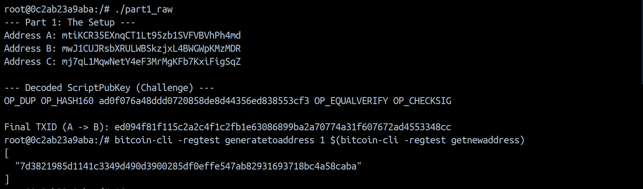
JSON file for A->B
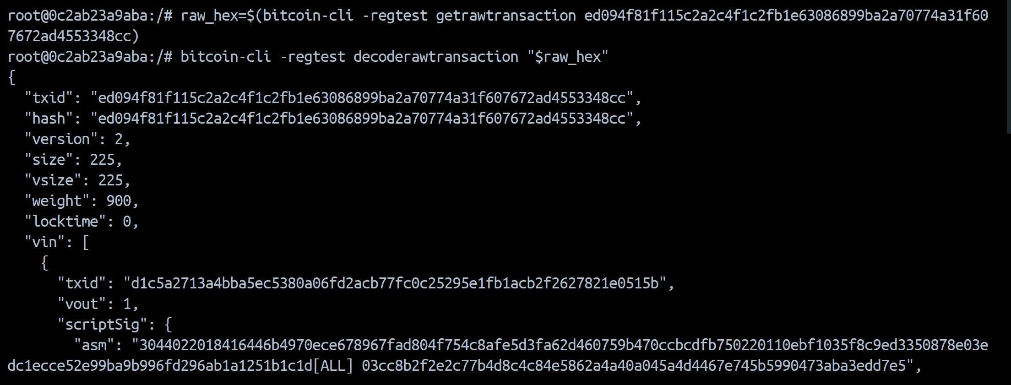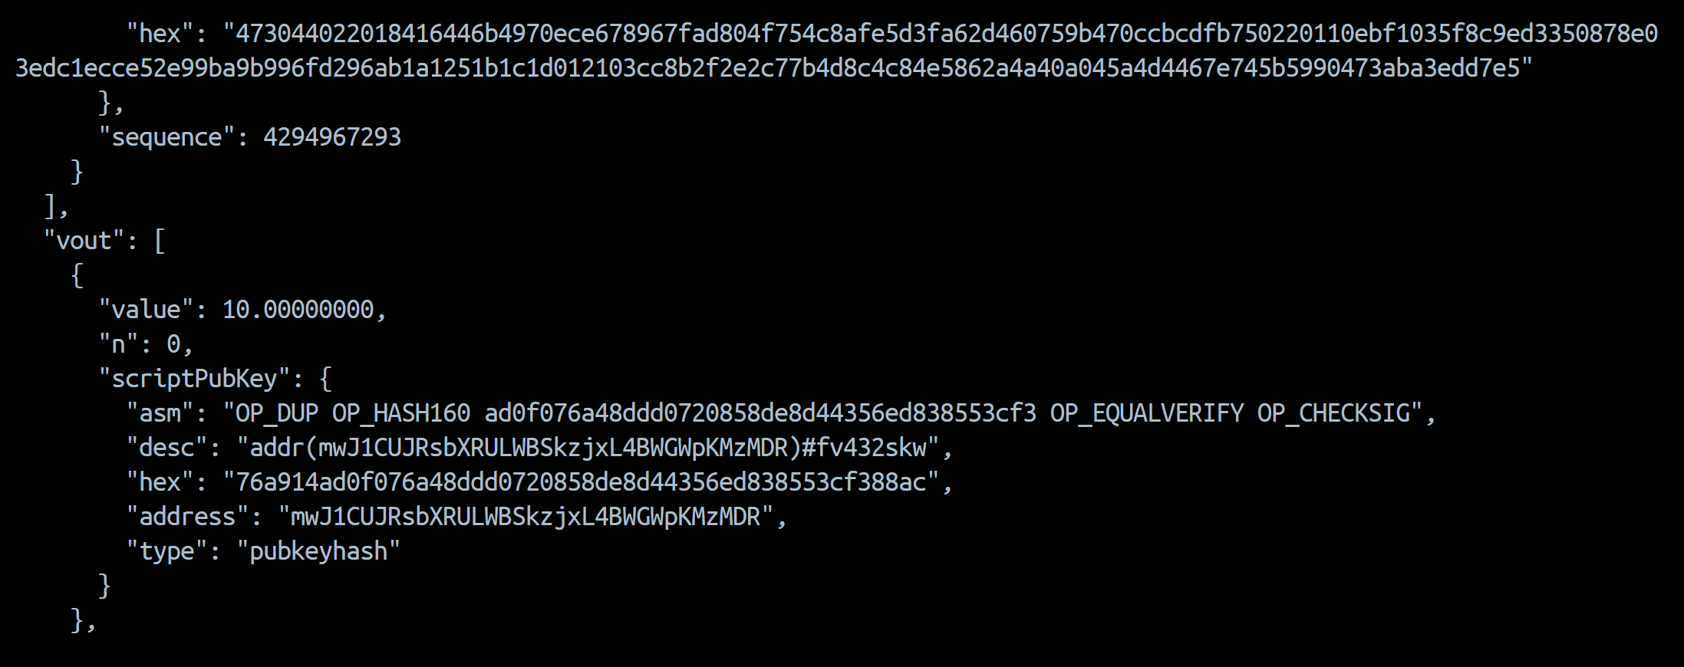
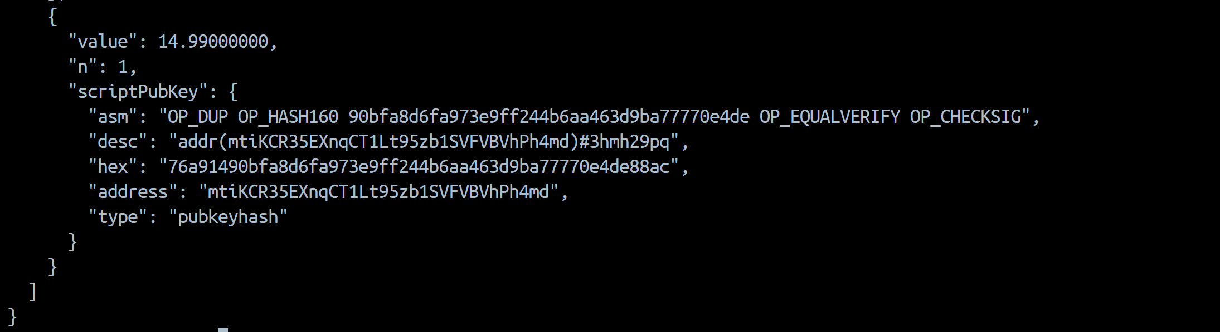
scriptPubKey.asm | OP_DUP OP_HASH160 ad0f076a48ddd0720858de8d44356ed838553df3 OP_EQUALVERIFY OP_CHECKSIG
scriptPubKey.type | pubkeyhash
scriptSig.asm | 3044022018416446b4970ece678967fad804f754c8afe5d3fa62d460759b470ccbcdfb750220110ebf1035f8c9ed3350878e03edc1ecce52e99ba9b996fd296ab1a1251b1c1d[ALL] 03cc8b2f2e2c77b4d8c4c84e5862a4a40a045a4d4467e745b5990473aba3edd7e5
size | 225
vsize | 225
weight | 900

Program 2 output
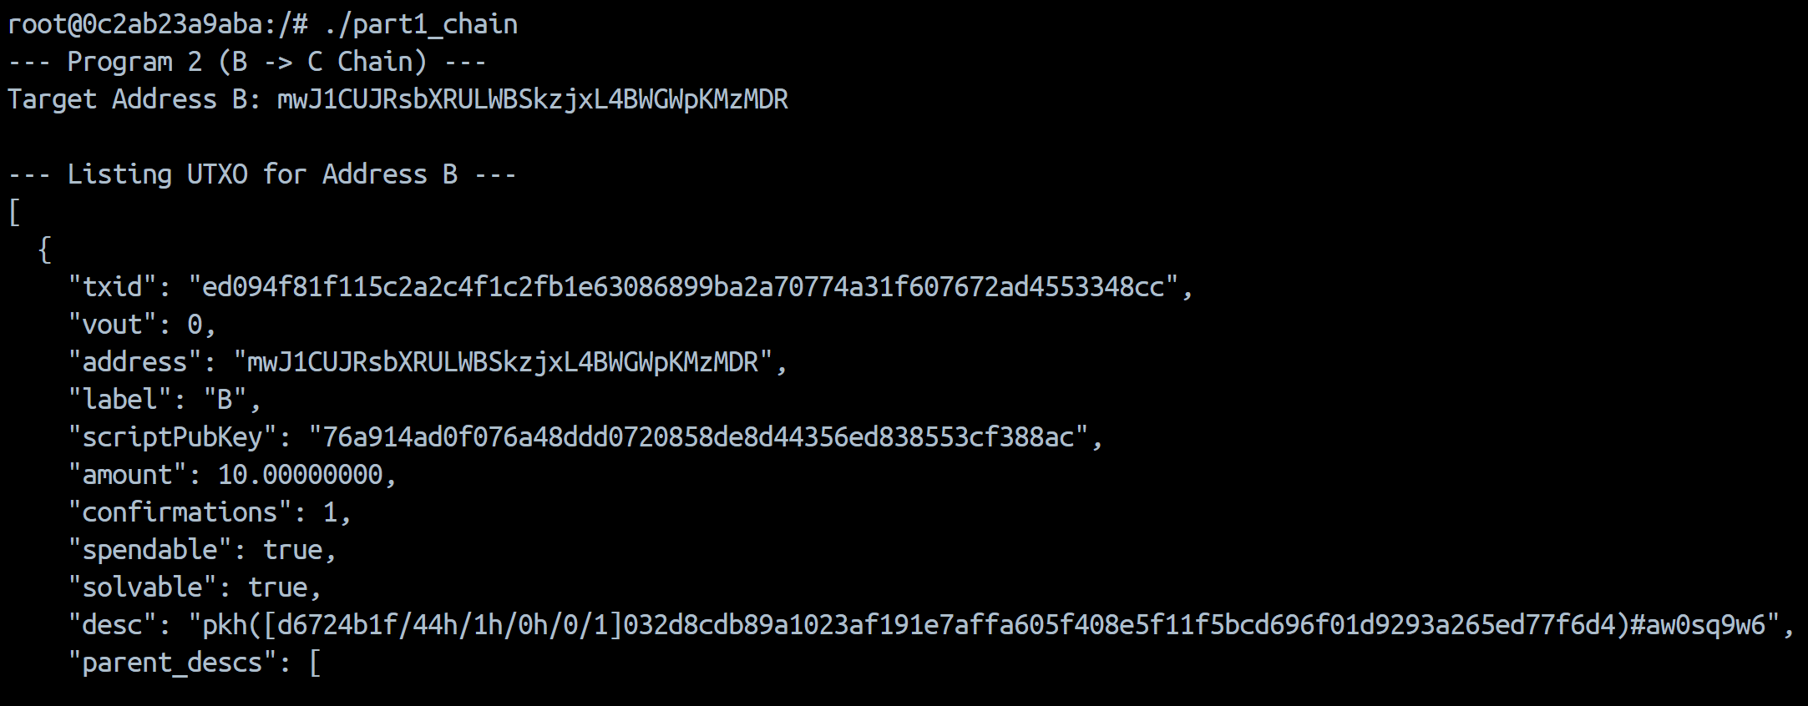
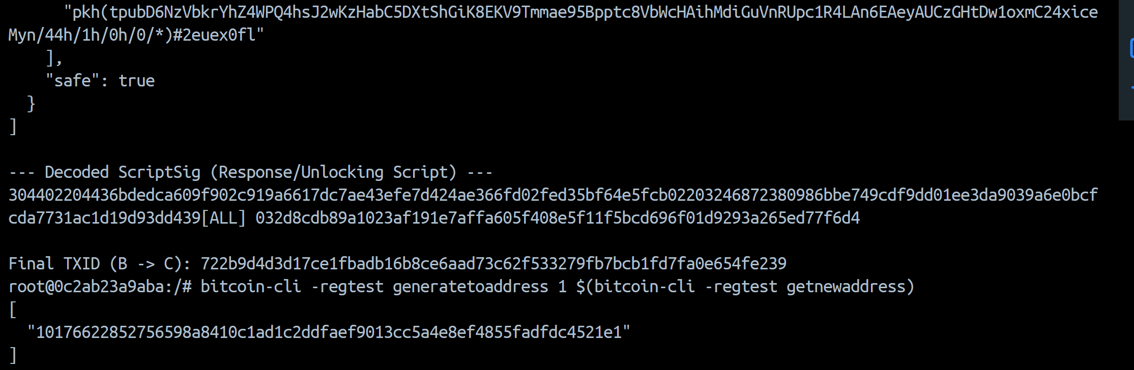

JSON file for B->C
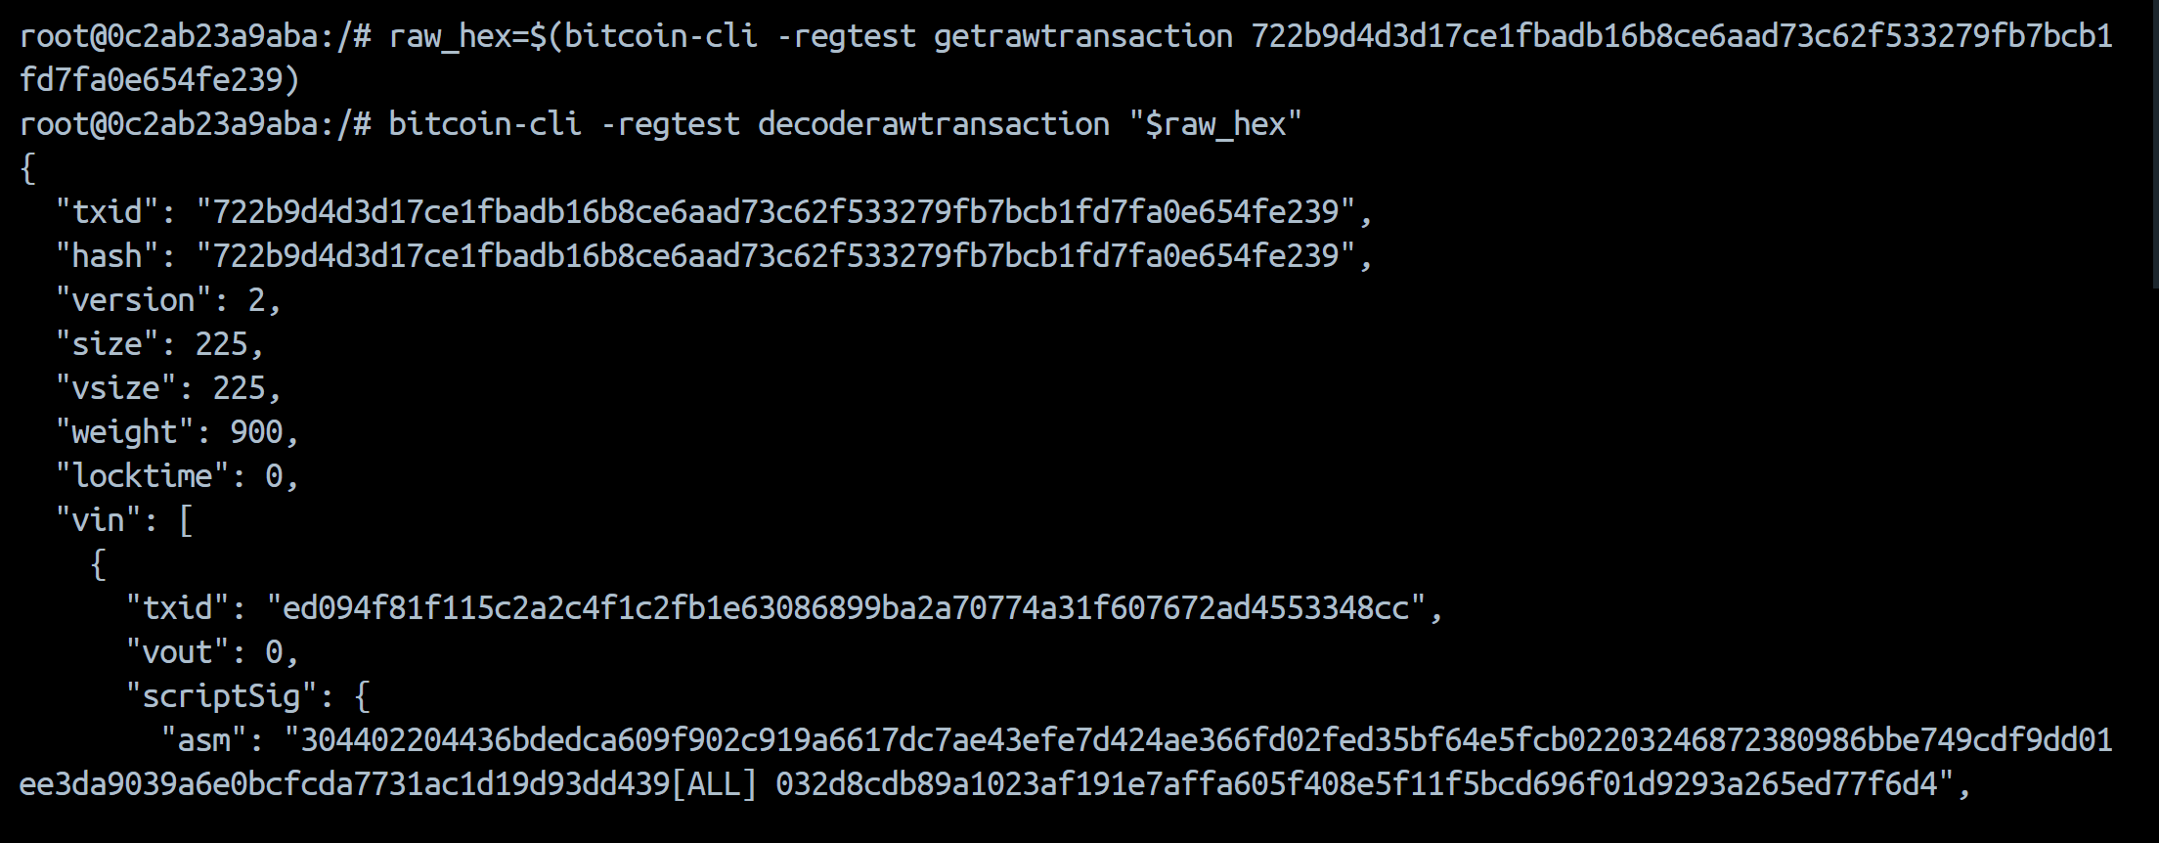
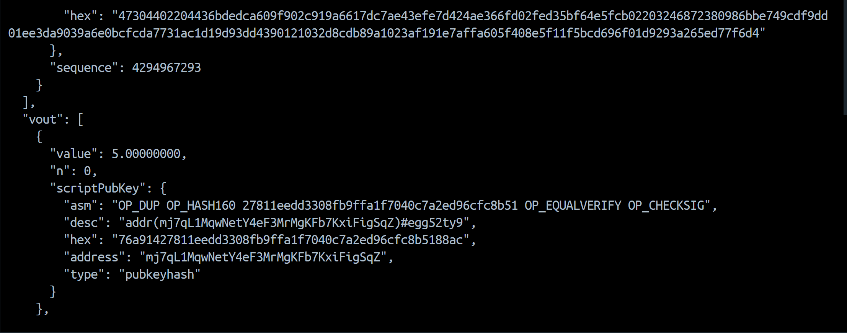
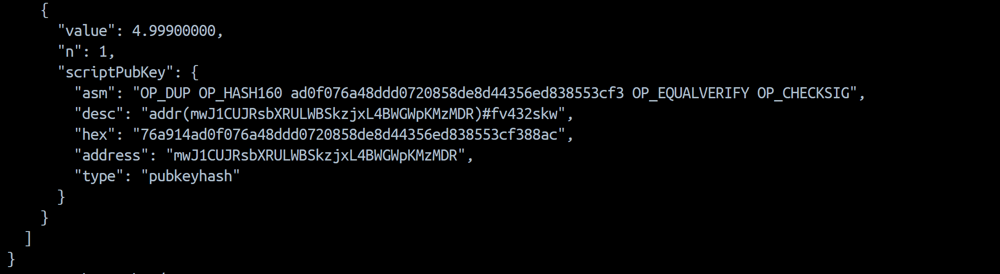
scriptPubKey.asm | OP_DUP OP_HASH160 ad0f076a48ddd0720858de8d44356ed838553cf3 OP_EQUALVERIFY OP_CHECKSIG
scriptPubKey.type | pubkeyhash
scriptSig.asm | 304402204436bdedca609f902c919a6617dc7ae43efe7d424ae366fd02fed35bf64e5fcb02203246872380986bbe749cdf9dd01ee3da9039a6e0bcfcda7731ac1d19d93dd439[ALL] 032d8cdb89a1023af191e7affa605f408e5f11f5bcd696f01d9293a265ed77f6d4
size | 225
vsize | 225
weight | 900

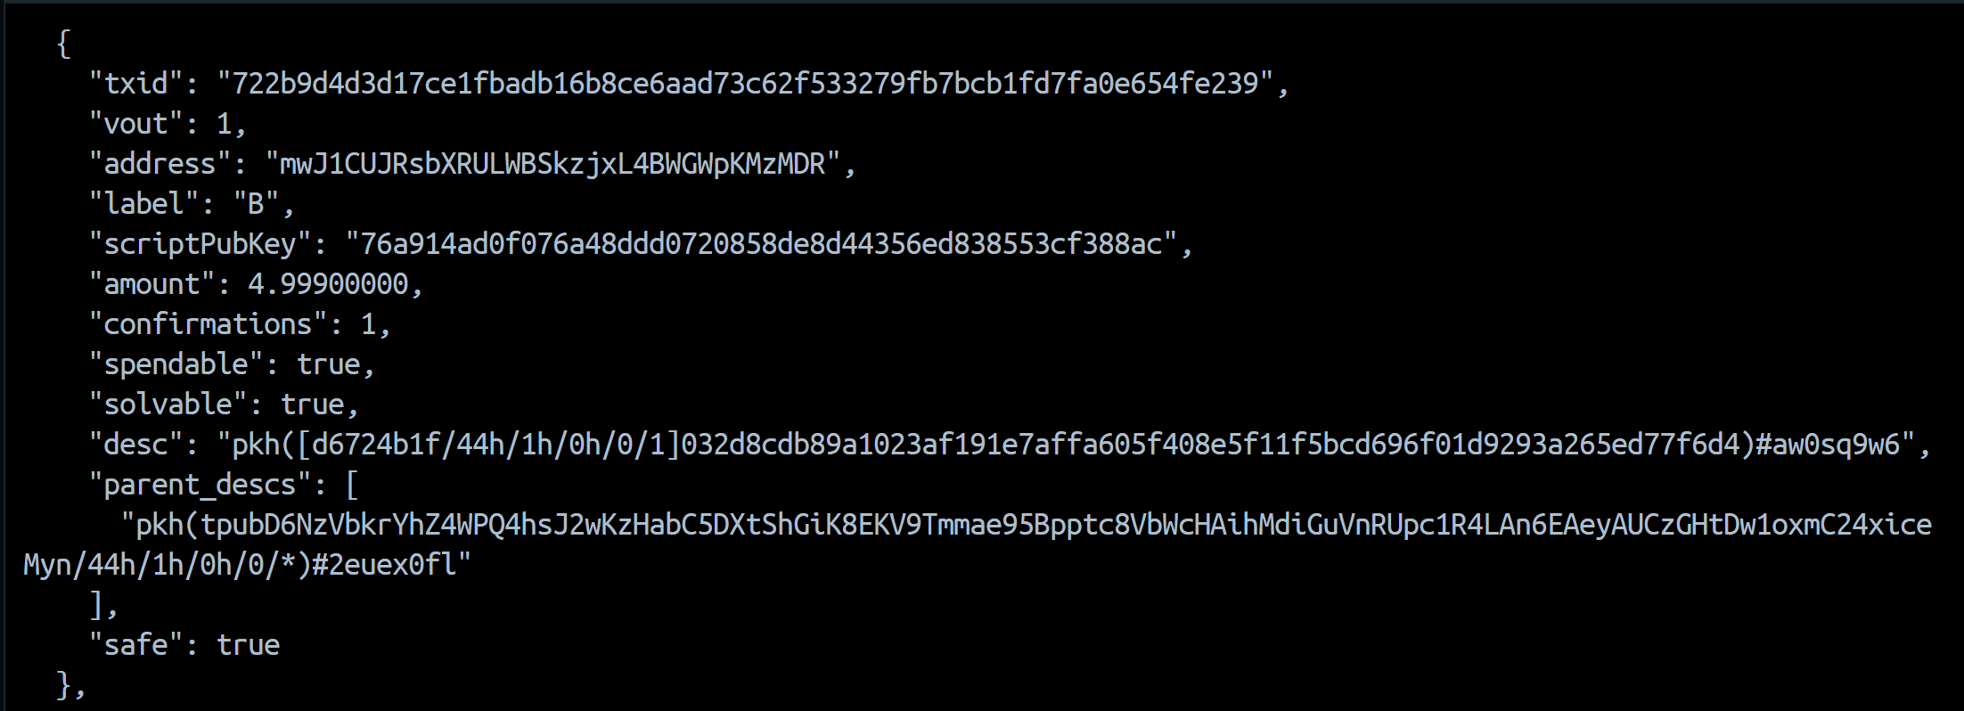
bitcoin-cli listunspent. shown here only for C and B
5 BTC goes to C and as a result 4.999 BTC goes back to B(which was initially 10 BTC as shown in output of program 2). This was because a transaction fee of 0.001 BTC was allocated in the regtest environment.

Structure of challenge, response and how validation occurs:
The transaction uses P2PKH. The response (ScriptSig) contains the digital signature and sender’s public key. The challenge (scriptPubKey) contains the cryptographic instructions and the target hash.
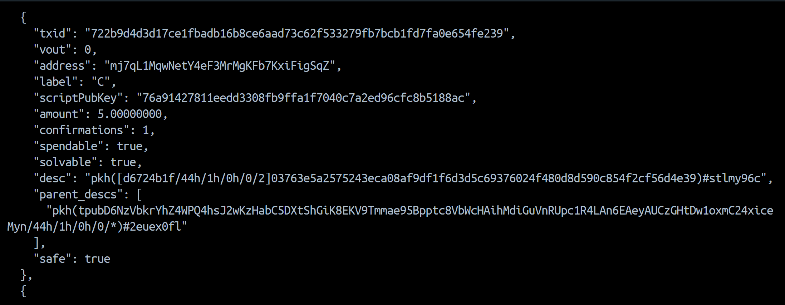

Btcdeb:
A->B
We used hex format. Appended hex of both scriptSig and scriptPubKey
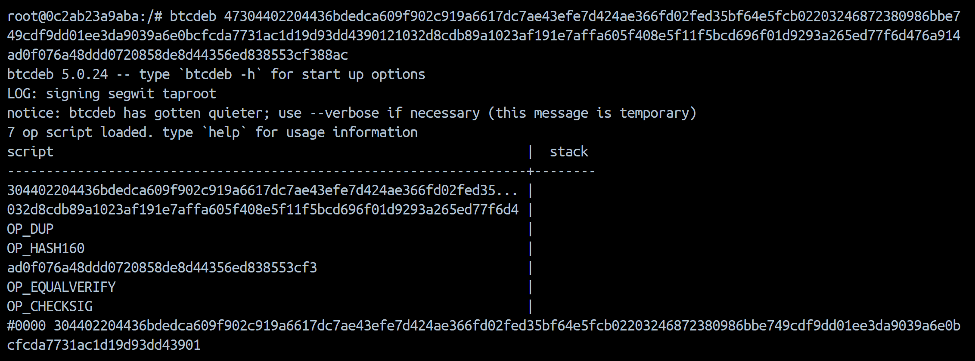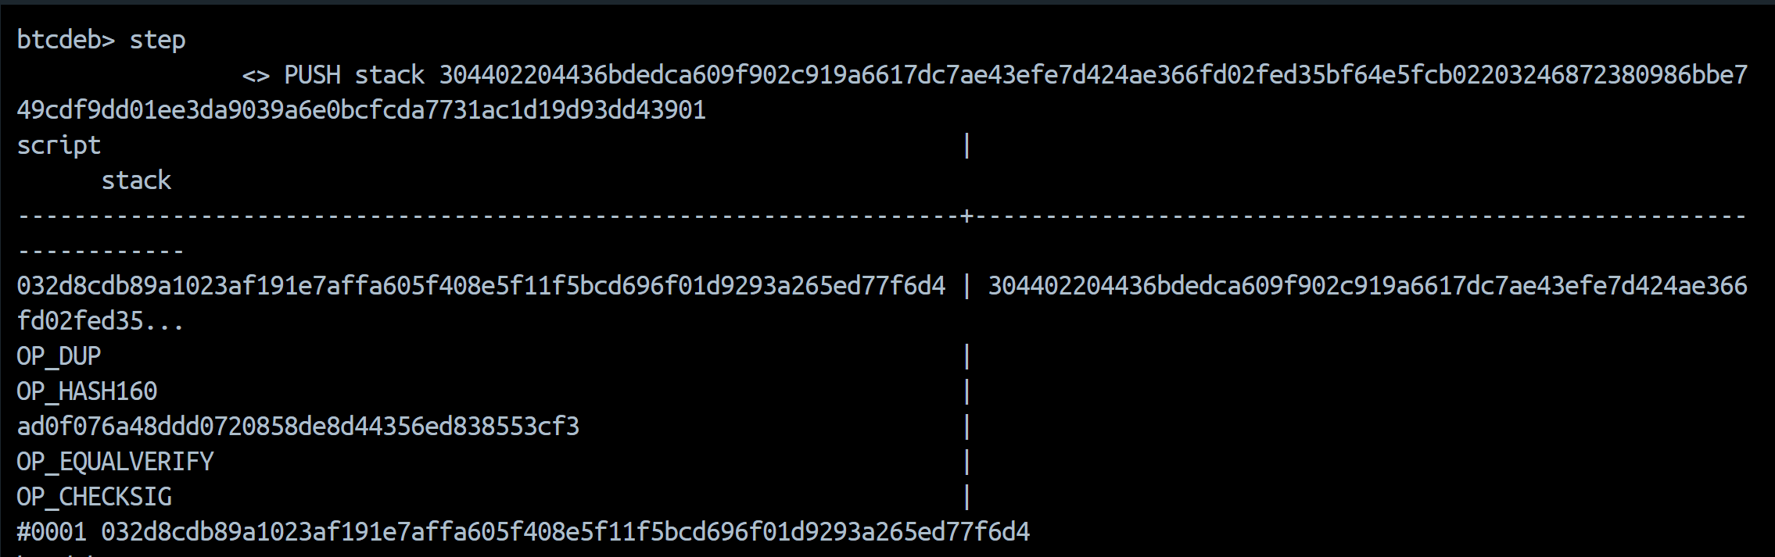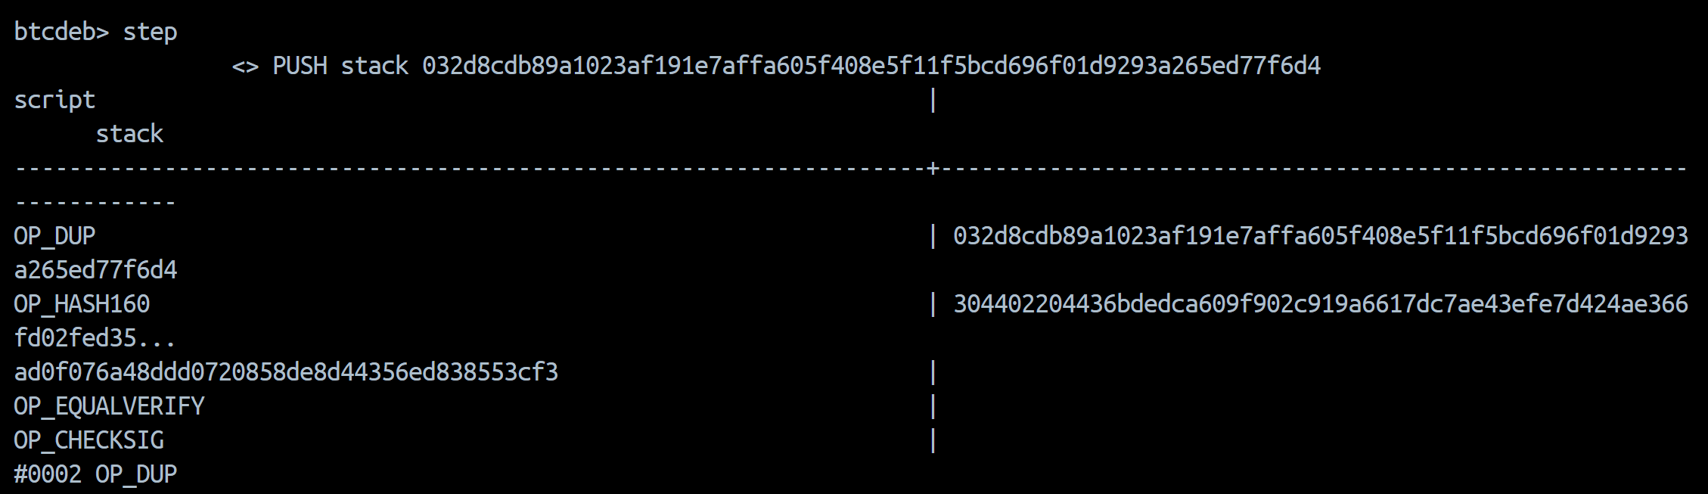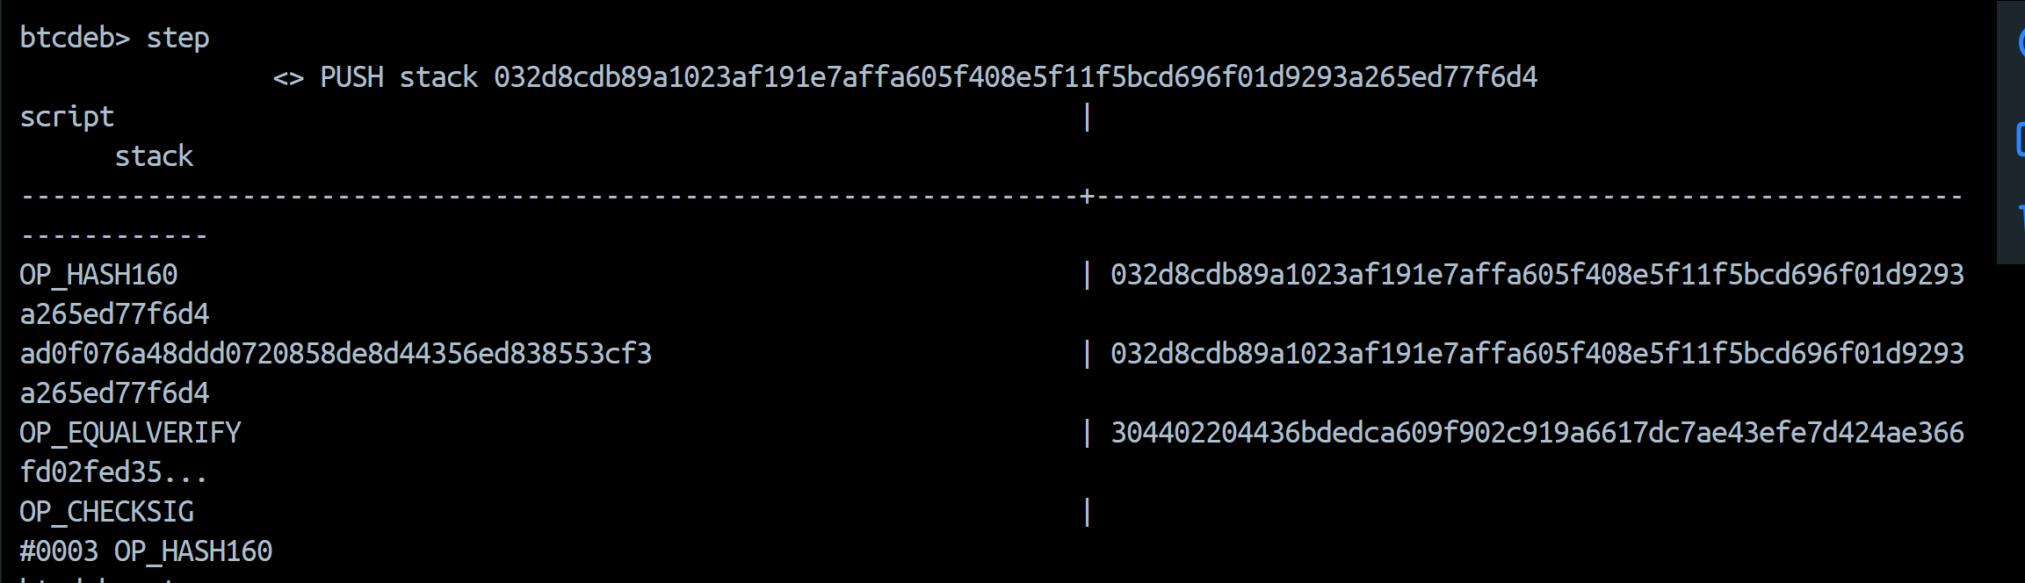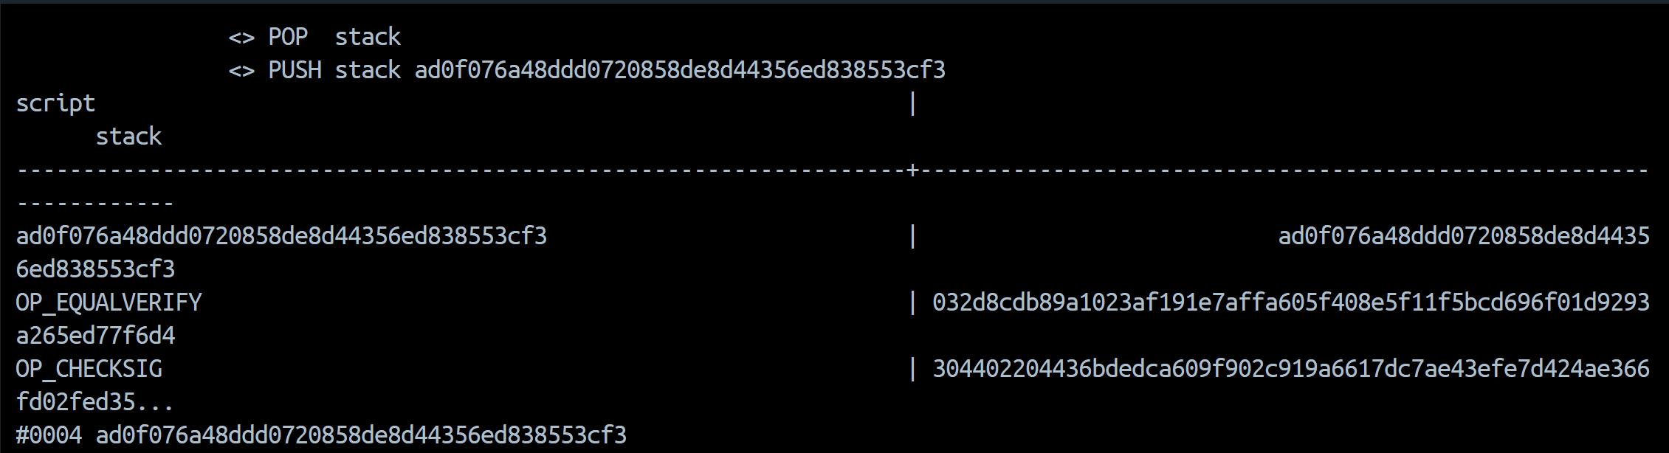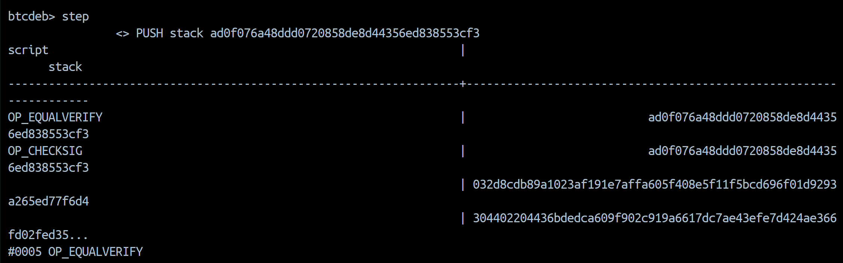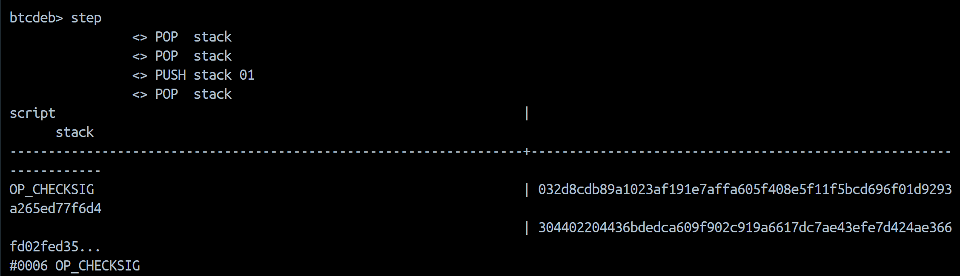

SegWit(P2WPKH):
Creating wallet and running programs
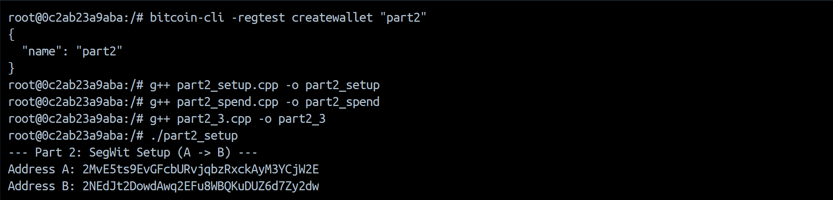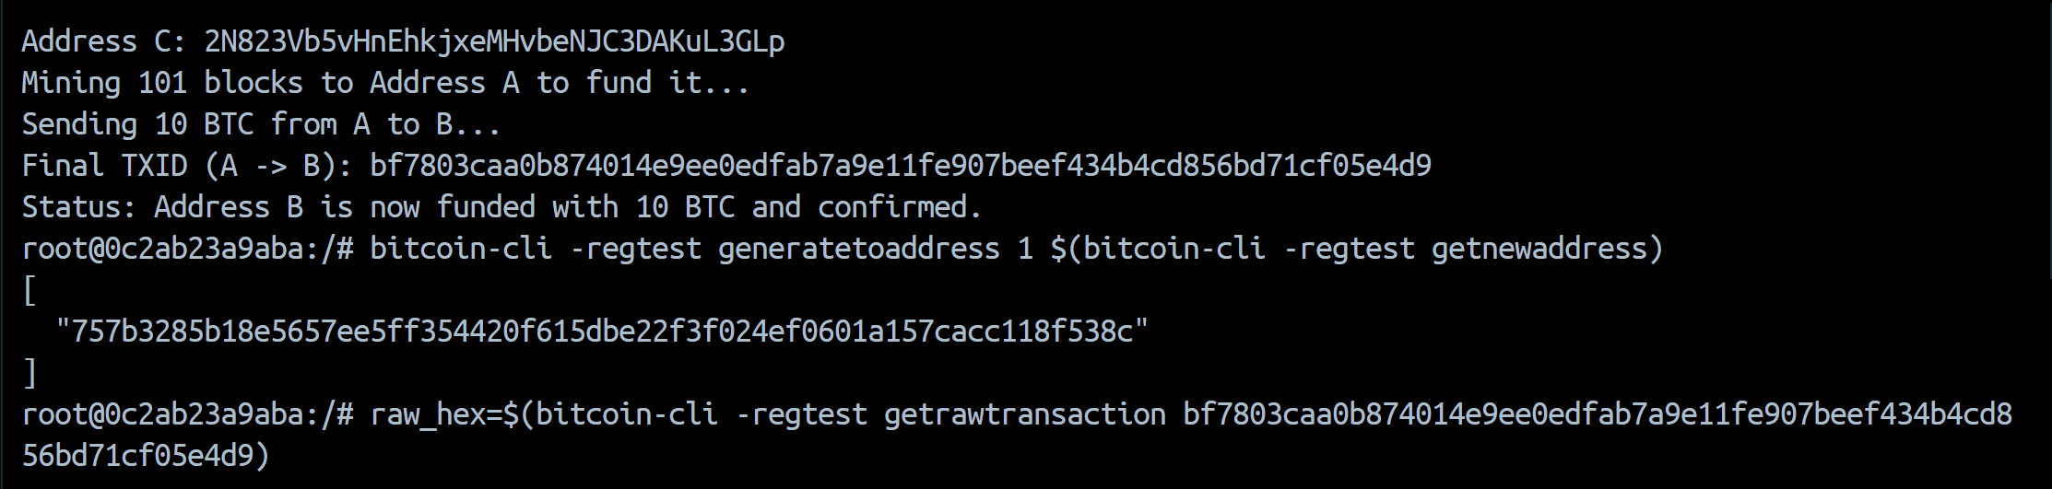
JSON file : A’->B’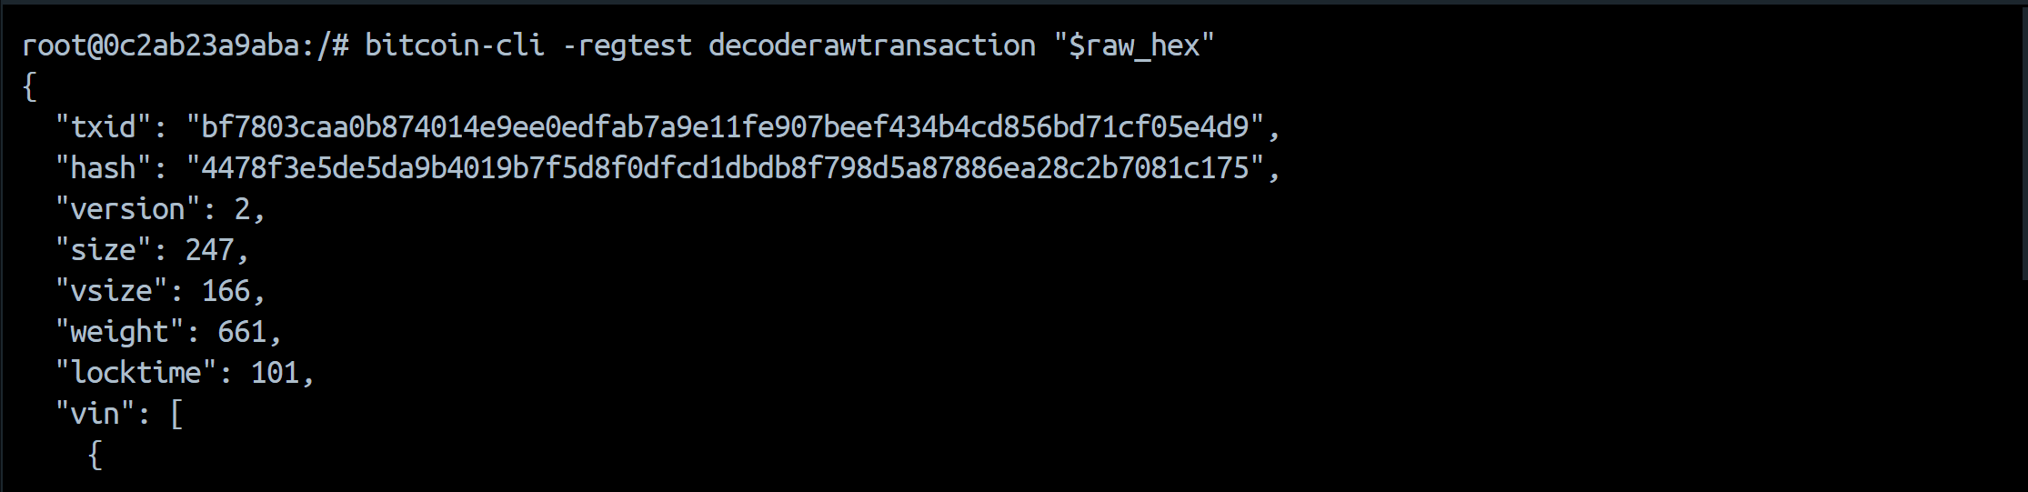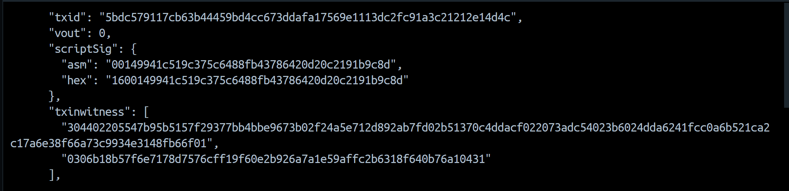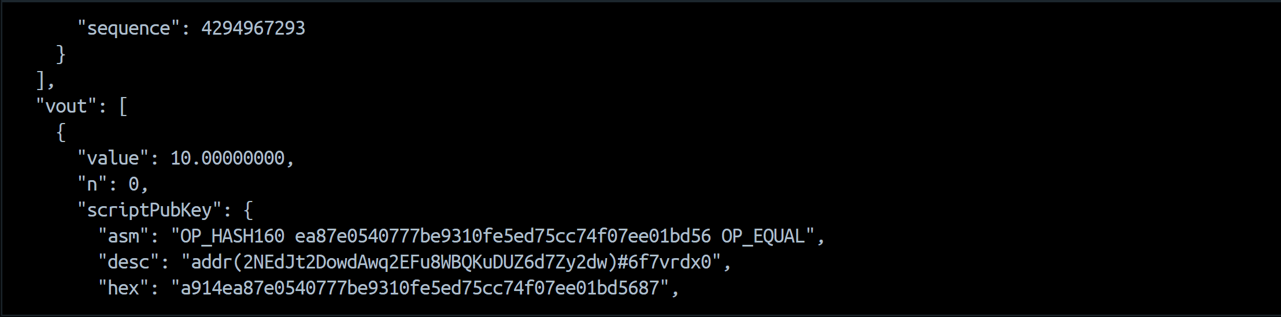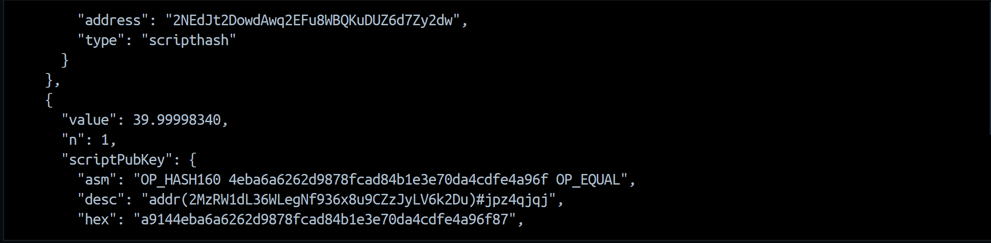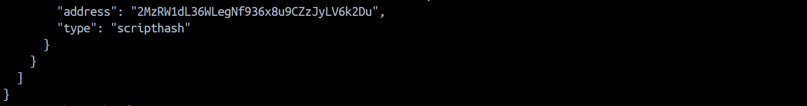

scriptPubKey.asm | OP_HASH160 ea87e0540777be9310fe5ed75cc74f07ee01bd56 OP_EQUAL
scriptPubKey.type | scripthash
scriptSig.asm | 00149941c519c375c6488fb43786420d20c2191b9c8d
txinwitness array | [  "304402205547b95b5157f29377bb4bbe9673b02f24a5e712d892ab7fd02b51370c4ddacf022073adc54023b6024dda6241fcc0a6b521ca2  c17a6e38f66a73c9934e3148fb66f01",  "0306b18b57f6e7178d7576cff19f60e2b926a7a1e59affc2b6318f640b76a10431"  ]
size | 247
vsize | 166
weight | 661

Program 2:
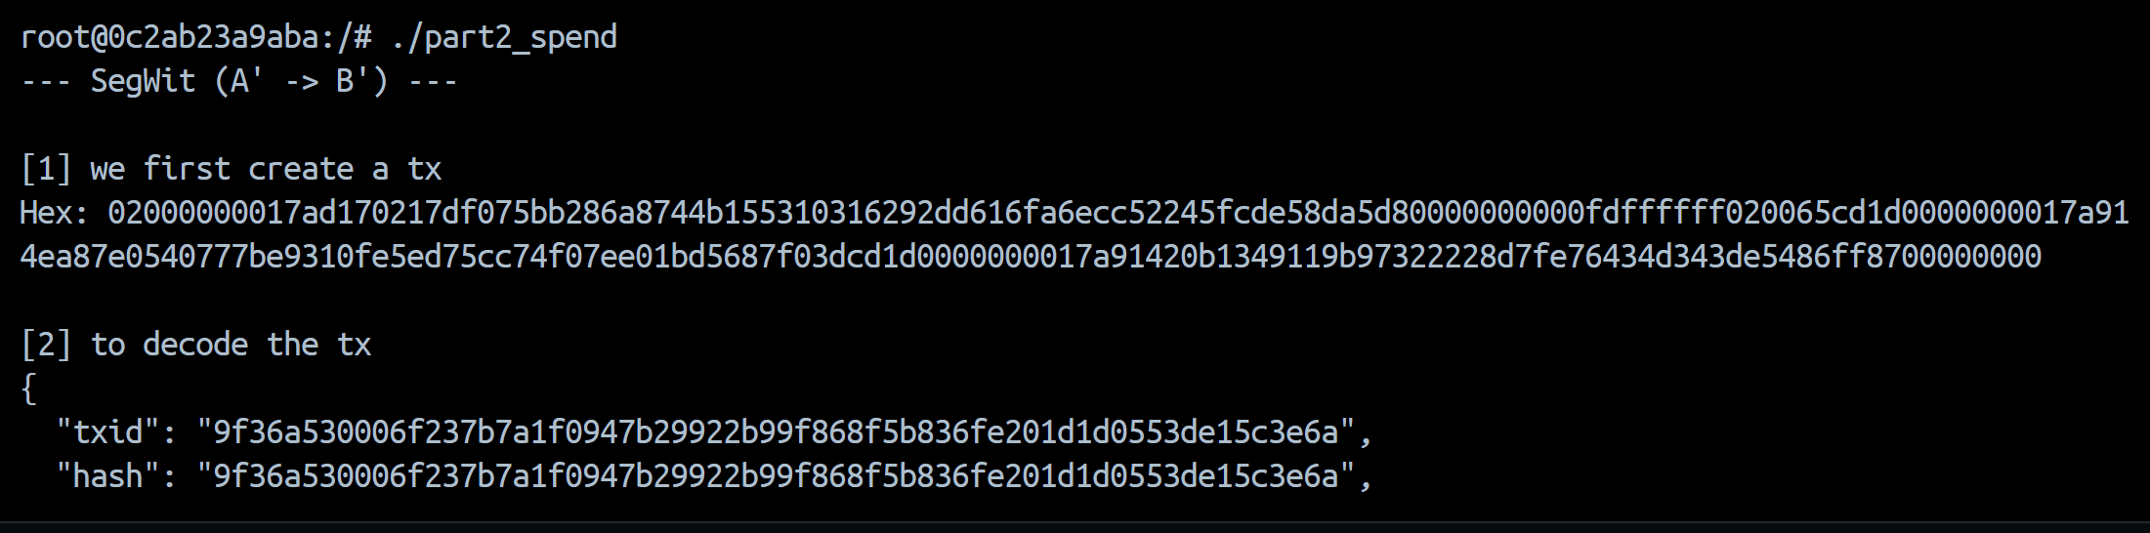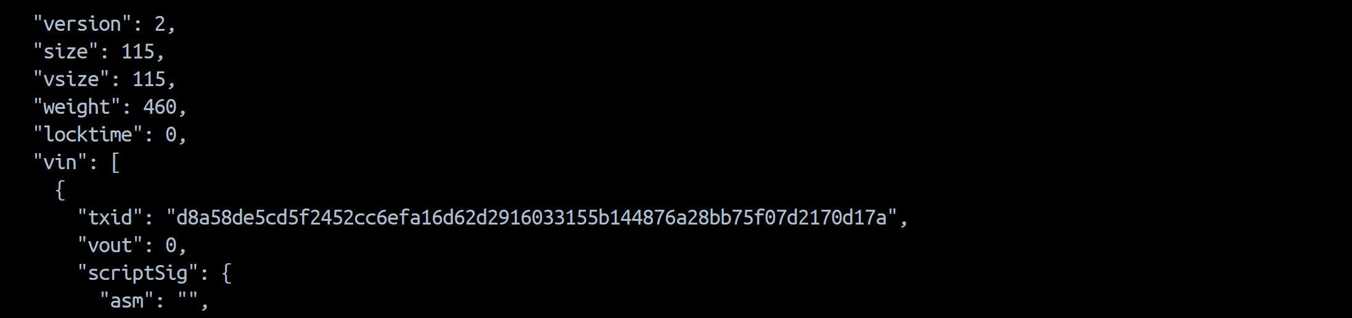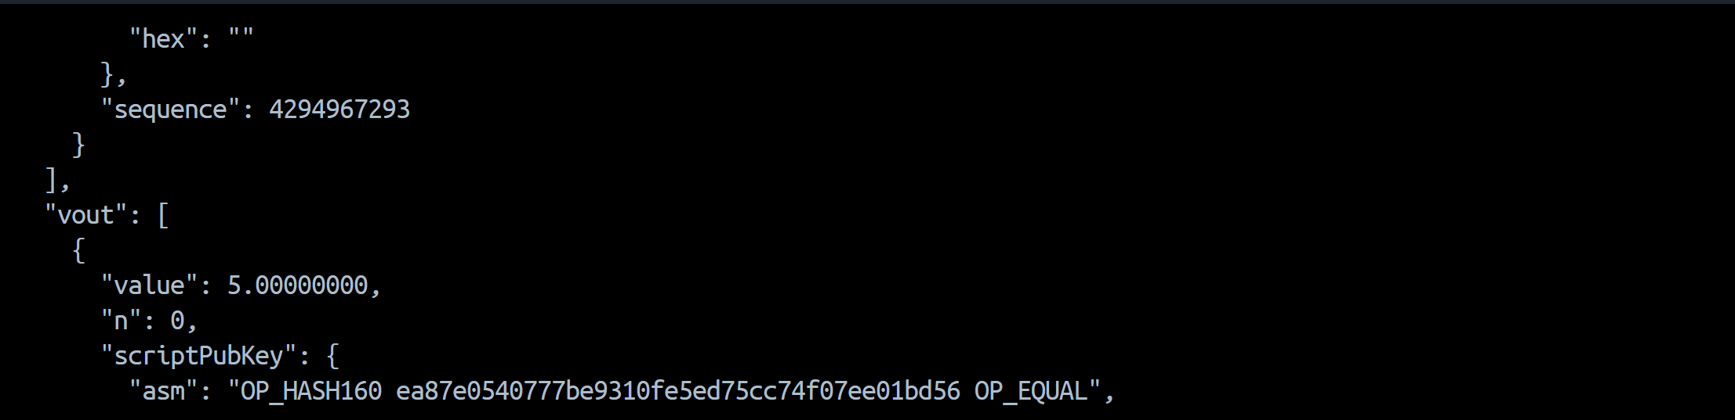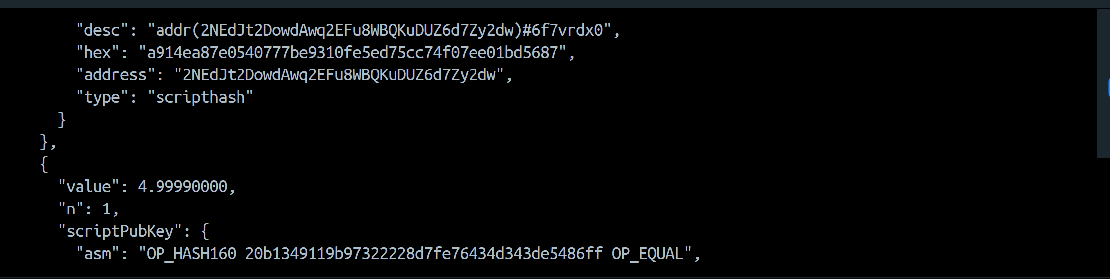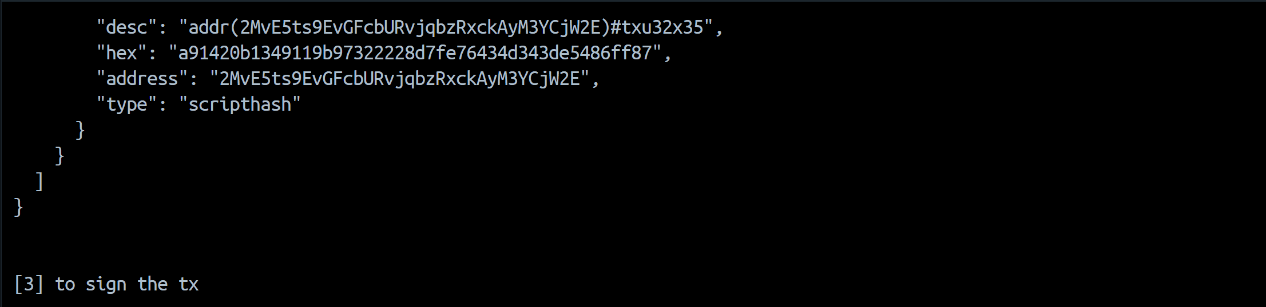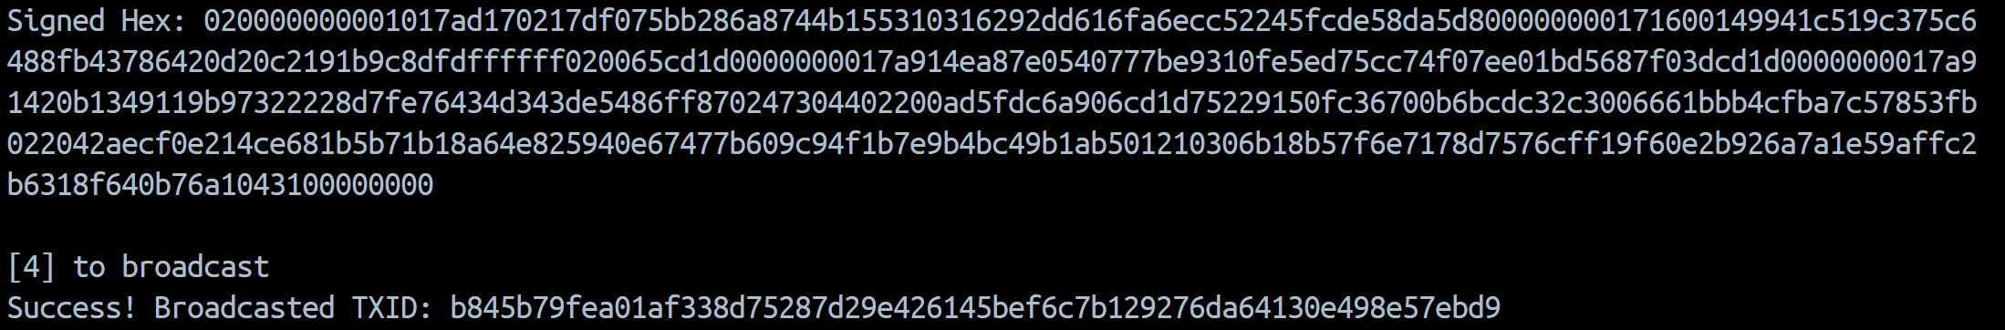
Repeating process for B’->C’:
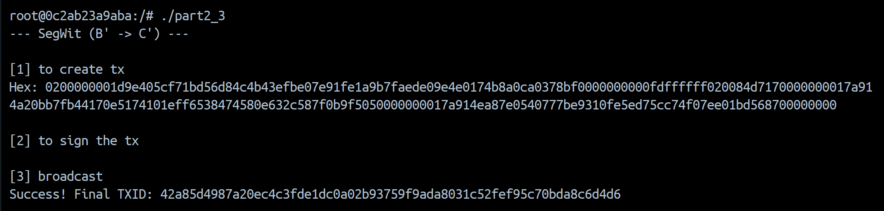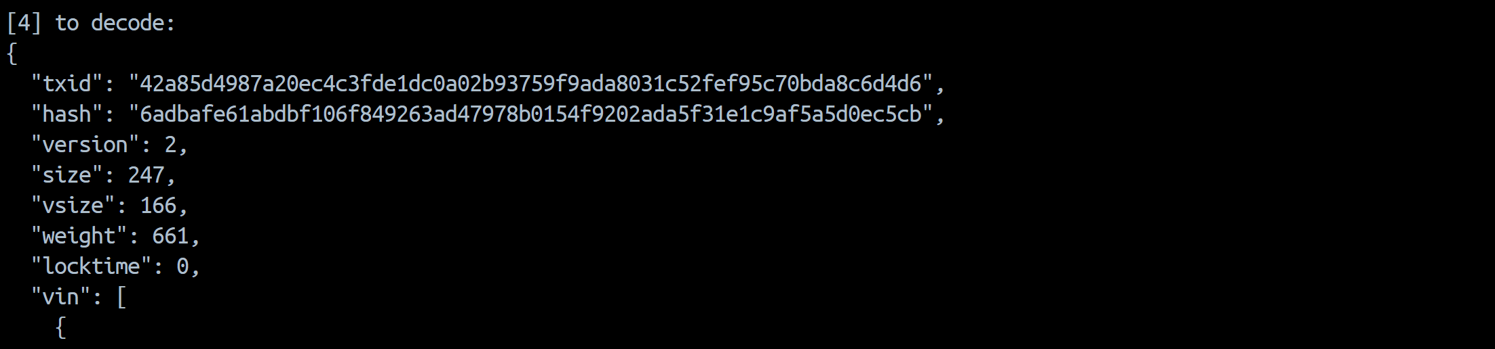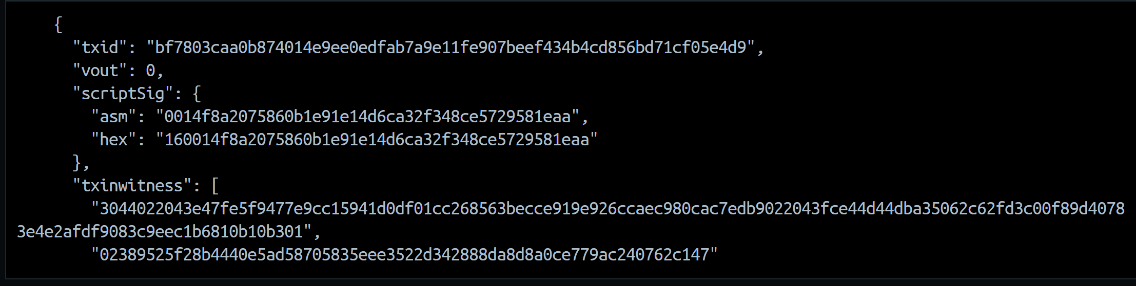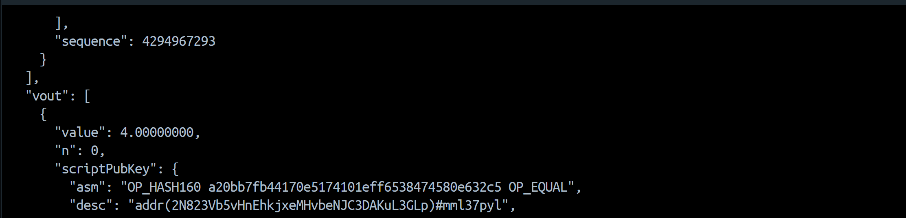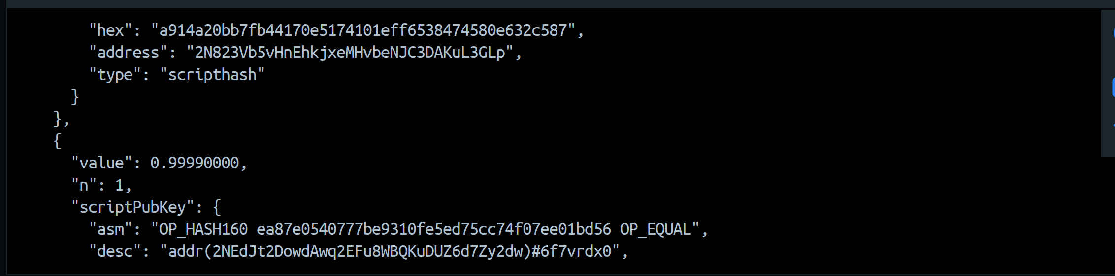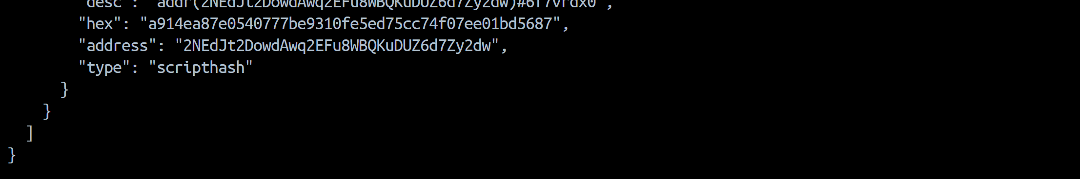
JSON file (B’ -> C’) is shown above.
scriptPubKey.asm | OP_HASH160 a20bb7fb44170e5174101eff6538474580e632c5 OP_EQUAL
scriptPubKey.type | scripthash
scriptSig.asm | 0014f8a2075860b1e91e14d6ca32f348ce5729581eaa
txinwitness array | [  "3044022043e47fe5f9477e9cc15941d0df01cc268563becce919e926ccaec980cac7edb9022043fce44d44dba35062c62fd3c00f89d4078  3e4e2afdf9083c9eec1b6810b10b301",  "02389525f28b4440e5ad58705835eee3522d342888da8d8a0ce779ac240762c147"  ]
size | 247
vsize | 166
weight | 661

btcdeb :
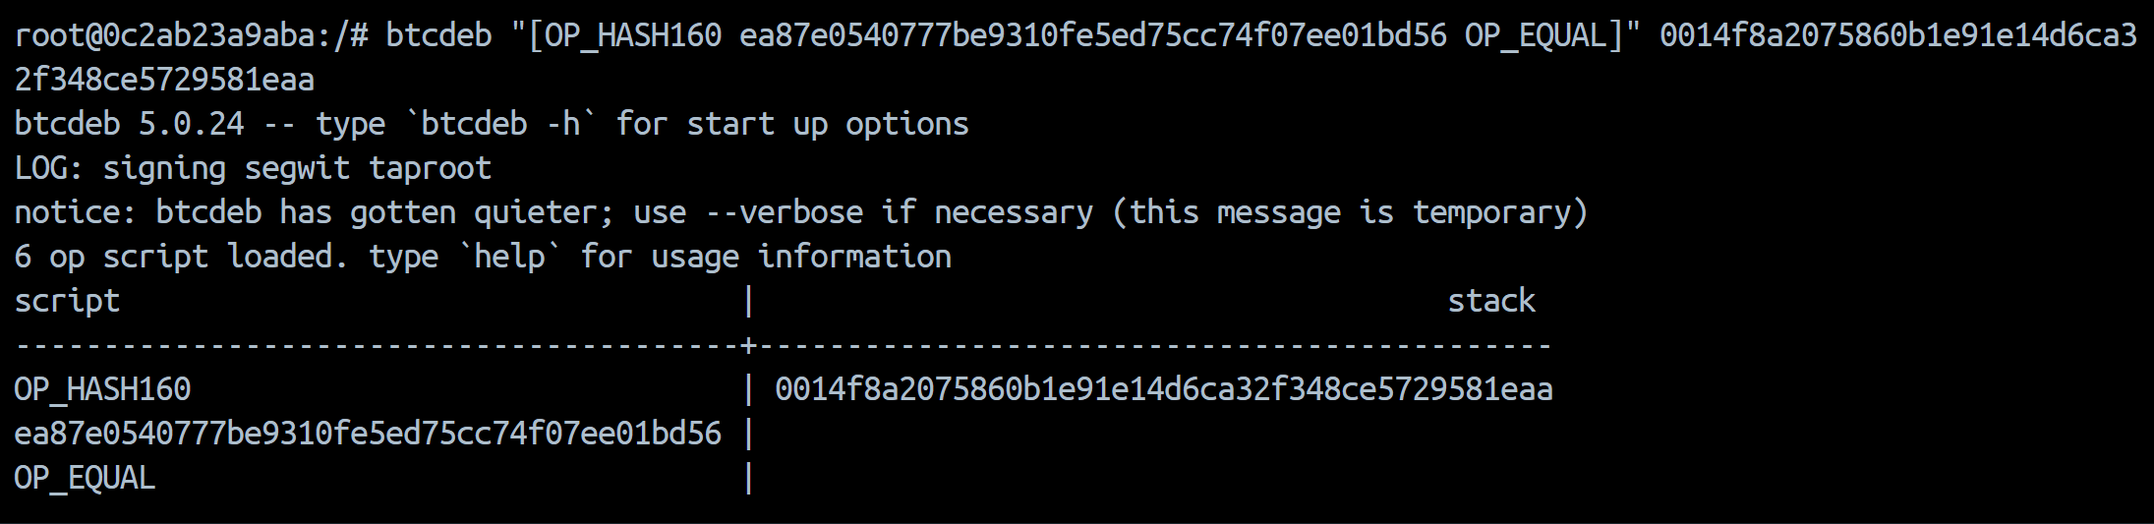
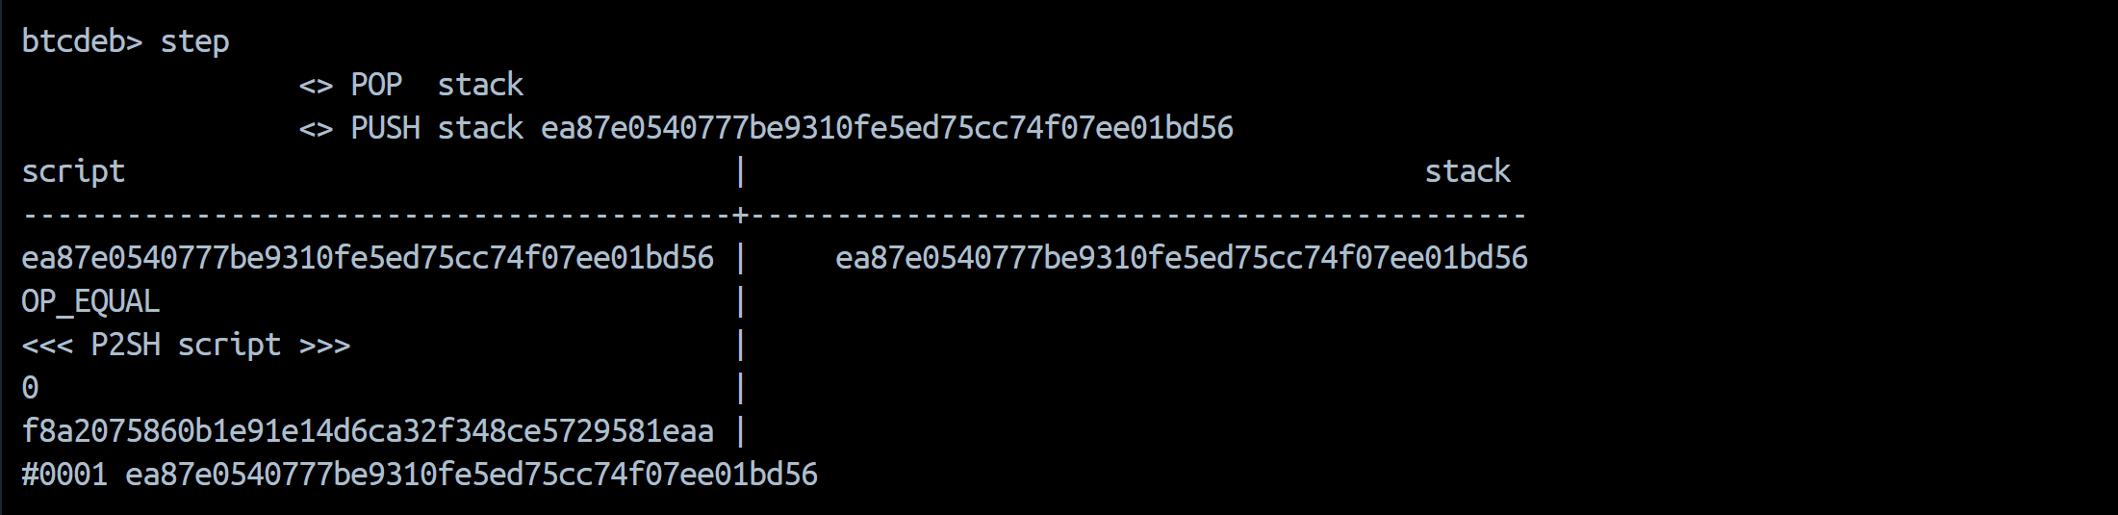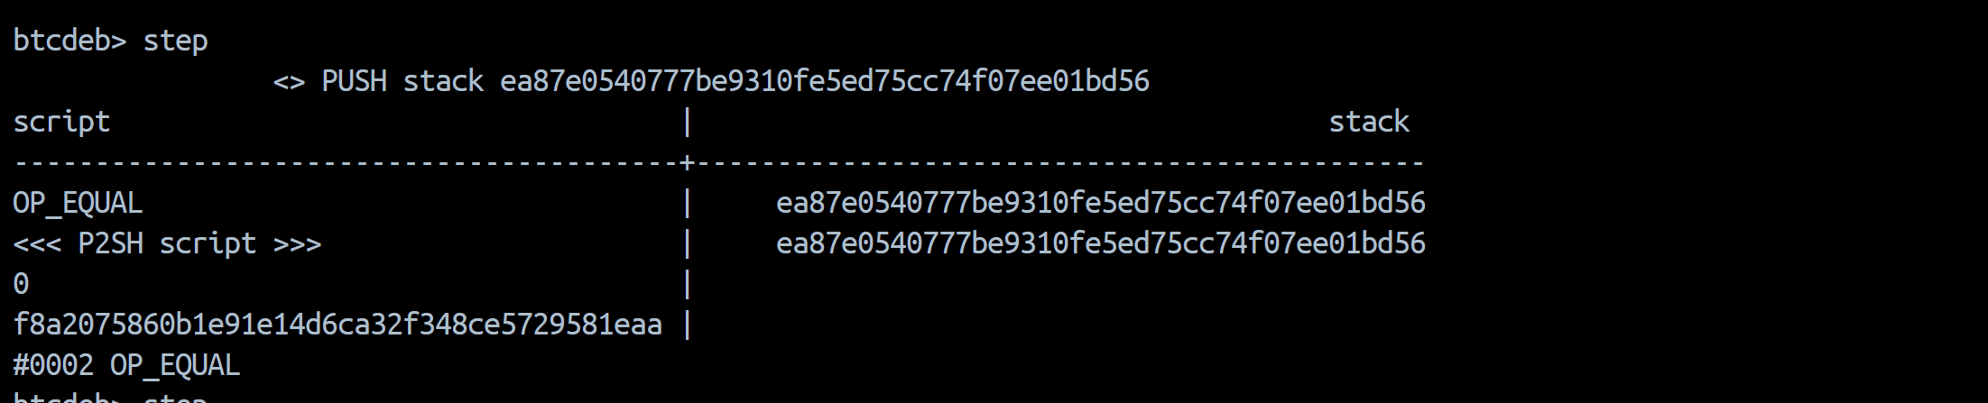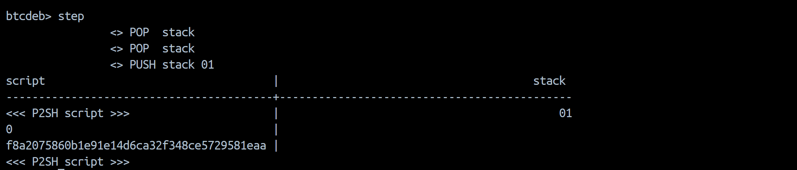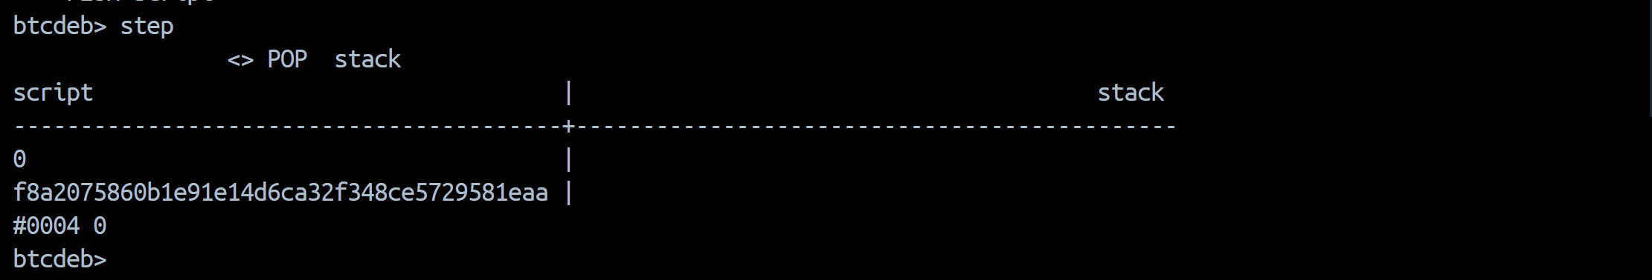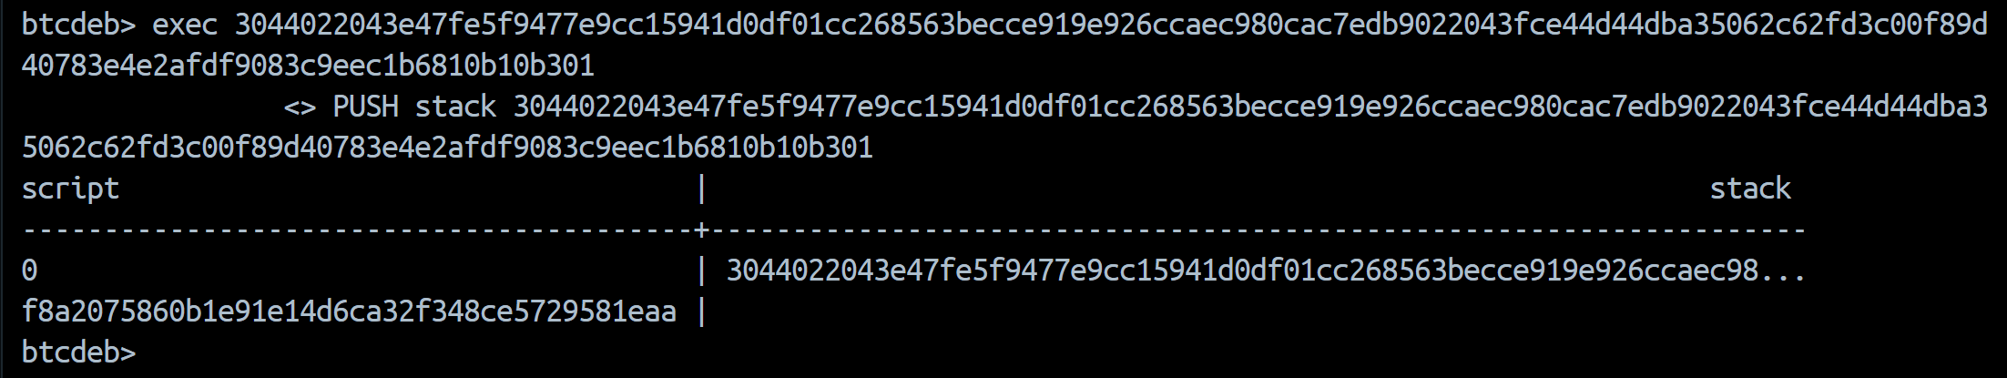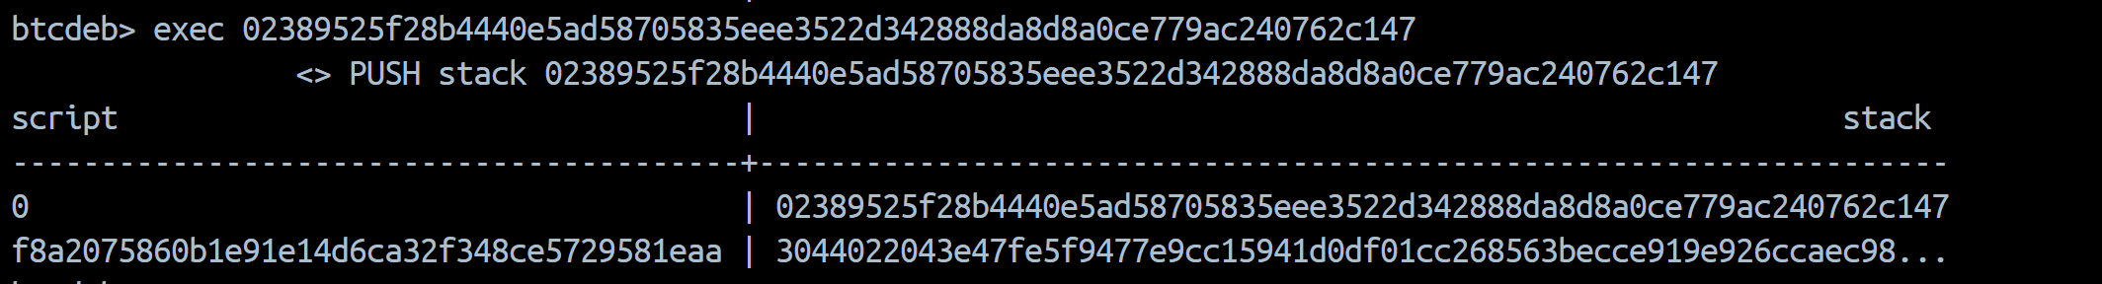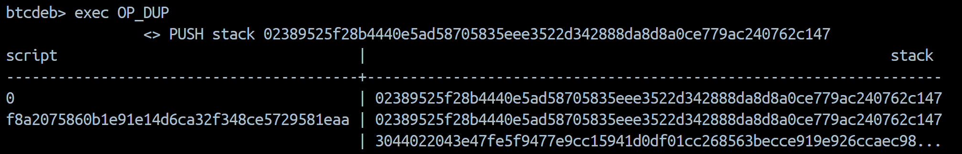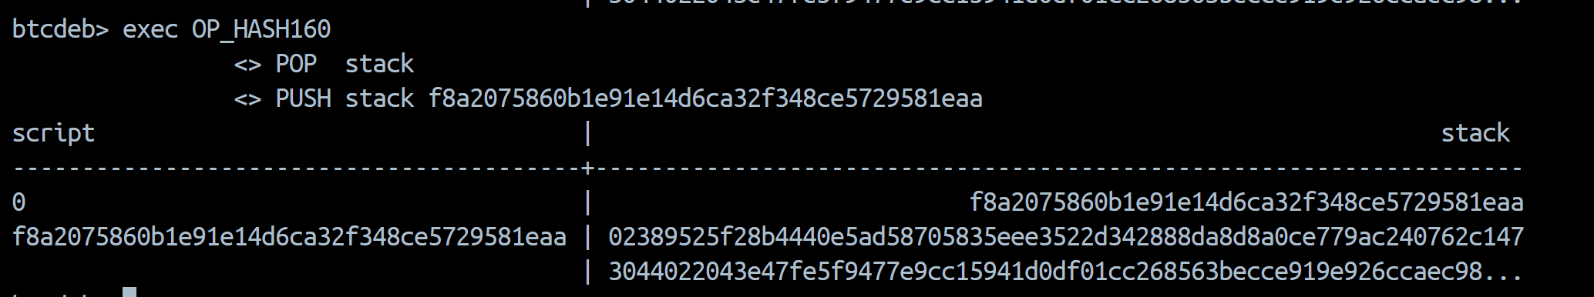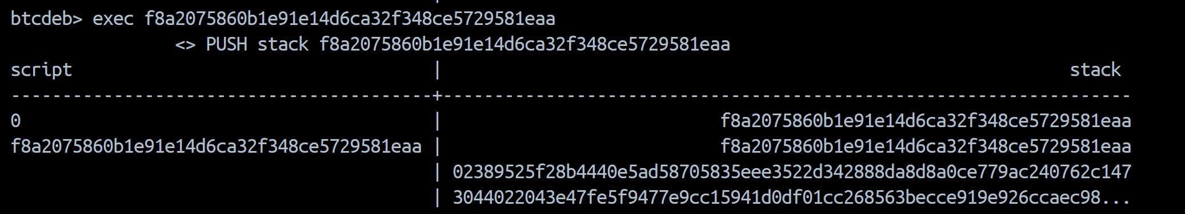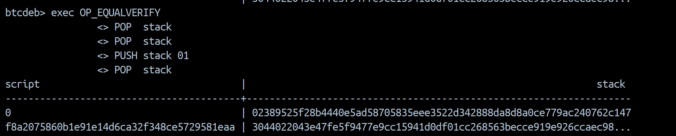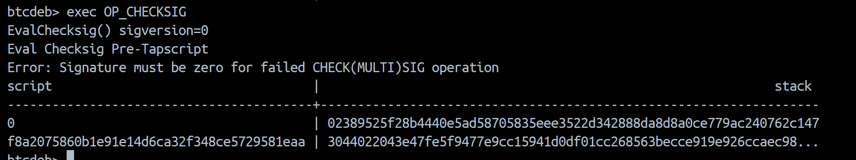

Part 3: Comparsion

