MANEJO DE ERRORES EN BASE DATOS

DELIMITER $$
CREATE PROCEDURE error2(p_id Int,p_alumno varchar(30))
MODIFIES SQL DATA
BEGIN
DECLARE CONTINUE HANDLER for 1062
SELECT CONCAT('Nº de matrìcula ' , p_id , 'ya existente') As 'Aviso de error';
INSERT INTO alumno VALUES (p_id,p-alumno);

end$$
DELIMITER ;

CLIENTES
DELIMITER $$
DROP PROCEDURE if EXISTS error1$$
CREATE PROCEDURE error1(p_id int)
MODIFIES SQL DATA
BEGIN
DECLARE CONTINUE HANDLER for 1062
SELECT concat("su codigo",p_id,"ya existe")As "Aviso de error grave";
INSERT INTO clientes(id_clientes) VALUES(p_id);
END $$
DELIMITER ;

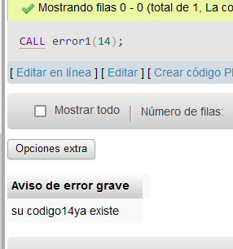
ARTICULOS
DELIMITER $$
CREATE PROCEDURE `error2`(p_id int)
MODIFIES SQL DATA
BEGIN
DECLARE CONTINUE HANDLER for 1062
SELECT concat("su codigo",p_id," ya existe")As "Aviso de error grave";
INSERT INTO articulos(id_PRODUCTO) VALUES(p_id);
END$$
DELIMITER ;

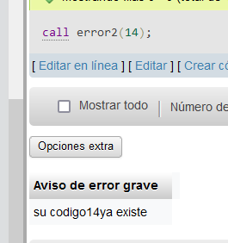

VENTAS
DELIMITER $$
CREATE PROCEDURE error3(p_id int)
MODIFIES SQL DATA
BEGIN
DECLARE CONTINUE HANDLER for 1062
SELECT concat("su codigo",p_id," ya existe")As "Aviso de error grave";
INSERT INTO ventas(Id_VENTAS) VALUES(p_id);
END$$
DELIMITER ;

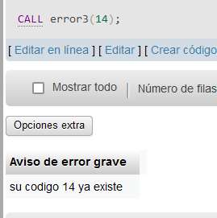

DELIMITER $$
CREATE DEFINER PROCEDURE error4(p_customer INT)
MODIFIES SQL DATA
BEGIN
DECLARE CONTINUE HANDLER for 1054
SELECT concat("su codigo",p_customer," ya existe")As "Aviso de error grave";
INSERT INTO clientes(Id_CLIENTES) VALUES(p_customer);
END$$
DELIMITER ;

